

**Tribhuvan University**

**Orchid International College**

**A Final Year Internship Report**

**On**

**“Aafnoghar”**

**At**

**Global Studio Pvt. Ltd**

**Under the Supervision of**

**Er. Dhiraj Kumar Jha**

**Project Coordinator**

**Orchid International College**

**Submitted By**

**Ashim Poudyal**

**TU Exam Roll No: 15698/074**

**Submitted To**

**Department of Computer Science and Information Technology**

**Orchid International College**

**In partial fulfillment of the requirement for the Bachelor Degree in Computer Science and Information Technology**

**June 2022**



# SUPERVISOR’S RECOMMENDATION LETTER

I hereby recommend that the report prepared under my supervision by Ashim Poudyal (TU Exam Roll No.15698/074) entitled **“Afnoghar” at “Global Studio pvt ltd”** in partial fulfillment of the requirements for the degree of B.Sc. in Computer Science and Information Technology be processed for evaluation.

**……………..…….**

**Er. Dhiraj Kumar Jha**

Internship Supervisor, Department of CSIT

Orchid International College

Bijayachowk, Gaushala



**CERTIFICATE OF APPROVAL**

The undersigned certify that they have read and recommended to the Department of Computer Science and Information Technology for acceptance, an internship report submitted by Mr. Ashim Poudyal in partial fulfillment for the degree of Bachelor of Science in Computer Science & Information Technology (B.Sc.CSIT).

|  |  |
| --- | --- |
| ---------------------------- **Er. Dhiraj Kumar Jha** Internal Examiner/Project Coordinator Department of Computer Science and IT Orchid International College  Bijayachowk, Gaushala | -------------------------  **Bidur Dahal**  Principal  Orchid International College Bijayachowk, Gaushala |
| -----------------------------  **External Examiner**  CDCSIT Tribhuvan University Kirtipur, Nepal | |

# ACKNOWLEDGEMENT

I would like to express my gratitude to my respected internship mentor **Mr. Roopesh Ghimire** and the team that gave me immense pleasure to express my deepest sense of gratitude and sincere thanks to him who had given his full effort in guiding the internship program and all the team of **Global Studio Pvt Ltd.**

It is a great pleasure to have the opportunity to extend my heartfelt gratitude to everyone who helped me throughout this project. I would like to express my profound gratitude to my supervisor **Er. Dhiraj Kumar Jha** for his guidance and support in each step for the progress of this project. His continuous inspiration and valuable suggestions has made me complete this project and achieve its target.

I would like to express my sincere gratitude towards the **Department of Computer Science and Information Technology, Orchid International College,** for providing me with the wonderful opportunity, encouragement and environment to explore my skills and gain learning experience through this internship opportunity.

Last but not the least; I would like to thank all the faculty members and friends who has direct and indirect contribution to my project. Any kind of suggestions or criticism will be greatly appreciated and acknowledged.

Sincerely.

**Ashim Poudyal**

**TU Exam Roll No: 15698/074**

**ABSTRACT**

As for the partial fulfillment, the author was interned as a Backend developer in an organization named Global Studio. Tasks like developing websites using HTML, CSS, BOOTSTRAP, PHP scripting using Laravel framework were given as a intern. During this internship period, task of building the restaurant website was successfully completed under the guidance of the organization’s mentor. It was very exciting experience of working in the real time platform with the implementation of knowledge that I have gained in college. It was really challenging. It was the experience of entering into professional life from student life.

Keywords: Ajax, Css, Html, Javascript, Laravel, Mysql, Php

Table of Contents

ACKNOWLEDGEMENT iv

ABSTRACT……………… v

Chapter 1- Introduction 9

**1.1** **Introduction** 2

**1.2** **Problem Statement** 1

**1.3** **Objective** 1

1**.3.1 Internship Objective** 1

**1.3.2 Project Objective** 2

**1.4** **Scope and Limitation** 2

**1.4.2 Scope.** 2

**1.4.2** **Limitations** 2

**1.5** **Report Organization** 2

Chapter 2- Organizational Details and Literature Review 4

**2.1** **Introduction to Organization** 4

2.1.1 Organizational Background 4

**2.1.2 Services Provided by Organization** 4

**2.2** **Organizational Hierarchy**  4

**2.3** **Working Domains of Organization** 4

**2.4** **Description of Intern Department/Unit** 5

**2.5** **Literature Review** 6

Chapter 3- Internship Activities 7

**3.1** **Roles and Activities** 7

**3.2** **Weekly Log** 7

**3.3** **Description of Projects involved in Internship** 8

**3.3.1** **Use Case Diagram** 8

**3.3.2** **Data Modeling** 9

Chapter 4- Conclusion and Learning Outcomes 11

**4.1** **Conclusion** 11

**4.2** **Learning Outcomes** 11

References 12

**Appendix 13**

**LIST OF FIGURES**

Figure 3.1 Use Case Diagram for Afnoghar 8

Figure 3.2 Class diagram for afnoghar 9

**LIST OF ABBREVIATIONS**

|  |  |
| --- | --- |
| **API :** | Application Programming Interface |
| **CDCSIT :** | Central Department of Computer Science and IT |
| **CSS :** | Cascading Style Sheets |
| **HTML :** | Hypertext Markup Language |
| **JSON :** | JavaScript Object Notation |
| **SQL :** | Structured Query Language |
| **UI :** | User Interface |

**AJAX :** Asynchronous JavaScript and XML

# 

# CHAPTER 1: INTRODUCTION

## **Introduction**

As an Intern I worked as a back-end developer under the supervision of Mr. Roopesh Ghimire Developer and Project Manager at Global Studio pvt. Ltd. I was assigned to work on a project **“Afnoghar”.**

Afnoghar is a web application of a Resturant in which an user can book rooms and also they can order food by using digital menu system in which there will be QR code and user can scan that QR code and order food.

## **Problem Statement**

Our company is a startup company so it is small compared to others. So in small company there will be many problems like time delay there will be less employee so there will be delay in project completion. There will not be employee like QA or UI/UX design so developer has to work on all so there will be pressure to one person. There will be net problem electricity problem and another main problem will be if one employee will be in leave that the project will be on hold.

## **Objective**

## Before setting up all the parameters for the internship there should be proper vision about what might be the goal or objectives of the internship and project. The following are the list of the some of the objectives that has been reported in discussing the internship and project.

**1.3.1 Internship Objectives**

1. To learn how to work in group with professionals.
2. To develop new skills
3. Develop real world system.

**1.3.2 Project Objectives**

1. To make management more efficient and connect all hierarchy levels within an organization.
2. To allow developers and designers to keep track of their tasks along with time and resources spent.
3. To allow developers and designers to keep track of their tasks along with time and resources spent.

## **Scope and Limitation**

**1.4.1 Scope**

This report is made only for academic purpose and to fulfil the requirement for industrial attachment. This report has covered the direct and indirect aspects of IT industry and their challenges. In addition, the report is focused on Resturant Management System.

**1.4.2 Limitations**

Limitations of this project are:

1. One needs to have internet connection to access this system.
2. Due to time constraint for internship, this report only describes the knowledge gained during working hour of SeeLogic International Pvt. Ltd.

## **Report Organization**

This project is organized into seven chapters as follows:

**Chapter 1: Introduction**

It contains the introduction of project, problem statement, objective of the internship, scope and limitation of Resturant Management System and how overall internship report is organized.

**Chapter 2: Organization Details and Literature Review**

This chapter contains details about the Global Studio Pvt. Ltd. like: introduction, hierarchy, working domains, intern department and Literature Review.

**Chapter 3: Internship Activities**

This chapter contains the roles and responsibilities, weekly log, description of project involved during internship and the activities that are performed during the involvement with the project.

**Chapter 4: Conclusion and Learning Outcomes**

It contains the conclusion and the learning outcomes based on the project

# CHAPTER 2- ORGANIZATION DETAILS AND LITERATURE REVIEW

## **2.1 Introduction to Organization**

**2.1.1 Organizational Background**

Global Studio Pvt. Ltd. is the company of Nepal that aims to produce high-quality software, providing solutions that work efficiently. Since its establishment in 2020, Global Studio has been providing the best possible services to meet user and client satisfaction. Bajra has a keen focus on understanding the vision of the client and maintaining strong communication during the planning, design and development phases to completely satisfy all requirements. Its main moto is Digitize Nepal.

**2.1.2 Services Provided by Organization**

Global Studio Pvt. Ltd. provides multiple services in the area of website design and development. The areas of expertise of the organization are:

1. Web development using Laravel
2. Mobile development using Flutter

## **2.2 Organizational Hierarchy**

## The head of the company is the CEO, who is responsible for taking all major decisions. The HR department manages the human resource and marketing and the software development department develops applications for the clients. The Project Manager defines the tasks for the developers and designers. I have been working as an intern under the development unit.

## **2.3 Working Domains of Organization**

Global Studio was established as software engineering firm. It was established for creating new software and applications with new technologies. The Company mainly focused on Mobile & Web Development.

The Domains are

1. Web Development:

One of the domains of Global Studio Pvt. Ltd. is Web development this company develop the web pages and put it in domain.

1. Mobile Development:

Another domains of Global Studio Pvt. Ltd. is Mobile development this company developes Mobile app using Flutter

## **2.4 Description of Intern Department/Unit**

Global Studio Pvt. Ltd. is always looking for qualified graduates to hire as an intern. They care less about your past experiences and more about your ability to learn as well as grasp of fundamental concepts. They provide internship opportunities in Software development, Software Design. The table below gives the detailed information about the internship including various topic such as working period, location, mentor as so on.

**Table 2.1: Internship Description**

|  |  |
| --- | --- |
| Internship Title | Developer |
| Organization | Global Studio Pvt. Ltd. |
| Address | Anamnagar |
| Mentor | Roopesh Ghimire |
| Time Period | 7th March 2022-7th June 2022 |
| Hours Per Day | 8 hrs. (10AM-6PM) |
| Office Days | 5 days (Monday-Friday) |
| Position | Intern |

## **2.5 Literature Review**

Literature Review on “Afnoghar”

Laravel is an open-source PHP framework, which is robust and easy to understand. It follows a model-view-controller design pattern. Laravel reuses the existing components of different frameworks which helps in creating a web application. The web application thus designed is more structured and pragmatic.

You might encounter a scenario where you want to reuse some feature(s) of your application in other applications, open-source a specific functionality or keep related code together but separate it from your main application. In those cases, it makes sense to extract parts to a package. Packages or "libraries" provide an easy way to add additional functionality to existing applications and focus on a single feature.

It is online restaurant management system in which a user can benefit from the site everything digitally. It is digital restaurant management system with many features like digital menu. One can sit in the table and there will be a QR code and user can scan that and order the menu he/she wants. User can also book room digitally. It is complete restaurant management system and very important for the context of Nepal.

**2.5.1 Related Works**

1. **VS Code Editor:**

It is the editor in which the coding is done. We write the code in VS Code and then only the code can execute properly. It is very important for coding

1. **Trello:**

Trello is a collaborative work management app designed to track team projects, highlight tasks underway, show who they are assigned to, and detail progress towards completion.

At its core, Trello relies on the principles of Kanban project boards to visualize workflows, providing managers and team members with a simple overview of a project from start to finish.

**CHAPTER 3: INTERNSHIP ACTIVITIES**

## **3.1 Roles and Responsibilities**

The author was placed in a project named Afnoghar (Restaurant Management System) during his internship period. The project required many different components and modules, the internship covered a few of them. The major roles and responsibilities assigned during the internship were:

1. Perform the Crud Operation.
2. Make the client-side dynamic.
3. Make reusable components and test these components.

## **3.2 Weekly Log**

The weekly log of internship includes the following:

**Table 3.1 Details of Weekly Log**

|  |  |
| --- | --- |
| Week | Activity Log |
| First | 1. Study the basic HTML, CSS, JS |
| Second | 1. Learnt Basics of Laravel  2. Learnt about helper function |
| Third | 1. Created own Dashboard for doing projects  2. Created simple login form |
| Fourth | 1. Learnt Validation  2. Learnt and did Front end dynamic |
| Fifth | 1. Got familier with different packages  2. Performed different packages operation  3. Completed Room booking process |
| Sixth | 1. Worked on databases |
| Seventh | 1. Got familier with cart system  2. Created checkout form  3. Added coupon in checkout form |
| Eighth | 1. Made changes according to clients requirements |
| Ninth | 1. Integrated everything in Dashboard |
| Tenth | 1. Created digital menu |
| Remaining | 1. Creating QR code for ordering food |

## **3.3 Description of Project Involved in the Internship**

The project named Afnoghar is a web-based application of a Restaurant named Afnoghar in which User can book the rooms as well as he/she can use digital menu to order the foods. The main objective of the project is to help user to book perfect room through online according to their estimated date and to buy food digitally so that they can order anything sitting only. The result of this project is project is to satisfy the clients and take the positive response.

Some of the page components features of the project application are:

* **Dashboard:** Provides the required data modules needed by the admin i.e. (menu, rooms, bookings, order)
* **Book rooms:** Provides the access to the customer to book the rooms through online by logging in to the system.
* **Order food:** Provides the customer to order the food by using QR code.

**3.3.1 Use Case Diagram**

The Use case diagram of the Project

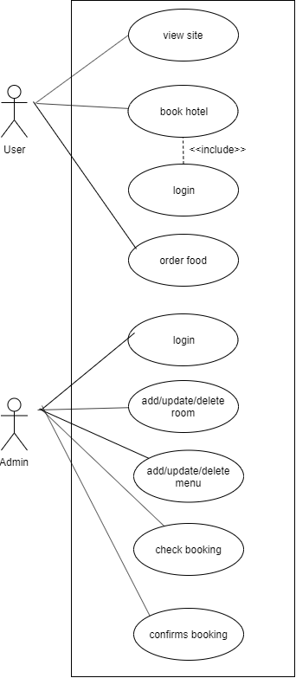

Figure 3.1 Use Case Diagram for Restaurant Management System

**Use-case Description**

Table 3-1 UC Admin Login

|  |  |
| --- | --- |
| Case Name | View Site |
| Primary Actor | User |
| Secondary Actor | None |
| Description | User will view site first |
| Post-condition | Access to respective dashboard |
| Failure Scenario | Invalid credentials |
| Post-condition | The admin should be acknowledged by the sytem. |
| Failure Scenario | Not logged in as admin |

### **3.3.2 Module Description**

### 

Fig 3.3.2 Class Diagram

**3.4 Activities Performed**

* Crud Operation

Perform crud operation of different data modules needed for the project.

* Database Relationship

Design different types of database relationship according to the design.

* Login

User authentication is being used for the login.

* Documentation

Document all libraries, dependencies and packages used during the project life cycle.

# CHAPTER 4: CONCLUSION AND LEARNING OUTCOMES

## **Conclusion**

After completing this internship, I learned how to work with real world projects. I learnt advance Laravel , the understanding of what it’s like to work on Laravel to become a web developer and programmer along with the responsibilities and innovative was explored and discovered. Along this internship period the realization was to experience and observation of the main element to find out the root cause of the problem.

To conclude, the author found that the internship was very beneficial as a part of development and the experience acquired through this would be useful and gainful for the future open doors.

## **Learning Outcomes**

Some of learning Outcomes of author after completion of the internship are:

1. Explore career options and alternatives.
2. Gain self-understanding, self-confidence, and interpersonal skills.
3. Assesses interests and abilities in field of IT.
4. Learn about the professional environment and work experience in group.
5. Develop work mentality and habits for better achievement.

**References**

0twell, T. (2018). Laravel — The PHP Framework for the Web Artisans. Retrieved from <https://laravel.com.>

Laravel Packages: <https://laravelpackage.com/>

[Kerkeb MOHAMED Larbi](https://www.researchgate.net/profile/Kerkeb-Larbi) (2019). A comparative study of laravel and symfony PHP frameworks

<https://www.researchgate.net/> [Accessed February 19, 2019]

Gilmore W. Jason (2017). Design patterns in PHP and Laravel

Stacy Katz (2019). What is Trello?

[libparlor.com/2019/07/16/organizing-the-research-process-using-trello/](https://libparlor.com/2019/07/16/organizing-the-research-process-using-trello/) [July 16, 2019]

# Appendix

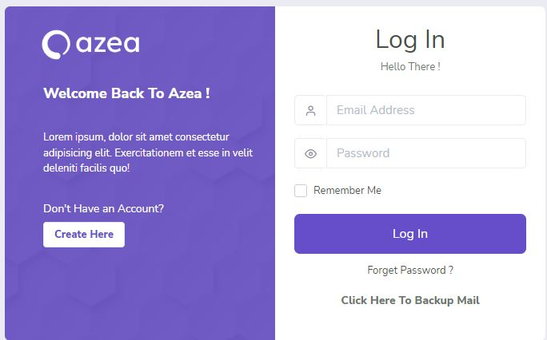

Figure A- Admin Login

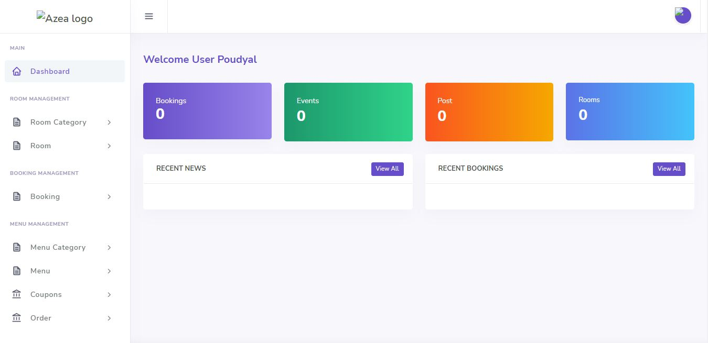

Figure B - Admin Dashboard

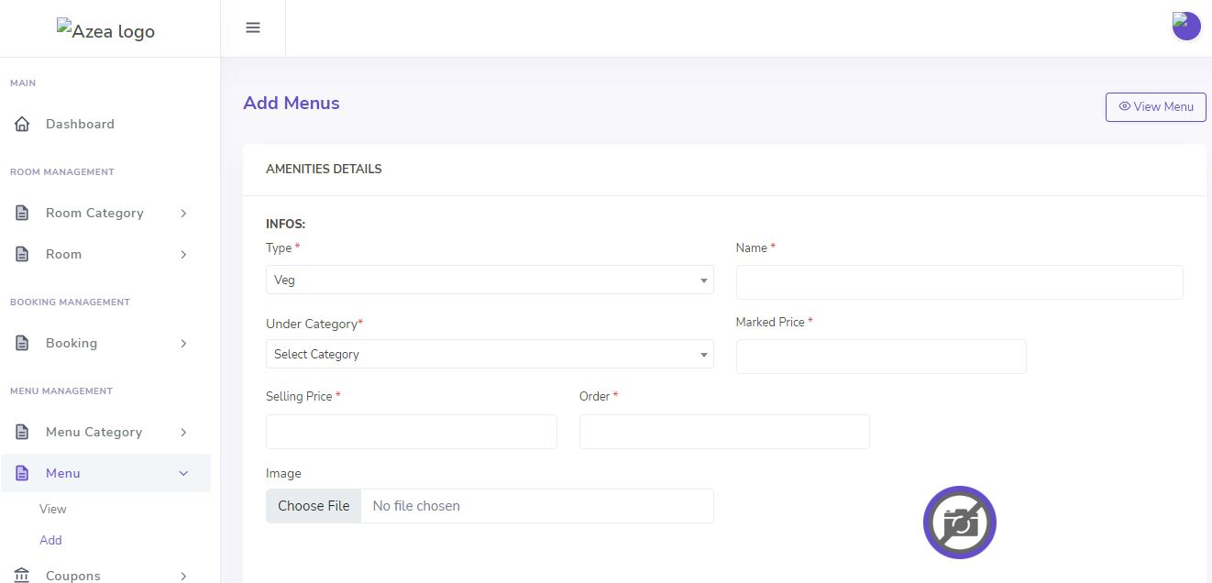

Figure C – Menu Add

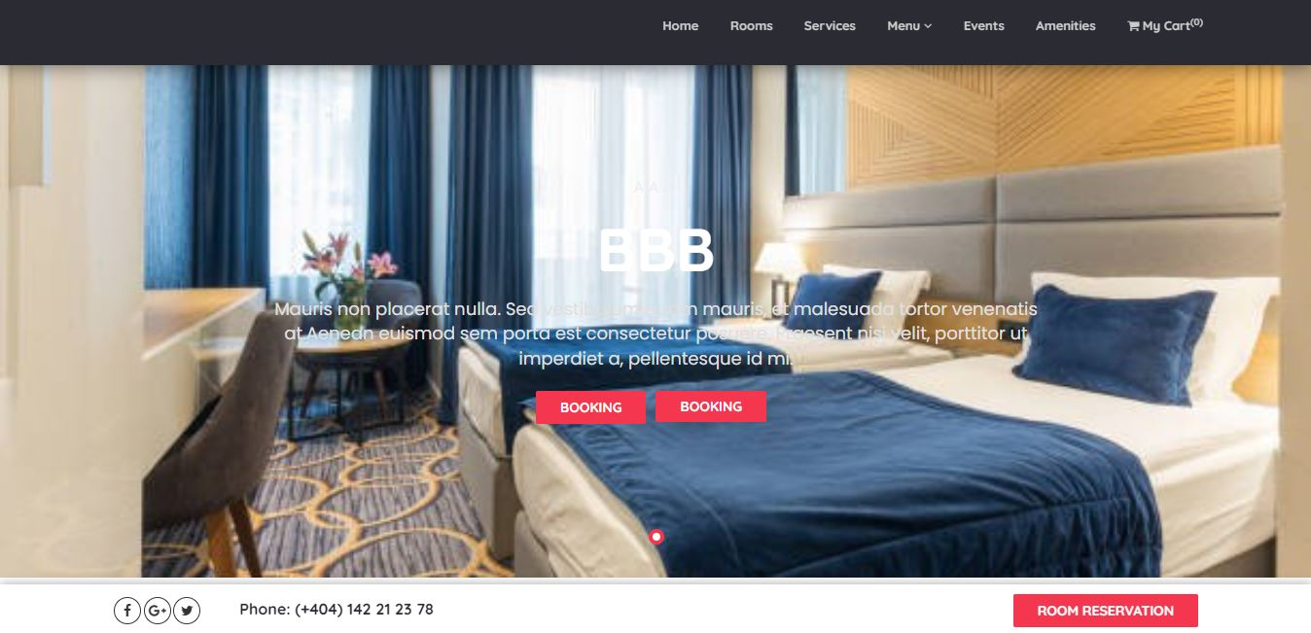

Figure D – UI Design

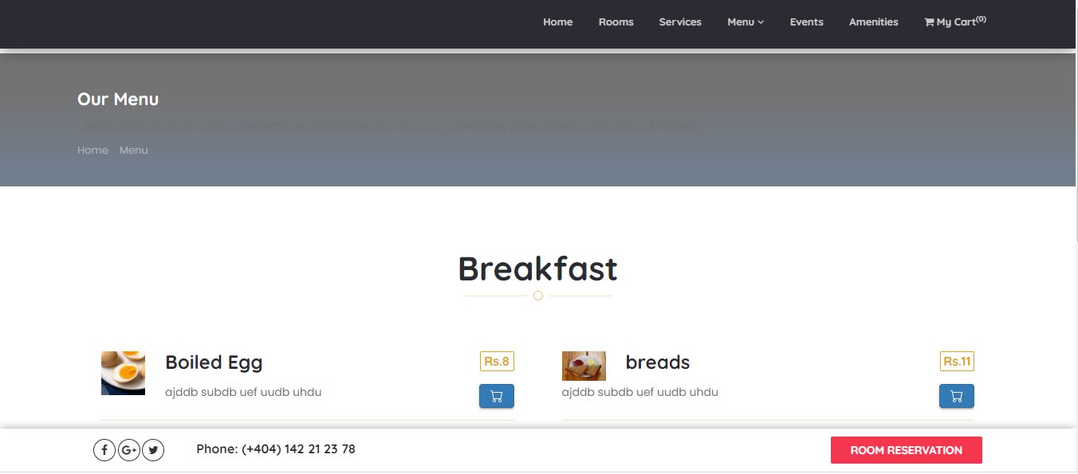

Figure E – Menu

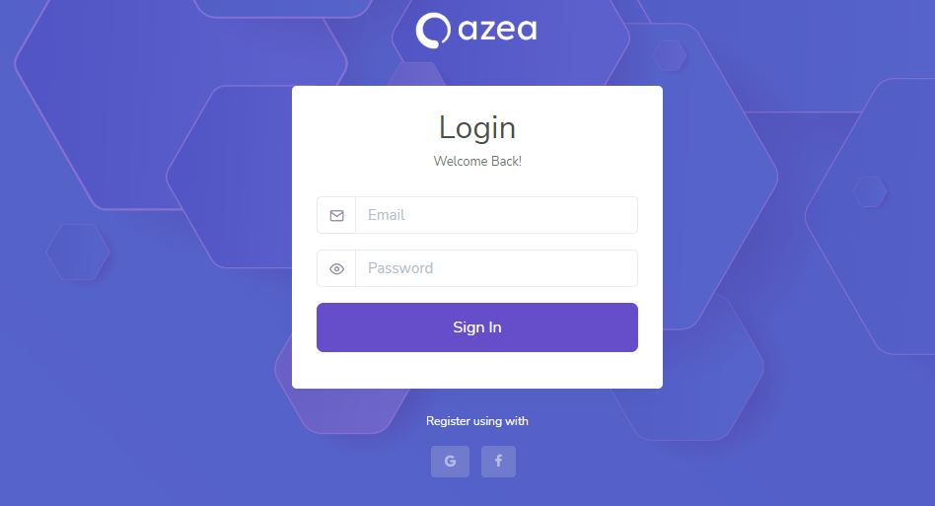

Figure F – User Login