**CSR Updating**

The CSR updating module mainly consists of the following steps:

1. To load original fingerprint file.

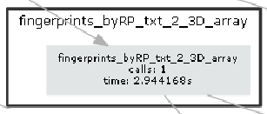

Note: each line of the data file represents a signal vector at a reference point (RP), i.e. the data are organized by RP. In each signal vector, there are multiple WiFi Access Point (AP) together with its RSSI.

1. To reorganize the fingerprint data structure.

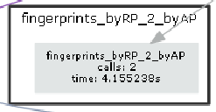

Note: this is to extract RSSI values for each individual AP.

1. To load batch of crowdsource signal data file.

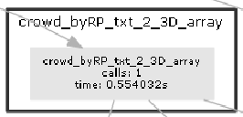

Note: the data file is from localization module, which means each line of the data has location information (x, y)

1. To reorganize the crowdsource data structure



Note: this is to extract crowdsource RSSI values for each individual AP.

1. To analyze crowdsource data for each AP, to identify a list of APs which have been changed.

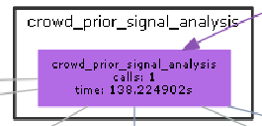

Note: to compare each AP’s RSSI value at the same RP

1. To update RSSI values for each AP that is in the changed AP list.

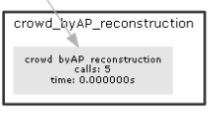

Note: each AP is updated independently using Bayesian Compressive Sensing

1. To output updated fingerprint data.

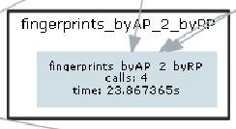

Note: to reorganized data structure

1. To output update fingerprint file

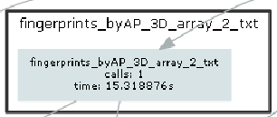

Note: to output as the same file format for fingerprint database