In this effort, we will assume that the dynamics of light incident on a spherical bead satisfies the model of a notch filter with a given notch frequency ω_{n}. The input into the system consists of light of a given wavelength (correspondingly an excitation frequency ω) and a known magnitude denoted as A. The output from the system consists of a light waveform with a given attenuated amplitude denoted as B.

System identification of a Notch Filter
The following methodology will utilize a measurement of B given a known input waveform consisting of A and ω, to estimate the notch frequency ω_{n}. To compute the notch frequency we employ the model of a second order notch filter with a given transfer function given by
 | 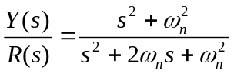. | (1)
Figure 1 shows the resulting magnitude bode plot of (1).
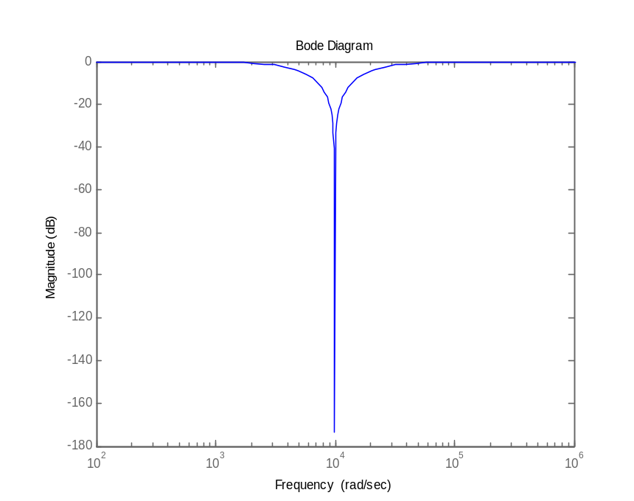
Figure 1: Magnitude bode plot of (1)

The input signal R(s) can be modeled as a pure cosine function described by 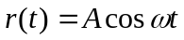. Using this excitation function into (1) produces a steady state solution for y(t) as follows
 | 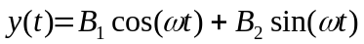, | (2)
where 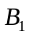 and 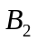 are defined as
 | 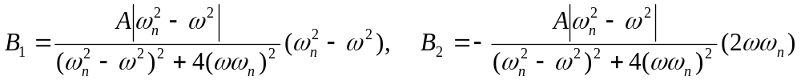. | (3)
Using (2) and (3), we can compute the magnitude of the output signal B to be 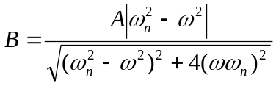, which can be further simplified as follows
 | 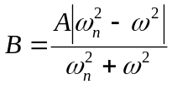, | (4)
From (4), if we choose an excitation frequency that is smaller than the notch frequency, then we can ignore the absolute sign and solve for 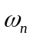 to yield an explicit solution for as follows
 | 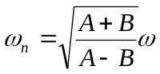. | (5a)
If we choose an excitation frequency that is larger than the notch frequency, then we can replace the absolute sign with a negative sign and solve for to yield an explicit solution for as follows
 | 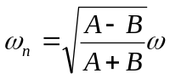. | (5b)

Now since we do not explicitly know what the notch frequency is, thus we can not determine whether the excitation frequency is larger or smaller than . However, we can compute two estimates of the notch frequency for a given data set of A, B, ω. So, if we compute another two estimates of the notch frequency for another data set that is relatively close to the first data set, then we can compare which of the two estimates does not vary. Thus, if we know the input and output signal amplitudes and the input signal frequency, we can determine the system notch frequency from (5).

Determine Notch Frequency using Feedback Control
The following methodology will utilize a hybrid feedback control algorithm to numerically converge to the system notch frequency. Specifically, we will employ the form of the excitation signal r(t) given in the previous section such that we will use the excitation frequency ω as the control input.
At a given time step of the control algorithm, we will obtain two responses of the system dynamics using the excitation function previously mentioned for two values of ω, i.e., 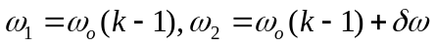, where 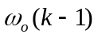 is the control frequency at a given step k -1 and 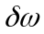 is a small, positive frequency. From these responses, we can compute the output amplitudes denoted by B₁ and B₂ which we will use to update 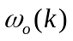 for the current time step.
We choose the following form for the control algorithm
 | 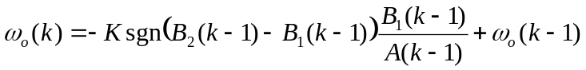. | (6)
where A(k-1) is the input amplitude of the (k-1)^{th} time step, K is an arbitrary, positive, constant, feedback control gain, and the sgn(·) is the sign function. The purpose of the sign function in (6) is to determine which direction the frequency change should occur in order to converge to the notch frequency. In addition, the term 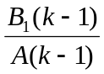 in (6) should decrease at every time step as we approach the notch frequency, such that when it comes close enough to the notch frequency the subsequent changes in (6) will only oscillate within two values of the excitation frequency. In this region, the oscillation will occur as a result of the sign function since near the notch frequency the sign function will repeatedly switch between positive and negative 1 while all other terms in (6) will be invariant with respect to time step. Taking the average of oscillating excitation frequencies should provide a good estimate for the notch frequency. Note that choosing a small the control gain K results in higher accuracy estimates of the notch frequency. However, the small values of K will also result in slower convergence rates to the notch frequency.
The following is a step-by-step procedure for computing the notch frequency using this methodology:
1) Guess an initial excitation frequency 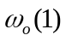
2) Compute the amplitudes B₁(1) and B₂(1) using the system dynamics
3) Compute the new excitation frequency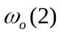 using (6) when k=2
4) Repeat the following until 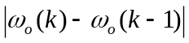 is small:
a) Compute the amplitudes B₁(k-1) and B₂ (k-1) using the system dynamics
b) Compute the new excitation frequency using (6)

We simulated the control algorithm of (6) on the system dynamics of (1) using the following parameters: 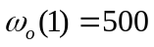, K = 5000, 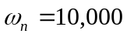. Figure 2 shows the resulting control frequency time history. Within 8-9 time steps, figure 2 shows the control frequency has converged to almost the exact value of the notch frequency.
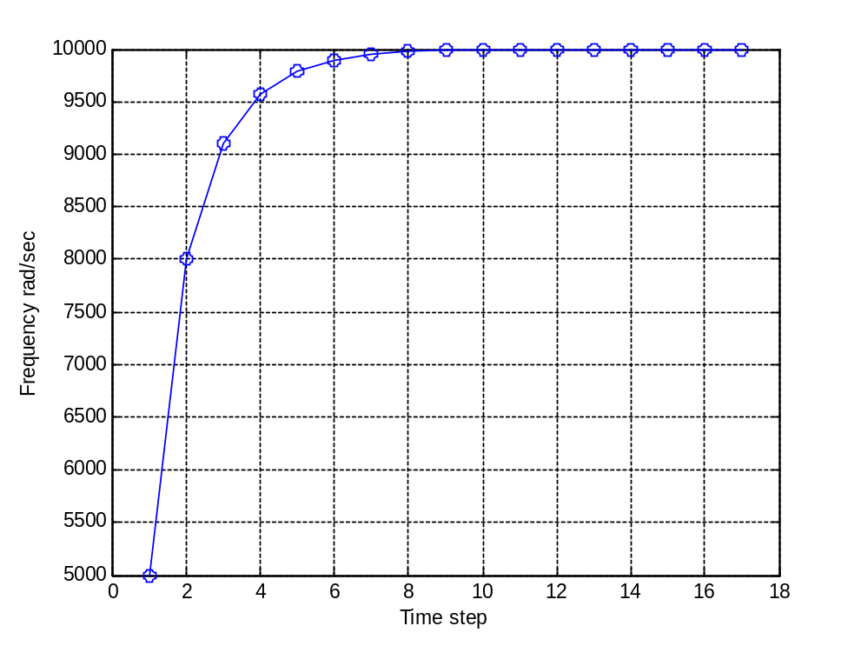
Figure 2: Sample iteration control plot to compute the notch frequency

