

User Guide
Everything teachers and students need to get started with LEO

FOR TEACHERS ● FOR STUDENTS

Language learning for the real world.
Version 1.0 · October 2026
WHAT'S INSIDE
Contents
This guide walks through LEO screen by screen. Part 1 is for everyone. Teachers can then go to Part 2 and students to Part 3. Every picture is a real screen from the app, so what you see here is what you'll see on yours.
01  Getting started  › What LEO is  › Creating your account  › Signing in  › Choosing your role  › Finding your way around | 02  Teacher guide  › Your dashboard  › Creating classrooms  › Inviting students  › Sharing materials  › Creating lessons with AI quizzes  › Scheduling lessons  › Reports
03  Student guide  › Your dashboard  › Joining a classroom  › Studying flashcards  › Translations and listening  › The matching game  › Taking a quiz  › Your learning report | 04  Help  › Your profile and password  › Common questions  › Quick reference

PART 1  Getting started  What LEO is, how to create an account and how to find your way around. | 

What is LEO?
LEO (Learn English Online) helps learners build English vocabulary they can use in everyday life and at work. Teachers create online classrooms and fill them with short lessons. Students join with a code and work through each lesson at their own pace.
Every lesson follows the same simple pattern:
1 Study  Flip through flashcards with a word on one side and its meaning on the other. | 2 Practise  Hear words read aloud, see translations and play the picture matching game. | 3 Check  Take a short multiple-choice quiz and see the right answers straight away. | 4 Track  Teachers and students both see progress, scores and study streaks.

Creating your account
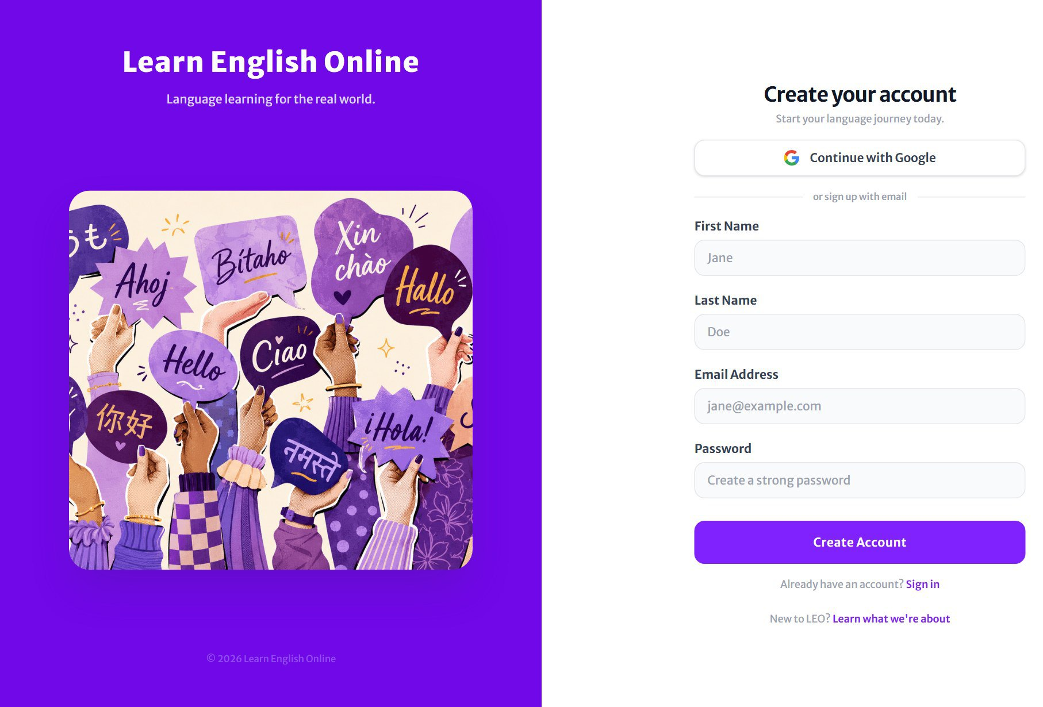
Figure 1 The sign-up page

- Open LEO in your web browser and choose Sign up (or follow the Sign up link on the sign-in page).
- Choose Continue with Google to use your Google account, or fill in your name, email address and a password.
- Press the sign-up button. You'll go straight on to choose your role.
GOOD TO KNOW
Each email address can only have one LEO account. If you see "An account with this email already exists", use Sign in instead. If you've forgotten the password, you can reset it.

Choosing your role
The first time you sign in, LEO asks how you'll use it. Pick Student if you're learning English, or Teacher if you'll create classrooms and lessons. LEO then opens the right dashboard for you and gives you a username, made from your name plus three digits (for example sipdla318).
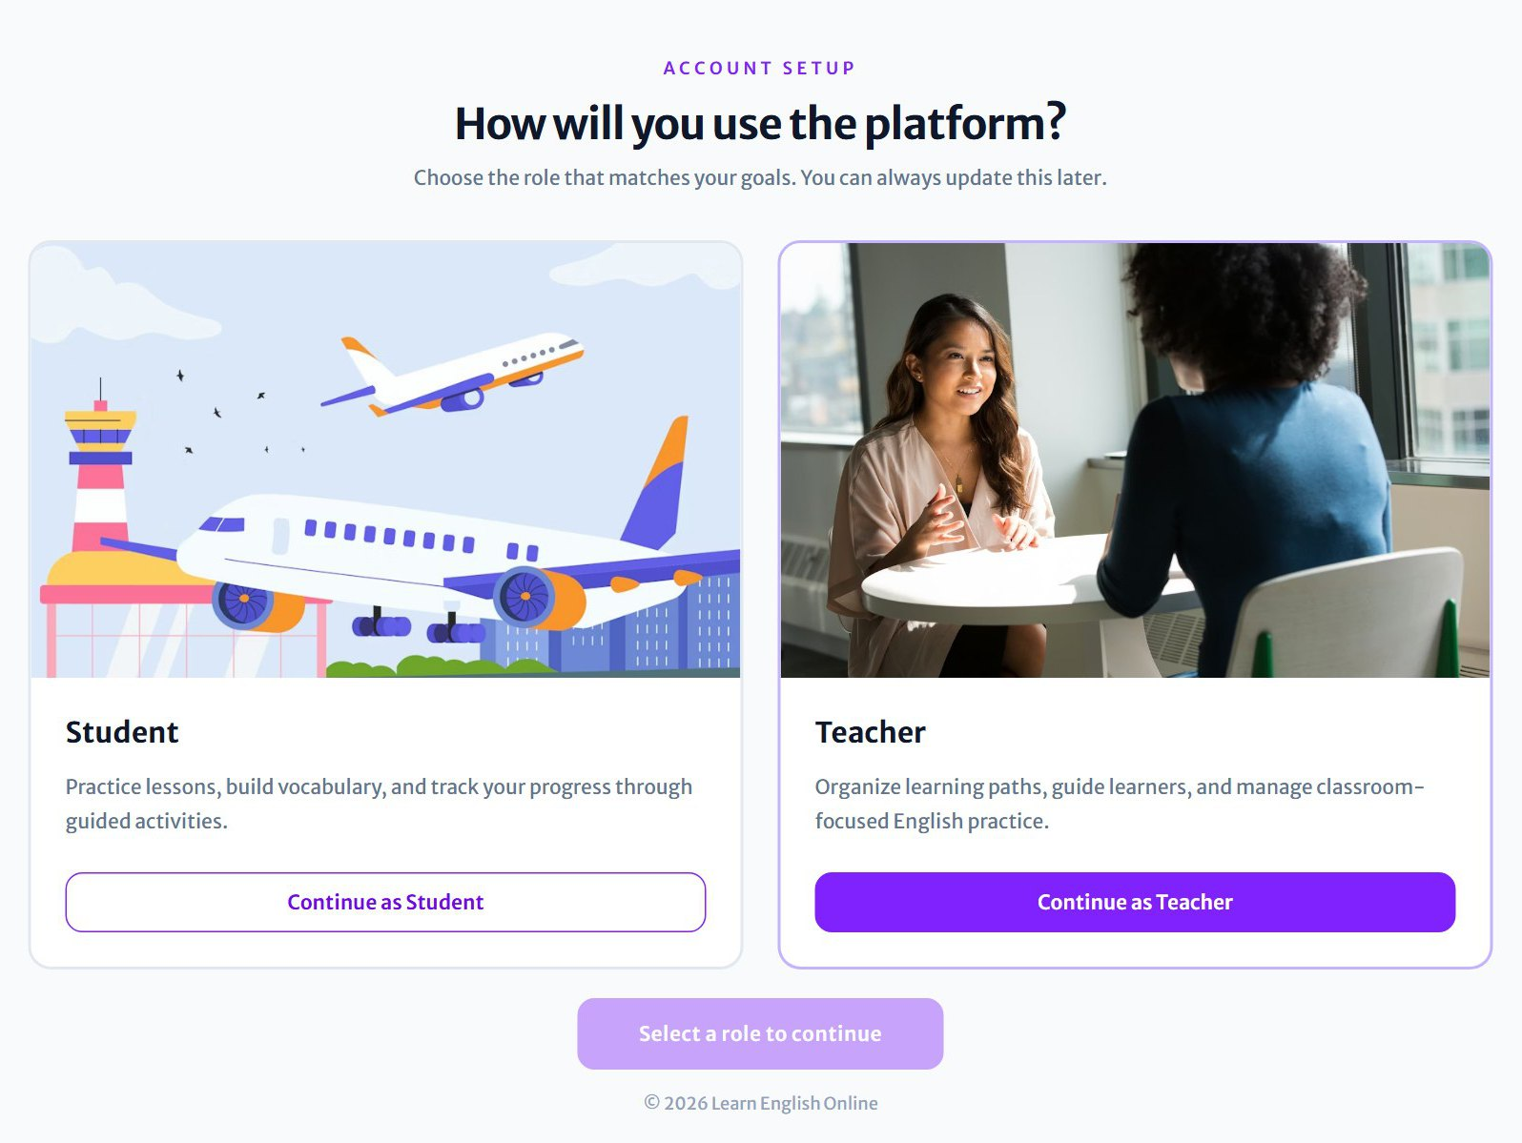
Figure 2 Choosing between the student and teacher role

Signing in
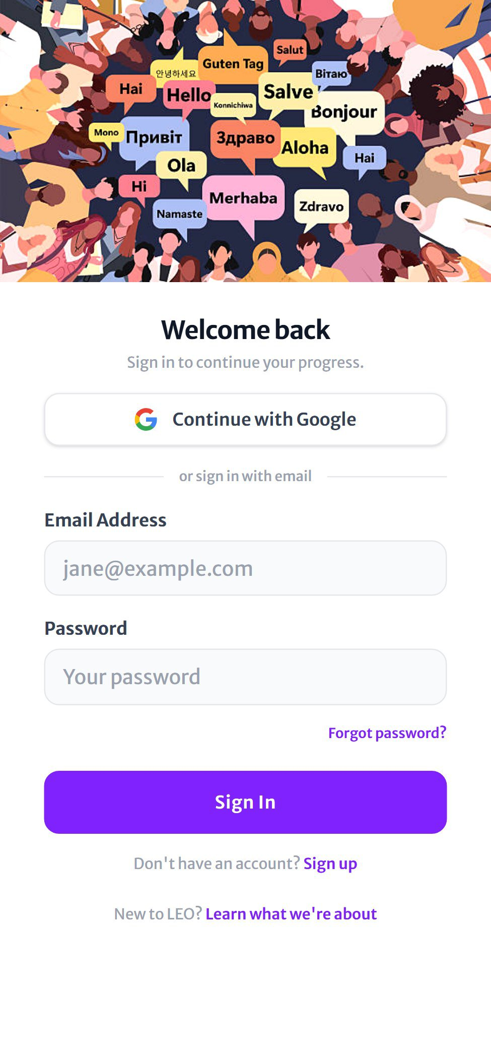  Figure 3 Sign in on a phone | Once you have an account, sign in from the Welcome back page:  - Choose Continue with Google, or type your Email Address and Password.  - Press Sign In. LEO opens your dashboard.  Forgotten your password?  - Press Forgot password? under the password box.  - Enter your email address. LEO emails you a reset link.  - Open the link, choose a new password, then sign in with it.
  TIP
  LEO works on phones, tablets and computers. You stay signed in on your device until you log out.

Finding your way around
LEO adjusts to your screen. The same pages appear on every device. Only the menu moves:
Device | Where the menu is
Computer | A violet sidebar on the left of every page, with the LEO logo at the top and Log out (students) or Settings (teachers) at the bottom.
Phone or tablet | A bar along the bottom of the screen. Tap an icon to move between pages. The page you're on is highlighted.
Notifications | The bell at the top right shows new activity, for example a new lesson for students or a completed quiz for teachers. A purple badge shows how many are unread.

PART 2  Teacher guide  Create classrooms, invite students, build lessons with AI-generated quizzes and follow your class's progress. | 

Dashboard  Your classes, recent lessons and the lesson planner. | Classes  Create, edit and open your classrooms. | Explore  Articles and tips on language teaching. | Reports  Progress reports for every classroom.

Your dashboard
The dashboard is the first page you see after signing in. It brings everything important together:
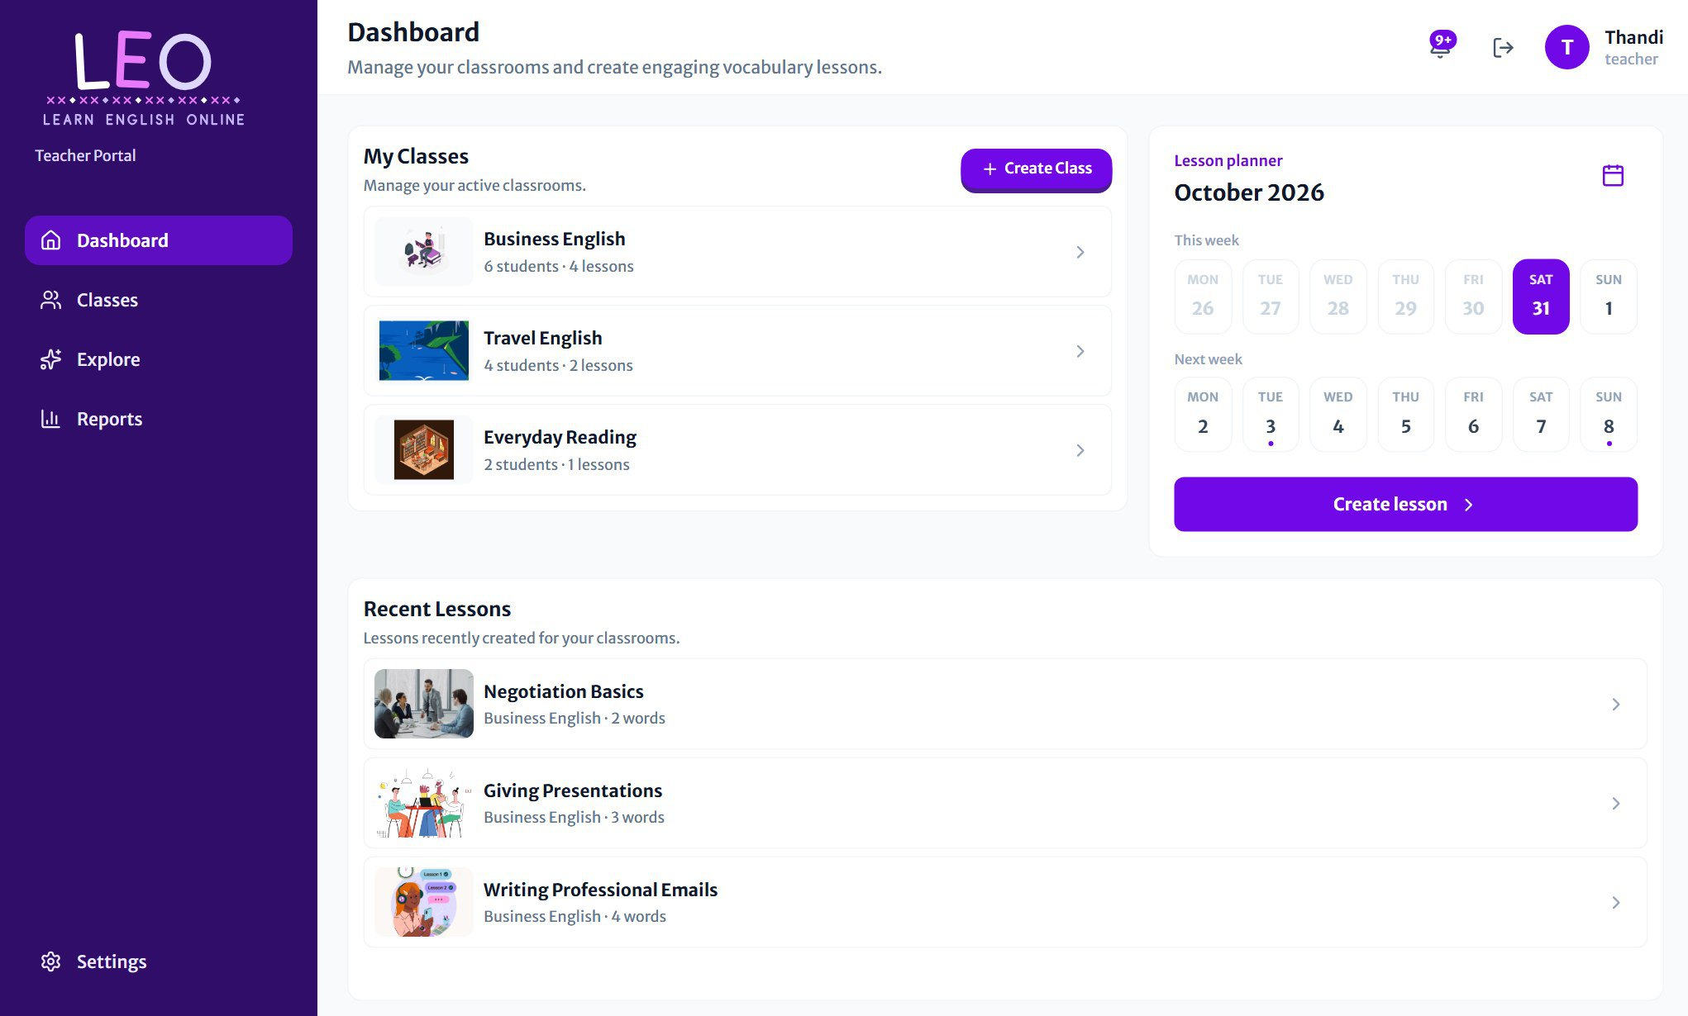
Figure 4 The teacher dashboard on a computer

- My Classes: your newest classrooms, with student and lesson counts. Create Class starts a new one.
- Lesson planner: a two-week calendar for creating and scheduling lessons (see *Scheduling lessons* below).
- Recent Lessons: the lessons you've created most recently. Click one to open it.
- Notifications (the bell, top right): a note each time a student completes a lesson, with their score. Use Mark all as read to clear them.
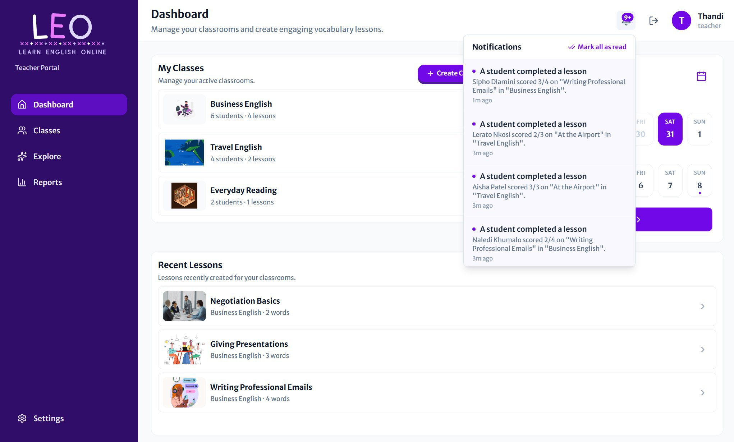
Figure 5 Notifications show each student's result as they finish a lesson

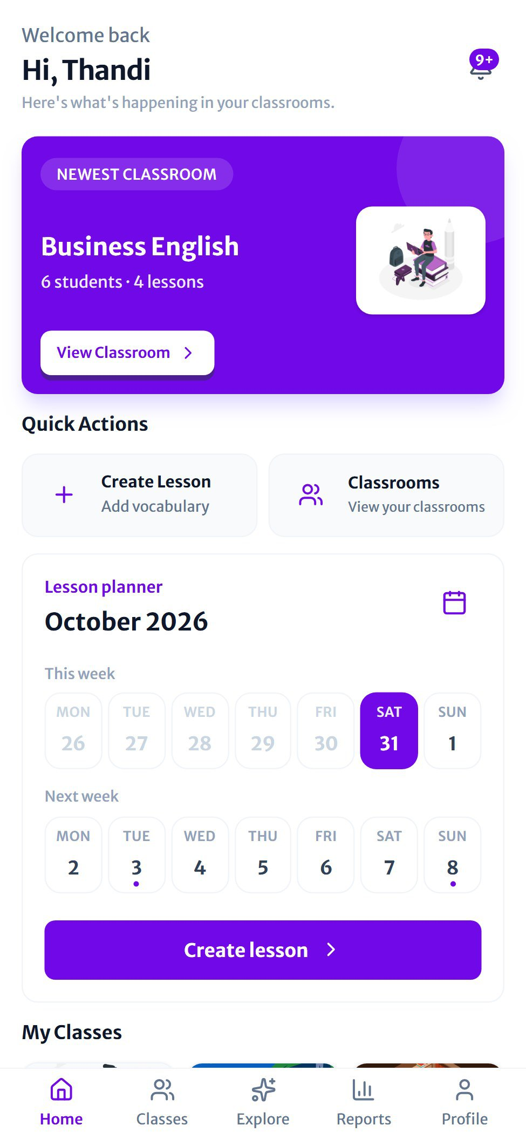  Figure 6 The dashboard on a phone | On a phone or tablet  The dashboard puts your newest classroom in a violet banner at the top, followed by Quick Actions for creating a lesson or opening your classrooms, then the lesson planner.  The bottom bar gives you Dashboard, Classes, Explore, Reports and Profile.

Creating a classroom
A classroom groups your students and the lessons you make for them. You can have as many classrooms as you need, and each holds up to 30 students and 50 lessons.
- Go to Classes and press Create Classroom (or Create Class on the dashboard).
- Enter a Classroom name that learners will recognise, and a short Description.
- Choose the Proficiency level, from Beginner to Advanced.
- Pick a Classroom cover image. It appears on the classroom card and banner.
- Press Create classroom. Your new classroom appears in the list.
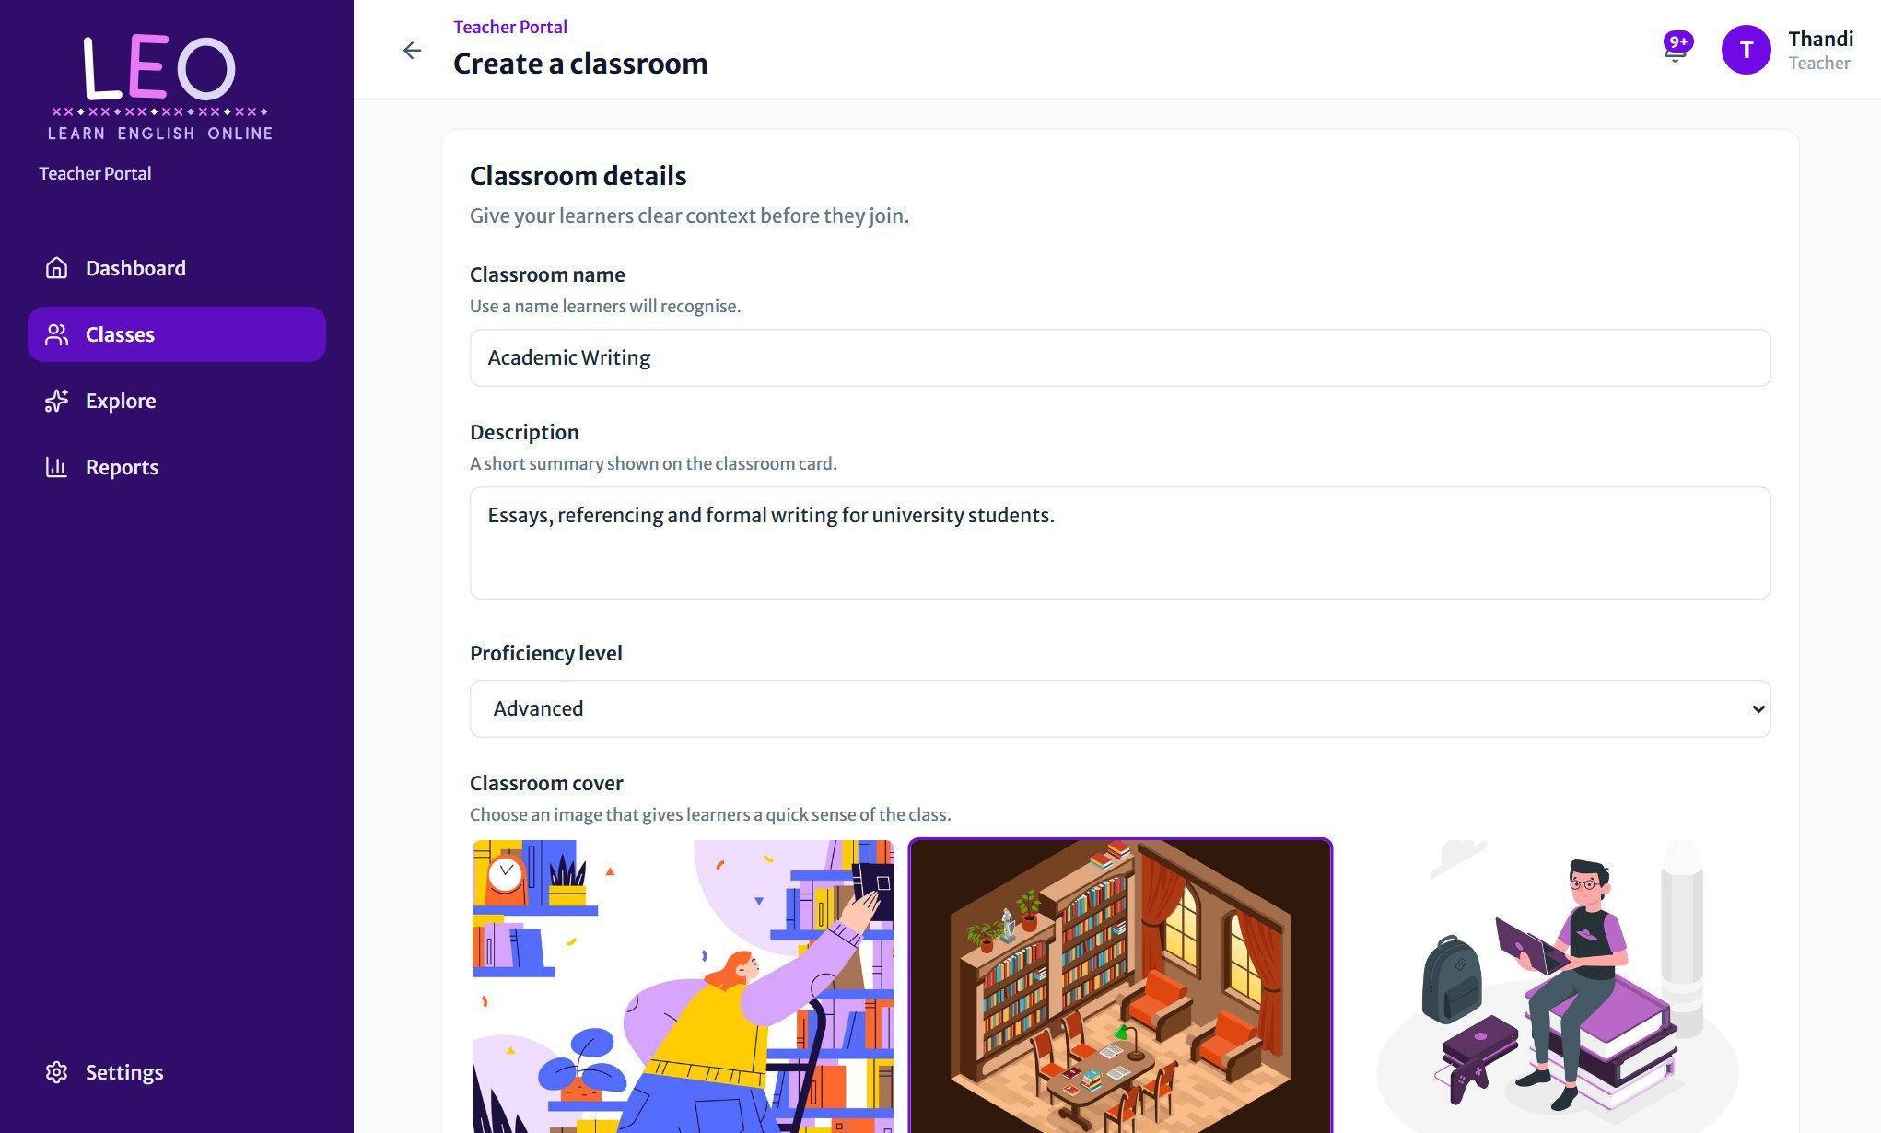
Figure 7 Filling in a new classroom's details

Managing your classrooms
The Classes page lists every classroom you teach, with its number of students and lessons. Use the search box to find a classroom by name, and the sort menu to change the order.
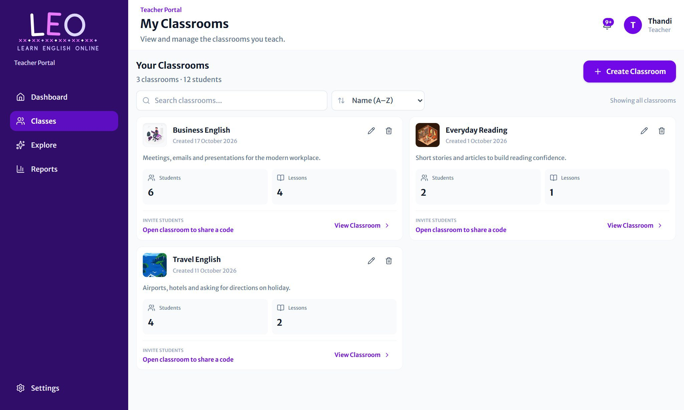
Figure 8 All your classrooms, with edit and delete buttons on each card

- Open a classroom: click its card or View Classroom.
- Edit: press the pen icon to change the name and description in a popup, then Save changes.
- Delete: press the bin icon. LEO asks you to confirm first.
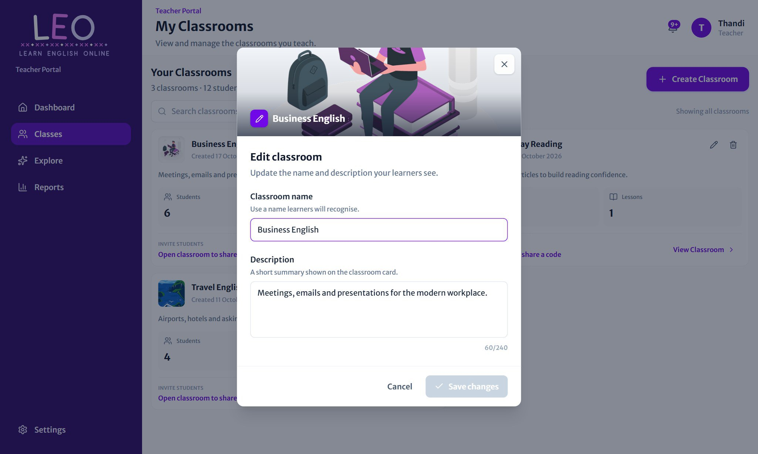
Figure 9 Editing a classroom's name and description

BE CAREFUL
Deleting a classroom also deletes its lessons, flashcards, quizzes and every student's results in it. This can't be undone.

Inside a classroom
Opening a classroom shows a violet banner with its name, description and totals. On a computer the page has three tabs: Lessons, Classroom material and Students.
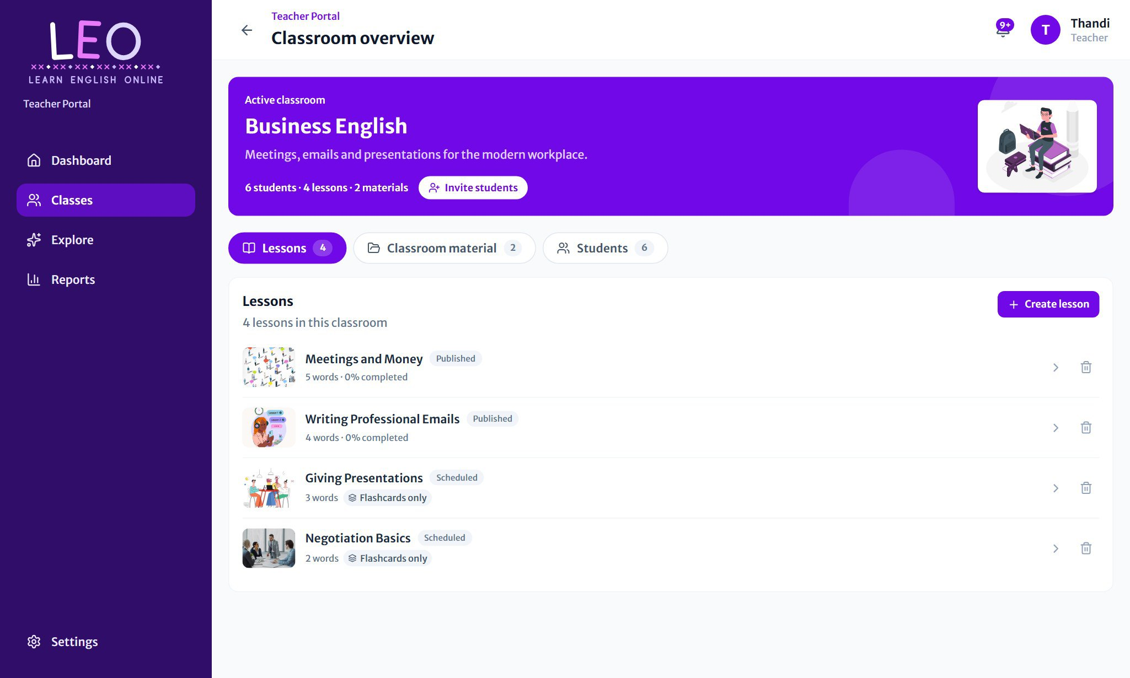
Figure 10 The Lessons tab lists published and scheduled lessons

Lessons
Each lesson shows its number of words, how many students have completed it, and a label: Published (students can see it) or Scheduled (it will appear on its release date). Lessons without a quiz are marked Flashcards only. Press Create lesson to add a new one, or click a lesson to open its report.

Inviting students
Every classroom has its own private code. Press Invite students in the banner to see it:
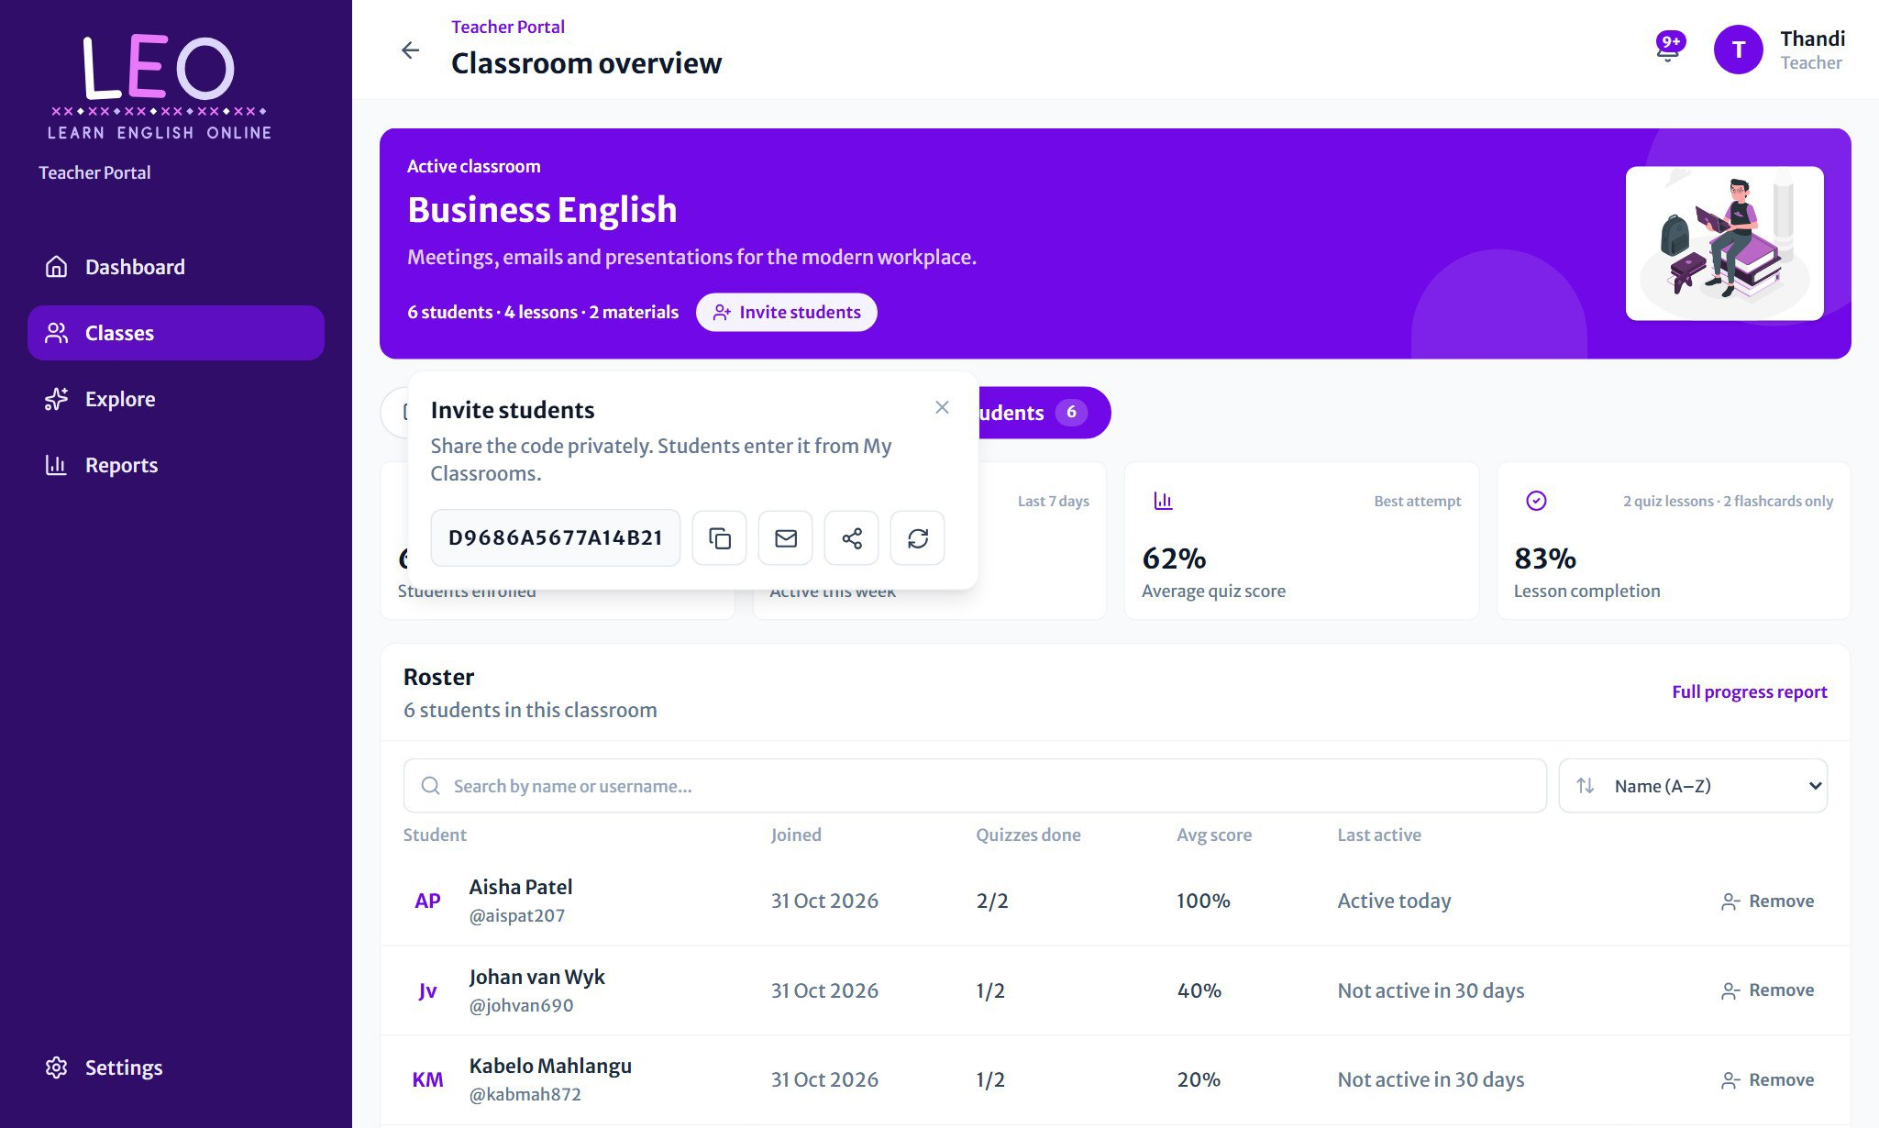
Figure 11 The invite popup with the classroom code and sharing buttons

Button | What it does
Copy | Copies the code so you can paste it into a message.
Email | Opens your email app with an invitation ready to send.
Share | Shares the invitation through your device's share menu (for example WhatsApp).
New code | Replaces the code. The old one stops working, and students who already joined stay in the classroom.

TIP
Share the code privately, for example with your class group only. Anyone with the code can join until the classroom is full. Make a new code at any time if it has been shared too widely.

Classroom material
Share files and links with the whole class. Students are notified each time you post something new.
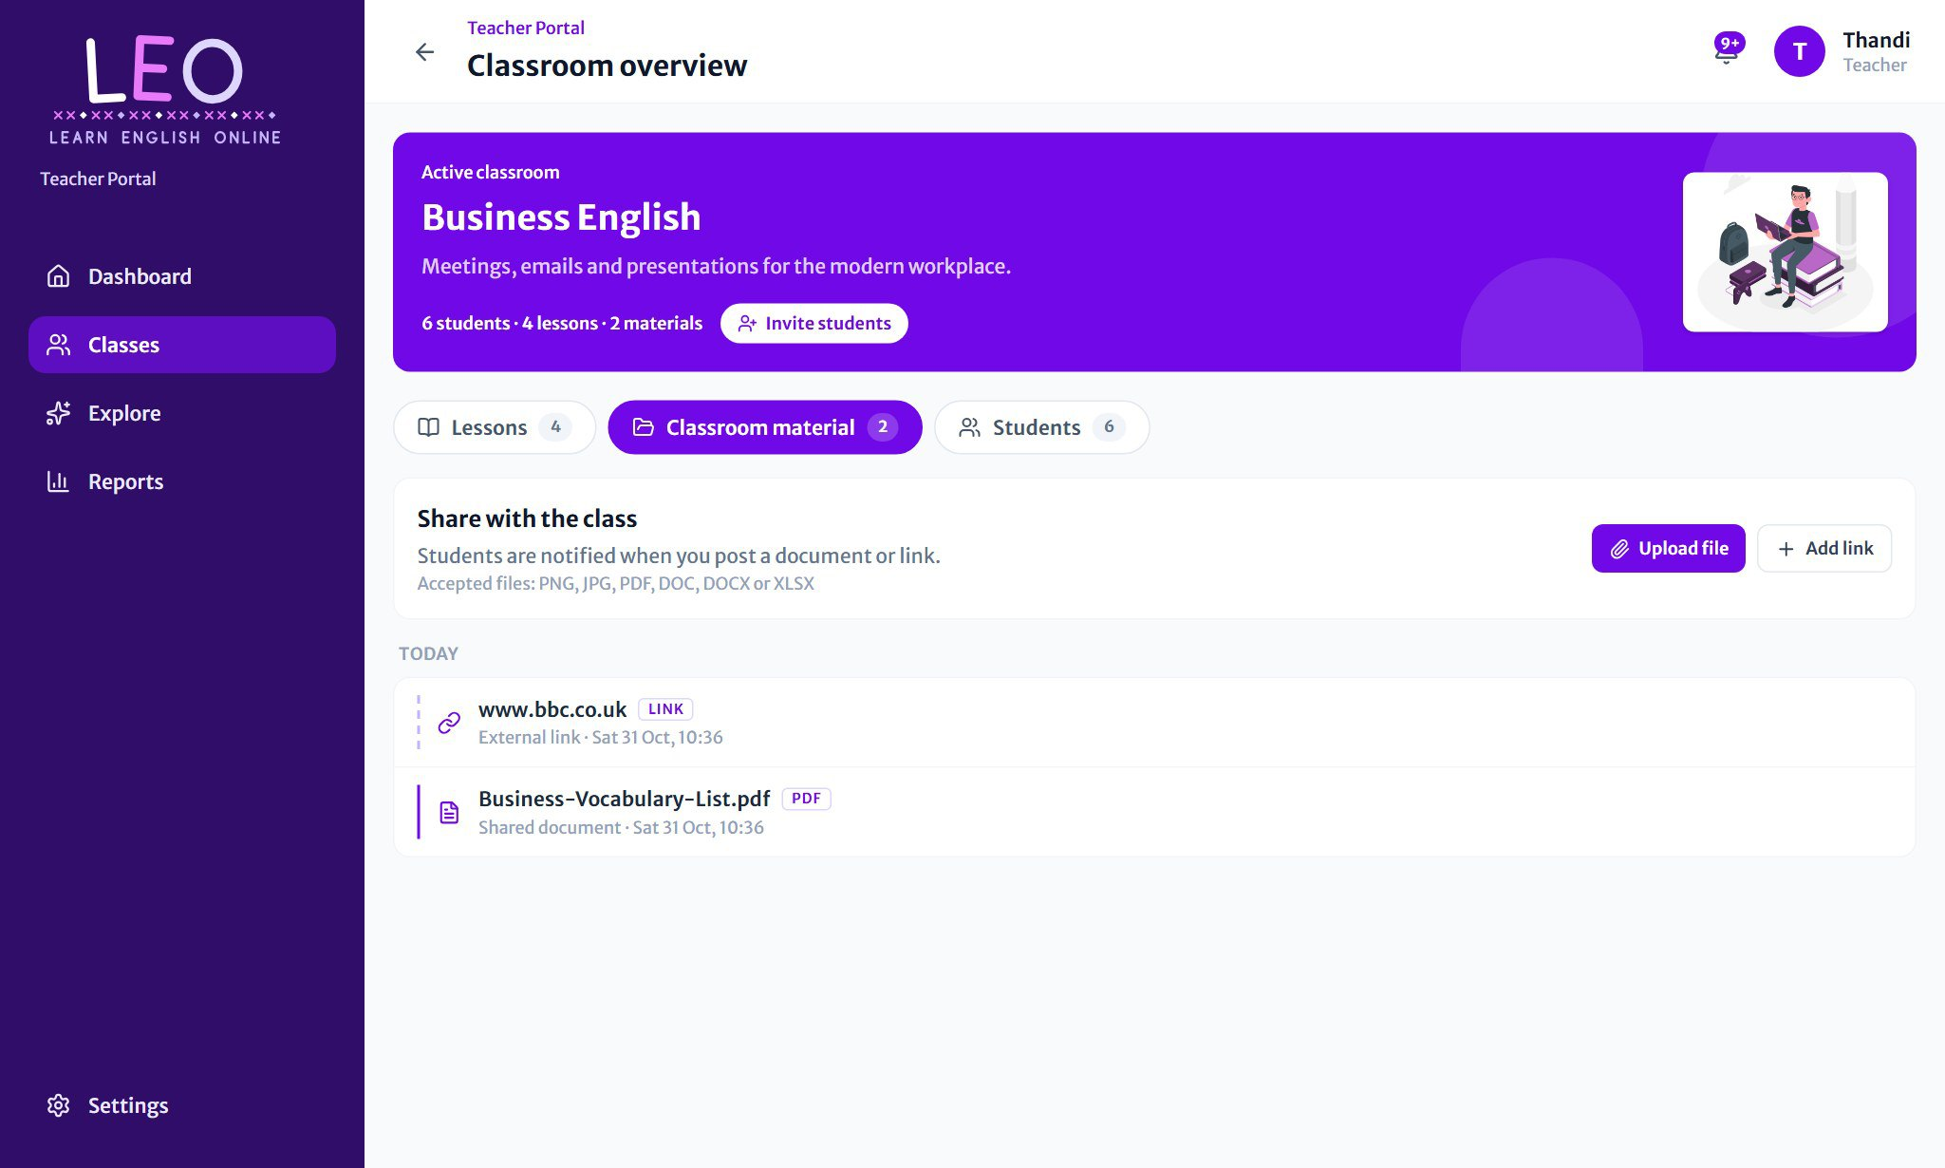
Figure 12 Files and links shared with the class, newest first

- Open the Classroom material tab.
- Press Upload file to share a document (PNG, JPG, PDF, DOC, DOCX or XLSX), or Add link to share a website.
- To remove an item, press its red bin icon.

Students
The Students tab shows how the class is doing at a glance: students enrolled, how many were active this week, the average quiz score and lesson completion. Below is the Roster, with each student's join date, quizzes done, average score and when they were last active.
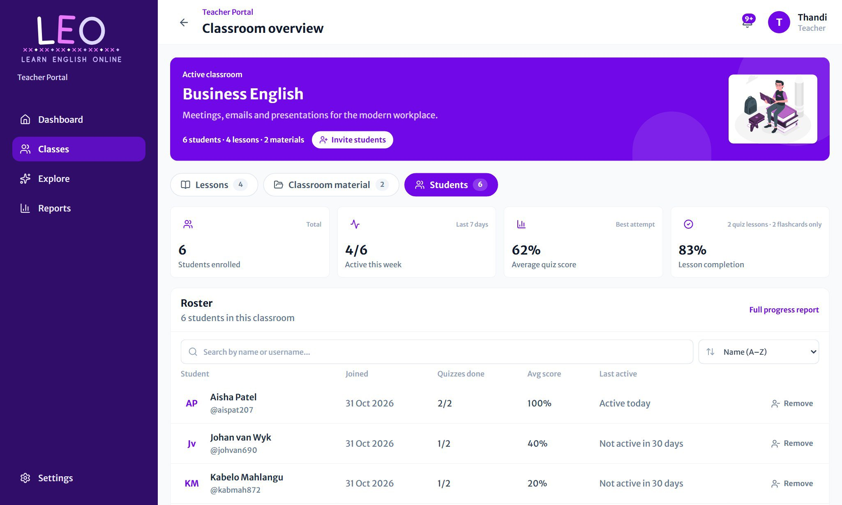
Figure 13 The class summary and student roster

- Search the roster by name or username, and sort it with the menu on the right.
- Press Remove to take a student out of the classroom.
- Full progress report opens the detailed class report (see *Reports*).
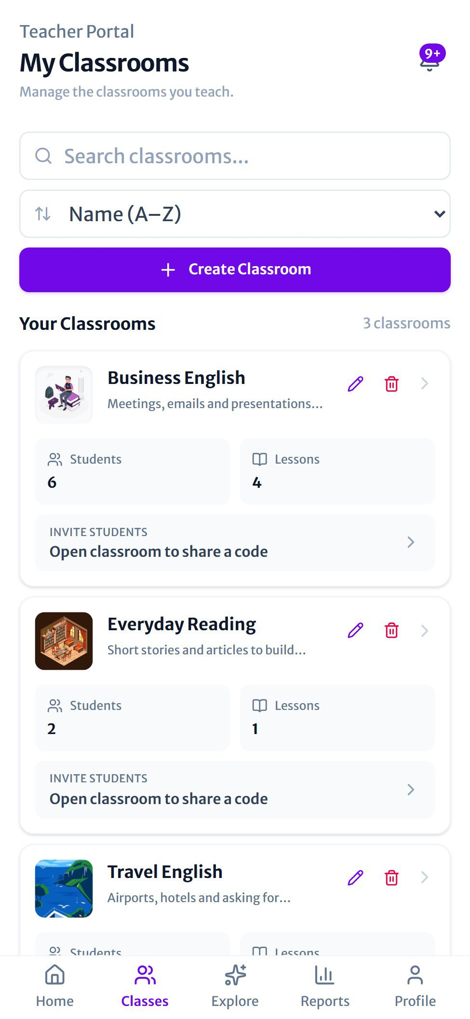  Figure 14 Your classrooms on a phone | 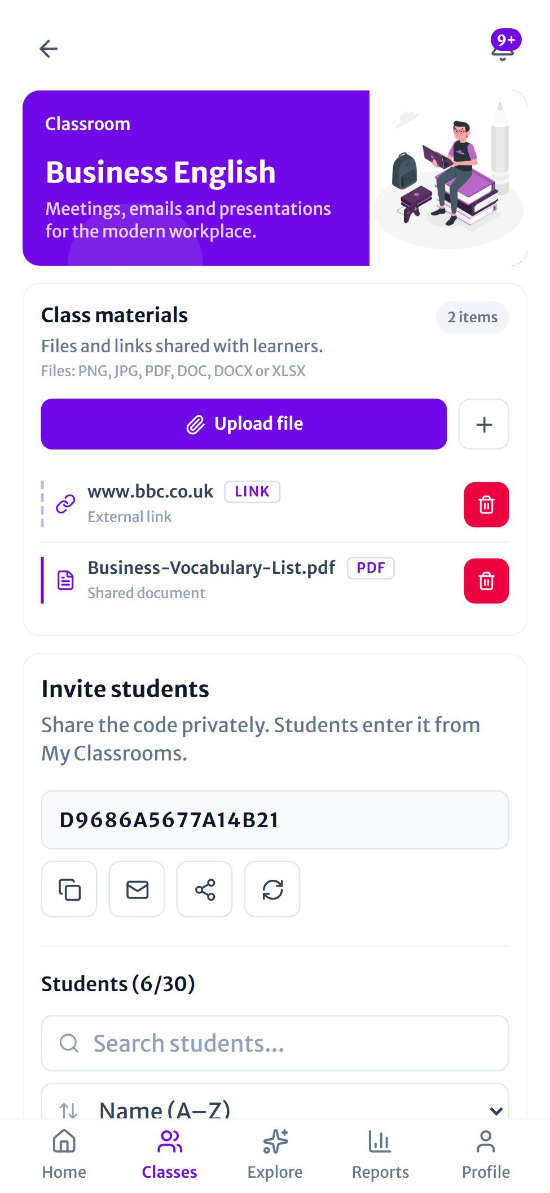  Figure 15 A classroom on a phone

On phones and tablets the classroom is one scrolling page: the banner, then class materials, the invite code with the student list, and the lessons.

Creating a lesson
A lesson is a set of up to 15 flashcards (words with their meanings), and usually a short quiz that LEO's AI writes from them. Creating one takes four steps. A progress bar at the top shows where you are, and you can go Back at any time.
Step 1  Lesson details | Step 2  Flashcards | Step 3  MCQ activity | Step 4  Review & edit

Step 1: Lesson details
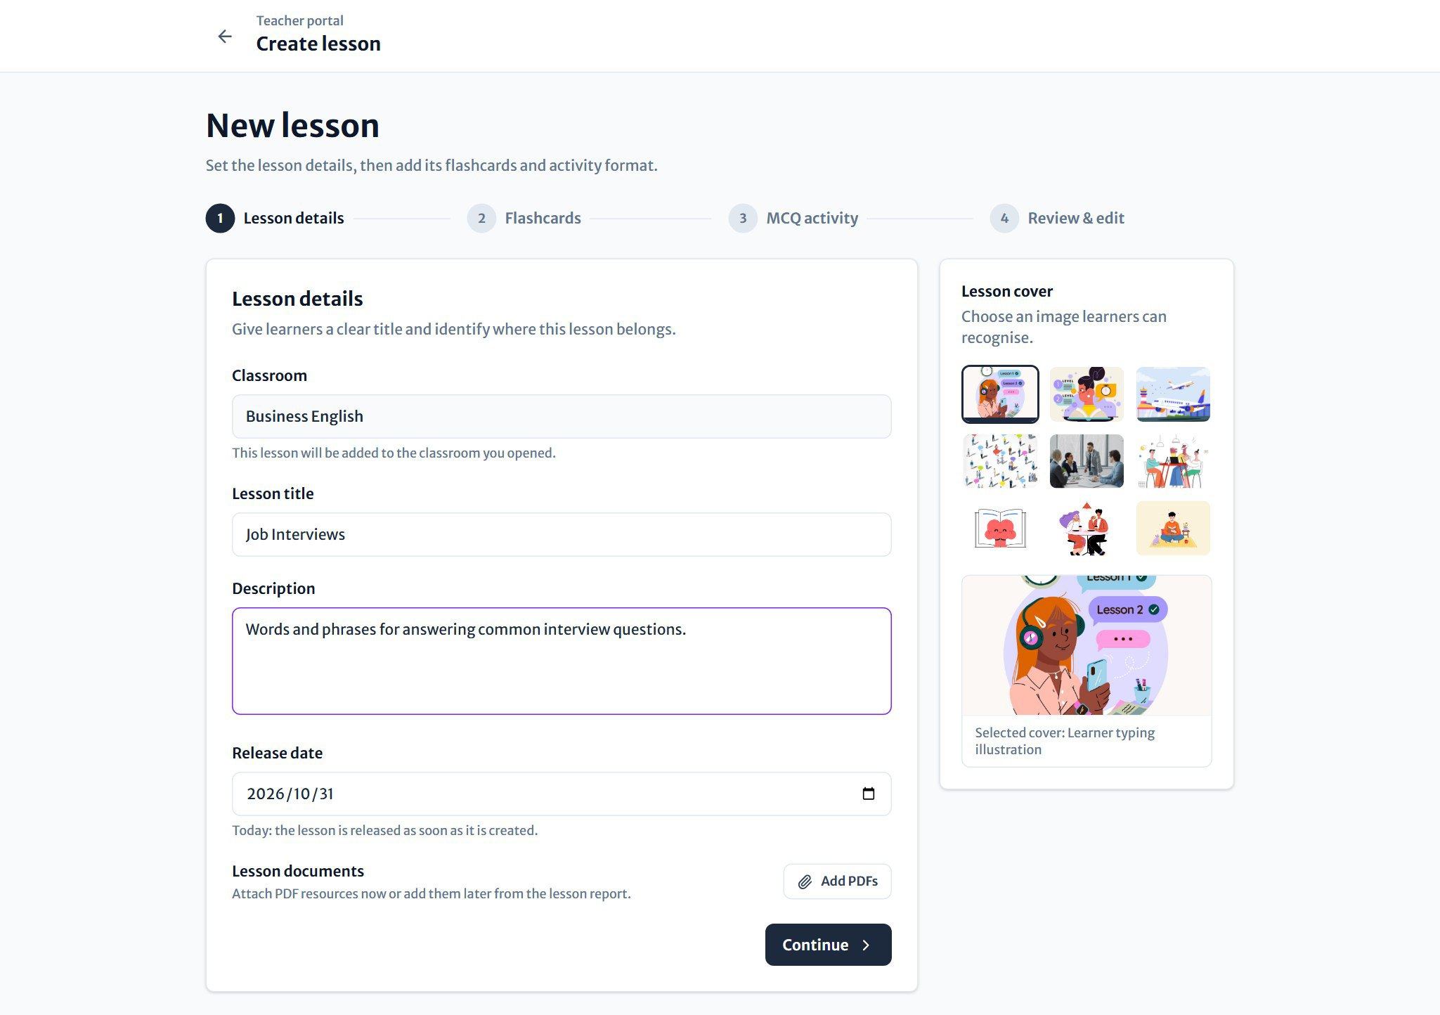
Figure 16 Step 1: title, description, release date and cover

- Open a classroom and press Create lesson, or use the button under the lesson planner. The Classroom is filled in for you.
- Enter a Lesson title and a short Description.
- Leave the Release date as today to publish straight away, or pick a later date to schedule the lesson.
- Optionally press Add PDFs to attach reading material to the lesson.
- Choose a Lesson cover picture on the right, then press Continue.

Step 2: Flashcards
The quickest way to add words is to type or paste them as a list, one per line, with the meaning after a dash or a colon:
strength - Something you are especially good at
experience - Knowledge and skill you get from doing a job
candidate - A person applying for a job

Press Add flashcards and each line becomes a card you can still edit:
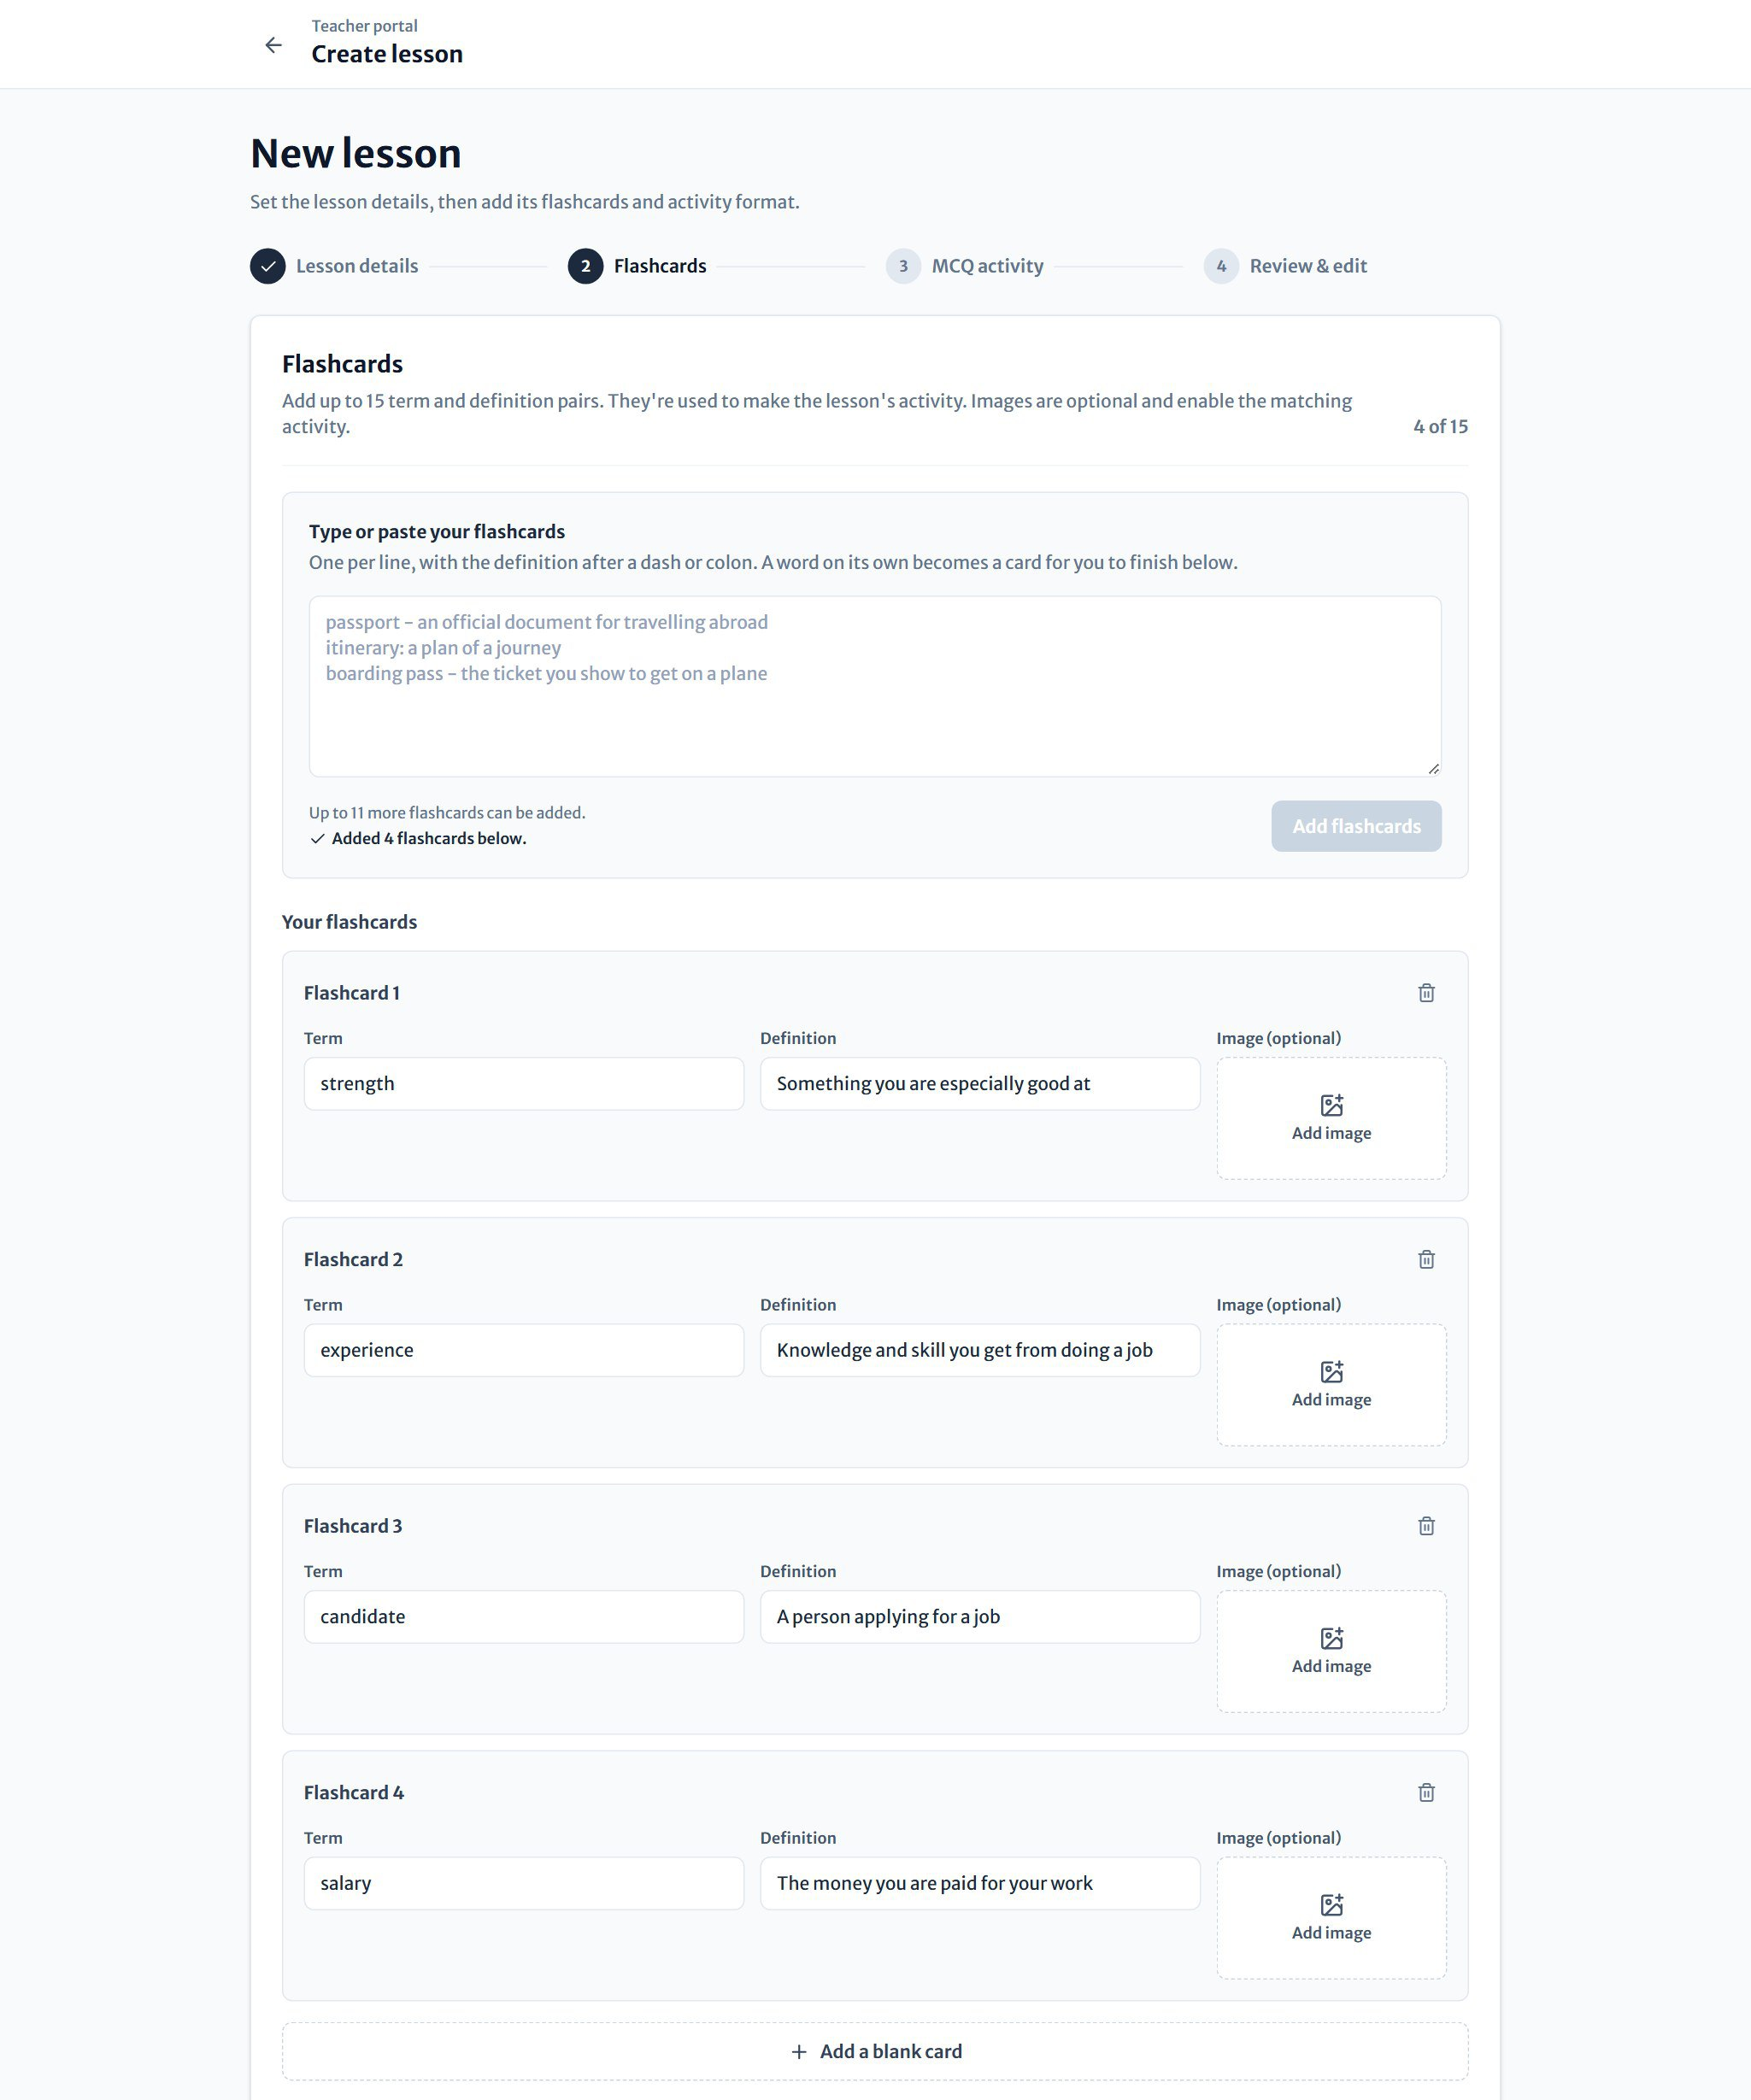
Figure 17 Step 2: each word becomes an editable card

- Change any Term or Definition directly on its card, or press the bin to remove it.
- Press Add image to give a card a picture (up to 5 MB). Lessons with at least two picture cards unlock the matching game for students.
- Press Add a blank card to type one in by hand.
- When you're happy, press Choose activity.

Step 3: Choose the quiz
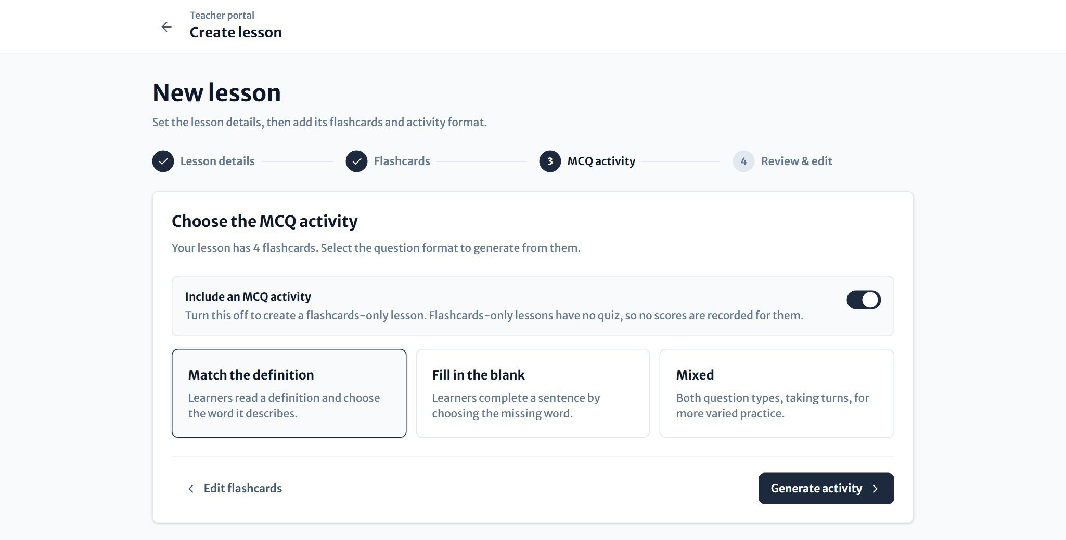
Figure 18 Step 3: choose the kind of quiz the AI should write

Choose one of three quiz formats. Every question is multiple choice, with four options:
Format | What students do
Match the definition | Read a definition and choose the word it describes.
Fill in the blank | Choose the missing word in a sentence.
Mixed | Both kinds of question, taking turns, for more varied practice.

Press Generate activity. LEO's AI writes one question per flashcard, usually in a few seconds.
GOOD TO KNOW
Want a lesson without a quiz? Switch off Include an MCQ activity to create a flashcards-only lesson. Students study the cards and press Finish lesson, and nothing is scored.
If the AI can't be reached, LEO explains what happened and lets you try again or create the lesson with flashcards only.

Step 4: Review and edit
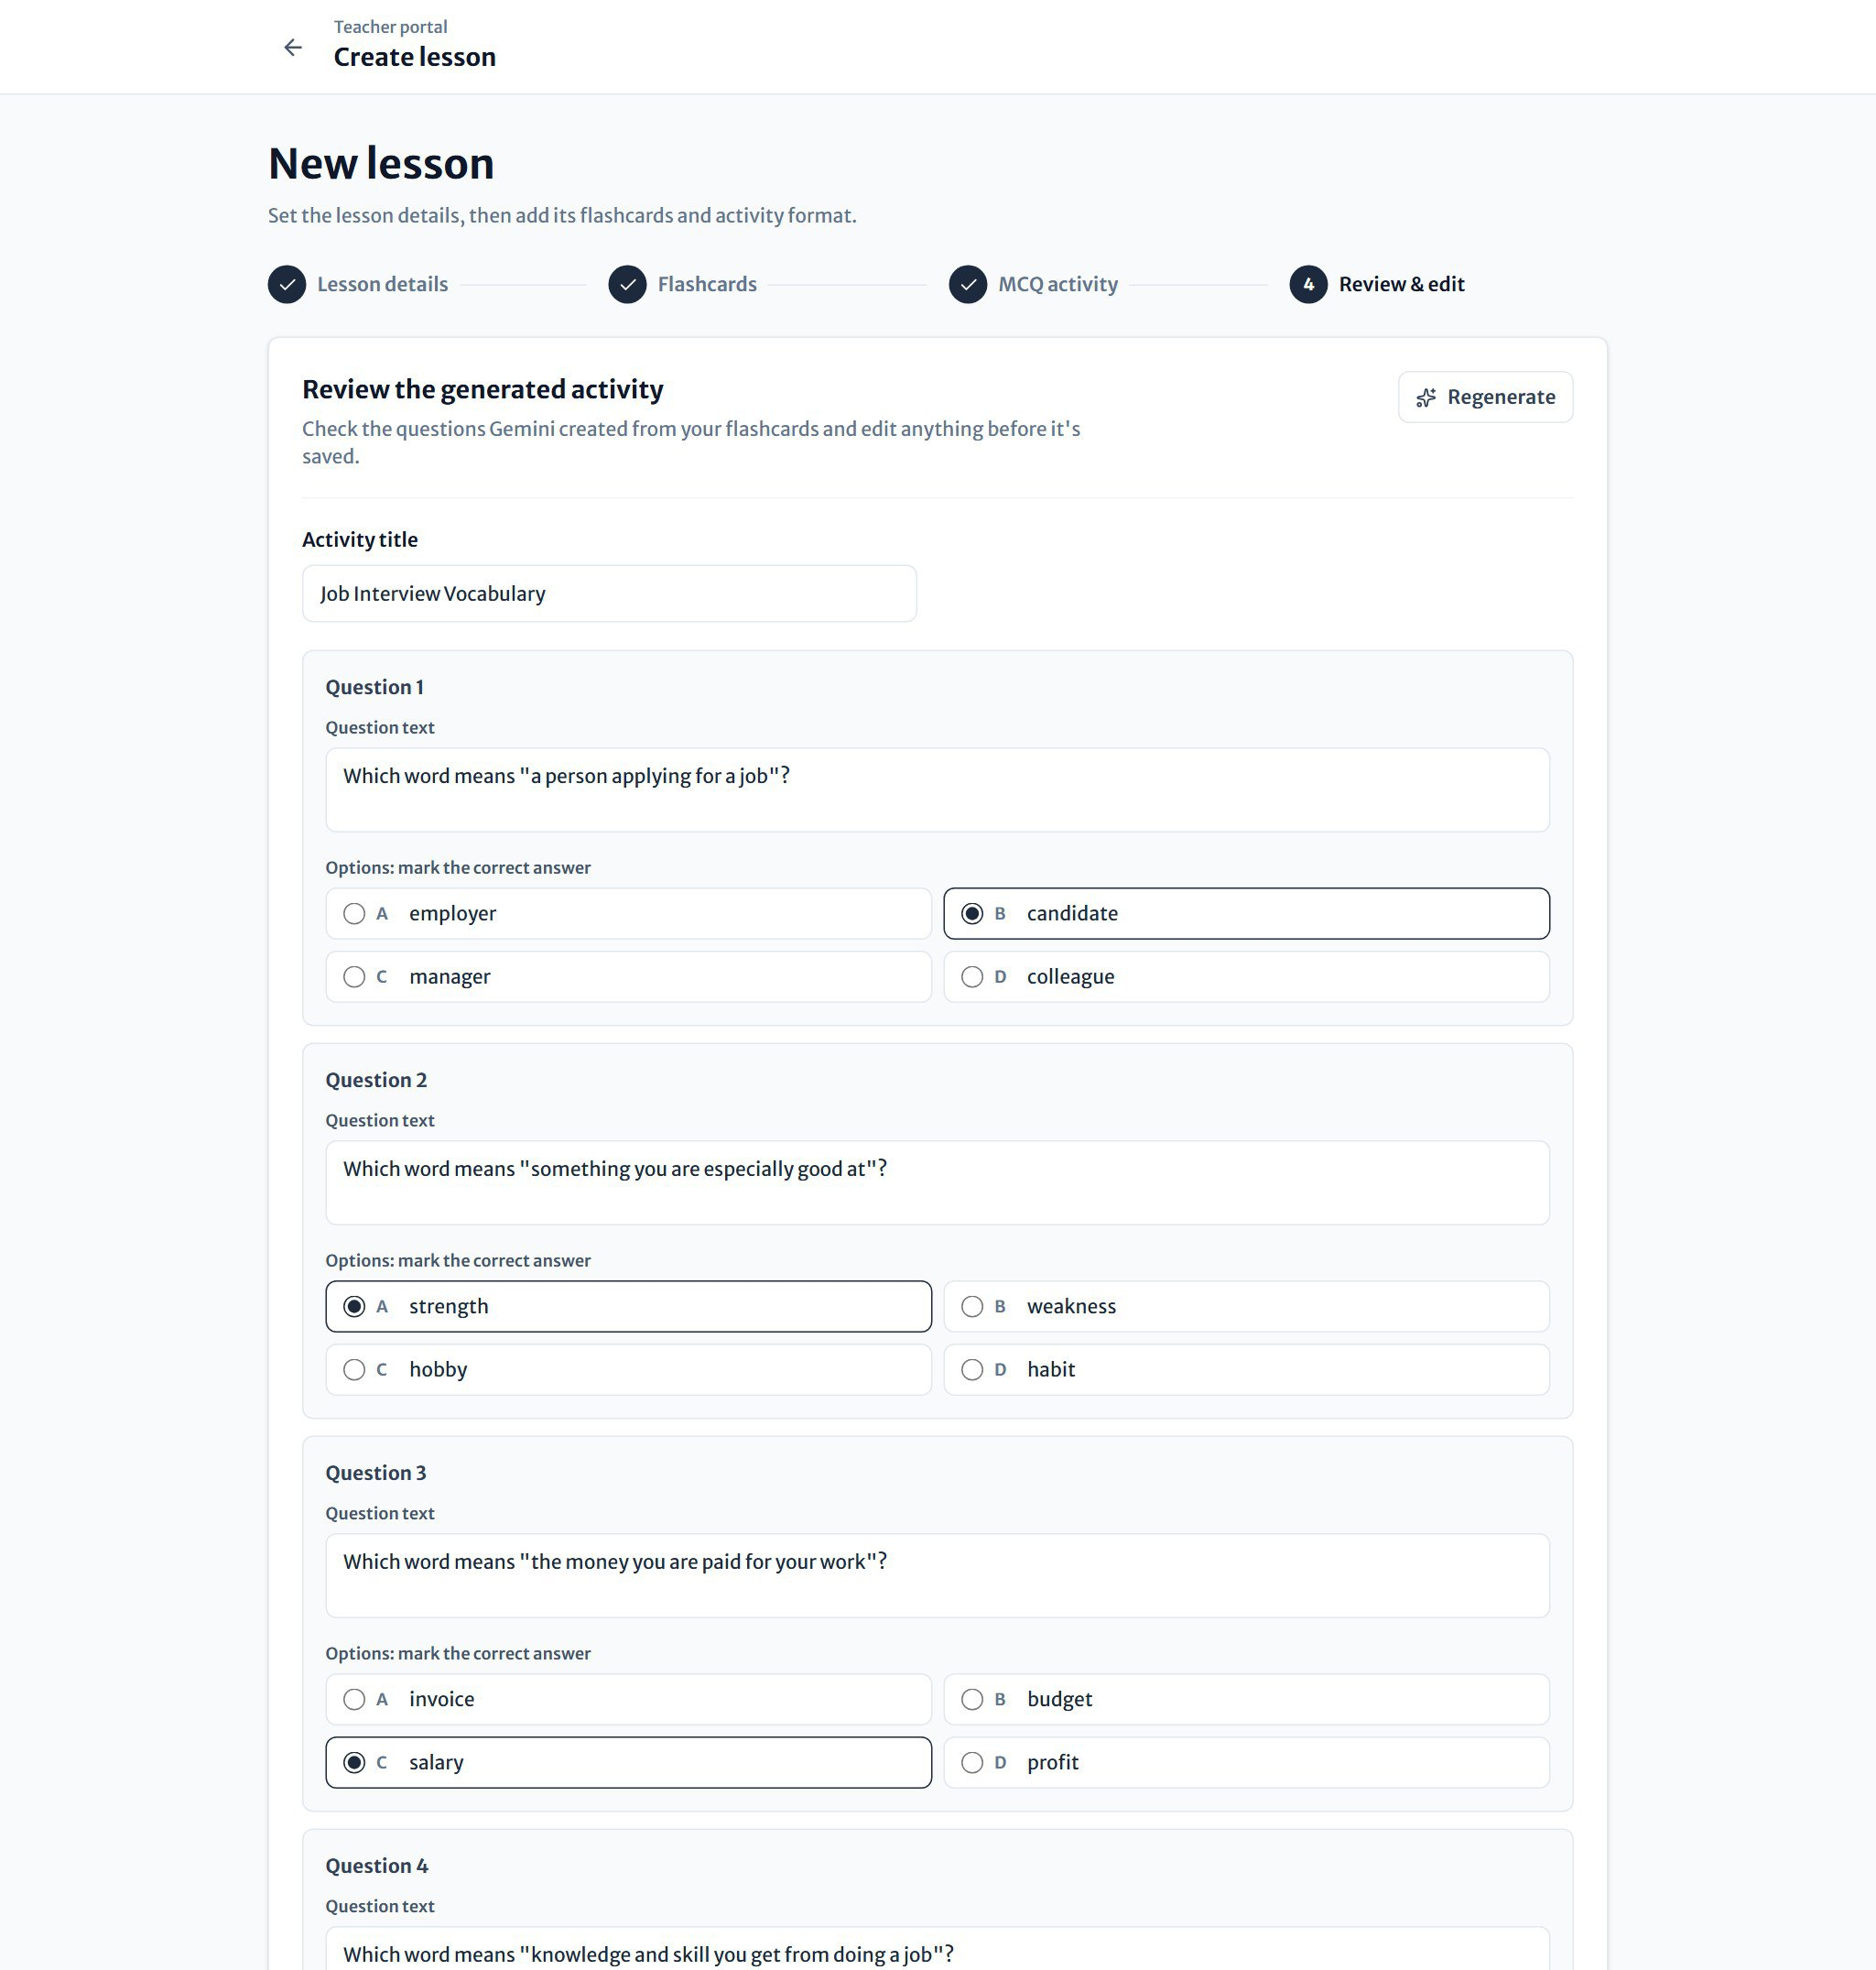
Figure 19 Step 4: check the AI's quiz and fix anything before saving

Always read through the generated quiz before you save it. You can change the Activity title, reword any question, edit the options, and choose a different correct answer with the round buttons. Regenerate asks the AI for a fresh quiz.
Press Create lesson to save. LEO returns to the classroom, where the new lesson is listed, and notifies your students when it's released.

Scheduling lessons with the planner
Figure 20 The lesson planner | The Lesson planner on your dashboard shows this week and next week. Days with a scheduled lesson have a small dot underneath.  - Pick today to create a lesson that's published straight away. The button reads Create lesson.  - Pick a later day and the button reads Schedule lesson. The lesson's release date is set to that day for you.  - Lessons already scheduled for the selected day are listed under the calendar, where you can edit their title, description and release date, or delete them.
  TIP
  Students can't see a scheduled lesson until its release date, so you can prepare a whole term's lessons in advance.

Lesson report
Click any lesson in a classroom to open its report:
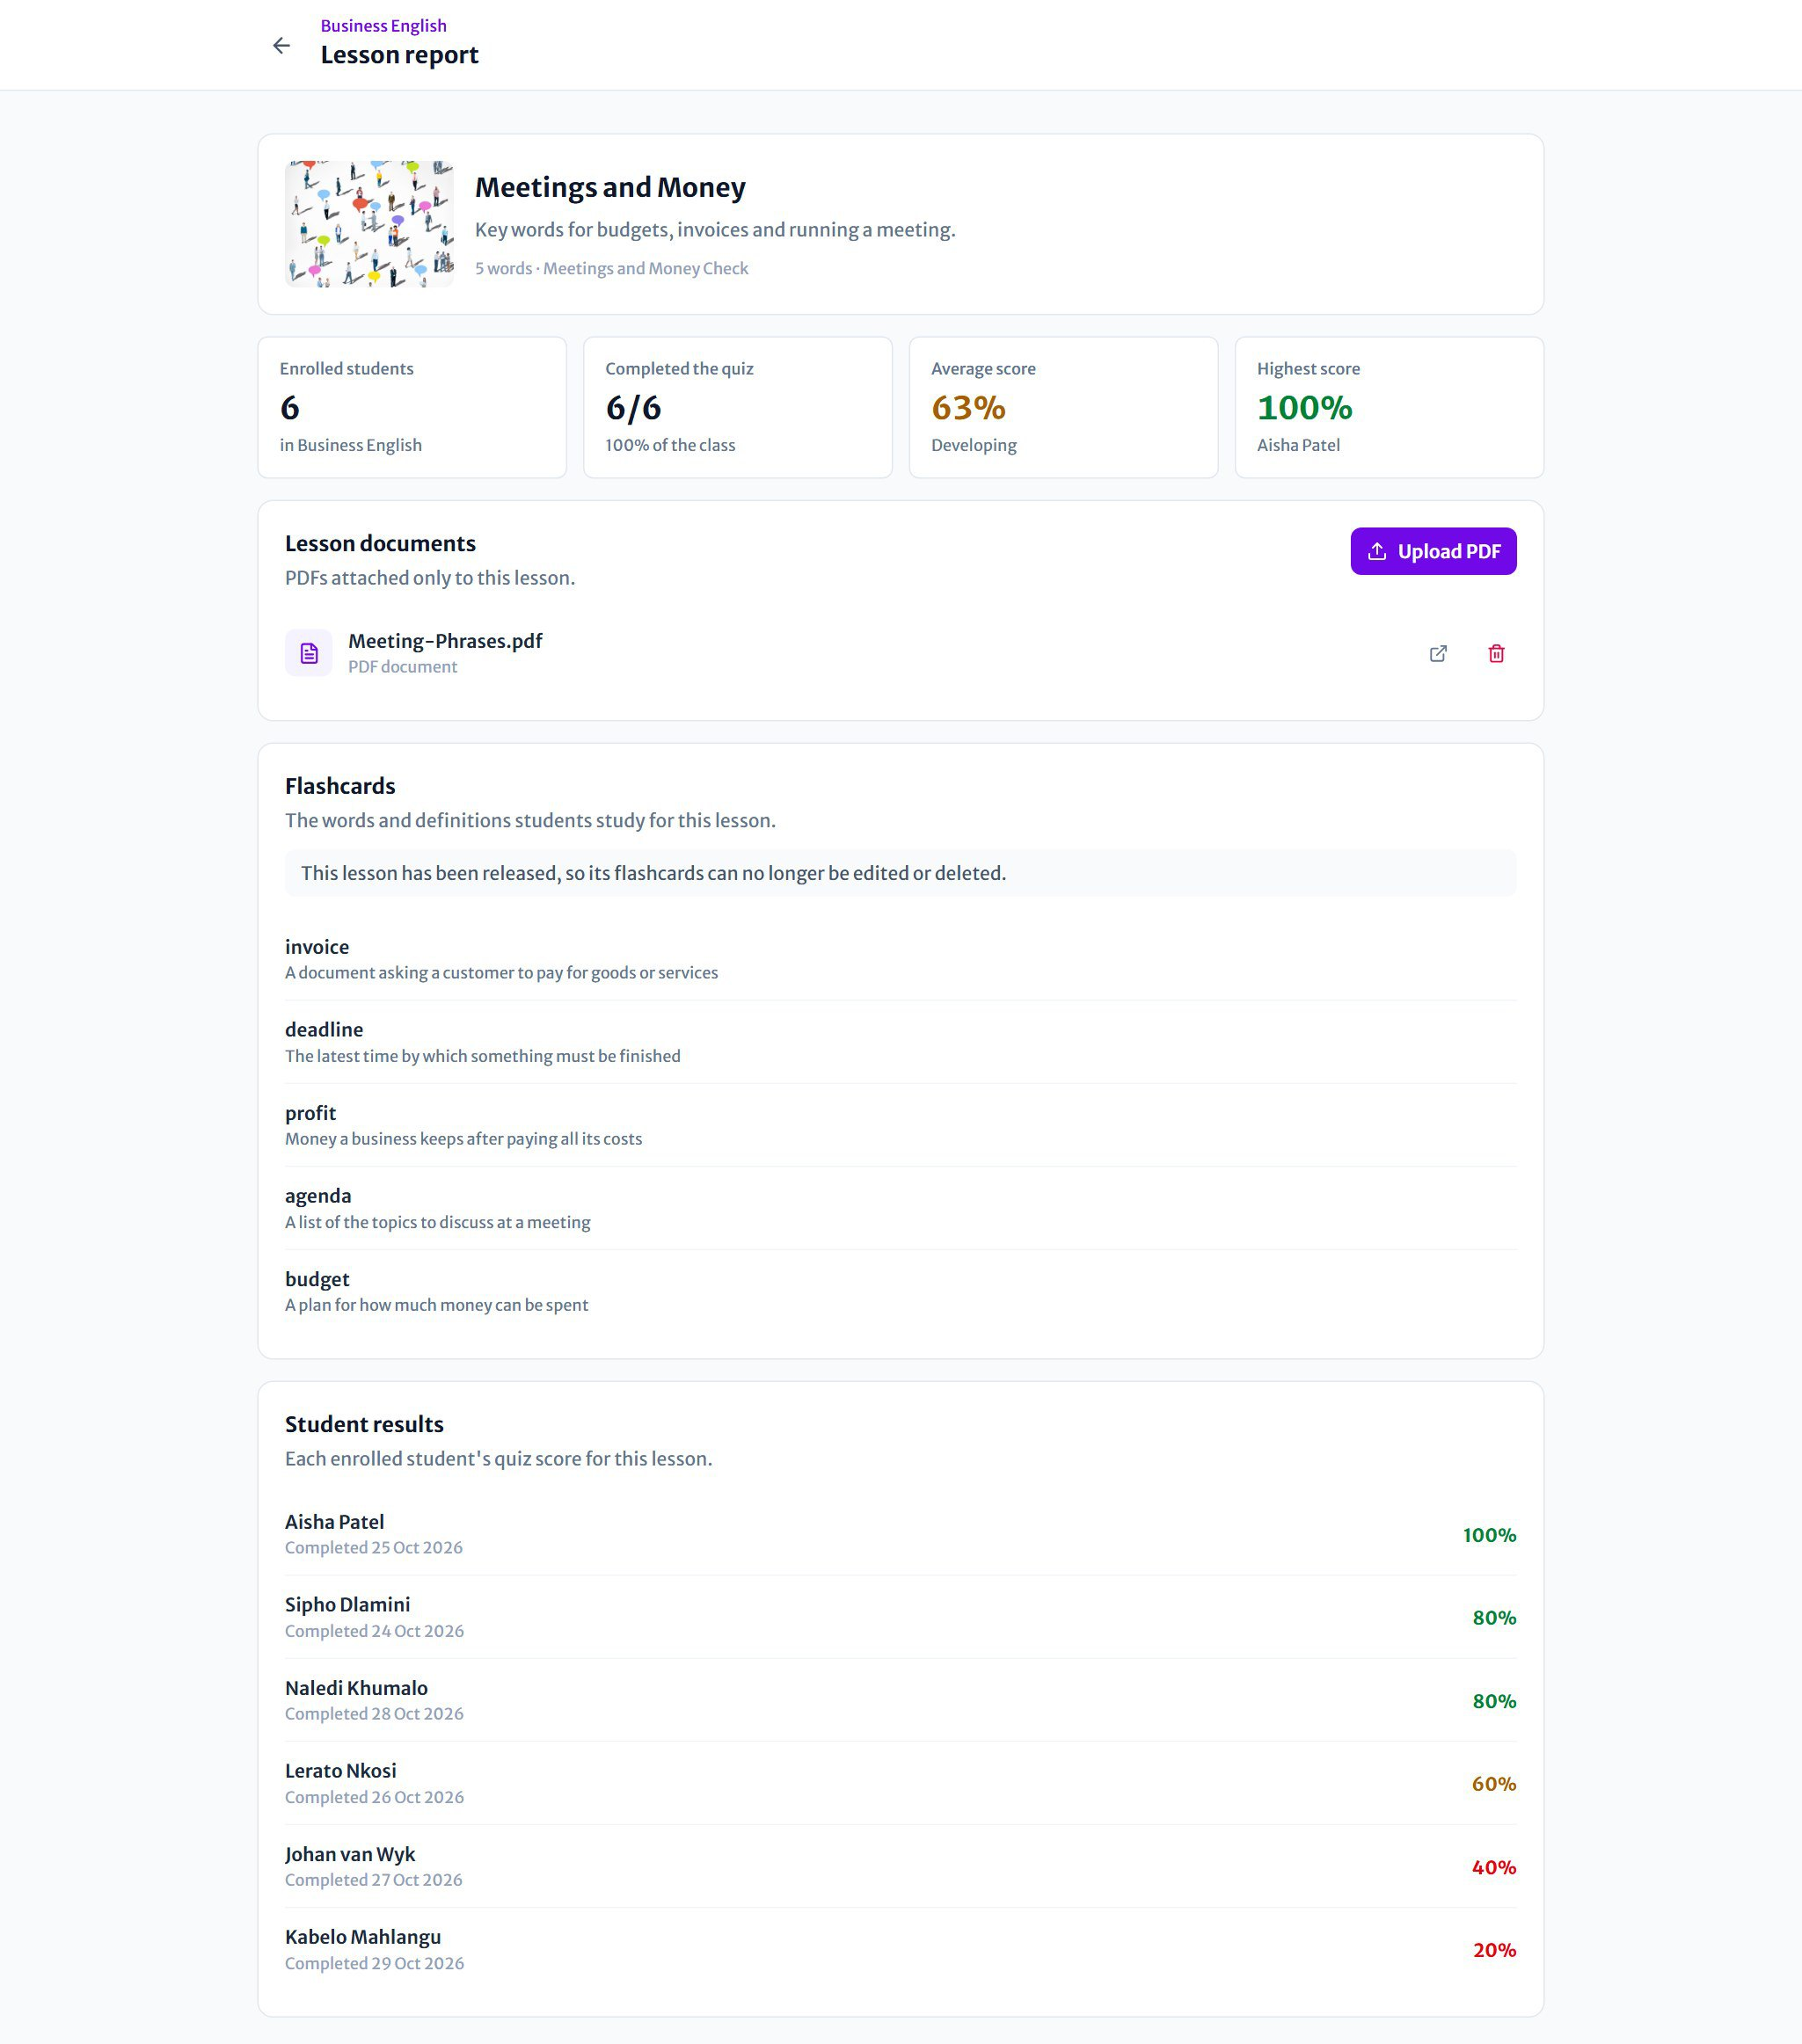
Figure 21 A lesson report with statistics, documents, flashcards and results

- Statistics: enrolled students, how many completed the quiz, and the average and highest scores.
- Lesson documents: PDFs attached to this lesson. Press Upload PDF to add one, or the bin to delete one.
- Flashcards: every word in the lesson.
- Results: each student's latest quiz score.
BE CAREFUL
You can edit a lesson's flashcards (word, definition and picture) only while it's scheduled. Once it's released, the cards are locked so every student studies the same thing.

Class reports
Open Reports in the menu and choose a classroom to see its full progress report. You can also reach it from Full progress report on a classroom's Students tab.
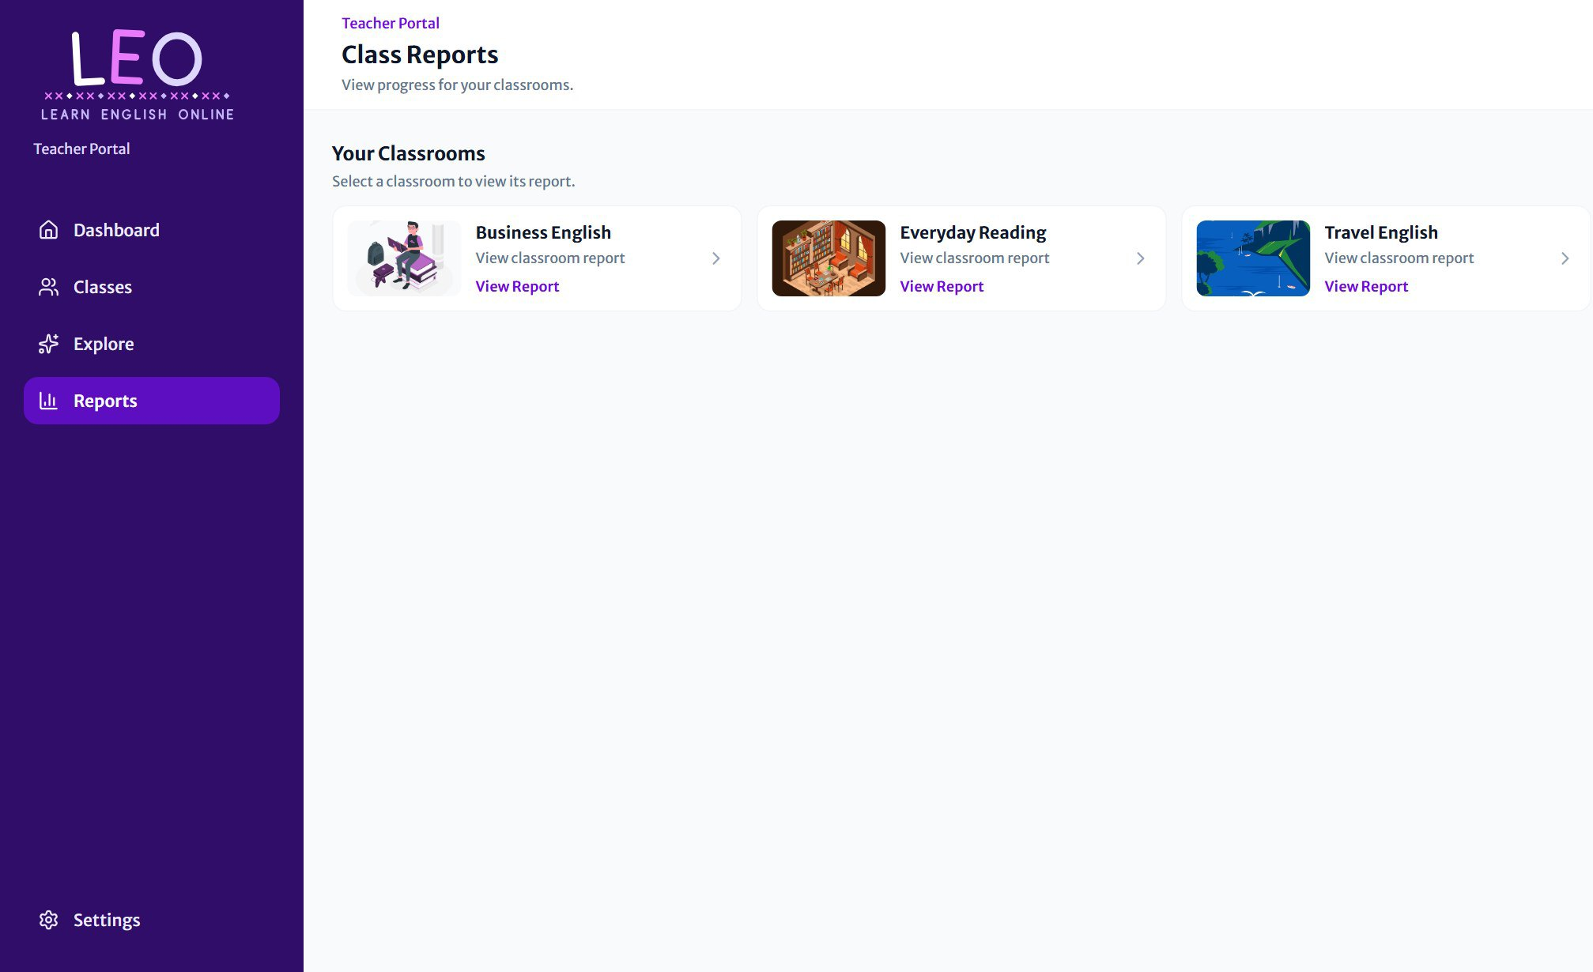
Figure 22 Choose a classroom to see its report

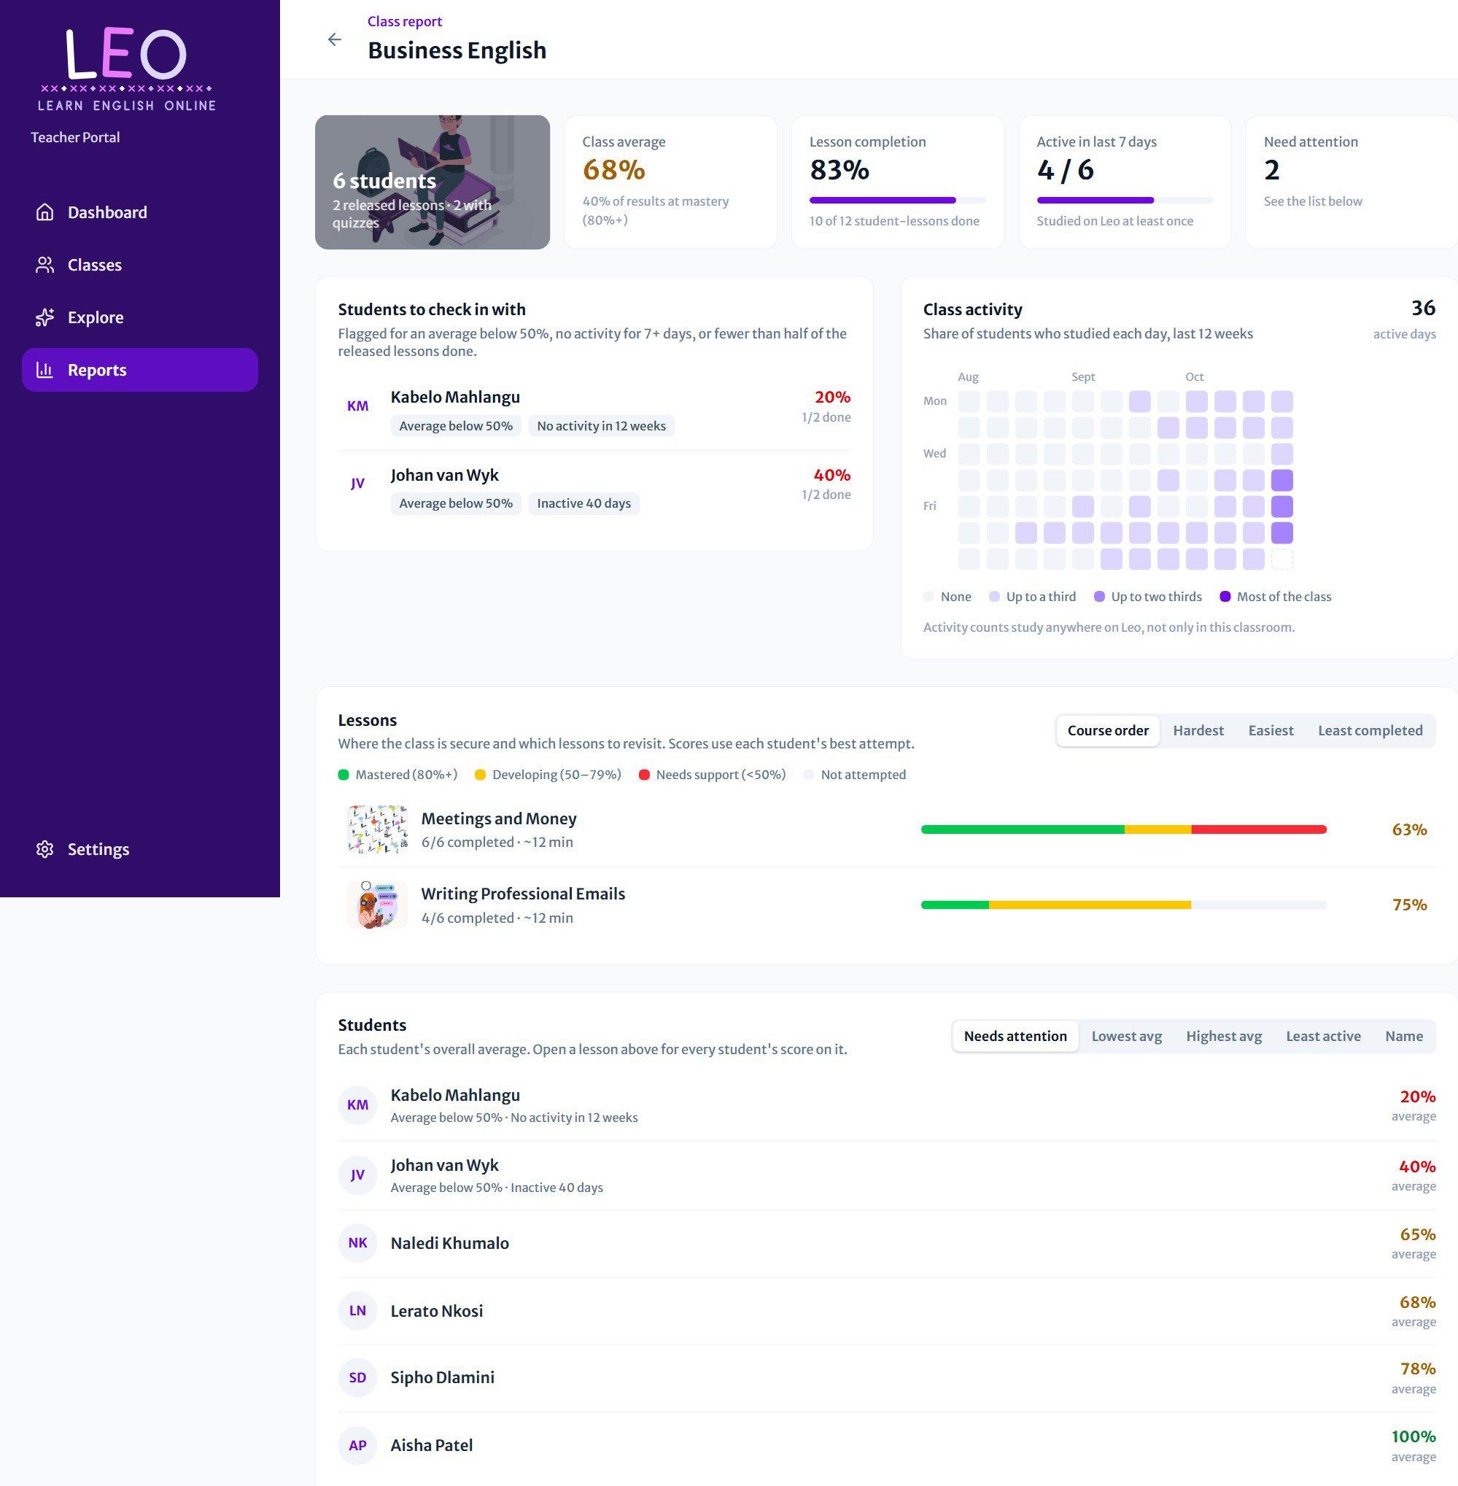
Figure 23 A full classroom report

Section | What it shows
Summary | Class size, class average, lesson completion, how many students were active in the last 7 days, and how many need attention.
Students to check in with | Students flagged for an average below 50%, no activity for 7 or more days, or completing fewer than half of the released lessons.
Class activity | A 12-week calendar. The darker the day, the more of the class studied that day.
Lessons | Each lesson's mastery bar, average and time taken. Sort by course order, hardest, easiest or least completed, and click a lesson for its report.
Students | Each student's overall average. Sort by Least active to see how many days each student studied.

Scores are grouped into three bands throughout LEO's reports:
Mastered  80% and above | Developing  50% to 79% | Needs support  Below 50%

Explore
Explore collects hand-picked articles and blogs about language teaching from trusted sources, such as BBC Learning English and the British Council. Click Read more to open one in a new tab.
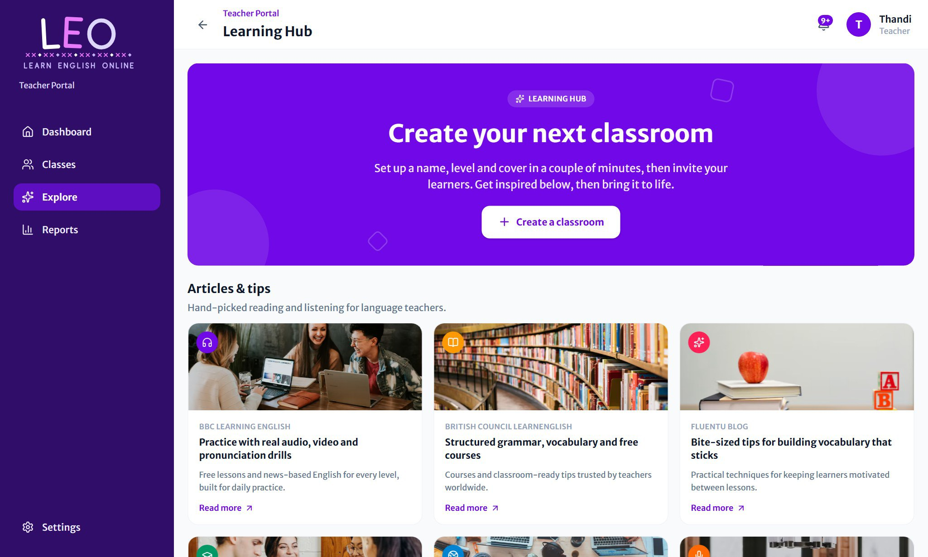
Figure 24 The Explore page

PART 3  Student guide  Join your classroom, study flashcards, play the matching game, take quizzes and watch your progress grow. | 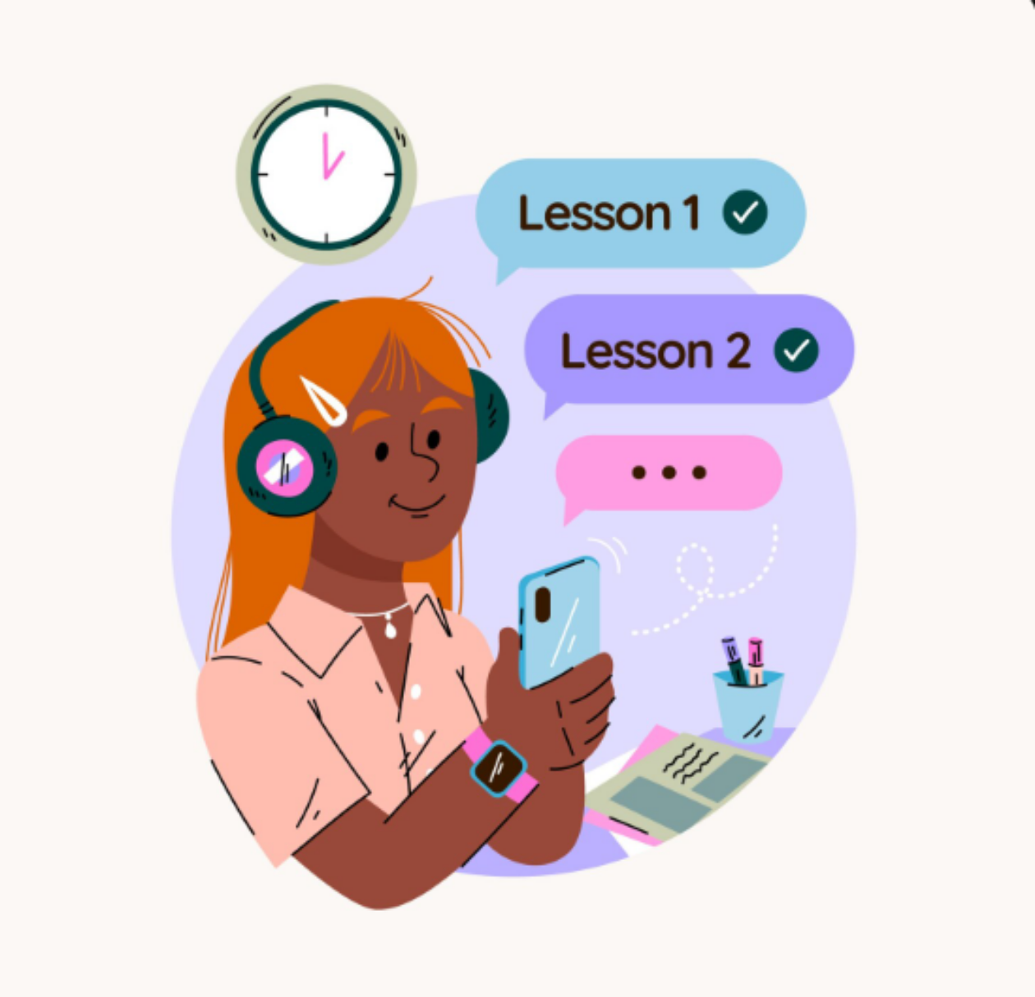

Home  Your classrooms, newest lessons and streak. | Classrooms  Join with a code and open each class. | Practice  Every lesson, ready to start. | Report  Your scores, streak and activity.

Your dashboard
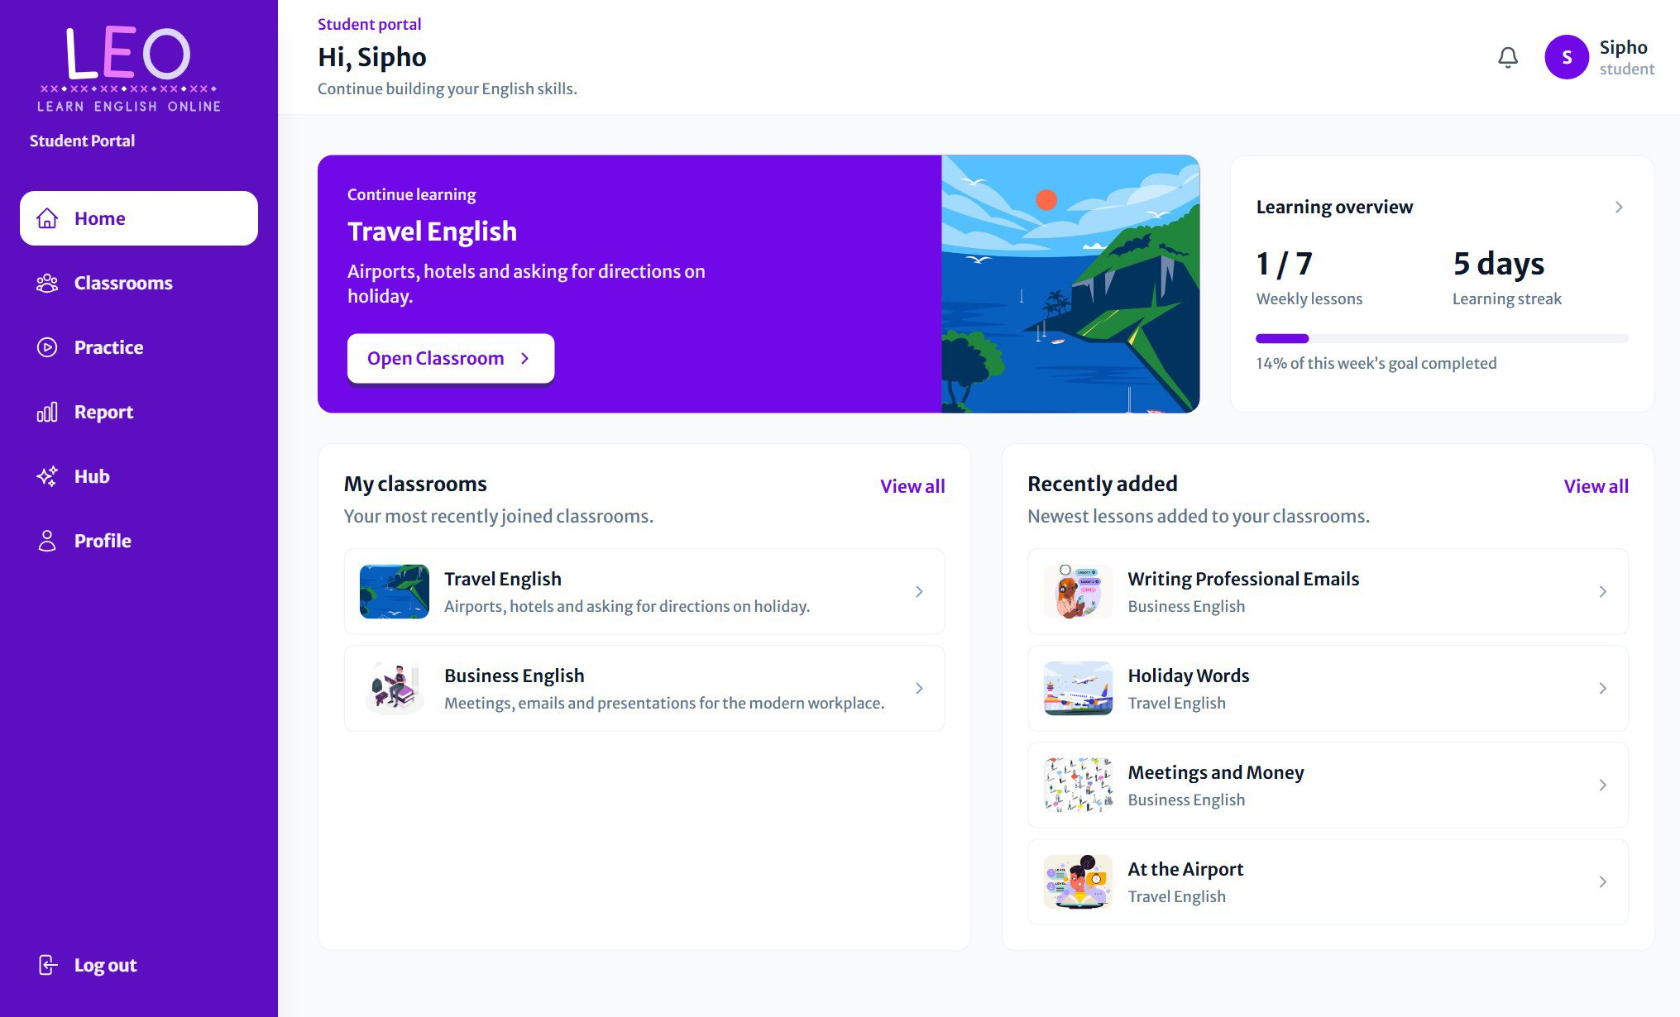
Figure 25 The student dashboard on a computer

- Continue learning: the classroom you joined most recently. Press Open Classroom to go in.
- Learning overview: lessons done this week against your weekly goal, and your learning streak (days in a row you've studied).
- My classrooms: your newest classrooms. View all shows every one.
- Recently added: the newest lessons from your teachers. Click one to start it.
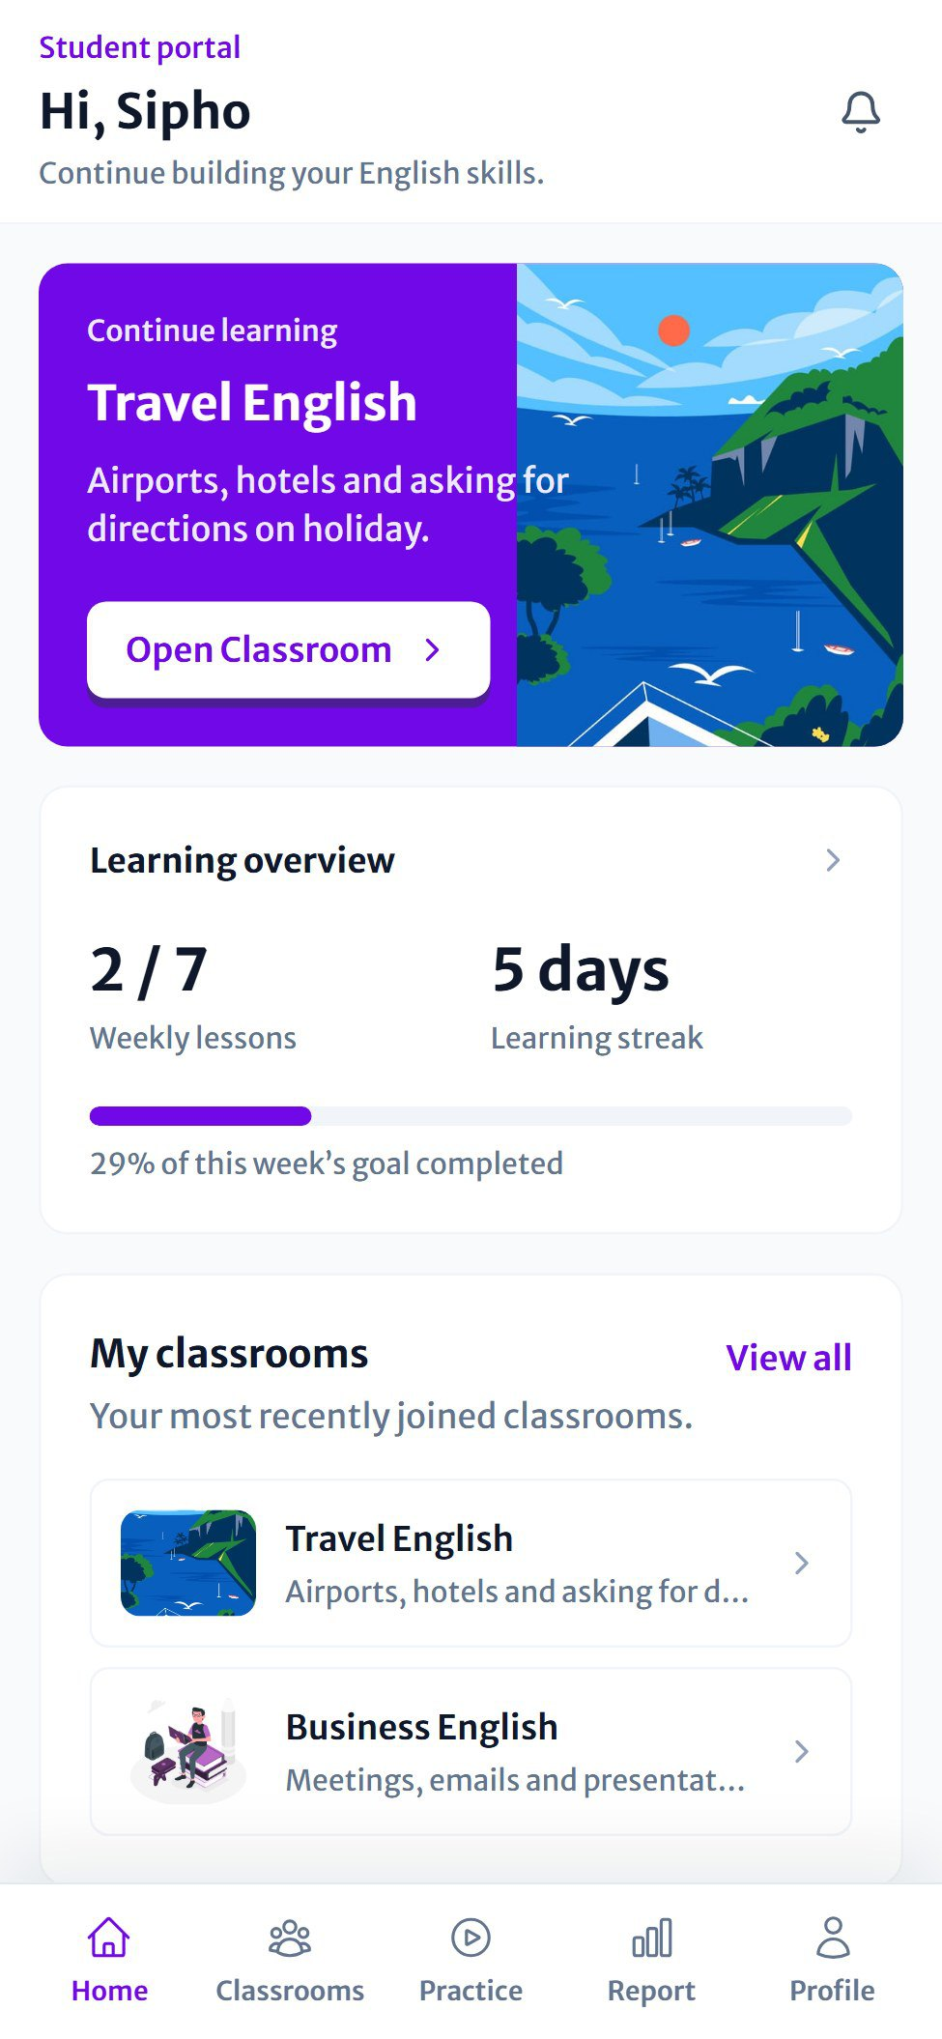  Figure 26 The dashboard on a phone | On a phone  The same information is stacked in one column. Use the bar at the bottom of the screen to move between Home, Classrooms, Practice, Report and Profile.
  TIP
  Study a little every day to keep your streak going. Even one lesson counts.

Joining a classroom
Your teacher will give you a classroom code. You only need to enter it once.
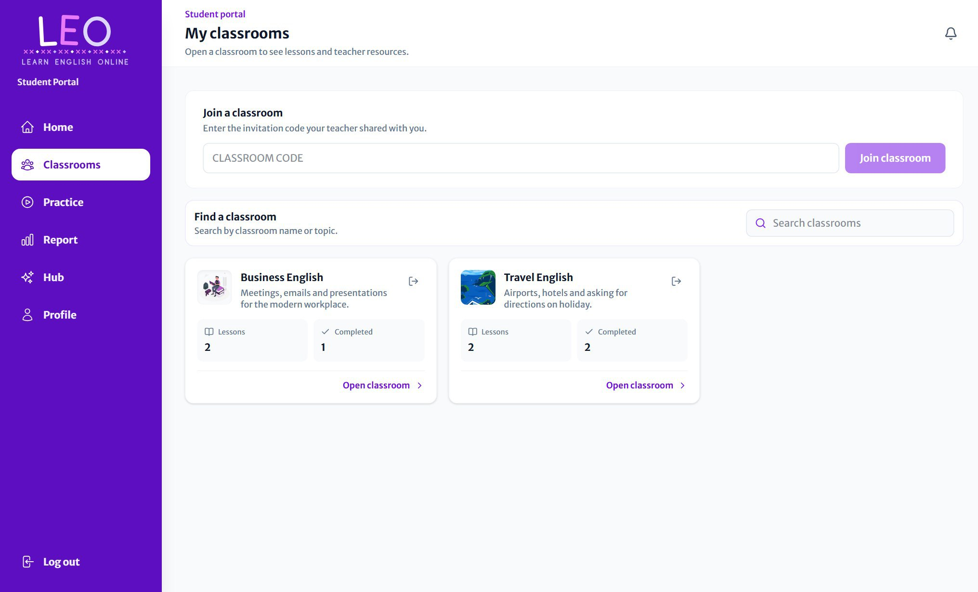
Figure 27 Join a classroom with a code, then find it in your list

- Open Classrooms from the menu.
- Type the code into the Join a classroom box.
- Press Join classroom. The classroom appears in your list straight away.
Each classroom card shows how many lessons it has and how many you've completed. Use Find a classroom to search when you have several.
GOOD TO KNOW
To leave a classroom, press the leave icon at the top right of its card or classroom page. LEO asks you to confirm first. You can rejoin later with the code.

Inside a classroom
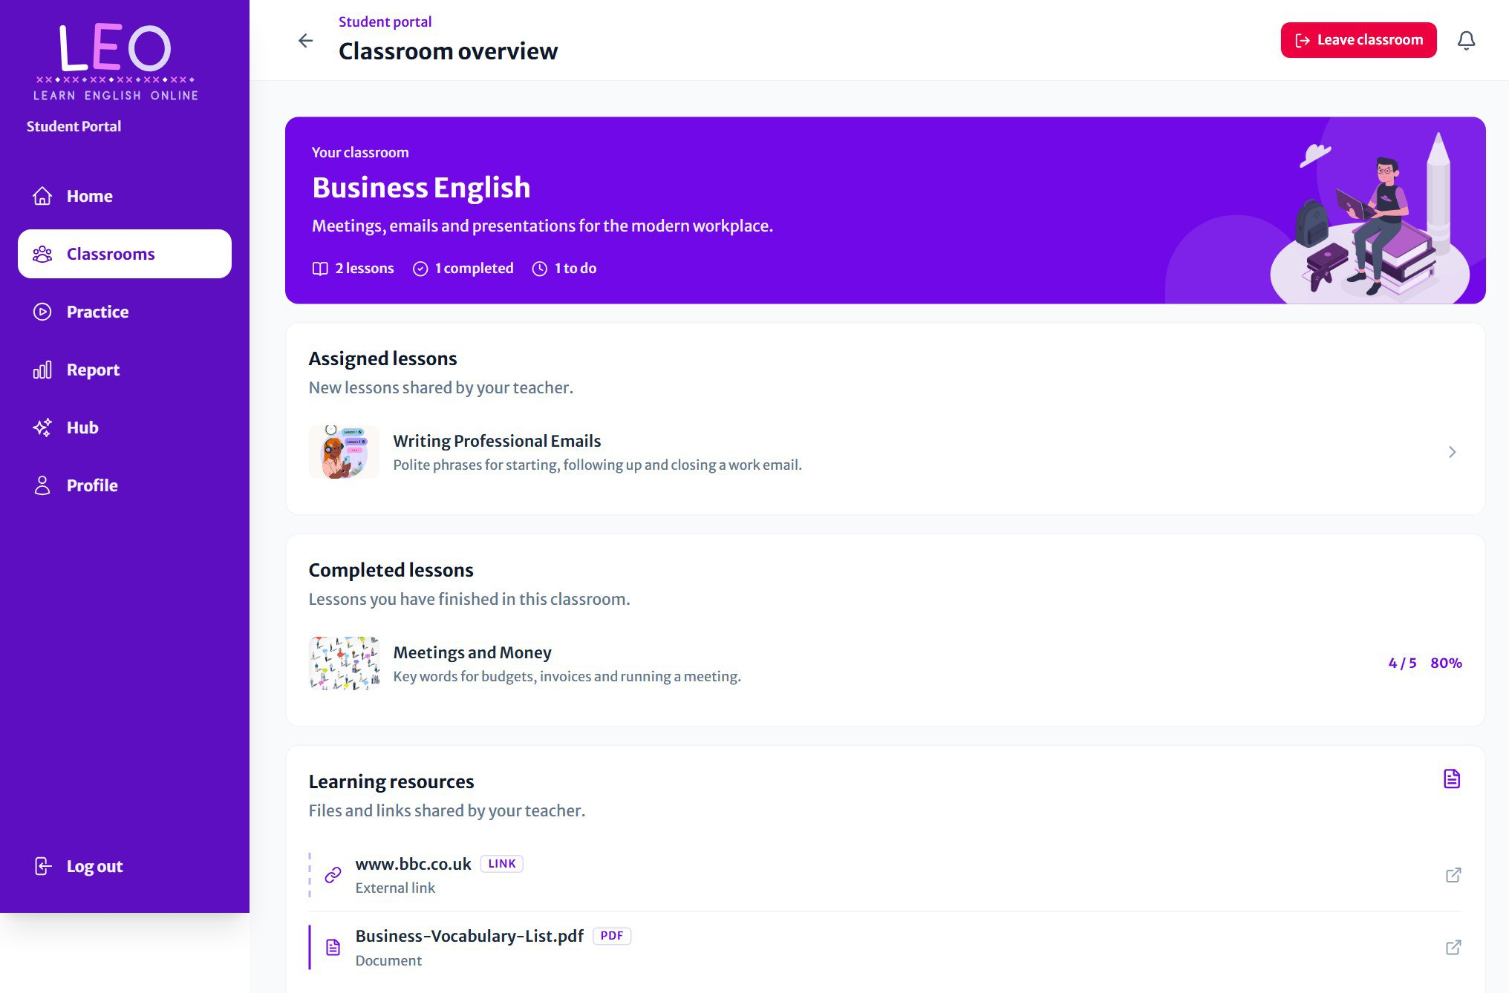
Figure 28 A classroom from the student's side

- Assigned lessons: lessons you haven't done yet. Click one to start.
- Completed lessons: lessons you've finished, with your latest score.
- Learning resources: files and links your teacher has shared. Click one to open it.

Studying flashcards
Every lesson starts with its flashcards. You see one card at a time, and the bar at the top shows how far through the lesson you are.
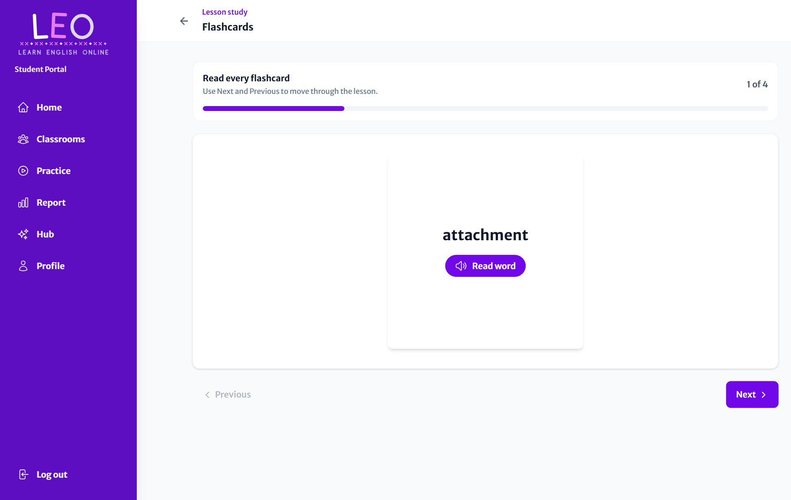
Figure 29 The front of a flashcard shows the word

- Read the word, and press Read word to hear it spoken.
- Tap or click the card to flip it and see the meaning.
- Press Next for the next card, or Previous to go back.
- On the last card, press Start quiz. If the lesson has no quiz, press Finish lesson.

The back of the card
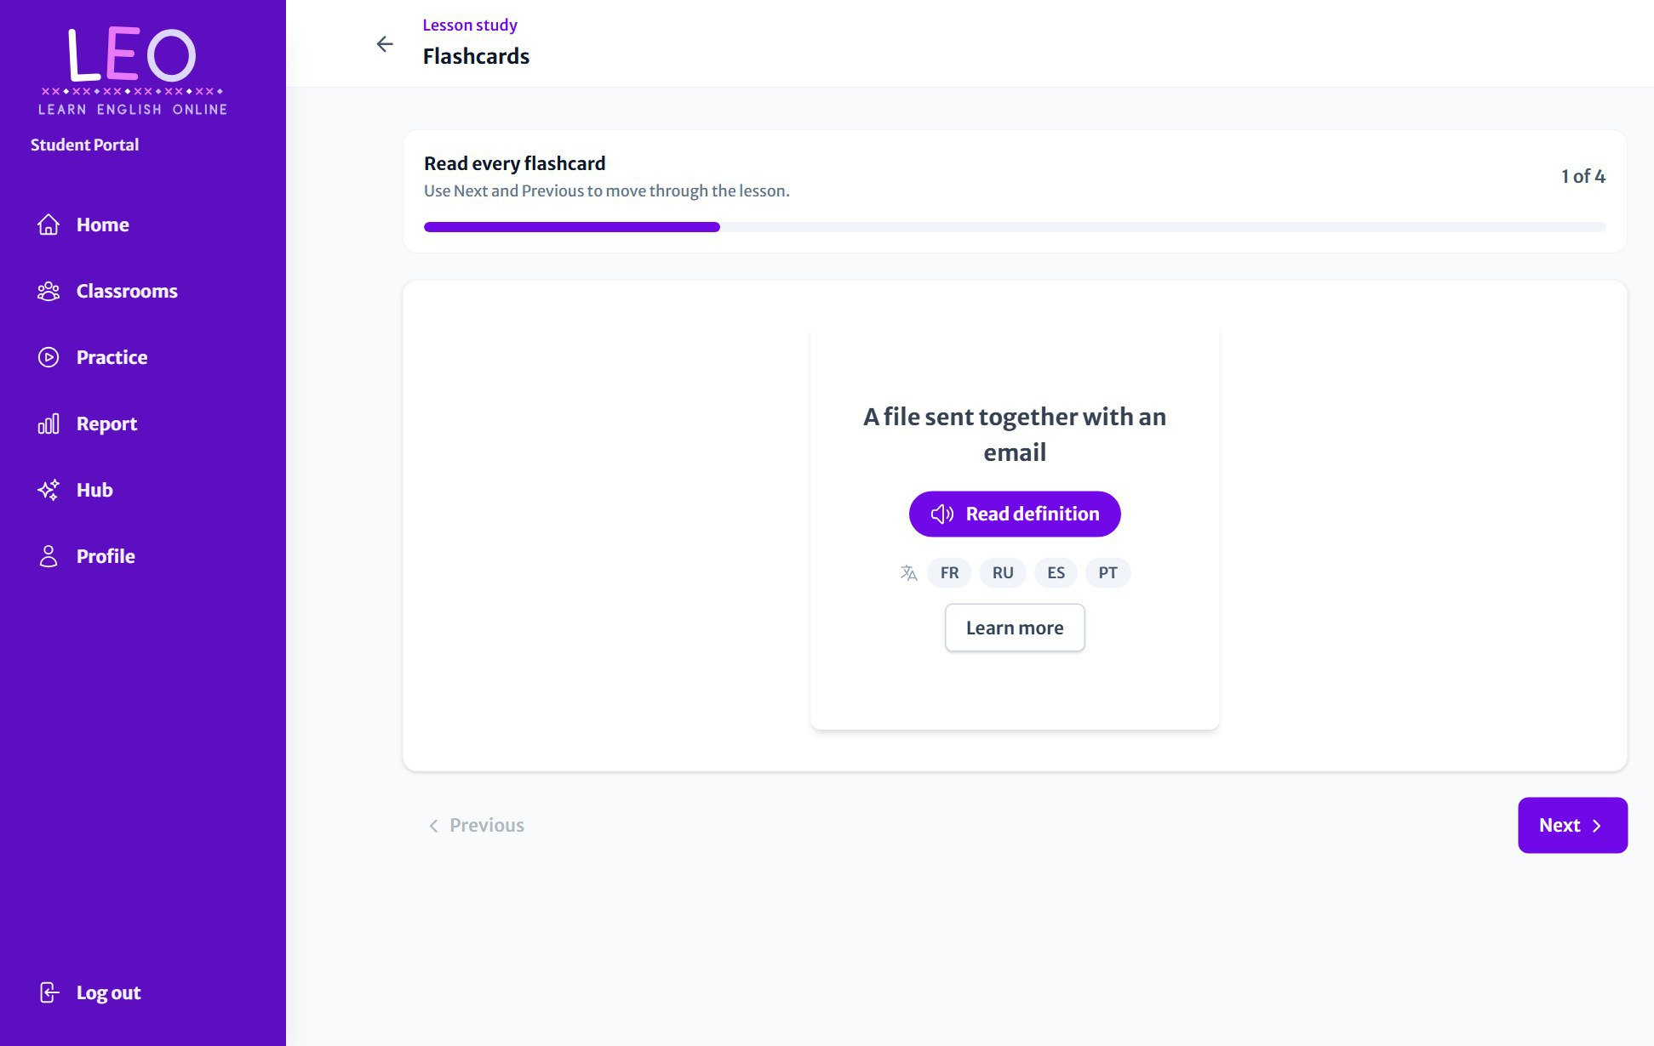
Figure 30 The back of the card shows the definition, with listening and translation tools

Tool | What it does
Read definition | Reads the meaning aloud.
FR RU ES PT | Translates the word and its meaning into French, Russian, Spanish or Portuguese. Press the same language again to return to English.
Learn more | Opens the word in the Oxford Learner's Dictionary for more examples and pronunciation.

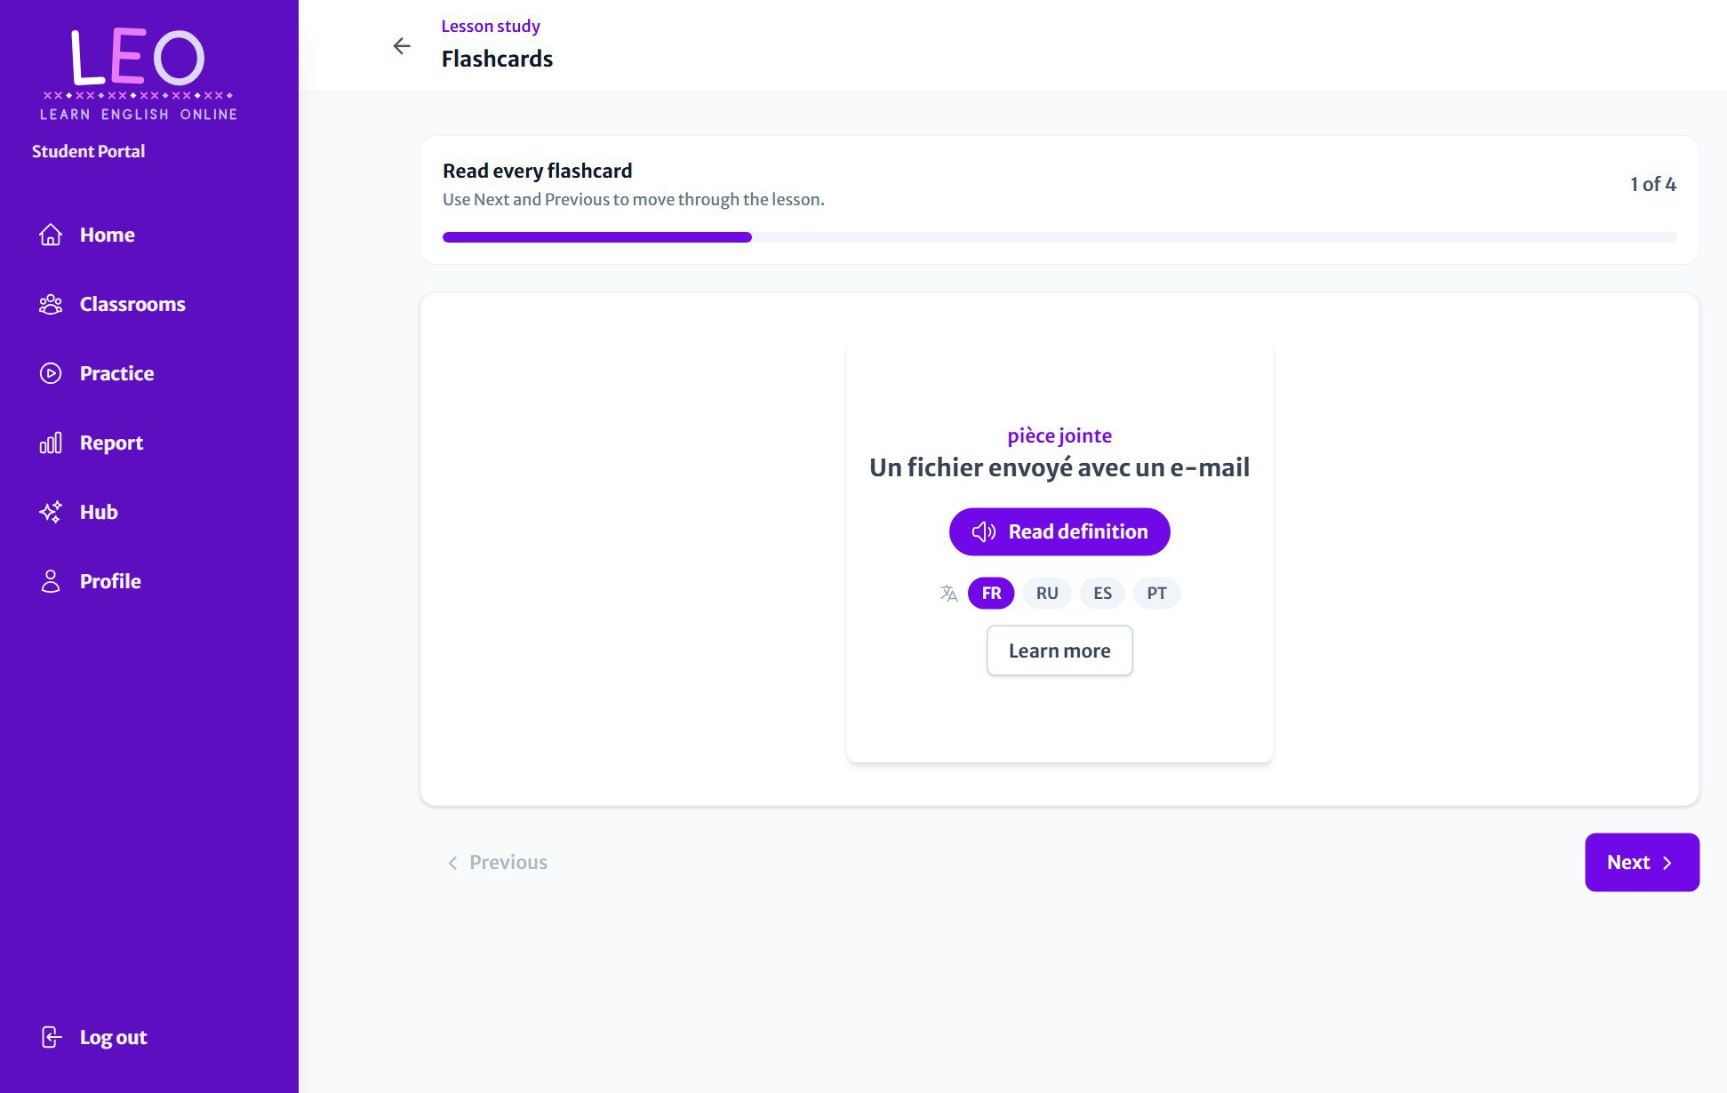
Figure 31 A flashcard translated into French

GOOD TO KNOW
Translated words are read aloud in that language. If your device has no voice for it, LEO shows a short note explaining how to add one in your device's settings.

The matching game
When a lesson has picture flashcards, a Match images button appears above the cards. It opens a game to test what you've learned:
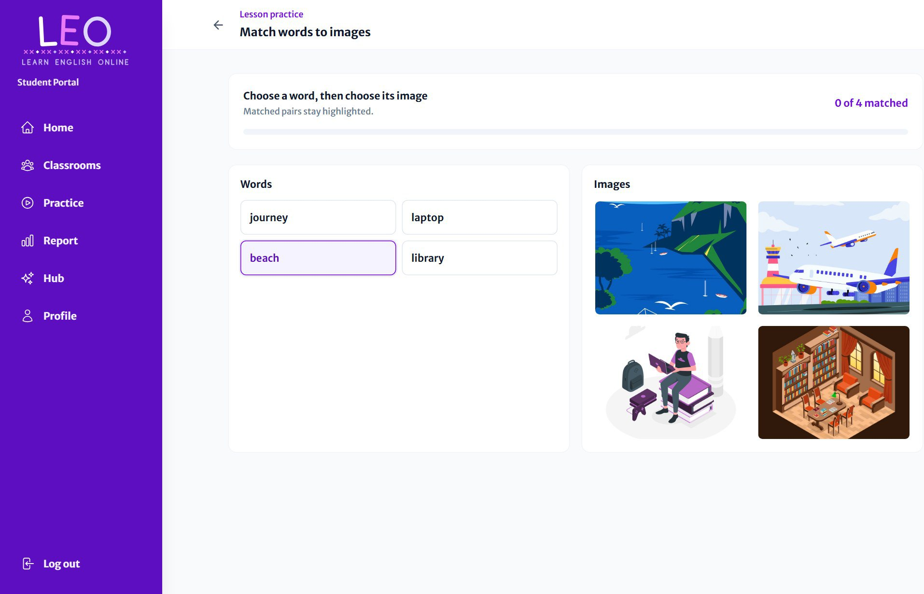
Figure 32 Choose a word, then the picture that goes with it

- Choose a word from the Words list.
- Choose the picture that matches it.
- Correct pairs turn green and stay matched. If you're wrong, just try again.
- Match every pair to finish, then press Play again to reshuffle.

Taking a quiz
After the flashcards comes the quiz: one multiple-choice question at a time.
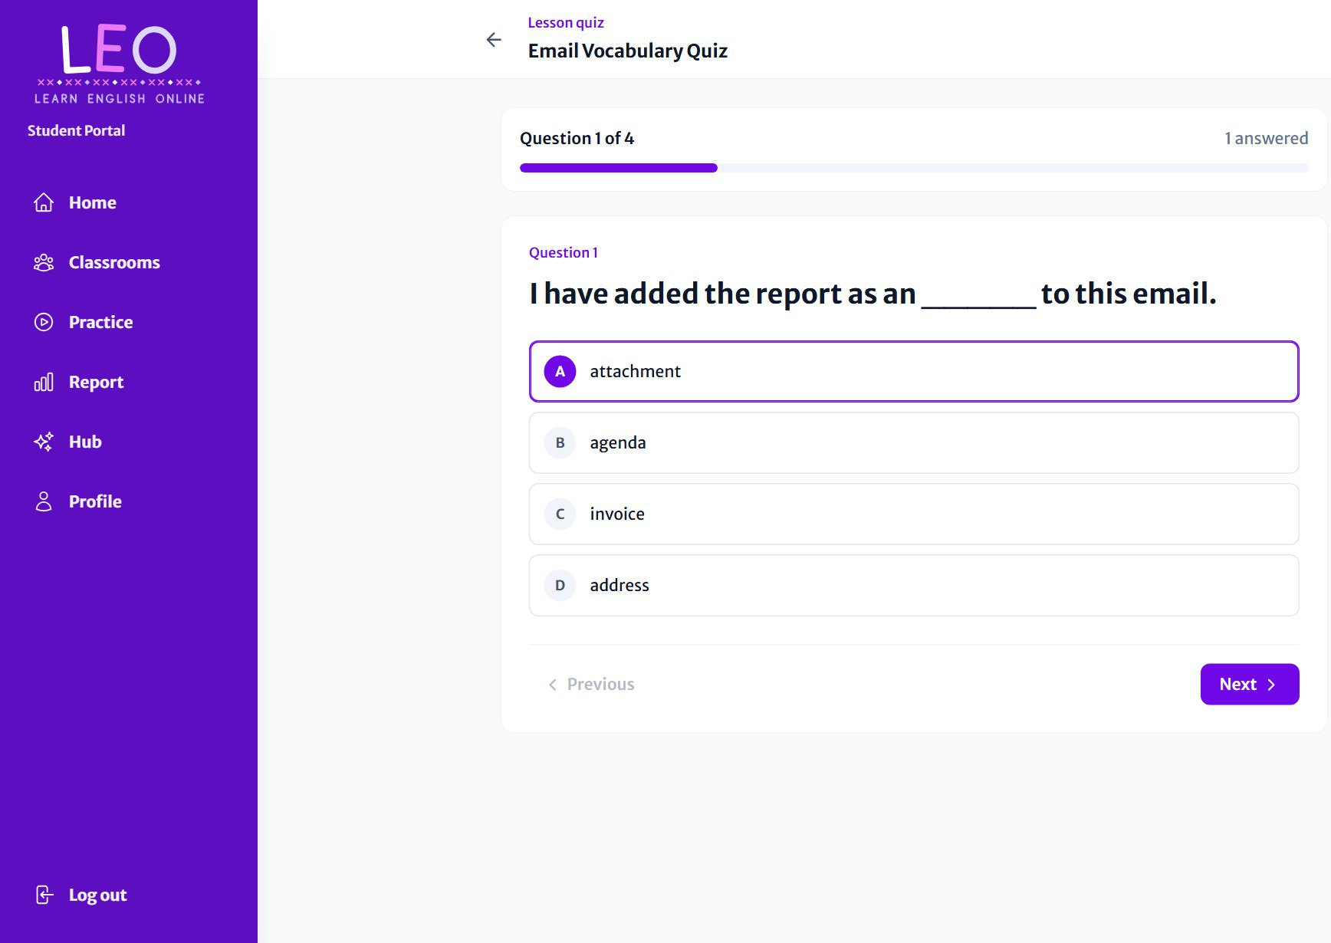
Figure 33 Choose an answer, then press Next

- Read the question and choose one of the four answers (A to D).
- Press Next. You need to choose an answer before you can move on.
- Use Previous to go back and change an answer at any time before you finish.
- On the last question, press Complete attempt.
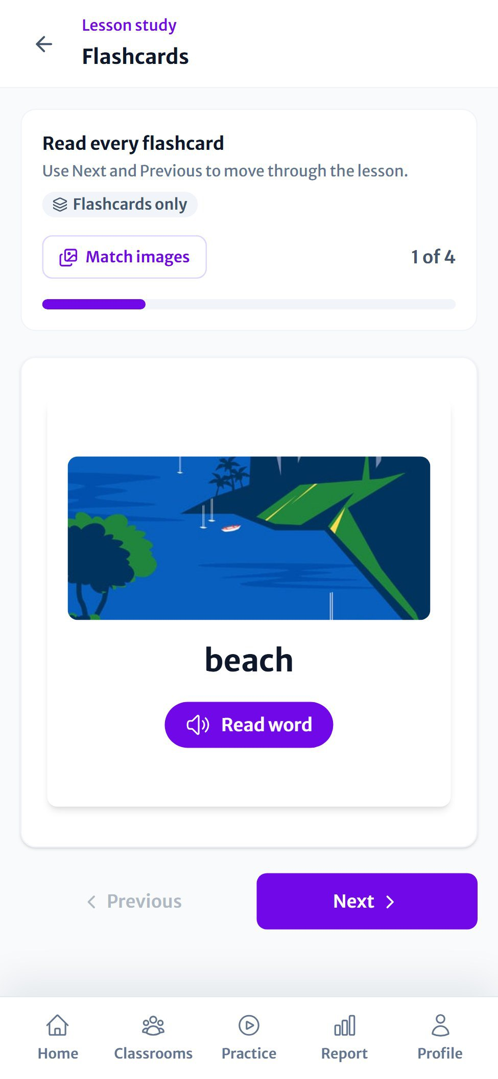  Figure 34 Flashcards on a phone | 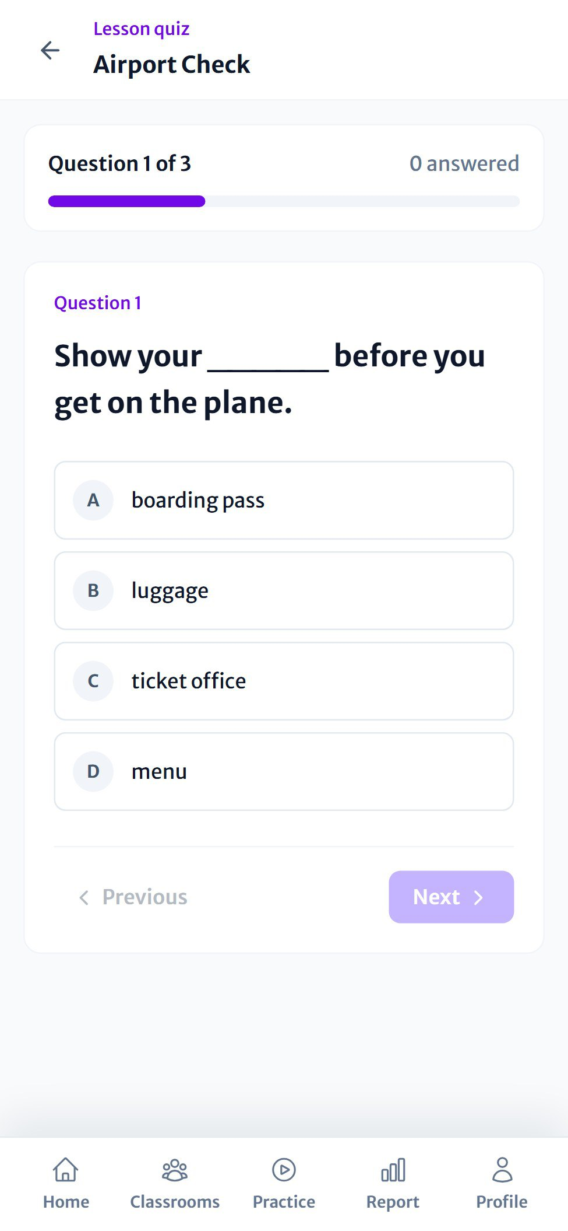  Figure 35 A quiz on a phone

Your results
As soon as you finish, LEO shows your score and a review of every question.
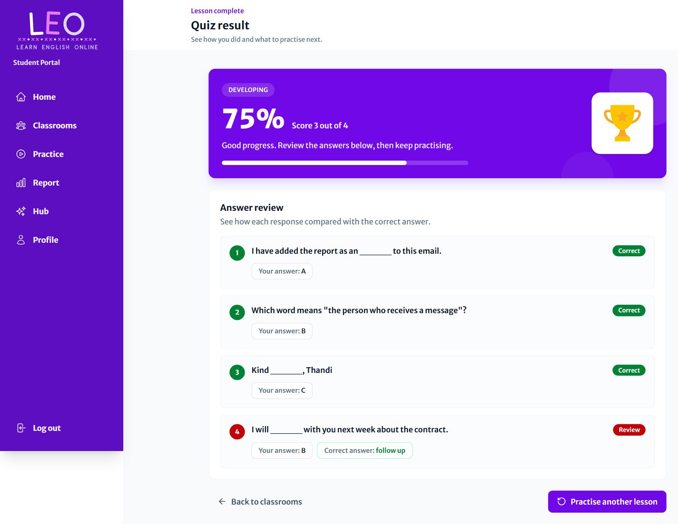
Figure 36 The quiz result with the answer review

- The violet banner shows your percentage, your score (for example 3 out of 4) and a band such as Developing or Mastered.
- Answer review marks each question Correct in green or Review in red, and shows the right answer for any you got wrong.
- Your teacher sees your result too.
TIP
You can take a lesson again for more practice. Your report always keeps your best score, so a retake never lowers it.

Practice
Practice shows every lesson from all your classrooms in one place. Press Start Practice on any lesson to study it again.
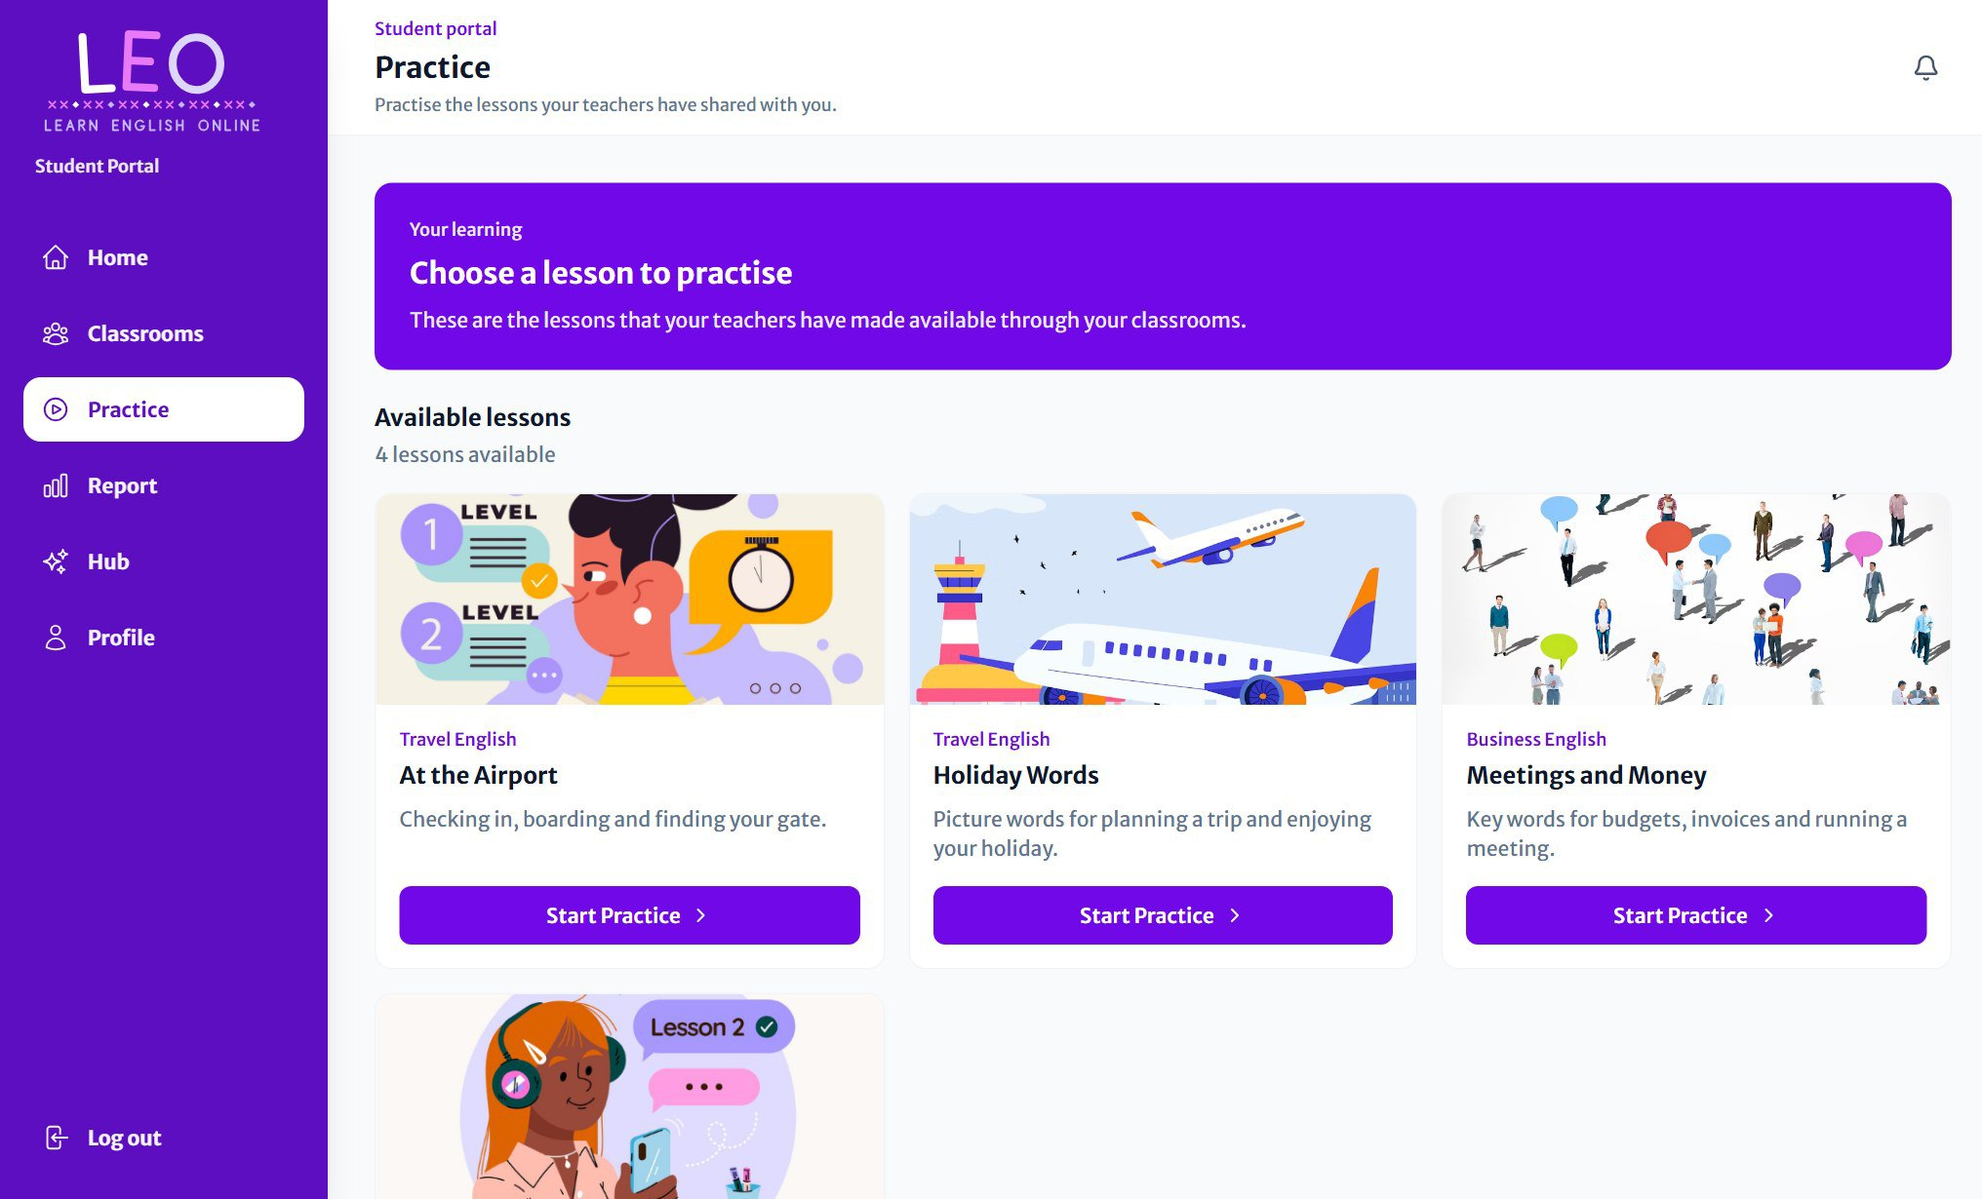
Figure 37 All your lessons, ready to practise

Your learning report
Report shows your progress across all your classrooms:
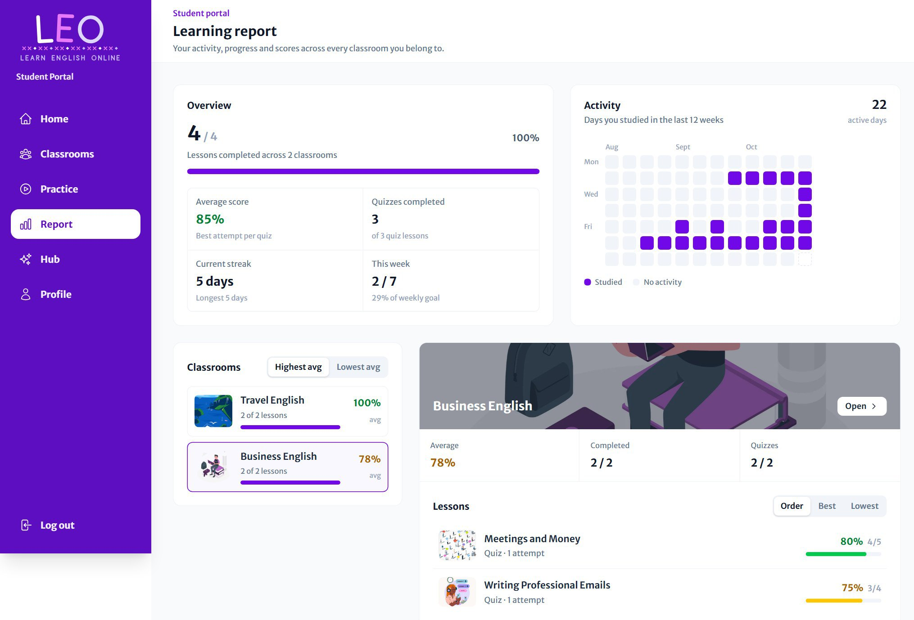
Figure 38 Your learning report

Section | What it shows
Overview | Lessons completed, your average score, quizzes completed, your current streak, and this week's progress towards your weekly goal.
Activity | A 12-week calendar with every day you studied filled in.
Classrooms | Each classroom with your average. Pick one to see its lessons and your best score in each, sorted by course order, best or lowest.

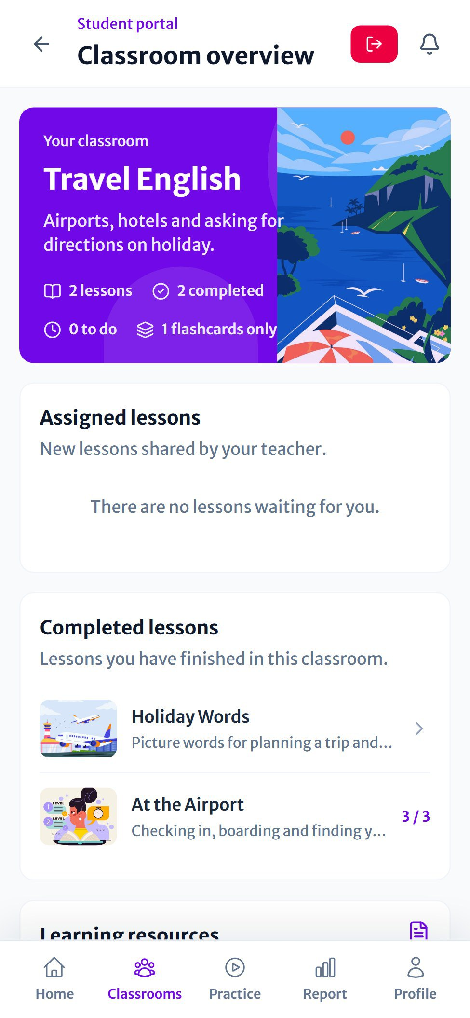  Figure 39 A classroom on a phone | 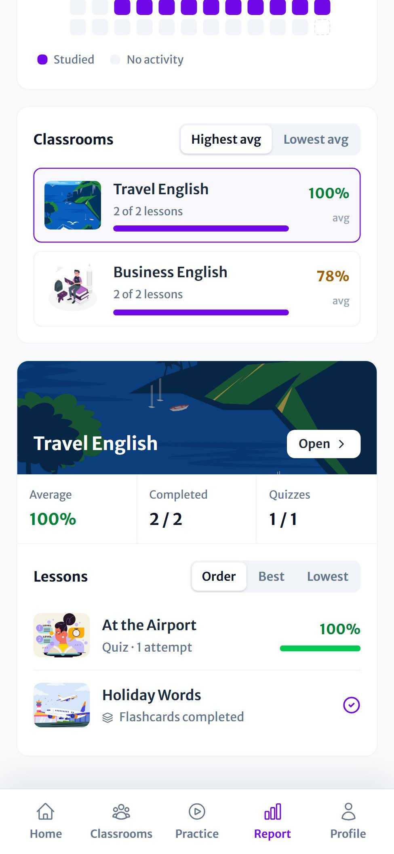  Figure 40 Your report on a phone | 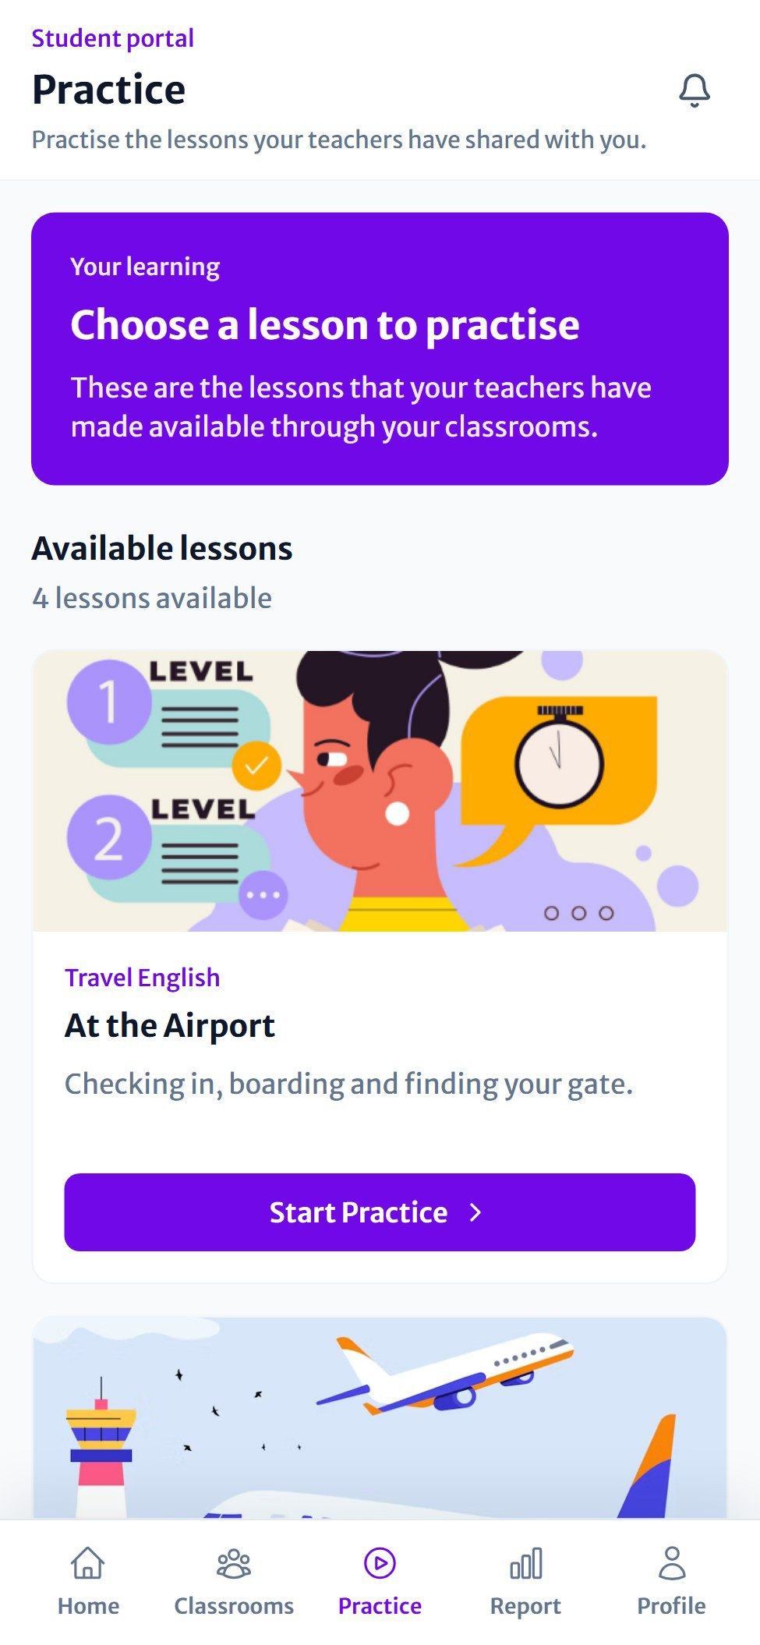  Figure 41 Practice on a phone

Learning hub
Hub collects free, trusted websites for practising English beyond the classroom (BBC Learning English, the British Council, VOA Learning English and the Cambridge Dictionary). Each card says whether it's for listening, practice, watching or vocabulary, and opens in a new tab.
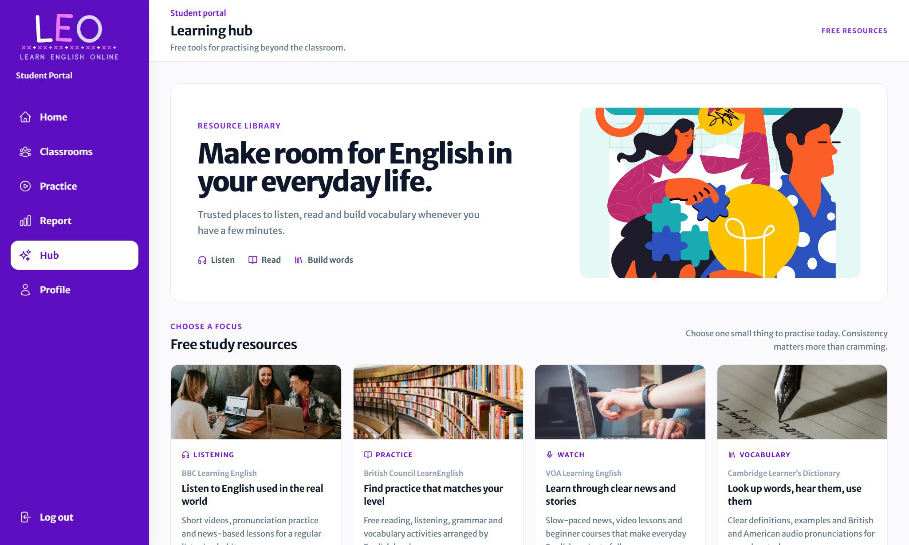
Figure 42 The learning hub

PART 4  Help  Your profile, common questions and a quick reference for both roles. | 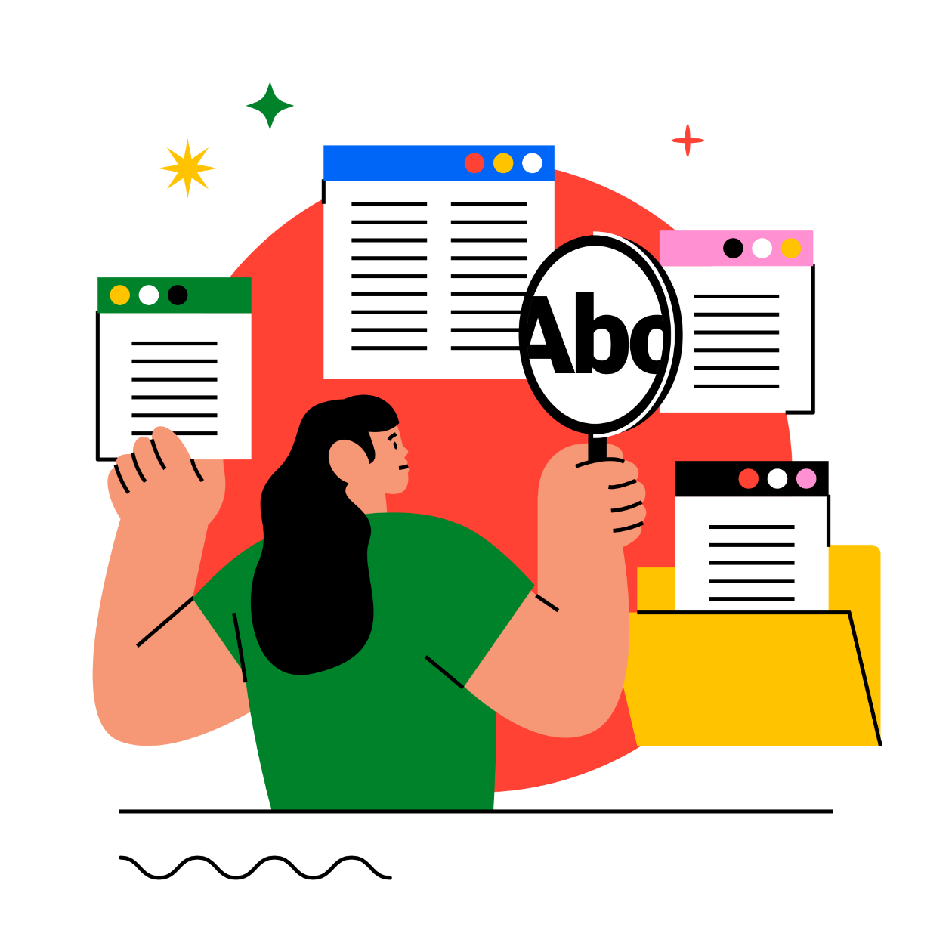

Your profile
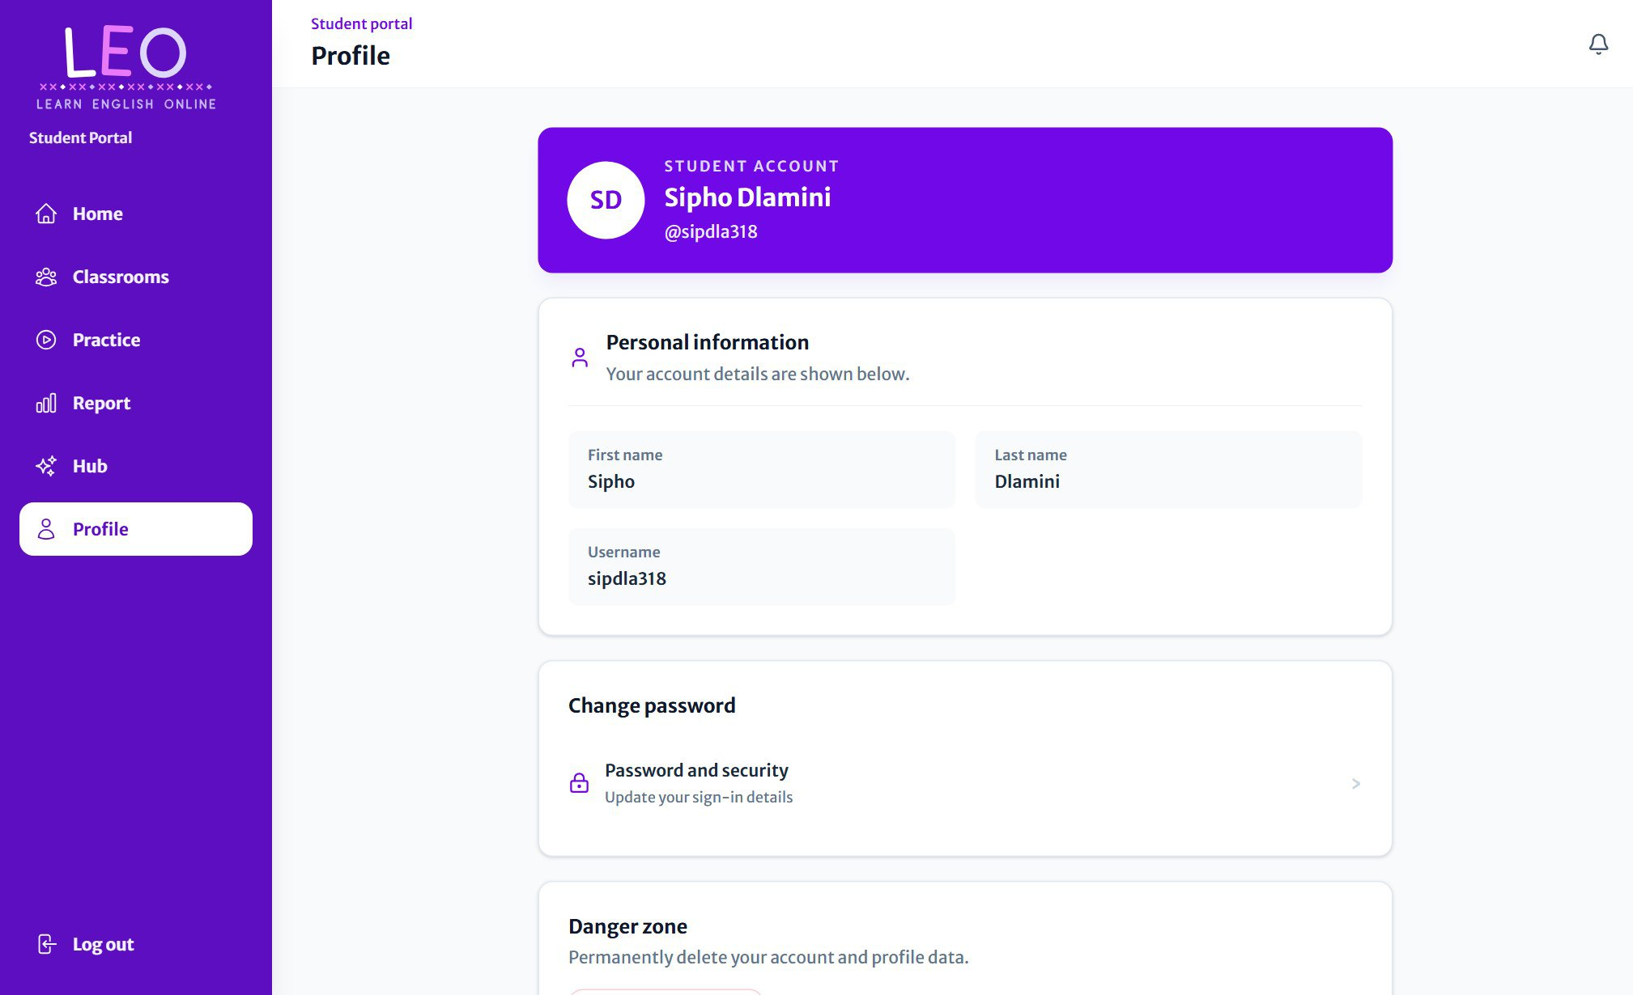
Figure 43 The profile page

Open Profile from the menu (teachers on a computer use Settings at the bottom of the sidebar). Here you can:
- See your name and, for students, your username.
- Change password: under Password and security.
- Log out of LEO on this device.
- Delete your account in the Danger zone. This permanently removes your account and your data, and LEO asks you to confirm first.

Common questions
Question | Answer
I can't see a lesson my teacher mentioned. | It may be scheduled for a later date. It appears automatically on its release day. Also check that you've joined the right classroom.
My classroom code doesn't work. | Check for typing mistakes. Your teacher may have made a new code, or the classroom may be full (30 students). Ask your teacher for the current code.
The Next button in the quiz is faded. | Choose an answer first. Every question needs an answer before you can move on.
Translation didn't load. | Check your internet connection and press the language again. Translations come from LEO's AI service.
I can't hear words read aloud. | Check your device's volume. For other languages, your device may need that language's voice installed, and LEO shows a note when one is missing.
(Teachers) The AI quiz failed. | Press Generate activity again, or save the lesson as flashcards only and add a quiz to a later lesson.
(Teachers) I can't edit a lesson's flashcards. | Flashcards are locked once a lesson is released. Only scheduled lessons can be edited.
I signed up with the wrong role. | Contact the LEO administrator to change your role.

Quick reference
TEACHERS  Create a classroom  Classes › Create Classroom  Invite students  Classroom › Invite students  Share a file or link  Classroom › Classroom material  Create a lesson  Classroom › Create lesson  Schedule a lesson  Dashboard › Lesson planner  See results  Reports › choose a classroom | STUDENTS  Join a classroom  Classrooms › Join a classroom  Start a lesson  Home › Recently added  Hear a word  Flashcard › Read word  Translate a card  Flip the card › FR RU ES PT  Practise again  Practice › Start Practice  Check progress  Report
Happy learning!

