Name of Project: Contractor Name:-
Sr.No:- Date:-
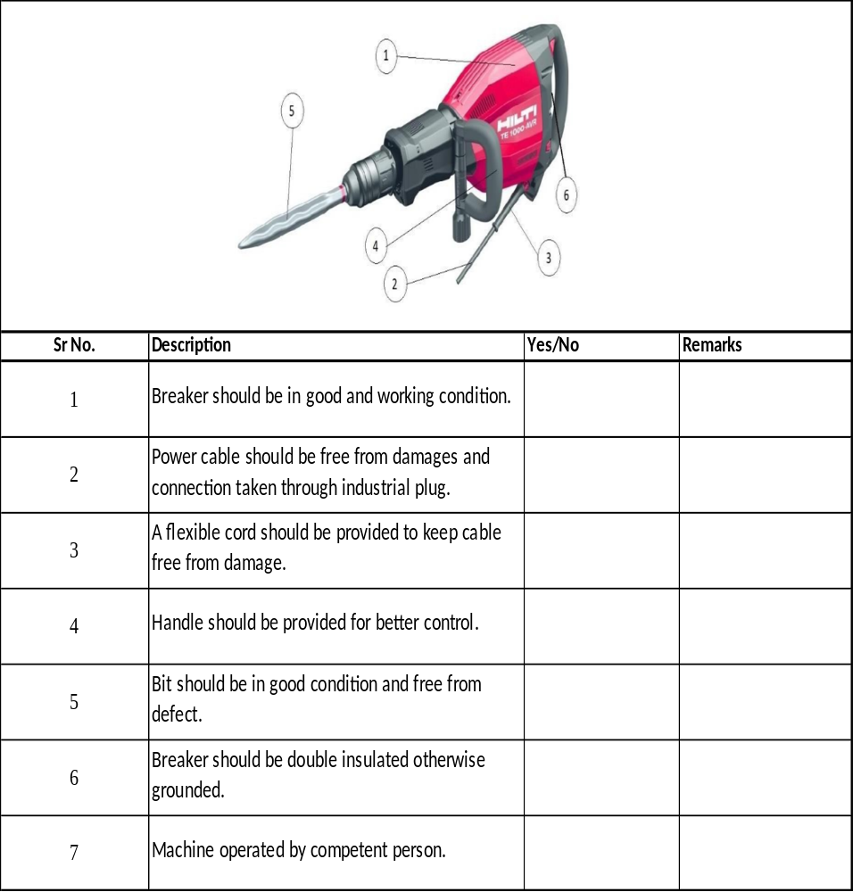

 | Name | Signature | Date
Checked by electrician
Verified By P& M in charge
Verified By EHS Officer

