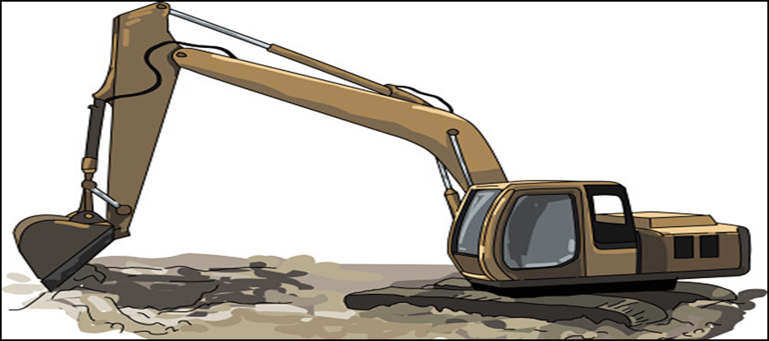










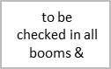
Sr. Number- Date -
Sr.No. | DESCRIPTION | OK | NOT OK | REMARKS
1 | Front & reverse horn working
2 | Head & tail lamps (for working at night)
3 | Leakage of oil (in hydraulic & pneumatic systems)
4 | Loose bolts /connecting pins(bucket)
5 | Back view mirror
6 | Roller-crawler / tyre condition (check for damaged / missing idle rollers)
7 | Structure beem condition (damage, cut, crack)
8 | Diesel, oil and grease spillage.
9 | Fire extinguisher in operator cabin
10 | Vehicle valid insurance
11 | Operator license (heavy duty).
12 | Is Fitness Certificate available
13 | Road tax/puc
 |  | Name | Signature | Date
Checked by V & M In charge
Verified by EHS Officer
Client/Consultant Representative

