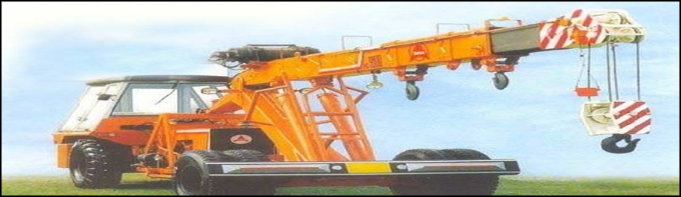









Sl .No | Check items |  | Yes | No
1 | Safety Hook latch available.
2 | Limit Switches Working Condition
3 | Safe Working Load displayed & marked on crane.
4 | Inspection tag provided.
5 | Wire rope and slings free from tolerable damage.
6 | No oil leak in hydraulic parts (piston drums).
7 | Condition of battery & battery connection
8 | Emergency Stop Button Working Condition,
9 | Out riggers working condition in smoothly
10 | Side mirror available
11 | Condition of tyres ( Crack, cut, air pressure etc).
12 | Head lights, tail lights & site indicators working condition
13 | Signal man provided
14 | Front and reverse horn in working condition
15 | Boom structure condition while full expansion (damage, crack and jamming while extending).
16 | Seats,Seat Belt in a good condition in operator cabin.
17 | operator having valid license.
18 | Vehicle documents. 1) Insurance, 2) TPI, 3) Fitness, 4) PUC etc.
 | Name | Signature | Date
Checked by V & M Incharge
Verified by EHS Officer
Client/Consultant Representative

