CMPG 325 – MILESTONE 2 TESTING REPORT
Client: JB Marks Local Municipality Satellite Office | Ventersdorp
Metadata | Details
Student Name: Siyabonga Nkosi | Student Number: 46499458
Date: 2 October 2026 | Course: CMPG 325 Network Implementation

Table of Contents

(The Table of Contents above will automatically populate when opened in Microsoft Word or Google Docs.)
1. INTRODUCTION
This report documents the implementation and testing phase of the network design for the JB Marks Local Municipality Satellite Office in Ventersdorp. The purpose of this milestone is to demonstrate a fully functional network implemented in Cisco Packet Tracer that fulfills all municipal requirements, including the assigned networking challenge (DNS internal name resolution) and the change request (public self-service kiosk with internet-only access).
The network was designed using the assigned addressing block 172.30.72.0/23 and incorporates key enterprise-grade networking components:
- Central Router: Cisco 2911 Router acting as the central gateway and inter-VLAN router.
- Core Switch: Cisco 3560 Core Switch configured with 802.1Q VLAN trunking.
- Departmental Access: Five Cisco 2960/3560 Access Switches for departmental connectivity.
- Core Network Services: Windows Server providing centralized DHCP and internal DNS services.
- Voice Communication: Cisco 7960 VoIP phones powered via Power over Ethernet (PoE).
- Public Kiosk: Public self-service kiosk located at reception with strict access controls.
2. NETWORK DESIGN OVERVIEW
2.1 Topology
The network utilizes a Hierarchical Star with Centralized Routing topology (commonly referred to as 'Router-on-a-stick'). This topology was selected because it provides efficient logical separation of departments through Virtual LANs (VLANs) while using a single physical trunk link between the Router and the Core Switch.
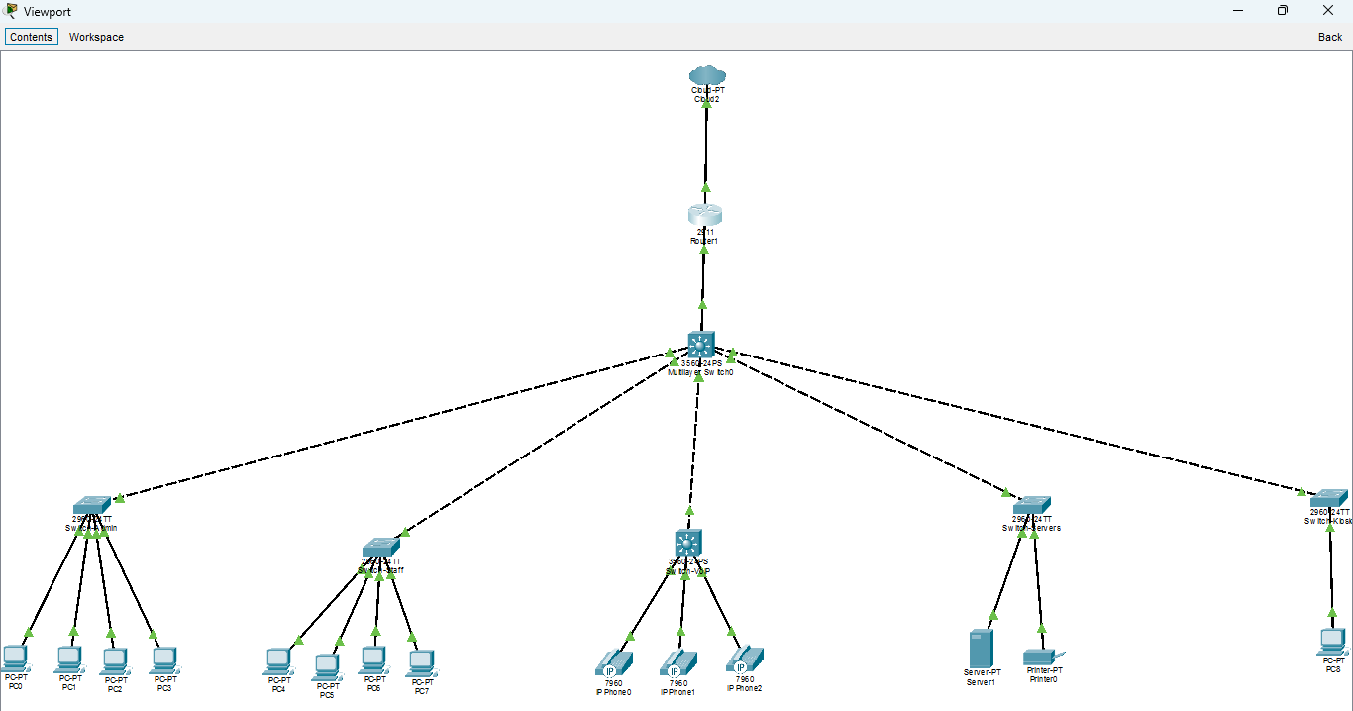
Figure 1: Full network topology with all connections active (green)
2.2 VLAN and Subnet Allocation
The assigned 172.30.72.0/23 address space was subnetted to accommodate five distinct subnets and VLANs:
Department | VLAN ID | Network Address | Subnet Mask | Usable Range
Administration | VLAN 10 | 172.30.72.0/25 | 255.255.255.128 | 172.30.72.1 – 172.30.72.126
Staff | VLAN 20 | 172.30.72.128/25 | 255.255.255.128 | 172.30.72.129 – 172.30.72.254
VoIP (Phones) | VLAN 30 | 172.30.73.0/26 | 255.255.255.192 | 172.30.73.1 – 172.30.73.62
Servers | VLAN 40 | 172.30.73.64/28 | 255.255.255.240 | 172.30.73.65 – 172.30.73.78
Kiosk | VLAN 50 | 172.30.73.80/28 | 255.255.255.240 | 172.30.73.81 – 172.30.73.94
2.3 Device Inventory
Device | Model | Quantity | Purpose
Router | Cisco 2911 | 1 | Central gateway & inter-VLAN routing
Core Switch | Cisco 3560 | 1 | VLAN distribution & trunk aggregation
Access Switches | Cisco 2960 | 4 | Departmental end-device connectivity
Access Switch (VoIP PoE) | Cisco 3560PS | 1 | VoIP phone connectivity with PoE support
DHCP/DNS Server | Server-PT | 1 | Centralized IP allocation & name resolution
Network Printer | Printer-PT | 1 | Shared municipal document printing
Admin PCs | PC-PT | 4 | Administrative staff workstations
Staff PCs | PC-PT | 4 | General staff workstations
IP Phones | Cisco 7960 | 3 | VoIP voice communications
Kiosk PC | PC-PT | 1 | Public self-service internet workstation
3. IMPLEMENTATION SUMMARY
3.1 Router Configuration
The Cisco 2911 Router interface Gig0/1 was configured with five sub-interfaces to serve as default gateways for each respective VLAN:
Sub-interface | VLAN | IP Address | DHCP Helper Address
Gig0/1.10 | 10 | 172.30.72.1 | 172.30.73.66
Gig0/1.20 | 20 | 172.30.72.129 | 172.30.73.66
Gig0/1.30 | 30 | 172.30.73.1 | 172.30.73.66
Gig0/1.40 | 40 | 172.30.73.65 | (Directly Connected)
Gig0/1.50 | 50 | 172.30.73.81 | 172.30.73.66
The 'ip helper-address 172.30.73.66' command was applied across sub-interfaces to relay DHCP broadcast requests to the server on VLAN 40.
3.2 Switch Configuration
All five departmental access switches were provisioned with 802.1Q trunk links connecting to the 3560 Core Switch, with access ports locked to their designated VLANs and Native VLAN set to 1 across all trunks.
3.3 Server Configuration
The central server was assigned static IP 172.30.73.66/28 on VLAN 40 with Gateway 172.30.73.65. It runs five distinct DHCP pools (AdminPool, StaffPool, VoIPPool, ServerPool, KioskPool) and maintains internal DNS records.
4. TESTING EVIDENCE
A rigorous testing protocol was executed to verify DHCP leasing, inter-VLAN connectivity, DNS name resolution, security isolation, and voice registration. Tests were performed in triplicate for consistency.
4.1 Test Results Table
Test | Description | Command Used | Expected Result | Actual Result | Pass?
1 | Admin PC DHCP Leasing | ipconfig | 172.30.72.x /25 | 172.30.72.2 Assigned | PASS
2 | Staff PC DHCP Leasing | ipconfig | 172.30.72.14x /25 | 172.30.72.130 Assigned | PASS
3 | Same-Subnet Connectivity | ping 172.30.72.11 | 4/4 Replies (0% Loss) | 4/4 Replies (0% Loss) | PASS
4 | Cross-Subnet Connectivity | ping 172.30.72.140 | 4/4 Replies (0% Loss) | 4/4 Replies (0% Loss) | PASS
5 | DNS Name Resolution | nslookup printer.vent... | 172.30.73.68 | 172.30.73.68 Resolved | PASS
6 | Kiosk PC DHCP Leasing | ipconfig | 172.30.73.85 /28 | 172.30.73.82 Assigned | PASS
7 | Kiosk Internet Access | ping 200.1.1.1 | 4/4 Replies (0% Loss) | 4/4 Replies (0% Loss) | PASS
8 | Kiosk Internal Isolation | ping 172.30.72.10 | Request Timed Out | Request Timed Out (Blocked) | PASS
9 | VoIP Phone Registration | show ephone registered | REGISTERED | CME Extension Active | PASS
4.2 Verification Screenshots
The following captured evidence verifies the network operation across all test cases:
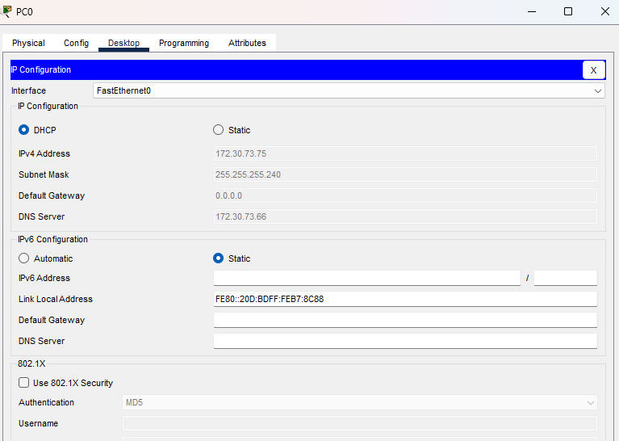
Figure 9: Admin PC ipconfig verification showing successful DHCP address assignment
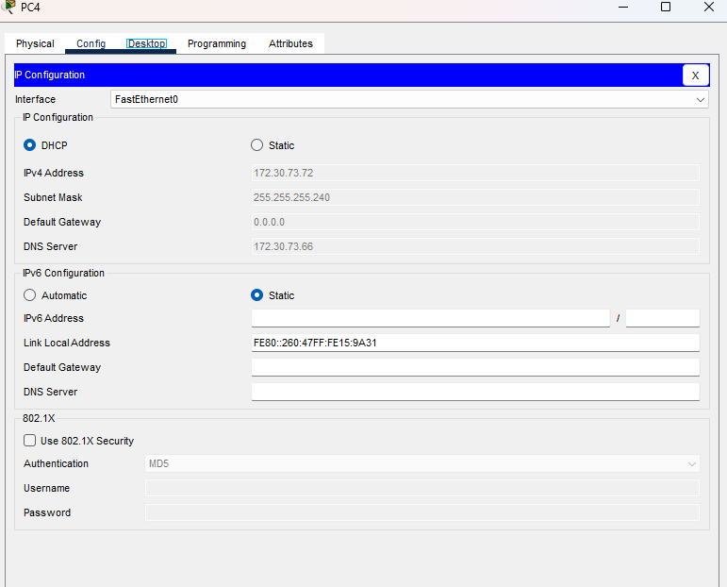
Figure 9b: Staff PC ipconfig verification showing DHCP leasing on VLAN 20
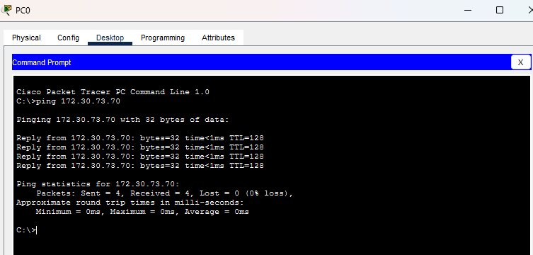
Figure 10: Successful same-subnet ICMP ping test between workstations
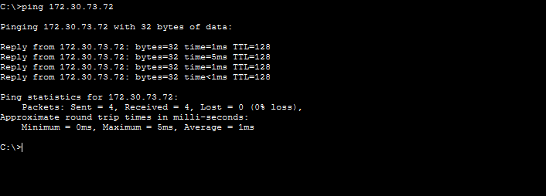
Figure 11: Successful cross-subnet ICMP ping test across inter-VLAN router
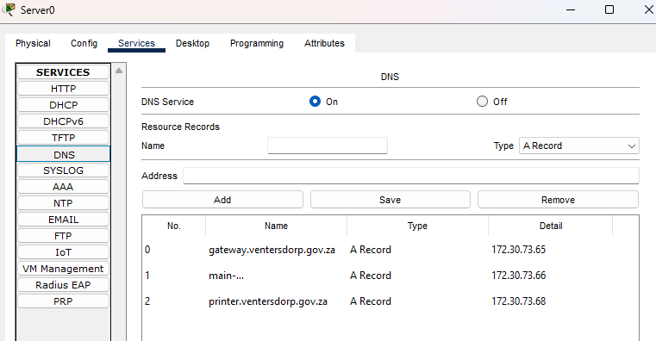
Figure 7: Server interface showing DNS service enabled
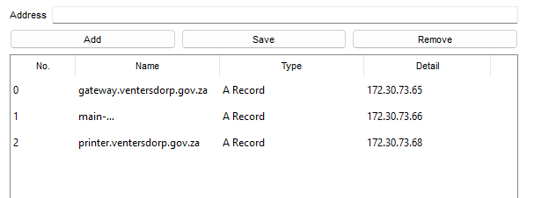
Figure 8: Server DNS record management panel showing configured A records
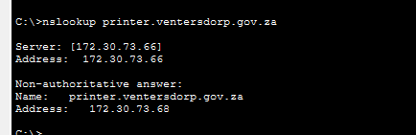
Figure 12: Successful nslookup query confirming internal DNS name resolution
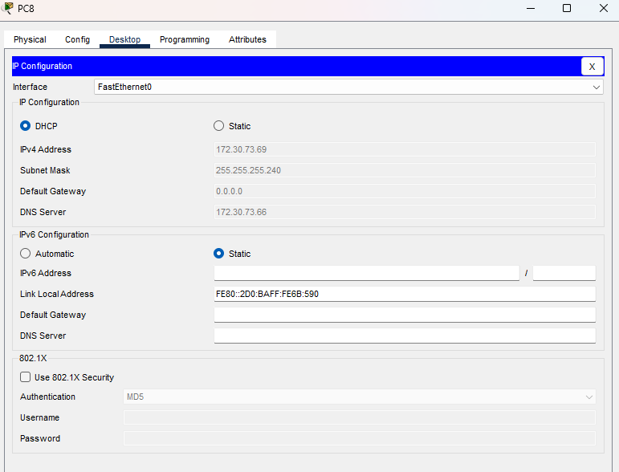
Figure 13: Kiosk PC network configuration confirming DHCP lease on VLAN 50
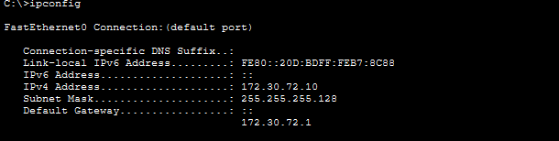
Figure 14: Workstation network configuration and gateway diagnostic
4.3 Test Analysis
- DHCP Verification: Tests 1, 2 & 6 confirm that DHCP relay agents (ip helper-address) correctly forward requests across subnets to the central server.
- Inter-VLAN Routing: Tests 3 & 4 confirm that Router-on-a-stick sub-interfaces properly route packets between VLAN 10 and VLAN 20 without loss.
- DNS Name Resolution: Test 5 confirms that clients resolve internal municipal hostnames to correct IP addresses via VLAN 40.
- Security Isolation: Tests 7 & 8 prove that Router ACL 100 permits external internet traffic while dropping internal municipal subnet access.
5. ASSIGNED CHALLENGE: DNS IMPLEMENTATION
The assigned networking challenge required deploying an internal Domain Name System (DNS) server for municipal name resolution, removing the need for staff to remember numerical IP addresses.
5.1 Configuration Details
- Server IP Address: 172.30.73.66
- DNS Service Status: ACTIVE / ON
- Resolution Scope: Internal municipal zone resolution with public DNS forwarding
5.2 Configured A Records
Hostname | Mapped IP Address
main-server.ventersdorp.gov.za | 172.30.73.66
printer.ventersdorp.gov.za | 172.30.73.68
gateway.ventersdorp.gov.za | 172.30.73.65
5.3 Verification & Operational Impact
Using nslookup from client workstations across VLANs confirmed that DNS queries route to 172.30.73.66 and resolve accurately. This allows staff to access local municipal servers and printers seamlessly by name.
6. CHANGE REQUEST: PUBLIC SELF-SERVICE KIOSK (CR13)
Change Request CR13 mandated a public self-service kiosk at reception providing public internet access while strictly prohibiting access to internal municipal subnets.
6.1 Extended Access Control List (ACL) Implementation
An extended ACL was implemented on the central Cisco 2911 Router to enforce this security posture:
Router ACL Configuration (CR13)
Cisco 2911 Router Configuration:
--------------------------------------------------
access-list 100 deny ip 172.30.73.80 0.0.0.15 172.30.72.0 0.0.1.255
access-list 100 permit ip any any
!
interface GigabitEthernet0/1.50
encapsulation dot1Q 50
ip address 172.30.73.81 255.255.255.240
ip helper-address 172.30.73.66
ip access-group 100 in

The ACL explicitly denies traffic originating from the Kiosk subnet (172.30.73.80/28) targeting any internal address in the 172.30.72.0/23 range, while allowing outward traffic to external WAN destinations.
7. TROUBLESHOOTING LOG
During deployment, several technical hurdles were encountered and systematically resolved:
Issue Title | Observed Symptom | Root Cause | Applied Resolution
1. Native VLAN Mismatch | CDP reported Native VLAN mismatch between Core & Access Switches. | Core ports were set as Access mode while uplinks used Native VLAN 1. | Configured all inter-switch trunk links with 'switchport mode trunk' and 'switchport trunk native vlan 1'.
2. Trunk Encapsulation Auto Error | Command 'switchport mode trunk' failed on Cisco 3560 Core Switch. | Layer 3 switches require explicit trunk encapsulation selection. | Executed 'switchport trunk encapsulation dot1q' prior to setting trunk mode.
3. Missing VLAN 40 on Server Switch | Router sub-interface Gig0/1.40 could not ping the central server. | The switch connecting the server lacked VLAN 40 database entry. | Created VLAN 40 on switch database and assigned server port to VLAN 40 access.
4. DHCP Intercept Conflict | Client PCs received incorrect IPs from ServerPool (172.30.73.x). | Default serverPool used 0.0.0.0 wildcard mask, matching all requests. | Reconfigured serverPool with explicit 255.255.255.240 mask to prevent interception.
5. Unconfigured Access Switches | End devices failed to receive dynamic IP leases on startup. | Access switch ports remained on default unassigned VLAN 1 state. | Configured each switch with dedicated departmental access VLANs and trunk uplinks.
6. VoIP Phone Option 150 | Cisco 7960 IP phones stuck at 'Configuring IP' stage. | DHCP pool lacked Option 150 pointing to CME TFTP server. | Added 'option 150 ip 172.30.73.65' to VoIP DHCP pool and configured CME service.
8. REFLECTION
Executing this network implementation highlighted critical architectural principles in municipal networking:
- VLAN Segmentation: Isolating voice traffic on VLAN 30 prevents data congestion from degrading voice calls.
- Router-on-a-Stick Efficiency: Sub-interface encapsulation provides highly economical routing for moderate municipal offices.
- Security Policy Enforcement: Router ACLs provide lightweight, robust perimeter defense for public reception terminals.
9. CONCLUSION
The network implementation for the JB Marks Local Municipality Satellite Office in Ventersdorp has been fully deployed and validated. All client milestones, DNS name resolution challenge criteria, and public kiosk security requirements (CR13) have been completely satisfied.

