FAKE NEWS DETECTION

Prof. Vivek S. Nikam
Department Of Computer science
Vishwakarma Institute Of Technology
Pune,India
vivek.nikam@vit .edu
Shreyash Palresha
Department Of Computer Science
Vishwakarma Institute Of Technology
Pune,India
shreyash.palresha17@vit.edu
Sachin Iyer
Department Of Computer Science
Vishwakarma Institute Of Technology
Pune,India
sachin.iyer17@vit.edu
Syed Nuaym Asfan
Department Of Computer Science
Vishwakarma Institute Of Technology
Pune,India
nuaym.syed17@vit.edu
Himanshu Kale
Department Of Computer Science
Vishwakarma Institute Of Technology
Pune,India
himanshu.kale17@vit.edu

Abstract— This Project comes up with the applications of NLP (Natural Language Processing) techniques for detecting the 'fake news', that is, misleading news stories that comes from the non-reputable sources. Only by building a model based on a count vectorizer (using word tallies) or a (Term Frequency Inverse Document Frequency) tfidf matrix, (word tallies relative to how often they’re used in other articles in your dataset) can only get you so far. It is very possible that two articles that are similar in their word count will be completely different in their meaning. So a proposed work on assembling a dataset of both fake and real news and employ a Naive Bayes classifier in order to create a model to classify an article into fake or real based on its words and phrases.

Introduction
Fake news and lack of trust in the media are growing problems with huge ramifications in our society. The formatter will need to create these components, The term 'fake news' became common parlance for the issue, particularly to describe factually incorrect and misleading articles published mostly for the purpose of making money through page views. In this paper,it is seeked to produce a model that can accurately predict the likelihood that a given article is fake news. Facebook has been at the epicenter of much critique following media attention. They have already implemented a feature to flag fake news on the site when a user sees’s it ; they have also said publicly they are working on to to distinguish these articles in an automated way. Certainly, it is not an easy task. A given algorithm must be politically unbiased – since fake news exists on both ends of the spectrum – and also give equal balance to legitimate news sources on either end of the spectrum. In addition, the question of legitimacy is a difficult one.However, in order to solve this problem, it is necessary to have an understanding on what Fake News is. Later, it is needed to look into how the techniques in the fields of machine learning, natural language processing help us to detect fake news.

PROPOSED MODEL

In this paper a model is build based on the naïve bayes ,count vectorizer or a tfidf matrix ( i.e ) word tallies relatives to how often they are used in other artices in your dataset ) can help . Since this problem is a kind of text classification, Implementing a Naive Bayes classifier will be best as this is standard for text-based processing. The actual goal is in developing a model which was the text transformation (count vectorizer vs tfidf vectorizer) and choosing which type of text to use (headlines vs full text). Now the next step is to extract the most optimal features for countvectorizer or tfidf-vectorizer, this is done by using a n-number of the most used words, and/or phrases, lower casing or not, mainly removing the stop words which are common words such as “the”, “when”, and “there” and only using those words that appear at least a given number of times in a given text dataset.

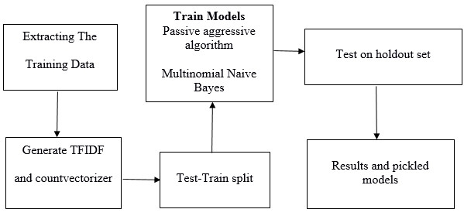

Requirements
- Python
- Numpy
- Scikitlearn
- Panda

CONFUSION MATRICES
- To evaluate the performance of algorithms for fake news detection problem, various evaluation metrics have been used. In this subsection, we review the most widely used metrics for fake news detection. Most existing approaches consider the fake news problem as a classification problem that predicts whether a news article is fake or not:
- True Positive (TP): when predicted fake news pieces are actually annotated as fake news;
- True Negative (TN): when predicted true news pieces are actually annotated as true news;
- False Negative (FN): when predicted true news pieces are actually annotated as fake news;
- False Positive (FP): when predicted fake news pieces are actually annotated as true news.
By formulating this as a classification problem, we can define following metrics,
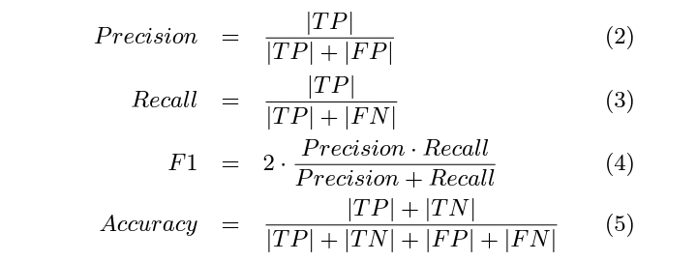

III . BRIEF IDEA OF WORKING MODEL

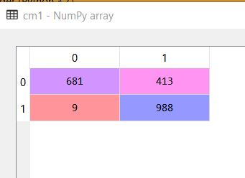
Cm matrix of naïve bayes using count vectorization

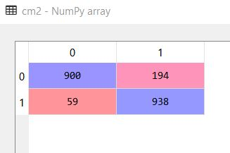
Cm matrix for naïve bayes using tfidf vectorization

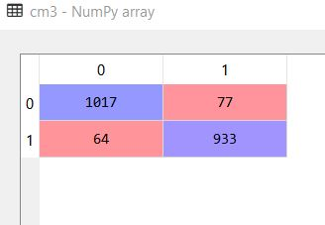

Cm matrix for Passive aggressive using count vectorization
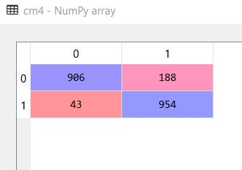

Cm matrix for naïve bayes using hashing vectorization
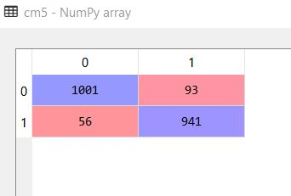
Cm matrix for passive aggressive using hashing vectorization

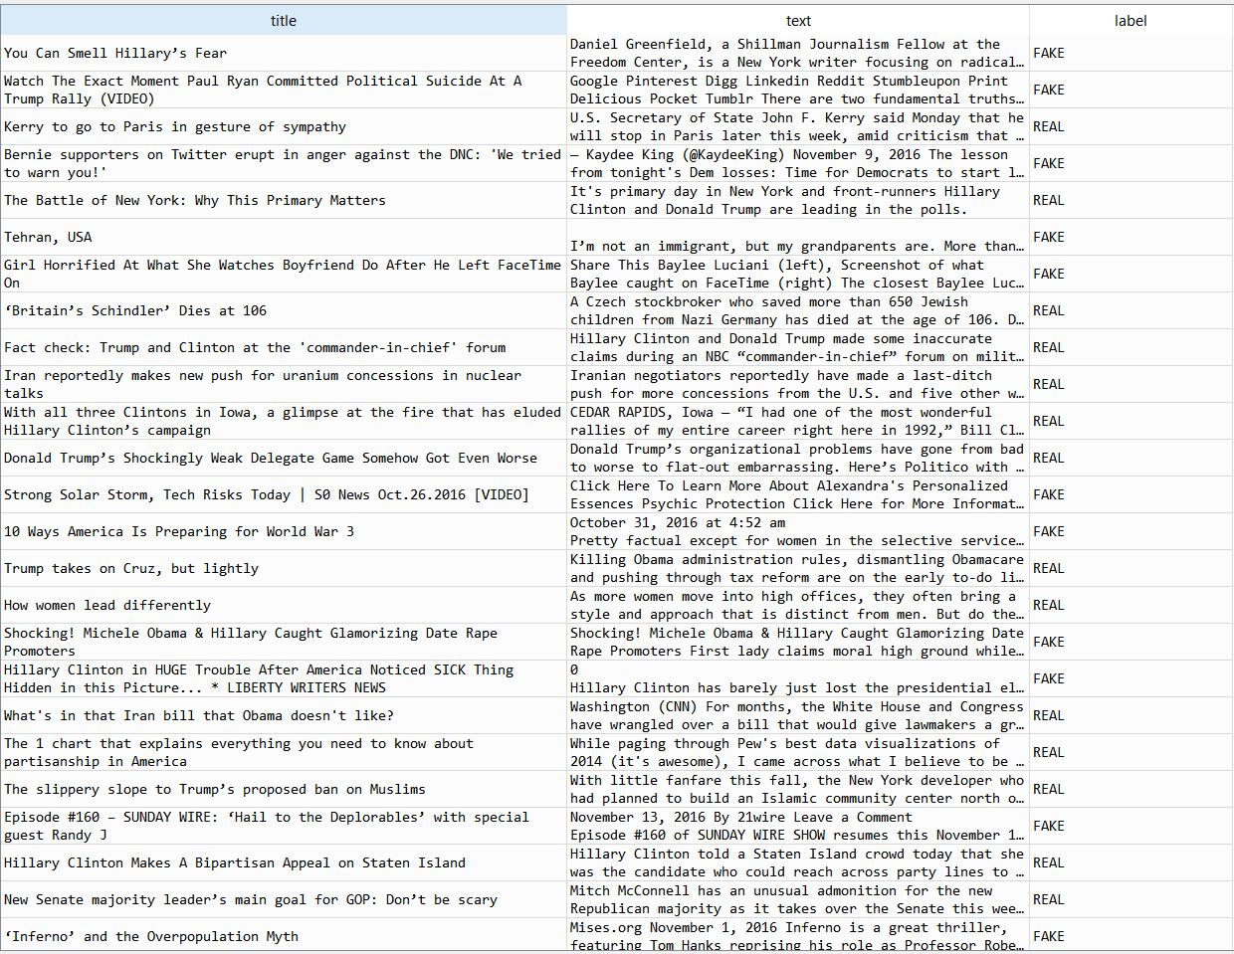
Data Set Sample

IV . FURTHER DEVELOPMENT
A strong classifier method or system which takes feedback from users in real-time , which helps to map the sparse matrix more better and fast.Implementation on multiple platform's simultaneously .
It can be used to develop a multiplatform system which can recognA strong classifier method or system which takes feedback from users in real-time , which helps to map the sparse matrix more better and fast.
It can be used to develop a multiplatform system which can recognize and tackle the problems caused by fake news.

V .CONCLUSION
Fake news is the difficult problem because it is the rumors which it is too hard to identify the fact in contents. The lie’s content was used into the corpus that has effected to the failure of IBM’s Watson prototype testing in the late 2016. Motivation of the proliferation the truth and fake news requiring strenuous effort to detection. It will be use fact checking to solve the fake news detection problem. Fake news can be accurately identified using machine learning methods. In the experiment, selected data collected from Twitter are profiled with twenty two attributes. From this information, all the machine learning methods: Naive Bayes, Neural Network, Support vector machine, are very good at detecting Fake news with high confidence. Of course, it may not represent the whole spectrum of News in the real-world. However, there is enough evidence that Fake news is not too difficult to detect, at least in some selected domain. It is also difficult to say with confidence how much the result of this experiment can be applied to real-world news. We hope to broaden the scope of our data collection and try to apply our method in a more general way in the future.

VI . ACKNOWLEDGEMENT
We thank our guide Mr. Vivek Nikam for their necessary assistance. Special thanks to CSE department for introducing this concept.

VII . REFRENCE
https://scikit-learn.org/stable/
https://www.udemy.com/machinelearning/
https://www.datacamp.com/courses/natural-language-processing-fundamentals-in-python

