Instructions for running Verbal Instruction Task

General information:

This task consists of 192 trials spread in 4 blocks of 48 trials each, with self-timed breaks in between blocks. Expected runtime is 35 minutes. Patients will read task instructions (in English or Spanish) presented in slides and then do a few training rounds before starting on the real task.

In each trial, patients see two images and a command related to those images, which they must then answer by pressing a button within the time limit of 3 seconds. In general, these images contain features of interest and the command is about choosing the image that contains the correct targeted feature. One key manipulation we implemented is changing where the command appears (before the images or in between the images, after the first one has already appeared).

Here’s one example trial:

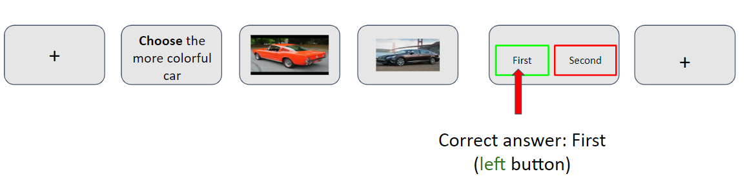

**Important**: Every time the MATLAB screen stops at a text message, you can press ‘C’ on the laptop to continue onto the next stage of the task.

Please refer to the summarized checklist at the end of the document for a quick guide on how to set up an entire recording session.

Where is the task?

The task is set up to work on the **Huxley** laptop. All the task code can be found under '<basefolder>\VerbalInstructionTask\Task\taskCode'.

We also have an equivalent version of this task in **Spanish**, which should be under

‘<basefolder>\VerbalInstructionTask\Task\taskCode_spanish'.

CEDRUS button box:

Make sure to use this model of the CEDRUS button box, and make sure the center left button is green and the center right button is red, exactly as in the image below. The patient will only need to press the green or the red button, the other ones do not matter.

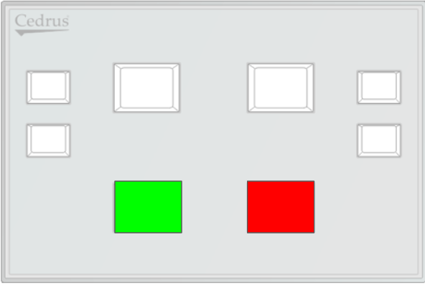

Instruction slides for patients:

Patients must read these instructions before starting training (pick the appropriate version depending on the patient’s preferred language).

**ENGLISH:**

<https://docs.google.com/presentation/d/1sN9bNha6UkbjJKCpP8SekyZDsTC221d25-zenTpLxJo/edit?usp=sharing>

**SPANISH:** <https://docs.google.com/presentation/d/1I3CaXzT1nfudL-xVTqlXUFgfcQQ2SX-X3vgwatqUAOA/edit?usp=sharing>

Patient training:

Before you start on the task, make sure TTL signals are being sent to the Neuralynx machine appropriately. To test this,

1) add these two folders to your MATLAB path:

<basefolder>\VerbalInstructionTask\Task\taskCode

<basefolder>\VerbalInstructionTask\Task\taskCode\io64

2) run the following lines in the MATLAB terminal:

config_io;

sendTTL(33);

3) Verify if the TTL window on the Pegasus/Cheetah/Neuralynx interface appropriately displays a TTL 33.

After patients have read the instruction slides and asked their clarification questions, make sure to run a training session with them by running the script ‘**main_training.m**’.

If prompted on the MATLAB terminal, enter the patient’s number (e.g., for P92, enter ‘92’), indicate whether CEDRUS will be utilized (1 for yes), and whether the task is being run in debug mode (for a real patient session, enter 0 for NOT in debug mode.).

The patient should be able to understand the task as much as possible before proceeding to the real task, even if that means training is run more than once.

Running the real task:

Running the main task is similar to running training. Run the main script ‘**main.m**’ on MATLAB.

If prompted on the MATLAB terminal, enter the patient’s number (e.g., for P92, enter ‘92’), indicate whether CEDRUS will be utilized (1 for yes), and whether the task is being run in debug mode (for a real patient session, enter 0 for NOT in debug mode.).

After each block of 48 trials, the task will pause for a rest break for the patient. After they’re ready to continue, press ‘C’ on the laptop’s keyboard. The break screen will also contain an accuracy score for that block (chance level is 50%).

Checklist for recording:

This is a general recording checklist for reference.

**Before recording:**

- Introduce ourselves to patient if needed

- Wipe laptop + interfaces with sanitizing wipes

- Test TTLs + button boxes

- Show instruction slides

**During recording:**

- Connect PCI parallel port to Neuralynx (or equivalent)

- On Pegasus/Cheetah, set range to 2000uV, broadband 300-3kHz (to see neurons better)

- Check disk space to see if at least 100GB are available

- Turn on raw NRD file recording, save to Z: hard drive

- Check TTLs manually before starting task

- Run training task

- Run main task script

- Fill experiment log paper with recording details

- Copy raw files + behavior to hard drive if PC not on network

- Create new folder for night seizures

- Turn off raw file nrd recording, leave Cheetah on 5000uV / 0.5-8kHz

- Ask patient about next session

**After recording:**

- Copy raw files + behavior to vault server

- Update PXXCS experiment sheet on Google Drive

- Send email to lab list

- Upload working version of task to Github

- Wipe laptop + interfaces with sanitizing wipes