Lim Si Yi

LOCKEDME.COM

Table of Contents

Project Description 2

Sprints 2

Flowchart 3

Further Enhancement 3

USPs (Unique Selling Points) 3

# Project Description

Create a prototype application for Company Lockers Pvt. Ltd.

* Application name
  + LockedMe.com
* Generic features
  + Retrieving the file names in an ascending order
* Business-level operations
  + Option to add a user specified file to the application
  + Option to delete a user specified file from the application
  + Option to search a user specified file from the application
  + Navigation option to close the current execution context and return to the main context
  + Option to close the application

# Sprints

This project is planned to completed within 3 sprints.

Sprint 1

Goal: Add or Search folder or file

Description: User specify folder to work on. If folder does not exist, to create. Allow user to search file in folder or to create new file.

Metrics: Use filepath which exist (1 test string) or create new filepath (2 test string) and create/search for test file name and varied file extensions. (Min 3 files). The function should be able to accept the input from user and if required, show exception error.

Timeline: week 1

Sprint 2

Goal: Delete folder or file

Description: Allow user to delete file or delete folder

Metrics: User search for the files in the directory indicated by user. (Min 3 test). The function should display the available filename shown in ascending order. If file is not found, show user error. User enter the filename to be deleted. If file is not found, show user error.

Timeline: week 2

Sprint 3

Goal: Develop navigation process from main context to closing application

Metrics: User testing from the main context to the selected execution and back to main or close. There should not be error during the transition flow.

Timeline: week 3

# Flowchart

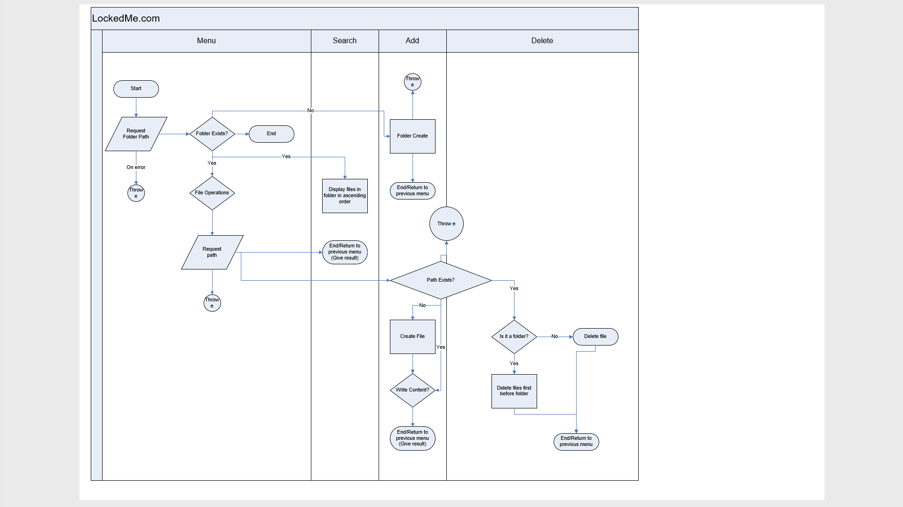

# Algorithms Used

* Collections, Lists, Arrays
* Exceptions
* Files
* Scanner, Reader
* If else, For Loop

# Core Concepts

* Overriding
* Encapsulation
* Abstraction

# Further Enhancement

* Prone to user entry error. Can replace string input with dropdown selection instead
* Actual product to have UXUI elements
* App will create files format which cannot be written. Eg. “.pdf” Can implement additional checks

# USPs (Unique Selling Points)

* Application can handle basic modifiers to both file and folder elements.
* Easy to operate
* Fast processing

# GitHub Link

<https://github.com/siyi1989/Simplilearn.git>

Refer to Simplilearn/00-Simplilearn-Projects/