Lim Si Yi

FLYAWAY

Table of Contents

Project Description 2

Sprints 2

Flowchart 3

Further Enhancement 3

USPs (Unique Selling Points) 3

# Project Description

Create a prototype ticket-booking portal -Flyaway. This website will allow people to book flights.

The website contains the following features:

* A homepage to allow both admin and user to login.
* For admin user features available-
  + change password
  + view all flights
  + store new flights
* For user features available-
  + Enter travel details and show available flights
  + View the summary flight details with the amount
  + Confirmation page with details

# Sprints

This project is planned to completed within 3 sprints.

Sprint 1

Goal: User login

Description: Admin user to be allowed to change password. New user to be allowed to registered.

Metrics: Create new user(3 test case) and change password for admin (3 test case)

Timeline: week 1

Sprint 2

Goal: Admin pages

Description: Allow admin user to view and store new flights

Metrics: New flights available to be shown in the view page. (3 test case) Storing new flights- to show error if the airport and the country does not tie, if the airport to and from is the same, if the price is 0 or seat available is 0.

Timeline: week 2

Sprint 3

Goal: User pages

Metrics: Search page to allow user to enter the flight details.(3 test case) Direct user to the available flights page. If the seat available is 0, flight will not show. After user select the seat, direct user to the confirmation page.

Timeline: week 3

# Flowchart

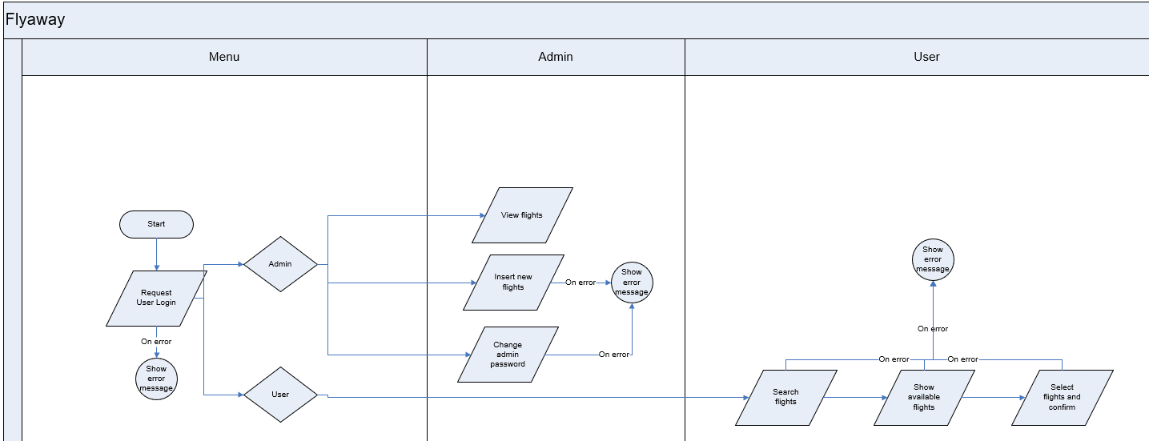

# Package Used

* Maven
* SQL

# Further Enhancement (Project incomplete)

* Cannot get correct date format to enter into sql query from getparameter.
* Cannot do cascading dropdown option as the jstl is not loading in maven
* User selection and booking not complete
* Many to one or one to many tables are not cascading. User will need to manually enter each table.

# USPs (Unique Selling Points)

* Easy to operate
* Fast processing

# GitHub Link

<https://github.com/siyi1989/Simplilearn.git>

Refer to Simplilearn/001-Project-Flyaway/