Lim Si Yi

ONLINE TEST APPLICATION

Table of Contents

Project Description 2

Sprints 2

Flowchart 3

Further Enhancement 3

USPs (Unique Selling Points) 3

# Project Description

The Online Test Application system creates an application that enables users to provide online tests, review them, and display the results.

This system contains three main modules: Quiz, Review, and Result. The quiz section of the online test application accepts the questions in JSON format. The JSON file can be easily shared from the server in the pre-defined format. The application renders the test at the client-side.

The “Review and display result” section allows users to declare the results immediately. You can simply call another JSON with the answers in it and evaluate and display the results immediately.

# Sprints

This project is planned to completed within 3 sprints.

Sprint 1

Goal: Allow user to sign in

Description: User enter username which is displayed throughout application. Format homepage. User will be redirected to homepage upon activation of application.

Metrics: Any username is allowed. If no homepage is mentioned, user will still be redirected.

Timeline: week 1

Sprint 2

Goal: Create json file for question and answer.

Description: Format question and answer in json format to attach.

Metrics: If user select wrong answer, the answer will turn red. If correct answer, the answer will be green. Each question will be limited by timing.

Timeline: week 2

Sprint 3

Goal: User result will be reflected at end of quiz

Metrics: User name and result will be reflected at the end of the last question in the quiz. Negative result is allowed if the user have multiple wrong answers. The points are cumulated. Each question worth 10 points

Timeline: week 3

# Flowchart

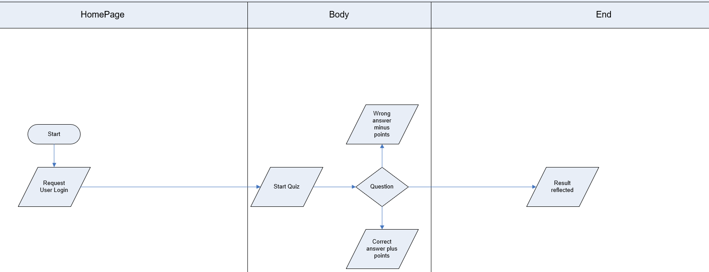

# Algorithms Used

* Angular
* Routing
* Bootstrap

# Core Concepts

* Web application creation using vscode

# Further Enhancement

* Questions and answers to be shuffled
* User shown correct answer and explanation before proceeding
* Only valid user allowed to take test

# USPs (Unique Selling Points)

* Easy to operate
* Fast processing

# GitHub Link

[siyi1989/Simplilearn at master (github.com)](https://github.com/siyi1989/Simplilearn/tree/master)