# GitHub Link

Refer to [siyi1989/Simplilearn at master (github.com)](https://github.com/siyi1989/Simplilearn/tree/master)

Starting page

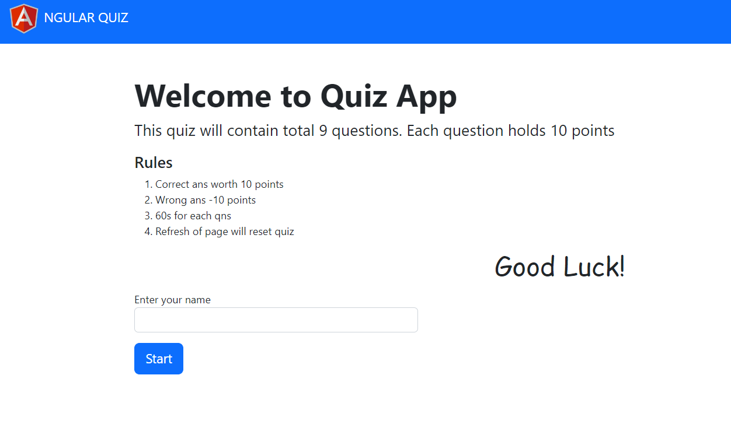

Question and answer page

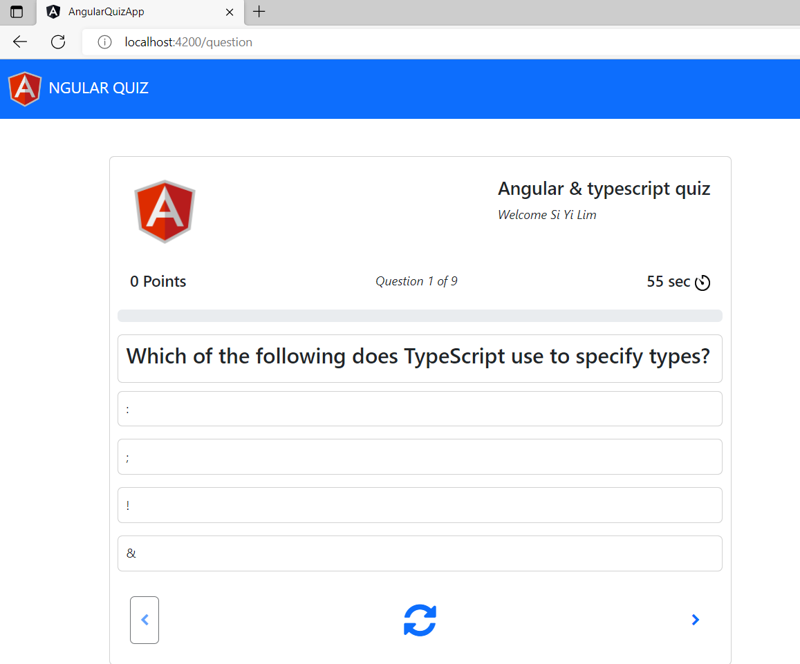

Result page

