Step 1: Jar project created in Eclipse target folder

Step 2: Repository created in Git to record project progress

Refer to link: https://github.com/siyi1989/awsproject.git

Step 3:Initialise AWS instance using key.

Ensure port number 8080 is included in inbound rules.

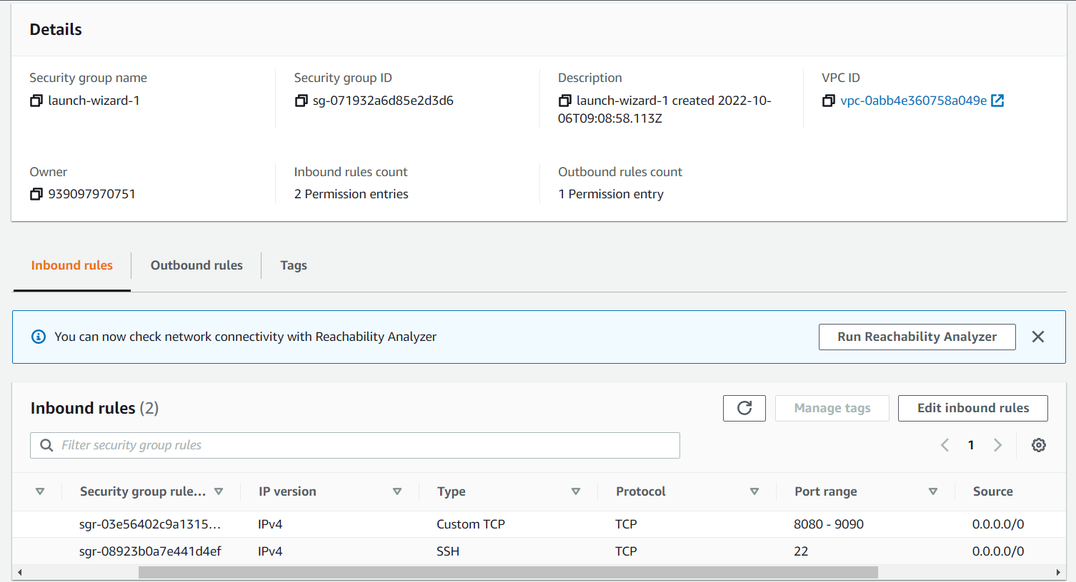

Step 5: Use Bash to install Git and Java and Jenkins and initialise

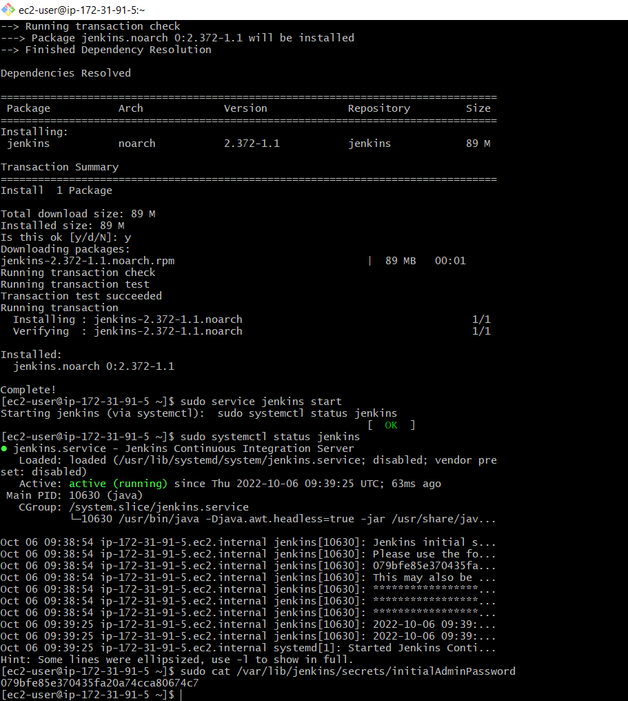

Step 6: Configure Jenkin (add plug in =post build task)

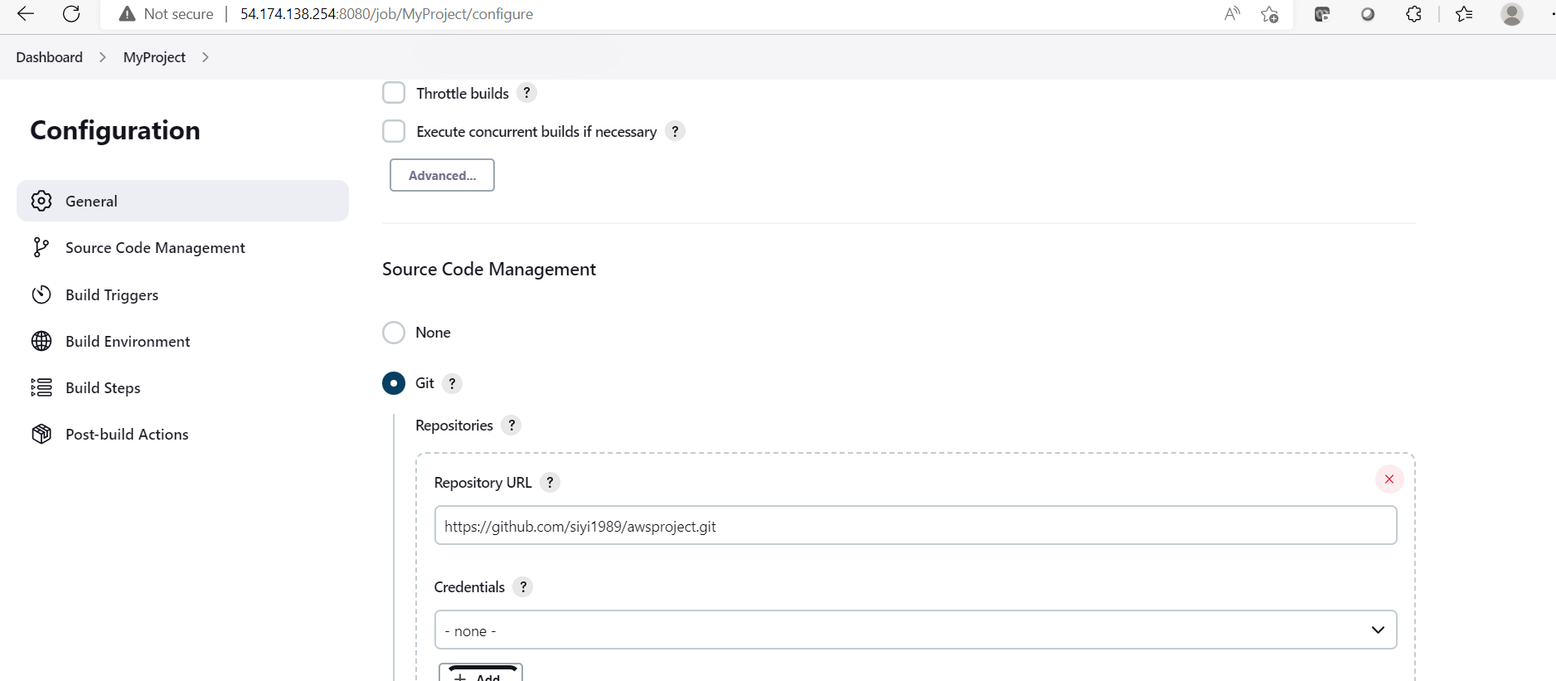

Step 7: Run build

