Ultrasound Vision Language Model Evaluation
Eight Week Undergraduate Experience Project Brief
Introduction: As medical artificial intelligence transitions from single-modality tasks toward multimodal reasoning, Vision-Language Models (VLMs) present a transformative opportunity for radiology workflow automation. However, clinical ultrasound images introduce distinct structural challenges that separate them from standard consumer computer vision datasets.
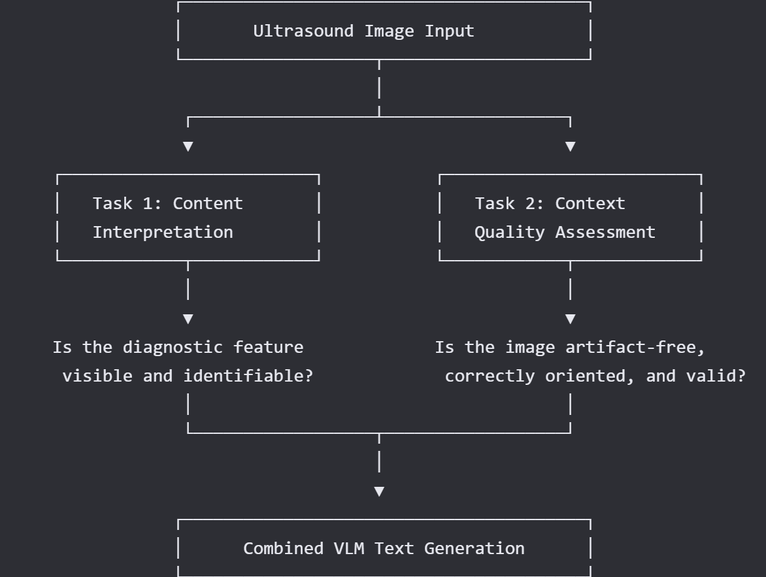
Fig. 1. Overall Idea of the Expected Framework
Project objective: Evaluate whether current vision language models, beginning with MedGemma, can interpret ultrasound images reliably and recognise when image quality is inadequate. The project is a research evaluation only: it must not be presented as a diagnostic system or used for clinical decision making.
- The Interpretation Dimension (Content): Evaluating a model's baseline domain knowledge begins with dedicated biomedical frameworks like MedGemma.
- The Verification Dimension (Context): A model must know what it does not know. If a VLM attempts to parse an incomplete, blurry, or acoustically shadowed capture without flagging it as insufficient image quality, it introduces catastrophic diagnostic risk.
1. Project question and contribution
The central question is: Can a medical VLM correctly classify and localise relevant ultrasound findings, and does it become appropriately uncertain when the image is degraded or visually ambiguous?
- Primary contribution: a reproducible reliability evaluation, rather than a demonstration based on a few attractive examples.
- Primary model: MedGemma 1.5 4B. Compare with one similarly sized general VLM where practical.
- Primary data: BUSI breast ultrasound. External quality and anatomy check: CAMUS echocardiography.
- Optional extension only after the core study is complete: TN3K thyroid ultrasound or a specialised ultrasound VLM on a demonstrably unseen test set.

2 Data and permitted scope
Dataset | Use in this project | What to prepare
BUSI | Primary evaluation: normal / benign / malignant classification; lesion localisation using masks. | 780 static B-mode images. Freeze a patient aware split if identifiers permit; otherwise document the limitation and use a fixed stratified image split. Convert masks to bounding boxes.
CAMUS | External robustness and quality study. | Use a fixed sample of end diastolic and end systolic frames. Test A2C vs A4C recognition and performance on the expert identified poor quality subgroup.
TN3K optional | Secondary external test or extension. | Use only after the BUSI and CAMUS pipeline is complete. Record exact source, version and licence.

Use only publicly available, de-identified data. Preserve original licences and citations. Do not upload patient data, confidential material, or personal information to Colab, model hosting services, or external APIs.

3 Experiments to complete

A Structured visual understanding on BUSI
Ask every model the same constrained question: “Classify this breast ultrasound image as normal, benign lesion, malignant lesion, or insufficient image quality. Return JSON only.” Do not use open ended prose as the primary outcome.
- Metrics to Report: Report macro F1, balanced accuracy, class wise recall, and a confusion matrix.
- Inference Constraints: Run with a fixed temperature of 0 or greedy decoding where supported.
- Schema Fields: Store the exact prompt, model revision, inference settings, response, parsed label, latency and any confidence proxy.

B Visual grounding on BUSI
For lesion images, ask the model to return one bounding box in normalised coordinates. Compare it with a bounding box derived from the reference segmentation mask.
- Metric: Intersectionover Union (IoU) and the fraction of boxes with IoU at least 0.25 and 0.50.
- Handling Failures: If a model cannot reliably emit coordinates, report this as a capability limitation; do not create pseudo ground truth from its prose.

C Reliability under image degradation
Construct a fixed corruption suite from the clean BUSI test images. Each corruption should have 4 to 5 severity levels and use a saved random seed.
Corruption | Why it is included | Measures
Contrast and brightness shifts | Approximate gain and display variation. | Accuracy, confidence, abstention rate
Blur and downsampling | Loss of fine lesion detail. | Accuracy versus severity
JPEG compression | Export and transmission artefacts. | Accuracy versus severity
Field of view crop | Partial lesion or missing context. | Wrong answer with high confidence
Occlusion band / text overlay | Screen annotation or shadow like obstruction stress test. | Abstention and grounding degradation

Important: call these controlled image perturbations, not simulations of physical ultrasound artefacts. The purpose is to test reliability, not to claim a full acoustic model.

D External validity on CAMUS
Evaluate view recognition A2C vs. A4C and appropriate model abstention on a fixed CAMUS frame set.
- Core Objective: Compare results between the ordinary and expert marked poor quality subsets.
- Expected Metric Alignment: The expected result is not necessarily high accuracy; the important question is whether the model’s confidence and abstention behaviour are safe.

4 Experimental rules
- Baseline Freezing: Freeze dataset files, split files, prompts and inference settings before running the final experiment.
- No Test-Set Tuning: Never tune prompts on the held out test set. Use a small development subset only for formatting and parser debugging.
- Label Constraint Execution: Keep answers constrained to an allowed label set. Treat invalid output as an error and log it.
- No Clinical Diagnostic Claims: Do not claim clinical diagnostic performance, safety, regulatory readiness, or superiority over clinicians.
- Data Leakage Preventions: Do not evaluate an ultrasound specialised model on data that may have been included in its training corpus unless a verified held out split is provided.
- Human-in-the-Loop Error Diagnostics: Inspect all high confidence errors manually and assign one primary failure type: anatomy confusion, artefact/context confusion, unsupported hallucination, wrong label, poor grounding, or failure to abstain.

5 Colab implementation requirements
Component | Requirement
Notebook structure | 00_setup, 01_data, 02_inference, 03_metrics, 04_figures (Divide the codebase). Each notebook must run from a clean runtime with documented commands.
Model loading | Start with MedGemma 1.5 4B. Use a quantised loading path if the assigned GPU memory is insufficient. Save package versions and GPU type.
Outputs | Write one row per image per model per prompt to CSV or Parquet. Never overwrite raw responses.
Reproducibility | Set random seeds; version dataset manifests; use a requirements file; save all prompt templates as plain text files.
Storage | Keep data and results in an approved project Drive location. Do not make raw images public through notebook outputs.

Project Drive Location: Ultrasound_Project-Siyona

6 Eight week schedule
Week | Milestone | Evidence of completion
1 | Read key papers; obtain data; reproduce one MedGemma inference. | One page literature note, Colab setup notebook, dataset manifest.
2 | Create fixed splits, prompts and output schema. | Versioned prompt file and a 20 image dry run.
3 | Complete BUSI clean image classification. | Metrics table, confusion matrix, raw output log.
4 | Complete BUSI grounding evaluation. | Mask to box conversion, IoU results and 10 visual examples.
5 | Implement corruption suite and rerun BUSI. | Robustness curves and calibration / abstention plots.
6 | Run CAMUS external quality and view study. | Results by view and by image quality subgroup.
7 | Manual error review and comparison across models. | Failure taxonomy and selected cases.
8 | Final report, repository cleanup and presentation. | Report, reproducible Colab links, results package and 10 slide briefing.

7 Final deliverables
- A clean Git repository or shared project folder with Colab notebooks, requirements, prompts and a README describing exact reproduction steps.
- A results table with macro F1, balanced accuracy, class wise recall, latency, valid response rate, IoU grounding measures and abstention measures.
- Three essential figures: clean versus corrupted performance, calibration or risk coverage curve, and a qualitative failure panel with reference masks or boxes.
- A 4 to 6 page technical report with methods, data governance, results, limitations and next steps.
- A 10 minute final presentation and a 5 minute demo of the reproducible pipeline.

8 Decision gates and fallback plan
Checkpoint | Decision
End of Week 2 | If MedGemma cannot be loaded reliably in Colab, use a 4 bit configuration or a smaller open VLM and record the change. Do not spend more than two days debugging infrastructure.
End of Week 4 | If coordinate grounding is not reliable, retain the qualitative grounding analysis and prioritise classification, robustness and abstention.
End of Week 6 | If CAMUS conversion is cumbersome, use a small hand checked set of exported frames; do not expand to full video analysis.
At any time | If labels or licence terms are unclear, stop using that subset until confirmed. Do not substitute web scraped ultrasound images.

9 Suggested reading
1. Sellergren et al., MedGemma Technical Report, 2025.
2. Le et al., U2 BENCH Benchmarking Large Vision Language Models on Ultrasound Understanding, 2025.
3. Wang et al., A Multimodal Instruction Dataset and Benchmark for Ultrasound Understanding, 2026.
4. Leclerc et al., Deep Learning for Segmentation using an Open Large Scale Dataset in 2D Echocardiography, IEEE TMI, 2019.
5. Al Dhabyani et al., Dataset of Breast Ultrasound Images, Data in Brief, 2020.

