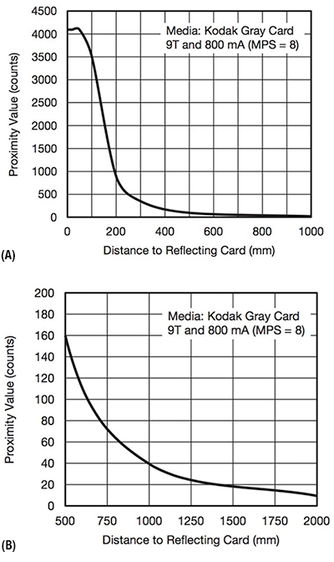

<https://www.14core.com/wiring-the-vcnl4200-infrared-proximity-ambient-light-sensor/>

<https://www.hackster.io/sdizdarevic/vcnl4000-integrated-proximity-and-ambient-light-sensor-d187bf>

The link above has wiring for the vcnl4000, which is very similar to the 4200. I looked through this to hook up the 4200.