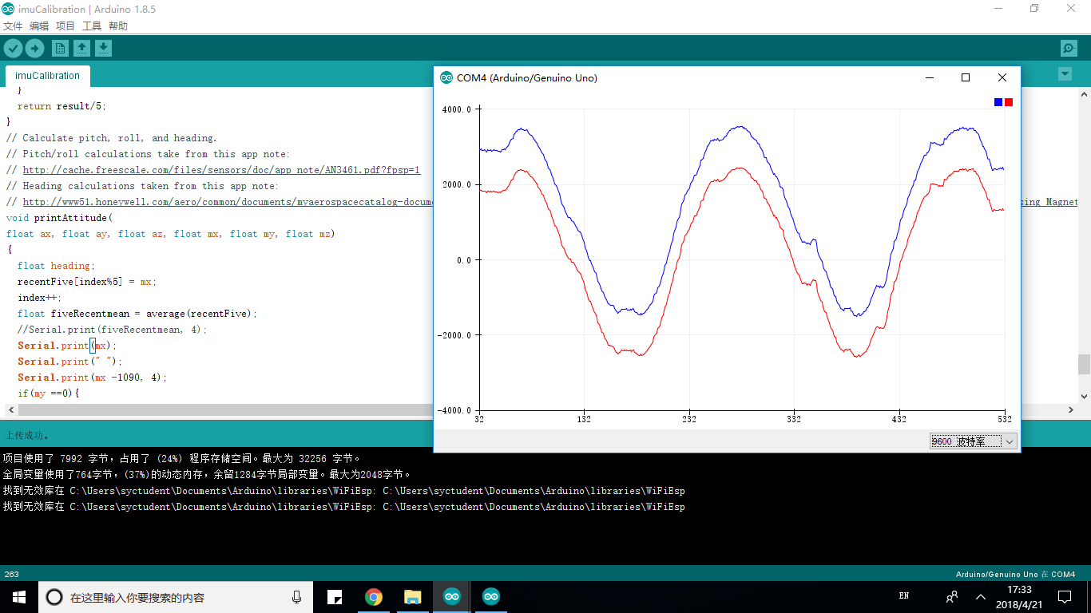

Blue line is the mx data before offset

Red line the mx data after offset