**Assignment 3 ---- University Model**

Submitted Date: Oct 24th

Authors: Siyuan He, Peixin Yao, Rongjin Dang

In order to evaluate and promote the education of university, we build a great platform for the administrator to compare and check the quality of the education they deliver to their students. In this project, 5 essential classes, University, School, Student, Course, Job are created, which was used to store the basic data (Picture 1).

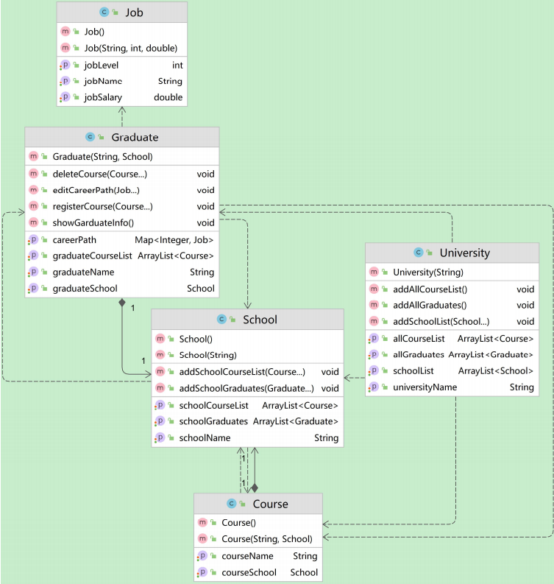

Picture 1

As we can see, class Job has three properties, jobLevel, jobName, jobSalary. jobLevel is in integer type, which uses 1,2,3,4 or more to represent job promotions of graduates. Class Graduate has a Map<Integer year, Job job> type property called careerPath, which represents the job in specific year of a student. Another ArrayList<Course> property called graduateCourseList, which saves all courses the graduate learned. At the same time, ArrayList<Course> (called schoolCourseList) and ArrayList<Graduate> (called schoolGraduates) in class School represent all courses in this school and all graduates graduated from this school respectively. Meanwhile, ArrayList<Course> (called allCourseList), ArrayList<Graduate> (called allGraduates) and ArrayList<School> (called schoolList) in class University represent all schools, courses and graduates of this university. Finally, some methods to edit and add each properties of these classed are created as well.

Also, we provide a System class like the interface to manipulate the basic class. It means that administrator will view and manage the data by System module and GUI (Picture 2 & 3).

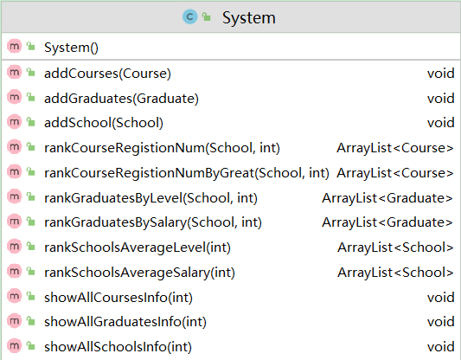

Picture 2

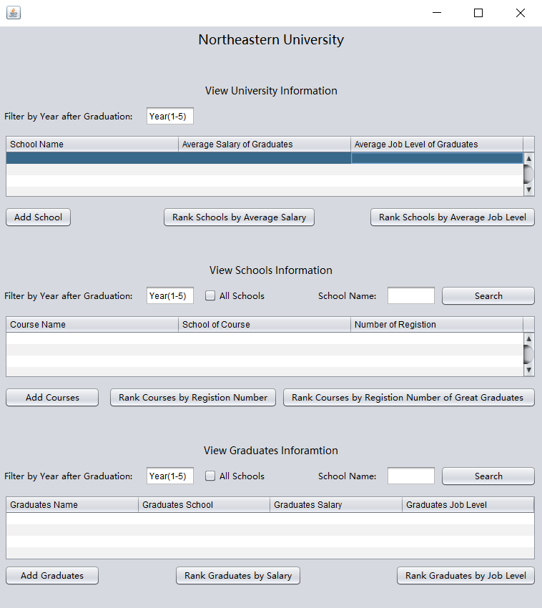

Picture 3

In the System modules, we created several ranks, schools rank, courses rank, graduates rank methods to solve the problems and designed functions accordingly on the GUI. Firstly, when viewing university information, adiministrators and students can rank schools according to the average salary or job level of students from each schools and see the outcome in the table. Because we assume that high quality education will bring good job to their students. If a school has a high average salary, it must have some positive polices and excellent professors. Also we need to input the the graduation year to select which data of year we want to see. We can also add new school by the button and according method. Secondly, when viewing schools information, adiministrators and students can rank courses according to registration number or registration number of great graduates (just assume that graduates whose salary is Top 10% of all are great graduates) and see the outcome in the table. Because we believe that some courses have a good impact on students, and we list the most popular courses so that the officer can open more courses. If there are many candidates for a course, which means the course is very useful for students. We still need to input the the graduation year to select which data of year we want to see and need to select whether we want to view data of all schools or any other schools by checkbox and text field. And we can add new courses by the button and according method as well. Thirdly, when viewing graduates information, adiministrators and students rank graduates by salary or job level. We create a way to find and track the graduate salaries or level rank. It can be a special college or all of them, This will be very helpful for assessing the quality of student education.

All in all, this system can help administrators to compare the performance of their academic units and students decide where they want to go for their studies by listing salary, job level of graduates from different schools and other useful information related to career prospects.