28. Transactions are processes of one or more changes made to the database. They can be performed by a database manager or programmed to happen automatically. For example, when I add some records into a table in my database. It is considered a transaction.

Locks is an operation that exists in the database to stop editors from making changes to the database. It is used when multiple ends are trying to make changes to the database at the same time. Locking provides a way to manage concurrent database access while minimizing the various problems it can cause.

Isolation levels represent different locking strategies to improve the database’ consistency. The higher the isolation level is, the more complicated the locking strategy is.

There are 4 levels:

•Read uncommitted (0): Locks are obtained on modifications to the database and held until the end of the transaction.

•Read committed (1) : Locks are obtained on reading and modifications to the database. Locks will release after reading, but locks on modification objects are held until EOT

•Repeatable read (2) : Locks are obtained for reading and nodingfing the database, released after EOT. Locks on non-modified access structures are related after reading.

•Serializable (3): A lock is placed on the affected rows of the Database until EOT.

29. Write a short essay, plus screenshots talking about performance tuning in SQL Server. Must include Tuning Advisor, Extended Events, DMV, Logs and Execution Plan.

Common ways to improved Query performance:

1. Extended Events

-click new session wizard

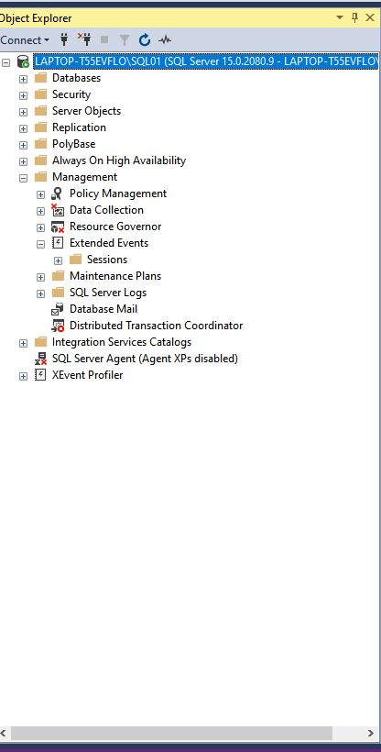

Start new session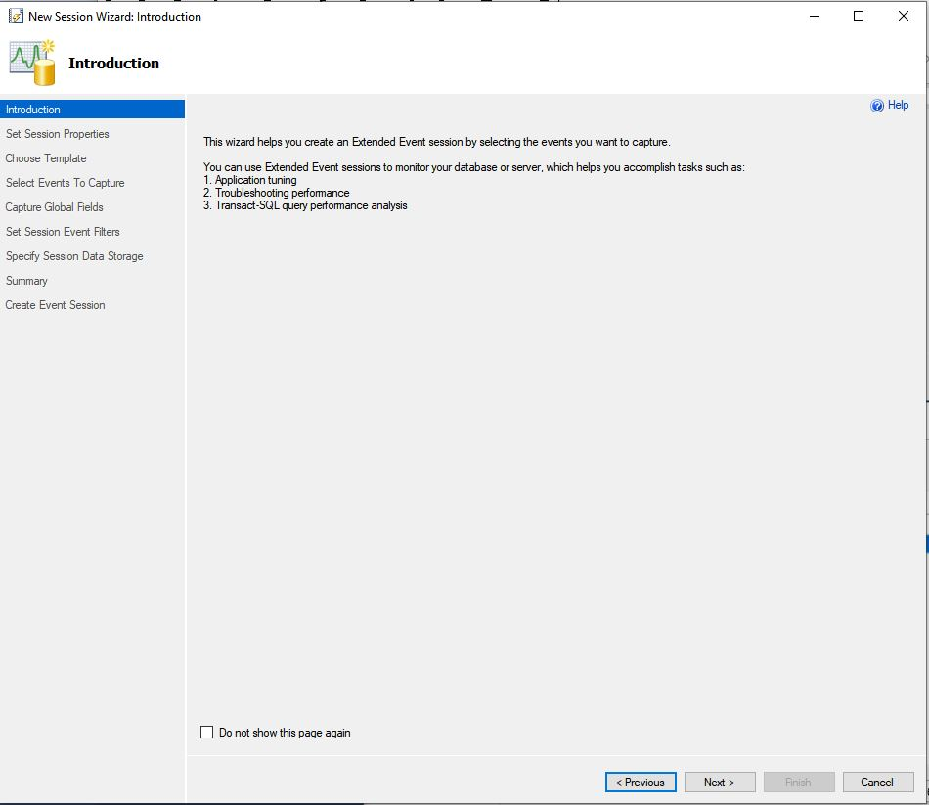

Choose a template: Count Query Locks

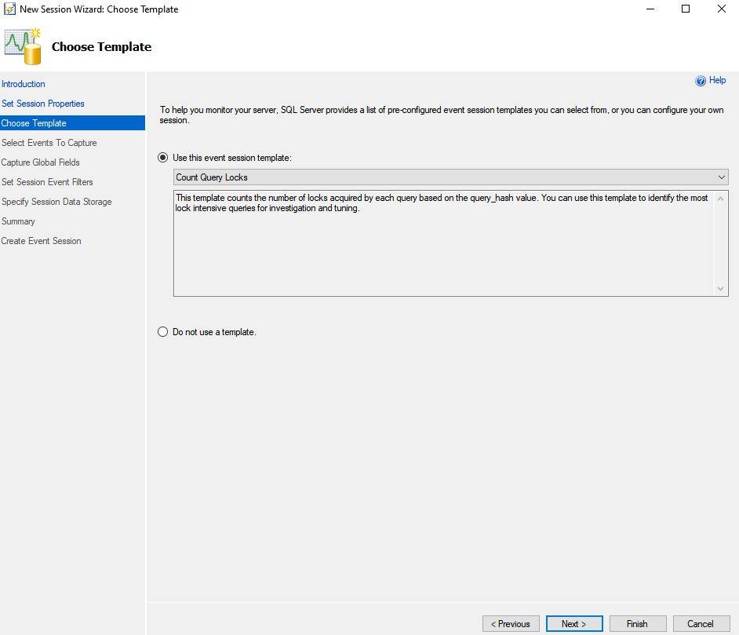

Select Events to capture: Here I choose lock related events

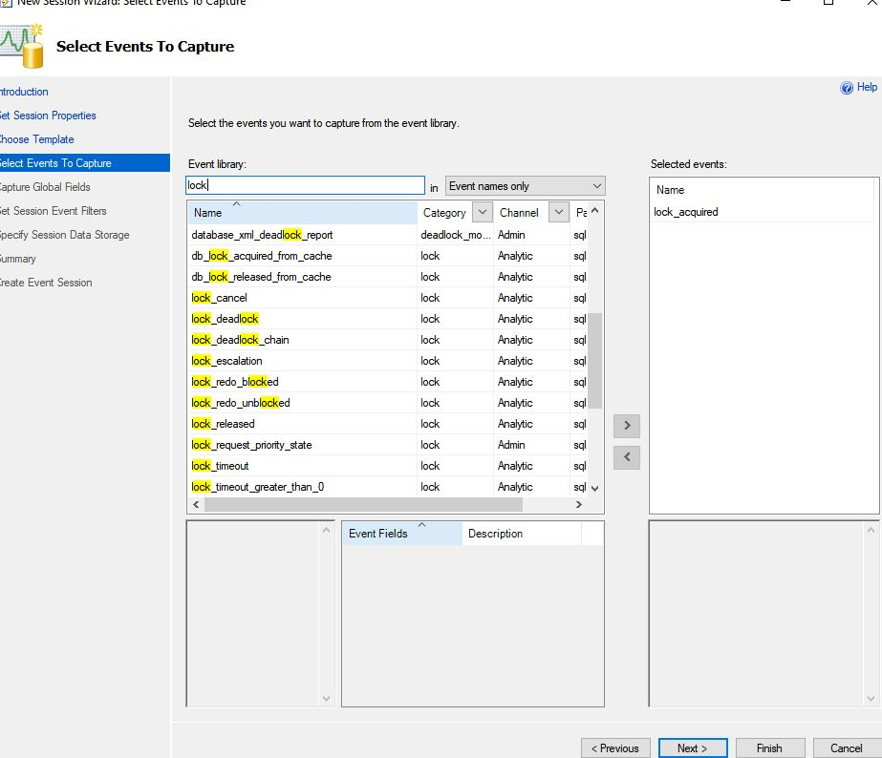

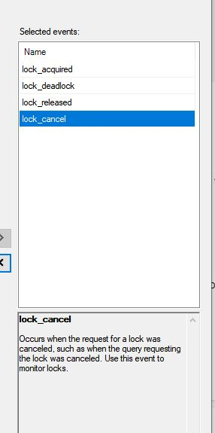

Choose what kind of data you want the events to be captured on

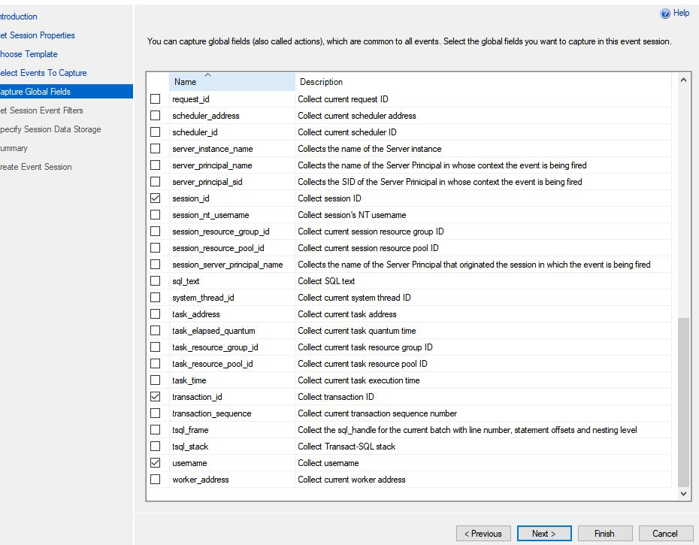

Use filter to set limit that will trigger the

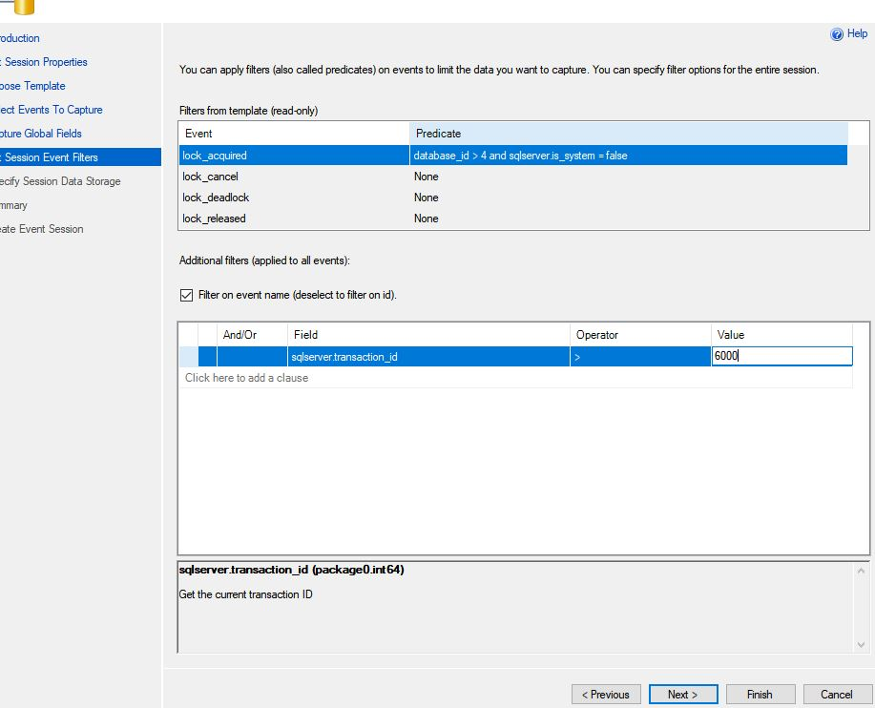

Choose if want to store the data for later analysis:

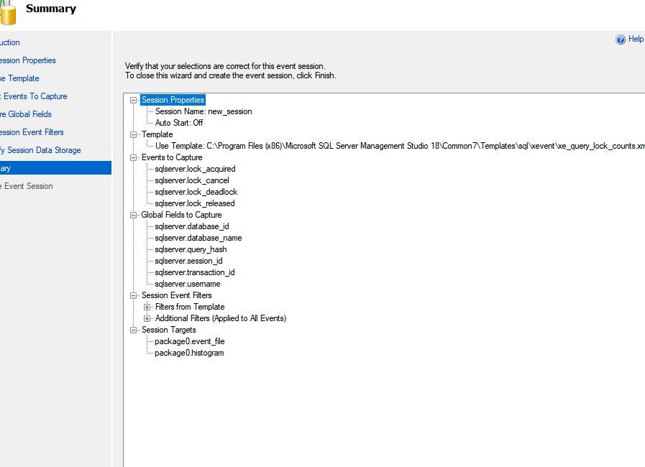

2.DMV (Dynamic Management Views)

DMV are queries that return information about model objects, server operations, and server health. The query, based on SQL, is an interface to *schema rowsets*.

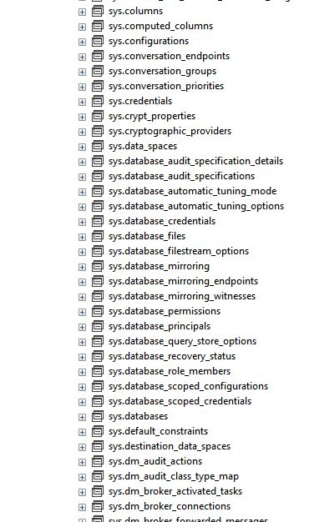

Logs:

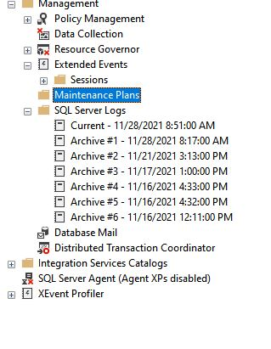

Use DBCC queries to turn on flag for certain events

Language : DBCC TRACEON(error_code, -1);

So that when the certain error happens, the log will catch it.

1. Resource Monitor

When you monitor SQL Server and the Microsoft Windows operating system to investigate performance-related issues, concentrate your initial efforts in three main areas:Disk activity, Processor utilization, Memory usage

1. Tuning Advisor  
   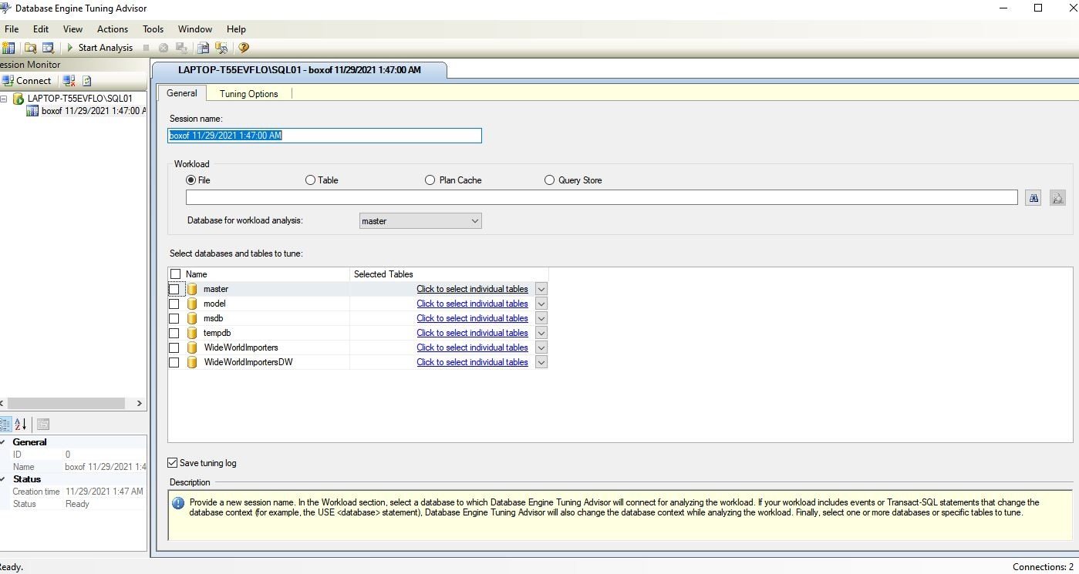

After checking tuning options, start analyzing. The advisor give us recommendations on build indexes:

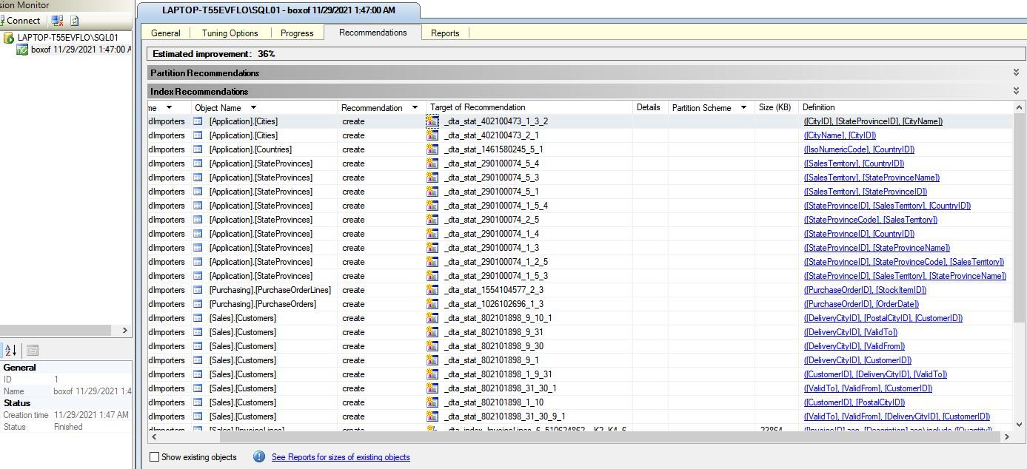

1. Execution Plan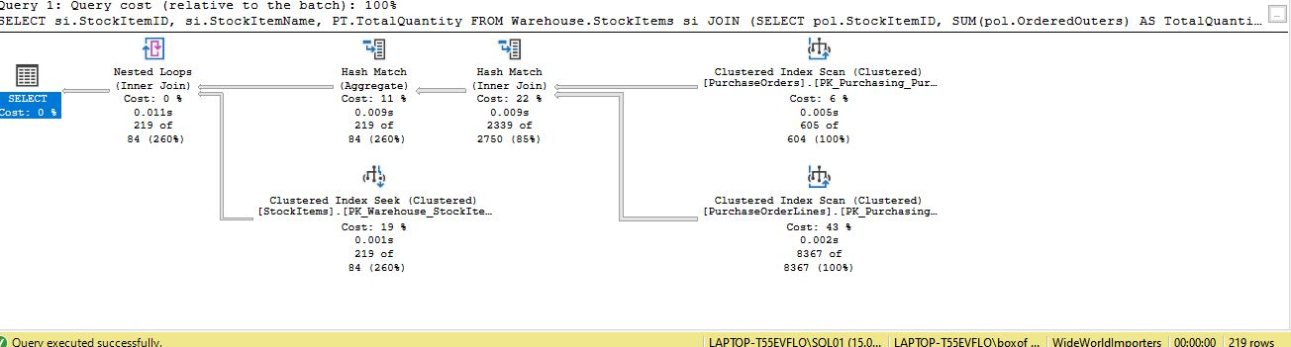

Where the execution plan has a higher percentage means the step can be improved. If table scan exist on nodes, we have a missing index