**Table of Contents**

1 Disclaimer 2

2 Purpose 2

3 Scope 2

4 Terminology / Abbreviations 3

5 Introduction 4

6 Preparation 5

6.1 Extraction of the Core 5

6.2 Extraction of the Japanese audio and subtitle files 6

6.3 Creation of a translation environment 7

7 Translation 8

7.1 The STREAM folder 8

7.2 Cinematics 9

7.2.1 Extraction of original AFS container 9

7.2.2 Modification of subtitles 10

7.2.3 Recreation of new AFS container 12

7.2.4 Recreation of valid IDX file 12

7.3 Free Quest 13

7.3.1 Container FREE0x 13

8 Passport 13

9 Details 14

9.1 Shenhua intro sequence 14

9.2 Original vending machine 14

9.2.1 Drink selection screen and drinking animation 14

9.2.2 Free quest mode 14

10 Test image creation 15

11 Testing 16

12 Sources 17

13 Document history 17

14 Appendix 18

14.1 AFS container list 18

14.2 Vending machine files 25

14.3 Disc scene list 25

14.4 Character ID list 27

# Disclaimer

This document and the information therein shall not be understood as any kind of liability and it may be changed without any notice at any time. Any usage of this document occurs exclusively at the individual users own responsibility.  
The author(s) of this document assume absolutely no responsibility for any errors that may appear in this document or any complications that are caused by the (ab)use of this document.  
In no event shall the author(s) of this document be liable for any damages of any kind arising from the (ab)use of the knowledge that is stored in this document.  
  
**This document is not designed to be used in countries where modification of video game data is prohibited by copyright laws. Stop reading right now if you live in such a country!**

# Purpose

The purpose of this document is to provide a complete and illustrated tutorial about how to “japanize” the PAL version of the SEGA® Dreamcast™ video game Shenmue™.  
The guide is based on the explanations written by Hiei- for Manic, the knowledge provided by the Shentrad team on their homepage and the knowledge provided by the shenmuedojo.net and metagames-eu.com forum members (for detailed sources go to chapter 12).

# Scope

The methods which are described in this document are supposed to only be used for “japanization” tasks of SEGA® Dreamcast™ Shenmue™ PAL. There is absolutely no warranty (explicit or implied) that it will also work with other versions.

# Terminology / Abbreviations

Technical:

|  |  |
| --- | --- |
| Google® | An American company, provides a free translation service |
| SONY® | A Japanese company |
| Philipps® | A Dutch company |
| SEGA® | A Japanese company, created Shenmue™ and the Dreamcast™ |
| Dreamcast™ | A video game console of the 6th generation created by SEGA® |
| Shenmue™ | A video game for the Dreamcast™ |
| Byte | A unit which describes the size of digital data |
| MB | Megabyte, means either 10002 or 10242 bytes |
| GB | Gigabyte, means either 1000 or 1024 MB |
| PNG | Portable Network Graphics, an image format |
| PAL | Phase Alternating Line, an analogue television encoding system used mainly in European countries, a PAL video game is designed for the European market |
| NTSC-J | National Television System Committee Japan, encoding system like PAL, used in Japan, a NTSC-J video game is designed for the Japanese market |
| GD-ROM | Gigabyte Disc Read Only Memory, optical disc format for the SEGA® Dreamcast™ optical drive, about 1.2 GB capacity, split to different areas, low density area can be read by a computer but it contains nothing of special interest (usually bonus pictures or music), high density area contains the game data itself |
| CD | Compact disc, developed by SONY® and Philipps®, optical disc format, used to store digital data, usually 700MB space, also available with 800MB space |
| CD-R | Compact disc recordable, variation of the CD, can be recorded once |
| USB | Universal serial bus, a standard for computer periphery |
| GDI | Full and untouched 1:1 copy of a GD-ROM, divided into several smaller files (formats like .raw and .bin) which the .gdi file seems to be linking together, usually about 1GB large |
| CDI | Discjuggler image format, 1 single .cdi file, often used as format for pirated Dreamcast ™ games, pirated .cdi game images are usually shrunk to fit on a 700MB or 800 MB CD-R,  **It is possible that pirated CDI disc images from the internet are unusable for translation tasks because they are not untouched 1:1 copies.** |

General:

|  |  |
| --- | --- |
| etc. | abbreviation for “et cetera” / “and so forth/on” |
| e.g. | abbreviation for “for example” |
| stream | media stream, audio and subtitle files |
| cinematics | cinematic scenes (e.g. intro sequence with Lan Di) |
| free quest | free quest mode (walking around, talking to people etc.) |
| NPC | non-playable-character (people like Ine-san) |

And some important basic knowledge about the file formats that are used:

|  |  |
| --- | --- |
| AFS | Container, uncompressed, usually filled with subtitle and voice files |
| SRF | Subtitles |
| STR | Audio, voices |
| XML | File with information about where a AFS has been extracted to |
| IDX | Index file, belongs to AFS with same name, contains information about AFS |
| PKS | Container, filled with model data (e.g. face and body) |
| PKF | Container, filled with textures or face morphing and subtitle data for NPC’s. |

# Introduction

The basic objective of such a “japanization” could be described as upgrading a Shenmue™ PAL game as near as possible to the NTSC-J version without losing the English text in the game.   
The main difference between the 2 versions is of course the Japanese dub which is considered by some fans as more authentic. This would represent the main reason for such a customization. There are also other minor differences like the design of the vending machine which is considered to be more authentic in the Japanese version.

A complete translation of the Japanese version would be extremely time-consuming. It would be necessary to translate all subtitles, **plus** all menus, **plus** the notebook entries, **plus** the move scrolls, **plus** the loading screens and possibly even more. This would be a waste of time because the mentioned stuff is already translated in the PAL version.

According to <http://fileforums.com/showthread.php?t=50423> it is possible to only inject the Japanese voices (.str files) from a Japanese game to an English one instead of translating stuff. If done so the lips will most likely be out of sync because it seems like SEGA® reanimated every conversation when Shenmue™ was translated to English. They might have done this in order to match the new English speech better or to have more flexibility for the translation. However if you are just injecting Japanese voice files to PAL AFS containers the animations will possibly look trashy because the old English speech animations will remain the same instead of being adapted to the Japanese voices.

Translating the complete Japanese stream (all AFS containers) and swapping it from one version into the other one seems to be the best way to get the best possible quality. It should end up in having a PAL Shenmue™ with Japanese dub, perfect lip-sync and English text. Other files like the ones for the original vending machine can also easily be swapped.

The following things are necessary for the translation tasks:

* Winrar (archive extraction)
* GDI dumps of Shenmue™ PAL and Shenmue™ NTSC-J
* GDI Explorer (to extract the data from your images)
* AFS Utils (to extract the audio and subtitle data from the container)
* AIO Cinematic Subtitles Editor (to edit the subtitles)
* IDX Creator (to create a new valid index file for your new container)
* (possibly) pvrext.exe and pvr2png (to extract and convert textures)
* Bootmake (to create a bootable CDI image for testing)
* binhack32.exe for modifying the IP.bin file for the image creation
* nullDC Dreamcast™ emulator (to test your work without wasting CD-Rs)

Most of the tools are available at the Shentrad homepage in the download section! It is recommended to get the latest versions of the tools.

**It’s highly recommended to backup all images and tools before starting with the translation!  
If you mess up some files you can extract them again from the original files.**

# Preparation

It is recommended to create a decent folder structure for the project. It may look like this:

Project (main project folder)  
|___ Disc1 (subfolder for disc 1)  
|___ Disc2 (subfolder for disc 2)  
|___ Disc3 (subfolder for disc 3)  
**Disc 4 (Passport) is not part of the story so you might forget it for now.**

This is important because there are a lot of files and folders to manage and such a folder structure will help you to keep the overview. You can store this project folder on an external drive if you like.

## Extraction of the Core

Open the .gdi file of disc 1 of your Shenmue™ PAL version with GDI Explorer. The dump is not saved as a single image file like known from ISO images but rather divided into several smaller files (.raw and .bin) which somehow seem to be linked together by the .gdi file.   
GDI Explorer should look like this after opening the GDI file:

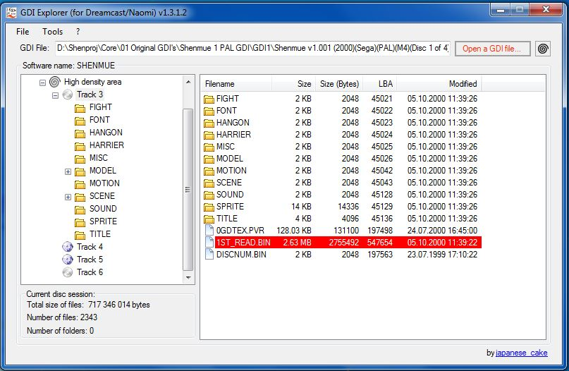

You will notice that there is a low and a high density area. The high density area is where the game data is stored. The other one contains only some bonus stuff like pictures which is not important for the translation itself but possibly nice for you as a fan.

Highlight all data in the high density area with your mouse and press the right mouse button. Click on “Extract selected files to …” and browse for the subfolder for disc 1 of your project folder.

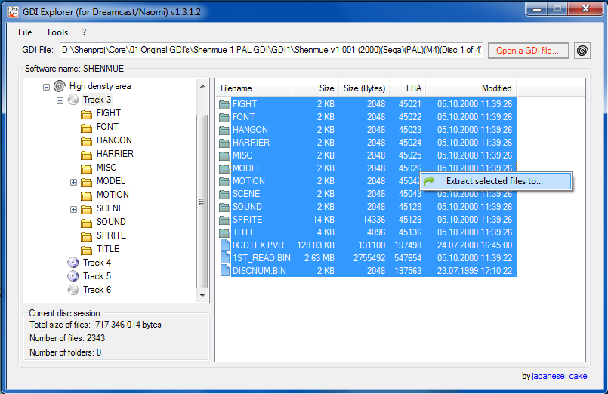

Navigate to the subfolder of disc 1 of your project folder and press OK. GDI Explorer should now be extracting the data of your disk to the project subfolder. A message should appear after the complete extraction. **Repeat this step for discs 2 and 3 as well.**

The files that were extracted are the core of the new version. It will have the translations of most of the content like menu entries, move scrolls and the notebook. It “only” needs the Japanese stream files with the modified subtitles and if required the other things from the NTSC-J that you like more (like the original vending machine).

## Extraction of the Japanese audio and subtitle files

Now open your NTSC-J image with GDI Explorer and browse to the following folder: SCENE\01\STREAM (that’s where the Japanese voices and subtitles are stored)

Highlight all files in this folder and press the right mouse button to extract those files to another folder (except of your project folder) on your computer. These files are the Japanese container files which contain the audio and subtitles.

The Japanese containers of disk 2 and 3 are stored in the following folders of the GDI images:

SCENE\02\STREAM (disc 2)  
SCENE\03\STREAM (disc 3)  
**Disc 4 is not part of the story so forget it for now** and close your GDI Explorer.

## Creation of a translation environment

At this point you should create another folder structure outside of your project folder. This new structure should be used for the translation process itself. It could look like this:

Trans (main translation task folder)  
|___<disc#> (disc number)  
|___ J (subfolder for extracted Japanese containers)  
|___ E (subfolder for extracted English containers)  
|___ JE (subfolder for translated containers)

Move the extracted files from the Japanese stream folder to the “J” folder and copy the original stream folder files from your project folder to the “E” folder.

You should translate a container from a “J” folder with the same container from the “E” folder as a template for your translation. Then move the newly created container to the “JE” folder and delete the original J and E folder’s container files. This will ensure you that you are not translating a container twice because the completed ones are deleted after the translation. You won’t waste time searching the right containers.

After some time you may copy your completed containers from “JE” to the STREAM folder of your project subfolder (copying means replacing the original files in this case). Don’t delete your JE folder containers and make sure you have a backup of your completed containers from the JE folder (e.g. on a USB drive)!

The idea behind this is outsourcing of translation tasks away from the original project folder. It won’t have disastrous impacts to the project if something gets messed up or a hard drive crashes.

OK, let’s summarize: the following subfolders in your project folder are important:   
<disc 1 subfolder>\SCENE\01\STREAM  
<disc 2 subfolder>\SCENE\02\STREAM  
<disc 3 subfolder>\SCENE\03\STREAM

These are the folders where the Japanese container files with the translated subtitles have to be copied to. The idea is copying more than only the AFS and IDX files to your extracted PAL version because there are some vending machine textures and models for the drink selection screen and the drinking animation as well in this folder.  
In the beginning it will be filled with the original containers of the PAL version. Replace an original AFS container as soon as you fully translated the subtitles of a Japanese container. This will keep the disc up to date and don’t forget the vending machine files!

# Translation

This chapter will cover the knowledge you need to translate the files.

## The STREAM folder

The main task from now on will be translating all the subtitles. There are cinematic scene subtitles and free quest mode subtitles in Shenmue™. It is important to know the difference.

All subtitles and audio files are grouped in AFS containers and stored in the STREAM folder of the disc. An AFS container is usually filled with .str files (voices) and .srf files (subtitles).

Most of the containers in this folder belong to one specific cinematic scene (the container A0114.AFS for example contains the audio and subtitle data for the intro sequence). In order to modify the subtitle file (SRF) which is stored in the AFS container you will need to extract the container first (like you may know it from .zip or .rar archives).

FREE0x.AFS (x stands for the disc number) is a container which contains all the free quest subtitles. The FREE0x container is similar to the “ordinary” cinematic containers like A0114 which belong to a specific scene. The only difference is that the FREE0x container has several subtitle files and several sets of audio files while a cinematic container has only 1 subtitle file and 1 set of audio files (just what is necessary for a specific cinematic scene).   
Compared to the cinematic containers you will see much more subtitle files (J disc 1 has 160+) and much more subtitles (disc 1 has about 50 lines per subtitle file). This means that the translation of the free quest subtitles is unfortunately more time-consuming compared to the cinematics.   
The subtitles in the FREE0x container can be edited after extraction with the same tools like the ordinary cinematic containers.  
  
The HUMANS.AFS container is different than the other AFS containers. There are no .srf or .str files (subtitles and audio) in it. Instead of them it has a lot of PKS and PKF files. A PKS file is a container filled with models (face and body of NPCs) while the PKF file contains textures or face morphing data and the subtitles of the model from the corresponding file in FREE0x. So basically these containers are the characters itself (for example INE_.pks from disc x contains all data for Ine-san in disc x).  
**It is recommended to leave this container untouched! Changes are not necessary here.**  
  
There are subtitle files in the PAL version which seem to be Japanese (weird characters if opened by the sub editor) and not translated yet (01BUS, 01NEK, A0134, A0142, SA1008, SA1092, SY01, SY02, SY03, SY04, SY05 and SY06 from disc 1 are confirmed to be such files). It is possible that these cinematic scenes got kicked out at some point of the development because they were not necessary. If you see such files leave them as they are.  
  
Then there are PKS and PKF files in the STREAM folder like CAFE, COKE, FATG, FATO, SPRT, VEND (model and texture files for the vending machine and soft drinks) and a file called HMOT_CAN.BIN (the animation file). Don’t forget to swap these files too because the real brands make the game more authentic. You don’t need to swap ATRK (winning can) and HIT (smileys).

## Cinematics

It is less time-intensive to translate the cinematic containers so translating the cinematics of all discs should be considered as the first priority in case of a serious project. Some containers are found in more than only 1 disc. You don’t have to translate them over and over again, just use the one you already translated.

### Extraction of original AFS container

Open AFS Utils. Go to File > Open directory … and browse the STREAM folder of your original Japanese disc 1’s image. AFS Utils will look like this:

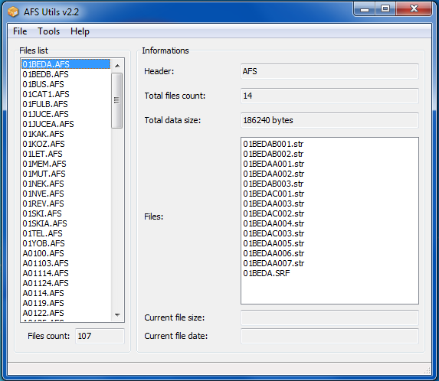

Highlight one of the AFS containers in the “Files list”, go to Tools > Mass extraction and choose a folder where your AFS containers will be extracted. I would recommend you to use the folder structure we discussed in the previous chapter. Extracting it to a folder called “J” would be a good option.Now repeat this step again for the English original subtitles and extract them to the “E” folder. It is almost impossible to translate the subs without using the original English subtitles as templates. You may close AFS Utils after the extraction process.

**IMPORTANT!**Don’t change the path of the extracted containers! After the extraction process a “?_list.xml” file in each container’s subfolder will remember the place where the container has been extracted to and where the other files are stored. If you move the subfolder to another place at any time AFS Utils won’t be able to recreate the container from the “?_list.xml” file. That’s why you need to think of a good folder structure before extracting the containers.

### Modification of subtitles

Extract AIO Cinematic Subtitles Editor twice into your translation folder (with different subfolder names of course) and open both of them. Go to File > Open directory… and browse for an extracted AFS data folder like A0114 (with one AIO CSE the Japanese and with the other one the English one). Click on the SRF in the files list and the editor will show the subs.

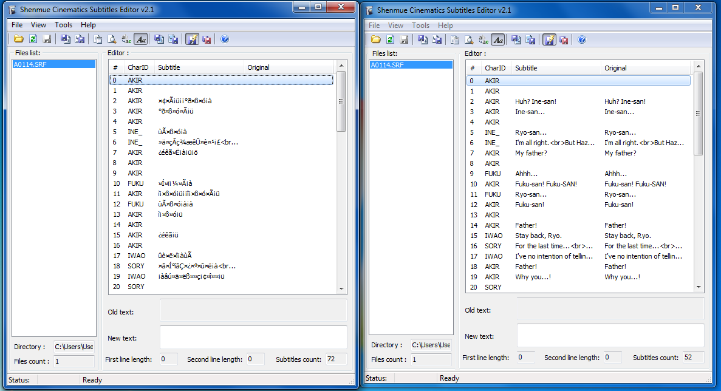  
(In the left window we have the Japanese SRF and the English one is in the right window)

It seems like the application is unable to display Japanese characters and so it will result in having a bunch of weird characters displayed instead. In the editor window you can edit the subtitles by clicking on them. That’s why it is recommended to use the English subtitles as a template. It doesn’t show Japanese characters which you could copy and paste into the Google® translator.

Enter your English subtitles in the new text box and don’t forget to save your file at the end if autosave is disabled. If you messed up something with the file you may delete it and extract it again from your backup (that’s why we are not working in the project folder itself…).

**Useful and important tips for the translation:**It is possible that the J and the E versions don’t have the same amount of subtitles (e.g. because of omitted sentences) or the order of subtitles may be different. In such a case you will unfortunately have to play try and error until you find out where which translated subtitle belongs to. That’s also why it is not smart to inject the Japanese voices only because possibly the total amount of voice files needs to be equal to the total amount of sentences in order to get valid AFS and IDX files afterwards.

Each line can display about 44 characters (depending on the character’s size) from which about 36 (depending on the character’s size) won’t be hidden by Ryo’s watch in the lower right corner of the screen. You can use a maximum of 2 lines per sentence for each dialog. Your subtitles might get displayed incorrectly if they exceed the 44 character / 2 line limitations so just don’t violate these rules and everything will be fine. There are no other known limitations so far.   
The amount of lines per sentence after the translation does not have to be the same as in the Japanese original. You can fill 2 lines for the sentence even if the Japanese version has only 1 line.  
If your translated sentence exceeds the 36 character limit stretch it from 1 line to 2 lines (with a line break) or if your sentence already has 2 lines shrink the amount of words. Try to keep the right meaning of the sentence in such a case.

Another thing is that the translation of the Japanese names and suffixes (–kun, –niichan, -neechan or   
–chan) has not been adapted 1:1 to the English version (e.g. Ryo calls Nozomi “Harasaki” and she calls him “Hazuki-kun”). It would be nice to translate it as near as possible to the original.

**A useful hint:**  
Go to File > Export subtitles in your sub editor to save SRF subs (Japanese/English) as .xml files.  
You can open XML’s with your browser. A Japanese one may look like this: 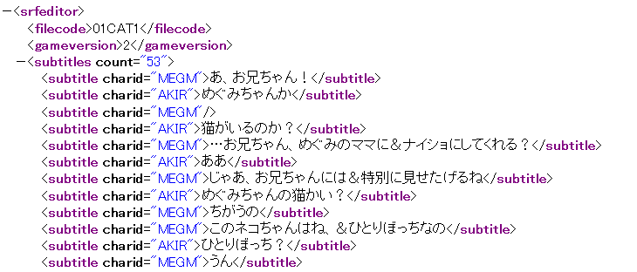  
It is also possible that there won’t be any Japanese characters at all but rather the same trash you already knew from the subtitles editor. In such a case your only help will be the English SRF file and you will have to experiment with the translation. Try to make the right translation. If the Japanese characters are displayed correctly and if you can read them you can translate it by heart. If you can’t read Japanese characters you may copy them to your clipboard and use Google® translator to translate it to English. Don’t forget to enable the Romanization [Ä] of the characters as this is quite useful! 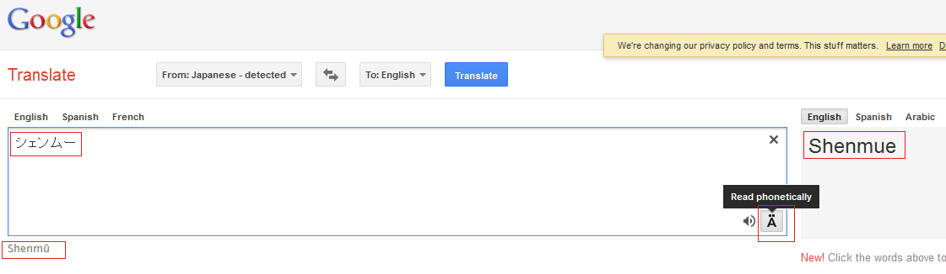 Sometimes Google translator may give you strange outputs for names like “Rantei” or “Hadzuki” instead of “Lan Di” and “Hazuki”. In such a case you can remain on the English original script.  
If you notice that the Japanese SRF has the same structure like the English template (same amount of lines and sentences) you can save the English SRF as a XML and then reimport this XML to your Japanese SRF instead of translating dozens of lines.

### Recreation of new AFS container

After translating the SRF file it is time to recreate the modified AFS container. Go to your open AFS Utils again and go to Tools > AFS Creator. A new window will pop up.

Go to File > Import XML list and browse to the folder of your modified AFS file. Click on the XXXX_list.xml file and import it. **A bunch of files should appear in the files list. If not you might have moved the extracted data from its original folder where it was extracted to.**

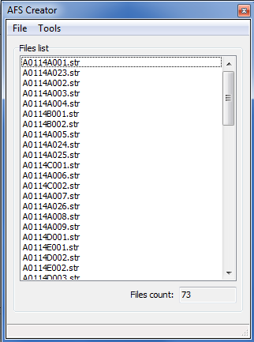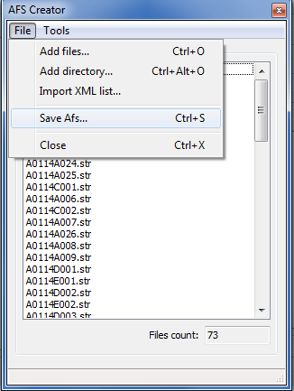

Go to File > Save AFS and save it to your “JE” folder. Then you may close AFS Utils again.  
**This AFS has to have the same name like the original AFS!**

**It is necessary to perform this step via importing the .xml file. If you don’t do it this way you will end up having a AFS that won’t be recognized by IDX Creator in the next step!**

### Recreation of valid IDX file

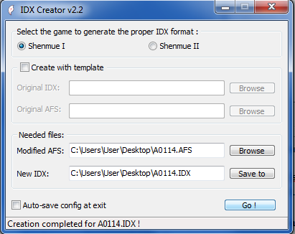Open IDX Creator. You may leave the “Create with template” box unchecked for cinematic files as it seems not to be absolutely necessary.   
Browse for your modified AFS file and hit the “Go!” button.  
Especially have a look at the status bar below the “Go!” button. If there are any problems to create this new AFS file they will appear as a message in this status bar. Keep an eye on it and make sure you created proper files. It is also possible that you need to use the original files as templates so don’t delete them yet.

## Free Quest

The translation of the free quest mode subtitles is tremendously time-intensive because there are so many NPC’s in Shenmue™ which can say so many different things to you (and all these dialogs have a subtitles which need to be translated).   
It should be performed at the end of a possible project otherwise you might get frustrated. It is recommended to form a crew which will be performing this work like the group that translated Shenmue II™ into French. They released their version on 2012-01-25 and nearly all the text was translated into French.

### Container FREE0x

The FREE0x container (x stands for the disc digit) is the first big issue and very similar to the other AFS packages. It seems like this package is storing the free quest voices and subtitles.  
The only difference is that you will have more than only 1 subtitle file and you will have more than only one set of voice files in it. FREE01 (the package from disc 1 of Shenmue™) for example has about 18’000 voice files, about 160 subtitle files (SRF) and each subtitle file has about 50 lines which need to be translated. Each subtitle file belongs to one certain NPC (F1005.SRF for example belongs to Ine-san) and it contains all dialog subtitles for the voices of the NPC (like when Ine-san talks to Ryo in the Hazuki residence).   
  
Modifying the SRF files in the FREE folder is not much different than translating the cinematic subtitles. Just open your subtitle editor as described in chapter 7.2.2 and navigate to your extracted FREE folder. Open 1 SRF file and translate it using the English SRF as your template. Use the same guidelines (line length, amount of lines) for the translation as you used in the cinematic task.  
  
**It makes no sense to open all SRF files because you will most likely not have the time to translate every file in only some hours. The other issue is that your subtitle editor might crash if you try opening all subtitle files from the FREE folder because there are so many files.  
It is important to remember which SRF is already translated so you should consider writing the file names and location to a list every time you complete it.**   
  
After all subtitles are translated you may rebuild the FREE0x.AFS package and recreate a valid IDX file as described in chapters 7.2.3 and 7.2.4. This will take a while because the archive is huge.   
**You will have to create the new IDX file for the FREE container with the original files as templates otherwise IDX creator will say the new FREE0x.afs is no valid file so check the boxes and browse for these files (don’t delete or lose them).**

# Passport

The Shenmue™ Passport (disc 4) is not part of the story and so this chapter will be left void for now because it has no priority.

# Details

There are still some things left that can be improved.

## Shenhua intro sequence

A0100.AFS from the disc 1 STREAM folder contains the audio and subtitle files for the Shenhua intro sequence. The subtitles are blanked out on both versions and the Japanese subtitle file can’t be edited. If you want Japanese speech and English subtitles you will have to extract both containers (PAL and J). Then you will need to edit the PAL subtitle file with your editor (search the internet for the 10 lines). Then you need to move the Japanese voice files from your Japanese extracted container folder to the European one’s folder. Then rebuild the AFS and create a new IDX file.

## Original vending machine

The original vending machine from Shenmue™ NTSC-J features soft drink brands like Coca Cola® while the one in PAL only has invented brands like “Jet Cola”. The invented brands make the game less authentic. In Shenmue™ you have to distinguish between:  
- the textures of the vending machine itself in the free quest mode   
- the textures of the cans in the selection screen (after throwing coins in the machine) and the drinking animation.   
**In order to get the original vending machine you need to do some file swapping. It is possible that there are more files to swap than described in the next chapters!**

### Drink selection screen and drinking animation

The models and textures (PKS/PKF) for the drinking animation and the drink selection screen are located in the STREAM folder and in the VEND folder of SCENE/0x.   
The interesting files are called “VEND, COKE, SPRT, FATO, FATG, CAFE”. The winning can is called “ATRK” and it does not have to be swapped. HIT contains only some smiley textures and you don’t need to swap it either. The animation of the drinking scene is called “HMOT_CAN.BIN”.   
If you swap these files from your Japanese version to your custom version you will have the real brands in the selection screen and the drinking animation but the vending machine itself in the free quest mode will still look the same.

### Free quest mode

Getting the original vending machine textures for the free quest mode is a bit more difficult because it seems like the vending machine is somehow embedded in the maps instead of being stored in a single file. The following files are located in SCENE/0x and they are already confirmed to contain the vending machine textures. Replace the European ones for the Japanese ones.  
  
**Location Folder File**  
Sakuragaoka JD00 JD00.PKF and JD00.PKS  
Dobuita D000 OMG.PKF and OMG.PKS  
Bar Yokosuka DBYO MPK00.PKF and MPK00.PKS  
New Yokosuka Harbor MFSY MPK00.PKF and MPK00.PKS  
Harbor lounge MKYU MPK00.PKF and MPK00.PKS  
  
This list may be incomplete. Search the map folders for vending machine textures (chapter 14.2).

# Test image creation

You have to make tests in order to find out how good your work is.  
The best way to do it is testing an image of your game on an emulator because you won’t need to compress and burn the images on CD-Rs. This will save you a lot of money.  
In order to do that you need to know how to create a bootable CDI image of your modified game.   
Search in the root folder of a disc you want to test for a file called “IP.bin”.   
If “IP.bin” was not in the directory then navigate to the “Tools” folder of “Bootmake” and copy the file to the folder of the disc you want to test.   
Now copy “binhack32.exe” to the folder where your image is, start it and fill in the gaps like this:

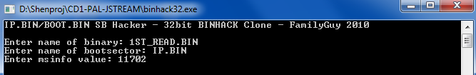

This will patch your IP.bin file and prevent freezing at the game startup. Open “Bootmake”.

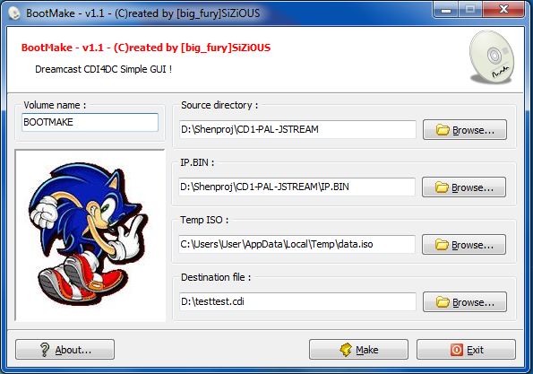  
  
Browse for your disc’s directory as source directory.   
Browse for the IP.bin file in **your disc’s folder. MAKE SURE YOU DID NOT FORGET THIS!**   
Choose a destination for the image file.   
Hit “Make”. A command line window will appear. This will take a while now. Wait until a light blue colored “*Woohoo... All done OK!*” appears.   
Your .cdi test image is now created and you can test it on your nullDC emulator.

**If you have problems with testing the image (game freezes at SEGA screen etc.) try patching your IP.bin one more time with binhack32 before creating the image.**

# Testing

NullDC is considered by many users as the best Dreamcast™ emulator so it will be used here.  
Start nullDC. Go to File > Normal Boot and choose your .cdi image. The game should start and you may have a look at your work.

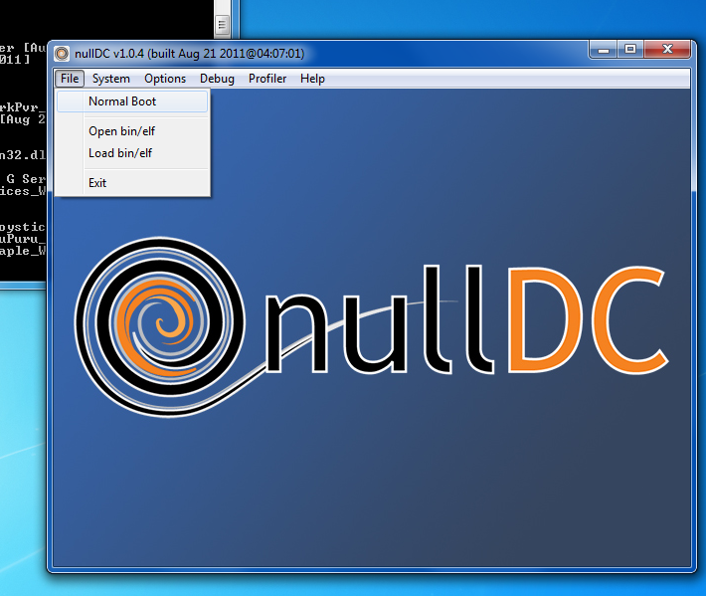

**nullDC needs DirectX 9 to work properly. Make sure you installed it before testing.**  
You can change the controller configuration in “Options > Maple > Port A > config key for Player 1”.

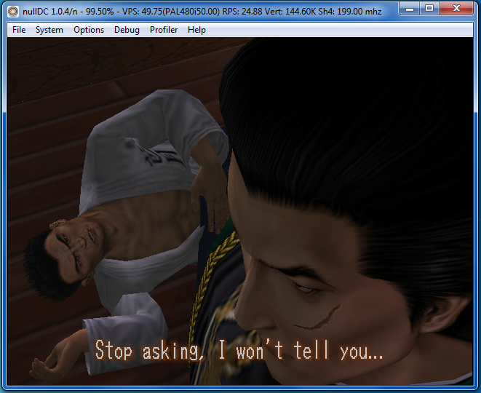

**Make sure you switched the subtitles on!** To enable them you have to go to Settings > Dialog & Text in the Shenmue™ main screen menu and switch it to “Game Mode”.

# Sources

This guide would not exist without the following resources:  
<http://www.hiei-tf.fr/shenmue1-howtotranslate-english.html>  
<http://shenmuesubs.sourceforge.net/howto.php>  
<http://shenmuesubs.sourceforge.net/specs.php>  
<http://shenmuesubs.sourceforge.net/download.php>  
<http://theisozone.com/tutorials/dreamcast/burning-and-backup/the-difference-between-gdi-and-cdi/>  
<http://fileforums.com/showthread.php?t=50423>  
<http://shenmueangel.free.fr/>  
<http://www.shenmuedojo.net/forum/viewtopic.php?f=3&t=43133>  
<http://www.metagames-eu.com/forums/dreamcast/projet-traduction-des-sous-titres-de-shenmue-1-et-2-a-65066.html>  
http://www.shenmuedojo.net/forum/viewtopic.php?t=3332&postdays=0&postorder=asc&start=25

**Special thanks to:**

Shentrad Team Tools  
Hiei- Original guide  
IlDucci AFS Utils (XML), FREE0x, A0100 and AFS container list  
Wude Vending machine file swapping   
Master Kyodai Disc scene list  
Mestre Ziming Character ID list

# Document history

|  |  |  |  |  |
| --- | --- | --- | --- | --- |
| **Version** | **Date** | **Changes** | **Chapter** | **Responsible** |
| 0.8.0 | 2012-04-22 | Completed | All | Shensoul |
| 0.8.1 | 2012-04-24 | AFS container list | 14.1 | Shensoul |
| 0.8.2 | 2012-04-25 | PKF containers | 9.2.2 | Shensoul |
| 0.8.3 | 2012-04-27 | Translation hint | 7.2.2 | Shensoul |

# Appendix

Possibly useful information:

## AFS container list

**Disc 1**

01BEDA - Bad ending: Lan Di returns to Hazuki Residence (all disks)

01BEDB – Bad Ending: Shenhua warning (all disks)

01BUS - Japanese text, no need to edit (all disks)

01CAT1 - Ryo finds Megumi with the kitten

01FULB - Nozomi cries because of her mother (all disks)

01JUCE - Subtitles of the soda drinking cutscene (all disks)

01JUCEA- Wang asks Ryo for a drink, Ryo asks him about the Chinese letter

01KAK - Ryo tells Fuku-san that he has a lead on the chinese cartel

01KOZ - Game start, Ine-san gives the first allowance to Ryo (disks 1 & 2)

01LET - Ryo finds Iwao Hazuki's farewell letter

01MEM - Ryo talks with Fuku-san about Iwao's farewell letter

01MIR - Ine-san tells Ryo that Iwao left something at the antique shop

01MUT - Nozomi asks Ryo to open himself up (disks 1 & 2)

01NEK - Japanese text, no need to edit

01NVE - Fight against Enoki and the other thug that is attacking Nozomi

01REV - Sailors attempt to ambush Ryo, gets info about the tattoo parlor

01SKI - Ryo talks with Nozomi about leaving Japan (disks 1 & 2)

01SKIA - Nozomi calls Ryo to meet at Sakuragaoka Park (disks 1 & 2)

01TEL - Searching the 61 area code on the phone book (all disks)

01YOB - Nozomi talks with Ryo after his fight with Charlie

A0100 - Demo trailer of the game, Shenhua intro sequence

A01103 - After Iwao's death, postman brings the Chinese letter

A01114 - QTE against Tony and Smith at the Heartbeats Bar alley

A01124 - Ine-san gives the letter in chinese to Ryo

A0114 - Game intro, Iwao Hazuki dies by the hand of Lan Di

A0119 - (Ryo's making gestures) Unsubbed cinematic

A0122 - Ryo's childhood memory: Iwao Hazuki makes him eat vegetables

A0125 - Ryo tells Fuku-san that he must avenge his father's murder

A0125A - Ryo tells Fuku-san that he must avenge his father's murder

A0125B - Childhood memory: Iwao speaks about the importance of friendship

A0128 - Childhood memory: Iwao teaches Ryo martial arts (under cherry tree)

A0134 - Japanese text, no need to edit

A0136 - End of Charlie's tattoo parlor QTE, he talks about the cartel

A0136A - Beginning of Charlie tattoo parlor QTE, Tony & Smith make a run

A0139 - Ryo and Fuku-san speak about the Chinese letter

A0142 - Japanese text, no need to edit

A0142B - Russiya China Shop's Xia Xiu Yu translates the letter in Chinese

A0173 - Fuku-san forces Ryo to sleep in bed for all the day (all disks)

E1001D - Work - Tutorial for driving a forklift. (disks 1 & 3)

E1002 - Fight against Tony and Smith while searching for Jimmy

E1003 - End of the QTE fight against Charlie at Sakuragaoka

E1011 - Ryo finds the markings and locks of the secret wall (disks 1 & 2)

E1014A - First QTE where Ryo has to catch a soccer ball

E1017 - Fuku-san asks Ryo to teach him the Pit Blow move

E1012 - Ryo investigates Hazuki Dojo's hidden basement

E1018 - Subtitles (Hazuki Residence) related to items and stuff (all disks)

E1020 - Yamagishi-san teaches Ryo the Double Blow move

E1024 - Subtitles seen at You Arcade/Slot House (all disks)

E1025 - Subtitles seen at You Arcade, Darts game. (all disks)

E1026 - Subtitles seen at You Arcade, Excite QTE. (all disks)

E1027 - Subtitles seen at You Arcade, Space Harrier/Hang-On (all disks)

E1030 - Ryo busts into Heartbeats Bar, QTE against the locals

E1031 - Subtitles (Hazuki Dojo) while sparring against Fuku-san (all disks)

E1032 - Subtitles of all the phone calls / characters (all disks)

E1036 - QTE fighting against the two brats that are with Mai (disks 1 & 2)

E1039 - Subtitles of MJQ Jazz Bar's base workers (playing pool) (all disks)

E1040 - Subtitles when training moves at an empty area (all disks)

E1041 - Subtitles related to the Yamanose Shrine's kitten (all disks)

E1044 - A lady at Sakuragaoka Park is trying to find the Yamamoto's House

E1049 - Fight & QTE at Sakuragaoka (Charlie steals soccer ball of a kid)

E1060 - Ryo's comments when reading Move Scrolls and Letters (all disks)

E1064 - First fight against Enoki and the other thug

E1065 - Second fight against Enoki and the other thug

E1066 - Subtitles found when using the Capsule Toy Machines (all disks)

E1067 - Subtitles found when using the Jukeboxes (all disks)

E1068 - End of ambush at You Arcade, Tony gives info on Tattoo Parlor

E1072 - Subtitles related to the Lapis Adivination (all disks)

E1076 - Subtitles related to the Slot Machines (all disks)

E1079 - Subtitles related to Batteries/Use of batteries (all disks)

SA1007 - Ryo in MJQ Jazz Bar asking for sailors before the bar's open.

SA1008 - Japanese text, no need to edit

SA1009 - Ryo asks Akemi (Yokosuka Bar) about sailors

SA1010 - Bar Yokosuka keeper tells Ryo that he can't serve him alcohol

SA1012 - Ryo finds the Tattoo Parlor, but it's closed

SA1060 - Subtitles related to shopping at the Antique Shop (all disks)

SA1062 - Ine asks Ryo to get back into the house before 11PM (all disks)

SA1063 - Ine-san argues with Ryo about arriving late at home (all disks)

SA1071 - Ryo stops trying to find something on the Phone book

SA1076 - Lines about having not much money / returning home (all disks)

SA1077 - Ryo swears he'll avenge his father, Fuku-san asks for sparring

SA1079 - Subtitles about shopping at Tomato Convenience Store (all disks)

SA1080 - Subtitles about trying to enter a closed shop (on all disks)

SA1081 - Duplicate of previous file (all disks)

SA1082 - Ryo trying to exit Hazuki Residence before talking with Fuku-san

SA1083 - Heartbeats Bar's owner kicks Ryo out

SA1084 - Heartbeats Bar's owner kicks Ryo out, extra subs

SA1085 - Subtitles related to shopping at Abe Store (Found on all disks)

SA1086 - Subtitles about having to talk with more people (all disks)

SA1087 - Subtitles about having to talk with more people / Yamagishi-san

SA1088 - Subtitles related to Ryo finding a closed door (all disks)

SA1089 - No visits to harbor before finding Phoenix Mirror (disks 1 & 2)

SA1091 - Subtitles about a shop closing while still inside (all disks)

SA1092 - Japanese-only subtitles (disks 1 & 3)

SA1095 - Ryo doesn't want to leave before buying a ticket (disks 1 & 2)

SA1100 - About finding Warehouse #8 via area code on the phone book.

SA1101 - Subtitles about Ryo in a hurry (Nozomi's kidnapped) (disks 1 & 3)

SA1102 - Subtitles about Ryo picking up his allowance. (all disks)

SA1116 - Ryo asks Fuku-san about the men who killed Iwao

SA1119 - Subtitles related to picking up the Hong Kong ticket (disks 1 & 2)

SA1120 - Subtitles about waiting for Jimmy's call (ticket) (disks 1 & 2)

SA1121 - Subtitles about the You Arcade date for the ticket (disks 1 & 2)

SA1122 - Subtitles after the fight against Chai at You Arcade (disks 1 & 2)

SY01 - Japanese-only subtitles (Found on all disks)

SY02 - Japanese-only subtitles (Found on all disks)

SY03 - Japanese-only subtitles (Found on all disks)

SY04 - Japanese-only subtitles (Found on all disks)

SY05 - Japanese-only subtitles (Found on all disks)

SY06 - Japanese-only subtitles (Found on all disks)

SY07 - Subtitles related for being too late and returning home (all disks)

SY08 - Subtitles related for being too late and returning home (all disks)

SY09 - Subtitles related for being too late and returning home (all disks)

SY10 - Subtitles related for being too late and returning home (all disks)

SY11 - Subtitles related to not spending more money (all disks)

**Disc 2**

01BEDA - Bad ending: Lan Di returns to Hazuki Residence (all disks)

01BEDB – Bad ending: Shenhua warning (all disks)

01BNK - "Guess Hong Kong's out."

01BTU - Nozomi brings flowers to Ryo's house

01BUS - Japanese text, no need to edit (Found on all disks)

01CAT3 - Kitten's leg is healed

01DIS - Ryo shows the Mirror to Fuku-san, he thinks Ryo's possessed

01EAR - Ryo asks Ine-san some money for the Hong Kong trip

01ETU - Ryo tries to talk with Asia Travel Co.'s girl

01FRE - Fuku-san's friends are worried about Ryo

01FRO - Two security guards kick the homeless guy out of a warehouse

01FULB - Nozomi cries because of her mother / she has to leave (all disks)

01GAK - Naoyuki and Ichiro go to Ryo's house to see him

01GAR - Goro and his pal distract a guard so Ryo can get inside a warehouse

01HIS - Mai asks some money from Hisaka-san, she refuses

01HOK - Ryo shows Xia-san the Phoenix Mirror, talking about stars

01INY - Ryo shows Yamagishi-san the Phoenix Mirror

01JIM - QTE when chasing Jimmy on Dobuita

01JIMB - Beginning of the QTE chase against Jimmy

01JUCE - Subtitles of the soda drinking cutscene (all disks)

01KEI - Ryo shows Oishi-san the Phoenix Mirror

01KOZ - Game start, Ine-san gives the first allowance to Ryo. (disks 1 & 2)

01MIR - Ine-san tells Ryo that Iwao left something at the antique shop.

01MIT - Ryo talks with owner of Global Travel Agency about a Hong Kong trip

01MON - Fuku-san shares his money with Ryo and tells him about cheap ticket

01MUT - Nozomi asks Ryo to open himself up (disks 1 & 2)

01OKO - Ryo says goodbye to Fuku-san after buying the ticket at Asia Travel

01SKI - Ryo talks with Nozomi about leaving Japan (disks 1 & 2)

01SKIA - Nozomi calls Ryo to meet at Sakuragaoka Park (disks 1 & 2)

01SOR - Fuku-san confess to Ryo that he told Ine-san everything he knew

01TAZ - Ryo asks Fuku-san if he knows of a cheap travel agency.

01TEL - Searching the 61 area code on the phone book. (all disks)

A0132 - Ryo obtains the Sword Handguard from the Antique Shop

A0154 - Ryo meets for the first time Gui Zhang and Master Chen

A0159 - Ryo meets Gui Zhang & Master Chen after obtaining the mirror

A0160 - Ryo & Fuku-san talk about the Chen meeting

A0165 - Ryo finds out that Asia Travel stole his Hong Kong ticket money

A0167 - Gui Zhang unveils himself as Ryo's bodyguard, spars to test him out

A0169 - Jimmy phone calls Ryo to "give him his ticket" at You Arcade

A0172 - Start of the fight against Chai at You Arcade

A0172A - End of the fight against Chai at You Arcade

A0173 - Fuku-san forces Ryo to sleep in bed for all the day (all disks)

A1136 - Ryo shows Ine-san the Sword Handguard

E1004A - QTE when chasing Jimmy through Dobuita's streets

E1005 - A druk tries to fight with Ryo

E1006 - Subtitles when searching for Old #8 and the guards patrolling

E1008 - Ryo tries to sneak into the New Warehouse #8

E1009A - Japanese text, no need to edit

E1009B - Subtitles when searching around / overhearing that Old #8 exists

E1010 - Ryo searches around Old #8

E1011 - Ryo finds the markings and locks of the secret wall (disks 1 & 2)

E1012 - Ryo investigates the Hazuki Dojo's hidden basement

E1018 - Subtitles related to Hazuki dojo stuff (all disks)

E1024 - Subtitles seen at You Arcade/Slot House (all disks)

E1025 - Subtitles seen at You Arcade, Darts game. (all disks)

E1026 - Subtitles seen at You Arcade, Excite QTE. (all disks)

E1027 - Subtitles seen at You Arcade, Space Harrier/Hang-On (all disks)

E1031 - Subtitles (Hazuki Dojo) while sparring against Fuku-san (all disks)

E1032 - Subtitles of all the phone calls / characters (all disks)

E1036 – QTE, fighting against the two brats that are with Mai (disks 1 & 2)

E1039 - Subtitles of Jazz Bar's workers that are playing pool (all disks)

E1040 - Subtitles when Ryo is going to train at an empty area (all disks)

E1041 - Subtitles related to the Yamanose Shrine's kitten (all disks)

E1042 - Ryo speaks with homeless (harbor) about the old district

E1046 - QTE against Goro and his pal at the harbor

E1060 - Ryo's comments when reading Move Scrolls and Letters (all disks)

E1061 - Ryo delivers the lunchboxes at the Old Warehouse District.

E1066 - Subtitles found when using the Capsule Toy Machines (all disks)

E1067 - Subtitles found when using the Jukeboxes (all disks)

E1072 - Subtitles related to the Lapis Adivination (all disks)

E1076 - Subtitles related to the Slot Machines (all disks)

E1079 - Subtitles related to Batteries/Use of batteries (all disks)

E1081 - Goro starts a conversation with Ryo.

Q1003 - QTE at the beginning of the Old Warehouse District infiltration.

SA1018 - Ryo's friends are at the Dojo.

SA1035 - Ryo tries to enter to the Old Warehouse District (guard posted)

SA1036 - Japanese text, no need to edit.

SA1037 - Ryo asks Fuku-san about the Sword Handguard.

SA1039 - Ryo tries to enter the Old Warehouse District (office entrance)

SA1060 - Subtitles related to shopping at the Antique Shop. (all disks)

SA1062 - Ine asks Ryo to get back into the house before 11PM (all disks)

SA1063 - Ine-san argues with Ryo about arriving late at home (all disks)

SA1070 - Japanese text, no need to edit.

SA1076 - Lines about not enough money and about returning home (all disks)

SA1079 - Subtitles about shopping at Tomato Convenience Store (all disks)

SA1080 - Subtitles about trying to enter a closed shop. (all disks)

SA1081 - Duplicate of previous file (all disks)

SA1085 - Subtitles related to shopping at Abe Store (all disks)

SA1086 - Subtitles about having to talk with more people (all disks)

SA1088 - Subtitles related to Ryo finding a closed door (all disks)

SA1089 - Ryo not going to harbor before finding the mirror (disks 1 & 2)

SA1090 - Ryo doesn't want to talk with Ine-san  
SA1091 - Subtitles about a shop closing while still inside. (all disks)

SA1095 - Ryo doesn't want to leave before buying a ticket. (disks 1 & 2)

SA1096 - A guard kicks Ryo out of a restricted area.

SA1097 - A guard kicks Ryo out of a restricted area.

SA1098 - A guard kicks Ryo out of a restricted area.

SA1099 - A guard kicks Ryo out of a restricted area.

SA1102 - Subtitles related to Ryo's picking up his allowance. (all disks)

SA1104 - Subtitles related to locked doors

SA1108 - Ryo asks Gui Zhang to translate the Stab Armor move scroll.

SA1109 - Ryo asks Gui Zhang to translate the poetry scroll.

SA1114 - Subtitles related to shopping at the Tomato Convenience Stores

SA1115 - Subtitles about returning home (late / need to talk with Fuku-san)

SA1117 - Ryo talks with Ine-san about the Sword Handguard.

SA1118 - Ryo talks with Fuku-san about the trip to Hong Kong.

SA1119 - Subtitles related to picking up the Hong Kong ticket (disks 1 & 2)

SA1120 - Subtitles about waiting for Jimmy's call (ticket) (disks 1 & 2)

SA1121 - Subtitles about the You Arcade date for the ticket (disks 1 & 2)

SA1122 - Subtitles after the fight against Chai at You Arcade (disks 1 & 2)

SY01 - Japanese-only subtitles (Found on all disks)

SY02 - Japanese-only subtitles (Found on all disks)

SY03 - Japanese-only subtitles (Found on all disks)

SY04 - Japanese-only subtitles (Found on all disks)

SY05 - Japanese-only subtitles (Found on all disks)

SY06 - Japanese-only subtitles (Found on all disks)

SY07 - Subtitles related for being too late and returning home (all disks)

SY08 - Subtitles related for being too late and returning home (all disks)

SY09 - Subtitles related for being too late and returning home (all disks)

SY10 - Subtitles related for being too late and returning home (all disks)

SY11 - Subtitles related to not spending more money (all disks)

**Disc 3**

01AYU - End of cutscene where Gui Zhang teaches Ryo a move

01BEDA - Bad ending: Lan Di returns to Hazuki Residence (all disks)

01BEDB – Bad ending: Shenhua warning (all disks)

01BIKE - Ryo asks for Naoyuki's bike at Sakuragaoka.

01BIKEB - "I wish" song cutscene: "Thanks for saving me."

01BUS - Japanese text, no need to edit (all disks)

01CAU - Ryo talks with Chen & Gui Zhang about the Long Zha

01CAUA - Ryo gets his wage and also gets a warning letter from Gui Zhang

01CBK - End of the Charlie bikes QTE, Lan Di's still on Amihama

01CJP - Yamanose Shrine's kitten is finally healed, jumps from the shrine

01CRA - Some bikers are terrorizing the old homeless at the harbor.

01CTS - QTE where you chase Tony/Smith for questions about Long Zha.

01CTSA - End of the QTE chase, Tony's got caught and talks about Long Zha.

01CTSB - End of the QTE chase, Smith's got caught and talks about Long Zha.

01FULB - Nozomi cries because of her mother / she has to leave. (all disks)

01GET - Ine-san mentions that Nozomi's missing, Chai calls Ryo to harbor

01GHO - Goro and Mai talk about getting married.

01GMO - Subtitles related to waking up and going to work.

01GOHA - Ryo asks Goro for help so he can find a job.

01GOJ - Ryo tries to ask Goro about the Mad Angels, he tries to get away.

01GORA - Goro and Mai tell Ryo they found him a job.

01HOK - Ryo shows Xia-san the mirror, talking about stars (disks 2 & 3)

01INY - Ryo shows Yamagishi-san the Phoenix Mirror. (disks 2 & 3)

01JIB - Fuku-san is worried about Ryo (they talk), after QTE Chase (Jimmy)

01JIN - Nozomi's asking for a wish at the Yamanose Shrine.

01JUCE - Subtitles of the soda drinking cutscene (all disks)

01KUB - Ryo's fired from Alpha Trading Office.

01LFT - Free Fight ambush of many thugs

01MAD - Two Mad Angels throw Mark's lunch to the sea, Ryo intervenes

01MAK - Ryo meets Yada-san and Mark, start of the forklift tutorial.

01MKB - Mark takes second beating, tells Ryo his brother was murdered

01MKJ - Mark tells Ryo that the Long Zha will take place soon.

01MSO - Empty subtitles related to Iwao Hazuki

01PHO - Eri takes two pictures of Ryo and Nozomi, Ryo has to pick one.

01ROO - Japanese text, no need to edit

01TAP - Ryo meets Terry, Terry asks him to take down Gui Zhang.

01TEL - Searching the 61 area code on the phone book. (all disks)

01TLY - 70 People Fight - Terry's caught, tries to hit Gui Zhang again

01TLYA - 70 People Fight - A thug takes Ryo to Gui Zhang

01TLYB - 70 People Fight - Terry invites Ryo and Gui Zhang to hell.

01TLYC - 70 People Fight - Ryo and Gui Zhang start the 70 people fight.

01TLYD - 70 People Fight - Ryo pulls Terry up / Lan Di already on a boat.

01TLYE - 70 People Fight - End of section  
01TOMA - Ryo sees Tom, Tom treats Ryo to lunch.

01TOMB - Tom tells Ryo he's going back to the States

01TOMC - "My friend... Tom." Ryo sees a plane and thinks about Tom.

01TOU - Some thugs attempt to ask an "insurance" to Ryo, start of a fight.

01TSM - Japanese text, no need to edit.

019RN - Goro's attacked, Ryo is QTE ambushed by five people.

A0173 - Fuku-san forces Ryo to sleep in bed for all the day (all disks)

A0174 - Disc 3 start: Ryo faces Jimmy at Asia Travel.

A0180 - Fuku-san gives some money to Ryo just before he leaves Japan.

A0184 - Pre-endgame - Chai drops an iron beam to Ryo that hits Gui Zhang

A0184B - Pre-endgame - Chai fights against Ryo.

A0184C - Pre-endgame - Ryo throws Chai to the sea

A0184D - Pre-endgame - Ryo defeats Chai and gets some info on Lan Di.

E1001A - Work - Worktime's over, subtitles related to the wage obtained.

E1001B - Work - Subtitles about moving a crate into a restricted area.

E1001C - Work - Mark instructs Ryo with the goal of each day.

E1001D - Work - Tutorial for driving the forklift. (Found on disks 1 & 3)

E1001E - Work - Ryo comments about the breaks and where to take the crates

E1011 – Ryo finds the markings and locks of the secret wall (disks 2 & 3)

E1012 - Ryo investigates the Hazuki Dojo's hidden basement. (disks 2 & 3)

E1016 - Pre-endgame - Gui Zhang and Chen meet Ryo at the ship

E1018 - Subtitles about items and stuff in Hazuki residence (all disks)

E1019 - Gui Zhang teaches the Swallow Dive at the harbor.

E1021 - Tom teaches Ryo his Tornado Kick before saying goodbye.

E1022 - QTE ambush from five Mad Angels thugs against Ryo.

E1023 - QTE chase against Tony / Smith

E1024 - Subtitles seen at You Arcade/Slot House (Found on all disks)

E1025 - Subtitles seen at You Arcade, Darts game. (Found on all disks)

E1026 - Subtitles seen at You Arcade, Excite QTE. (Found on all disks)

E1027 - Subtitles seen at You Arcade, Space Harrier/Hang-On (all disks)

E1031 - Subtitles on Dojo, while sparring against Fuku-san (all disks)

E1032 - Subtitles of all the phone calls / characters (all disks)

E1037 - Subtitles seen in the middle of the 70 people fight.

E1039 - Subtitles Jazz Bar's base workers that are playing pool (all disks)

E1040 - Subtitles when Ryo is going to train at an empty area (all disks)

E1041 - Subtitles related to the Yamanose Shrine's kitten (all disks)

E1045 - Final del enfrentamiento entre Ryo y Gui Zhang, Terry intenta golpear a Gui Zhang con una barra de metal.

E1047 - Frases que se dicen durante el enfrentamiento entre Ryo y Gui Zhang.

E1060 - Ryo's comments when reading Move Scrolls and Letters on the inventory. (Found on all disks)

E1062 – Some phrases from Chai

E1063 – homeless from the harbor teaches Ryo moves

E1066 - Subtitles found when using the Capsule Toy Machines. (all disks)

E1067 - Subtitles found when using the Jukeboxes. (all disks)

E1069 - QTE fight against three bikers, Charlie among them.

E1070 - QTE race against the bikers at the harbor.

E1071 - QTE fight at the harbor, thugs re-attempt to steal money from Ryo

E1072 - Subtitles related to the Lapis Adivination. (Found on all disks)

E1073 - Ryo gets the information about the Mad Angels base

E1076 - Subtitles related to the Slot Machines. (all disks)

E1077 - Ryo reaches the harbor trying to find Nozomi

E1078 - Subtitles related to the forklift races.

E1079 - Subtitles related to Batteries/Use of batteries (all disks)

E1081 - Goro starts a conversation with Ryo. (disks 2 & 3)

SA1035 - Ryo tries to enter to the Old Warehouse District (disks 2 & 3)

SA1039 - Ryo tries to enter the Old Warehouse District (disks 2 & 3)

SA1053 - Ryo asks Ono for his bike, Ono-san mentions Naoyuki has one.

SA1060 - Subtitles related to shopping at the Antique Shop. (all disks)

SA1062 - Ine asks Ryo to get back into the house before 11PM (all disks)

SA1063 - Ine-san argues with Ryo about arriving late at home. (all disks)

SA1076 - Lines related to having not much money (all disks)

SA1079 - Subtitles about shopping at Tomato Convenience Store (all disks)

SA1080 - Subtitles about entering a shop that's closed. (all disks)

SA1081 - Duplicate of previous file. (Found on all disks)

SA1085 - Subtitles related to shopping at Abe Store. (Found on all disks)

SA1086 - Subtitles about having to talk with more people. (all disks)

SA1088 - Subtitles about closed doors. (all disks)

SA1091 - Subtitles related to a shop closing while still inside (all disks)

SA1092 - Japanese-only subtitles (Found on disks 1 & 3)

SA1093 - Goro scolds Ryo (he didn't got to Alpha Trading in time).

SA1094 - Fuku-san gives Ryo the photo of a younger Iwao with someone else.

SA1096 - A guard kicks Ryo out of a restricted area. (disks 2 & 3)

SA1097 - A guard kicks Ryo out of a restricted area. (disks 2 & 3)

SA1098 - A guard kicks Ryo out of a restricted area. (disks 2 & 3)

SA1099 - A guard kicks Ryo out of a restricted area. (Found on disks 2 & 3)

SA1101 - Subtitles about Ryo in a hurry (Nozomi's kidnapped) (disks 1 & 3)

SA1102 - Subtitles related to Ryo's picking up his allowance. (all disks)

SA1103 - Ryo arrives late at Alpha Trading and finds a different foreman.

SA1104 - Subtitles related to a locked door.

SA1105 - Mark asks Ryo to arrive to the harbor at 9AM

SA1106 - Ryo refuses to leave the harbor because of the main quest.

SA1108 - Ryo asks Zhang to translate a move scroll (disks 2 & 3)

SA1109 - Ryo asks Gui Zhang to translate the poetry scroll. (disks 2 & 3)

SA1114 - About shopping at Tomato Stores. (1 is repeated) (disks 2 & 3)

SA1115 - Subtitles about returning home / talking with Fuku (disks 2 & 3)

SY01 - Japanese-only subtitles (Found on all disks)

SY02 - Japanese-only subtitles (Found on all disks)

SY03 - Japanese-only subtitles (Found on all disks)

SY04 - Japanese-only subtitles (Found on all disks)

SY05 - Japanese-only subtitles (Found on all disks)

SY06 - Japanese-only subtitles (Found on all disks)

SY07 - Subtitles related for being too late and returning home. (all disks)

SY08 - Subtitles related for being too late and returning home. (all disks)

SY09 - Subtitles related for being too late and returning home. (all disks)

SY10 - Subtitles related for being too late and returning home. (all disks)

SY11 - Subtitles related to not spending more money (all disks)

## Vending machine files

VEND Vending machine  
ATRK Winning can (don’t swap this!)  
COKE Coca Cola®  
SPRT Sprite®  
FATO Fanta® Orange  
FATG Fanta® Grapefruit  
CAFE Coffee  
HIT some unidentified smileys (don’t swap this)  
HMOT_CAN.BIN drinking animation

**How to find out if a file has vending machine textures in it:**  
You will need pvrext.exe and pvr2png.exe. Create a folder (e.g. C:/X) and move pvrext and pvr2png into it. Then create a .cmd file with the following lines in the same folder using your windows editor:  
  
pvrext.exe -e *.pkf C:\X

pvrext.exe -e *.tmp C:\X

pvr2png.exe *.pvr

del C:\X\*.pvr  
  
Open the folder of a map (e.g. SCENE/01/JD00 for Sakuragaoka) and search for texture files (e.g. JD00.PKF) in it. Move one PKF file to your folder where the script is. Run your script and wait until the textures are extracted as .png images. If you get error messages open the file with Winrar or 7zip, double-click on your PKF, extract the TMP file and try again extracting the TMP instead of the PKF. You can also try to extract the PKF from the PAL version if the NTSC-J won’t work. However it’s possible that some PKFs won’t extract. If it was extracted successfully have a look on the PNGs and search for any image with vending machine textures on it. If you find one it is clear which file you need to replace.

## Disc scene list

SCENE/01 (Disc 1)

JD00 - Sakuragaoka (In middle of sakuragaoka at 1/1)

JD99 - Sakuragaoka Beta (0,1,2 hangs)

JU00 - Yamanose (1/1 being coming from the Hazuki residence)

JU99 - Yamanose Beta (Enter 0,1,2 hangs)

OP00 - Opening scene (Intro at 1/1)

OP02 - Intro with shenhua (at 1/1)

MO99 - Warehouse No. 8 (Beta? at 1/1)

MK99 - Old Warehouse district (Beta? No guards at 1/1)

MF99 - In front of old warehouse district (Beta? Glitched a bit)

DYKZ - Nagai Industries

DURN - Lapis Fortune teller

DTKY - Maeda Barber shop

DSUS - Takara Sushi

DSLT - Slot House

DSLI - Linda

DSKI - Global Travel Agency

DSBA - Yamaji Soba Noodles

DRSA - Russiya China shop

DRME - Manpukuken Ramen

DRHT - Liu Barber and Hair salon

DPIZ - Bob's Pizzeria

DNOZ - Nozomi Crying Cutscene

DMAJ - Daisangen (Mahjongg Parlor)

DKTY - Antique shop

DKPA - Nana's Karaoke Bar

DJAZ - MJQ Jazz Bar

DHQB - Heart beats (Beta? Cutscene? Crashes!)

DGCT - Game You Arcade

DCHA - Ajiichi Chinese Restaurant

DCBN - Tomato Convenience Store

DBYO - Bar Yokosuka

DBHB - Heart Beats

DAZA - Asia Travel Company

D000 - Dobuita

BETD - Bad ending cutscene (Enter 0)

0000 - Test area (quite empty)

YG14 - Crashes

YD8S - Goro distraction cutscene (Enter 0)

YD01 - Cherry tree Iwao Fight Flashback

VEND - Crashes (Vending machine scene i guess)

TOKI - Russiya China shop (Cutscene? Hangs!)

TATQ - Tatoo Parlor

JABE - Abe Store (little baby ryo)

FREE - Crashes (Not really a scene folder)

JOMO - Ryo's Room

JHD0 - Hazuki Residence (outside)

SCENE/02 (Disc 2)

ARAR - Asia Travel Company Cutscene

GMCT - You arcade cutscene

MFSY - New Yokosuka harbor

MK80 - Translate Scroll cutscene

MKSG - old warehouse district

MKYU - Harbor Lounge

MS08 - Warehouse No 8

MS8A - Warehouse No 8

MS8S - Warehouse No 8

YDB1 - Hazuki Residence Basement

SCENE/03 (Disc 3)

NBIK - Motorcycle (Nozomi Ryo Motorcycle)

## Character ID list

AKIR Ryo Hazuki AAA_M

SORY Lan Di KOK_M

IWAO Iwao Hazuki IWA_M

JAKR Ryo Hazuki (Childhood) JKB_M

FUKU Masayuki Fukuhara FUK_M

INE_ Ine Hayata INE_M

KISY Chen Gui Zhang KIS_M

TAIJ Master Chen SYU_M

CHAI Chai CHA_M

KURA Man in black A BLA_M

KURB Man in black B BLB_M

KAME Kame Shibukawa FUU_L

JIMY Jimmy Yan JIM_M

TONY Tony Abrams GIJ_M

SMTH Smith Bradley GIB_M

AKMI Akemi Sato HOS_L

YOKO Yoko Minato HOB_L

YUKK Yuka Komine X61_L

SYZU Shozo Mizuki KOG_L

JUKY Junko Yamamoto YAM_L

OISI Keizo Oishi KOT_L

NAMS Natsumi Sakuragi NAT_L

SETA Setsu Abe SEU_L

MTUK Mitsuru Kumeta MRU_L

HORS Takashi Takashiro TAT_M

SNKC Shinkichi Noda SAK_L

YOSE Yoshie Aoi BWW_L

MRIG Mario Grianni MAL_L

NITO Yuji Nito GAT_L

TSUC Shingo Mochizuki MCZ_L

HATO Yoshifumi Hato BAT_L

ITOI Bukichi Itoi WAP_L

TURU Noriyuki Tsuruoka SCA_L

KURI Shiro Kurita KZM_L

AOKI Motoyuki Aoki BUR_L

MADA Ichiro Maeda TOK_L

ETKO Etsuko Sekine JOJ_M

BUSS Shinya Onoue OGM_L

TOM_ Tom Johnson AME_L

HIRA Haru Hirata TUB_L

HISA Hisaka Sawano FRO_L

YURI Yuriko Kikuchi FRB_L

NANS Nanako Shinohara NAN_L

HRKO Hiroyuki Orihara ORI_L

AKSK Kazuo Akasaka JEA_L

MRUA Minoru Asada ASD_L

HOND Soichi Honda HND_L

ONRR Liu En Ling ONL_L

TATM Ryuji Tatsumi DOR_L

KYUR Liu Ji You KUU_L

UNO_ Tao Duo Ji CHU_L

KYOH Kyoko Hayashi KHY_L

ASDA Xia Xiu Yu KAS_L

YAMA Shigeo Yamagishi YMG_L

MISM Fusayo Mishima KYF_L

KOND Fusako Kondo X77_L

RNKT Tao Lin Xia FUW_L

NORK Noriko Nakamura SHA_L

KKBN Xie Gao Wen KOM_L

YOPA Tsuyoshi Takashima

YOP_L CATM Kitten KC1_M

KJIY Koji Yabe BIB_L

PEDR Pedro Warren JNC_L

PAUR Paulo McCoy PAL_L

KEBA Tadashi Akita KEB_L

KEBB Yasutomo Miyagi KVB_L

KEBC Yoshio Yamagata KVC_L

KEBD Hirotaka Chiba KVD_L

SAGA Naoki Shoji SAG_L

RYBI Lidia Bennett RED_L

KYAS Cathy Wilkins KYS_L

SKGK Hideo Shiga SOU_L

KIM_ Kim Shihan KIM_L

MIKM Takafumi Mitsuzuka X70_L

NSMR Yoshihito Nishii X72_L

MTUR Mitsuko Mitsura MTK_L

MYKN Kirino Matsuyama KRN_L

TMNY Naomichi Tsukamoto YAC_L

MYTY Takuya Maruyama YAE_L

HROT Hiroko Tahashi HPD_L

HREO Harue Okuno HPI_L

SCKO Sachiko Okae HPJ_L

EIKK Eiko Kusano HPX_L

KUKT Kyoko Takai HPY_L

CMAL Lu Tang Chen CMA_L

SATM Santa Maeno SNT_L

BIKA Takashi Watanabe MJA_L

BIKB Takahiro Iwami MJB_L

TMMR Tomi Maruyama MYT_L

MEYS Mari Yamashita KAO_L

TYHG Toya Hasegawa YKZ_L

KJHS Koji Hase TPL_L

TYMK Tsuyoshi Murakami RFA_L

SIND Satoshi Shinoda SND_L

MASR Masaru Aoi BGA_L

ONO_ Goro Ono ONO_L

MIKI Miki Maeda SHB_L

HATR Mamoru Hattori HTR_L

YAMO Tatsuhito Yamaoka YMO_L

NOMR Mitsugu Nomura NMR_L

MEGM Megumi Mishima SIA_L

MAYM Mayumi Mishima SIB_L

YKDM Seiya Kumagai YDA_L

YOS2 Osamu Murakawa YEB_L

YOB1 Rumiko Ishiwatari YEC_L

YOB2 Michiko Miyoshi YED_L

YJJI Genzo Todaka YEF_L

SUMI Natsuki Sumiya SMY_L

KOMN Hiromi Komine KMN_L

SAJO Teruhiko Saijo BAU_L

SKMT Yohei Sakamoto SMT_L

KOTA Kota Mitsui KTA_L

YASU Yasuo Ito YSO_L

KAYO Kayoko Ito KYK_L

TTYA Tatsuya Yamamoto TTY_L

SOBA Kiyoshi Yamanaka SBY_L

ASOU Hiroshi Tamura ASO_L

HINA Mai Sawano MIB_L

YSHY Yoshio Yamada FLI_L

KKEN Kyosuke Nishida NZG_L

TKNB Akihito Anzai PAN_L

TOSK Toshiki Kagawa TOS_L

SERA Takeshi Sera TUW_L

HMRO Hidekazu Himuro BTM_L

BSJM Katsutoshi Busujima BTK_L

BOB_ Bob Dickson BOB_L

FKSM Kinuyo Sawano FKS_L

KJMA Shigeru Kojima KJM_L

NRSK Kazuomi Narasaki NRS_L

ASNO Haruo Asano SGA_L

NAKA Noboru Nakatani SGB_L

NMKI Hiroshi Ueda SGC_L

YMGC Yosuke Yamaguchi SGD_L

KOGA Wataru Koga SGE_L

TMRA Ryozo Yada KWD_L

MITA Shinobu Mita SGG_L

YAYI Yayoi Arisugawa YYI_L

HTSI Hitoshi Numakubo SGH_L

JOE_ Jo Higuchi JOE_L

SAKI Saki Shirakura GRL_L

MIHO Miho Sagawa MIH_L

ENDO Shozo Endo SGI_L

YOSI Yoshihiko Tashiro SGJ_L

TKSA Tsukasa Takagi SGK_L

TAGW Kazuyuki Tagawa DRV_L

RYKO Ryoko Hattori JMA_L

IRIE Yukiko Irie JMB_L

KURT Masahiro Kurata SGL_L

HANA Yoshiharu Hanaoka SVA_L

SIMZ Kenta Shimizu SVB_L

TTAY Tota Yoshino TPR_L

DICK Dick Philips GIA_L

MARK Mark Kimberly GIC_L

RBRT Robert Wells GID_L

HARY Harry Thompson GIE_L

JONZ Jones Henders GIF_L

TAKI Manabu Takimoto ZZA_L

HIRI Takeshi Hirai ZZB_L

TAKE Hiroaki Takeuchi ZZC_L

AKTG Susumu Aketagawa YGG_L

TOKI Toki Aida TKI_L

KNJI Kenji Aoyama GKA_L

RIKA Rika Sato GKB_L

STSI Satoshi Nagata KMA_L

GORO Goro Mihashi KMB_L

TDSI Tadashi Hama KMD_L

HRNO Minako Hirano HPF_L

KUDO Susumu Kudo FSB_L

MURI Hiroshi Murai FSC_L

FLD1 Hiromasa Ono FLA_L

FLD2 Osamu Ushio FLB_L

FLD3 Seiji Uchishiro FLC_L

FLD4 Shogo Sugai FLD_L

FLD5 Koichi Tsuda FLE_L

FLD6 Yasuomi Kujirai FLF_L

FLD7 Atsushi Sayama FLG_L

FLD8 Mitsuharu Koda FLH_L

FLD9 Hiroshi Sugiyama SGF_L

FLDA Yasuo Kusano FLJ_L

FLDB Takayoshi Hanazawa FLK_L

FLDC Naomi Koshiba FLL_L

FLDD Satoru Tsukakoshi FLM_L

KEBE Tokumasa Kogo KVE_L

KEBF Shoichi Tezuka KVF_L

KEBG Shozo Kuga KVG_L

KEBH Ryosuke Hoya KVH_L

KEBI Mitsuyoshi Muta KVI_L

KEBJ Shingo Kanno KVJ_L

KEBK Tadashi Uwajima KVK_L

KEBL Sakae Uzawa KVL_L

YOHI Yohei Kondo YHI_L

NGAI Akira Nagai ZZE_L

ITOH Naoyuki Ito RFB_L

SKRD Ichiro Sakurada NKK_L

YJIH Yuji Hirano RFC_L

TJMA Eri Tajima RFD_L

JONO Kosaku Shirono YPB_L

UDGW Kimie Udagawa WDB_L

OKYS Minoru Okayasu OKA_L

ISDA Akihiro Ishida JMC_L

MURA Tadashi Muraoka JMD_L

SNGA Izumi Sunaga JME_L

MITI Takako Michii JMF_L

MSTA Yuka Mashita JMG_L

MRSK Shingo Murasaki PPL_L

MNWA Kazumi Minowa MIR_L

HTNK Yoshihide Hatanaka KAZ_L

HRSK Nozomi Harasaki NZM_M

NMNO Yumiko Minamino SHX_L

ISYM Rena Isayama SHY_L

KYMA Azusa Kayama SHE_L

ENKI Akio Enoki YAA_L

NGSM Tetsuya Nagashima YAB_L

TKHS Kaoru Takahashi THK_L

HIDE Hideki Tajima TJH_L

KTRO Kotaro Sumiya SMK_L

KENI Kenta Iwasaki BCA_L

YMST Shinichi Yamashita UBA_L

SNDO Rikiya Shindo BGM_L

NMTO Junichiro Nemoto FRA_L

KWMT Hiroshi Kawamoto NPB_L

TAEN Taeko Nomura OBA_L

KYSN Kiyoshi Nishida OYA_L

SATO Arihiro Sato OYB_L

YSKT Yoshikazu Takahashi OYC_L

STAK Yukio Satake TOF_L

IZWA Midori Aizawa FRG_L

SGRH Suguru Hirano OYD_L

MTRI Mitsuru Iwata YPA_L

TERY Terry Ryan ACS_M

YKHI Wang Guang Ji KHI_L

RINS Lin Xiang Xuan RSS_L

ECHO Yong Zhu Yan QHB_L

RKKI Liu Gong Hui X32_L

GRKN Wu Li Xian SSI_L

MAGO Ryoko Nishizawa QHT_L

CHRL Charlie Grant BIK_L

MORN Mohamad Hassan SGM_L

HDEI Akiim Chant SGN_L

TEYI Sadam Daei SGO_L

TOMH Toshimichi Fukui SGP_L

FLDE Tomo Uemoto FLN_L

FLDF Shuichiro Ida FLO_L

FLDG Kyosuke Hatanaka FLP_L

TMHN Tomohito Niizato KWA_L

DJUN Taiki Nimura KWB_L

GJHM Gilbert Flakes HJW_L

GJBM Wilson Bonett HJB_L

GJBF Honey Jackson HWB_L

YUMM Yumi Morino HSA_L

SYKU Shoko Usui HSB_L

HTSK Hitoshi Kai SAB_L

SMIK Sumio Kosuge SAC_L

SNJY Shinji Yamatani SAD_L

SINF Ling Sha Hua SIN_M

GRYU Tomoaki Tange BTA_L

Yukito Tomonari BTB_L

Makoto Ojima BTC_L

Tsuyoshi Seino BTD_L

Yasushi Shima BTE_L

Kazushi Shoji BTF_L

Yoshiyuki Tokuchi BTG_L

Norihiko Kazuhara BTH_L

Tatsuya Honda BTI_L

Yuichi Tsuge BTJ_L

Naomichi Aizawa BTN_L

Eiji Tonomura BTO_L

Toshihito Takii BTP_L

Masaya Tokumitsu CVA_S

Daisuke Ono CVB_S

Masamune Tokuda CVC_S

Kosuke Saito CVD_S

Kosaku Noda CVE_S

Tetsu Shimizu CVF_S

Makoto Kanamori CVH_S

Shunsuke Tada CVI_S

Terumasa Moriya CVK_S

Kyoichiro Konno CVL_S

Tatsuki Mitsumine CVM_S

Yoshinori Kondo CVN_S

Atsushi Kuwata CVO_S

Fumio Ebina CVP_S

Motohiro Anzai CVR_S

Kaname Honjo CVY_S

Hajime Sato CVZ_S

Jin Kaido MTB_L

Rin Kaido

Akimichi Kunieda NBA_S

Kazuhiro Ino NBB_S

Kiminari Misawa NBC_S

Masato Wada NBD_S

Tadatsugu Kimura NBE_S

Kei Yamashita NBF_S

Hiroyuki Kiba NBG_S

Ko Muratani NBH_S

Tsukasa Ishigaki NBI_S

Yoshihiro Horiuchi NBJ_S

Kengo Kamijo NBK_S

Takeru Majima NBL_S

Isao Terashima NBM_S

Yutaka Koizumi NBN_S

Kentaro Sekizaki NBO_S

Takayuki Shibata NBP_S

Akira Fujiwara NBQ_S

Hiroshi Sakiyama NBR_S

Takeo Narumi NBS_S

Shota Yamaguchi NVA_S

Akihisa Shigematsu NVC_S

Jin Kano NVD_S

Hironobu Kikuchi NVG_S

Kazuki Goya NVI_S

Jake Lambert NVJ_S

Makoto Ogishima NVK_S

Goshi Uchiyama NVL_S

Shigeki Murayama NVM_S

Yoshihiro Oguchi NVO_S

Giichi Imaichi NVQ_S

Roy Miller NVB_S

Yoshio Ishikawa CVX_S

Saburo Yoshino NVR_S

Ichiro Tano CVU_S

Masashi Yoneda CVT_S

Kenichi Okabayashi CVW_S

Takefumi Kagawa CVV_S

Jack Nickinen NVU_S

Fumihiko Hotei NVH_S

Takichi Yamada NVS_S

Daisuke Joujima NVP_S

CATC Cat (black) CT3_M

CATB Cat (yellow) CT4_M

CATA Cat (white) CT5_M

DOGA Dog (brown) DG2_M

DOGB Dog (white) DG3_M

EIIU Hidekazu Yukawa YWT_M