TECHNICAL DESIGN DOCUMENT
System Architecture
NCLEX Practice & Mock Examination Platform
System context, components, key runtime designs, security, non-functional requirements, deployment and architecture decisions.

Document ID: NCLEX-TDD-01
Version 1.0 · 14 October 2026
Status: Submitted for approval
Prepared by: Muritala .T. Aliyu
Document control
Document | System Architecture
Document ID | NCLEX-TDD-01
Version | 1.0
Date | 14 October 2026
Status | Submitted for approval
Prepared by | Muritala .T. Aliyu
Based on | Product Requirements Document v1.0 (August 2026)
Technology stack | Next.js (frontend), .NET 10 / ASP.NET Core (backend), PostgreSQL 16 (database)
Revision history
Version | Date | Author | Description
1.0 | 14 October 2026 | Muritala .T. Aliyu | Initial version submitted for approval
Approval
Signing below confirms that this document is accepted as the basis for implementing the MVP. Approval may be conditional; record any conditions in the Comments column.
Role | Name | Decision | Signature | Date | Comments
Product Owner
Technical Lead / Architect
Engineering Manager
QA Lead
Decision: Approved / Approved with conditions / Rejected
Related documents
Reference | Title
NCLEX-TDD-00 | Design Package Overview
NCLEX-TDD-02 | Database Design
NCLEX-TDD-03 | API Specification
NCLEX-TDD-04 | Interfaces Specification
PRD v1.0 | Product Requirements Document — NCLEX Practice & Mock Examination Platform (August 2026)

Contents
1. Goals that shape the architecture
2. System context
3. Containers
4. Backend structure (nclex-be)
5. Key designs
5.1 Server-authoritative timers
5.2 Autosave and cross-device continuity
5.3 Attempt lifecycle
5.4 Item-type plug-in model
5.5 Grading, results and notification pipeline
5.6 Notifications
5.7 Custom test builder
5.8 CAT adaptive mode (Phase 2, designed now)
6. Security
7. Non-functional requirements mapping
8. Deployment
9. Observability
10. Architecture decisions

1. Goals that shape the architecture
The design is built around these PRD requirements:
Requirement | Architectural consequence
Timers must be server-authoritative and survive lost connections (§8) | Timer state lives in Postgres as deadlines, not counters. The server enforces expiry with three independent mechanisms (§5.1).
Autosave loses at most a few seconds (§5.3, §8) | Each answer change is written to the server with a debounce. The client keeps a retrying write queue. Writes are idempotent.
Pause/resume across devices (§5.4) | All attempt state is server-side. A single-device "lease" prevents two tabs from overwriting each other.
Answer keys and rationales must not leak before reveal (§5.1 Tutor/Exam mode) | Content, answer key and rationale are stored in separate columns. Candidate endpoints never select the key or rationale until the reveal rules allow it.
18 NGN item types, grading rules 0/1, +/−, Rationale (§2.6, §2.7) | Each item type is a pluggable module: a JSON payload contract, a validator, a pure grading function and a renderer.
Result notification "within seconds" (§7.5) | Grading runs synchronously when the attempt is submitted. The notification and the email outbox row are written in the same transaction. Delivery is pushed over SSE.
Content changes must not alter past results | Questions are versioned. Attempts reference an immutable question_version.
99.9% availability (§8) | Stateless API behind a load balancer, multi-AZ Postgres. Redis is treated as rebuildable, so Postgres is the only source of truth.

2. System context
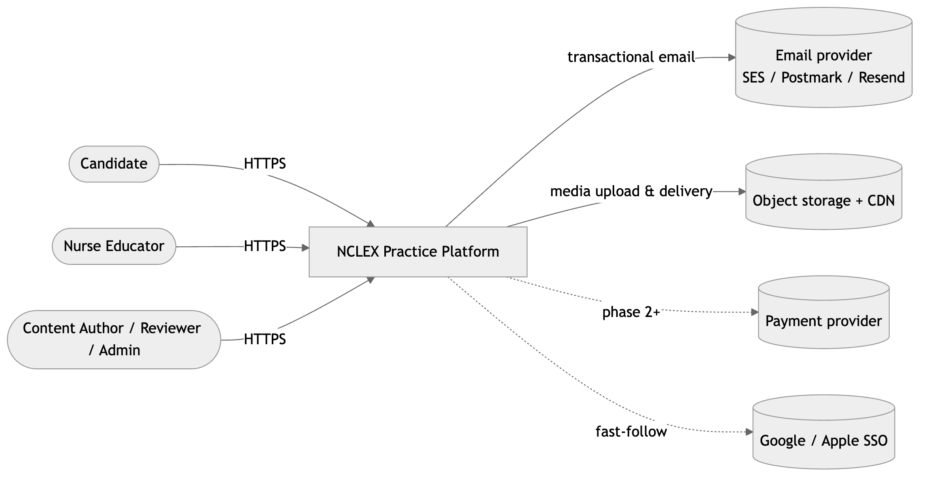
Figure 1: System context

3. Containers
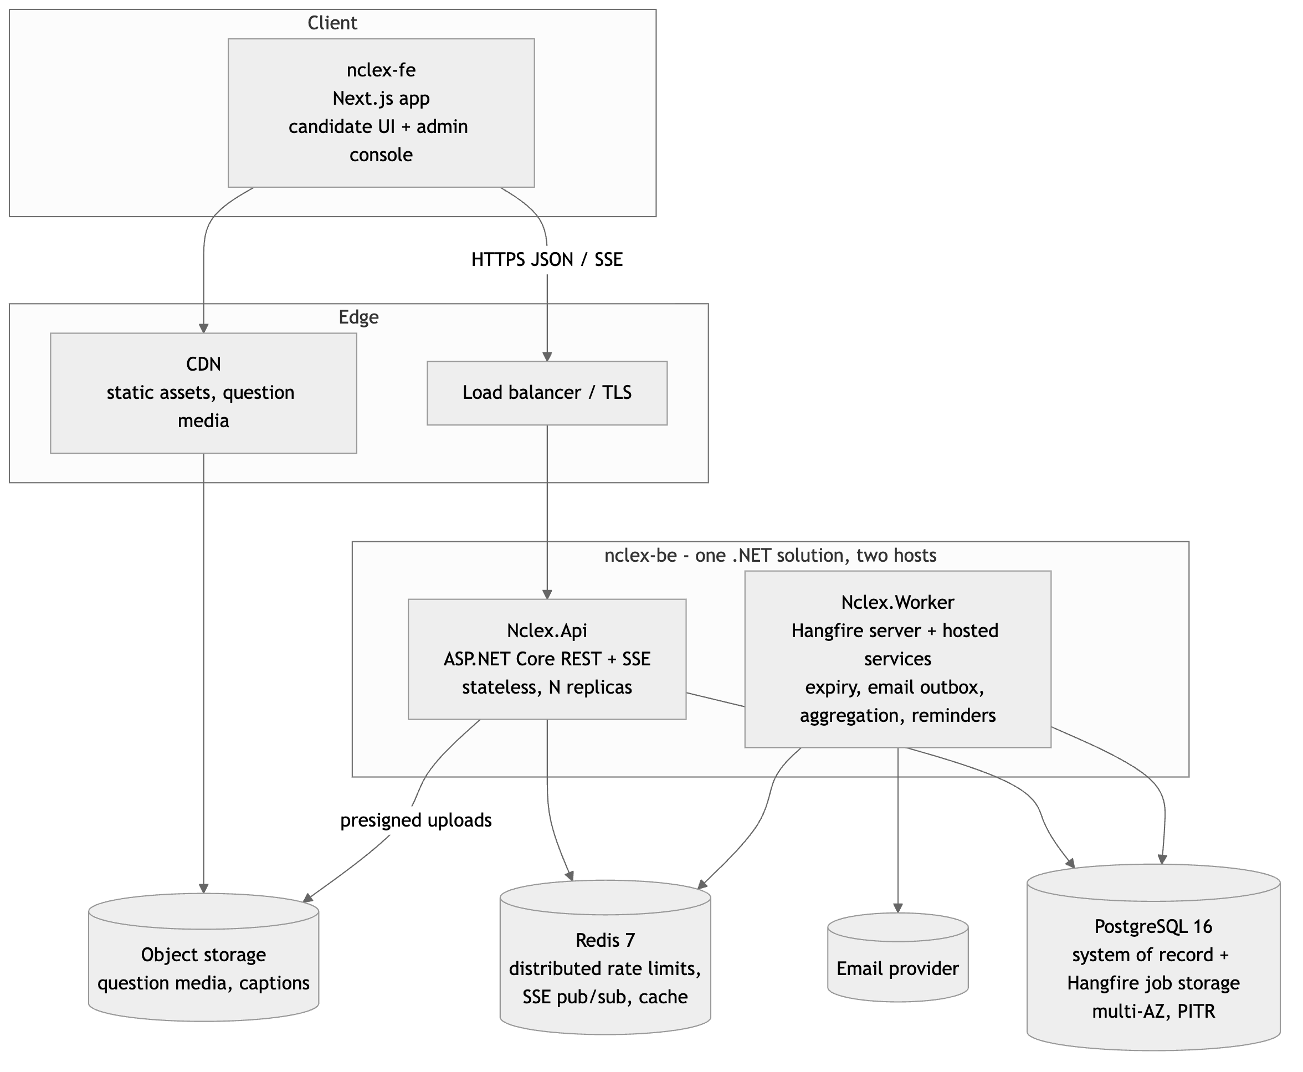
Figure 2: Containers
Why a modular monolith. There is one product team, one domain and strongly transactional workflows: grading writes results, the category breakdown, a notification and an email outbox row together. Microservices would add network failure modes to exactly the paths that must not fail. The modules below have clear boundaries, so the codebase can be split later if it ever needs to be.
Why two hosts. Request latency is kept separate from background work: emails, snapshot aggregation, expiry sweeps and reminders. Both hosts reference the same class libraries, so domain logic is written once.
Why Hangfire on Postgres for jobs. It supports delayed jobs (timer expiry), recurring jobs (sweeper, reminders) and retries, and it stores jobs in the same Postgres database. Jobs therefore survive a Redis outage, and Redis only holds things that can be rebuilt.

4. Backend structure (nclex-be)
Stack: .NET 10 (LTS), ASP.NET Core (controllers), EF Core 10 + Npgsql, Hangfire (PostgreSQL storage), StackExchange.Redis, FluentValidation, Serilog + OpenTelemetry, xUnit + Testcontainers.
nclex-be/
NclexPractice.sln
src/
Nclex.Domain/ no dependencies; pure C#
Entities/ User, Question, QuestionVersion, TestSet, Attempt, AttemptItem, ...
ItemTypes/ one folder per item type: payload records, validator, grader
MultipleChoice/ Sata/ SelectN/ Matrix/ Dropdown/ Highlight/ Calc/ Ordered/ ...
ItemTypeRegistry.cs
Timing/ AttemptTimer (deadline/remaining maths, pause-overrun rule)
Scoring/ ReadinessPolicy, category aggregation
Nclex.Application/ use cases, by feature (vertical slices)
Auth/ Users/ Taxonomy/ Content/ Banks/ TestSets/ Attempts/
Grading/ Analytics/ Notifications/ Flags/ Admin/
Abstractions/ IAppDbContext, IEmailOutbox, INotificationBus, IJobScheduler, IMediaStorage
Nclex.Infrastructure/
Persistence/ AppDbContext, EF configurations, migrations, raw SQL for hot paths
Jobs/ Hangfire job classes (AttemptExpiryJob, ExpirySweeperJob, DraftReminderJob, SnapshotRefreshJob)
Messaging/ Redis pub/sub for SSE fan-out
Email/ provider client + templates
Storage/ S3 presigned URLs
Security/ Argon2id hasher, JWT issuer, refresh token service, rate-limit store
Nclex.Api/ ASP.NET Core host
Controllers/ one per resource group (Auth, Me, Attempts, TestSets, Notifications, Admin*)
Sse/ notifications stream endpoint
Auth/ JWT bearer setup, authorization policies (Role, VerifiedEmail, PlanTier, AttemptOwner)
Middleware/ ProblemDetails mapping, request id, attempt-lease header
Nclex.Worker/ Generic Host: Hangfire server + EmailOutboxDispatcher (BackgroundService)
tests/
Nclex.Domain.Tests/ grader golden fixtures, timer maths
Nclex.Application.Tests/
Nclex.Api.IntegrationTests/ WebApplicationFactory + Testcontainers (Postgres, Redis)
Dependency rule: Domain ← Application ← Infrastructure / Api / Worker. Item types and graders live in Domain and are pure functions over immutable records. This keeps graders unit-testable in isolation, and they carry most of the correctness risk. Inside Application, Attempts and Grading depend on Domain.ItemTypes. Grading also calls Analytics and Notifications through interfaces.
Key library choices:
Need | Choice
ORM / migrations | EF Core 10 + Npgsql. Postgres enums mapped with MapEnum. JSONB columns as JsonDocument or ToJson() owned types.
Hot paths (autosave, builder pool) | Raw SQL through EF SqlQuery / ExecuteSql, or Dapper on the same connection
Background jobs | Hangfire with Hangfire.PostgreSql. Hangfire's minimum interval is one minute, so the email outbox uses its own BackgroundService polling every 2 seconds instead.
Validation | FluentValidation for request DTOs. Item payloads are checked by each item type's own validator.
Auth | Microsoft.AspNetCore.Authentication.JwtBearer, custom refresh-token service, Argon2id (Konscious.Security.Cryptography.Argon2)
Rate limiting | ASP.NET Core rate-limiting middleware, partitioned by IP and email, backed by Redis so limits apply across replicas
Errors | ProblemDetails (RFC 7807) through IExceptionHandler
OpenAPI | Microsoft.AspNetCore.OpenApi (built-in) → /api/v1/openapi.json
SSE | TypedResults.ServerSentEvents (.NET 10) fed by a Redis subscription
Time | TimeProvider injected everywhere, so timer tests can fake the clock

5. Key designs

5.1 Server-authoritative timers
Timers are stored as deadlines while running and remaining milliseconds while paused. The server never counts down; it only compares now() with a deadline.
State | exam_deadline_at | exam_remaining_ms
running | now + remaining | value at last transition (informational)
paused | NULL | authoritative remaining time
untimed | NULL | NULL

The same pair exists per item (item_deadline_at, item_remaining_ms) for per-question timers. It starts when the candidate navigates to an item and freezes when they leave it or pause.
Expiry is enforced three ways. Any one of them is enough on its own.
- On every write. Each attempt mutation runs inside SELECT … FOR UPDATE on the attempt row. If now > deadline + 2s grace, the write is rejected with 409 ATTEMPT_TIME_EXPIRED and the attempt is finalized in the same request.
- Delayed job. Every time a timer starts or resumes, the server schedules a Hangfire job, BackgroundJob.Schedule<AttemptExpiryJob>(j => j.Run(attemptId, timerEpoch), deadline). Pause and resume increment timer_epoch, so stale jobs become no-ops.
- Sweeper cron (every 60s). It finalizes status='in_progress' AND exam_deadline_at < now() - interval '30 s'. It's a Hangfire recurring job and covers any delayed job that was missed or failed.

When an item timer expires, that item is locked with its current response, as PRD §5.2 requires. When the exam timer expires, the whole attempt is auto-submitted and unanswered items are graded as blank (the R.O.O.T. behaviour).
Client display. Every attempt response includes serverNow and the timer block. The client computes offset = serverNow - Date.now() and renders deadline - (Date.now() + offset), so a wrong local clock can't change the time limit.
Pause limits (challenge mode). settings.pause = {maxPauses, maxPauseSec}. On pause the server records pause_started_at. On resume:
remaining = remaining_at_pause - max(0, (now - pause_started_at) - maxPauseSec*1000).
Overrunning a break therefore consumes exam time, as at a real testing centre, and no background job is needed. Practice mode uses maxPauses = null, which means unlimited.

5.2 Autosave and cross-device continuity
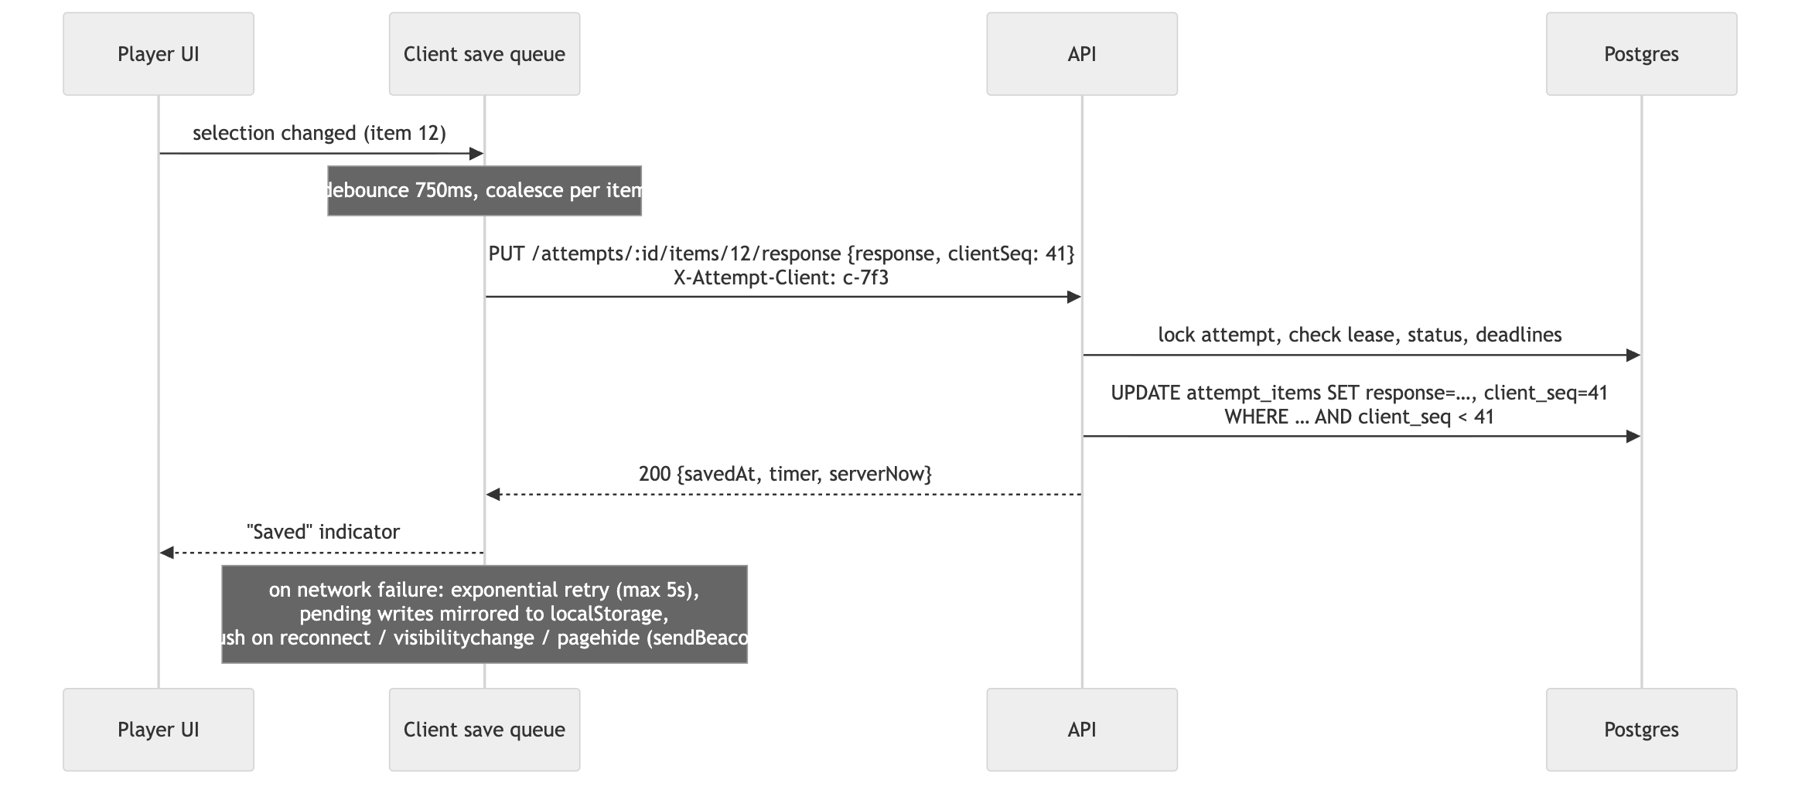
Figure 3: Autosave and cross-device continuity
- Idempotent and ordered. Every client session has a monotonic clientSeq. A write with a stale sequence number is ignored and returns 200 with the current state.
- Single active device (lease). Opening an attempt calls POST /attempts/:id/open with a fresh clientId, which becomes attempts.active_client_id. Writes from any other client return 409 ATTEMPT_OPENED_ELSEWHERE, and the UI offers "Continue here", which re-opens the attempt and takes over the lease. This is what makes desktop → mobile handoff safe.
- Time spent per item is server-derived. It's computed from navigation timestamps minus paused intervals, never sent by the client. This satisfies §5.2 time-per-item analytics without trusting the client.

5.3 Attempt lifecycle
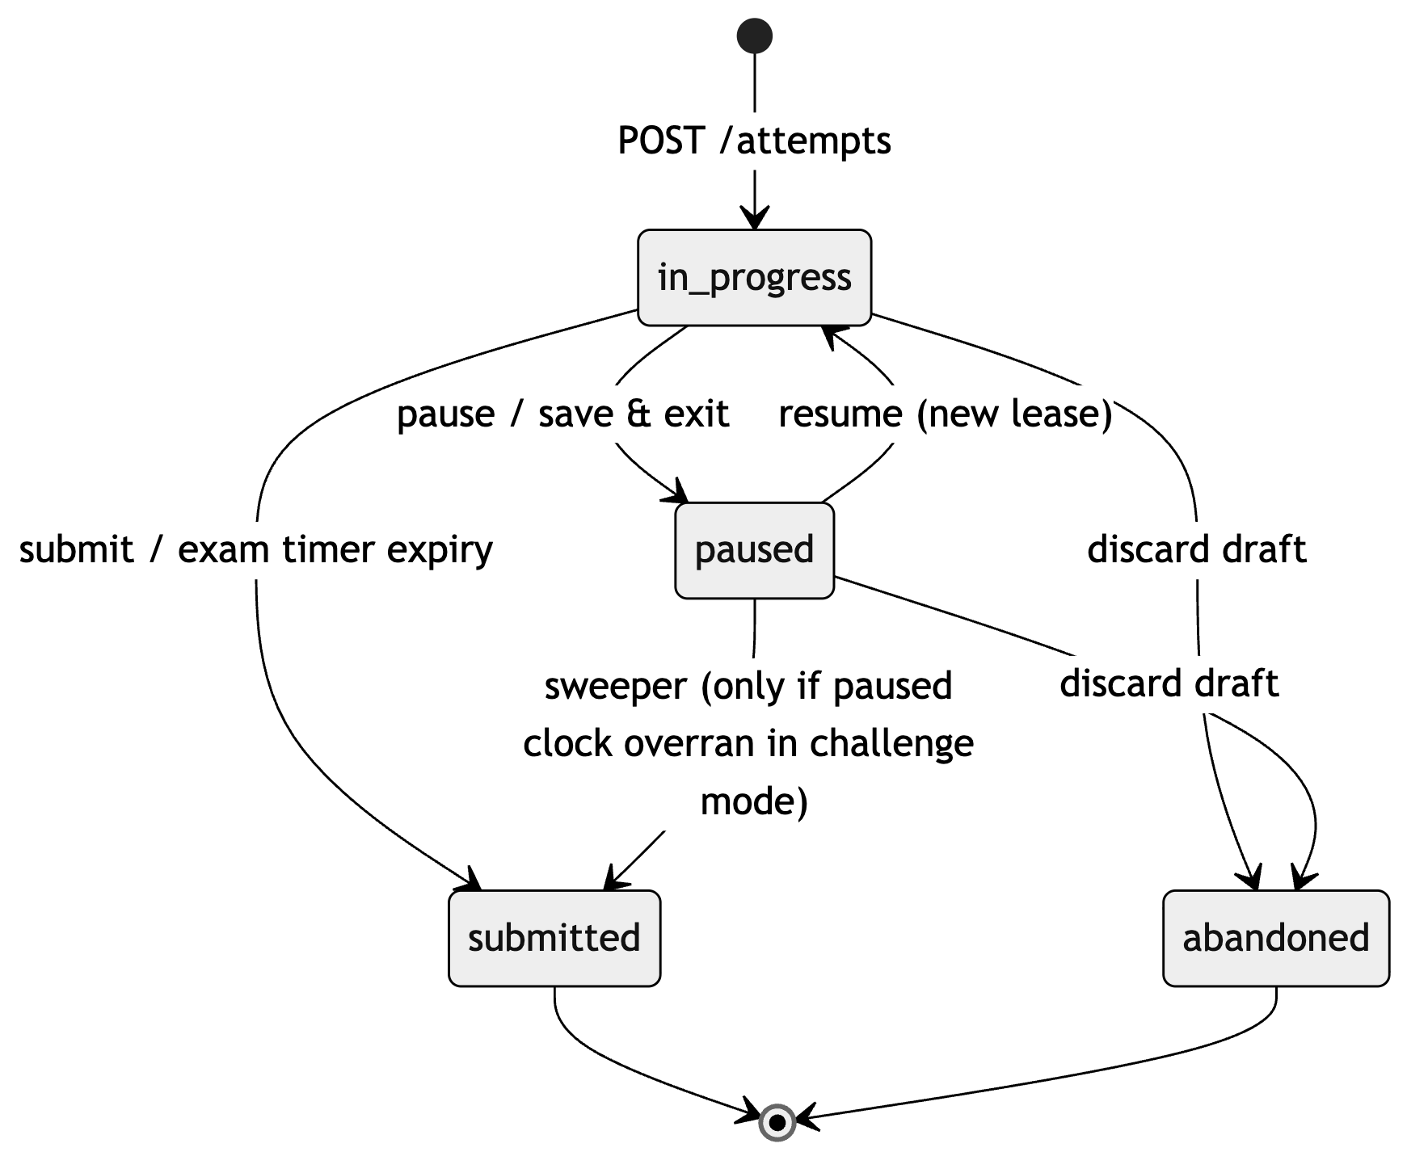
Figure 4: Attempt lifecycle
A draft is any attempt with status in_progress or paused. "Save & Exit" is a pause with reason='save_exit'. Drafts never expire automatically. When last_activity_at is more than 30 days old, the dashboard shows a "resume or discard?" prompt (PRD §5.3), and the reminder job sends a draft_reminder notification after N days of inactivity (configurable, default 3).

5.4 Item-type plug-in model
Every item type is a module implementing one interface (full contract in Interfaces Specification):
Nclex.Domain/ItemTypes/<Type>/
<Type>Payloads.cs records: Content, AnswerKey, Response (System.Text.Json)
<Type>Module.cs implements IItemTypeModule: ValidateAuthoring, ValidateResponse, MaxPoints, Grade, Present
Nclex.Domain.Tests/ItemTypes/<Type>/
fixtures/*.json golden test cases, including the PRD scoring examples
- Content is validated when an author saves a draft, so invalid items can't be published.
- Responses are validated on autosave against the item's content (option IDs must exist, a Select-N response can't exceed N, and so on).
- Graders are pure and deterministic. They are unit-tested with tables of (key, response) → points.
- Graders run only on the server. The frontend has a renderer per type but never sees the key before the reveal.
- Trend, chart/exhibit, audio, video and graphic-option items are not separate types. They are any base item type plus exhibits[] (a flowsheet, chart, media) or options with mediaId. This matches the PRD's note that trend scoring "depends on underlying item type".

MVP types: multiple_choice, sata, select_n, matrix_mc, matrix_mr, multiple_response_grouping, dropdown_cloze, dropdown_table, highlight_text, highlight_table, fill_blank_calc, ordered_response.
Phase 2: drag_drop_cloze, drag_drop_rationale, dropdown_rationale, bowtie, hotspot.

5.5 Grading, results and notification pipeline
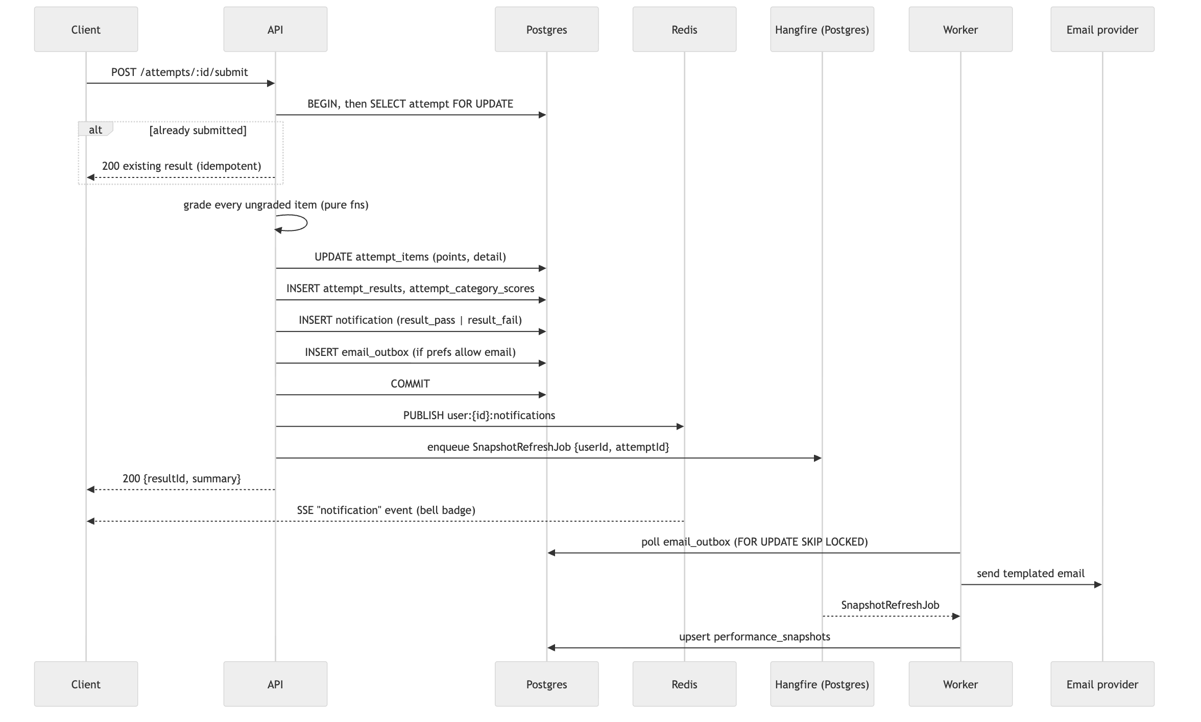
Figure 5: Grading, results and notification pipeline
- Tutor mode grades each item when the candidate submits it, which locks the item and returns the rationale. The final submit grades only the items that are still ungraded.
- Exam mode grades everything at final submit. Rationales are revealed only after that.
- Category breakdown is computed per dimension (client_needs at category and subcategory level, body_system, item_type, cjmm_skill) and stored in attempt_category_scores, so the results page is a single indexed read.
- Readiness (passed, readiness_label) is set only when the set has a pass_threshold. The UI always shows it with an "estimate, not a prediction of the real exam" caveat.
- Transactional outbox. The email is written in the same transaction as the result, so a crash can never produce a result without its notification, or an email without a result.

5.6 Notifications
- Stored per user in notifications, with read state.
- Real-time delivery: the client opens an SSE stream (GET /notifications/stream). API replicas subscribe to the Redis channel user:{id}:notifications, so any replica can deliver to any client. If the stream drops, the client falls back to polling unread-count every 60 seconds.
- Channels: notification_preferences(user, category) → {in_app, email}. Defaults: results and security go to both channels, everything else is in-app only.
- Producers: grading (results), the reminder cron (drafts, streaks), flag resolution (content admin action), and auth (security events).

5.7 Custom test builder
POST /test-sets/custom with filters (categories, systems, item types, difficulty, count, "unused/incorrect only"):
- It builds a candidate pool in SQL: published questions on the user's track and tier, filtered by tags, and optionally excluding questions already answered (user_question_history).
- It samples proportionally to the NCLEX test-plan weights when more than one category is selected, then fills any shortfall at random. Case-study items are kept together as a block of 6.
- It persists a test_sets row (kind='custom', owner_user_id) and its test_set_items, then immediately starts an attempt.

GET /test-sets/custom/available-count gives live counts while the user adjusts the filters.

5.8 CAT adaptive mode (Phase 2, designed now)
The schema already supports it: attempt_items rows are appended one at a time instead of being created up front, and attempts.cat_state holds {theta, se, administered, contentCounts}.
- Model: Rasch (1PL) using question_versions.irt_b. Until real calibration data exists, it's seeded from difficulty tiers (easy = −1, moderate = 0, difficult = +1).
- Selection: maximum information at the current θ, constrained by test-plan content balancing, with randomesque exposure control (pick from the top 5).
- Stopping: the 95% confidence interval excludes the passing standard (after the minimum number of items), or the item maximum is reached, or time runs out (the R.O.O.T. rule). The minimum and maximum are configurable per set and default to 85/150.

6. Security
Concern | Design
Passwords | argon2id (memory 64 MB, t=3), minimum length 10, checked against a breached-password list.
Sessions | Access token: a JWT valid for 15 minutes, sent in the Authorization header. Refresh token: an opaque 256-bit value, stored hashed, sent as an HttpOnly; Secure; SameSite=Strict; Path=/api/v1/auth cookie. It is rotated on every use, and reuse detection revokes the whole token family.
CSRF | The refresh cookie is path-scoped and SameSite=Strict, and the refresh endpoint also requires an X-Requested-With header. All other endpoints use bearer tokens.
Brute force | Redis sliding-window limits: login allows 5 attempts per 15 minutes per (email, IP) and 50 per IP, followed by a temporary lock with a security notification. Forgot-password always returns 202 so it doesn't reveal whether an account exists.
Email tokens | Random tokens, stored hashed, single-use. Verification tokens last 24 hours and reset tokens last 30 minutes. A password reset revokes all refresh sessions (optional, user-chosen).
Authorization | Role guards (candidate, educator, author, reviewer, admin). Every attempt route also checks ownership. Tier guard for premium sets and banks. Verified-email guard for non-sample attempts.
Answer-key secrecy | The key and rationale are separate columns, selected only by the reveal service. A contract test checks that no candidate DTO contains answerKey before the reveal.
Data at rest / in transit | TLS 1.2+ everywhere, encrypted storage (KMS) for Postgres, backups and objects. Premium media can be served through signed CDN URLs.
Privacy | No third-party sharing of performance data. Leaderboards (phase 2) use opt-in display names. Account deletion anonymises attempts and hard-deletes PII.
Audit | audit_events records admin actions (publish, retire, flag resolution, role changes) and security events.

7. Non-functional requirements mapping
NFR (PRD §8) | How it's met
Reliability: autosave and timers | §5.1–5.2. Postgres is the source of truth, writes are idempotent, the client retry queue mirrors to localStorage, and expiry has three enforcement paths.
Performance: render in under 1 second | Item payloads are small (JSON, typically under 10 KB). The next item is prefetched while the current one is answered. Media goes through a CDN with responsive image variants, and video is HLS or short MP4. Item reads are a primary-key lookup. Target API p95 is under 150 ms.
Availability 99.9% | At least 2 API replicas across AZs, multi-AZ Postgres with PITR, health-checked rolling or blue-green deploys, and zero-downtime migrations (expand → migrate → contract). Losing Redis degrades rate limiting and SSE but loses no data.
Security & privacy | §6.
Accessibility WCAG 2.1 AA | Covered in Interfaces Specification §4: every renderer has a keyboard path, and drag-and-drop has a tap-to-place and keyboard alternative.
Device support | Responsive Next.js. The player layout collapses to a single column under 768 px.
Content accuracy | Versioned authoring workflow draft → in_review → approved → published. Only the reviewer role (a qualified nurse educator) can approve. Candidate flags route to a moderation queue.

8. Deployment
Reference target is AWS. Azure is an equally good fit for .NET: App Service or Container Apps, Azure Database for PostgreSQL Flexible Server (zone-redundant HA), Azure Cache for Redis, Blob Storage + Front Door, and Key Vault. For an MVP budget, Fly.io or Render with Neon and Upstash also work.
Component | Service
Frontend | Next.js on Vercel, or a container behind CloudFront
API and worker | ECS Fargate, two container images built from the same solution (Nclex.Api, Nclex.Worker, on the mcr.microsoft.com/dotnet/aspnet:10.0 base), autoscaling on CPU and p95 latency.
Postgres | RDS PostgreSQL 16, Multi-AZ, PITR 14 days, read replica later for analytics
Redis | ElastiCache (Multi-AZ replica)
Media | S3 + CloudFront
Email | SES, Postmark or Resend, with bounce and complaint webhooks
Secrets | AWS Secrets Manager
CI/CD | GitHub Actions. Backend: dotnet format --verify-no-changes → dotnet test (grader fixtures, then integration tests with Testcontainers Postgres/Redis) → publish images → EF Core migration bundle (dotnet ef migrations bundle) → deploy. Frontend: lint → typecheck → build.

Environments: local (docker compose: Postgres, Redis, MinIO, Mailpit; run the API with dotnet watch), staging, production.

9. Observability
- Structured JSON logs that carry a requestId, userId and attemptId.
- OpenTelemetry traces from the API to Postgres and Redis.
- Metrics: autosave success rate and latency, number of ATTEMPT_TIME_EXPIRED rejections, sweeper finalizations (should be close to zero; a spike means the delayed jobs are failing), grading duration, outbox lag, SSE connections.
- Alerts: outbox lag over 60 seconds, autosave error rate over 1%, p95 latency over 500 ms, any failure in the grading transaction.

10. Architecture decisions
# | Decision | Alternatives considered | Reason
ADR-1 | Modular monolith (one .NET solution) with an API host and a worker host | Microservices | Small team; grading and notification must be one transaction.
ADR-2 | PostgreSQL with JSONB item payloads | Document DB; one table per item type | Strong relational core (attempts, results, analytics) plus flexible per-type payloads validated in the application. One question_versions table avoids 18 tables.
ADR-3 | Immutable question versions | Edit in place | Past attempts and reviews must show exactly what the candidate saw.
ADR-4 | Deadline-based timers | Client countdown; server tick | Tamper-proof, no background tick, survives disconnects (PRD §8).
ADR-5 | Synchronous grading on submit | Async grading job | It's milliseconds of CPU, and the candidate sees results immediately.
ADR-6 | SSE for real-time notifications | WebSockets; polling only | Traffic is one-way, works through proxies and is simpler to scale with Redis pub/sub.
ADR-7 | Transactional outbox for email | Send inline | No lost or phantom emails, and provider outages don't block grading.
ADR-8 | OpenAPI-generated TypeScript client for the frontend | Hand-written fetch wrappers | The backend is C# and the frontend is TypeScript, so the OpenAPI document is the single source of truth. CI fails if the generated client is out of date.
ADR-9 | ASP.NET Core (.NET 10 LTS) backend, Next.js frontend | NestJS; Next.js API routes as the backend | Team preference. Strong typing, mature EF Core/Npgsql support for Postgres JSONB and enums, and LTS support until November 2028. The cost is that item payload types are defined twice (C# records and TypeScript); the OpenAPI-generated client and shared grader fixtures keep them in sync.
ADR-10 | Hangfire with Postgres storage for background jobs | Quartz.NET; Redis-backed queue | Delayed and recurring jobs with retries and a dashboard, with no extra infrastructure. Jobs stay durable even if Redis is lost.

