TECHNICAL DESIGN DOCUMENT
Database Design
NCLEX Practice & Mock Examination Platform
Entity relationships, PostgreSQL schema, indexes, invariants, retention and sizing.

Document ID: NCLEX-TDD-02
Version 1.0 · 14 October 2026
Status: Submitted for approval
Prepared by: Muritala .T. Aliyu
Document control
Document | Database Design
Document ID | NCLEX-TDD-02
Version | 1.0
Date | 14 October 2026
Status | Submitted for approval
Prepared by | Muritala .T. Aliyu
Based on | Product Requirements Document v1.0 (August 2026)
Technology stack | Next.js (frontend), .NET 10 / ASP.NET Core (backend), PostgreSQL 16 (database)
Revision history
Version | Date | Author | Description
1.0 | 14 October 2026 | Muritala .T. Aliyu | Initial version submitted for approval
Approval
Signing below confirms that this document is accepted as the basis for implementing the MVP. Approval may be conditional; record any conditions in the Comments column.
Role | Name | Decision | Signature | Date | Comments
Product Owner
Technical Lead / Architect
Engineering Manager
QA Lead
Decision: Approved / Approved with conditions / Rejected
Related documents
Reference | Title
NCLEX-TDD-00 | Design Package Overview
NCLEX-TDD-01 | System Architecture
NCLEX-TDD-03 | API Specification
NCLEX-TDD-04 | Interfaces Specification
PRD v1.0 | Product Requirements Document — NCLEX Practice & Mock Examination Platform (August 2026)

Contents
1. ERD (core)
1.1 Identity, notifications and feedback
1.2 Questions and taxonomy
1.3 Banks and test sets
1.4 Attempts and results
2. DDL
2.1 Extensions and enums
2.2 Identity and auth
2.3 Taxonomy
2.4 Content
2.5 Test sets
2.6 Attempts (session engine)
2.7 Results and analytics
2.8 Notifications
2.9 Content feedback and audit
3. Phase 2 and 3 tables (outline)
4. Data lifecycle and retention
5. Sizing estimate (year 1, for capacity planning)

PostgreSQL 16. All primary keys are uuid (generated with gen_random_uuid()), except small lookup tables, which use smallint. All timestamps are timestamptz in UTC. The backend uses EF Core 10 with the Npgsql provider. Schema changes are EF Core migrations, shipped as a migration bundle. Hot-path statements such as autosave, grading and the builder pool query are hand-written SQL, run through EF ExecuteSql/SqlQuery or Dapper.
EF Core mapping notes:
- Naming: UseSnakeCaseNamingConvention() (EFCore.NamingConventions), so C# PascalCase properties map to the snake_case columns below.
- Enums: Postgres enums are registered with NpgsqlDataSourceBuilder.MapEnum<T>() and modelBuilder.HasPostgresEnum<T>().
- JSONB: item payload columns (content, answer_key, rationale, response, grade_detail) are JsonDocument. Each item type deserializes them into its own records. Fixed-shape JSON (settings, pause_policy) uses ToJson() owned types.
- Concurrency: attempt writes take SELECT … FOR UPDATE inside an explicit transaction, not EF optimistic concurrency.
- citext, inet, bytea, text[] map to string, IPAddress, byte[] and string[].
- Postgres-only features such as partial indexes, generated columns and CHECK constraints are declared with HasFilter, HasComputedColumnSql and ToTable(t => t.HasCheckConstraint(…)), or with raw SQL in a migration.

Mapping to the PRD §9 data model:
PRD entity | Table(s)
User | users, refresh_sessions, email_tokens
QuestionBank | question_banks, question_bank_items
Question | questions + immutable question_versions (+ case_studies, media_assets)
Exam / TestSet | test_sets, test_set_items
Attempt | attempts
Response | attempt_items (one row per item in the attempt, created before it's answered)
PerformanceSnapshot | performance_snapshots (+ per-attempt attempt_results, attempt_category_scores)
Notebook / Flashcard | notebook_entries, flashcards (phase 2)
Notification | notifications, notification_preferences, email_outbox

1. ERD (core)
The model is split into four areas so each diagram stays readable. Tables that appear in more than one diagram (users, questions, question_versions, test_sets, attempts) are the links between areas.

1.1 Identity, notifications and feedback
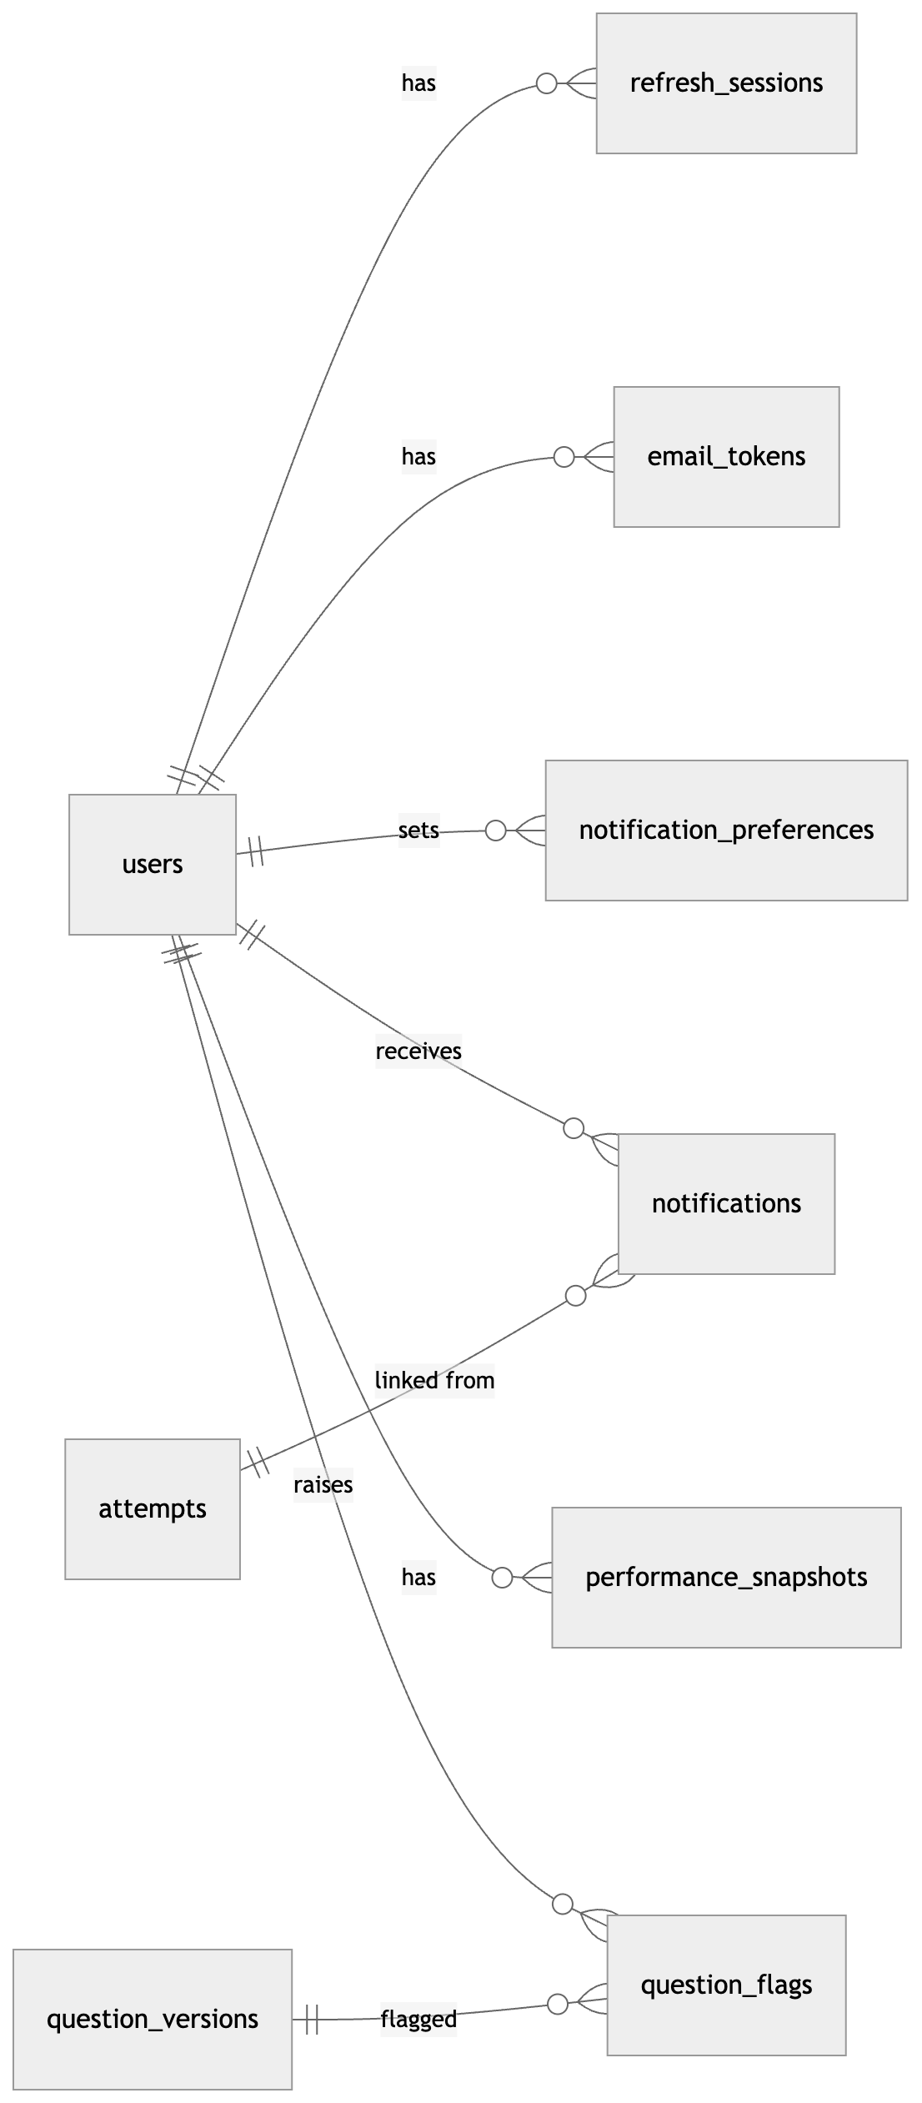
Figure 1: Identity, notifications and feedback

1.2 Questions and taxonomy
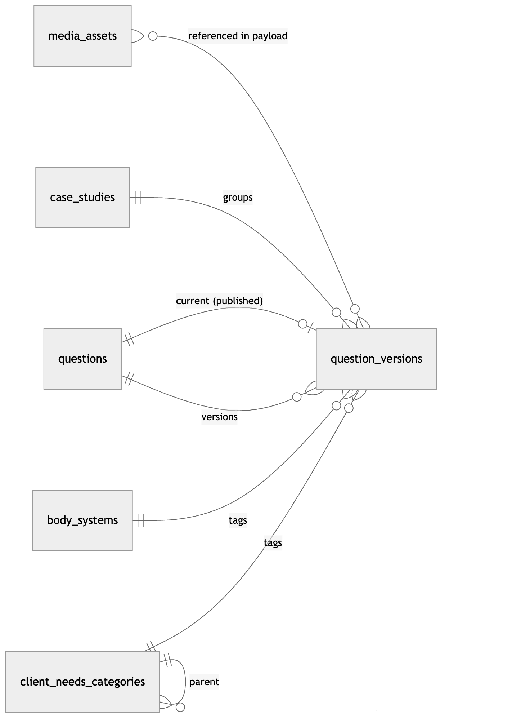
Figure 2: Questions and taxonomy

1.3 Banks and test sets
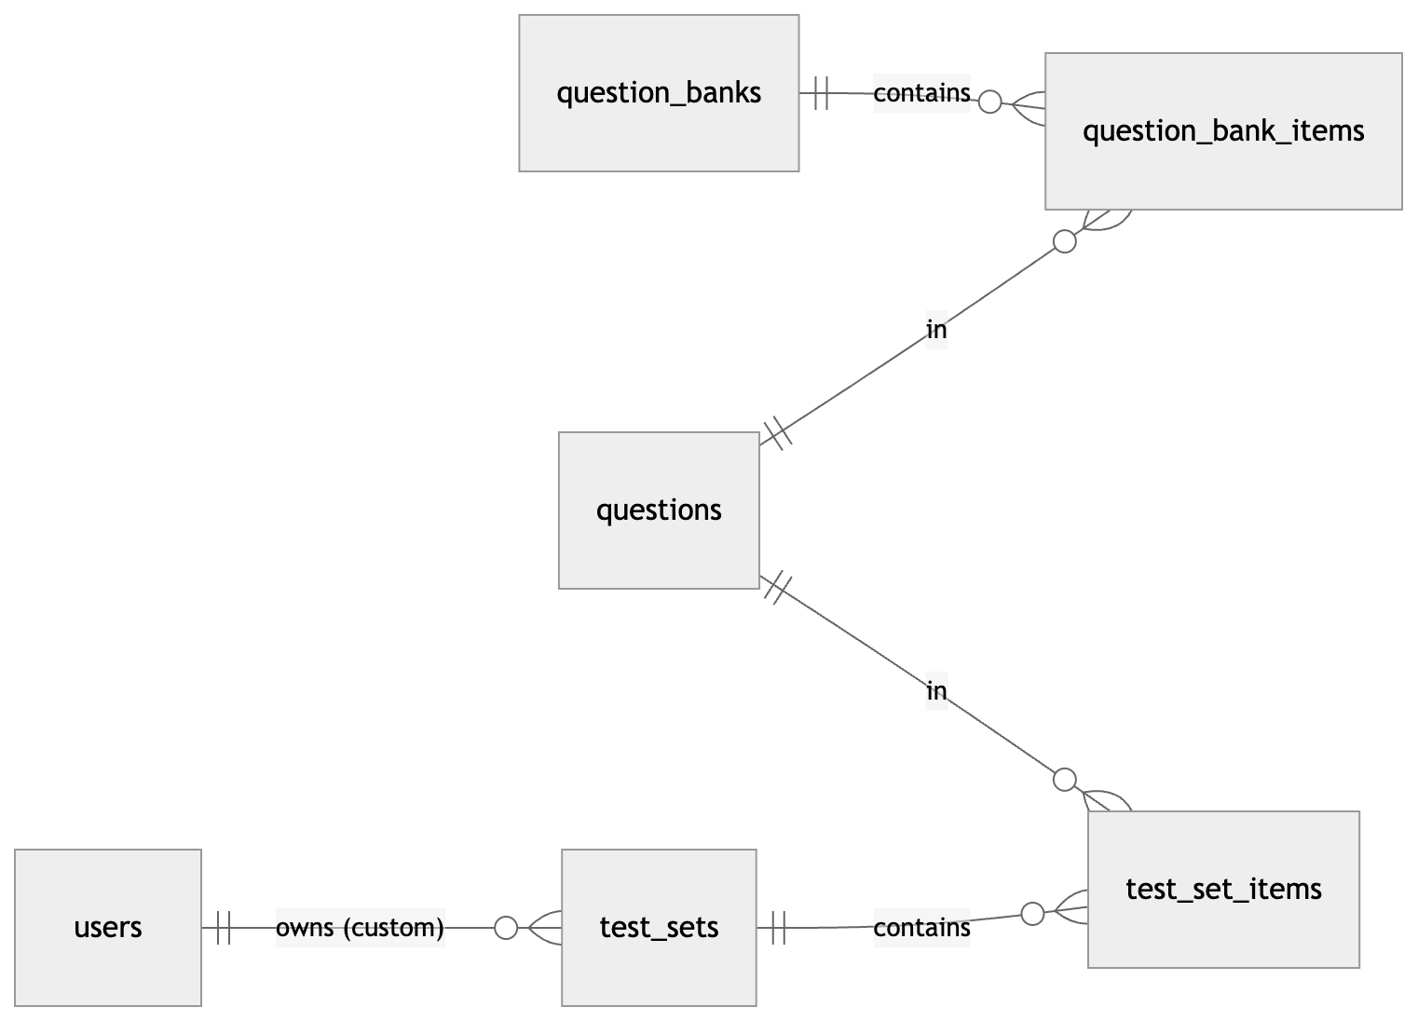
Figure 3: Banks and test sets

1.4 Attempts and results
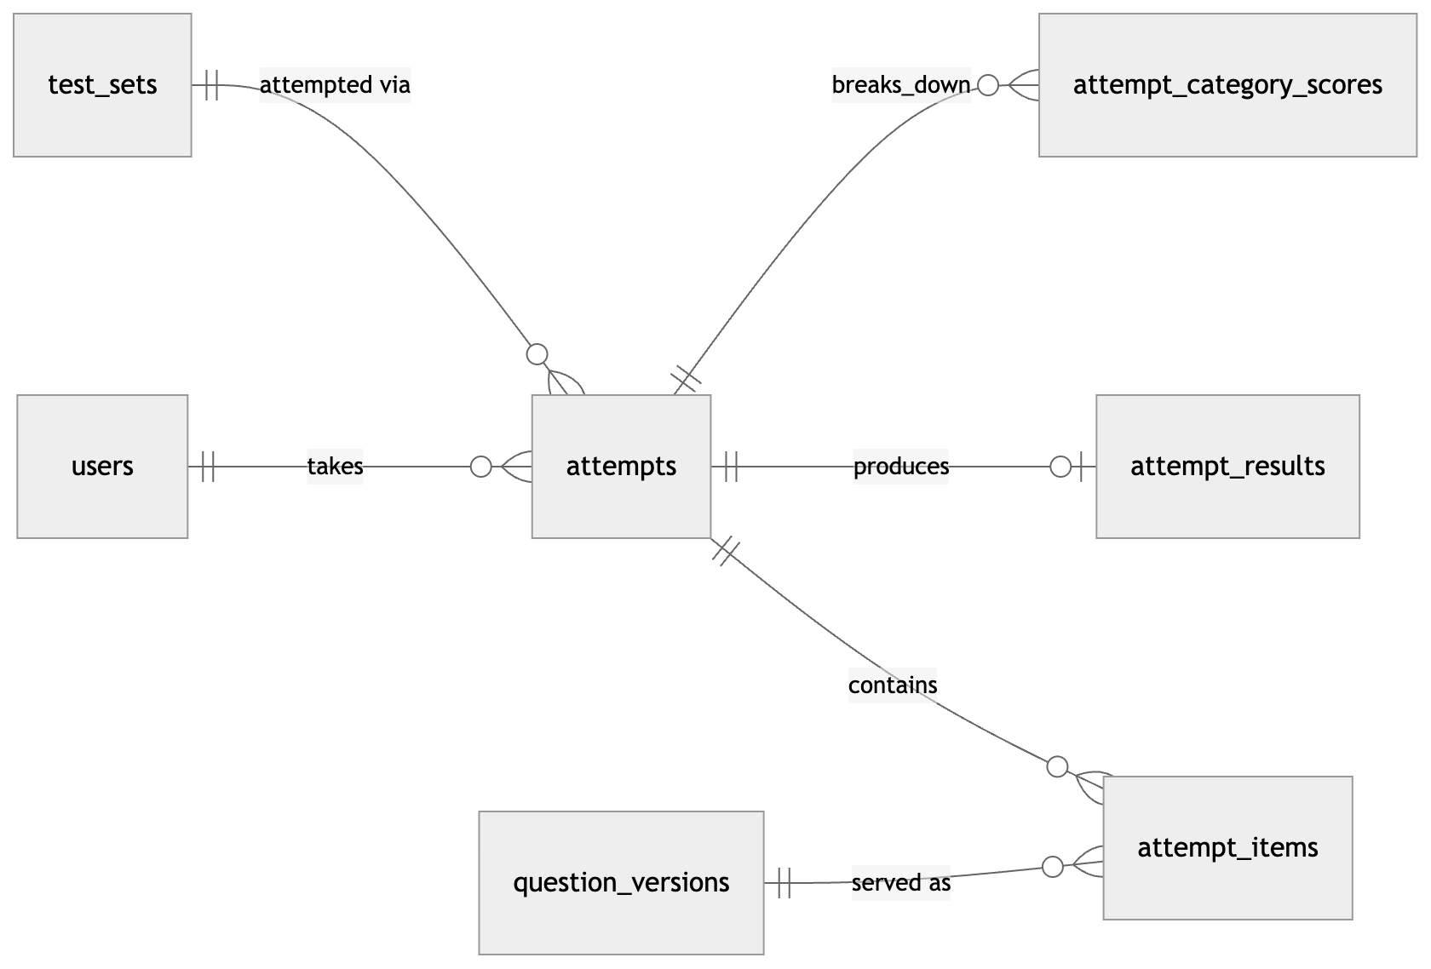
Figure 4: Attempts and results

2. DDL

2.1 Extensions and enums
CREATE EXTENSION IF NOT EXISTS pgcrypto; -- gen_random_uuid()
CREATE EXTENSION IF NOT EXISTS citext; -- case-insensitive email
CREATE TYPE exam_track AS ENUM ('RN','PN');
CREATE TYPE user_role AS ENUM ('candidate','educator','author','reviewer','admin');
CREATE TYPE plan_tier AS ENUM ('free','premium');
CREATE TYPE email_token_purpose AS ENUM ('verify_email','reset_password','change_email');
CREATE TYPE item_type AS ENUM (
'multiple_choice','sata','select_n',
'matrix_mc','matrix_mr','multiple_response_grouping',
'dropdown_cloze','dropdown_table','dropdown_rationale',
'highlight_text','highlight_table',
'fill_blank_calc','ordered_response',
'drag_drop_cloze','drag_drop_rationale','bowtie','hotspot'
);
-- Trend / chart / exhibit / audio / video / graphic-option = base type + exhibits (see architecture §5.4)
CREATE TYPE difficulty_tier AS ENUM ('easy','moderate','difficult');
CREATE TYPE cjmm_skill AS ENUM ('recognize_cues','analyze_cues','prioritize_hypotheses',
'generate_solutions','take_action','evaluate_outcomes');
CREATE TYPE version_status AS ENUM ('draft','in_review','approved','published','superseded','rejected');
CREATE TYPE question_status AS ENUM ('active','retired');
CREATE TYPE test_set_kind AS ENUM ('prebuilt','custom','cat','assigned');
CREATE TYPE test_mode AS ENUM ('practice','challenge','cat');
CREATE TYPE reveal_mode AS ENUM ('tutor','exam');
CREATE TYPE attempt_status AS ENUM ('in_progress','paused','submitted','abandoned');
CREATE TYPE submit_reason AS ENUM ('user','time_expired','cat_stop');
CREATE TYPE item_state AS ENUM ('unseen','seen','answered','locked'); -- locked = submitted (tutor) or item timer expired
CREATE TYPE notification_type AS ENUM ('result_pass','result_fail','result_ready','draft_reminder',
'streak','goal_met','flag_resolved','security','system');
CREATE TYPE notification_category AS ENUM ('results','reminders','engagement','content','security');
CREATE TYPE flag_reason AS ENUM ('rationale_unclear','incorrect_answer_key','typo','outdated_guideline',
'media_problem','other');
CREATE TYPE flag_status AS ENUM ('open','triaged','resolved','rejected');

2.2 Identity and auth
CREATE TABLE users (
id uuid PRIMARY KEY DEFAULT gen_random_uuid(),
email citext NOT NULL UNIQUE,
password_hash text, -- NULL only for future SSO-only accounts
email_verified_at timestamptz,
role user_role NOT NULL DEFAULT 'candidate',
track exam_track NOT NULL,
plan_tier plan_tier NOT NULL DEFAULT 'free',
display_name text,
timezone text NOT NULL DEFAULT 'UTC',
target_exam_date date,
locked_until timestamptz, -- set after repeated failed logins
password_changed_at timestamptz,
created_at timestamptz NOT NULL DEFAULT now(),
updated_at timestamptz NOT NULL DEFAULT now(),
deleted_at timestamptz
);
CREATE TABLE refresh_sessions (
id uuid PRIMARY KEY DEFAULT gen_random_uuid(),
user_id uuid NOT NULL REFERENCES users(id) ON DELETE CASCADE,
family_id uuid NOT NULL, -- rotation chain; reuse => revoke family
token_hash bytea NOT NULL UNIQUE, -- sha256(token)
user_agent text,
ip inet,
created_at timestamptz NOT NULL DEFAULT now(),
last_used_at timestamptz NOT NULL DEFAULT now(),
expires_at timestamptz NOT NULL, -- e.g. 30 days
revoked_at timestamptz,
replaced_by uuid REFERENCES refresh_sessions(id)
);
CREATE INDEX ON refresh_sessions (user_id) WHERE revoked_at IS NULL;
CREATE INDEX ON refresh_sessions (family_id);
CREATE TABLE email_tokens (
id uuid PRIMARY KEY DEFAULT gen_random_uuid(),
user_id uuid NOT NULL REFERENCES users(id) ON DELETE CASCADE,
purpose email_token_purpose NOT NULL,
token_hash bytea NOT NULL UNIQUE,
new_email citext, -- change_email only
expires_at timestamptz NOT NULL,
consumed_at timestamptz,
created_at timestamptz NOT NULL DEFAULT now()
);
CREATE INDEX ON email_tokens (user_id, purpose) WHERE consumed_at IS NULL;

2.3 Taxonomy
CREATE TABLE client_needs_categories (
id smallserial PRIMARY KEY,
track exam_track NOT NULL,
parent_id smallint REFERENCES client_needs_categories(id),
code text NOT NULL, -- e.g. 'SECE', 'SECE.MOC'
name text NOT NULL, -- e.g. 'Management of Care'
weight_min numeric(5,2), -- 15.00
weight_max numeric(5,2), -- 21.00
sort_order smallint NOT NULL DEFAULT 0,
UNIQUE (track, code)
);
-- Leaf rows are the "subcategory" (or the category itself when it has no subcategories,
-- e.g. Psychosocial Integrity). Questions are always tagged to a leaf.
CREATE TABLE body_systems (
id smallserial PRIMARY KEY,
slug text NOT NULL UNIQUE, -- 'cardiovascular', 'pharmacology', ...
name text NOT NULL
);
Seed data for RN follows PRD §2.4. The PN test plan is seeded separately because its categories and weights differ.

2.4 Content
CREATE TABLE media_assets (
id uuid PRIMARY KEY DEFAULT gen_random_uuid(),
kind text NOT NULL CHECK (kind IN ('image','audio','video')),
storage_key text NOT NULL UNIQUE,
mime_type text NOT NULL,
bytes bigint NOT NULL,
width int, height int, duration_ms int,
alt_text text, -- required for images before publish
captions_key text, -- WebVTT, required for audio/video before publish
created_by uuid REFERENCES users(id),
created_at timestamptz NOT NULL DEFAULT now()
);
CREATE TABLE case_studies ( -- NGN unfolding case (usually 6 items)
id uuid PRIMARY KEY DEFAULT gen_random_uuid(),
track exam_track NOT NULL,
title text NOT NULL,
scenario jsonb NOT NULL, -- tabs: nurses' notes, vitals, labs, orders, history
created_at timestamptz NOT NULL DEFAULT now()
);
CREATE TABLE questions ( -- stable identity of an item across edits
id uuid PRIMARY KEY DEFAULT gen_random_uuid(),
track exam_track NOT NULL,
status question_status NOT NULL DEFAULT 'active',
current_version_id uuid, -- FK added below; the published version
access_tier plan_tier NOT NULL DEFAULT 'free',
created_by uuid REFERENCES users(id),
created_at timestamptz NOT NULL DEFAULT now(),
retired_at timestamptz
);
CREATE TABLE question_versions ( -- immutable once status leaves 'draft'
id uuid PRIMARY KEY DEFAULT gen_random_uuid(),
question_id uuid NOT NULL REFERENCES questions(id),
version int NOT NULL,
status version_status NOT NULL DEFAULT 'draft',
item_type item_type NOT NULL,
stem text NOT NULL, -- sanitized Markdown
content jsonb NOT NULL, -- render payload (options, grid, blanks...) — safe to send
answer_key jsonb NOT NULL, -- NEVER sent to candidates before reveal
rationale jsonb NOT NULL, -- per-option + correct explanation; hidden until reveal
educational_objective text NOT NULL,
exhibits jsonb NOT NULL DEFAULT '[]', -- charts, flowsheets (trend), media refs
client_needs_id smallint NOT NULL REFERENCES client_needs_categories(id),
body_system_id smallint NOT NULL REFERENCES body_systems(id),
cjmm_skill cjmm_skill,
difficulty difficulty_tier NOT NULL,
irt_a numeric(6,3), -- discrimination (future)
irt_b numeric(6,3), -- difficulty (CAT)
irt_c numeric(6,3), -- guessing (future)
time_allotment_sec int NOT NULL DEFAULT 120 CHECK (time_allotment_sec > 0),
max_points smallint NOT NULL CHECK (max_points > 0), -- derived from key at save time
case_study_id uuid REFERENCES case_studies(id),
case_position smallint, -- 1..6 within case study
author_id uuid NOT NULL REFERENCES users(id),
reviewer_id uuid REFERENCES users(id),
review_notes text,
reviewed_at timestamptz,
published_at timestamptz,
created_at timestamptz NOT NULL DEFAULT now(),
UNIQUE (question_id, version),
CHECK ((case_study_id IS NULL) = (case_position IS NULL))
);
ALTER TABLE questions
ADD CONSTRAINT questions_current_version_fk
FOREIGN KEY (current_version_id) REFERENCES question_versions(id);
-- Builder pool query: filter by tags on published current versions
CREATE INDEX qv_filter_idx ON question_versions (client_needs_id, body_system_id, item_type, difficulty)
WHERE status = 'published';
CREATE INDEX qv_question_idx ON question_versions (question_id, version DESC);
CREATE INDEX qv_review_queue_idx ON question_versions (status, created_at) WHERE status = 'in_review';
CREATE TABLE question_banks (
id uuid PRIMARY KEY DEFAULT gen_random_uuid(),
track exam_track NOT NULL,
name text NOT NULL,
description text,
access_tier plan_tier NOT NULL DEFAULT 'free',
is_published boolean NOT NULL DEFAULT false,
created_at timestamptz NOT NULL DEFAULT now()
);
CREATE TABLE question_bank_items (
bank_id uuid REFERENCES question_banks(id) ON DELETE CASCADE,
question_id uuid REFERENCES questions(id),
PRIMARY KEY (bank_id, question_id)
);
Rules enforced in the application:
- A version's content, answer_key and rationale are validated against the item type's schema on every save. Every option ID in content must have an entry in rationale.perOption (PRD §5.1: a "why" for every option).
- Publishing a version sets the previous published version to superseded and updates questions.current_version_id in one transaction.
- Only reviewer and admin roles can move a version in_review → approved. Authors can't approve their own versions (reviewer_id <> author_id).

2.5 Test sets
CREATE TABLE test_sets (
id uuid PRIMARY KEY DEFAULT gen_random_uuid(),
track exam_track NOT NULL,
kind test_set_kind NOT NULL,
owner_user_id uuid REFERENCES users(id), -- custom sets only
title text NOT NULL,
description text,
mode test_mode NOT NULL DEFAULT 'practice',
reveal_mode reveal_mode NOT NULL DEFAULT 'tutor',
timed boolean NOT NULL DEFAULT false,
per_question_sec int, -- NULL = no per-item timer
time_budget_sec int, -- NULL = no exam timer
pass_threshold numeric(5,4), -- 0.6500; NULL = no pass/fail estimate
pause_policy jsonb NOT NULL DEFAULT '{"maxPauses":null,"maxPauseSec":null}',
allow_back_nav boolean NOT NULL DEFAULT true,
is_sample boolean NOT NULL DEFAULT false, -- startable by unverified users
access_tier plan_tier NOT NULL DEFAULT 'free',
is_published boolean NOT NULL DEFAULT false,
generator_criteria jsonb, -- custom builder filters (for "retake similar")
cat_config jsonb, -- {minItems, maxItems, passingTheta} for CAT
question_count int NOT NULL,
created_at timestamptz NOT NULL DEFAULT now(),
CHECK (kind <> 'custom' OR owner_user_id IS NOT NULL),
CHECK (NOT timed OR per_question_sec IS NOT NULL OR time_budget_sec IS NOT NULL)
);
CREATE INDEX ON test_sets (track, kind) WHERE is_published;
CREATE INDEX ON test_sets (owner_user_id) WHERE kind = 'custom';
CREATE TABLE test_set_items (
test_set_id uuid REFERENCES test_sets(id) ON DELETE CASCADE,
position int NOT NULL,
question_id uuid NOT NULL REFERENCES questions(id), -- resolved to current version at attempt start
PRIMARY KEY (test_set_id, position),
UNIQUE (test_set_id, question_id)
);

2.6 Attempts (session engine)
CREATE TABLE attempts (
id uuid PRIMARY KEY DEFAULT gen_random_uuid(),
user_id uuid NOT NULL REFERENCES users(id),
test_set_id uuid NOT NULL REFERENCES test_sets(id),
track exam_track NOT NULL,
status attempt_status NOT NULL DEFAULT 'in_progress',
settings jsonb NOT NULL, -- snapshot of mode/reveal/timing/pause policy/threshold at start
total_items int NOT NULL,
current_position int NOT NULL DEFAULT 1,
-- exam-level timer (architecture §5.1)
exam_deadline_at timestamptz, -- non-NULL only while running and timed
exam_remaining_ms bigint, -- authoritative while paused
timer_epoch int NOT NULL DEFAULT 0, -- bumps on pause/resume; invalidates delayed expiry jobs
-- pause
pauses_used smallint NOT NULL DEFAULT 0,
pause_started_at timestamptz,
pause_reason text CHECK (pause_reason IN ('break','save_exit')),
total_paused_ms bigint NOT NULL DEFAULT 0,
-- device lease (architecture §5.2)
active_client_id text,
lease_acquired_at timestamptz,
cat_state jsonb, -- phase 2: {theta, se, contentCounts}
started_at timestamptz NOT NULL DEFAULT now(),
last_activity_at timestamptz NOT NULL DEFAULT now(),
submitted_at timestamptz,
submit_reason submit_reason,
CHECK (status <> 'submitted' OR submitted_at IS NOT NULL),
CHECK (status <> 'paused' OR exam_deadline_at IS NULL)
);
CREATE INDEX attempts_drafts_idx ON attempts (user_id, last_activity_at DESC)
WHERE status IN ('in_progress','paused');
CREATE INDEX attempts_history_idx ON attempts (user_id, submitted_at DESC) WHERE status = 'submitted';
CREATE INDEX attempts_expiry_idx ON attempts (exam_deadline_at) WHERE status = 'in_progress'; -- sweeper
CREATE TABLE attempt_items (
attempt_id uuid NOT NULL REFERENCES attempts(id) ON DELETE CASCADE,
position int NOT NULL,
question_version_id uuid NOT NULL REFERENCES question_versions(id),
state item_state NOT NULL DEFAULT 'unseen',
response jsonb, -- validated against item type's response schema
client_seq int NOT NULL DEFAULT 0,
flagged boolean NOT NULL DEFAULT false, -- "mark for review" (not a content flag)
struck_options jsonb NOT NULL DEFAULT '[]', -- strike-through tool (phase 3 UI; stored now)
-- time tracking (server-derived)
entered_at timestamptz, -- set when navigated to; cleared on leave/pause
time_spent_ms bigint NOT NULL DEFAULT 0,
item_deadline_at timestamptz,
item_remaining_ms int,
-- grading
points_earned numeric(6,2),
max_points smallint,
is_correct boolean, -- points_earned = max_points
grade_detail jsonb, -- per-target +1/-1/0 (partial-credit visibility, PRD §5.6)
graded_at timestamptz,
locked_at timestamptz,
answered_at timestamptz,
PRIMARY KEY (attempt_id, position)
);
Invariants:
- Every mutation of an attempt or its items first runs SELECT … FROM attempts WHERE id=$1 FOR UPDATE. That serialises writes per attempt, which is cheap because only one device holds the lease.
- An attempt_items row with state='locked' is never written again.
- question_version_id is fixed when the item is created, so a later edit to the question never changes this attempt.

2.7 Results and analytics
CREATE TABLE attempt_results (
attempt_id uuid PRIMARY KEY REFERENCES attempts(id) ON DELETE CASCADE,
points_earned numeric(8,2) NOT NULL,
max_points numeric(8,2) NOT NULL,
score_pct numeric(5,4) NOT NULL,
items_correct int NOT NULL,
items_answered int NOT NULL,
items_total int NOT NULL,
total_time_ms bigint NOT NULL,
avg_time_ms int NOT NULL,
pass_threshold numeric(5,4),
passed boolean, -- NULL when no threshold
readiness_label text, -- 'likely_ready' | 'needs_more_practice'
cat_theta numeric(6,3), cat_se numeric(6,3),
graded_at timestamptz NOT NULL DEFAULT now()
);
CREATE TABLE attempt_category_scores (
attempt_id uuid REFERENCES attempts(id) ON DELETE CASCADE,
dimension text NOT NULL CHECK (dimension IN ('client_needs','client_needs_parent','body_system','item_type','cjmm_skill','difficulty')),
dimension_key text NOT NULL, -- category code, system slug, item_type...
items int NOT NULL,
items_correct int NOT NULL,
points_earned numeric(8,2) NOT NULL,
max_points numeric(8,2) NOT NULL,
time_ms bigint NOT NULL,
PRIMARY KEY (attempt_id, dimension, dimension_key)
);
CREATE TABLE performance_snapshots ( -- denormalized, rebuilt incrementally by worker
user_id uuid REFERENCES users(id) ON DELETE CASCADE,
track exam_track NOT NULL,
dimension text NOT NULL,
dimension_key text NOT NULL,
items_answered int NOT NULL,
items_correct int NOT NULL,
points_earned numeric(10,2) NOT NULL,
max_points numeric(10,2) NOT NULL,
accuracy numeric(5,4) GENERATED ALWAYS AS
(CASE WHEN max_points > 0 THEN points_earned / max_points ELSE 0 END) STORED,
avg_time_ms int NOT NULL,
attempts_count int NOT NULL,
last_attempt_id uuid, -- idempotency guard for incremental updates
updated_at timestamptz NOT NULL DEFAULT now(),
PRIMARY KEY (user_id, track, dimension, dimension_key)
);
CREATE TABLE user_question_history ( -- powers "unused only" / "incorrect only" builder filters
user_id uuid REFERENCES users(id) ON DELETE CASCADE,
question_id uuid REFERENCES questions(id),
times_seen int NOT NULL DEFAULT 0,
last_correct boolean,
last_seen_at timestamptz NOT NULL,
PRIMARY KEY (user_id, question_id)
);
Trend charts (PRD §5.6 "historical trend") are read from attempt_category_scores joined to attempts.submitted_at and grouped by week. That's indexed on (user_id, submitted_at), so no extra table is needed.

2.8 Notifications
CREATE TABLE notifications (
id uuid PRIMARY KEY DEFAULT gen_random_uuid(),
user_id uuid NOT NULL REFERENCES users(id) ON DELETE CASCADE,
type notification_type NOT NULL,
category notification_category NOT NULL,
title text NOT NULL,
body text NOT NULL,
data jsonb NOT NULL DEFAULT '{}', -- {scorePct, weakestCategories[], deepLink}
related_attempt_id uuid REFERENCES attempts(id) ON DELETE SET NULL,
channels text[] NOT NULL, -- {'in_app'} | {'in_app','email'}
read_at timestamptz,
created_at timestamptz NOT NULL DEFAULT now()
);
CREATE INDEX notif_feed_idx ON notifications (user_id, created_at DESC);
CREATE INDEX notif_unread_idx ON notifications (user_id) WHERE read_at IS NULL;
CREATE UNIQUE INDEX notif_result_once ON notifications (related_attempt_id)
WHERE type IN ('result_pass','result_fail','result_ready'); -- grading retry can't double-notify
CREATE TABLE notification_preferences (
user_id uuid REFERENCES users(id) ON DELETE CASCADE,
category notification_category NOT NULL,
in_app boolean NOT NULL DEFAULT true,
email boolean NOT NULL,
PRIMARY KEY (user_id, category)
);
-- Defaults are applied at signup: results=email on, security=email on (in-app forced on), others email off.
CREATE TABLE email_outbox (
id uuid PRIMARY KEY DEFAULT gen_random_uuid(),
user_id uuid REFERENCES users(id) ON DELETE CASCADE,
to_email citext NOT NULL,
template text NOT NULL, -- 'verify_email','reset_password','result_pass',...
payload jsonb NOT NULL,
status text NOT NULL DEFAULT 'pending' CHECK (status IN ('pending','sending','sent','failed')),
attempts smallint NOT NULL DEFAULT 0,
send_after timestamptz NOT NULL DEFAULT now(),
sent_at timestamptz,
provider_id text,
last_error text,
created_at timestamptz NOT NULL DEFAULT now()
);
CREATE INDEX outbox_pending_idx ON email_outbox (send_after) WHERE status = 'pending';

2.9 Content feedback and audit
CREATE TABLE question_flags (
id uuid PRIMARY KEY DEFAULT gen_random_uuid(),
user_id uuid NOT NULL REFERENCES users(id),
question_version_id uuid NOT NULL REFERENCES question_versions(id),
attempt_id uuid REFERENCES attempts(id) ON DELETE SET NULL,
reason flag_reason NOT NULL,
comment text CHECK (char_length(comment) <= 2000),
status flag_status NOT NULL DEFAULT 'open',
assignee_id uuid REFERENCES users(id),
resolution_note text, -- shown to the candidate in flag_resolved notification
resolved_by uuid REFERENCES users(id),
resolved_at timestamptz,
created_at timestamptz NOT NULL DEFAULT now(),
UNIQUE (user_id, question_version_id, reason)
);
CREATE INDEX flags_queue_idx ON question_flags (status, created_at) WHERE status IN ('open','triaged');
CREATE TABLE audit_events (
id bigserial PRIMARY KEY,
actor_id uuid REFERENCES users(id),
action text NOT NULL, -- 'question.publish','flag.resolve','auth.login_failed',...
entity_type text, entity_id text,
metadata jsonb NOT NULL DEFAULT '{}',
ip inet,
created_at timestamptz NOT NULL DEFAULT now()
);
CREATE INDEX ON audit_events (entity_type, entity_id);

3. Phase 2 and 3 tables (outline)
These don't affect the MVP schema. They only add tables or nullable columns.
Table | Key columns | Feature
notebook_entries | id, user_id, question_id?, attempt_id?, note_md, tags[], created_at | Digital notebook (§6.1)
flashcards | id, user_id, source (missed_question/rationale/manual), front, back, question_id?, ease (2.5), interval_days, repetitions, due_at | SM-2 spaced repetition
study_plans / study_plan_days | user_id, target_date, daily_goal; day, planned_count, focus_category_ids[] | Study planner
user_daily_activity | user_id, day, items_answered | Streaks and goals (computed from attempt_items, upserted at grading)
achievements, user_achievements | code, name, criteria; user_id, code, earned_at | Achievements
leaderboard_entries | test_set_id, user_id, display_name, score_pct, time_ms | Opt-in challenge leaderboard
subscriptions | user_id, provider, provider_customer_id, status, current_period_end | Paid tier
organizations, cohorts, cohort_members, assignments | org_id; cohort_id, user_id, role; cohort_id, test_set_id, due_at | Educator console (phase 3)
user_identities | user_id, provider, subject | Google / Apple SSO

4. Data lifecycle and retention
- Attempts and results: kept for the life of the account. Abandoned drafts are hard-deleted after 90 days.
- Custom test sets: deleted when they have no attempts and are more than 30 days old.
- refresh_sessions and email_tokens: purged 30 days after expiry.
- email_outbox: sent rows purged after 30 days.
- Account deletion: PII in users is scrubbed (email → deleted+{id}@invalid), sessions are deleted, and attempts are kept anonymised for item statistics such as IRT calibration.
- Backups: continuous WAL archiving / PITR (14 days) plus a daily snapshot copied to a second region.

5. Sizing estimate (year 1, for capacity planning)
Assumptions: 50k users, 10k active per month, about 300 items each per month.
- attempt_items grows by about 3M rows a month, roughly 1.5 KB per row → about 55 GB per year. Postgres handles this comfortably. Hash-partition attempt_items by attempt_id only if it goes past about 500M rows.
- Question content: about 10k versions × about 8 KB → under 100 MB.

