**What is the Internet of Things?**

The [Internet of Things (IoT)](https://www.elprocus.com/application-internet-of-things-iot-future/) is a scenario in which objects, animals or people are provided with single identifiers and the capability to automatically transfer and the capability to automatically transfer data more to a network without requiring human-to-human or human-to-computer communication. IoT has evolved from the meeting of wireless technologies, [micro-electromechanical systems (MEMS)](https://www.elprocus.com/understanding-fabrication-mems/) and the internet.

### IoT Design Methodology

**All web application is developed natively in Java Programming Language. It includes java technologies similar to JSP, servlets, hibernate, and web services, etc., the latest version of net beans IDE is basically used for web application development. Additional technologies like bootstrap, javascript, jQuery, etc are used to handle UI and client-side validations. Cisco provided APIs are used to develop application related to Cisco IP phones**.

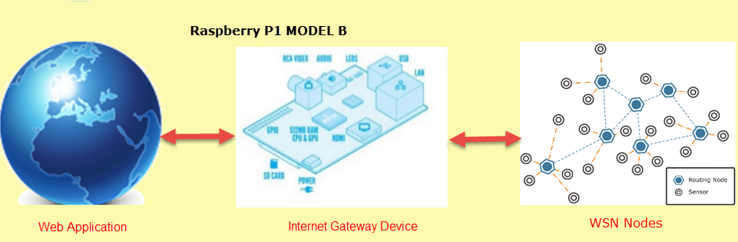IOT uisng Raspberry Pi

Five steps are used in web applications

* Installing Apache Webserver
* Create a My SQL database system
* Developed web application For the GUI (Graphical User Interface)
* Write lots of PHP, JAVA script, CSS and Python Programs for the Web Application
* Host Web application on our Web server

#### Raspberry Pi

The history of the Raspberry Pi was basically introduced in 2006. Its main concept is based on Atmel ATmega644 which is particularly designed for educational use and intended for Python. A Raspberry Pi is of small size i.e., of a credit-card-sized single-board computer, which is developed in the United Kingdom(U.K) by a foundation called Raspberry Pi. The main motto of this foundation is to promote the teaching of basic computer science in the education institutes and also in developing countries. The first generation of Raspberry (Pi 1) was released in the year 2012, which has two types of models namely model A and model B.

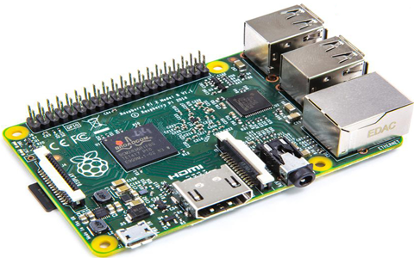Raspberry Pi

In the subsequent year, A+ and B+ models were released. Again in 2015, Raspberry Pi2 model B was released and an immediate year Raspberry Pi3 model B was released in the market.

Raspberry Pi can be plugged into a TV, computer monitor, and it uses a standard keyboard and mouse. It is user-friendly as it can be handled by all the age groups. It does everything you would expect a desktop computer to do like word-processing, browsing the internet spreadsheets, playing games to playing high definition videos. It is used in many applications like in a wide array of digital maker projects, music machines, parent detectors to the weather station and tweeting birdhouses with infrared cameras.

All models feature on a Broadcom system on a chip (SOC), which includes chip graphics processing unit GPU(a Video Core IV), an ARM-compatible and CPU. The CPU speed ranges from 700 MHz to 1.2 GHz for the Pi 3 and onboard memory range from 256 MB to 1 GB RAM. An [operating system](https://www.elprocus.com/different-types-of-computer-operating-systems/) is stored in the secured digital SD cards and program memory in either the MicroSDHC or SDHC sizes. Most boards have one to four USB slots, composite video output, HDMI and a 3.5 mm phone jack for audio. Some models have WiFi and Bluetooth.

The Raspberry Pi Foundation provides Arch Linux ARM and Debian distributions for download, and promotes Python as the main programming language, with support for BBC BASIC, Java, C, Perl, Ruby, PHP, Squeak Smalltalk, C++, etc.

The following are essential to get started

* Video cable to suit the TV or monitor used
* SD card containing Linux Operating system
* Power supply (see Section 1.6 below)
* USB keyboard
* TV or monitor (with DVI, HDMI, Composite or SCART input)

Recommended optional extras include

* Internet connection, Model B only: LAN (Ethernet) cable
* USB mouse
* Powered USB hub
* Internet connection, Model A or B: USB WiFi adaptor

#### What is a System on Chip?

A system on chip is a complex IC that integrates the functional elements into a single chip or chipset. It is a programmable processor on a chip memory, accelerating function hardware, software, hardware, and analog components.

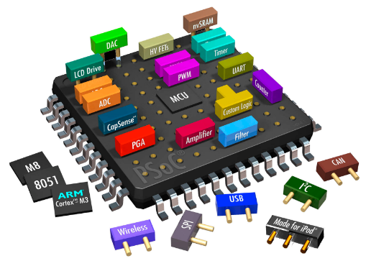System on Chip

**Benefits of SoC**

* Lower power consumption
* Reduces size
* Reduces overall system cost
* Increases performance

#### Internet Gateway Device

Internet Gateway Device has the ability to route data approaching from the WSN network to the internet and Send data coming from the internet to the WSN network. It is like a Wi-Fi router for the Internet of Things. In the internet gateway device, we use raspberry pi model B, it features a quad-core ARM Cortex- A7 CPU is running at 900MHz (for a 6x presentation improve on the first generation Raspberry Pi Model B+) and 1GB of LPDDR2 SDRAM (for a 2x memory increase). And yes, there is total compatibility with Raspberry Pi1 we are secured. Broadcom’s new SoC, the BCM2836, is the key factor.  
Five steps we are using Internet Gateway Device

* Port Linux operating system on Raspberry Pi
* Modify Linux to work with Our Prototype
* Developed Python Library for Communication of RPI with Xbee ZB
* Wrote Program from sensors and Device controlling
* Create WI-FI functionality on RPI for Internet Connection

#### WSN Nodes

A wireless sensor network (WSN) consists of three main components: nodes, gateways, and software. The spatially dispersed measurement nodes interface with the sensors to monitor assets or their surroundings. The acquired information is wirelessly transmitted to the gateway, which provides a connection to the wired globe where you can collect, procedure, analyze, and present your measurement information using the software. Routers are an individual type of dimension node that you can use to expand the distance and dependability in a WSN. Sensors can be dispersed on the roads, vehicles, hospitals, buildings, people and allow dissimilar applications such as medical services, battlefield operations, disaster response, disaster relief, and environmental monitoring.

#### IoT Applications

* Weather security and temperature cam
* The working doctor who props with raspberry pi
* Sensually an air quality monitoring hat
* Beer and wine fridge of awesomeness
* Raspberry pi Internet doorbell
* Internet of things toilet
* Train your rat behavioral science at home
* Pebbly smart doorbell
* The raspberry pi microwave

This is all about IoT using Raspberry Pi. Currently, IoT is made up of a loose collection of different, purpose-built networks. Today’s cars, intended, for example, have multiple networks to control engine function, safety features, communication system, and so on. Commercial and residential buildings also have various control systems for heating, venting, and air condition (HVAC), telephone service, security, and lighting.

As IoT evolves, these networks and a lot of others will be connected with additional security, analytics, and management capabilities. This will allow IoT to become even more powerful in what it can help people achieve. Furthermore, any queries regarding this concept or  please give your valuable suggestions by commenting in the comment section below.

import qwiic_bme280

import time

import sys

def runExample():

print("\nSparkFun BME280 Sensor Example 1\n")

mySensor = qwiic_bme280.QwiicBme280()

if mySensor.isConnected() == False:

print("The Qwiic BME280 device isn't connected to the system. Please check your connection", \

file=sys.stderr)

return

mySensor.begin()

while True:

print("Humidity:\t%.3f" % mySensor.humidity)

print("Pressure:\t%.3f" % mySensor.pressure)

print("Altitude:\t%.3f" % mySensor.altitude_feet)

print("Temperature:\t%.2f" % mySensor.temperature_fahrenheit)

print("")

time.sleep(1)