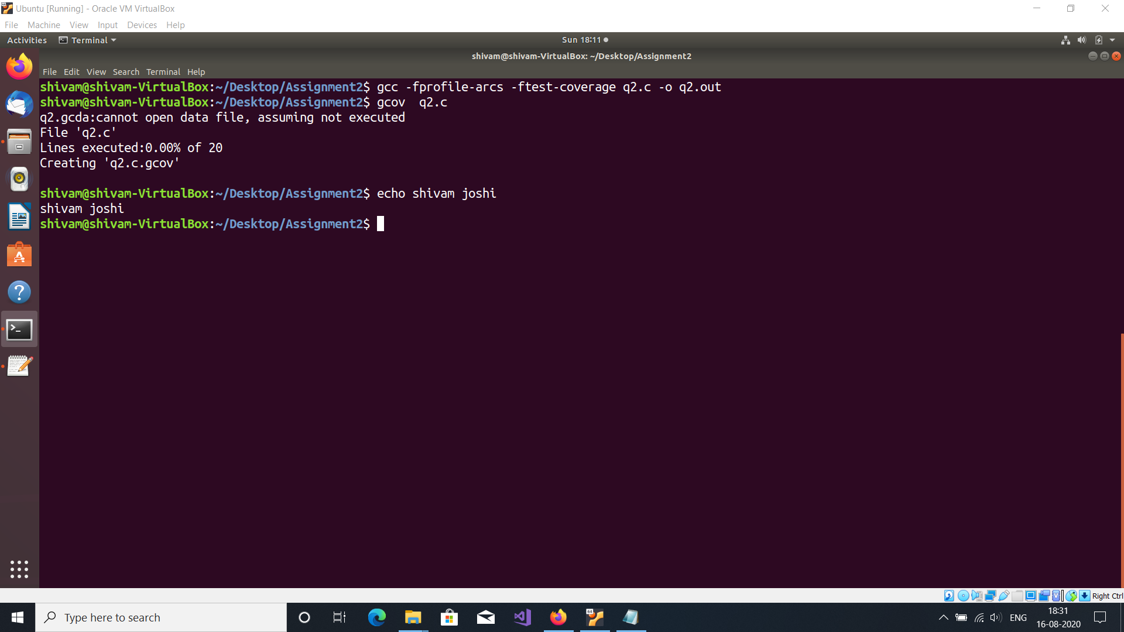

#include <stdio.h>

int main (void)

{

int i, total, num;

total = 0;

for (i = 0; i < 10; i++)

total += i;

if (total != 45)

printf ("Failure\n");

else

printf ("Success\n");

num = 0;

switch(num) {

case 1: printf("1");

break;

case 2: printf("2");

break;

case 3: printf("3");

break;

case 4: printf("4");

break;

default: printf("0");

break;

}

return 0;

}

Compiler the file q2.c with Gcov with options **-fprofile-arcs -ftest-coverage**

This tells the compiler to generate additional information needed by gcov (basically a flow graph of the program) and also includes additional code in the object files for generating the extra profiling information needed by gcov.

Upon execution of instruction Gcov q2.c q2.c.Gcov file is created which is shown below

Output:The file *q2.c.gcov* contains output from **gcov**. Here is a sample:

-: 0:Source:q2.c

-: 0:Graph:q2.gcno

-: 0:Data:-

-: 0:Runs:0

-: 0:Programs:0

-: 1://Shivam Joshi

-: 2:#include <stdio.h>

-: 3:

#####: 4:int main (void)

-: 5:{

-: 6:

-: 7: int i, total, num;

-: 8:

#####: 9: total = 0;

-: 10:

#####: 11: for (i = 0; i < 10; i++)

#####: 12: total += i;

-: 13:

#####: 14: if (total != 45)

#####: 15: printf ("Failure\n");

-: 16: else

#####: 17: printf ("Success\n");

-: 18:

#####: 19: num = 0;

#####: 20: switch(num) {

#####: 21: case 1: printf("1");

#####: 22: break;

-: 23:

#####: 24: case 2: printf("2");

#####: 25: break;

-: 26:

#####: 27: case 3: printf("3");

#####: 28: break;

-: 29:

#####: 30: case 4: printf("4");

#####: 31: break;

-: 32:

#####: 33: default: printf("0");

#####: 34: break;

-: 35:

-: 36: }

#####: 37: return 0;

-: 38:}

-: 39:

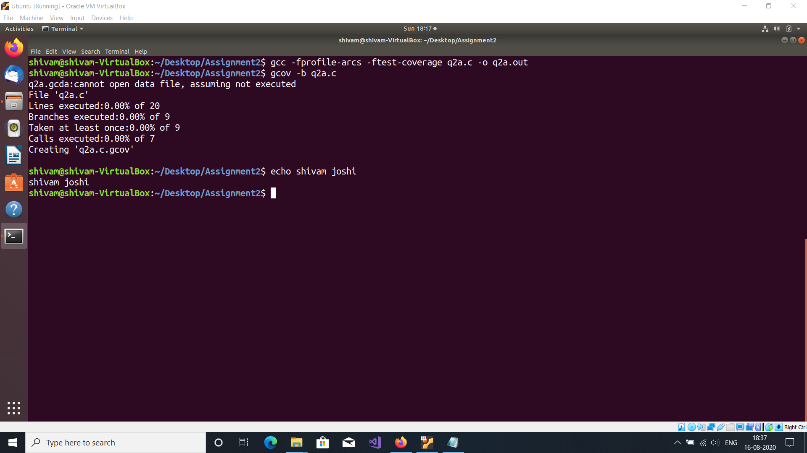

To get the branch and call counts after each block of code.

I have used gcov -b q2.c

For each function, a line is printed showing how many times the function is called, how many times it returns and what percentage of the function's blocks were executed

Output:The file *q2.c.gcov* contains output from **gcov**. Here is a sample:

-: 0:Source:q2a.c

-: 0:Graph:q2a.gcno

-: 0:Data:-

-: 0:Runs:0

-: 0:Programs:0

-: 1://Shivam Joshi

-: 2:#include <stdio.h>

-: 3:

function main called 0 returned 0% blocks executed 0%

#####: 4:int main (void)

-: 5:{

-: 6:

-: 7: int i, total, num;

-: 8:

#####: 9: total = 0;

-: 10:

#####: 11: for (i = 0; i < 10; i++)

branch 0 never executed

branch 1 never executed

#####: 12: total += i;

-: 13:

#####: 14: if (total != 45)

branch 0 never executed

branch 1 never executed

#####: 15: printf ("Failure\n");

call 0 never executed

-: 16: else

#####: 17: printf ("Success\n");

call 0 never executed

-: 18:

#####: 19: num = 0;

#####: 20: switch(num) {

branch 0 never executed

branch 1 never executed

branch 2 never executed

branch 3 never executed

branch 4 never executed

#####: 21: case 1: printf("1");

call 0 never executed

#####: 22: break;

-: 23:

#####: 24: case 2: printf("2");

call 0 never executed

#####: 25: break;

-: 26:

#####: 27: case 3: printf("3");

call 0 never executed

#####: 28: break;

-: 29:

#####: 30: case 4: printf("4");

call 0 never executed

#####: 31: break;

-: 32:

#####: 33: default: printf("0");

call 0 never executed

#####: 34: break;

-: 35:

-: 36: }

#####: 37: return 0;

-: 38:}

-: 39: