1. Introduction
The Movie Night Picker is a web feature designed to help users find movies based on their personal preferences. The feature was proposed in Task 7.3HD and has now been implemented using HTML, CSS and JavaScript.
Users can enter a movie title or keyword and select their preferred genre, mood, maximum runtime and minimum IMDb rating. The system uses the OMDb API to retrieve movie information and JavaScript to filter and match the movies with the user's preferences.
The main goal of this feature is to make movie searching easier and more personalised. Instead of manually checking many movies, users can enter their preferences and receive a smaller list of suitable movies.

2. Awesome Feature Overview
The main feature is the Personalised Movie Recommendation Feature.
The user can enter a movie title or keyword and select four main preferences:
- Genre
- Mood
- Maximum runtime
- Minimum IMDb rating
After the user selects their preferences, they click Find My Movies. The system searches the OMDb API and retrieves movie information.
The application then applies the selected filters and calculates a match percentage for each movie. The movies are sorted according to their match percentage and displayed as movie cards.
Each result includes:
- Movie poster
- Movie title
- Release year
- IMDb rating
- Runtime
- Match percentage
- View Details button
This allows users to quickly compare the results and choose a movie.

3. How the Feature Works
3.1 User Input
The user starts by entering a movie title or keyword.
The system checks that the input is not empty and contains at least three characters.
The user can then select:
- Genre
- Mood
- Maximum runtime
- Minimum IMDb rating
If the input is invalid, the system displays an error message instead of starting the search.

3.2 Movie Data Retrieval
JavaScript sends requests to the OMDb API using the movie title or keyword.
The application first searches for matching movies and then retrieves detailed information using each movie's IMDb ID.
The information includes:
- Title
- Year
- Genre
- Runtime
- IMDb rating
- Poster
- Director
- Actors
- Plot
The application can retrieve results from more than one search page and uses the available results to create the recommendation list.

3.3 Filtering and Matching
After retrieving the movie information, JavaScript processes the movies according to the user's preferences.
Movies can be filtered using:
- IMDb rating
- Runtime
- Genre
The system also checks the selected mood using rule-based matching.
For example, an exciting mood can match movies containing genres such as Action, Adventure or Thriller.
The mood is therefore not provided directly by the OMDb API. It is calculated by the application using predefined JavaScript rules based on movie genres and plot information.

4. Technical Implementation
The feature uses three main technologies.
HTML
HTML provides the structure of the Movie Night Picker interface.
It contains the input field, preference selectors, buttons, loading area, results area and movie details section.
CSS
CSS controls the visual design and responsive layout.
The movie cards are displayed using a grid layout. The layout changes for smaller screen sizes so that the website remains usable on mobile devices.
CSS is also used for:
- Buttons
- Form controls
- Movie cards
- Match scores
- Focus states
- Spacing and typography
JavaScript
JavaScript provides the main functionality of the feature.
The main functions include:
- Searching the OMDb API
- Retrieving movie details
- Validating user input
- Filtering movies
- Matching moods
- Calculating match percentages
- Displaying movie results
- Displaying movie details
- Resetting the search
Comments have been included in the JavaScript code to explain the main implementation sections and functions.

5. Personalised Movie Matching
The application uses a weighted matching system.
The current scoring system uses:
Preference | Weight
IMDb rating | 30%
Genre | 30%
Runtime | 20%
Mood | 20%
The application calculates a score based on the selected preferences and converts the result into a percentage.
Movies with higher match percentages are displayed first.
This gives users a simple way to understand how closely each movie matches their selected preferences.
The matching system is rule-based rather than machine learning. It uses predefined JavaScript rules to compare the movie information with the user's preferences.

6. Movie Results and Details
After processing the movies, the application displays the results as movie cards.
Each card provides the main information needed to compare movies quickly.
The View Details button allows the user to see additional information about a selected movie.
The details page displays:
- Movie poster
- Title
- Release year
- Genre
- Runtime
- IMDb rating
- Director
- Actors
- Plot
The Back to Results button allows the user to return to the previous results without starting another search.
The New Search button resets the search and allows the user to enter new preferences.

7. User Experience
The feature improves the user experience by reducing the amount of manual searching required.
Without the feature, users would need to search for movies individually and compare their ratings, genres and runtimes themselves.
With the Movie Night Picker, users can provide their preferences once and receive a filtered list.
The loading messages also provide feedback while the application is retrieving information from the API.
For example, the application displays messages such as:
Searching OMDb for movies...
and
Matching movies to your preferences...
This helps users understand that the application is working instead of appearing unresponsive.

8. Usability
Several usability features were implemented.
Clear form controls
Each preference has a clear label and selection option.
Input validation
The system prevents searches that contain fewer than three characters.
For example:
Please enter at least 3 characters.
No-result feedback
If no movie matches the selected preferences, the application displays:
No movies matched your selected preferences. Try changing your genre, rating or runtime.
This tells the user what happened and provides a possible next action.
Simple navigation
The user can easily:
Search → View Results → View Details → Back to Results
or start again using:
New Search

9. Accessibility
Accessibility was considered during the implementation.
The form controls have labels so users can understand what information is required.
The website can also be operated using the keyboard.
During testing, the Tab key was used to move through the interface and the Enter key was used to activate the focused View Details button.
A visible focus state is provided when a form control or button receives keyboard focus.
The colour choices were also reviewed for readability and contrast between text, backgrounds and interactive elements.
The layout is responsive so that users can access the feature on smaller screens.

10. Responsive Design
The website was tested using a mobile-sized viewport.
At smaller screen sizes:
- The form changes to a single-column layout.
- Movie cards are displayed in a single column.
- Content remains inside the screen.
- Buttons remain accessible.
- No obvious horizontal scrolling was required.
This allows the feature to be used on both desktop and mobile screens.
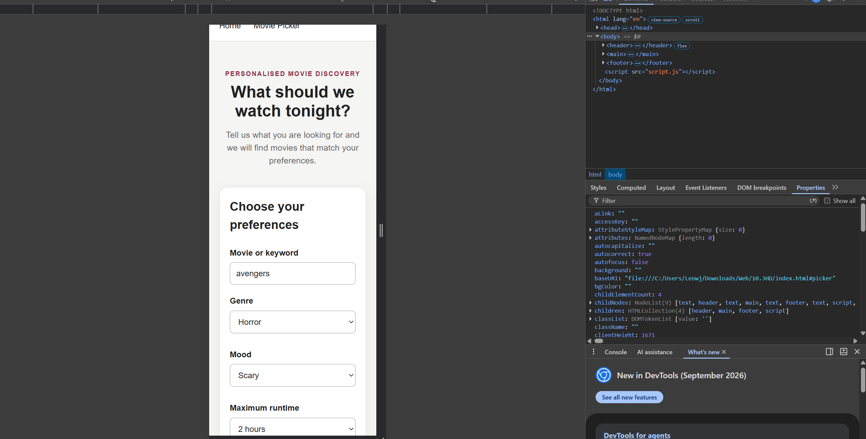

11. Performance
The application uses asynchronous JavaScript requests to retrieve movie information from the OMDb API.
A loading state is displayed while requests are being processed.
The application retrieves and processes a limited set of movie results rather than an unlimited number of results.
The results are also processed before being displayed, which allows the user to see movies that are more relevant to their selected preferences.
One limitation is that the application needs to request detailed information for selected movies from the external API. Therefore, performance can depend on the API response time and network connection.

12. Security and Technical Considerations
The current prototype uses an OMDb API key in the client-side JavaScript.
This is suitable for demonstrating the feature, but exposing an API key in client-side code is not recommended for a production application because users can inspect the JavaScript source code.
For a production version, the API request could be moved to a server-side application. The server would store the API key and communicate with OMDb on behalf of the client.
This would improve the protection of the API key.
13. Testing
The implemented feature was tested using functional, responsive and accessibility tests.
Test | Expected Result | Result
Movie Search | Movies are displayed according to the search | Pass
View Details | Full movie information is displayed | Pass
Back to Results | User returns to results | Pass
New Search | Search form is reset | Pass
No Results | Appropriate message is displayed | Pass
Input Validation | Invalid input is rejected | Pass
Loading State | Loading feedback is displayed | Pass
Responsive Design | Layout works on mobile | Pass
Keyboard Accessibility | User can navigate using keyboard | Pass
Colour Contrast | Text and controls remain readable | Pass

14. Testing Evidence
The following screenshots provide evidence of the implemented feature.
Screenshot 1 – Main Feature
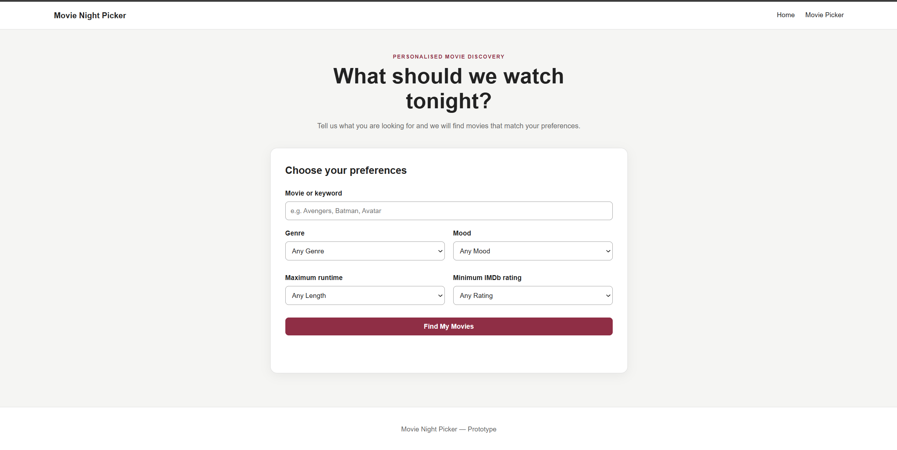
The screenshot shows the Movie Night Picker interface and the available movie preferences.
Screenshot 2 – Personalised Results
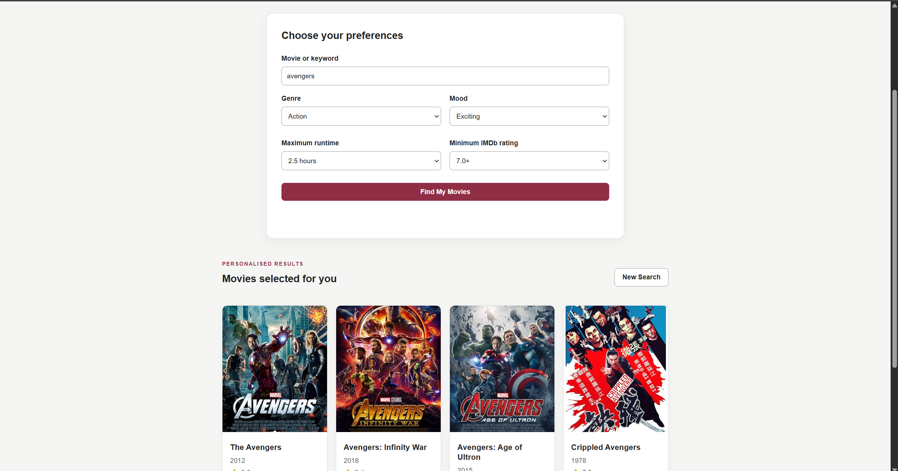
The screenshot shows the movie results after applying the user's selected preferences.

Screenshot 3 – Movie Details
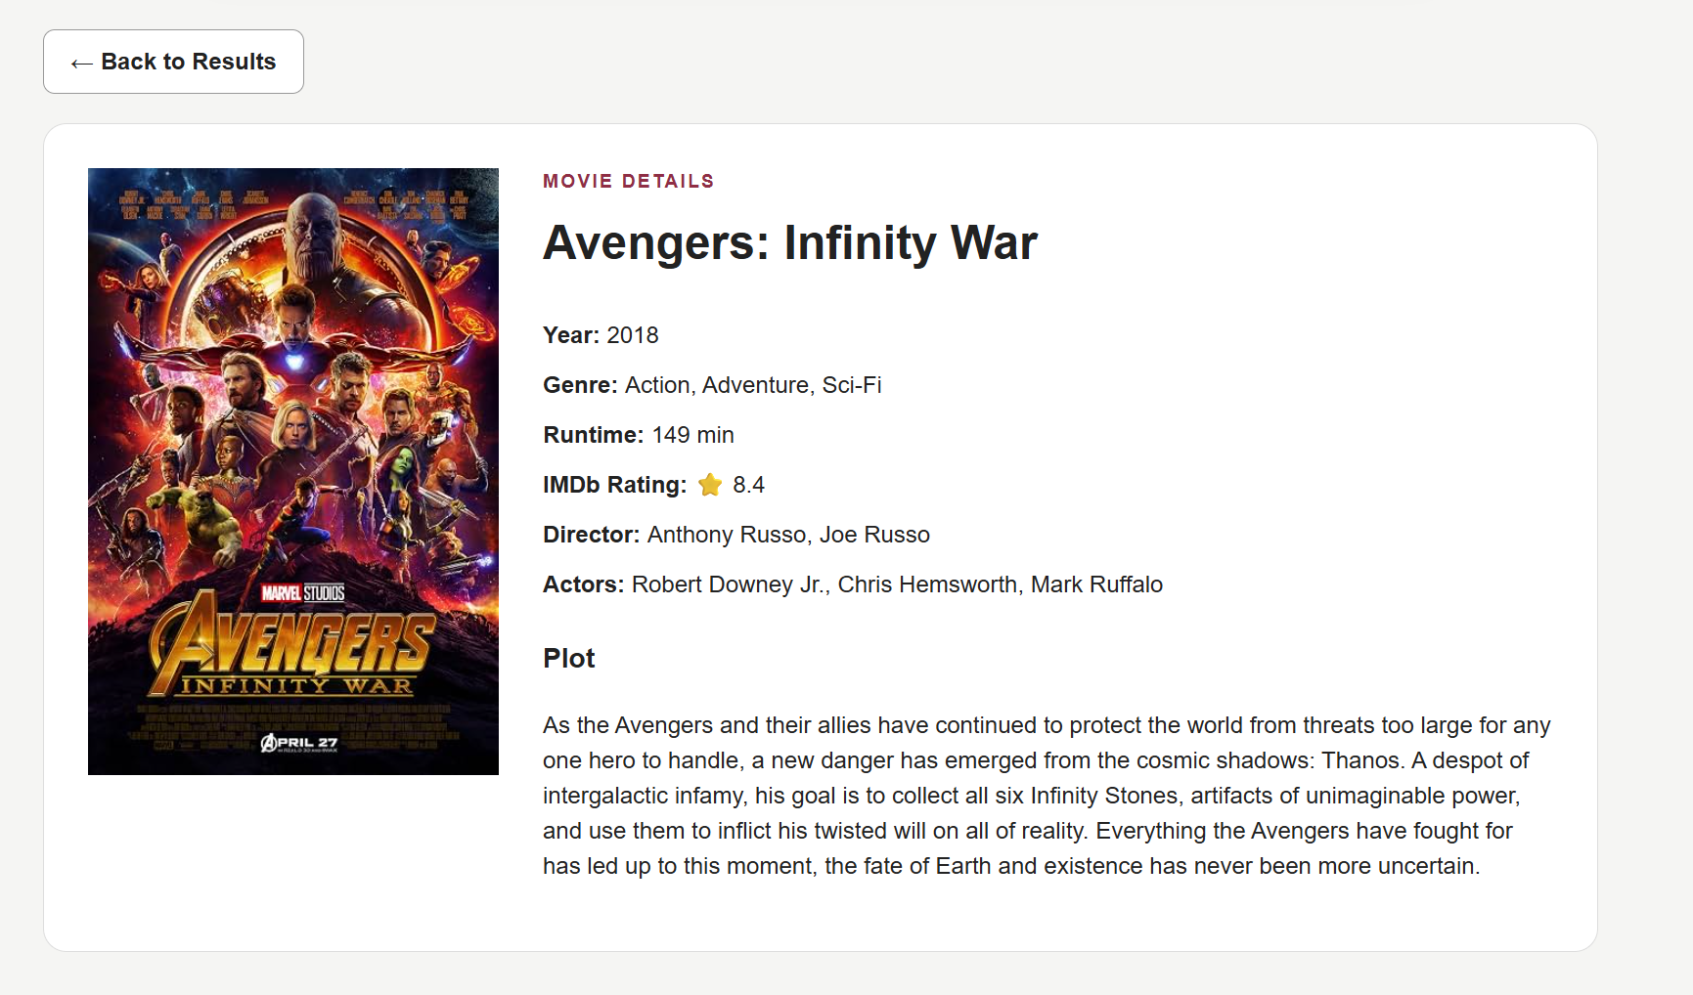
The screenshot shows the detailed information for a selected movie.
Screenshot 4 – No Results
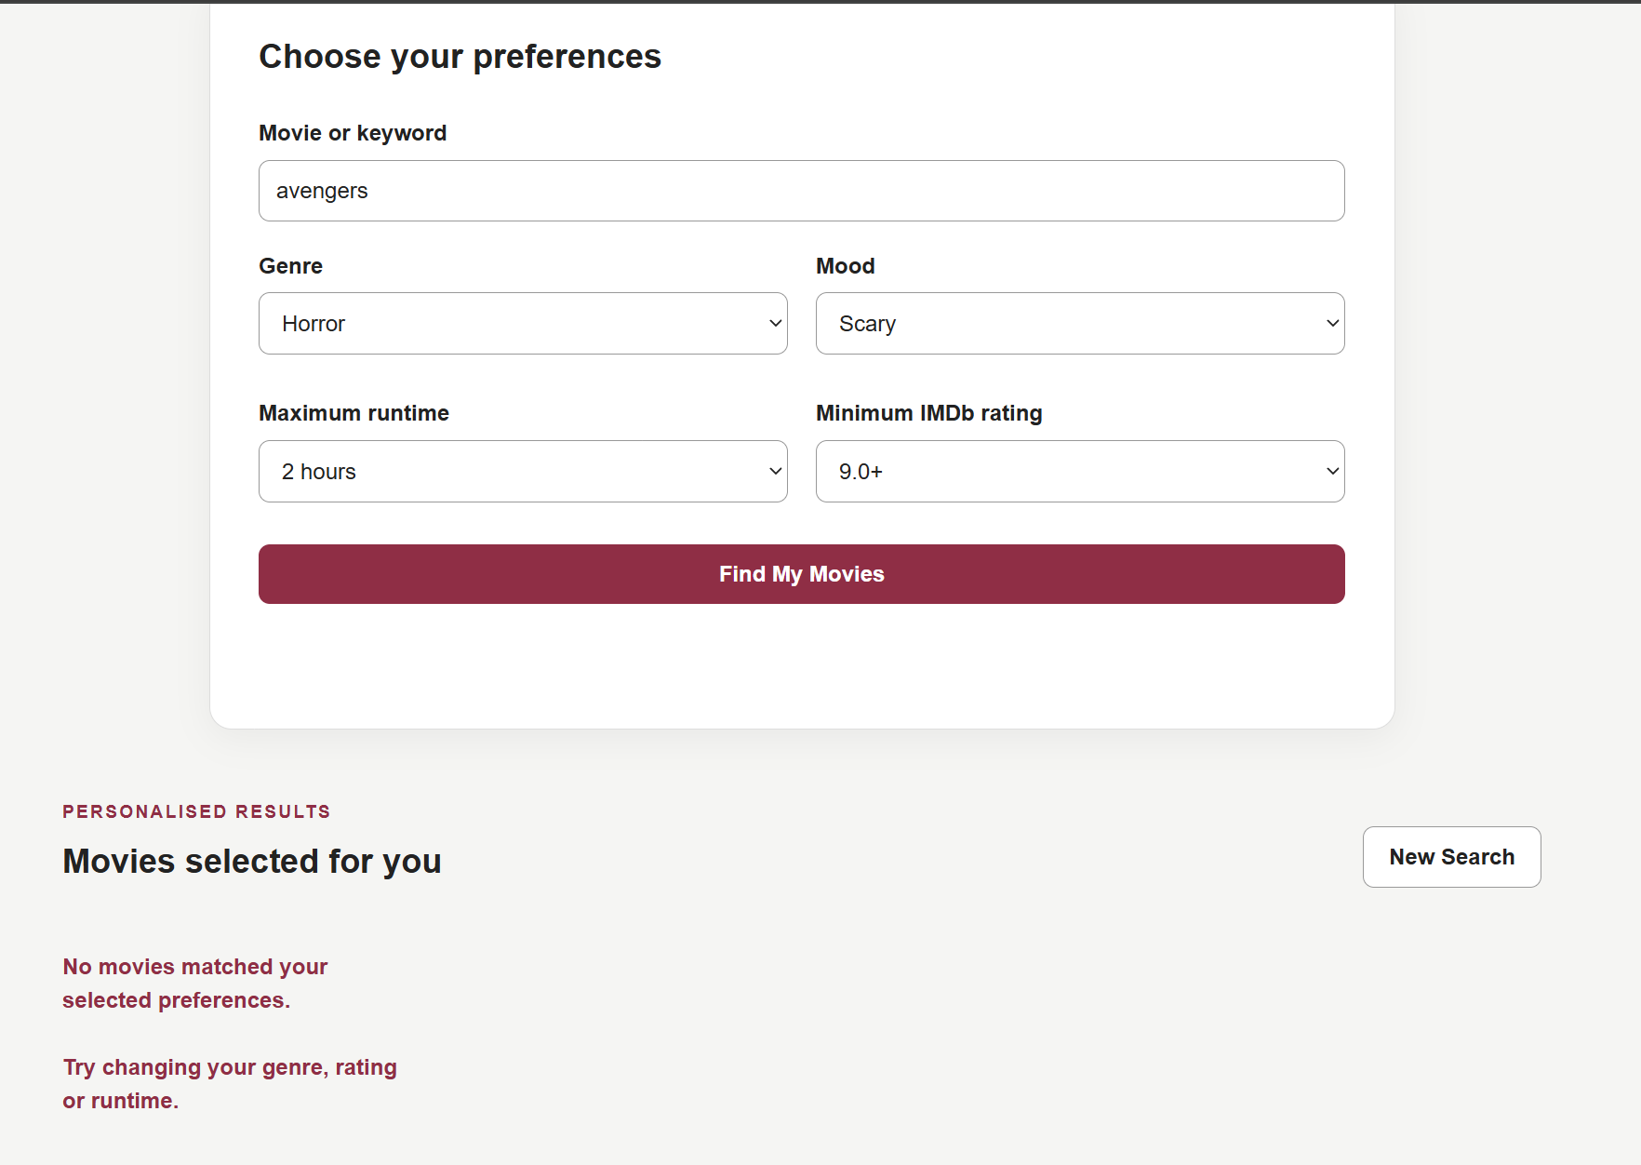
The screenshot shows the message displayed when no movies match the selected preferences.
Screenshot 5 – Mobile Responsive Design
The screenshot demonstrates that the interface changes to a mobile-friendly layout.
Screenshot 6 – Keyboard Focus
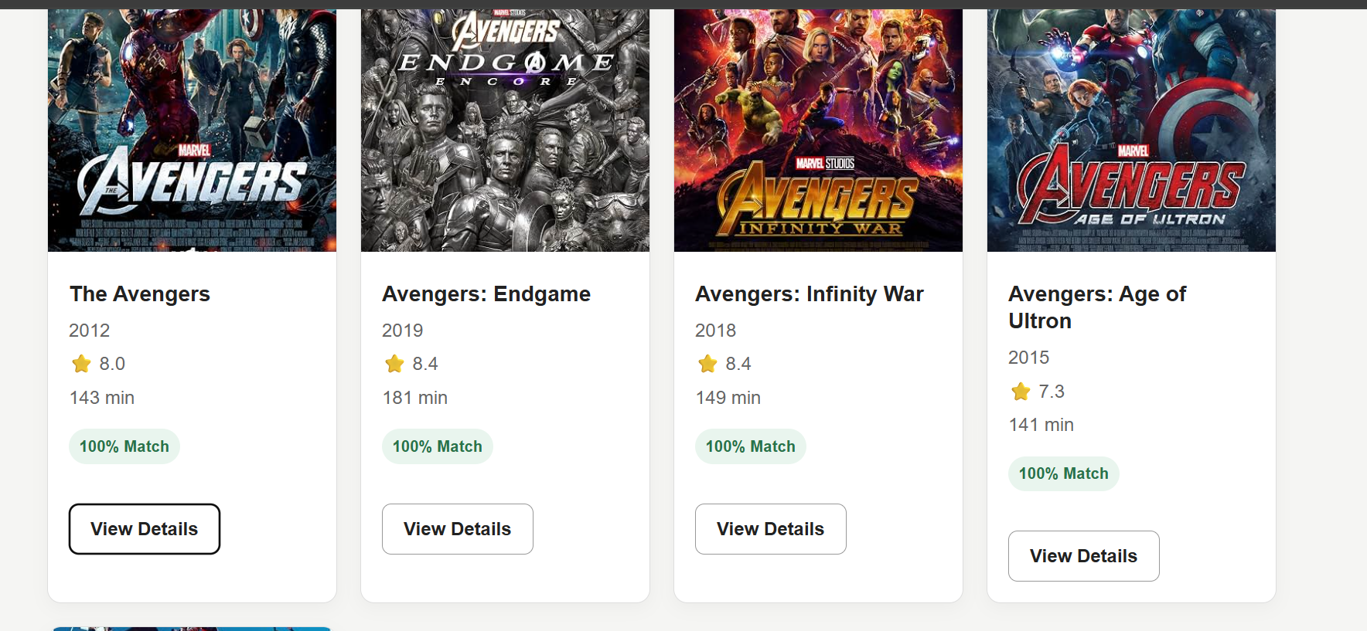
The screenshot shows the View Details button with the visible keyboard focus state.

15. Code Repository
The complete source code for the Movie Night Picker is available in the GitHub repository.
GitHub Repository:
https://github.com/sj226384658/SIT774.git
The repository contains:
- index.html
- style.css
- script.js
The JavaScript file contains the main implementation of the movie search, filtering, matching and display functionality.

16. Demonstration Video
A narrated demonstration video was created to demonstrate the implemented feature.
The demonstration explains:
- The Movie Night Picker interface
- Entering a movie keyword
- Selecting preferences
- Searching for movies
- Viewing personalised results
- Viewing movie details
- Returning to results
- Starting a new search
- Responsive design
- Accessibility and usability features
Panopto Video:
https://deakin.au.panopto.com/Panopto/Pages/Viewer.aspx?id=8bb44c6c-de24-4337-a28c-b4ca0085ef59
The video demonstrates the actual working website rather than only showing the source code.
17. AI Development and Critical Prompts
AI tools were used during the development process as a support tool for understanding, debugging and improving the implementation.
The AI was not used simply to generate the entire project without review. The suggestions were tested against the actual website and adjusted when necessary.
Examples of meaningful prompts included:
- How can I implement a personalised movie recommendation feature using JavaScript and the OMDb API?
- How can I retrieve movie details using an IMDb ID?
- How can I filter movies according to genre, runtime and IMDb rating?
- How can I create a mood matching system without a mood field in the OMDb API?
- How can I calculate a match percentage based on user preferences?
- How can I display a loading message while the API request is running?
- How can I show a useful message when no movies match the user's preferences?
- How can I create a View Details function for each movie?
- How can I make the movie results responsive on mobile screens?
- How can I improve keyboard accessibility for the Movie Night Picker?
- Why does my API return only a limited number of search results?
- How can I test the Movie Night Picker feature systematically?
These prompts helped with implementation, debugging, testing and improving the user experience.
AI Conversation Link:
https://chatgpt.com/share/6aae4644-5604-83ec-8d8c-34f6b2ea07e7

18. Conclusion
The Movie Night Picker successfully implements the personalised movie recommendation feature proposed in Task 7.3HD.
Users can enter a movie keyword and select preferences such as genre, mood, runtime and IMDb rating. The application retrieves movie information from the OMDb API, applies the selected filters and calculates a match percentage using rule-based JavaScript logic.
The implemented feature improves the user experience by reducing manual movie searching and presenting relevant results in a simple interface.
Testing showed that the main functions work correctly, including movie searching, filtering, movie details, navigation, validation, responsive design and keyboard accessibility.
The current implementation is suitable as a working prototype. For a production version, the API key could be moved to a server-side application to improve security.

19. References
Use the same reference style throughout the document.
- OMDb API - The Open Movie Database. (2000). Omdbapi.Com. https://www.omdbapi.com/
- Using Fetch. (n.d.). MDN Web Docs. Retrieved September 19, 2026, from https://developer.mozilla.org/en-US/docs/Web/API/Fetch_API/Using_Fetch
- W3C. (2024, December 12). Web content accessibility guidelines (WCAG) 2.2. Www.W3.Org; W3C. https://www.w3.org/TR/WCAG22/
- Making network requests with JavaScript - Learn web development | MDN. (2025, February 20). MDN Web Docs. https://developer.mozilla.org/en-US/docs/Learn_web_development/Core/Scripting/Network_requests

