**Assignment for JS components usage:**

***Application:***

*Create an e-commerce app, which shall display items that can be added to cart along with filter options.*

***Description:***

Your application shall have 3 screens.

**Screen 1** – Main page which displays Items based on the selected category along with its price details (can display hardcoded data)

**Screen 2** – Item details page – on click on any item in the main page opens the item details page. Also have an option to add to cart.

**Screen 3** – Click on filter option in main screen opens the filter page where-in user can set the filter option and based on the options selected, main page display changes.

**Screens:**

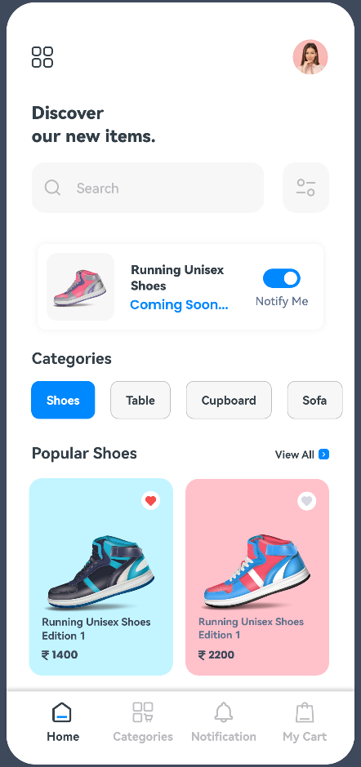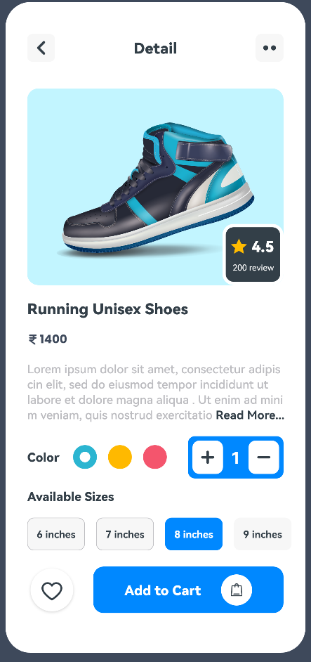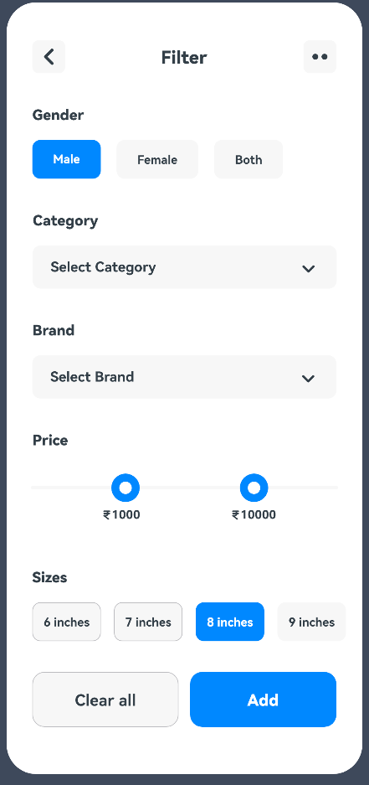

**NOTE:** Mainly focus on the UI. Data can be hardcoded and functionality can be extended later.

**References:**

1. **Sample:** <https://gitee.com/harmonyos/harmonyos_app_samples/tree/master/JSUI/JsComponents>
2. **Codelabs for building basic HarmonyOS Apps in JS**: <https://codelabs.applibgroup.dev/codelabs/smpl-applib-js-guide/index.html?index=..%2F..index#0>
3. **HarmonyOS documentation for available components in JS and usage**: <https://developer.harmonyos.com/en/docs/documentation/doc-references/js-components-versions-0000001185761140>
4. **JS Training YouTube playlist:** <https://youtube.com/playlist?list=PLRrqeu3aCzBtaQRapexMuWNcZwJQZtWhC>
5. **DevEco Studio Usage:** <https://www.youtube.com/watch?v=3cw5RGl0hjc>
6. **More Training Videos please find on Applibgroup YouTube Channel:** <https://www.youtube.com/applibengineeringgroup>