Color: The Third-Order Greek
Gamma decay under the Black-Scholes-Merton model with a continuous dividend yield

1. Color
An option's Color is the change in its gamma over some duration of time. Gamma is already a second-order greek (the change in delta for a change in the underlying), so a greek that measures how gamma moves with time is a third-order greek. Color stands to gamma exactly as charm stands to delta, and because the order of differentiation does not matter it can be read three ways: the change in gamma over time, the change in charm over the stock price, or the change in theta for a second change in the stock price.
Color = ∂Γ/∂t
Color = ∂Charm/∂S = ∂²θ/∂S² = ∂³V/∂S²∂t
V is the price of the option, S the price of the underlying stock and t calendar time. Γ (gamma) is the change in delta for a change in the underlying price, and charm, worked out in the previous section, is the change in delta for a change in time. Color is often called gamma decay or gamma bleed. A trader who is delta-hedging uses it to know how much the gamma of the book, and therefore the size of the next re-hedge, will drift overnight even if the stock does not move.

1.1 Formula for color by Black-Scholes Model
Under BSM with a continuous dividend yield q, gamma is the same for a call and a put. Put-call parity says the two deltas differ by e^(−qT), which does not depend on S, so differentiating once more in S removes the difference. Differentiating gamma with respect to calendar time gives color (per year):
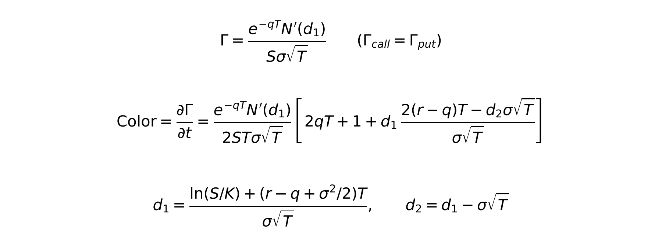
The sign convention is the same one used for charm: t is calendar time, so as one day passes the time to maturity T falls by 1/365. Color is therefore the negative of ∂Γ/∂T. Every value reported below is per calendar day, i.e. the formula divided by 365, which is directly comparable to Γ(T − 1/365) − Γ(T).
- S: Current market price of underlying
- K: Strike price (K = 100 throughout; moneyness is varied through S = K × S/K)
- T: Time to maturity in years
- r: Continuously compounded risk-free rate
- q: Continuously compounded dividend yield
- σ: Volatility of the underlying
- N(x): standard normal cdf
- N'(x): standard normal pdf
Unlike delta and charm, gamma and color are not scale-free: gamma is measured per unit of stock price, so its level depends on the price of the underlying. All figures below use K = 100. Doubling every price would halve each gamma and color value without changing the shapes or the sign-change points.

1.2 Case Setup
The same underlying price, strike and time to maturity, and the same volatilities, risk-free rates and dividend yields used for theta and charm are used for color. The base case is T = 1 year, σ = 20%, r = 5% and q = 0, with moneyness of 0.9, 1.0 and 1.1. Each section then changes one input at a time: maturity (1 week, 1 month, 3 months, 1 year), volatility (10%, 20%, 40%), the risk-free rate (0%, 5%, 10%) and the dividend yield (0%, 5%, 10%).

1.3 Color's base case with call and put
Gamma is calculated for two consecutive days for options at S/K = 0.9, 1.0 and 1.1. The change in gamma from today to tomorrow is the realised color for that day, and it is shown next to the closed-form color from 1.1.
Option | S/K | Gamma today | Gamma tomorrow | Actual change | Color (per day)
call | 0.9 | 0.021820 | 0.021845 | 0.00002529 | 0.00002526
call | 1.0 | 0.018762 | 0.018791 | 0.00002891 | 0.00002885
call | 1.1 | 0.012887 | 0.012902 | 0.00001583 | 0.00001581
put | 0.9 | 0.021820 | 0.021845 | 0.00002529 | 0.00002526
put | 1.0 | 0.018762 | 0.018791 | 0.00002891 | 0.00002885
put | 1.1 | 0.012887 | 0.012902 | 0.00001583 | 0.00001581
Table 1: Gamma today and tomorrow and color per day (T = 1 yr, σ = 20%, r = 5%, q = 0, K = 100)
Across a 2,001-point grid of moneyness from 0.5 to 1.5, the one-day change in gamma and the closed-form color differ by at most 7.5e-8, against color values of up to 3.04e-5. That gap is the second-order error from using a one-day step, so the formula is confirmed.
Analysis:
- All three one-year options gain gamma as a day passes: +0.00002526 at S/K = 0.9, +0.00002885 at the money and +0.00001581 at S/K = 1.1. One year out, all three sit inside the region where gamma is still building up towards expiry. Gamma will eventually concentrate around the strike, and these strikes are close enough to collect some of that.
- The ATM option has the largest color. Gamma is greatest around the strike, and that is where it grows fastest as time passes, because the remaining distribution of the stock price gets narrower around today's price.
- The option at S/K = 1.1 has the smallest color, about 55% of the ATM value. It is further from the strike, so the narrowing distribution adds less gamma to it. At 0.9 the color is close to the ATM figure, because the gamma curve at T = 1 year peaks below the strike (around S/K = 0.90, see 1.4).
- Put rows are identical to call rows. This is the main difference from charm, where the sign of delta flips between call and put. Gamma has no such sign flip, so color does not have one either. A long call and a long put on the same strike see their gamma grow or decay by exactly the same amount each day.

1.4 Color over different moneyness
Before plotting color across moneyness, it is worth looking at how gamma itself is spread across moneyness at different maturities.
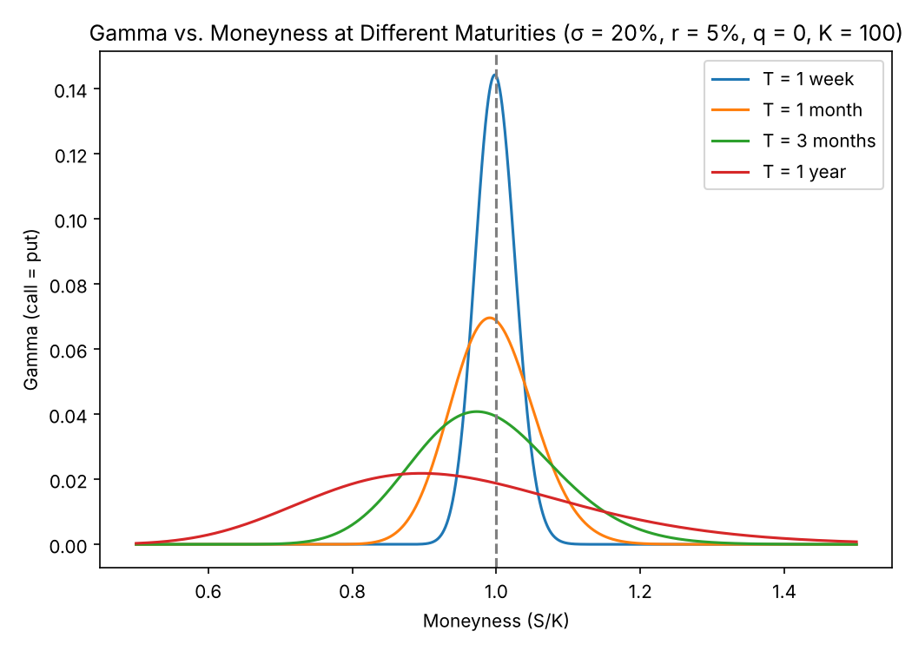
Figure 1: Gamma vs. moneyness at different maturities
Maturity | Gamma at S/K = 0.9 | Gamma at S/K = 1.0 | Gamma at S/K = 1.1
1 week | 0.000139 | 0.143869 | 0.000297
1 month | 0.017375 | 0.068747 | 0.013541
3 months | 0.030133 | 0.039288 | 0.019194
1 year | 0.021820 | 0.018762 | 0.012887
Table 2: Gamma at selected moneyness levels
Gamma is a bell around the strike. The shorter the maturity, the taller and narrower the bell: ATM gamma rises from 0.0188 at one year to 0.1439 at one week, while gamma at S/K = 0.9 and 1.1 collapses from about 0.02 to almost nothing. Since color is the speed at which one of these curves turns into the next, the centre should gain gamma and the wings should lose it.
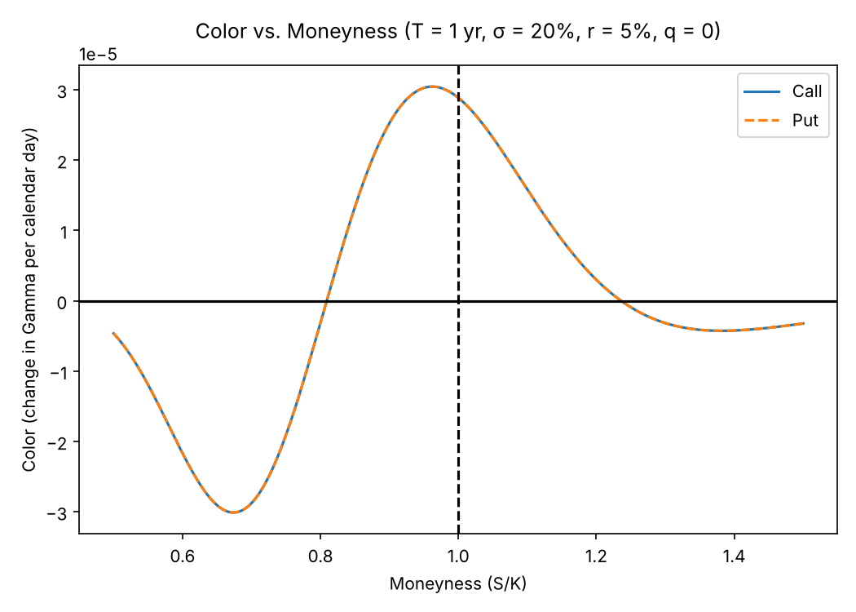
Figure 2: Color vs. moneyness (T = 1 yr, σ = 20%, r = 5%, q = 0)
Case | Most negative at S/K | Most negative color | Most positive at S/K | Most positive color | Sign changes at S/K | ATM color
Base case | 0.674 | −0.00003009 | 0.962 | 0.00003044 | 0.809 / 1.236 | 0.00002885
Table 3: Key points of the color curve, base case
Analysis:
- Color is positive between S/K = 0.810 and 1.237 and negative outside that band. Inside the band gamma builds up as time passes; outside it gamma drains away. This is the curve in Figure 1 getting taller and narrower, seen one day at a time.
- The positive peak is +0.00003044 at S/K = 0.962, slightly below the strike, where the one-year gamma curve is highest. The ATM color is +0.00002885.
- The most negative color is −0.00003009 at S/K = 0.674, a fairly deep OTM call. That option has a meaningful amount of gamma today but is losing its chance to be near the strike at expiry, so its gamma bleeds out. On the ITM side the decay is milder. Color only turns negative at 1.237 and stays small beyond it (lowest about −0.0000043 near S/K = 1.38).
- Call and put curves lie on top of each other everywhere, as explained in 1.3.
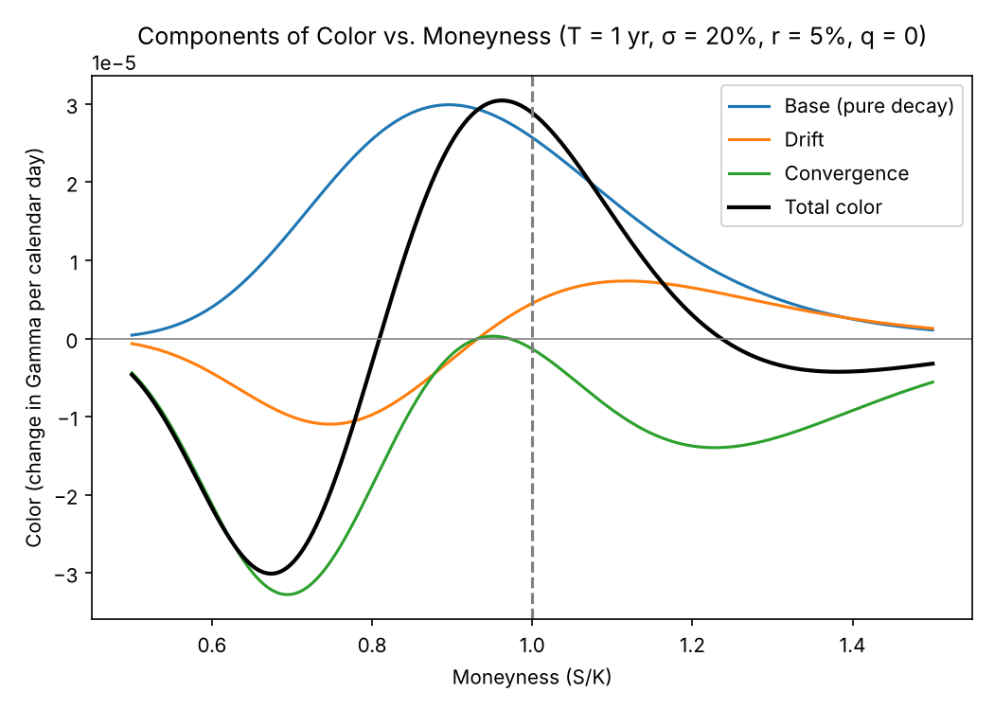
Figure 3: Components of color vs. moneyness
The bracket in the color formula splits into three terms in the same way charm splits into drift and convergence. The base or pure-decay term (1 + 2qT) is always positive. The drift term d₁·2(r − q)T/(σ√T) comes from the risk-free growth of the stock. The convergence term −d₁d₂ comes from the distribution of the stock price narrowing as expiry approaches.
Component | Most negative at S/K | Most negative | Most positive at S/K | Most positive | Sign changes at S/K | ATM value
Base | 0.500 | 0.00000043 | 0.896 | 0.00002990 | — | 0.00002570
Drift | 0.748 | −0.00001097 | 1.118 | 0.00000735 | 0.932 | 0.00000450
Convergence | 0.694 | −0.00003277 | 0.951 | 0.00000029 | 0.932 / 0.971 | −0.00000135
Table 4: Key points of the color components
The base term is positive everywhere and peaks at +0.00002990 at S/K = 0.896. Around the money it supplies almost all of the color (+0.00002570 of the +0.00002885 at ATM). The convergence term is what pulls the wings below zero. It is negative almost everywhere, reaching −0.00003277 at S/K = 0.694, and is only marginally positive (at most +0.0000003) in the narrow strip between 0.933 and 0.971, where d₁ and d₂ have opposite signs. The drift term is the smallest of the three. It is negative below S/K = 0.933 (where d₁ < 0) and positive above it, ranging from −0.00001097 to +0.00000735, which tilts the whole curve so that the OTM side decays faster than the ITM side.

1.5 Color against moneyness at different maturities
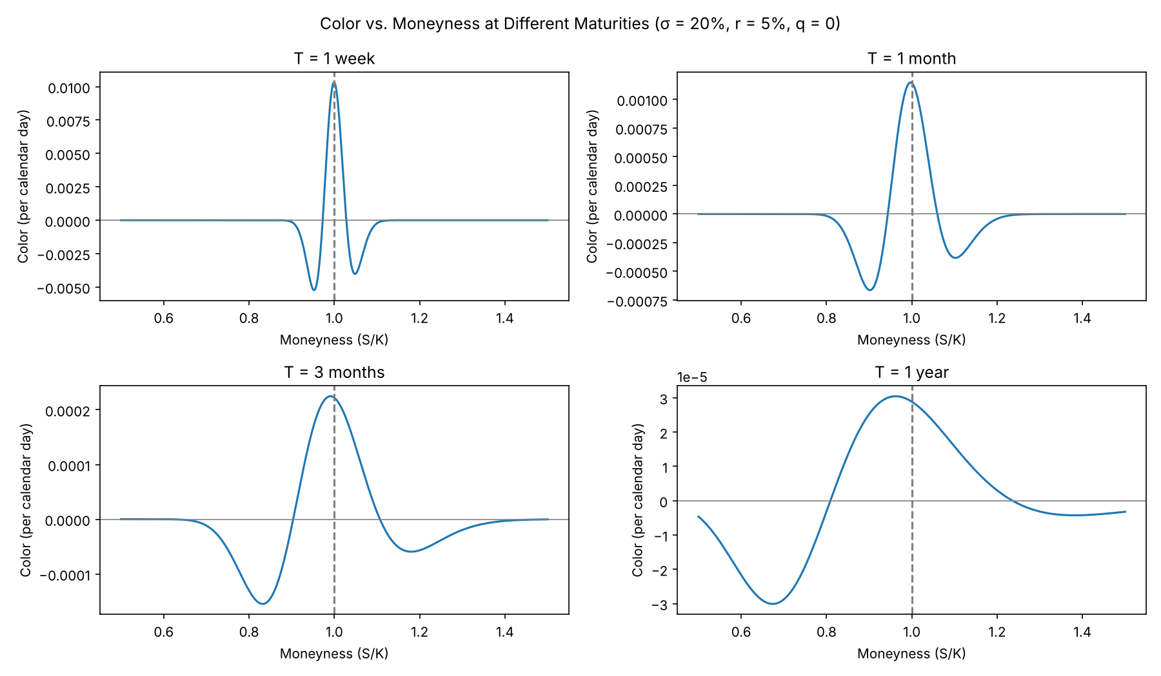
Figure 4: Color vs. moneyness at different maturities
Maturity | Most negative at S/K | Most negative | Most positive at S/K | Most positive | Sign changes at S/K | ATM color
1 week | 0.953 | −0.00523188 | 1.000 | 0.01030964 | 0.973 / 1.028 | 0.01030050
1 month | 0.902 | −0.00066372 | 0.997 | 0.00114646 | 0.944 / 1.060 | 0.00114162
3 months | 0.832 | −0.00015473 | 0.990 | 0.00022473 | 0.903 / 1.107 | 0.00022187
1 year | 0.674 | −0.00003009 | 0.962 | 0.00003044 | 0.809 / 1.236 | 0.00002885
Table 5: Key points of the color curve by maturity
Analysis:
- The shape is the same at every maturity: a positive hump around the strike and negative wings either side. The positive band narrows sharply as maturity shortens. It runs from 0.810 to 1.237 at one year, 0.904 to 1.107 at three months, 0.944 to 1.060 at one month and only 0.973 to 1.029 at one week.
- The size of color grows very quickly as expiry approaches. The positive peak is +0.0000304 at one year, +0.000225 at three months, +0.00115 at one month and +0.0103 at one week, about 340 times the one-year figure. For an ATM option a week from expiry, gamma grows by roughly 7% of its own value (0.0103 against 0.144) in a single day.
- The peak moves towards the strike as maturity shortens (0.962 → 0.991 → 0.997 → 0.9995) because the drift that pushed it below the strike has less time to act. The negative trough on the OTM side stays deeper than the ITM side at every maturity. At one week it is −0.00523 at S/K = 0.953: an option just out of the money, which still carries gamma today, sees it disappear quickly as the market judges that it will expire worthless.

1.6 Color against time to maturity
Now moneyness is held constant while the time to maturity changes from 1 day to 2 years.
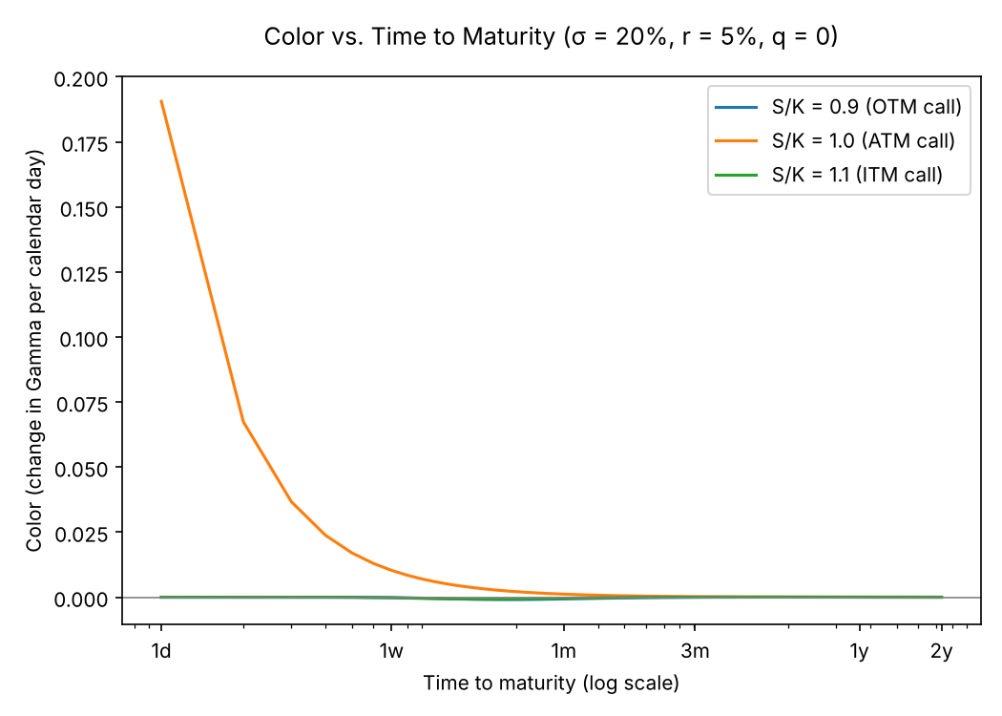
Figure 5: Color vs. time to maturity
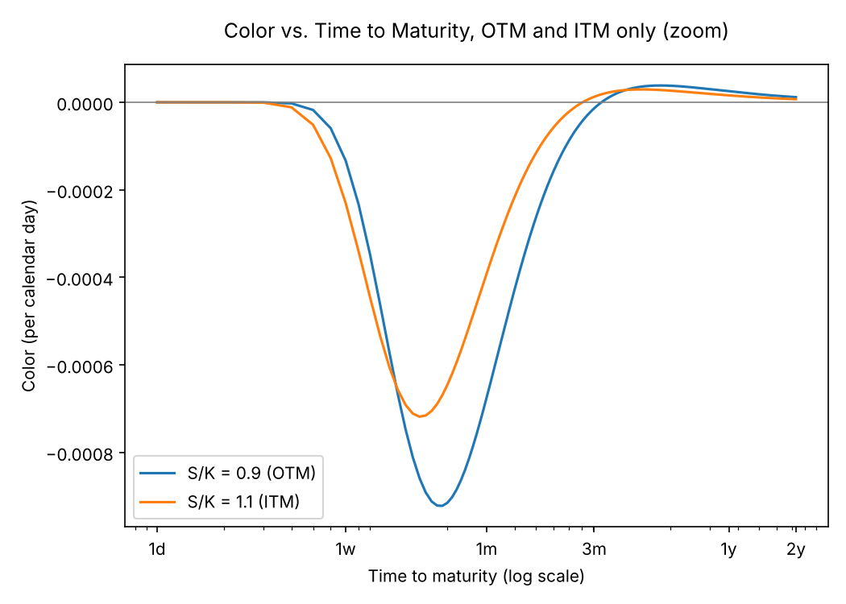
Figure 6: Color vs. time to maturity, OTM and ITM only
S/K | Type | 1 day | 1 week | 30 days | 1 year | 2 years | Largest at (days) | Changes sign at (days)
0.9 | OTM | 0.000000 | −0.000133 | −0.000674 | 0.0000253 | 0.0000118 | day 19: −0.000922 | 99
1.0 | ATM | 0.190577 | 0.010301 | 0.001165 | 0.0000288 | 0.0000106 | day 1: 0.190577 | never
1.1 | ITM | 0.000000 | −0.000230 | −0.000391 | 0.0000158 | 0.0000070 | day 15: −0.000718 | 81
Table 6: Color per day at selected maturities
Analysis:
- The ATM option behaves completely differently from the other two. Its color is positive at every maturity and explodes as expiry approaches: +0.0000288 at one year, +0.00117 at 30 days, +0.0103 at one week and +0.191 with one day left. ATM gamma grows like 1/√T, so its rate of change grows like T^(−3/2). This is the gamma risk that option desks worry about on expiry day. It is the third-order counterpart of the ATM charm in the previous section, which also had its largest value at one day and never changed sign.
- The OTM option (S/K = 0.9) has negative color for short maturities: −0.000133 at one week and −0.000674 at 30 days, with the largest magnitude of −0.000922 at 19 days. Over that horizon the option is losing its gamma as it heads towards expiring worthless. Its color turns positive at 99 days. For longer-dated OTM options, passing time narrows the distribution enough to bring the strike closer in probability terms, so gamma builds instead (+0.0000253 at one year).
- The ITM option (S/K = 1.1) follows the same pattern with a smaller size. It is most negative at −0.000718 on day 15 and turns positive at 81 days. As with charm, the OTM option reacts more strongly than the ITM one (−0.000922 against −0.000718). The deep negative pocket sits in the two-to-five-week window, the same horizon where the charm report found the strongest delta changes, which is the monthly roll-over horizon for hedgers.
- With one day left, color for the OTM and ITM options is effectively zero. Their gamma is already gone, so there is nothing left to decay.

1.7 Color against moneyness at different volatilities
As with charm at a zero dividend yield, color is identical for calls and puts. Here that holds for any dividend yield, so only one curve per case is shown.
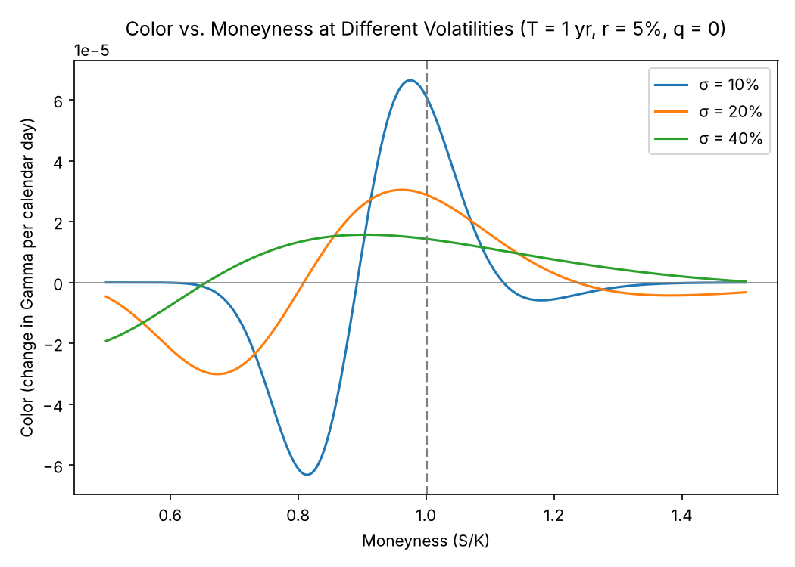
Figure 7: Color vs. moneyness at different volatilities
Case | Most negative at S/K | Most negative color | Most positive at S/K | Most positive color | Sign changes at S/K | ATM color
σ = 10% | 0.814 | −0.00006316 | 0.976 | 0.00006642 | 0.893 / 1.121 | 0.00006119
σ = 20% | 0.674 | −0.00003009 | 0.962 | 0.00003044 | 0.809 / 1.236 | 0.00002885
σ = 40% | 0.500 | −0.00001924 | 0.905 | 0.00001571 | 0.657 | 0.00001433
Table 7: Key points of the color curve by volatility
Analysis:
- Lower volatility gives a taller and narrower color curve. At σ = 10% the peak is +0.0000664 and the trough −0.0000632, about double the 20% case, and the positive band shrinks to 0.893–1.121. Low volatility does the same thing to color as a short maturity, because both reduce σ√T, the width of the distribution the option is priced on.
- At σ = 40% the curve is flatter and wider. The peak falls to +0.0000157, ATM color is roughly half the 20% value (+0.0000143 against +0.0000288), and the positive band starts at S/K = 0.657 and runs past the right edge of the grid. In this case the most negative point in the grid is at its left edge (S/K = 0.5), so the true trough lies deeper out of the money.
- The peak moves further below the strike as volatility rises (0.976 at 10%, 0.962 at 20%, 0.906 at 40%), following the peak of gamma itself, which sits at a lower stock price when the distribution is wider. A high-volatility book therefore has its gamma growth concentrated in OTM calls, while a low-volatility book has it tightly concentrated at the strike.

1.8 Color against moneyness at different interest rates
Like volatility, the call and put color are the same at every interest rate.
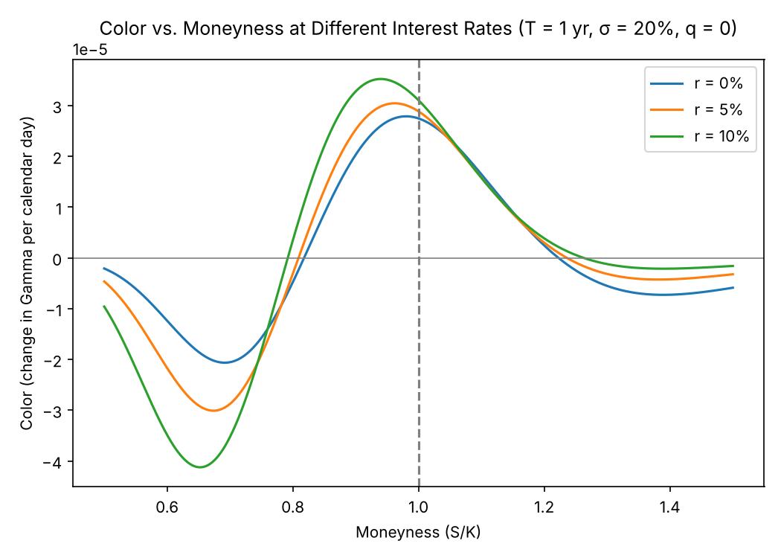
Figure 8: Color vs. moneyness at different interest rates
Case | Most negative at S/K | Most negative color | Most positive at S/K | Most positive color | Sign changes at S/K | ATM color
r = 0% | 0.692 | −0.00002064 | 0.980 | 0.00002788 | 0.818 / 1.223 | 0.00002746
r = 5% | 0.674 | −0.00003009 | 0.962 | 0.00003044 | 0.809 / 1.236 | 0.00002885
r = 10% | 0.652 | −0.00004123 | 0.940 | 0.00003523 | 0.792 / 1.263 | 0.00003104
Table 8: Key points of the color curve by interest rate
Analysis:
- The interest rate only enters color through the drift term, d₁·2(r − q)T/(σ√T). With r = 0 that term disappears and the curve is shaped by the base and convergence terms alone. The trough is −0.0000206 and the peak +0.0000279, and the peak sits almost at the money (0.980).
- Raising the rate amplifies both ends of the curve rather than shifting it in one direction. At r = 10% the trough deepens to −0.0000412 and the peak rises to +0.0000352. Charm behaved differently: higher rates pushed the whole charm curve downwards. For color, the drift term is negative where d₁ < 0 and positive where d₁ > 0, so it deepens the OTM decay and lifts the gamma build-up near the money.
- Higher rates move the peak and trough to lower moneyness (peak 0.980 → 0.962 → 0.940) and widen the positive band slightly (0.818–1.223 at 0%, 0.809–1.237 at 5%, 0.792–1.263 at 10%). ATM color rises gently with the rate: +0.0000275, +0.0000288 and +0.0000310.

1.9 Color against moneyness at different dividend yields
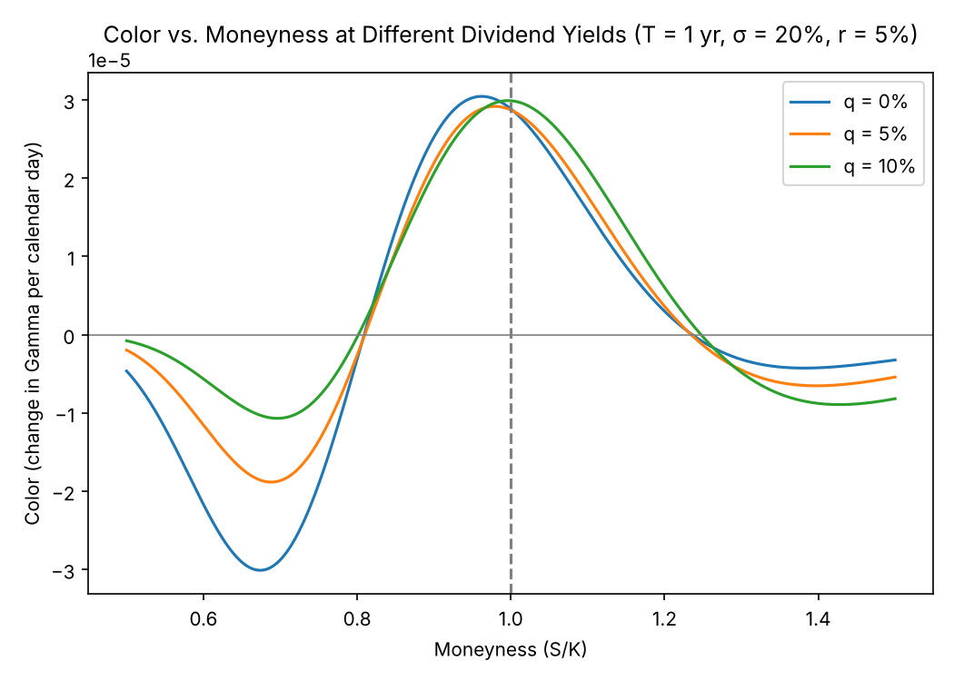
Figure 9: Color vs. moneyness at different dividend yields (call = put)
Case | Most negative at S/K | Most negative color | Most positive at S/K | Most positive color | Sign changes at S/K | ATM color
q = 0% | 0.674 | −0.00003009 | 0.962 | 0.00003044 | 0.809 / 1.236 | 0.00002885
q = 5% | 0.688 | −0.00001883 | 0.979 | 0.00002917 | 0.810 / 1.235 | 0.00002871
q = 10% | 0.696 | −0.00001068 | 0.996 | 0.00002990 | 0.802 / 1.248 | 0.00002989
Table 9: Key points of the color curve by dividend yield
Analysis:
- This is the one place where color departs most clearly from charm. With charm, a dividend yield split the call and put curves apart by q·e^(−qT)/365. Gamma is the same for a call and a put at any dividend yield, so color is too. Recomputing the put gamma numerically from the put delta at q = 10% matches the call color to within 5.9e-8, so a single curve per yield is shown.
- The dividend works against the interest rate in the drift term, through (r − q), and also adds 2qT to the base term. Raising q from 0% to 10% makes the effective drift go from +5% to −5%, so the drift term changes sign. The OTM trough becomes much shallower (−0.0000301 → −0.0000188 → −0.0000107) and moves slightly closer to the money (0.674 → 0.688 → 0.696).
- The positive peak barely changes in height (+0.0000304, +0.0000292, +0.0000299) but moves to the strike (0.962 → 0.979 → 0.996). The crossover points hardly move (about 0.80–0.81 and 1.235–1.248). On the ITM side the pattern reverses: higher dividends make the far-ITM decay slightly deeper (lowest point about −0.0000043 at q = 0%, −0.0000065 at 5% and −0.0000089 at 10%). A dividend-paying stock is expected to drift down towards the strike, which keeps OTM call gamma alive for longer and bleeds ITM call gamma a little faster.

