Lab 3, Task 6: VaR comparison and scenario analysis
IndusInd Bank (INDUSINDBK.NS), one-day VaR on the 200 trading days from 20 January to 12 November 2026

Data and conventions
All estimates use the same 200 simple daily returns, the sample used in Tasks 3 to 5. Over this window the mean daily return is 0.0106% and the daily standard deviation is 1.982%. VaR is a one-day loss expressed as a positive percentage of the position. The code, the tables and the charts are in the Task 6 notebook; this report interprets them.

Part A: Comparison of VaR methods

Comparison table
Method | 90% VaR | 95% VaR | 99% VaR
Historical simulation | 2.362% | 3.444% | 5.061%
Parametric, historical volatility (200 days) | 2.529% | 3.249% | 4.600%
Parametric, GARCH(1,1) | 3.382% | 4.344% | 6.148%
Monte Carlo simulation (Student-t, ν = 5.6) | 2.292% | 3.107% | 5.130%
Table 1: One-day VaR by method. The EWMA (λ = 0.94) cross-check from Task 4 gives 2.749%, 3.531% and 4.999%; a normal Monte Carlo gives 2.546%, 3.276% and 4.634%.
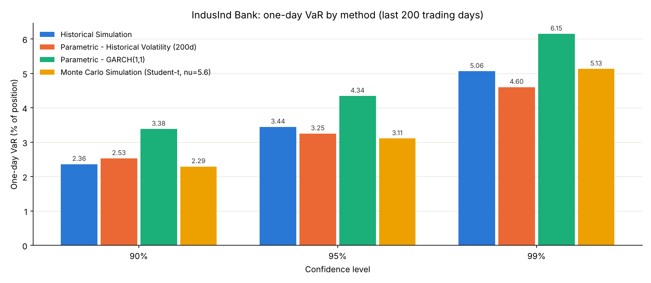
Figure 1: VaR by method and confidence level

Which methods give higher or lower VaR, and why
GARCH gives the highest VaR at every confidence level: 3.38%, 4.34% and 6.15%, between 21% and 43% above historical simulation. The reason is its volatility input. The one-day-ahead GARCH forecast is 2.65%, compared with 1.98% for the 200-day standard deviation, a ratio of 1.34. The normal formula scales VaR in proportion to volatility, so the whole GARCH row sits 34% above the historical-volatility row.
Part of that gap says more about the model than about current risk. The last return in the sample, on 12 November, was a gain of 3.48%. GARCH responds to the squared return, so a large up-move raises the forecast as much as a large fall would, and the forecast jumped from 2.23% for 12 November to 2.65% for the next day. The model also has a high reaction coefficient (α = 0.28) and a long-run volatility of 2.99%, both estimated over a sample that includes the 27% fall of March 2025. Task 2 found that the ARCH test was not significant on raw returns (p = 0.64) but was strongly significant once the most extreme days were winsorised, which suggests the volatility dynamics are dominated by a few very large days. Two other measures of current volatility point lower: the EWMA forecast is 2.15% and the standard deviation of the last 21 days is 2.16%. So recent volatility is somewhat above the 200-day average, but the GARCH figure probably overstates it.
The lowest estimate depends on the confidence level. At 90% and 95% it is the Student-t Monte Carlo (2.29% and 3.11%); at 99% it is the normal parametric model with historical volatility (4.60%). The reason is tail shape, not volatility, because these two methods use exactly the same mean and standard deviation. A fat-tailed distribution with the same variance puts more probability near the centre and in the far tails and less in between. Its 10% and 5% quantiles are therefore closer to zero than the normal ones, and its 1% quantile is further out. With ν = 5.6, the Student-t VaR is 9% below the normal at 90%, 4% below at 95% and 12% above at 99%.
Historical simulation shows the same crossover in the actual data. Writing each estimate as VaR = k·σ − μ, with σ the 200-day volatility, gives an implied multiplier k that can be compared with the normal z-value:
Method | 90% | 95% | 99%
Normal z-value | 1.282 | 1.645 | 2.326
Historical simulation | 1.197 | 1.743 | 2.559
Monte Carlo (Student-t) | 1.162 | 1.573 | 2.594
Parametric, GARCH(1,1) | 1.712 | 2.197 | 3.107
Table 2: Implied multipliers k = (VaR + μ) / σ, with σ = 1.982%
The empirical 90% quantile is closer to zero than the normal one would be, while the 95% and 99% quantiles are further out. The 200 returns have excess kurtosis of 1.05 and a Jarque-Bera p-value of 0.017, so normality is rejected at the 5% level, but the tails are only moderately fat. That is because the window does not include the March 2025 crash.

How volatility estimators and distributional assumptions affect the results
The two choices act in different ways. The volatility estimator scales the whole distribution, so it moves VaR by the same percentage at every confidence level: replacing the 200-day volatility with GARCH adds 34% everywhere. The distributional assumption changes the shape, so its effect depends on the confidence level and changes sign between 95% and 99%. For this stock, at 95%, the volatility estimator matters far more (34% against 4%). At 99% both matter (34% against 12%). The mean barely matters: at 0.0106% a day it shifts every estimate by about 0.01 percentage points.
The choice of volatility window also matters less than the choice of model. Task 4 showed 95% VaR between 2.97% and 3.36% for windows of 21 to 200 days, all well below the GARCH figure of 4.34%.

Similarities, differences and unusual patterns
Three of the four methods (historical simulation, normal parametric and Student-t Monte Carlo) agree to within about 0.5 percentage points at each level, which is expected because they are built from the same 200 returns. GARCH is the outlier, for the reasons above. The normal Monte Carlo reproduces the analytic normal VaR to within simulation noise (3.276% against 3.249% at 95%), which confirms that the Monte Carlo code is correct.
Some patterns are less expected. Historical simulation gives a higher 95% VaR (3.44%) than the fat-tailed Student-t model (3.11%), although one would expect the empirical distribution and the fitted t to agree. Historical quantiles of 200 observations are noisy. The 5% quantile is set by the 10 worst days, and three of the five worst days in the sample fall between 12 and 30 March 2026 (−5.2%, −5.1% and −4.9%), with the worst on 23 July (−6.0%). A single cluster of bad days moves the estimate noticeably. The 99% historical VaR rests on just the two worst returns. The estimate of ν is also uncertain: maximum likelihood gives 5.6 while the method of moments gives 9.7, and Task 5 showed that this range moves the 99% VaR by about 0.3 percentage points.
The most important pattern is what the sample leaves out. IndusInd Bank fell 27.2% on 11 March 2025 and 18.6% on 25 October 2024. Neither day is in the 200-day window, so none of the four estimates reflects jumps of that size. The 27.2% loss is 8.4 times the baseline 95% VaR, and under a normal distribution with the current volatility it would be a 13.7-standard-deviation event.

Most appropriate method for IndusInd Bank
To judge which method works best, each one was run every day from 16 March 2021 using only the previous 200 returns, and the days on which the loss exceeded the VaR were counted. The GARCH and Student-t rows use parameters estimated on the full sample, so this is an indicative check rather than a strict out-of-sample test.
Method | 90% (target 10%) | 95% (target 5%) | 99% (target 1%)
Historical simulation | 9.81% (0.81) | 5.08% (0.89) | 1.79% (0.01)
Parametric, historical volatility | 7.09% (0.00) | 3.94% (0.06) | 1.57% (0.05)
Parametric, GARCH(1,1) | 7.09% (0.00) | 3.87% (0.04) | 1.50% (0.08)
Monte Carlo (Student-t) | 8.02% (0.01) | 4.29% (0.22) | 1.15% (0.59)
Table 3: Share of 1,397 days on which the loss exceeded the VaR, with Kupiec p-values in brackets (p < 0.05 rejects the method). Shaded cells pass comfortably.
The two normal models exceed their 99% VaR about 1.5 times as often as they should, while being too cautious at 90%. That is the signature of fat tails. Historical simulation is accurate at 90% and 95% but fails at 99%, because 200 observations hold only two returns beyond the 1% quantile. The Student-t Monte Carlo is the only method that passes at both 95% and 99%; it is somewhat too cautious at 90%.
My choice for IndusInd Bank is the Monte Carlo simulation with Student-t returns as the main estimate, especially at 95% and 99%, which are the levels used for risk limits. The stock has a history of sudden large falls tied to company news, and a model that allows fat tails handles that better than the normal distribution. Its weakness is that it uses an equally weighted 200-day volatility and so adjusts slowly when conditions change. I would therefore watch the GARCH or EWMA estimate alongside it as an early warning, while keeping in mind that the current GARCH reading is pushed up by a single positive day. A natural improvement would combine both features: Task 2 found that a GARCH model with Student-t errors fits much better than the normal GARCH (AIC 6,714 against 6,981, with ν ≈ 4.1). None of the four methods covers a jump like March 2025, which is why scenario and stress analysis is still needed alongside them.

Part B: Parametric VaR scenario analysis

Set-up
The selected model is the 95% parametric VaR with 200-day historical volatility from Task 4, VaR = 1.6449·σ − μ. The baseline inputs are μ = 0.0106% and σ = 1.982% per day, which give a baseline VaR of 3.2495%, the same as in Task 4. The baseline cell in the grid reproduces that value exactly.
Volatility is varied in proportion to its baseline, from 0.5 to 3.5 times. The expected return is varied by adding a shift of between −2 and +2 percentage points per day to the baseline. A proportional change in the mean would be meaningless here: the baseline mean is so small that doubling it moves VaR by 0.01 percentage points, and multiplying a positive number can never make it negative. The ranges match what the stock has actually done. The calmest 21-day period since 2020 had 0.34 times today's volatility. The most stressed had 3.41 times. The worst and best 21-day average returns were −2.1% and +2.1% a day.
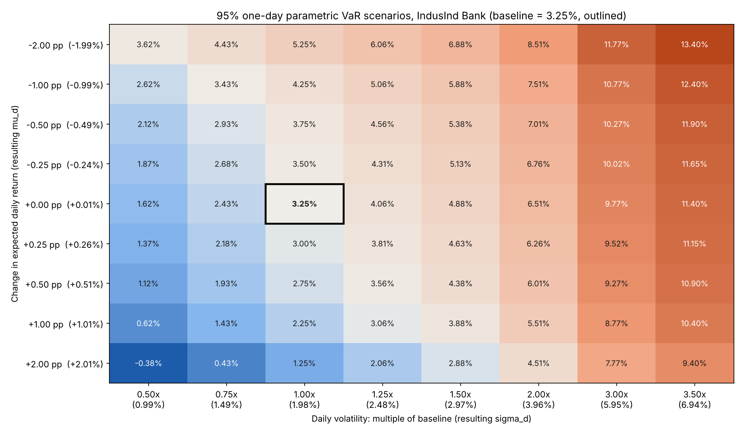
Figure 2: 95% one-day VaR for each combination. Orange cells carry more risk than the baseline, blue cells less; the baseline is outlined.
Δ mean \ volatility | 0.50× | 0.75× | 1.00× | 1.25× | 1.50× | 2.00× | 3.00× | 3.50×
−2.00 pp | 3.62 | 4.43 | 5.25 | 6.06 | 6.88 | 8.51 | 11.77 | 13.40
−1.00 pp | 2.62 | 3.43 | 4.25 | 5.06 | 5.88 | 7.51 | 10.77 | 12.40
−0.50 pp | 2.12 | 2.93 | 3.75 | 4.56 | 5.38 | 7.01 | 10.27 | 11.90
−0.25 pp | 1.87 | 2.68 | 3.50 | 4.31 | 5.13 | 6.76 | 10.02 | 11.65
Baseline | 1.62 | 2.43 | 3.25 | 4.06 | 4.88 | 6.51 | 9.77 | 11.40
+0.25 pp | 1.37 | 2.18 | 3.00 | 3.81 | 4.63 | 6.26 | 9.52 | 11.15
+0.50 pp | 1.12 | 1.93 | 2.75 | 3.56 | 4.38 | 6.01 | 9.27 | 10.90
+1.00 pp | 0.62 | 1.43 | 2.25 | 3.06 | 3.88 | 5.51 | 8.77 | 10.40
+2.00 pp | −0.38 | 0.43 | 1.25 | 2.06 | 2.88 | 4.51 | 7.77 | 9.40
Table 4: The scenario grid (95% VaR, %). Rows add the shift to the daily mean of 0.0106%; columns multiply the daily volatility of 1.982%.

Changes in expected return
VaR moves one for one with the expected return, in the opposite direction. Lowering the daily mean by 1 percentage point raises VaR from 3.25% to 4.25%; raising it by 1 point lowers VaR to 2.25%. The shift is the same in every column, so the effect of the mean does not depend on volatility. In practice the mean shifts in the table are large. A drift of +0.25 points a day is about 63% a year, and the ±2-point rows have only occurred over short windows such as the March 2025 crash or the rebound in late 2020. The baseline mean itself is estimated with a standard error of about 0.14 points a day (σ/√200), so the ±0.25 rows are within two standard errors of the estimate. In other words, the data cannot tell those scenarios apart from the baseline.

Changes in volatility
VaR rises in proportion to volatility: doubling volatility doubles VaR to 6.51%, and halving it gives 1.62%. Because the multiplier is z = 1.645, a 1-point rise in daily volatility adds 1.645 points to VaR, which is more than the effect of a 1-point fall in the mean. Volatility also changes far more in practice. It has ranged from about 0.3 to 3.4 times today's level over 21-day windows since 2020, while the realistic change in the mean is a fraction of a point. Volatility is therefore the input that drives the scenarios.

Highest-risk combination
The highest VaR in the grid is 13.40%, 4.1 times the baseline, when the mean falls by 2 points and volatility rises to 3.5 times. Falling prices and rising volatility tend to occur together, so this corner is not as unlikely as treating the two inputs separately would suggest. The worst 21-day window in IndusInd Bank's history, ending 11 March 2025, had a mean 2.14 points below the baseline and 3.05 times its volatility, which gives a 95% VaR of 12.1%. That window lies near this corner.
At the opposite corner, a 2-point rise in the mean with half the volatility gives a VaR of −0.38%. A negative VaR says the position makes money even on the 5% worst day. This is not a real reduction in risk; it shows that the formula lets an assumed positive drift cancel out volatility.

Sensitivity and limitations of parametric VaR
Parametric VaR is linear and symmetric in its inputs, which makes the scenarios easy to read but also exposes its weaknesses. The result is only as good as μ and σ, and both are uncertain: the standard error of σ is about 5% of its value, and μ is barely distinguishable from zero. A small, poorly measured assumption about drift can visibly change the answer, which is why many practitioners set the mean to zero for one-day VaR. More fundamentally, the normal distribution understates the tails. Every scenario keeps the same normal shape and only scales it, whereas real stress also makes the distribution more fat-tailed. The 27.2% fall of March 2025 was 8.4 times the baseline 95% VaR, and even the 3.5× volatility column (11.4% at the baseline mean) is below it. VaR also says nothing about how large the loss is beyond the threshold, it assumes the position can be closed within a day at market prices, and the scenarios carry no probabilities, so the grid shows what would happen but not how likely it is.

Plausible market conditions for IndusInd Bank
Several episodes in the stock's own history map onto regions of the grid:
- Governance or accounting shock (top-right). In March 2025 the bank disclosed discrepancies in the accounting of its derivatives portfolio, and the stock fell 27% in a day. The 21-day window around it had a mean shift of −2.1 points and volatility 3.05 times the baseline (VaR 12.1%). Volatility kept rising into April 2025, peaking at 3.41 times, as management changes followed. These are the −1 to −2 point rows in the 3× to 3.5× columns.
- Disappointing quarterly results (upper middle). The 18.6% fall on 25 October 2024 came after a weak quarterly result. An earnings shock of this type looks like a sharp but short rise in volatility to 2× to 3× with a moderately negative mean.
- Calm, steady market (bottom-left). The quietest 21 days since 2020, ending 8 June 2023, had volatility of 0.34 times the baseline and a positive drift (VaR 0.55%). This is the 0.5× column.
- Strong rebound with high volatility (bottom-centre). The best 21-day window, ending 1 December 2020, combined a mean 2.1 points above the baseline with 1.7 times its volatility, giving a VaR of only 3.6%. This is the misleading region of the grid, where a strong recent rally makes a volatile stock look safe.
- Today (near the baseline). The last 21 days had a mean 0.43 points above the baseline and volatility 1.09 times it (VaR 3.1%), close to the baseline cell.
Looking ahead, the scenarios most relevant to IndusInd Bank are those tied to quarterly results, asset-quality news (for example in microfinance lending), regulatory action, management or governance events, and sector-wide sell-offs in Indian bank stocks. Each tends to raise volatility abruptly, and the history above shows that this stock can move from the centre of the grid to its top-right corner within days.

Practical relevance and limitations of the scenario analysis
The scenario grid is useful because it is transparent and quick. It shows a risk manager straight away that volatility, not expected return, drives one-day VaR, and it turns that into decisions: if volatility doubles, a position must roughly halve to keep the same VaR limit. It also gives a common language for discussing what-if questions with people who do not work with the model every day, and it lets the analyst attach real episodes to each region of the grid.
Its limitations follow from the model behind it. It inherits every assumption of normal parametric VaR: a fixed bell-shaped distribution, linear scaling, and no jumps. The scenarios move one or two inputs while everything else, including the shape of the distribution, liquidity and correlations with other holdings, stays fixed, whereas in a real crisis all of these change together. The grid gives no probabilities, so it cannot say which scenario to plan for. It can even produce reassuring numbers, such as a negative VaR, when a strong drift is assumed. For a stock with IndusInd Bank's history of one-day falls of 19% and 27%, the grid is best read as a first sensitivity check and should be paired with historical stress tests, expected shortfall and a fat-tailed model.

Note on data consistency
Task 1 removed two days with zero traded volume (18 March 2025 and 15 January 2026), while the original Task 4 and 5 notebooks did not. The combined notebook applies the filter throughout so that Tasks 2 and 4 use the same GARCH fit. This leaves the 200-day sample unchanged and moves only the GARCH VaR, in the third decimal place (95%: 4.341% in the original Task 4 notebook, 4.344% here). The data end date is fixed so that the last return is 12 November 2026, as in Tasks 3 to 5.

