**Python Programming Assignment-1**

1 Write a program that takes two numbers as input and prints their sum.

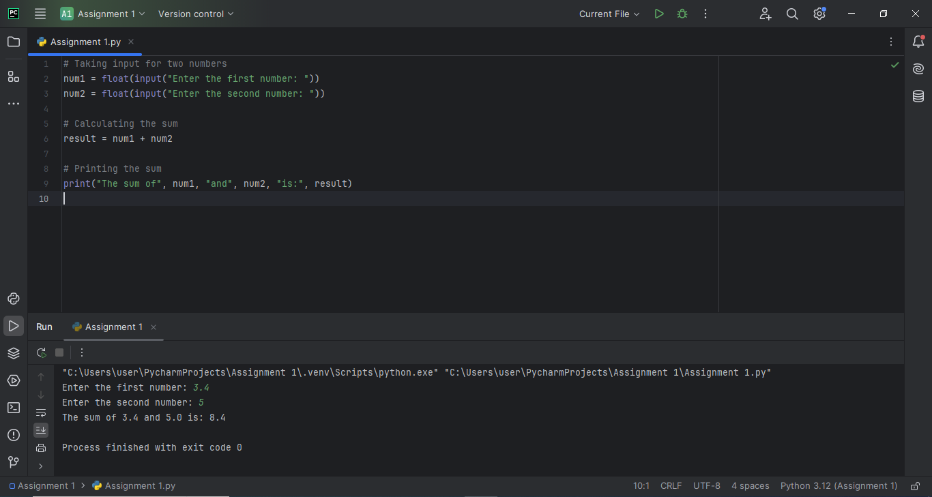

1. Write a python program that checks whether a given number is even or odd.

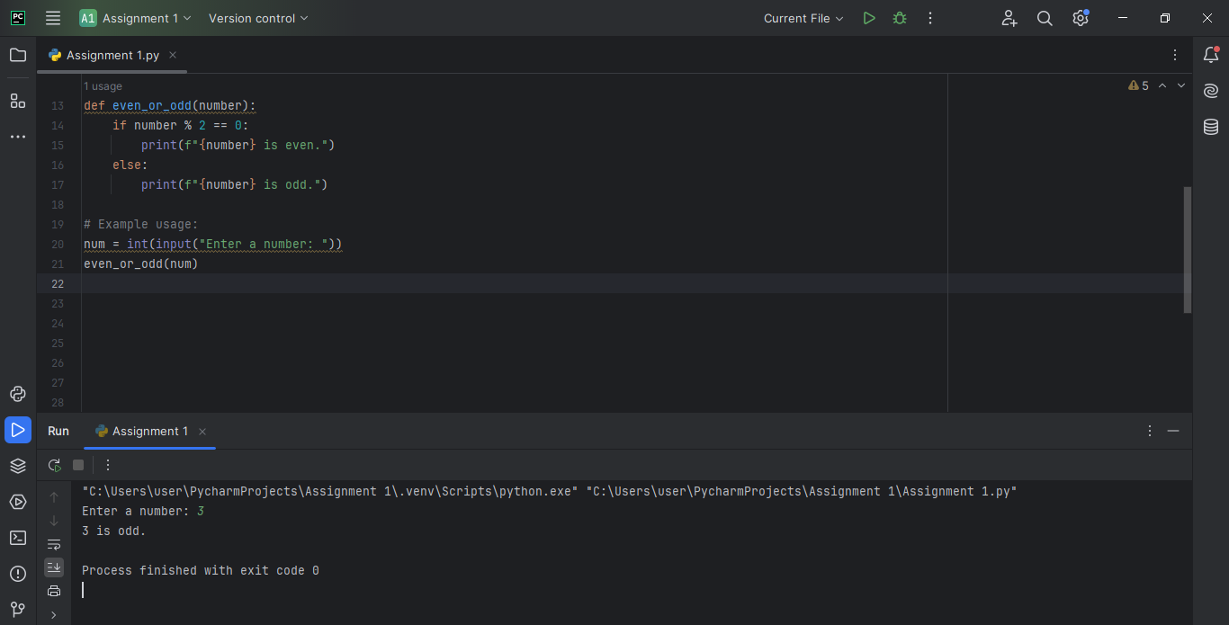

1. Write a python program that calculates the factorial of a given number.

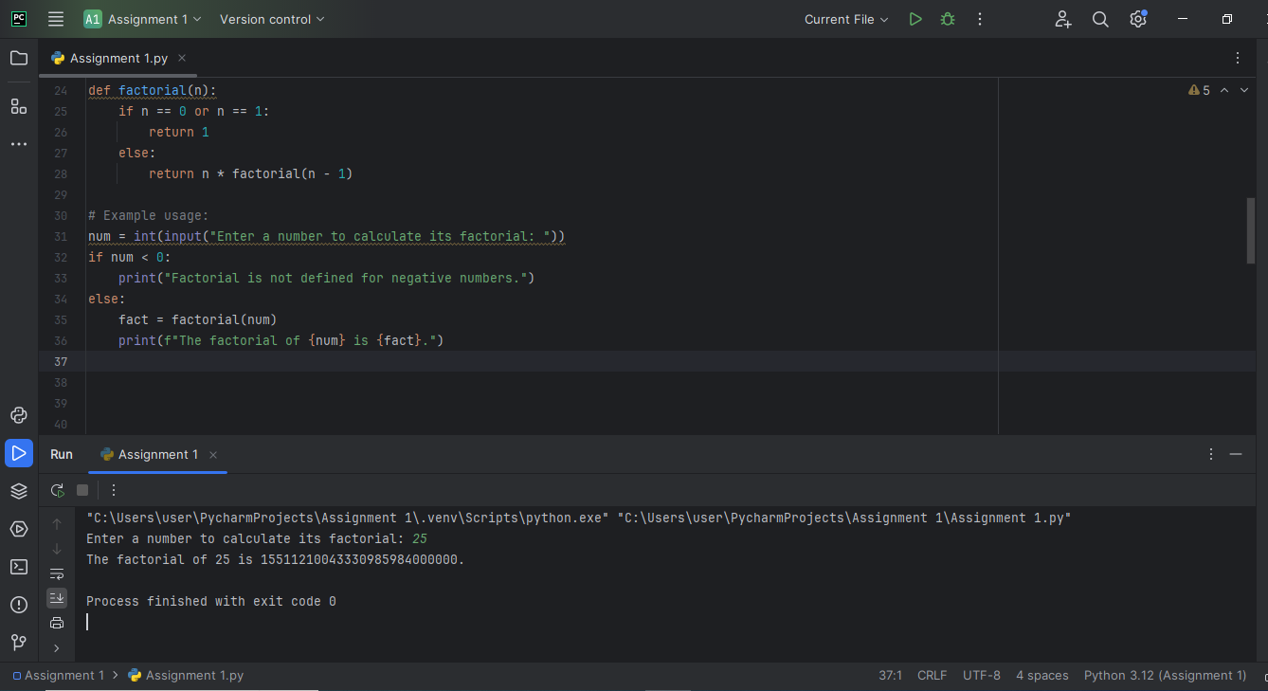

4. Write a program that asks the user for their name and then prints a

greeting message.

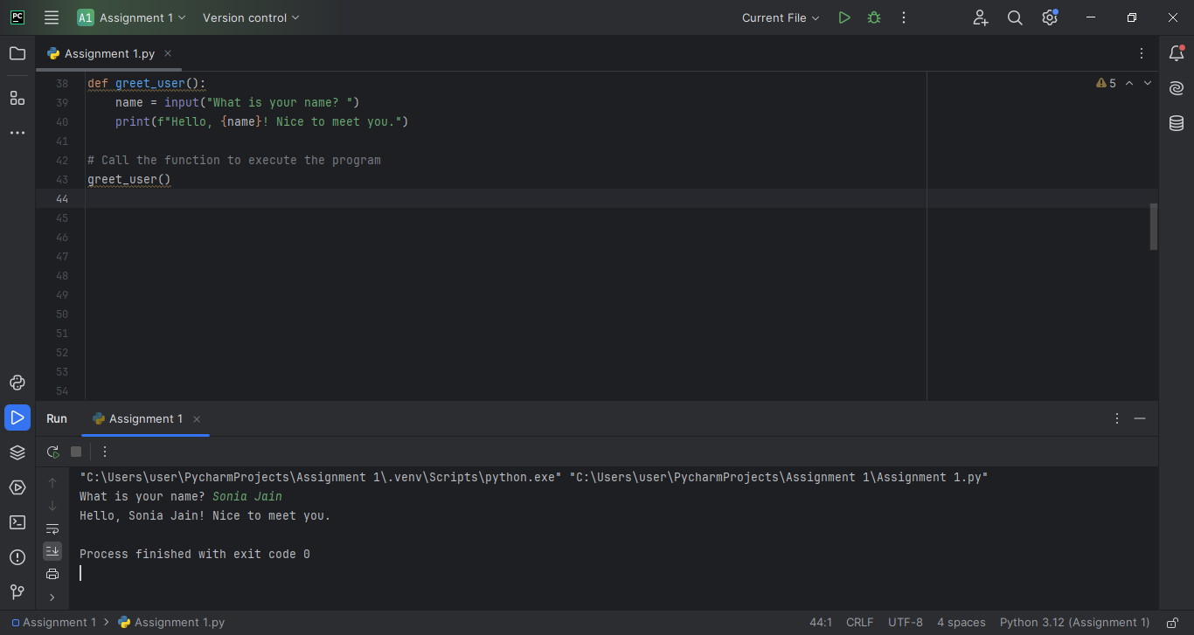

5. Write a program that takes a string input from the user and writes it to a text file.

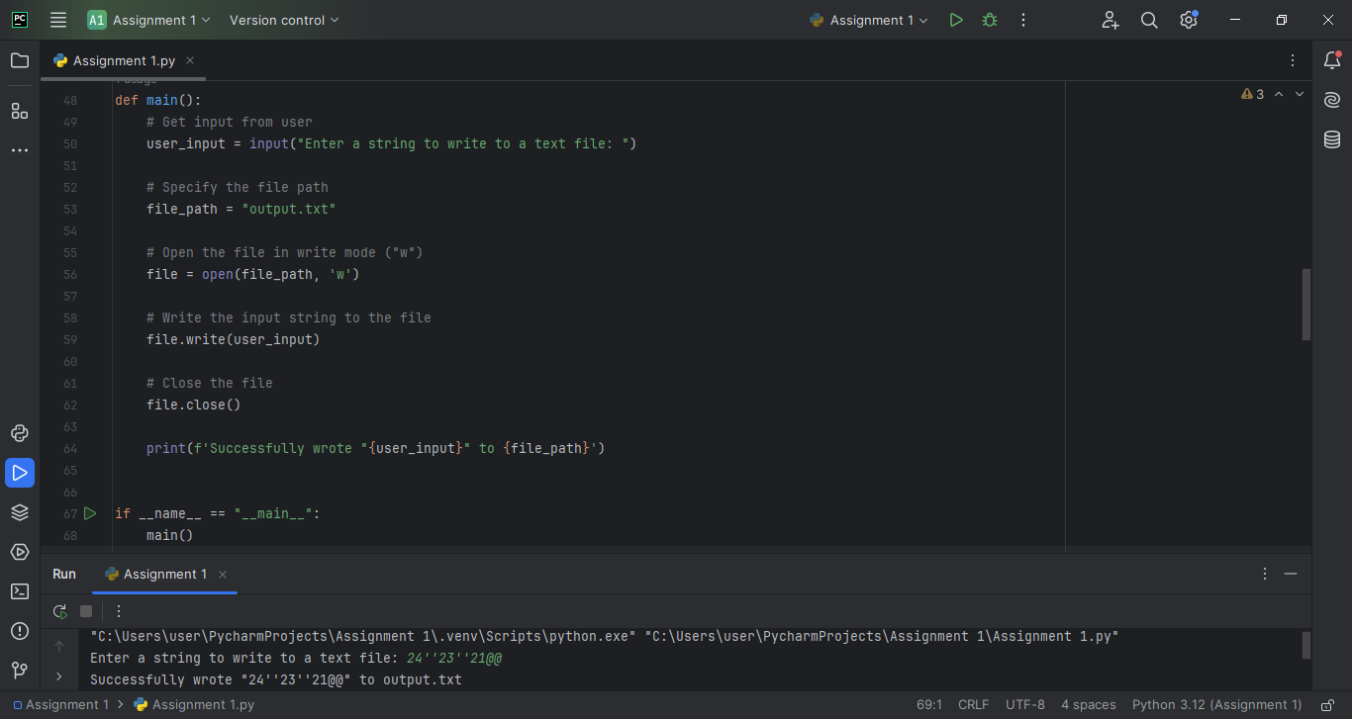

6. Write a program that reads the content of a text file and prints it to the console.

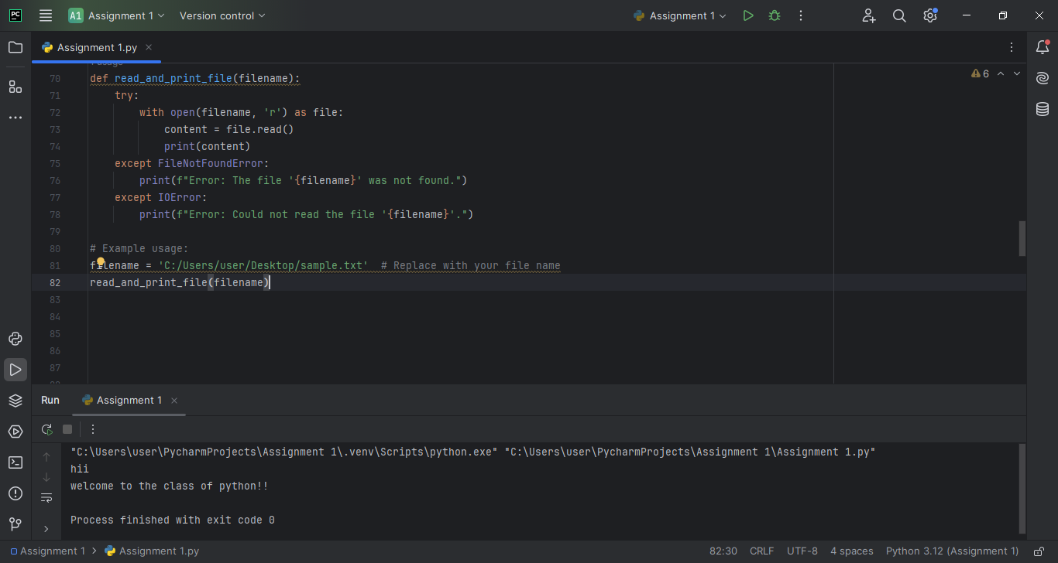

7. Write a python program that takes a string as input and returns its length

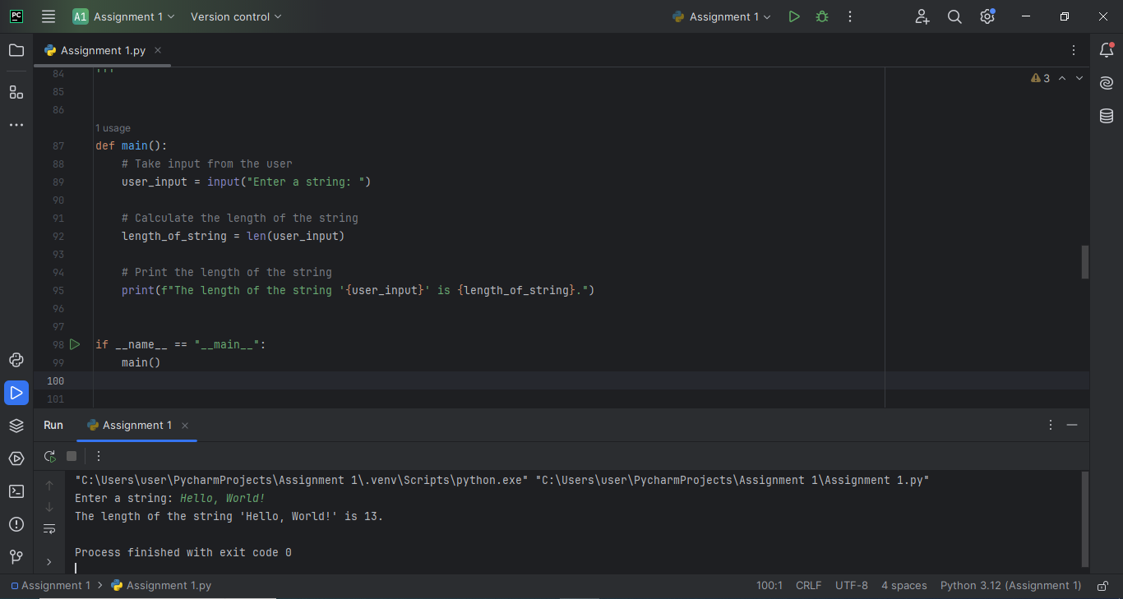

8. Write a python program that concatenates two strings and returns the

result.

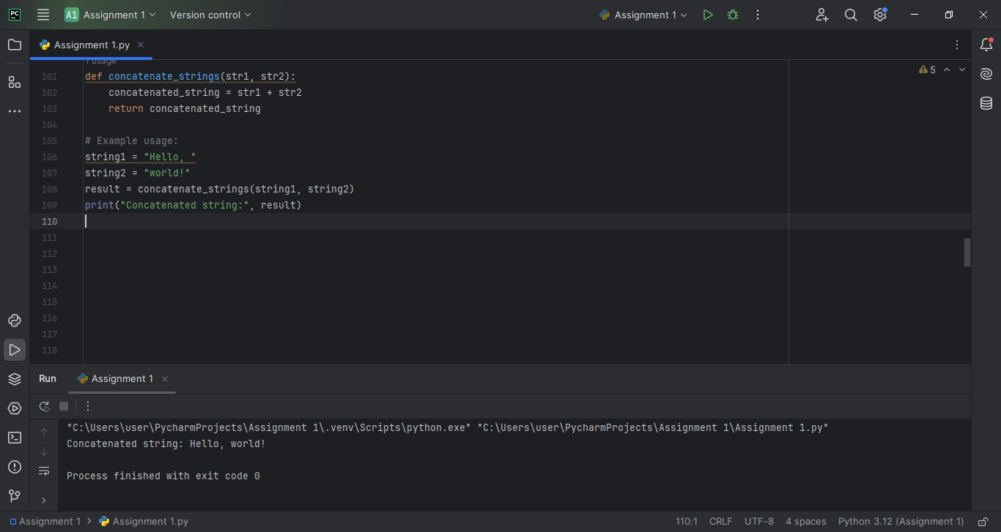

9. Write a python program that checks if a substring is present in a given

string.

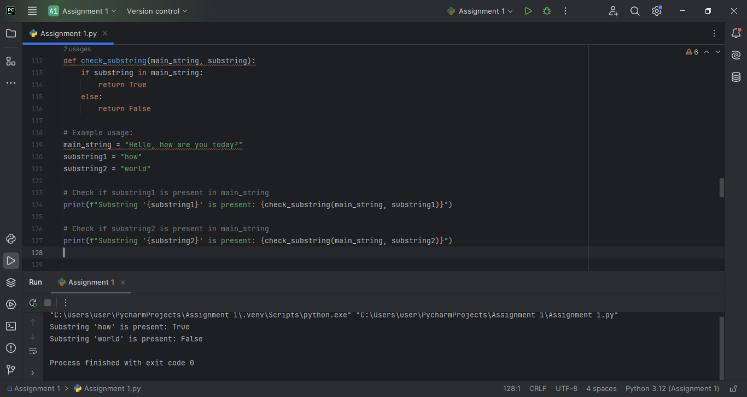

1. Write a python program that converts a given string to uppercase.

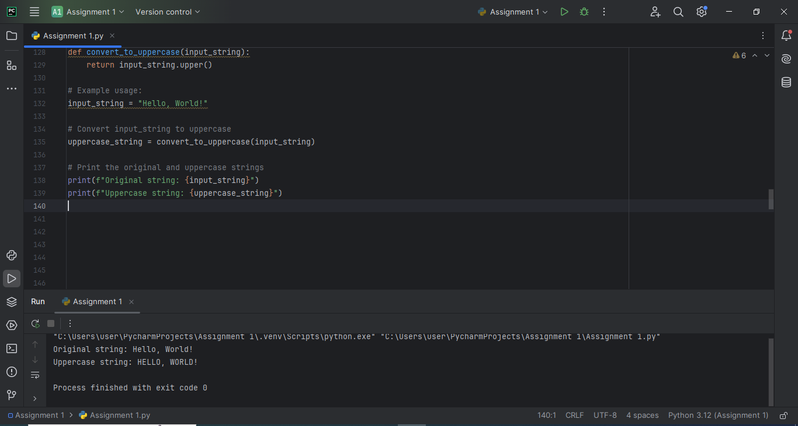

11. Write a python program that generates the first n numbers in the

Fibonacci sequence

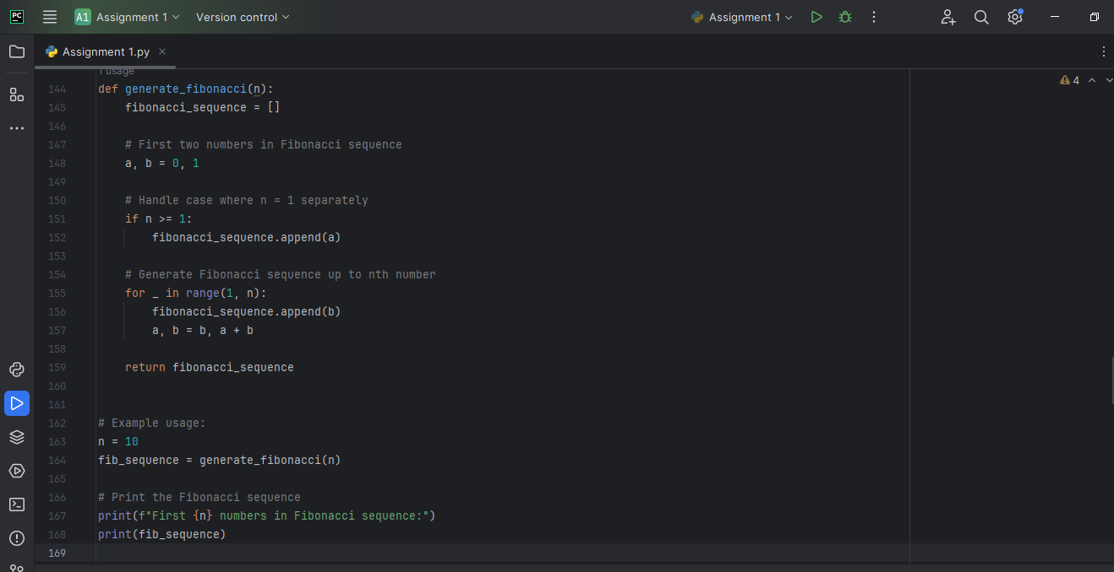

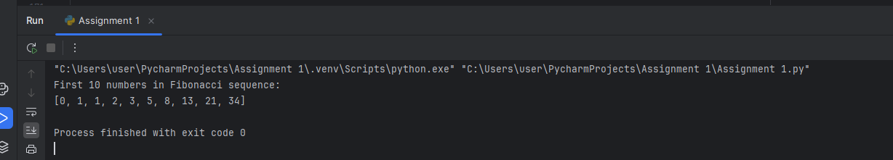

12. Write a python program that calculates the sum of the digits of a given number.

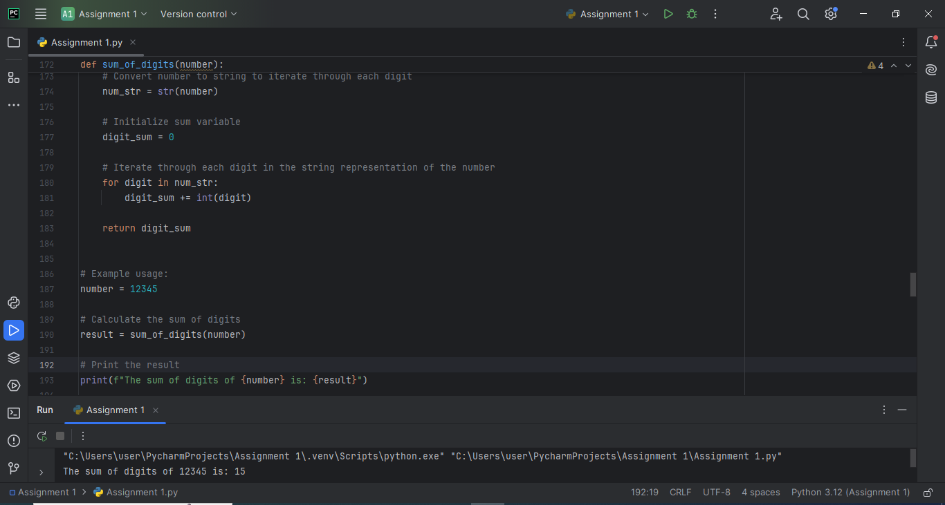

13. Write a program that asks the user for their birth year and calculates their age.

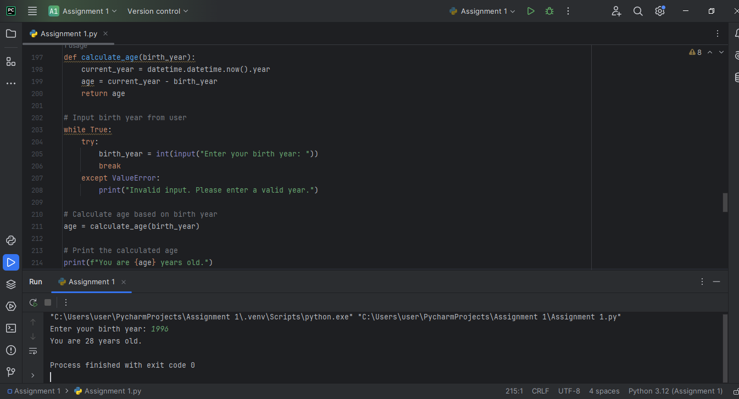

1. Write a program that reads multiple lines of input from the user until they enter an empty line, then prints all the lines.

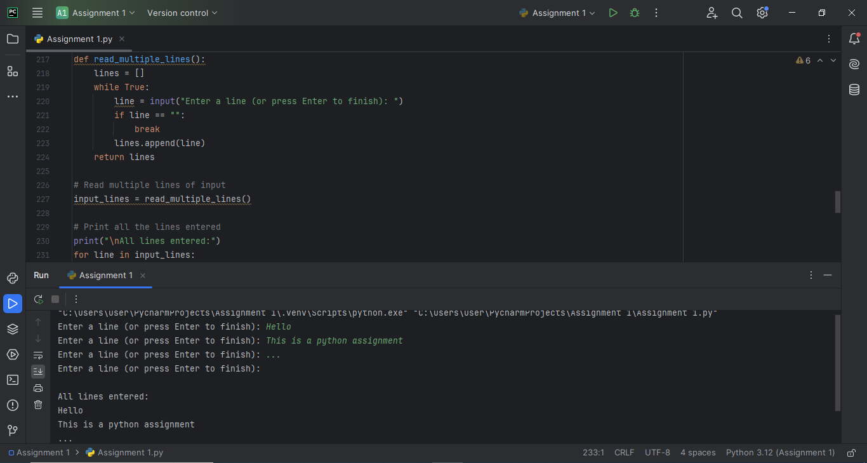

15. Write a program that reads data from a CSV file and prints it to the

console.

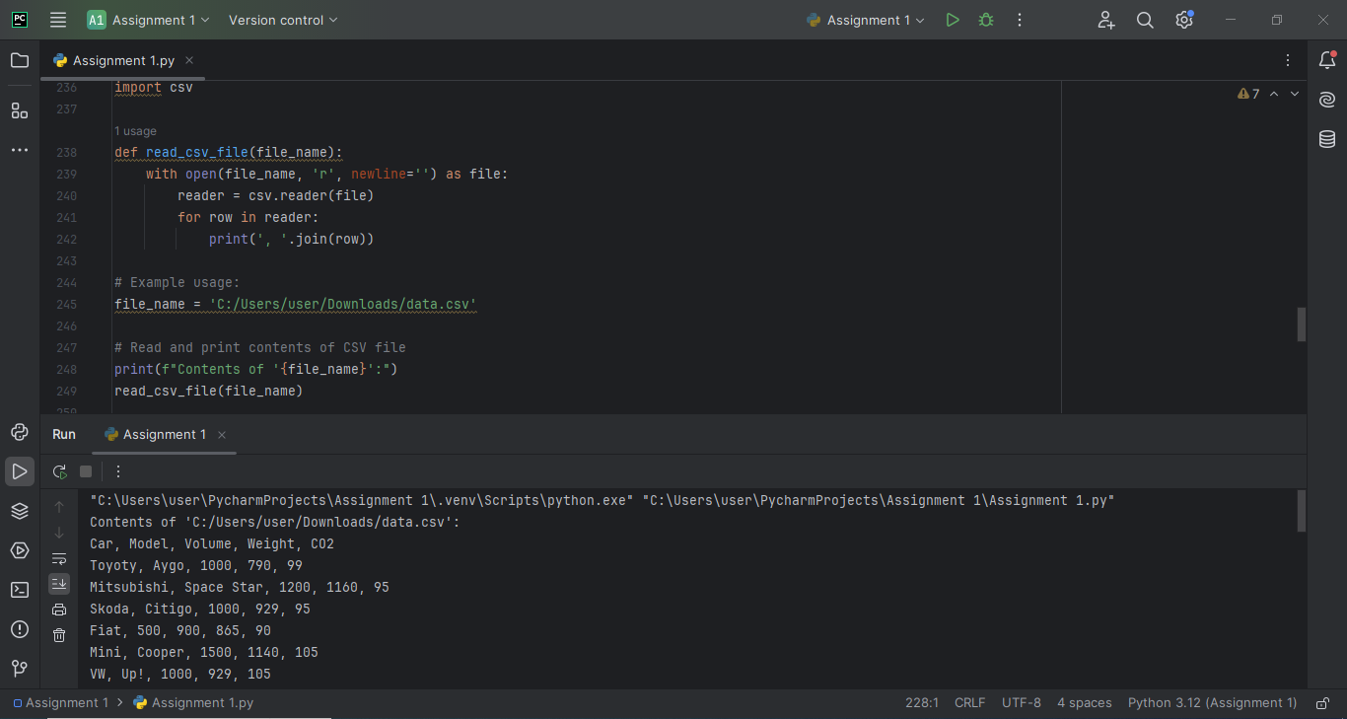

16. Write a program in python that counts the frequency of each character in a string.

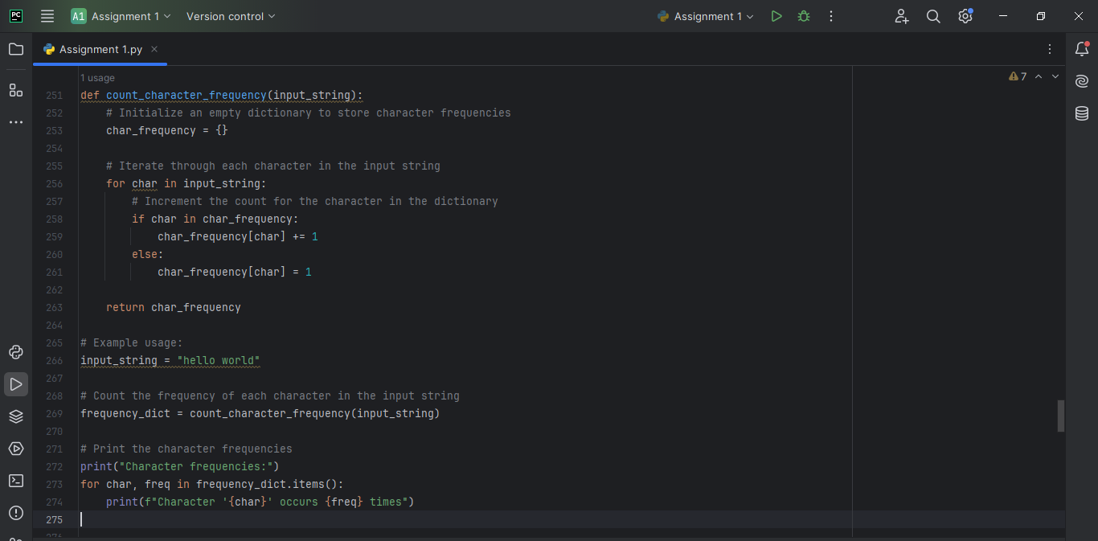

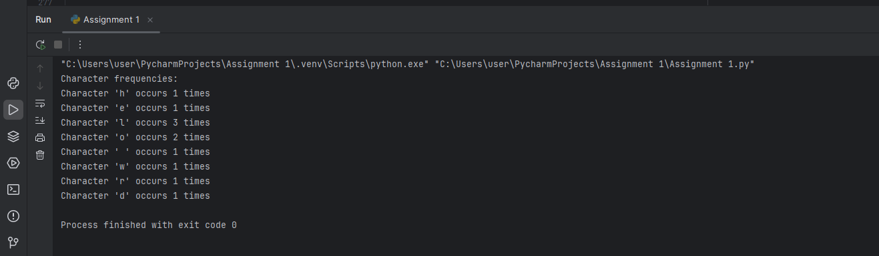

1. Write a program in python that converts a given string to title case (first letter of each word capitalized).

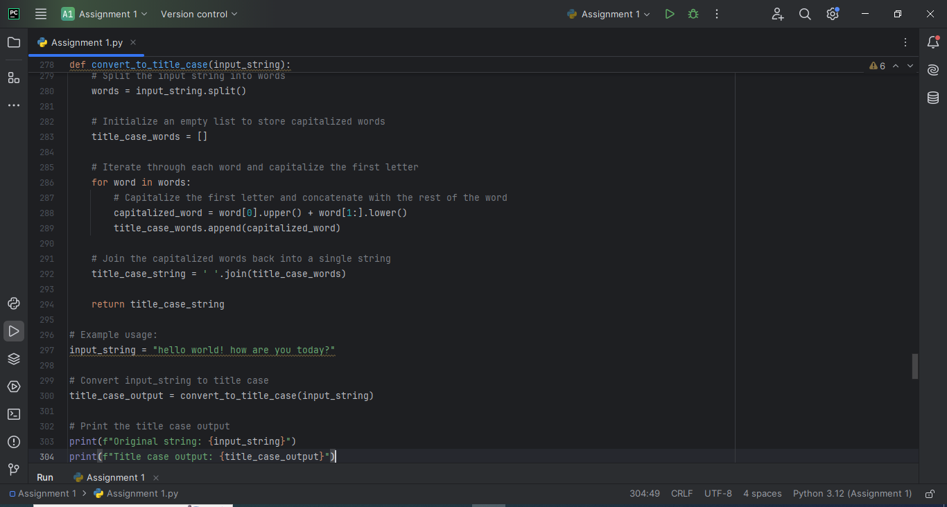

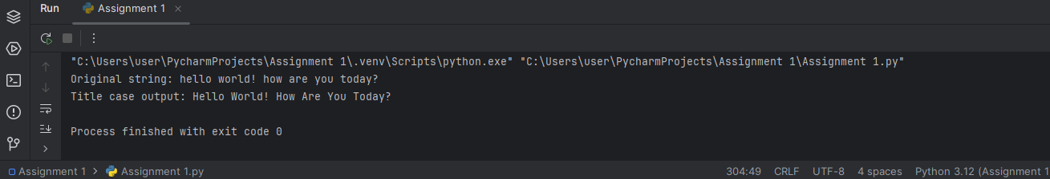

18. Write a python program that checks if two strings are anagrams of each other.

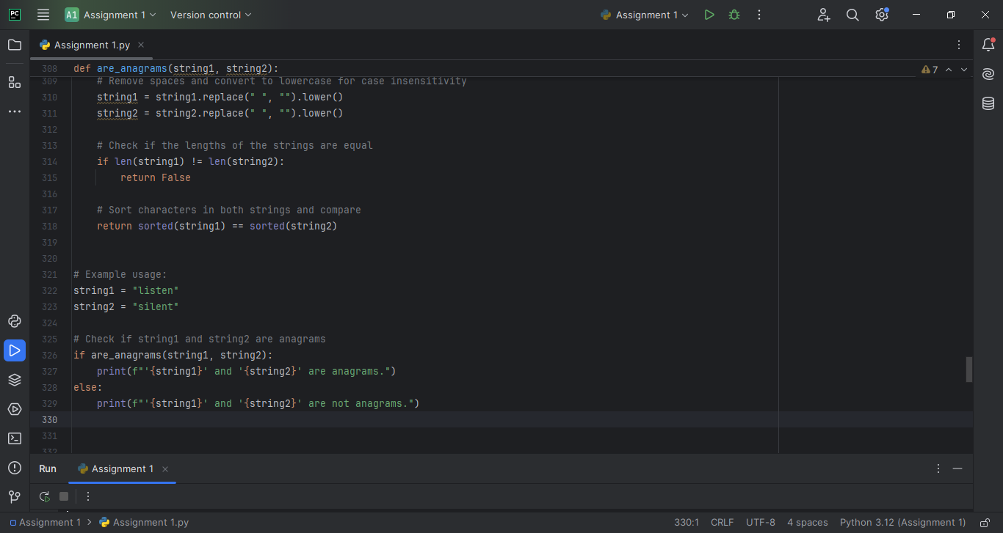

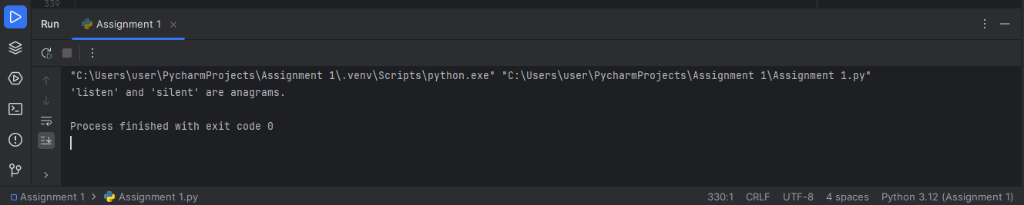

19. Write a python program that removes all punctuation from a given string.

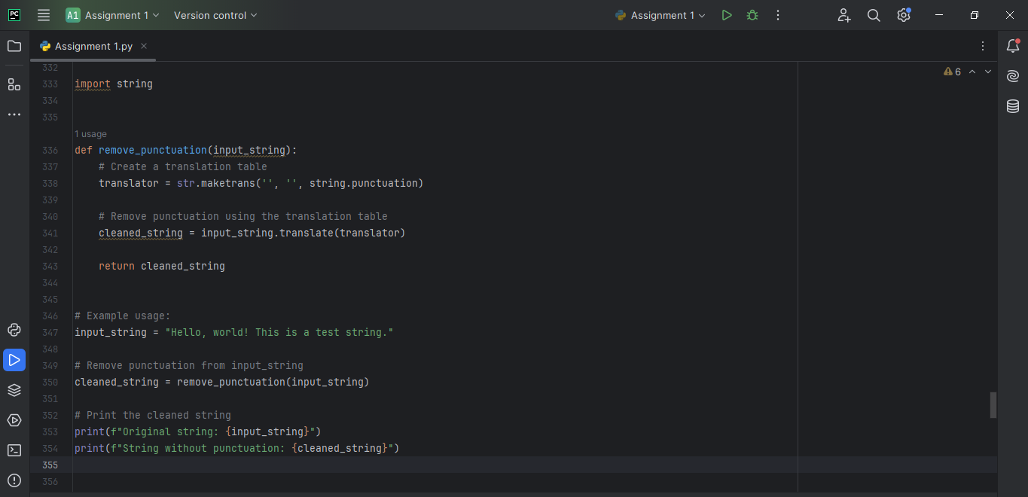

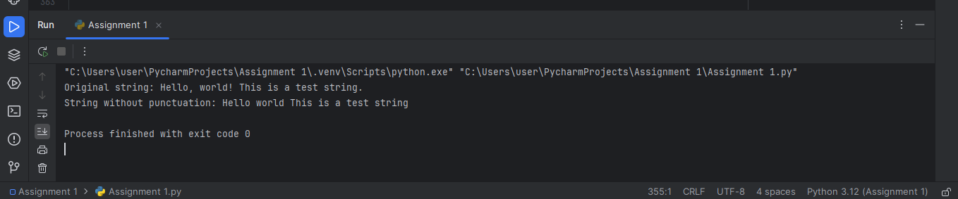

1. Write a python program that takes a list of numbers and returns their sum.

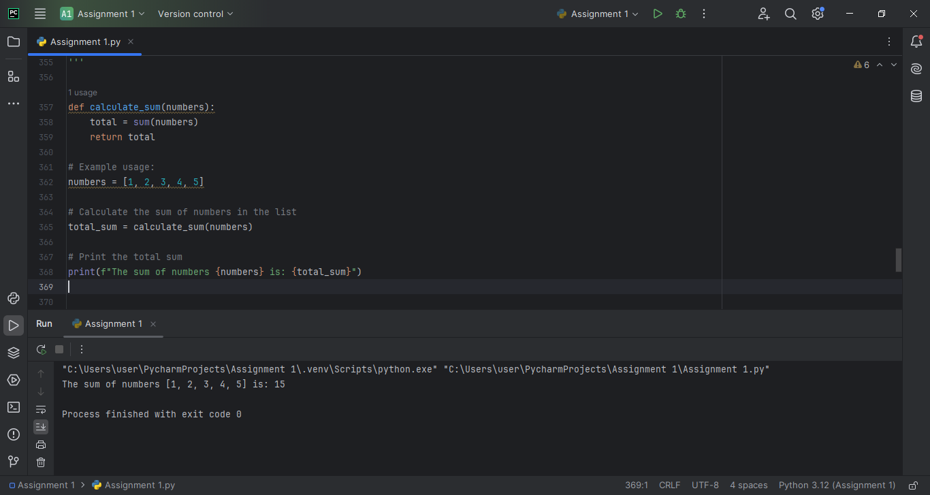

1. Write a python program that counts the occurrences of a specific element in a list.

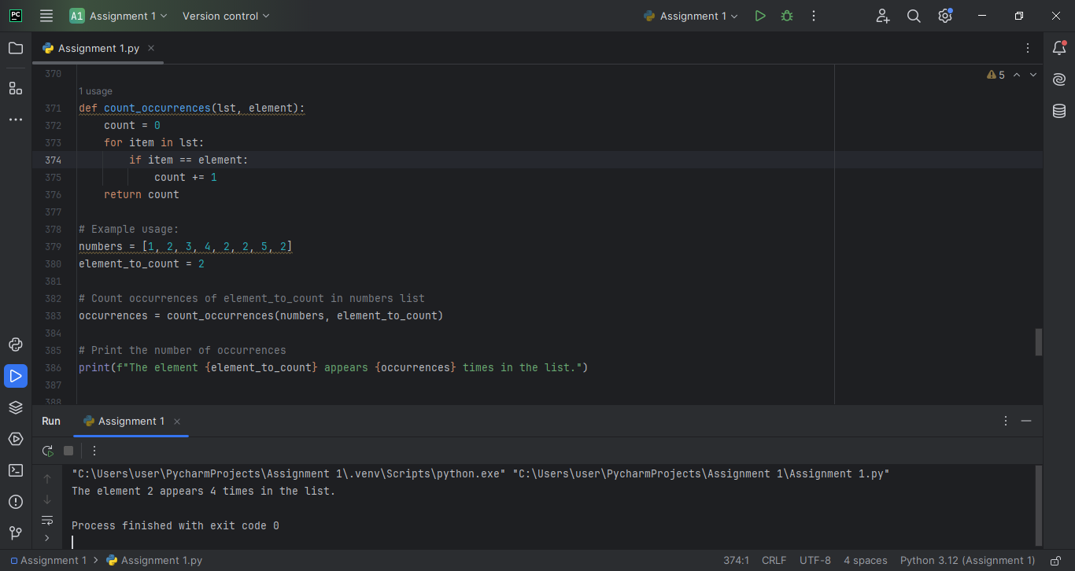

1. Write a python program that returns the minimum and maximum values in a list of numbers.

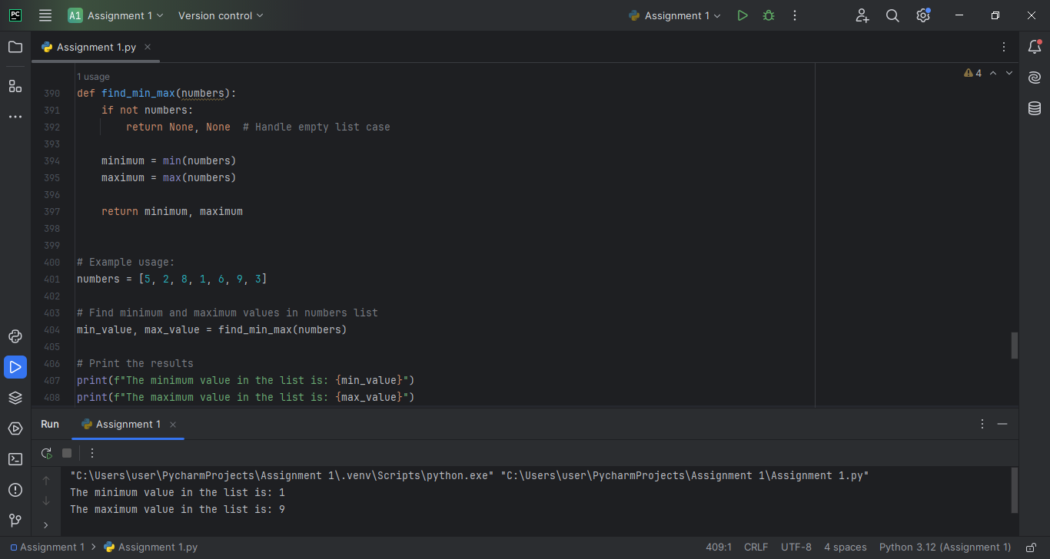

23. Write a program that converts temperature from Celsius to Fahrenheit and vice versa based on user input.

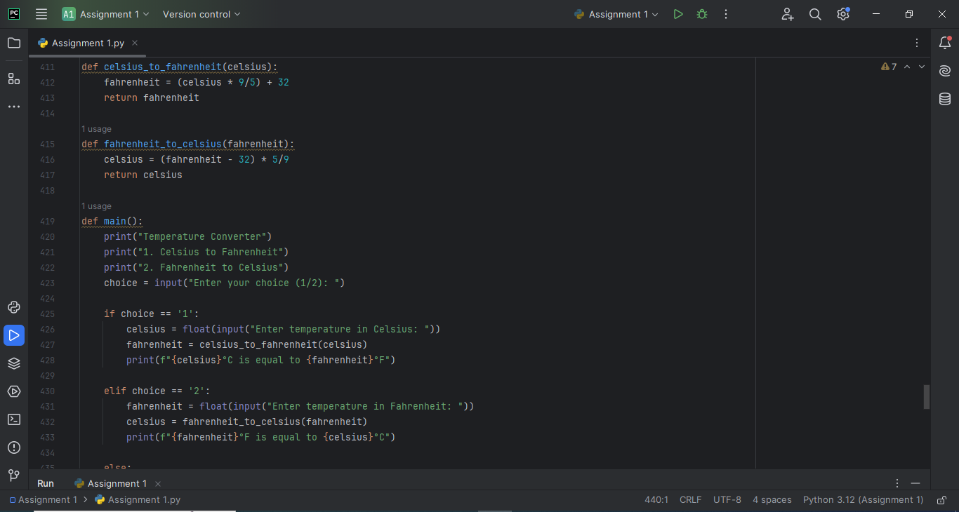

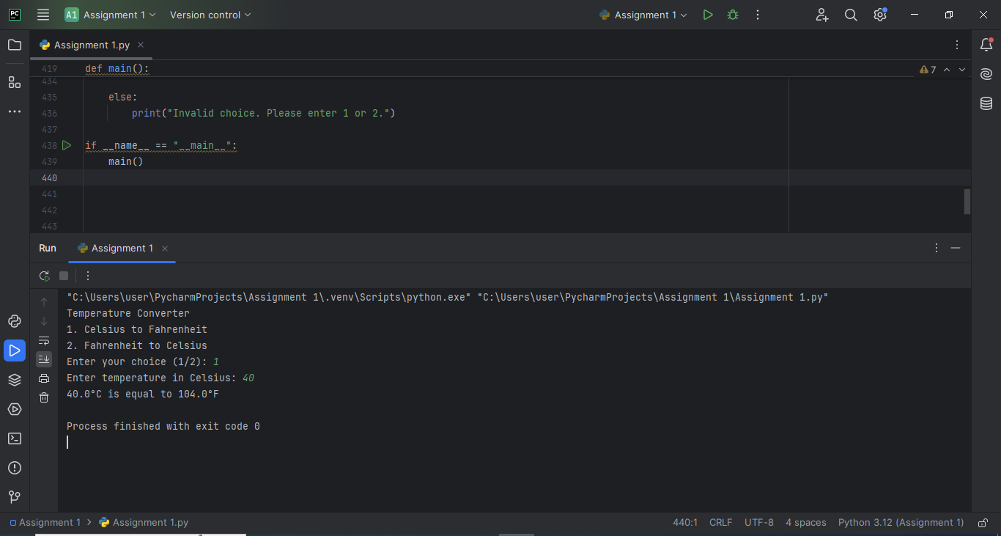

24. Write a program that acts as a simple calculator. It should take two

numbers and an operator (+, -, *, /) as input and print the result.

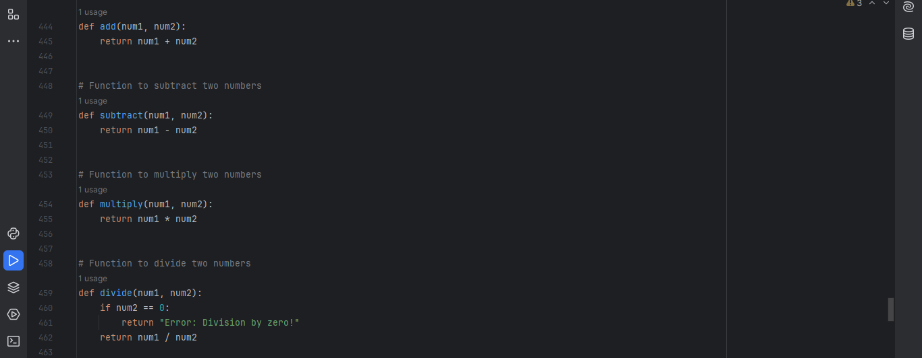

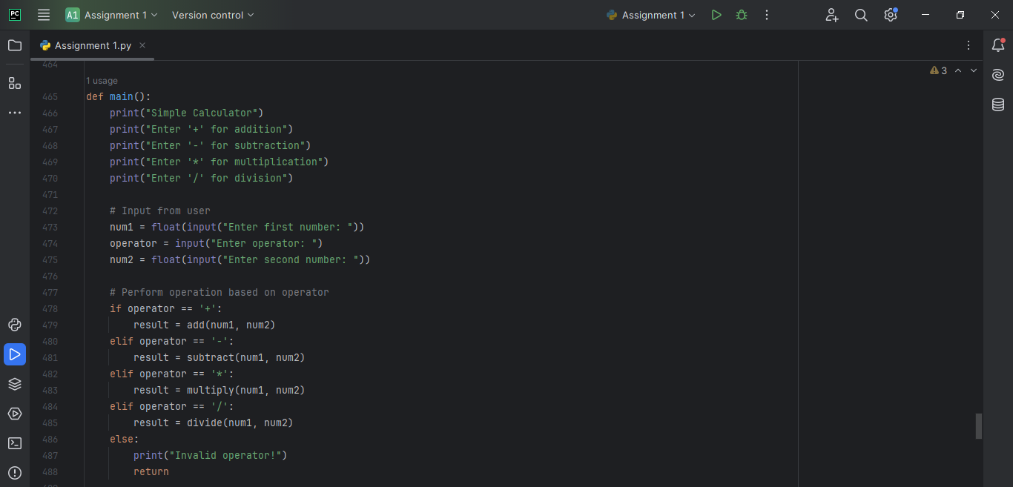

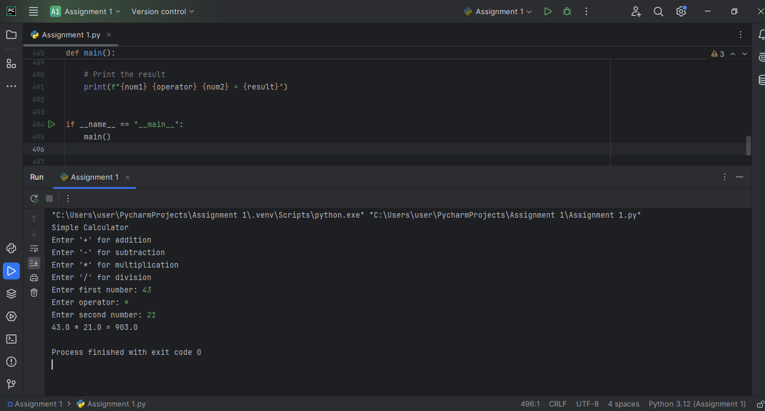

25. Write a program that copies the contents of one text file to another.

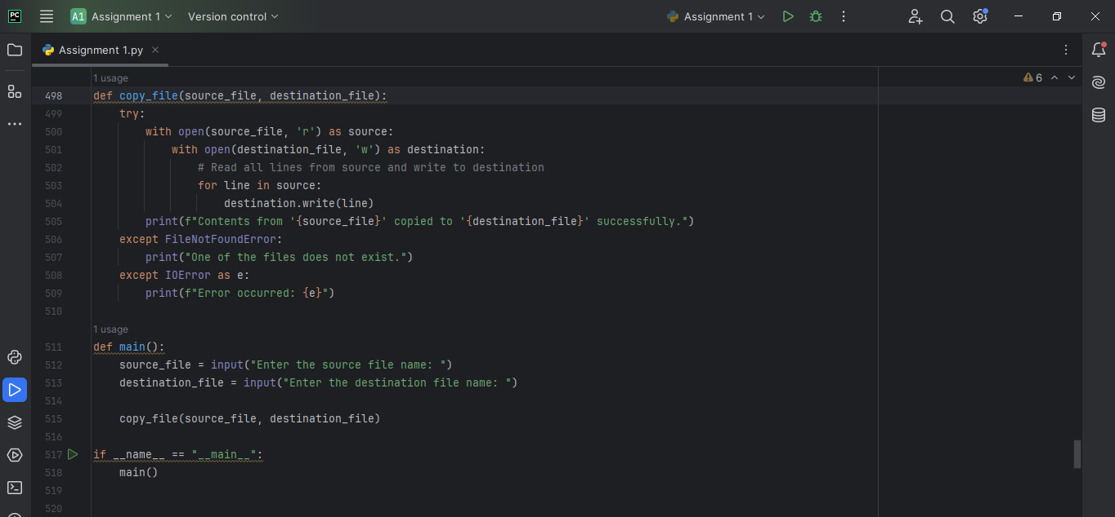

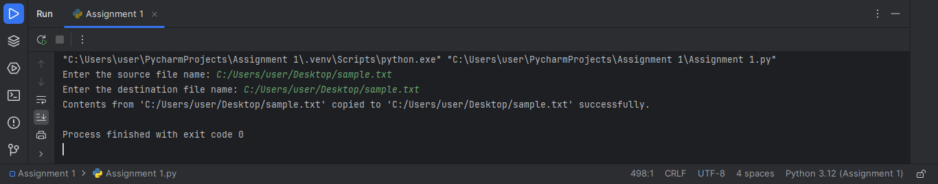

26. Write a program in python that checks if a string starts with a given prefix or ends with a given suffix.

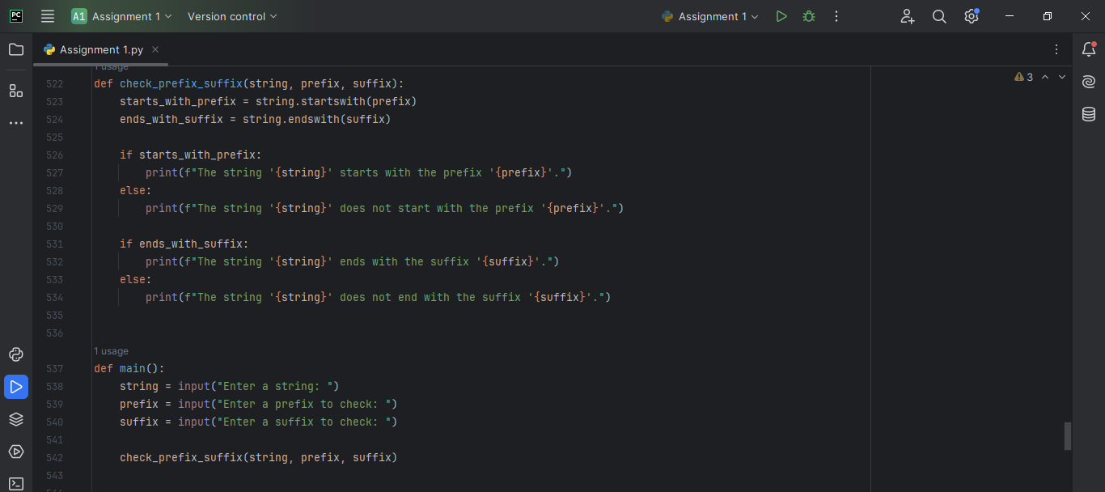

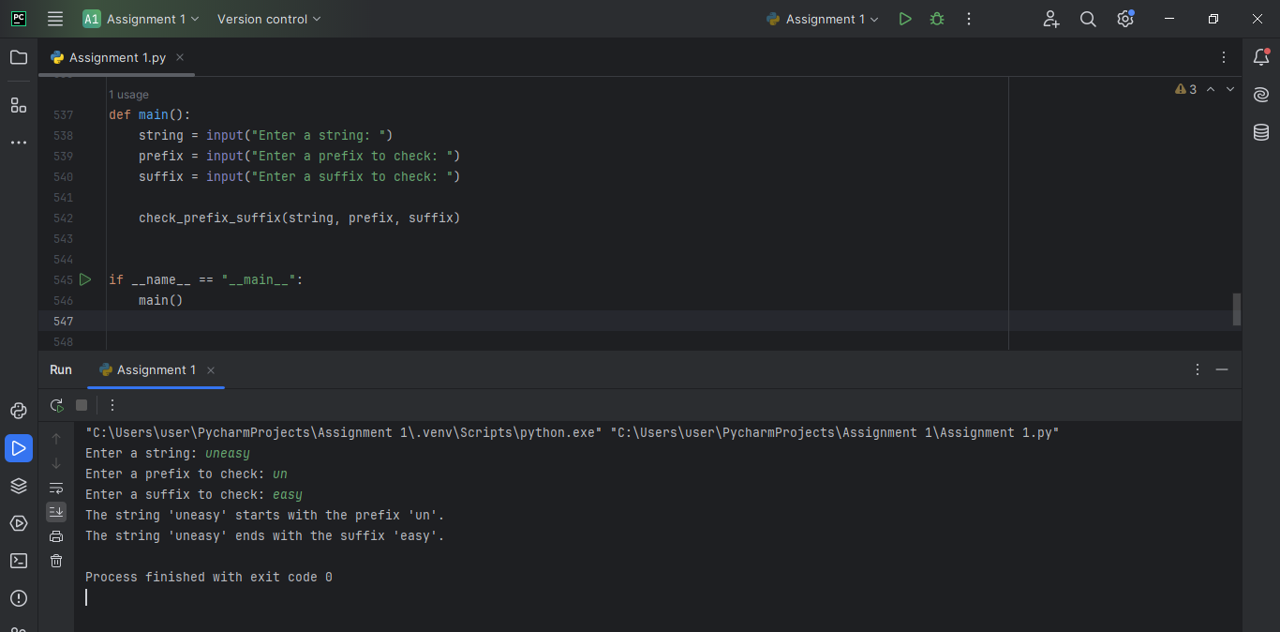

27. Write a program in python that converts a string into a list of its characters.

