* I chose a problem about making a program that can calculate your age by years, months, and days. There’s a few QoL adjustments I can make, as well as functional ones. Minus the days function, the calculator is pretty accurate.
* I started with trying to make an app that separated a phone number into smaller chunks, but I ran into a lot of problems with that. I switched to this app because it had important features of Javascript that I could use to bolster my learning.
* While I didn’t use CSS, I did use a lot of HTML. I preferred doing my coding in HTML because it was easier to understand what the Javascript was manipulating. To me, the trickiest part about Javascript was manipulating each feature. Unlike Java, Javascript wasn’t super intuitive when it came to its function. I feel the syntax is more convoluted then with Java or Python.

Calculate Days:

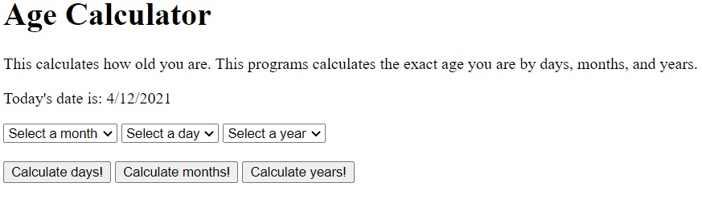

Calculate Months:

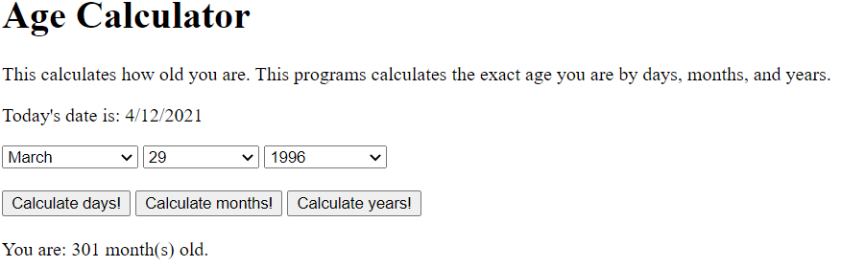

Calculate Years:

