VIRTUAL R DATA ANALYST INTERNSHIP
WEEK 1 PROJECT REPORT

DATA CLEANING AND PRELIMINARY ANALYSIS
Titanic Passenger Dataset

Report Information | Details
Intern Name | Sahil S. Jadhao
Internship | Virtual R Data Analyst Internship
Internship Duration | 07 July 2026 – 04 August 2026
Project | Week 1 – Data Cleaning and Preliminary Analysis
Programming Language | R
Development Environment | Visual Studio Code
Dataset | Titanic Passenger Dataset
Report Date | 31 October 2026

Submitted as part of the Week 1 internship assignment

ABSTRACT
This report presents the data cleaning and preliminary exploratory analysis of the Titanic passenger dataset using the R programming language. The dataset contains 891 passenger records and 12 original variables. The work includes data inspection, duplicate checking, missing-value treatment, outlier detection, normalization, categorical encoding, descriptive statistics, visualization and correlation analysis.
The cleaning process retained all 891 passenger records. Missing Age and Embarked values were treated, while the Cabin variable was removed because of its high proportion of missing observations. Fare outliers were identified and flagged rather than deleted. The final cleaned dataset contains 891 records and 14 columns.

TABLE OF CONTENTS
- 1. Introduction
- 2. Objectives
- 3. Dataset Description
- 4. Tools and Technologies
- 5. Data Importing and Initial Inspection
- 6. Data Cleaning and Preprocessing
- 7. Outlier Detection
- 8. Data Normalization and Categorical Encoding
- 9. Exploratory Data Analysis
- 10. Correlation Analysis
- 11. Key Findings
- 12. Conclusion
- 13. Project Output Files
- 14. Appendix – R Source Code

1. INTRODUCTION
Data analysis is the process of inspecting, cleaning, transforming and interpreting data to discover useful information. Data cleaning is an important stage because incomplete, duplicated or inconsistent data can affect analytical results.
This project uses the Titanic passenger dataset to demonstrate a practical data analysis workflow in R. The analysis focuses on passenger survival, passenger class, gender, age and fare.

2. OBJECTIVES
- Import and understand a real-world dataset using R.
- Identify missing values and duplicate records.
- Apply appropriate missing-value treatment.
- Detect potential outliers using the IQR method.
- Normalize selected numerical variables.
- Encode categorical variables for analysis.
- Perform exploratory data analysis and descriptive statistics.
- Study relationships between selected numerical variables.
- Create graphs and export cleaned data and analytical results.

3. DATASET DESCRIPTION
The Titanic dataset contains information about passengers aboard the RMS Titanic. It includes demographic details, ticket and fare information, family relationships, passenger class, embarkation port and survival status.
Dataset Property | Value
Dataset | Titanic passenger training dataset
Original observations | 891
Original variables | 12
Final observations | 891
Final variables | 14
Target variable | Survived
Numerical variables | Age, Fare, SibSp, Parch, etc.
Categorical variables | Sex, Pclass, Embarked
Data format | CSV

3.1 Description of Important Variables
Variable | Description
PassengerId | Unique passenger identification number.
Survived | Survival indicator: 0 = No, 1 = Yes.
Pclass | Passenger ticket class: 1, 2 or 3.
Name | Passenger name.
Sex | Passenger gender recorded in the dataset.
Age | Passenger age in years.
SibSp | Number of siblings or spouses aboard.
Parch | Number of parents or children aboard.
Ticket | Ticket identification information.
Fare | Passenger fare.
Cabin | Cabin identification information.
Embarked | Port of embarkation.

4. TOOLS AND TECHNOLOGIES
Tool / Package | Purpose
R 4.6.2 | Statistical programming and analysis.
Visual Studio Code | Code editing and execution.
dplyr | Data manipulation.
ggplot2 | Data visualization.
tidyr | Data transformation support.
readr | CSV data import and export.
corrplot | Correlation matrix visualization.

5. DATA IMPORTING AND INITIAL INSPECTION
The Titanic CSV file was imported into R using read_csv() from the readr package. Initial inspection was performed using dimension, structure, preview, missing-value counts and summary statistics.
The original dataset contained 891 rows and 12 columns.
Variable | Missing Values | Percentage
Age | 177 | 19.87%
Cabin | 687 | 77.10%
Embarked | 2 | 0.22%
All other variables | 0 | 0%

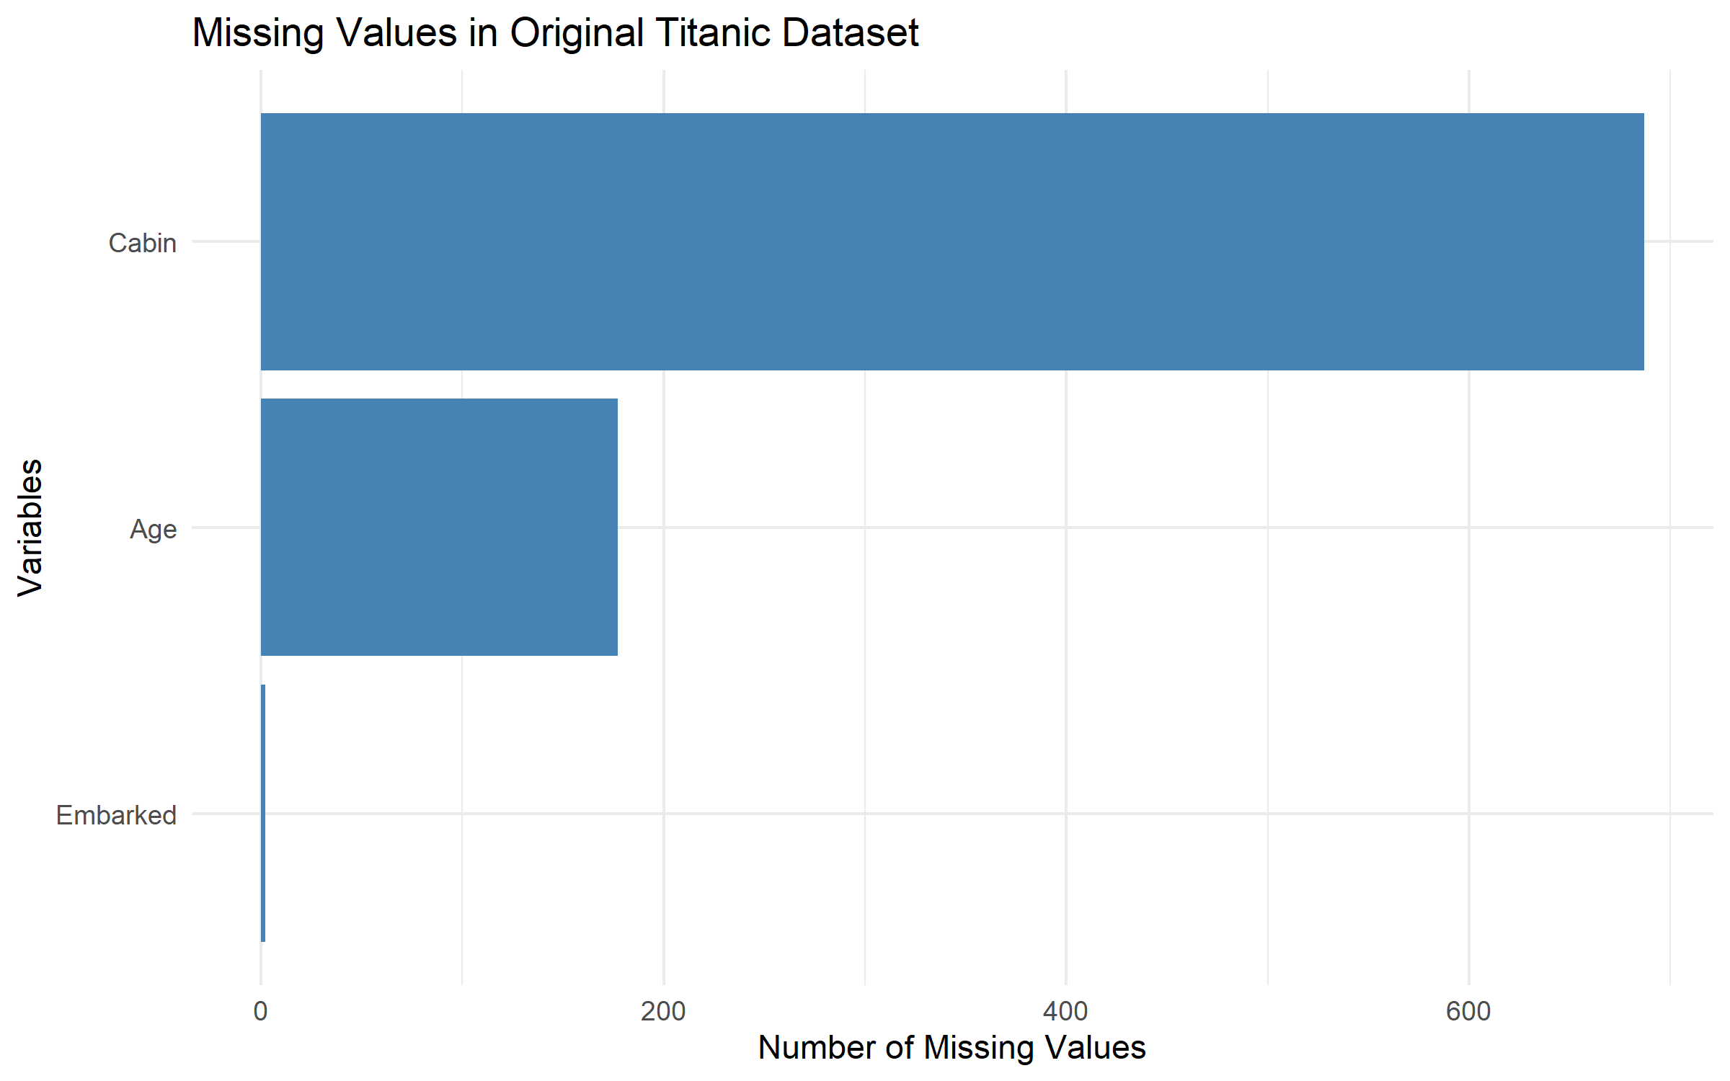
Figure 1: Missing values in the original Titanic dataset.

6. DATA CLEANING AND PREPROCESSING

6.1 Duplicate Checking
The duplicated rows and duplicated PassengerId values were checked. The analysis detected zero duplicate rows and zero duplicate passenger IDs.

6.2 Missing-Value Treatment
Variable | Original Missing Values | Treatment | Final Status
Age | 177 | Median imputation by Pclass and Sex; overall median fallback if needed. | 0 missing
Embarked | 2 | Mode imputation. | 0 missing
Cabin | 687 | Removed due to high missingness. | Column removed

Age values were imputed using the median age of passengers belonging to the same passenger class and sex group. Embarked missing values were replaced using the mode. Cabin was excluded from the cleaned dataset because approximately 77.10% of its observations were missing.

6.3 Missing-Value Comparison

Missing-value comparison output
Variable | Before | After
PassengerId | 0 | 0
Survived | 0 | 0
Pclass | 0 | 0
Name | 0 | 0
Sex | 0 | 0
Age | 177 | 0
SibSp | 0 | 0
Parch | 0 | 0
Ticket | 0 | 0
Fare | 0 | 0
Cabin | 687 | NA
Embarked | 2 | 0

7. OUTLIER DETECTION
Potential outliers in the Fare variable were identified using the Interquartile Range (IQR) method. The lower and upper thresholds were calculated using Q1 - 1.5 × IQR and Q3 + 1.5 × IQR.
Outlier Measure | Actual Result
Lower threshold | -26.724
Upper threshold | 65.6344
Detected Fare outliers | 116
Records retained | 891

The detected outliers were flagged in a new Fare_Outlier column. They were not deleted because unusually high fares may represent valid passenger observations.
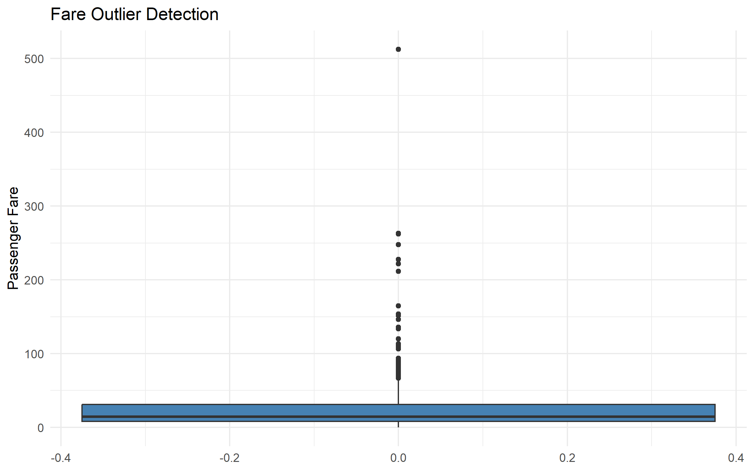
Figure 2: Boxplot used for Fare outlier detection.

8. DATA NORMALIZATION AND CATEGORICAL ENCODING

8.1 Min-Max Normalization
Min-Max normalization was applied to Age and Fare. This transformation scales numerical values to a range from 0 to 1. The resulting variables were stored as Age_Normalized and Fare_Normalized.
The original Age and Fare columns were retained so that the normalized values could be compared with the original measurements.

8.2 Categorical Encoding
Sex, Pclass and Embarked were converted into categorical factors. A one-hot encoded matrix was generated using model.matrix() and exported as titanic_encoded.csv.

9. EXPLORATORY DATA ANALYSIS
Exploratory Data Analysis (EDA) was performed to understand passenger survival patterns and the distributions of important variables.

9.1 Overall Survival Distribution
Survival Status | Passengers | Percentage
Did not survive | 549 | 61.6%
Survived | 342 | 38.4%

Out of 891 passengers, 342 survived and 549 did not survive. The overall survival percentage was approximately 38.4%.
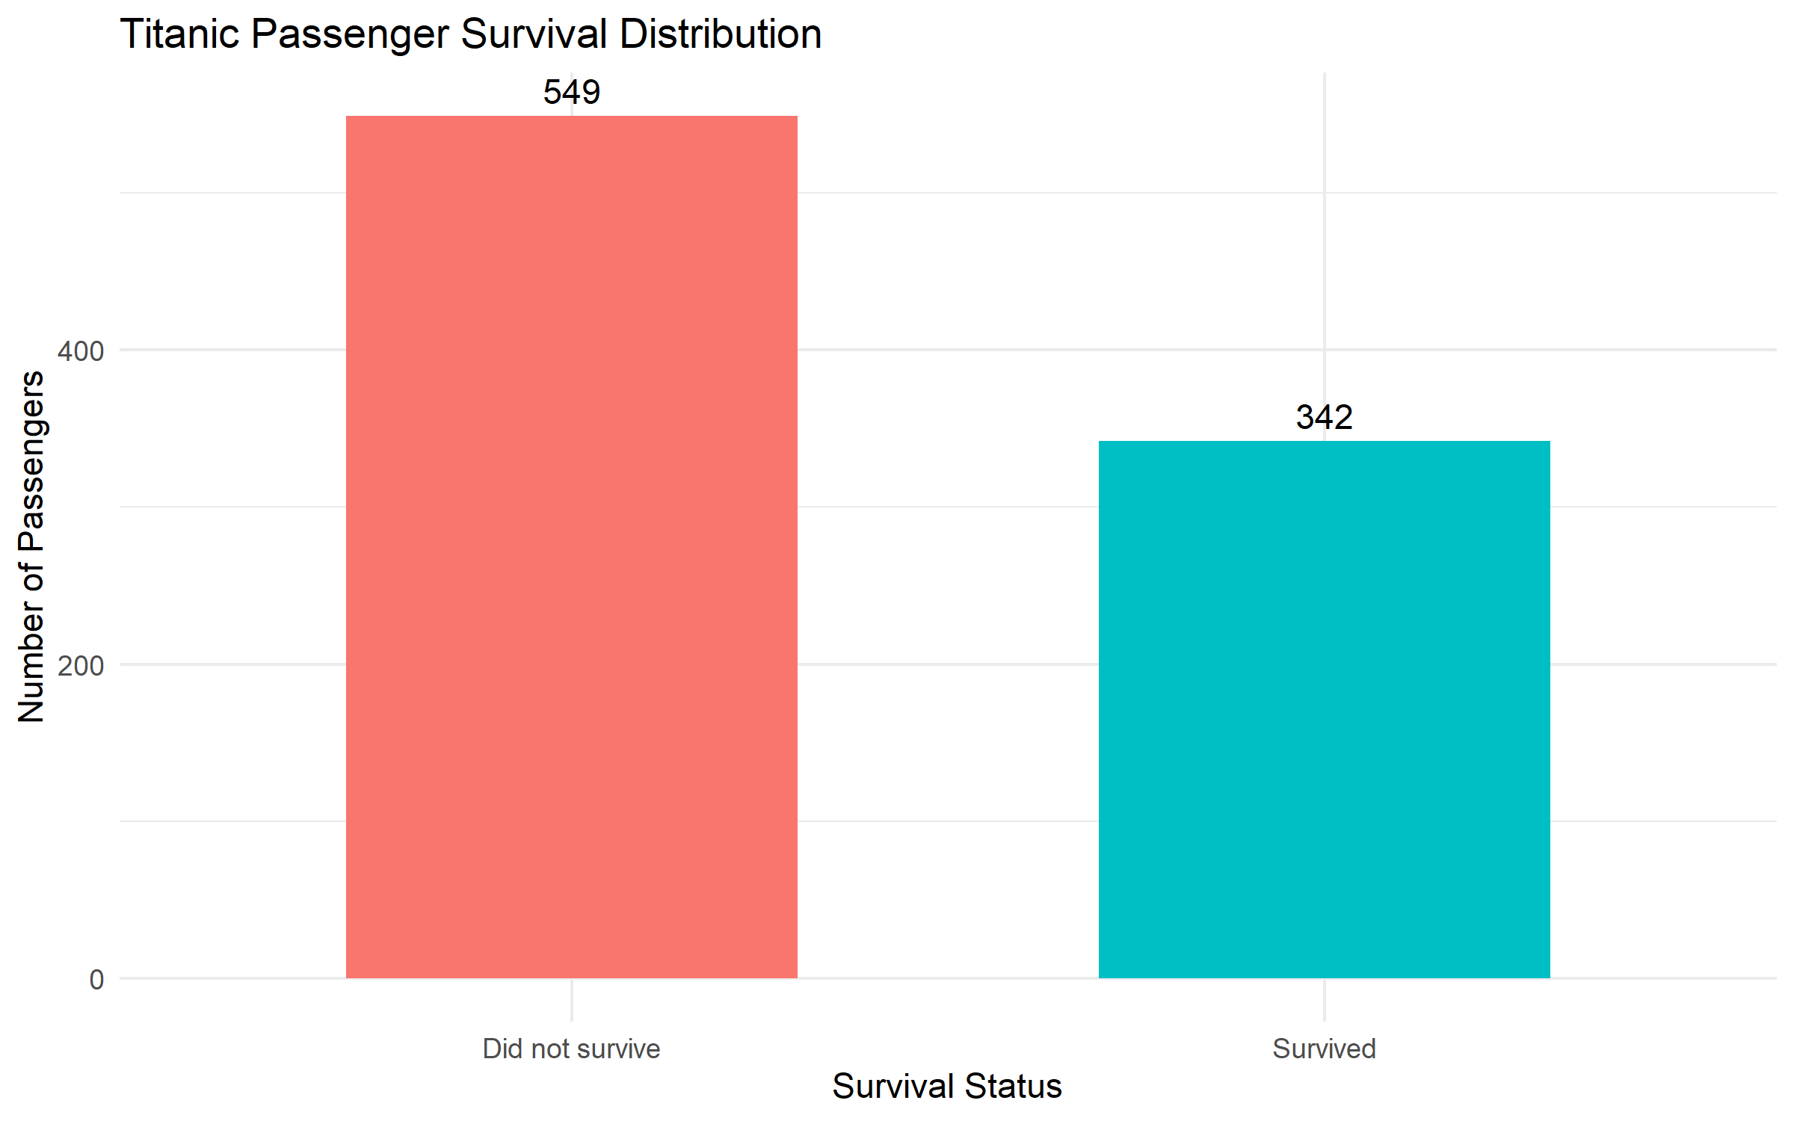
Figure 3: Overall passenger survival distribution.

9.2 Survival by Gender
Gender | Total Passengers | Survivors | Survival Rate
Female | 314 | 233 | 74.2%
Male | 577 | 109 | 18.9%

The observed survival rate was higher among female passengers (74.2%) than male passengers (18.9%) in this dataset.
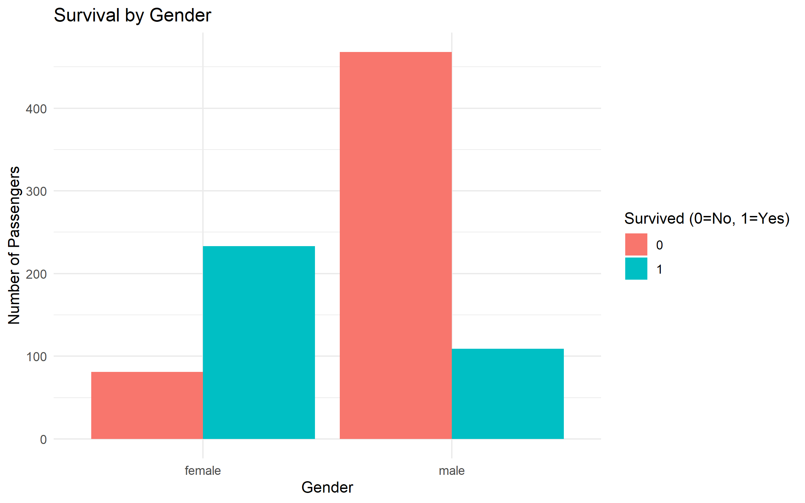
Figure 4: Passenger survival counts by gender.

9.3 Survival by Passenger Class
Passenger Class | Total | Survivors | Survival Rate
First class | 216 | 136 | 63.0%
Second class | 184 | 87 | 47.3%
Third class | 491 | 119 | 24.2%

The first-class group had the highest observed survival rate at 63.0%, followed by second class at 47.3% and third class at 24.2%.
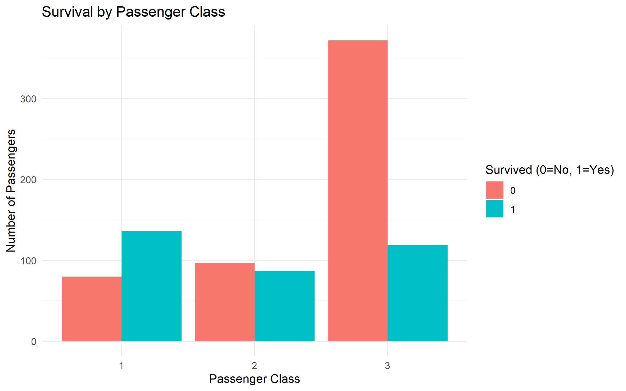
Figure 5: Passenger survival counts by passenger class.

9.4 Age Distribution
Age Statistic | Value
Mean age | 29.11 years
Median age | 26 years
Minimum age | 0.42 years
Maximum age | 80 years
Standard deviation | 13.3 years

After missing-value treatment, the mean passenger age was approximately 29.11 years and the median was 26 years.
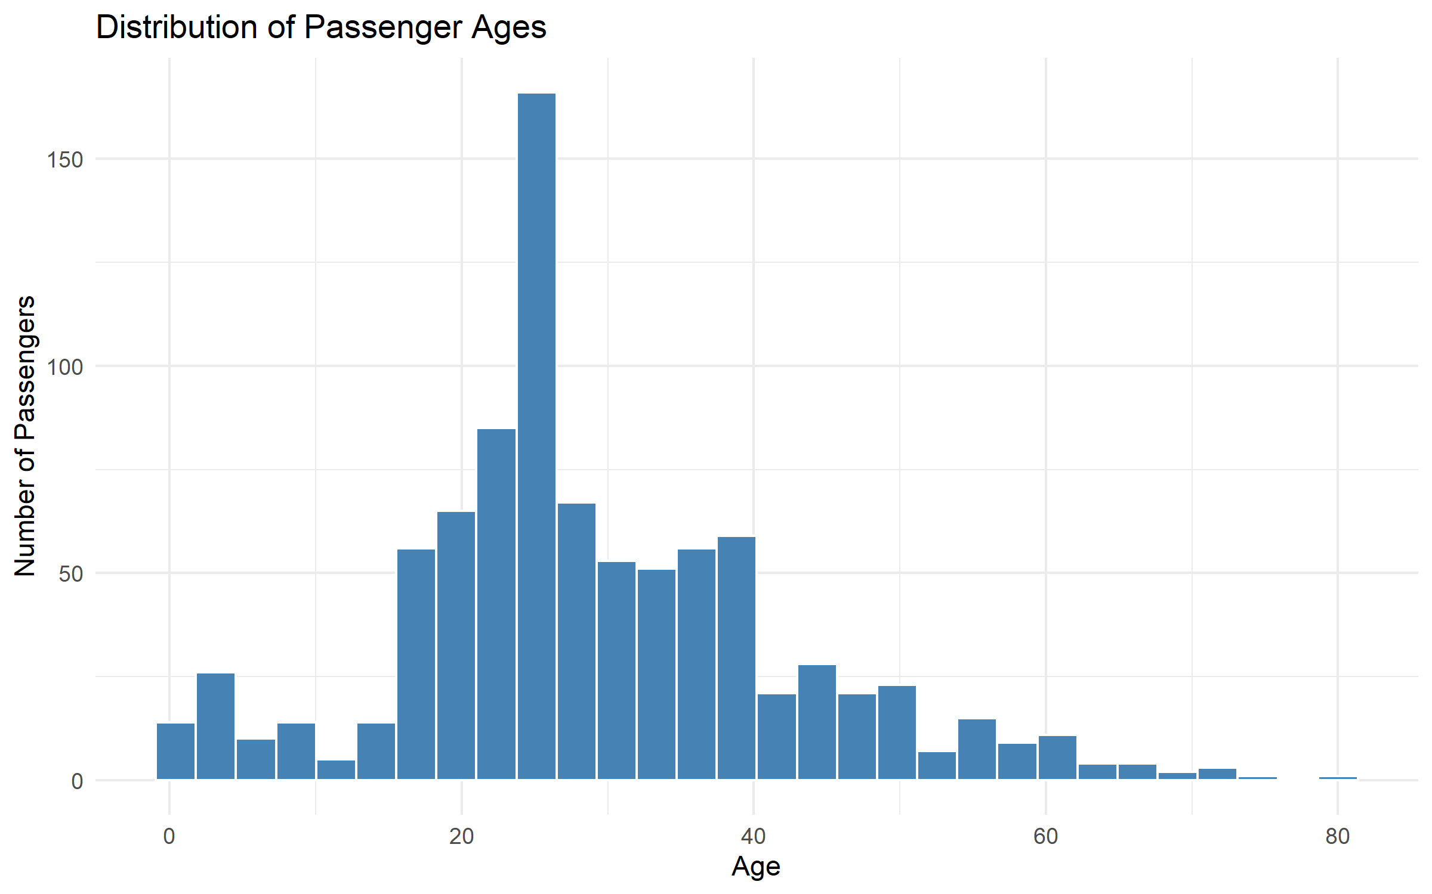
Figure 6: Distribution of passenger ages after cleaning.

9.5 Fare Distribution
Fare Statistic | Value
Mean fare | 32.20
Median fare | 14.45
Minimum fare | 0
Maximum fare | 512.33
Standard deviation | 49.7

The mean fare was higher than the median fare. The distribution includes some high-value fares, which is consistent with the outlier detection results.
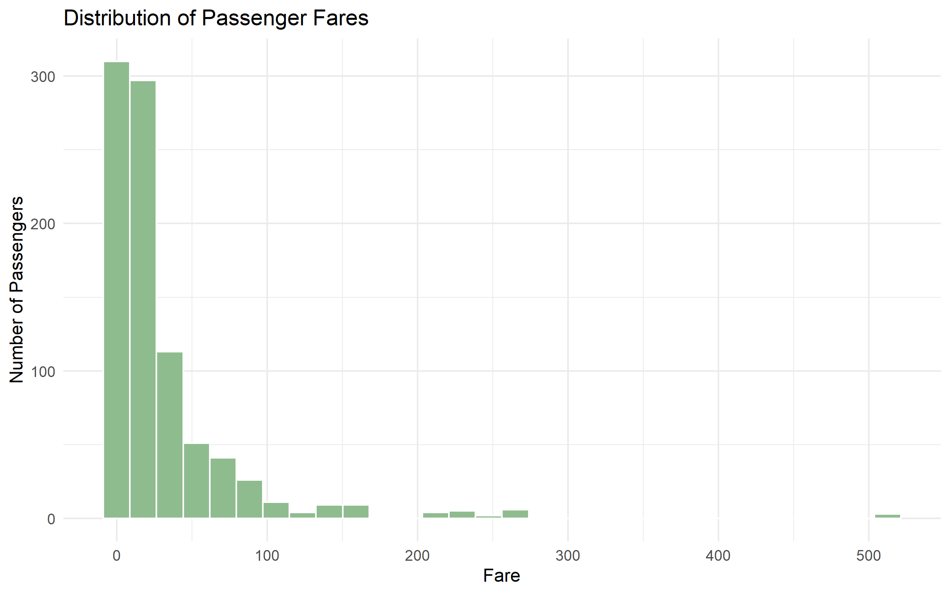
Figure 7: Distribution of passenger fares.

10. CORRELATION ANALYSIS
Pearson correlation analysis was performed on selected numerical variables: Survived, Pclass, Age, SibSp, Parch and Fare. PassengerId was excluded because it is an identifier rather than a meaningful measurement for this analysis.
Variable Pair | Correlation | Interpretation
Survived – Pclass | -0.338 | Moderate negative relationship.
Survived – Fare | +0.257 | Weak positive relationship.
Survived – Age | -0.060 | Very weak negative relationship.
SibSp – Parch | +0.415 | Moderate positive relationship.
Pclass – Fare | -0.549 | Moderate negative relationship.

Pclass is numerically coded from 1 (first class) to 3 (third class). Therefore, its negative correlation with survival indicates that higher class-number values were associated with lower survival in this dataset. Correlation indicates association and does not prove causation.
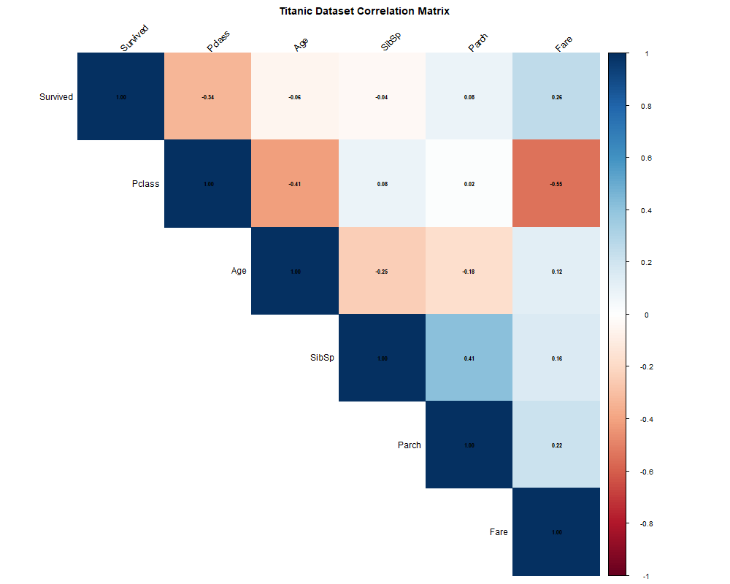
Figure 8: Pearson correlation heatmap of selected numerical variables.

11. KEY FINDINGS
- The original dataset contained 891 passenger records and 12 variables.
- No duplicate rows or duplicate passenger IDs were detected.
- 177 missing Age values and 2 missing Embarked values were treated.
- The Cabin variable was removed due to 687 missing values.
- A total of 116 Fare observations were flagged as potential outliers.
- All 891 records were retained in the cleaned dataset.
- The cleaned dataset contains 14 columns and has no remaining missing values.
- The overall survival rate was approximately 38.4%.
- Female passengers had a higher observed survival rate than male passengers.
- First-class passengers had the highest observed survival rate among the three classes.
- Age and Fare were normalized, and categorical variables were encoded.
- The correlation analysis showed a negative association between Pclass and survival.

12. CONCLUSION
The Week 1 data cleaning and preliminary analysis task was completed successfully using R. The Titanic dataset was imported, inspected, cleaned and transformed. Missing values were handled using suitable statistical methods, duplicates were checked, and potential Fare outliers were detected and flagged.
Min-Max normalization and categorical encoding were performed. Exploratory analysis revealed differences in survival rates across gender and passenger class. Descriptive statistics and correlation analysis provided additional understanding of the dataset.
The project generated cleaned data, encoded data, analytical CSV files and visualizations. These outputs provide a foundation for further statistical analysis and predictive modelling. The findings describe associations in the dataset and should not be interpreted as proof of causal relationships.

13. PROJECT OUTPUT FILES
Folder | Generated Files
Dataset | titanic_train.csv
R_Scripts | week1_analysis.R, week1_cleaning.R, week1_eda.R
Outputs/Results | titanic_cleaned.csv, titanic_encoded.csv, fare_outliers.csv, missing_value_comparison.csv, survival_summary.csv, gender_survival.csv, class_survival.csv, age_summary.csv, fare_summary.csv, correlation_matrix.csv
Outputs/Graphs | 8 PNG visualizations
Report | This Word report

APPENDIX A – INITIAL DATA ANALYSIS SOURCE CODE
.libPaths(c(
"C:/Users/Sahil/AppData/Local/R/win-library/4.6",
.libPaths()
))

library(dplyr)
library(ggplot2)
library(tidyr)
library(readr)

cat("\n===== TITANIC DATA ANALYSIS =====\n")

titanic <- read_csv(
"Dataset/titanic_train.csv",
show_col_types = FALSE
)

cat("\n===== DATASET DIMENSIONS =====\n")
print(dim(titanic))

cat("\n===== FIRST SIX RECORDS =====\n")
print(head(titanic))

cat("\n===== DATA STRUCTURE =====\n")
str(titanic)

cat("\n===== SUMMARY STATISTICS =====\n")
print(summary(titanic))

cat("\n===== MISSING VALUES =====\n")
print(colSums(is.na(titanic)))

cat("\n===== COLUMN NAMES =====\n")
print(names(titanic))

cat("\n===== DATASET IMPORT SUCCESSFUL =====\n")

APPENDIX B – DATA CLEANING SOURCE CODE
# ==========================================
# R DATA ANALYST INTERNSHIP
# WEEK 1 - DATA CLEANING
# Dataset: Titanic
# ==========================================

.libPaths(c(
"C:/Users/Sahil/AppData/Local/R/win-library/4.6",
.libPaths()
))

library(dplyr)
library(ggplot2)
library(tidyr)
library(readr)

# Project directories
dir.create("Outputs/Graphs", recursive=TRUE, showWarnings=FALSE)
dir.create("Outputs/Results", recursive=TRUE, showWarnings=FALSE)

# Import original dataset
titanic <- read_csv(
"Dataset/titanic_train.csv",
show_col_types=FALSE
)

cat("\n===== 1. DUPLICATE CHECK =====\n")

duplicate_rows <- sum(duplicated(titanic))
duplicate_ids <- sum(duplicated(titanic$PassengerId))

cat("Duplicate rows:", duplicate_rows, "\n")
cat("Duplicate Passenger IDs:", duplicate_ids, "\n")

# Create a working copy
clean_data <- titanic

cat("\n===== 2. MISSING VALUE TREATMENT =====\n")

# Age: median based on Pclass and Sex
age_medians <- clean_data %>%
group_by(Pclass, Sex) %>%
summarise(
group_median_age = median(Age, na.rm=TRUE),
.groups="drop"
)

clean_data <- clean_data %>%
left_join(age_medians, by=c("Pclass", "Sex")) %>%
mutate(
Age = ifelse(
is.na(Age),
group_median_age,
Age
)
) %>%
select(-group_median_age)

# Fallback for any remaining missing Age
clean_data$Age[is.na(clean_data$Age)] <-
median(titanic$Age, na.rm=TRUE)

# Embarked: fill using mode
get_mode <- function(x) {
values <- na.omit(x)
names(which.max(table(values)))
}

embarked_mode <- get_mode(clean_data$Embarked)

clean_data$Embarked[
is.na(clean_data$Embarked)
] <- embarked_mode

# Cabin: remove due to high missing percentage
clean_data <- clean_data %>%
select(-Cabin)

cat("Age missing values:", sum(is.na(clean_data$Age)), "\n")
cat("Embarked missing values:", sum(is.na(clean_data$Embarked)), "\n")
cat("Cabin column removed due to high missingness.\n")

cat("\n===== 3. OUTLIER DETECTION =====\n")

# IQR method for Fare
Q1 <- quantile(clean_data$Fare, 0.25, na.rm=TRUE)
Q3 <- quantile(clean_data$Fare, 0.75, na.rm=TRUE)

IQR_value <- IQR(clean_data$Fare, na.rm=TRUE)

lower_limit <- Q1 - 1.5 * IQR_value
upper_limit <- Q3 + 1.5 * IQR_value

fare_outliers <- clean_data %>%
filter(Fare < lower_limit | Fare > upper_limit)

cat("Lower limit:", lower_limit, "\n")
cat("Upper limit:", upper_limit, "\n")
cat("Fare outliers detected:", nrow(fare_outliers), "\n")

# Save outlier records separately
write_csv(
fare_outliers,
"Outputs/Results/fare_outliers.csv"
)

# Flag outliers without deleting them
clean_data <- clean_data %>%
mutate(
Fare_Outlier = Fare < lower_limit |
Fare > upper_limit
)

# Fare boxplot
p1 <- ggplot(clean_data, aes(y=Fare)) +
geom_boxplot(fill="steelblue") +
labs(
title="Fare Outlier Detection",
y="Passenger Fare"
) +
theme_minimal()

ggsave(
"Outputs/Graphs/fare_boxplot.png",
p1,
width=8,
height=5
)

cat("\n===== 4. NORMALIZATION =====\n")

# Min-Max normalization
min_max <- function(x) {
if (diff(range(x, na.rm=TRUE)) == 0) {
return(rep(0, length(x)))
}

(x - min(x, na.rm=TRUE)) /
(max(x, na.rm=TRUE) - min(x, na.rm=TRUE))
}

clean_data <- clean_data %>%
mutate(
Age_Normalized = min_max(Age),
Fare_Normalized = min_max(Fare)
)

cat("Age normalization completed.\n")
cat("Fare normalization completed.\n")

cat("\n===== 5. CATEGORICAL ENCODING =====\n")

clean_data <- clean_data %>%
mutate(
Sex = factor(Sex),
Pclass = factor(Pclass),
Embarked = factor(Embarked)
)

# One-hot encoding
encoded_matrix <- model.matrix(
~ Sex + Pclass + Embarked - 1,
data=clean_data
)

encoded_data <- data.frame(
PassengerId=clean_data$PassengerId,
encoded_matrix
)

write_csv(
encoded_data,
"Outputs/Results/titanic_encoded.csv"
)

cat("Categorical encoding completed.\n")

cat("\n===== 6. FINAL DATA VALIDATION =====\n")

cat("Final dimensions:\n")
print(dim(clean_data))

cat("\nRemaining missing values:\n")
print(colSums(is.na(clean_data)))

cat("\nFinal summary:\n")
print(summary(clean_data))

# Save cleaned dataset
write_csv(
clean_data,
"Outputs/Results/titanic_cleaned.csv"
)

# Save missing value comparison
missing_comparison <- data.frame(
Variable=names(titanic),
Before=colSums(is.na(titanic))
)

missing_comparison <- missing_comparison %>%
mutate(
After=ifelse(
Variable %in% c("Age", "Embarked"),
0,
ifelse(Variable == "Cabin", NA, Before)
)
)

write_csv(
missing_comparison,
"Outputs/Results/missing_value_comparison.csv"
)

# Missing value visualization
missing_plot_data <- data.frame(
Variable=names(titanic),
Missing=colSums(is.na(titanic))
) %>%
filter(Missing > 0)

p2 <- ggplot(
missing_plot_data,
aes(x=reorder(Variable, Missing), y=Missing)
) +
geom_col(fill="steelblue") +
coord_flip() +
labs(
title="Missing Values in Original Titanic Dataset",
x="Variables",
y="Number of Missing Values"
) +
theme_minimal()

ggsave(
"Outputs/Graphs/missing_values.png",
p2,
width=8,
height=5
)

cat("\n===== DATA CLEANING COMPLETED =====\n")
cat("Cleaned dataset saved successfully.\n")
cat("Graphs saved successfully.\n")

APPENDIX C – EXPLORATORY DATA ANALYSIS SOURCE CODE
.libPaths(c(
"C:/Users/Sahil/AppData/Local/R/win-library/4.6",
.libPaths()
))

library(dplyr)
library(ggplot2)
library(readr)
library(corrplot)

dir.create("Outputs/Graphs", recursive=TRUE, showWarnings=FALSE)
dir.create("Outputs/Results", recursive=TRUE, showWarnings=FALSE)

data <- read_csv(
"Outputs/Results/titanic_cleaned.csv",
show_col_types=FALSE
)

# Prepare categorical variables
data <- data %>%
mutate(
Survived = as.numeric(Survived),
Pclass = factor(Pclass),
Sex = factor(Sex),
Embarked = factor(Embarked)
)

cat("\n===== 1. SURVIVAL DISTRIBUTION =====\n")

survival_summary <- data %>%
count(Survived) %>%
mutate(
Status = ifelse(Survived == 1, "Survived", "Did not survive"),
Percentage = round(n / sum(n) * 100, 2)
)

print(survival_summary)

write_csv(
survival_summary,
"Outputs/Results/survival_summary.csv"
)

p1 <- ggplot(survival_summary, aes(x=Status, y=n, fill=Status)) +
geom_col(width=0.6) +
geom_text(aes(label=n), vjust=-0.5) +
labs(
title="Titanic Passenger Survival Distribution",
x="Survival Status",
y="Number of Passengers"
) +
theme_minimal() +
theme(legend.position="none")

ggsave(
"Outputs/Graphs/survival_distribution.png",
p1, width=8, height=5
)

cat("\n===== 2. SURVIVAL BY GENDER =====\n")

gender_summary <- data %>%
group_by(Sex) %>%
summarise(
Total = n(),
Survivors = sum(Survived == 1),
Survival_Percentage = round(mean(Survived) * 100, 2),
.groups="drop"
)

print(gender_summary)

write_csv(
gender_summary,
"Outputs/Results/gender_survival.csv"
)

p2 <- ggplot(data, aes(x=Sex, fill=factor(Survived))) +
geom_bar(position="dodge") +
labs(
title="Survival by Gender",
x="Gender",
y="Number of Passengers",
fill="Survived (0=No, 1=Yes)"
) +
theme_minimal()

ggsave(
"Outputs/Graphs/survival_by_gender.png",
p2, width=8, height=5
)

cat("\n===== 3. SURVIVAL BY PASSENGER CLASS =====\n")

class_summary <- data %>%
group_by(Pclass) %>%
summarise(
Total = n(),
Survivors = sum(Survived == 1),
Survival_Percentage = round(mean(Survived) * 100, 2),
.groups="drop"
)

print(class_summary)

write_csv(
class_summary,
"Outputs/Results/class_survival.csv"
)

p3 <- ggplot(data, aes(x=Pclass, fill=factor(Survived))) +
geom_bar(position="dodge") +
labs(
title="Survival by Passenger Class",
x="Passenger Class",
y="Number of Passengers",
fill="Survived (0=No, 1=Yes)"
) +
theme_minimal()

ggsave(
"Outputs/Graphs/survival_by_class.png",
p3, width=8, height=5
)

cat("\n===== 4. AGE DISTRIBUTION =====\n")

age_summary <- data %>%
summarise(
Mean_Age = mean(Age),
Median_Age = median(Age),
Minimum_Age = min(Age),
Maximum_Age = max(Age),
Standard_Deviation = sd(Age)
)

print(age_summary)

write_csv(
age_summary,
"Outputs/Results/age_summary.csv"
)

p4 <- ggplot(data, aes(x=Age)) +
geom_histogram(
bins=30,
fill="steelblue",
color="white"
) +
labs(
title="Distribution of Passenger Ages",
x="Age",
y="Number of Passengers"
) +
theme_minimal()

ggsave(
"Outputs/Graphs/age_distribution.png",
p4, width=8, height=5
)

cat("\n===== 5. FARE DISTRIBUTION =====\n")

fare_summary <- data %>%
summarise(
Mean_Fare = mean(Fare),
Median_Fare = median(Fare),
Minimum_Fare = min(Fare),
Maximum_Fare = max(Fare),
Standard_Deviation = sd(Fare)
)

print(fare_summary)

write_csv(
fare_summary,
"Outputs/Results/fare_summary.csv"
)

p5 <- ggplot(data, aes(x=Fare)) +
geom_histogram(
bins=30,
fill="darkseagreen",
color="white"
) +
labs(
title="Distribution of Passenger Fares",
x="Fare",
y="Number of Passengers"
) +
theme_minimal()

ggsave(
"Outputs/Graphs/fare_distribution.png",
p5, width=8, height=5
)

cat("\n===== 6. CORRELATION ANALYSIS =====\n")

correlation_data <- data %>%
transmute(
Survived = Survived,
Pclass = as.numeric(as.character(Pclass)),
Age = Age,
SibSp = SibSp,
Parch = Parch,
Fare = Fare
)

correlation_matrix <- cor(
correlation_data,
use="complete.obs",
method="pearson"
)

print(round(correlation_matrix, 3))

correlation_output <- as.data.frame(correlation_matrix)
correlation_output <- tibble::rownames_to_column(
correlation_output,
var="Variable"
)

write_csv(
correlation_output,
"Outputs/Results/correlation_matrix.csv"
)

png(
"Outputs/Graphs/correlation_heatmap.png",
width=1000,
height=800
)

corrplot(
correlation_matrix,
method="color",
type="upper",
addCoef.col="black",
tl.col="black",
tl.srt=45,
number.cex=0.7,
title="Titanic Dataset Correlation Matrix",
mar=c(0,0,2,0)
)

dev.off()

cat("\n===== EDA COMPLETED SUCCESSFULLY =====\n")
cat("All EDA graphs and result files have been saved.\n")

