WEEK 2 INTERNSHIP REPORT
DATA VISUALIZATION AND
INSIGHT COMMUNICATION USING R
Titanic Passenger Dataset
Submitted by
Sahil Jadhao
Virtual R Data Analyst Internship
Week 2 Task
Tools: R, ggplot2, dplyr, Visual Studio Code

Abstract
This project focuses on visualizing and communicating insights from the Titanic passenger dataset using the R programming language. The analysis uses the ggplot2 visualization library to create six different chart types: bar chart, histogram, scatter plot, line chart, box plot, and heatmap.
The visualizations explore passenger survival distribution, age patterns, fare differences, and survival rates across passenger age groups and classes. The report includes visualization outputs, interpretations, and the R source code used to generate them.

Table of Contents
1. Introduction
2. Objectives
3. Dataset Overview
4. Tools and Technologies
5. Data Preparation
6. Visualization Design and Interpretation
7. Statistical Results
8. Key Findings
9. Limitations
10. Conclusion
11. Appendix: Complete R Source Code

1. Introduction
Data visualization is the graphical representation of information and data. It helps analysts identify patterns, trends, relationships, and unusual observations. Well-designed visualizations make complex data easier to understand for technical and non-technical audiences.
In this project, the Titanic passenger dataset is used to demonstrate different visualization techniques in R. The charts are designed to communicate findings clearly and support data-driven interpretation.

2. Objectives
- Create multiple visualizations using R and ggplot2.
- Represent categorical and numerical data graphically.
- Understand passenger survival patterns.
- Compare survival rates across passenger age groups.
- Study the relationship between passenger age and fare.
- Compare fare distributions across passenger classes.
- Communicate insights through clear explanations.

3. Dataset Overview
The Titanic dataset contains passenger information from the Titanic disaster. The original training dataset contains 891 rows and 12 columns.
Important variables used in this project:
Variable | Description
Survived | Survival indicator: 0 = Did not survive, 1 = Survived.
Pclass | Passenger ticket class: 1, 2, or 3.
Sex | Passenger gender category.
Age | Passenger age in years.
Fare | Passenger ticket fare.
SibSp | Number of siblings or spouses aboard.
Parch | Number of parents or children aboard.
Embarked | Port of embarkation.

4. Tools and Technologies
- R: Statistical computing and data analysis.
- ggplot2: Creation of high-quality statistical graphics.
- dplyr: Data manipulation and summarization.
- tidyr: Data organization and transformation.
- Visual Studio Code: Code editing and project development.
- Microsoft Word: Report preparation and documentation.

5. Data Preparation
The original Titanic dataset was loaded using read.csv(). The dataset contained missing values in Age and Embarked. For this visualization task, missing Age values were replaced with the median age and missing Embarked values were assigned the most frequent category, S.
A Survival factor was created to display readable survival labels. Passenger classes were converted into First Class, Second Class, and Third Class. Age values were grouped into Child, Teenager, Young Adult, Adult, and Senior categories.
These transformations were performed to improve the readability and interpretability of the visualizations. The original dataset was not overwritten.

6. Visualization Design and Interpretation

6.1 Bar Chart: Survival Distribution
The bar chart compares the number of passengers who survived with the number who did not survive.
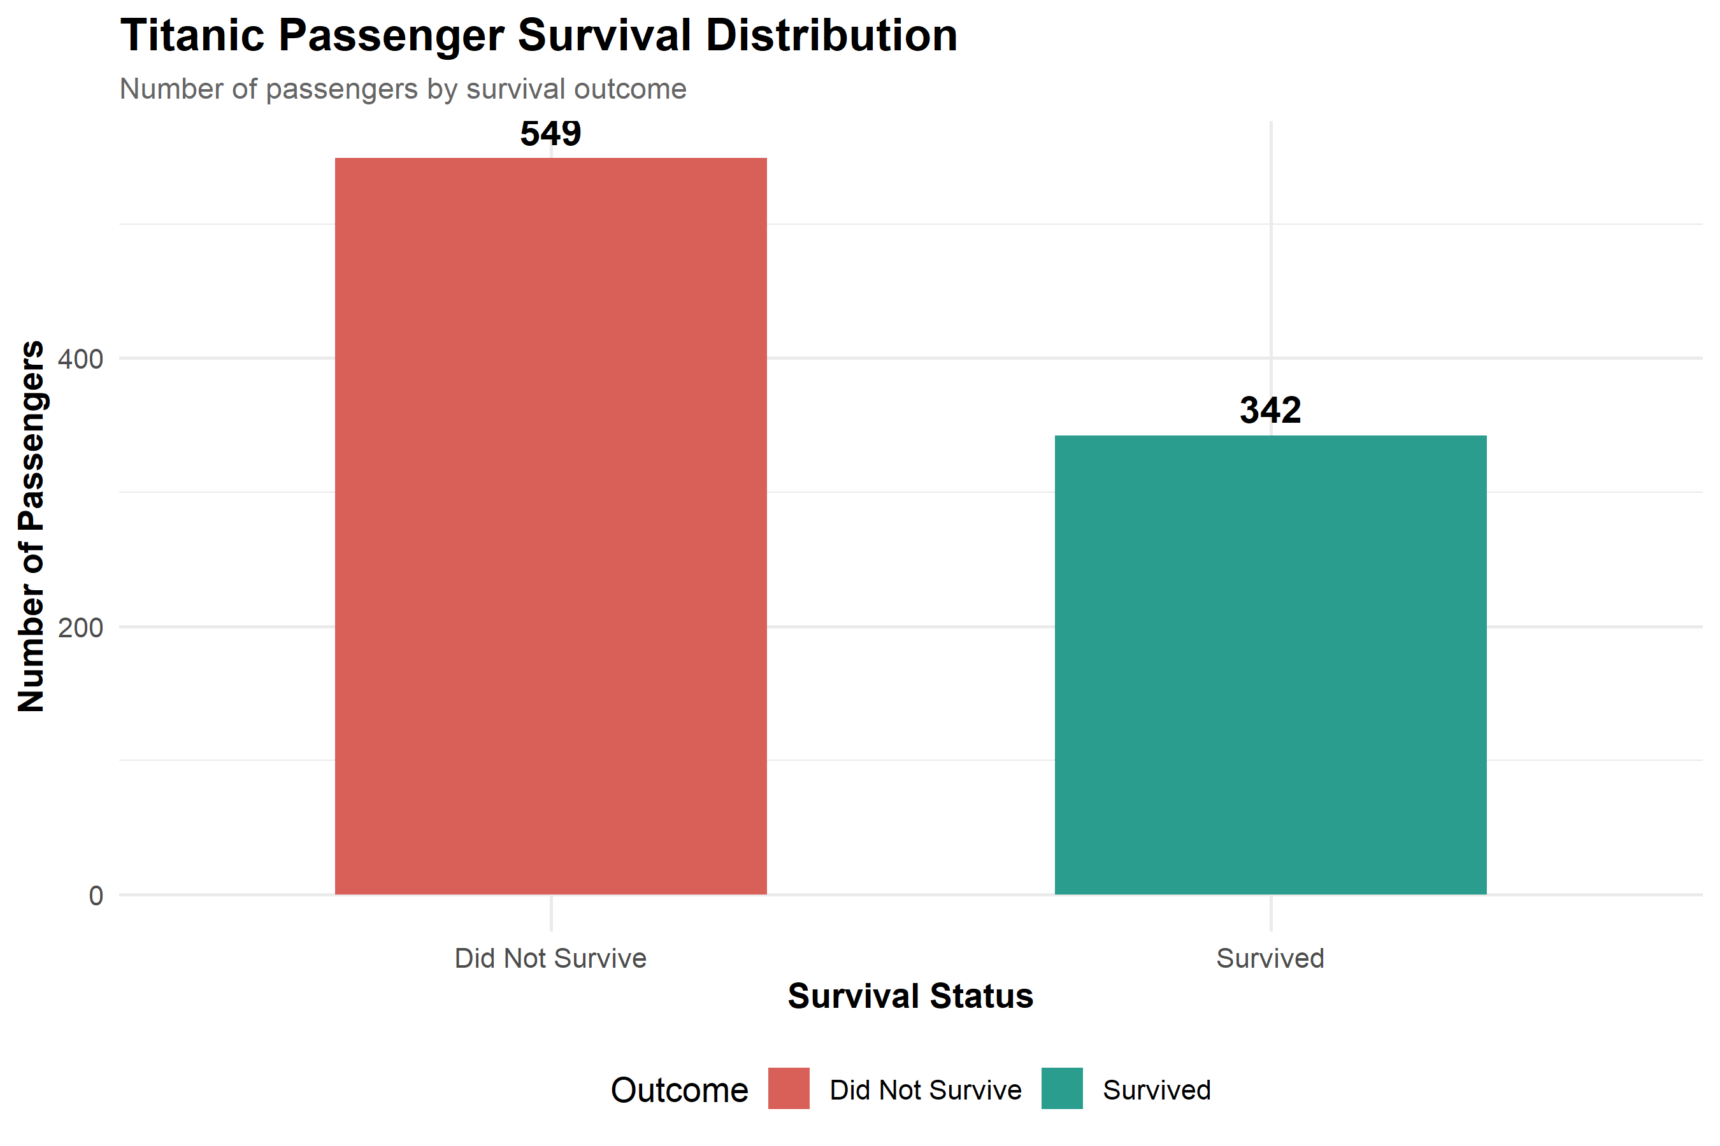
Key Insight: The dataset contains 342 survivors and 549 non-survivors. Approximately 38.4% of passengers survived.
Why this chart was selected: A bar chart is suitable for comparing counts across discrete categories.

6.2 Histogram: Passenger Age Distribution
The histogram displays the frequency distribution of passenger ages using five-year intervals.
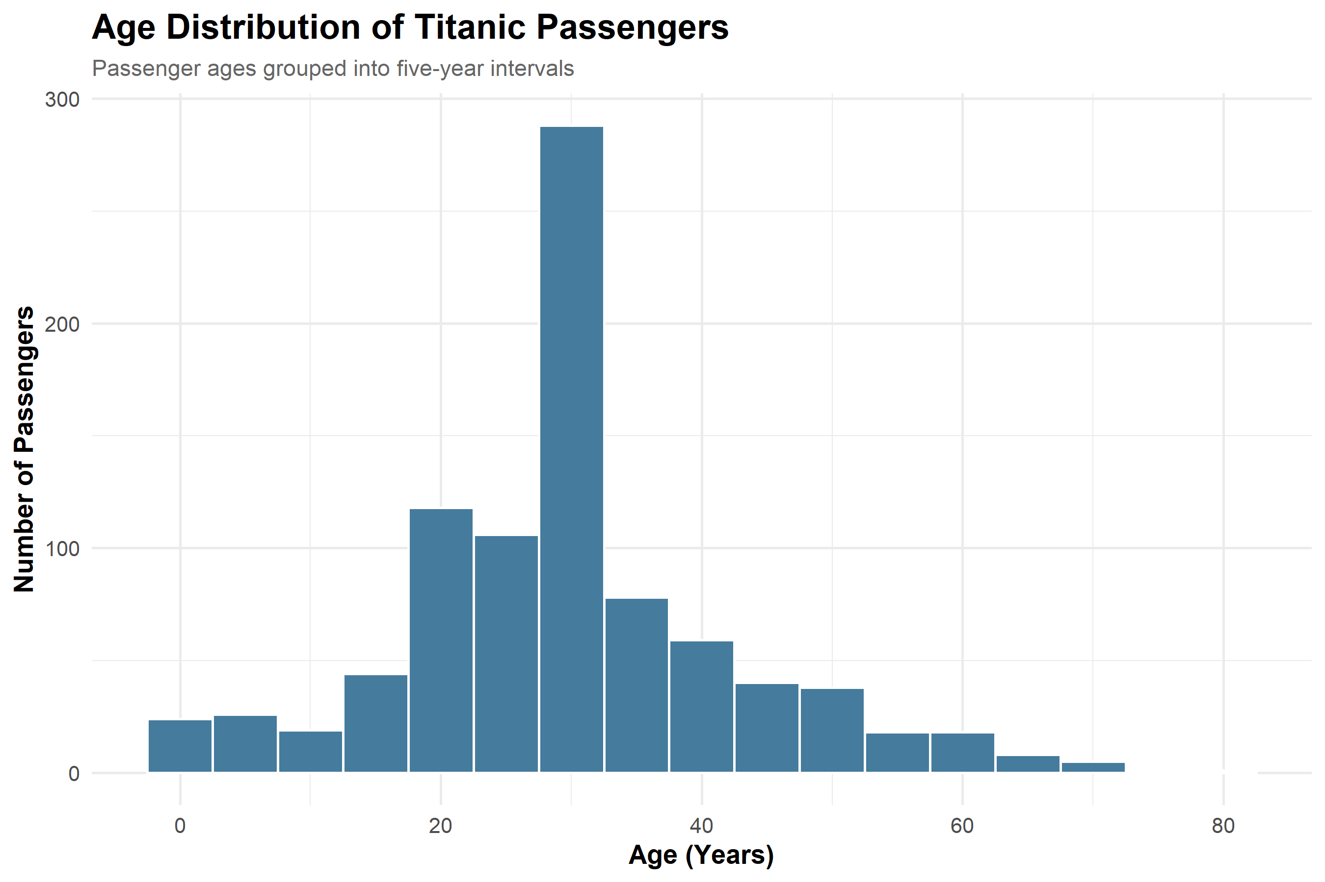
Key Insight: The passenger dataset includes children, young adults, adults, and senior passengers. The largest concentration is among younger and middle-aged passengers.
Why this chart was selected: A histogram is effective for understanding the distribution of a continuous numerical variable.

6.3 Scatter Plot: Age Versus Fare
Each point represents a passenger. The horizontal axis shows age, while the vertical axis represents ticket fare. Point colors indicate survival outcome.
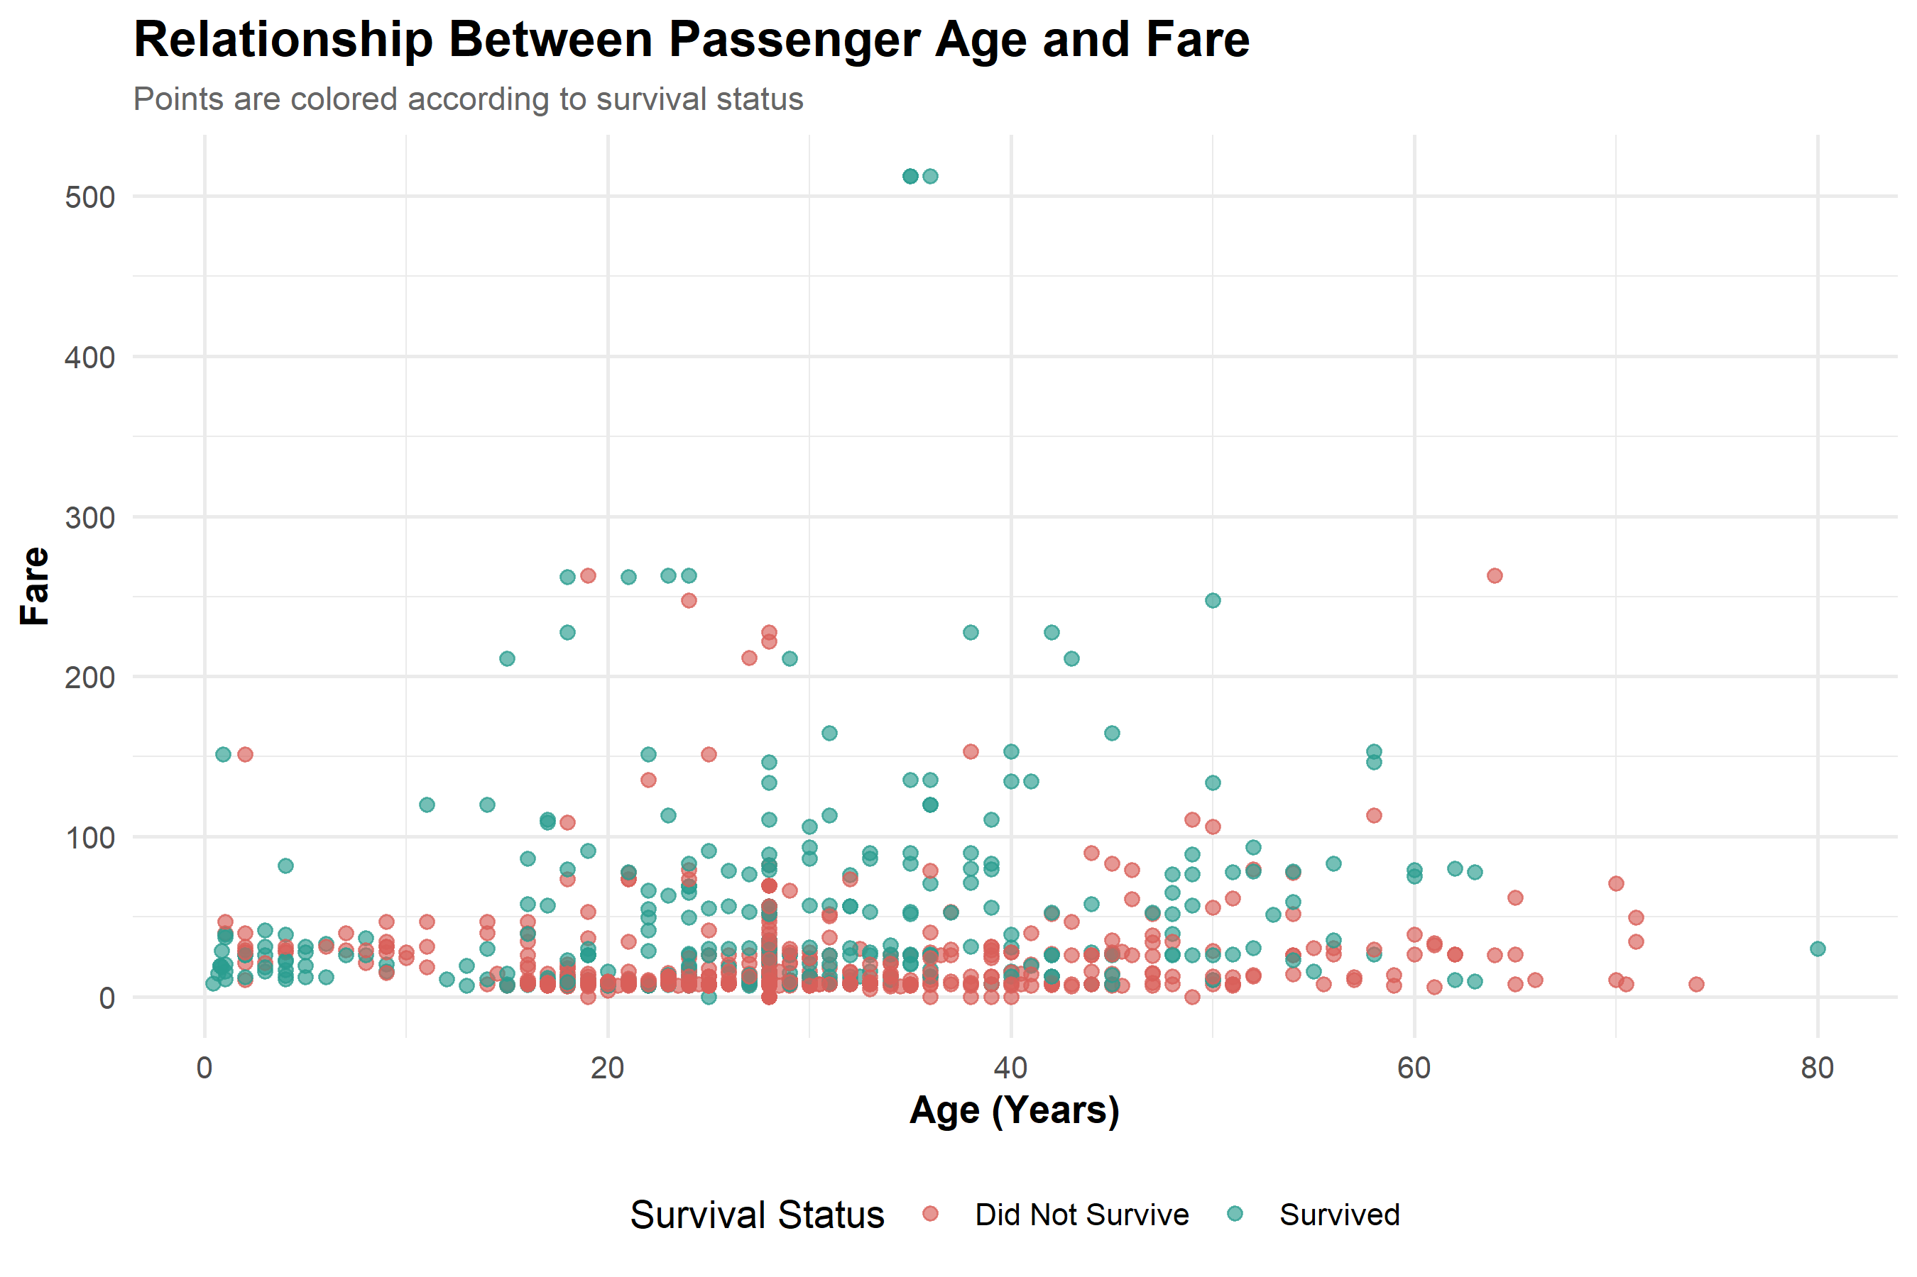
Key Insight: The scatter plot helps compare passenger age, ticket fare, and survival status. It also shows variation in fares among passengers of different ages.
Why this chart was selected: A scatter plot is appropriate for examining the relationship between two numerical variables.

6.4 Line Chart: Survival Rate by Age Group
This chart displays survival percentages across five ordered age groups: Child, Teenager, Young Adult, Adult, and Senior.
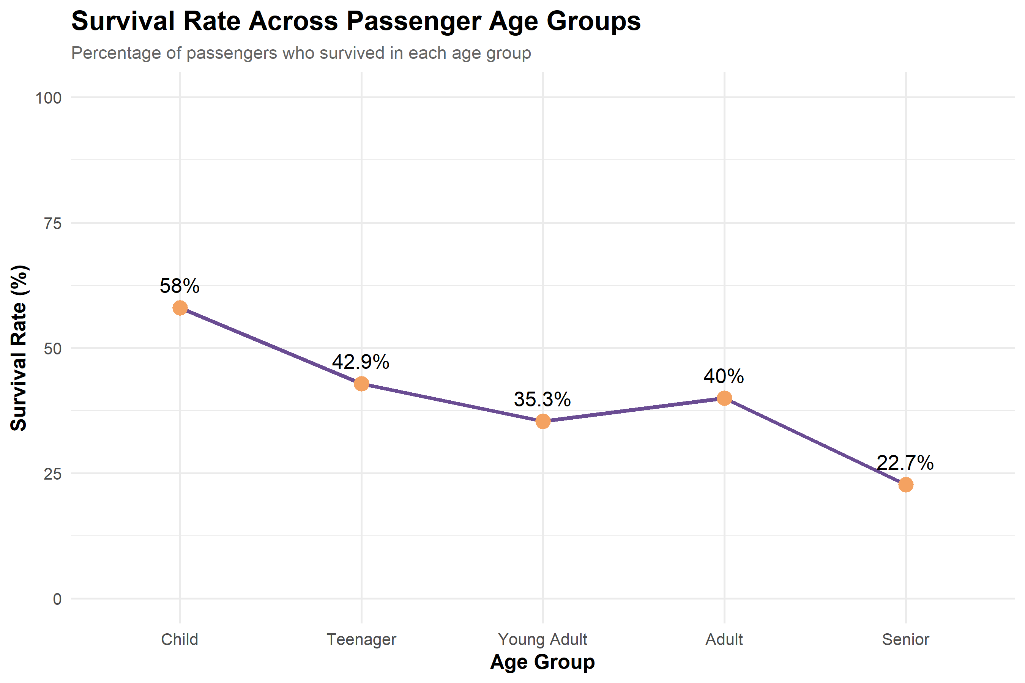
Key Insight: Children recorded a 58.0% survival rate, while seniors recorded 22.7%. Teenagers recorded 42.9%, young adults 35.3%, and adults 40.0%.
Why this chart was selected: A line chart highlights changes across ordered categories. Here it is used to compare age-group progression, not a time series.

6.5 Box Plot: Fare Distribution by Passenger Class
The box plot compares the median, spread, and potential outliers of ticket fares across the three passenger classes.
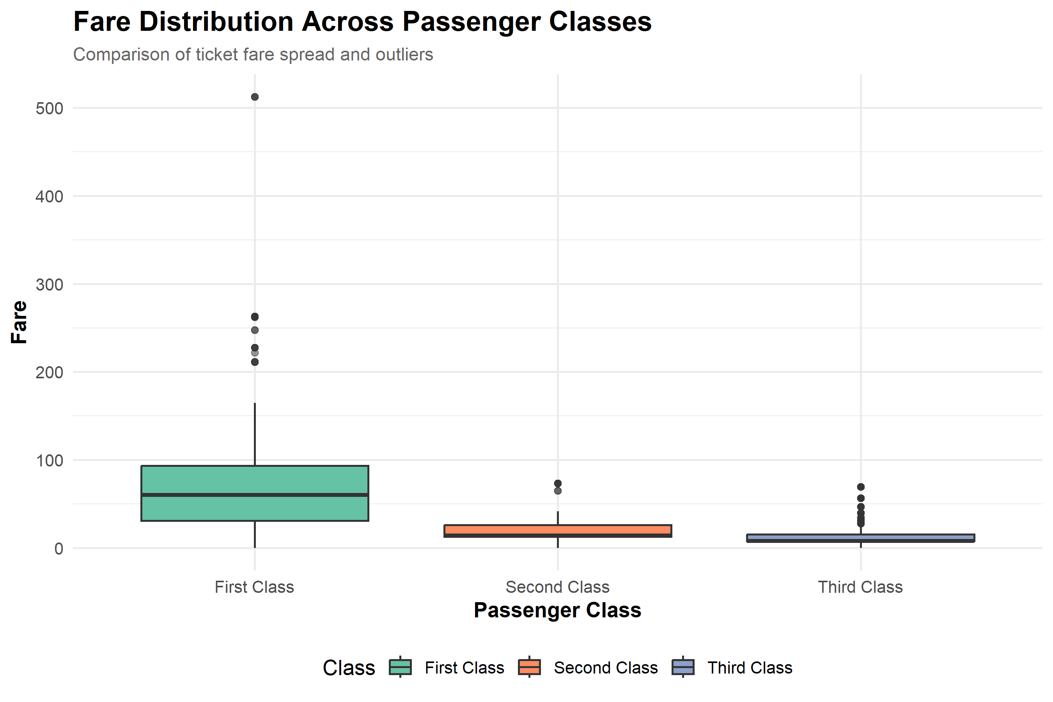
Key Insight: The visualization helps show differences in fare distributions between first, second, and third class passengers. Higher fares and wider variation are visible in the first-class group.
Why this chart was selected: A box plot is useful for comparing numerical distributions and identifying potential outliers across categories.

6.6 Heatmap: Survival by Age Group and Passenger Class
The heatmap represents survival percentages using different color intensities for combinations of passenger class and age group.
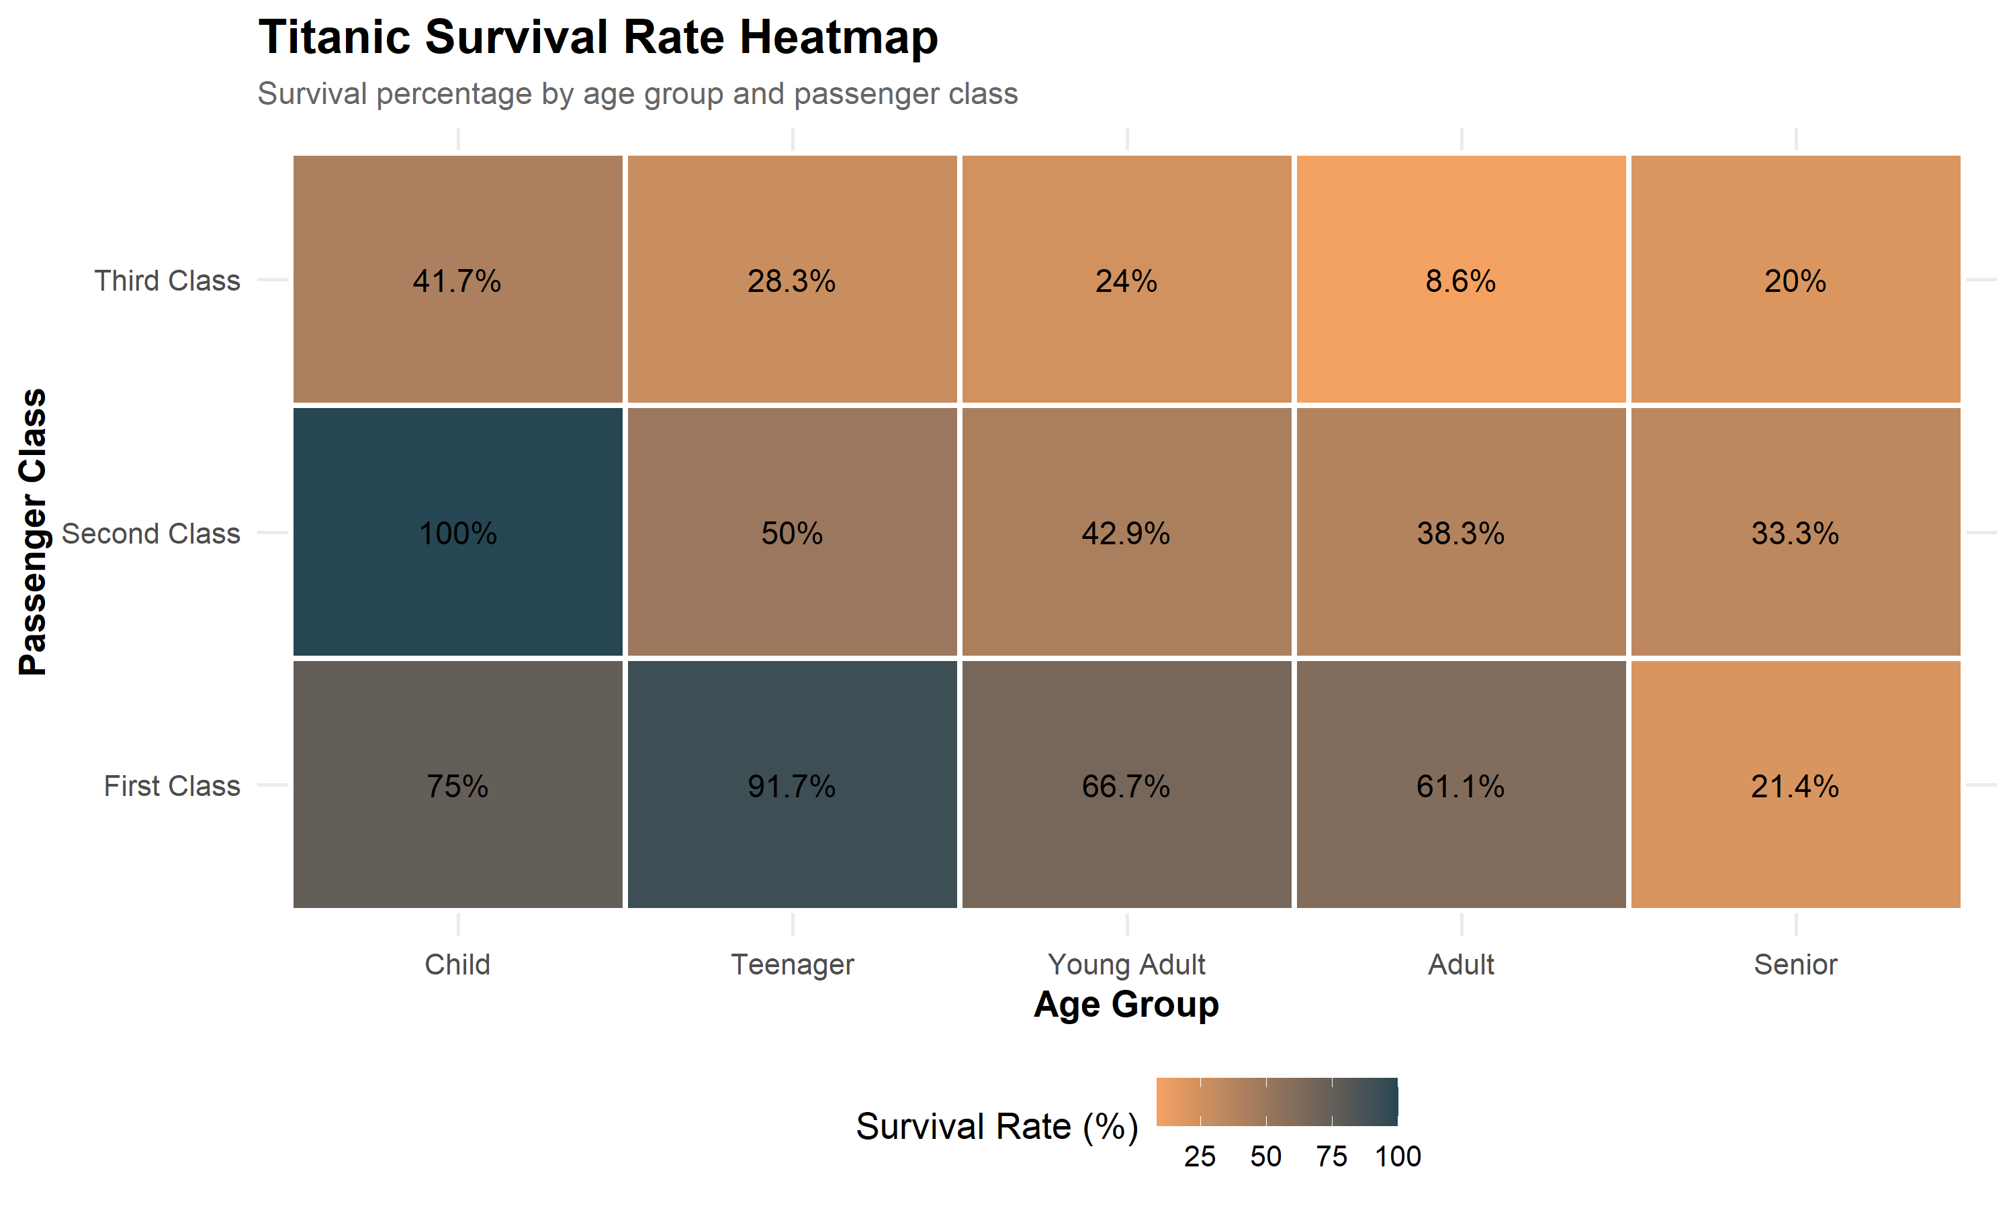
Key Insight: First-class teenagers had a 91.7% survival rate, while third-class adults had an 8.62% survival rate. These groups contain 12 and 58 passengers respectively.
Why this chart was selected: A heatmap helps compare values across two categorical dimensions and makes high and low values easy to identify.

7. Statistical Results
The following tables contain the actual summary results exported by the R visualization script.

7.1 Survival Distribution
Survival | n
Did Not Survive | 549
Survived | 342

7.2 Survival Rate by Age Group
AgeGroup | Total | Survivors | Survival_Rate
Child | 69 | 40 | 57.9710144927536
Teenager | 70 | 30 | 42.8571428571429
Young Adult | 535 | 189 | 35.3271028037383
Adult | 195 | 78 | 40
Senior | 22 | 5 | 22.7272727272727

7.3 Survival Heatmap Summary
Pclass | AgeGroup | Survival_Rate | Passengers
First Class | Child | 75 | 4
First Class | Teenager | 91.6666666666667 | 12
First Class | Young Adult | 66.6666666666667 | 96
First Class | Adult | 61.1111111111111 | 90
First Class | Senior | 21.4285714285714 | 14
Second Class | Child | 100 | 17
Second Class | Teenager | 50 | 12
Second Class | Young Adult | 42.8571428571429 | 105
Second Class | Adult | 38.2978723404255 | 47
Second Class | Senior | 33.3333333333333 | 3
Third Class | Child | 41.6666666666667 | 48
Third Class | Teenager | 28.2608695652174 | 46
Third Class | Young Adult | 23.9520958083832 | 334
Third Class | Adult | 8.62068965517241 | 58
Third Class | Senior | 20 | 5

8. Key Findings
- Out of 891 passengers, 342 survived and 549 did not survive.
- The overall survival rate was approximately 38.4%.
- Children had the highest survival rate among the five age groups.
- Seniors had the lowest survival rate, although the group was small.
- Survival percentages differed across passenger classes.
- The heatmap revealed substantial differences between age and class combinations.
- The scatter plot showed how age and fare varied across survival outcomes.

9. Limitations
- The analysis uses the Titanic training dataset and may not represent all passengers.
- Missing age values were imputed with the median, which may affect the displayed distribution.
- Some age-group and class combinations contain very few passengers.
- The visualizations show associations and descriptive patterns, not causal relationships.
- A line chart across age groups is a categorical comparison rather than a time-based trend.

10. Conclusion
This project demonstrates how R and ggplot2 can be used to communicate data insights through different visualization techniques. Six chart types were created to explore survival distribution, age patterns, fare differences, and survival percentages across passenger groups.
The analysis shows that visualizations make it easier to identify important patterns and communicate findings to non-technical audiences. The project strengthened practical skills in R programming, graphical analysis, interpretation, and report writing.

11. Appendix: Complete R Source Code

# ============================================================
# WEEK 2: DATA VISUALIZATION AND INSIGHT COMMUNICATION
# Dataset: Titanic Passenger Dataset
# Author: Sahil Jadhao
# ============================================================

# 1. Load required libraries
library(ggplot2)
library(dplyr)
library(tidyr)

# 2. Set project paths
project_dir <- normalizePath(".", winslash = "/", mustWork = TRUE)

dataset_path <- file.path(
project_dir, "Dataset", "titanic_train.csv"
)

graph_dir <- file.path(project_dir, "Outputs", "Graphs")
result_dir <- file.path(project_dir, "Outputs", "Results")

dir.create(graph_dir, recursive = TRUE, showWarnings = FALSE)
dir.create(result_dir, recursive = TRUE, showWarnings = FALSE)

# 3. Load dataset
titanic <- read.csv(
dataset_path,
stringsAsFactors = FALSE
)

cat("Dataset loaded successfully!\n")
cat("Rows:", nrow(titanic), "\n")
cat("Columns:", ncol(titanic), "\n")

# 4. Prepare visualization data
# Age is filled with the median for visualization.
titanic$Age[is.na(titanic$Age)] <-
median(titanic$Age, na.rm = TRUE)

titanic$Embarked[is.na(titanic$Embarked)] <- "S"

titanic$Survival <- factor(
titanic$Survived,
levels = c(0, 1),
labels = c("Did Not Survive", "Survived")
)

titanic$Sex <- factor(titanic$Sex)

titanic$Pclass <- factor(
titanic$Pclass,
levels = c(1, 2, 3),
labels = c("First Class", "Second Class", "Third Class")
)

titanic$AgeGroup <- cut(
titanic$Age,
breaks = c(0, 12, 18, 35, 60, Inf),
labels = c("Child", "Teenager", "Young Adult",
"Adult", "Senior"),
include.lowest = TRUE
)

# Consistent theme
professional_theme <- theme_minimal(base_size = 13) +
theme(
plot.title = element_text(
face = "bold", size = 17
),
plot.subtitle = element_text(
size = 11, color = "gray40"
),
axis.title = element_text(face = "bold"),
legend.position = "bottom"
)

# ============================================================
# CHART 1: SURVIVAL DISTRIBUTION - BAR CHART
# ============================================================

survival_data <- titanic %>%
count(Survival)

p1 <- ggplot(
survival_data,
aes(x = Survival, y = n, fill = Survival)
) +
geom_col(width = 0.6) +
geom_text(
aes(label = n),
vjust = -0.5,
fontface = "bold",
size = 5
) +
labs(
title = "Titanic Passenger Survival Distribution",
subtitle = "Number of passengers by survival outcome",
x = "Survival Status",
y = "Number of Passengers",
fill = "Outcome"
) +
scale_fill_manual(
values = c("#D95F59", "#2A9D8F")
) +
professional_theme

ggsave(
file.path(graph_dir, "01_survival_distribution.png"),
p1, width = 9, height = 6, dpi = 300
)

# ============================================================
# CHART 2: AGE DISTRIBUTION - HISTOGRAM
# ============================================================

p2 <- ggplot(
titanic,
aes(x = Age)
) +
geom_histogram(
binwidth = 5,
fill = "#457B9D",
color = "white"
) +
labs(
title = "Age Distribution of Titanic Passengers",
subtitle = "Passenger ages grouped into five-year intervals",
x = "Age (Years)",
y = "Number of Passengers"
) +
professional_theme

ggsave(
file.path(graph_dir, "02_age_distribution.png"),
p2, width = 9, height = 6, dpi = 300
)

# ============================================================
# CHART 3: AGE VS FARE - SCATTER PLOT
# ============================================================

p3 <- ggplot(
titanic,
aes(x = Age, y = Fare, color = Survival)
) +
geom_point(alpha = 0.65, size = 2) +
scale_color_manual(
values = c("#D95F59", "#2A9D8F")
) +
labs(
title = "Relationship Between Passenger Age and Fare",
subtitle = "Points are colored according to survival status",
x = "Age (Years)",
y = "Fare",
color = "Survival Status"
) +
professional_theme

ggsave(
file.path(graph_dir, "03_age_vs_fare_scatter.png"),
p3, width = 9, height = 6, dpi = 300
)

# ============================================================
# CHART 4: SURVIVAL RATE BY AGE GROUP - LINE CHART
# ============================================================

age_survival <- titanic %>%
group_by(AgeGroup) %>%
summarise(
Total = n(),
Survivors = sum(Survived),
Survival_Rate = mean(Survived) * 100,
.groups = "drop"
)

p4 <- ggplot(
age_survival,
aes(
x = AgeGroup,
y = Survival_Rate,
group = 1
)
) +
geom_line(
color = "#6A4C93",
linewidth = 1.2
) +
geom_point(
color = "#F4A261",
size = 4
) +
geom_text(
aes(label = paste0(round(Survival_Rate, 1), "%")),
vjust = -1
) +
labs(
title = "Survival Rate Across Passenger Age Groups",
subtitle = "Percentage of passengers who survived in each age group",
x = "Age Group",
y = "Survival Rate (%)"
) +
scale_y_continuous(limits = c(0, 100)) +
professional_theme

ggsave(
file.path(graph_dir, "04_survival_by_age_group.png"),
p4, width = 9, height = 6, dpi = 300
)

# ============================================================
# CHART 5: FARE BY PASSENGER CLASS - BOXPLOT
# ============================================================

p5 <- ggplot(
titanic,
aes(x = Pclass, y = Fare, fill = Pclass)
) +
geom_boxplot(outlier.alpha = 0.5) +
labs(
title = "Fare Distribution Across Passenger Classes",
subtitle = "Comparison of ticket fare spread and outliers",
x = "Passenger Class",
y = "Fare",
fill = "Class"
) +
scale_fill_brewer(palette = "Set2") +
professional_theme

ggsave(
file.path(graph_dir, "05_fare_by_class_boxplot.png"),
p5, width = 9, height = 6, dpi = 300
)

# ============================================================
# CHART 6: SURVIVAL RATE HEATMAP
# ============================================================

heatmap_data <- titanic %>%
group_by(Pclass, AgeGroup) %>%
summarise(
Survival_Rate = mean(Survived) * 100,
Passengers = n(),
.groups = "drop"
)

p6 <- ggplot(
heatmap_data,
aes(x = AgeGroup, y = Pclass, fill = Survival_Rate)
) +
geom_tile(color = "white", linewidth = 1) +
geom_text(
aes(label = paste0(round(Survival_Rate, 1), "%")),
size = 4
) +
scale_fill_gradient(
low = "#F4A261",
high = "#264653",
name = "Survival Rate (%)"
) +
labs(
title = "Titanic Survival Rate Heatmap",
subtitle = "Survival percentage by age group and passenger class",
x = "Age Group",
y = "Passenger Class"
) +
professional_theme

ggsave(
file.path(graph_dir, "06_survival_heatmap.png"),
p6, width = 10, height = 6, dpi = 300
)

# ============================================================
# 7. EXPORT ANALYSIS RESULTS
# ============================================================

write.csv(
survival_data,
file.path(result_dir, "survival_distribution.csv"),
row.names = FALSE
)

write.csv(
age_survival,
file.path(result_dir, "survival_by_age_group.csv"),
row.names = FALSE
)

write.csv(
heatmap_data,
file.path(result_dir, "survival_heatmap_data.csv"),
row.names = FALSE
)

# ============================================================
# 8. DISPLAY COMPLETION MESSAGE
# ============================================================

cat("\n====================================\n")
cat("WEEK 2 VISUALIZATION COMPLETED!\n")
cat("====================================\n")

cat("Graphs generated: 6\n")
cat("Results exported: 3 CSV files\n")
cat("Graph folder:", graph_dir, "\n")
cat("Results folder:", result_dir, "\n")

cat("\nSurvival by age group:\n")
print(age_survival)

cat("\nSurvival heatmap data:\n")
print(heatmap_data)

