WEEK 3 INTERNSHIP REPORT
STATISTICAL ANALYSIS AND
PREDICTIVE MODELING USING R
Titanic Passenger Survival Prediction
Submitted by
Sahil Jadhao
Virtual R Data Analyst Internship
Week 3 Task
Tools: R, Visual Studio Code, Logistic Regression

Abstract
This project focuses on statistical analysis and predictive modeling using the R programming language. The Titanic passenger dataset is used to investigate relationships between passenger characteristics and survival outcomes.
Statistical techniques include descriptive statistics, normality testing, Spearman correlation, Chi-square testing, and the Wilcoxon rank-sum test. A Logistic Regression classification model is developed to predict passenger survival. The model is evaluated using a training-testing split, five-fold cross-validation, confusion matrix, and classification metrics.

1. Objectives
- Identify and prepare a suitable public dataset.
- Perform exploratory statistical analysis.
- Examine numerical variable distributions and correlations.
- Formulate and test statistical hypotheses.
- Develop a Logistic Regression classification model.
- Apply five-fold cross-validation.
- Evaluate model performance using classification metrics.
- Analyze model diagnostics and identify possible improvements.

2. Dataset Identification and Overview
The Titanic training dataset was selected because it contains passenger characteristics and a binary survival outcome. This makes it suitable for statistical analysis and binary classification.
Dataset property | Details
Dataset | Titanic passenger training dataset
Original observations | 891
Original variables | 12
Target variable | Survived
Prediction type | Binary classification
Model | Logistic Regression
Important variables used in the model:
Variable | Description
Survived | Target: No or Yes
Pclass | Passenger ticket class
Sex | Passenger gender category
Age | Passenger age
Fare | Ticket fare
SibSp | Siblings or spouses aboard
Parch | Parents or children aboard
Embarked | Port of embarkation

3. Data Cleaning and Preparation
The original dataset contains 891 observations and 12 variables. The Age variable has 177 missing values. Missing Age and Fare values were replaced with their respective medians. Missing Embarked values were intended to be replaced with the most frequent category.
PassengerId, Name, Ticket, and Cabin were excluded from the predictive model. The Survived variable was converted into a factor with two classes: No and Yes. Categorical predictors were converted into factors.
The cleaned modeling dataset contains eight variables, including the survival target and seven predictors.

4. Exploratory Statistical Analysis
Descriptive statistics were calculated to understand the distribution and central tendency of numerical variables.
Statistic | Observed result
Total passengers | 891
Mean age | 29.36 years
Median age | 28 years
Age standard deviation | 13.02
Mean fare | 32.20
Median fare | 14.45
Fare standard deviation | 49.69
Overall survival rate | 38.38%

5. Distribution and Normality Testing
The Shapiro-Wilk test was applied to Age and Fare to examine whether their distributions were consistent with normality.
Variable | W statistic | P-value | Interpretation
Age | 0.9541 | 4.65 × 10⁻¹⁶ | Evidence against normality
Fare | 0.5219 | 1.08 × 10⁻⁴³ | Evidence against normality
At the 5% significance level, both p-values are below 0.05. Therefore, the null hypothesis of normality is rejected for both variables. The tests are sensitive to sample size, so histograms and other graphical evidence should also be considered.

5.1 Passenger Age Distribution
The histogram shows the frequency distribution of passenger ages.
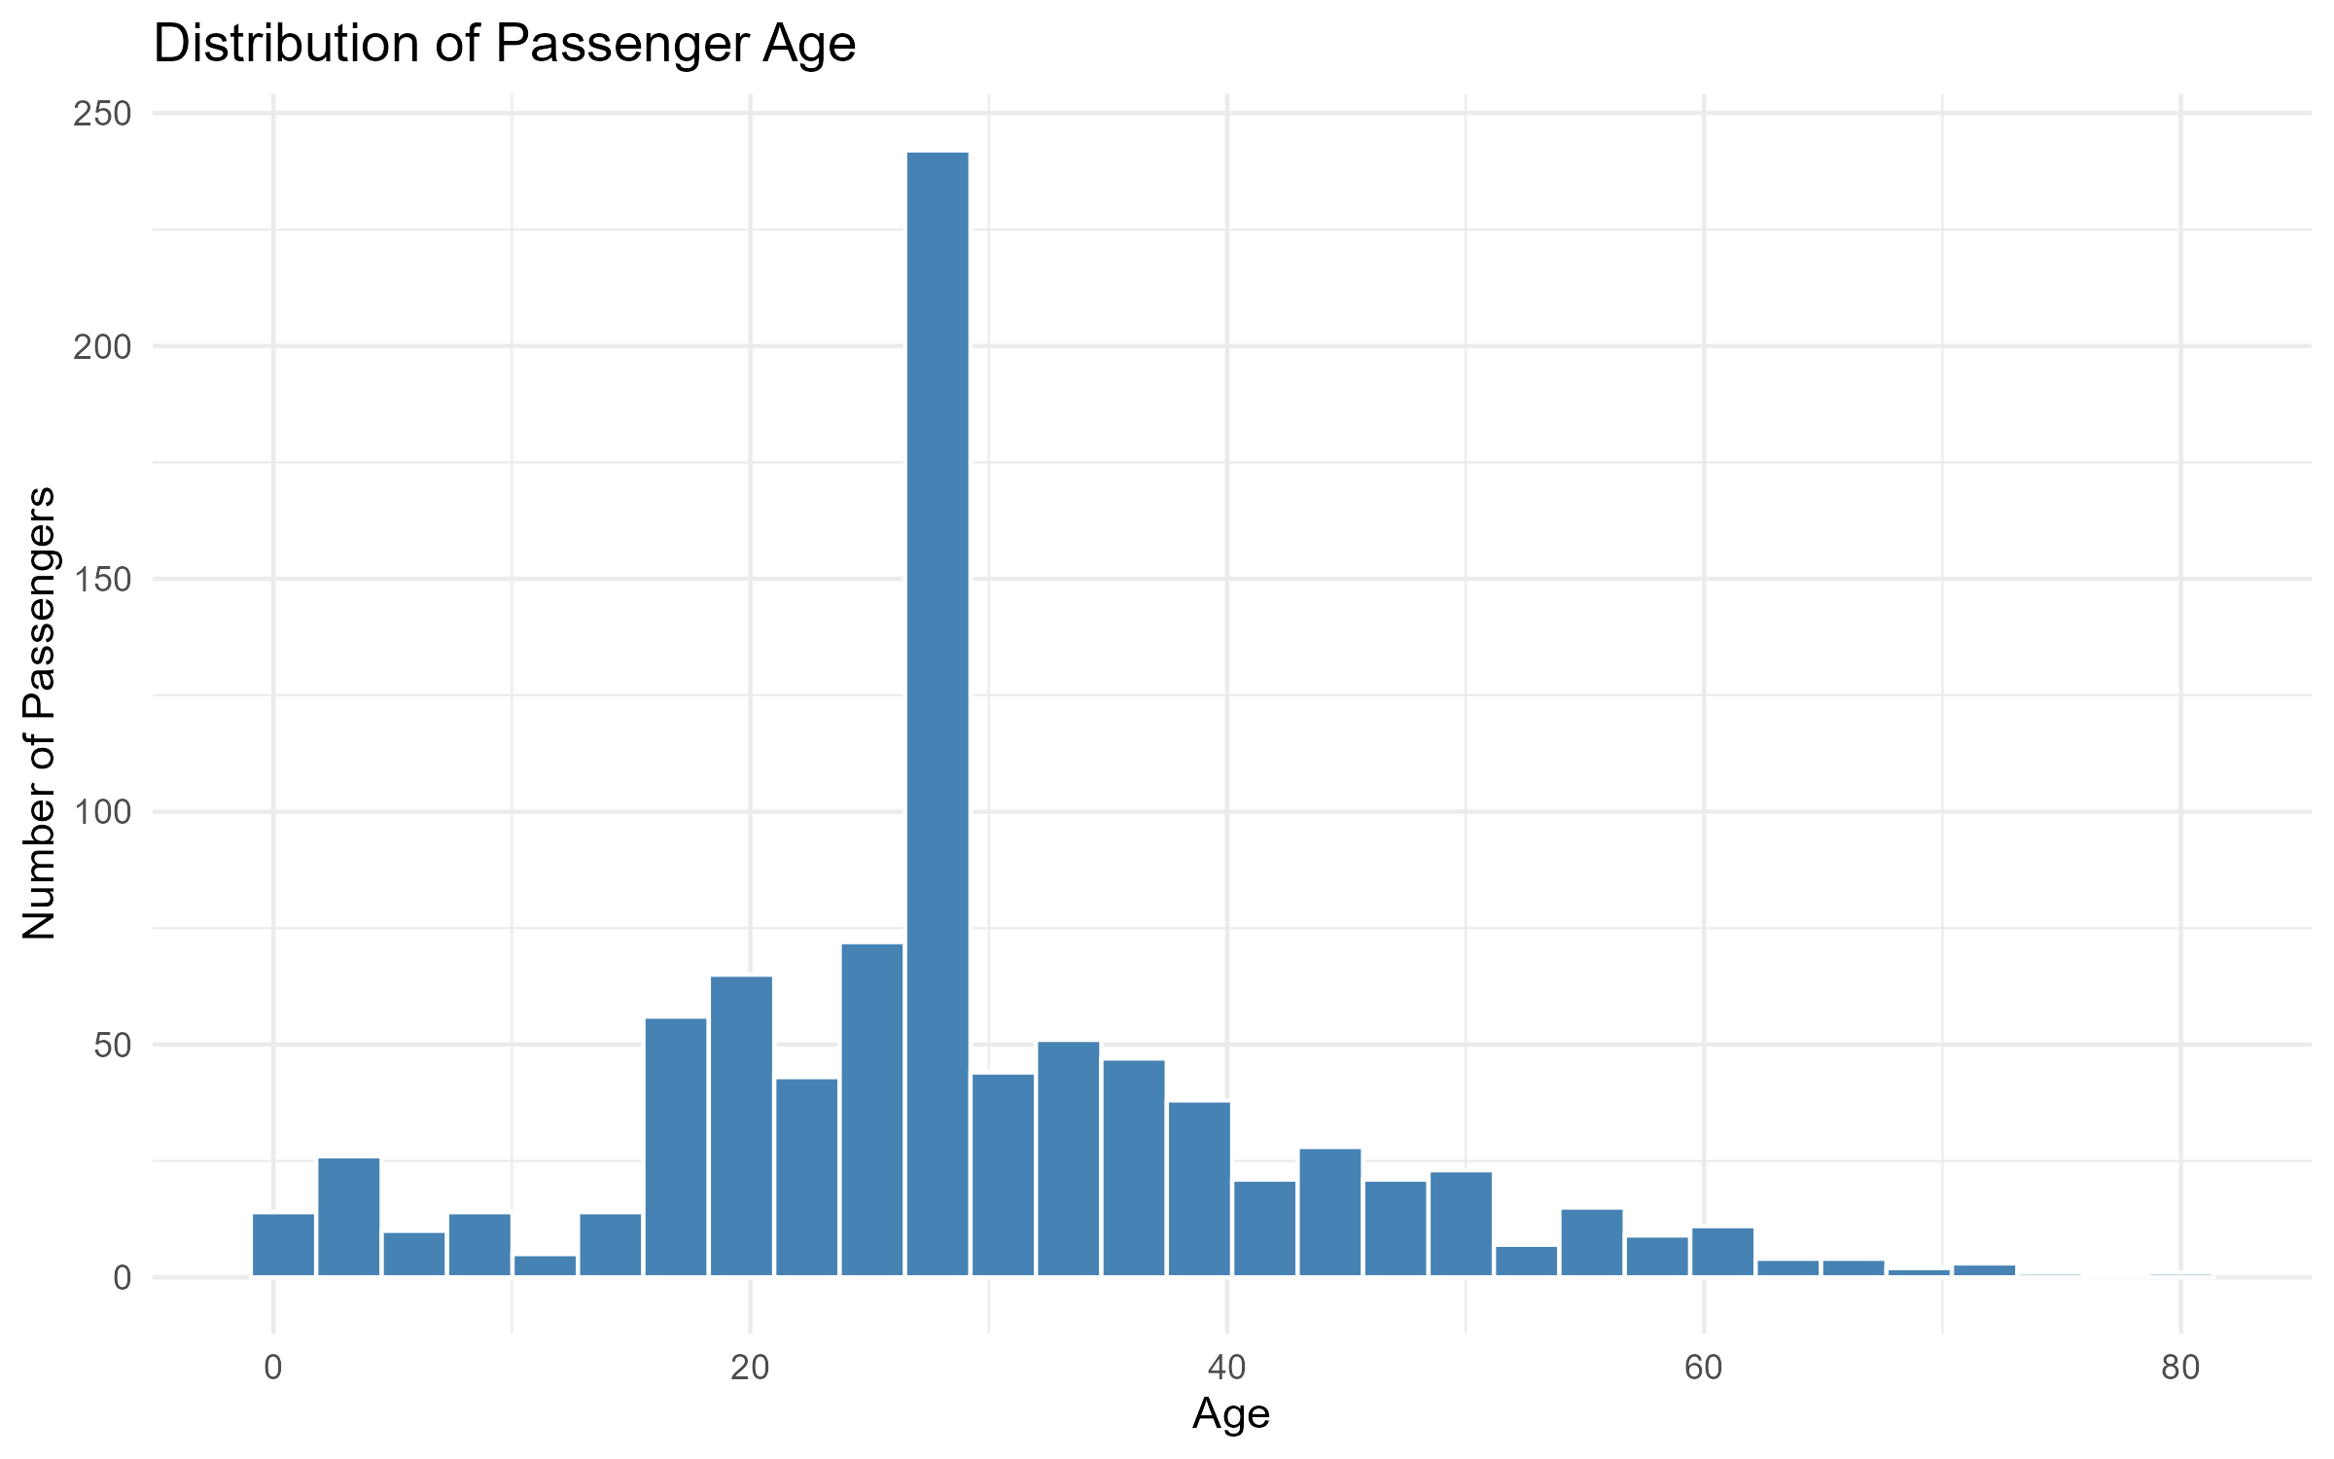
Interpretation: It helps identify the concentration and spread of passenger ages. The median age used for missing-value replacement was 28 years.

5.2 Passenger Fare Distribution
The histogram displays the distribution of passenger ticket fares.
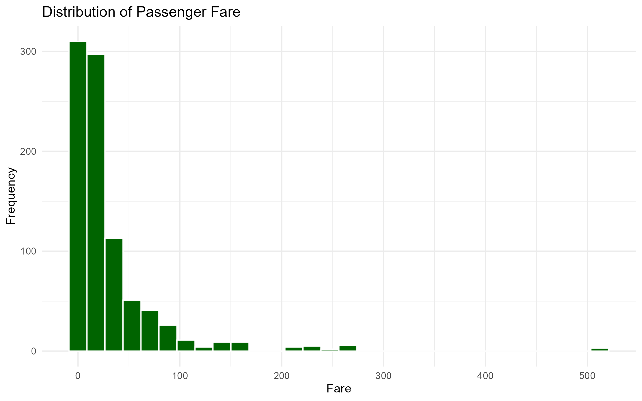
Interpretation: The fare distribution is strongly non-normal and includes substantial variation between passengers.

6. Correlation Analysis
Spearman rank correlation was used to examine the relationship between passenger age and fare. This method is suitable for assessing monotonic association without requiring normally distributed variables.
Variables | Spearman correlation | P-value | Interpretation
Age and Fare | 0.1260 | 0.000163 | Weak positive association
The result indicates a weak positive association between Age and Fare. The warning about ties means an exact p-value was not calculated; the reported p-value is an approximation.

7. Hypothesis Testing

7.1 Chi-square Test: Gender and Survival
Null hypothesis (H0): Gender and passenger survival are independent.
Alternative hypothesis (H1): Gender and passenger survival are associated.
The Chi-square test produced a statistic of 263.05 with one degree of freedom and a p-value below 2.2 × 10⁻¹⁶.
Since the p-value is below 0.05, the null hypothesis is rejected. There is strong statistical evidence of an association between gender and survival in this dataset.

7.2 Wilcoxon Test: Age and Survival
Null hypothesis (H0): The age distributions of survivors and non-survivors have the same location.
Alternative hypothesis (H1): The age distributions have different locations.
The Wilcoxon rank-sum test produced W = 97,979 and p = 0.2697. At the 5% significance level, the null hypothesis is not rejected. This test did not detect a statistically significant location difference between the two age distributions.

8. Predictive Model Development
Logistic Regression was selected because the target variable Survived has two categories: No and Yes. The model estimates the probability of survival using passenger characteristics.
The predictors used were passenger class, sex, age, fare, number of siblings or spouses, number of parents or children, and embarkation port.

8.1 Training and Testing Split
Dataset portion | Observations | Percentage
Training data | 714 | 80%
Testing data | 177 | 20%
The dataset was divided into training and testing subsets using an 80:20 split. A fixed random seed was used for reproducibility.

8.2 Five-Fold Cross-Validation
Five-fold cross-validation was configured on the training data. The training observations were divided into five folds, with each fold used for validation in turn.
The cross-validation accuracy was approximately 79.97%. This provides an estimate of model performance across different training and validation partitions.

9. Model Evaluation
The trained Logistic Regression model was evaluated on the 177 observations in the testing dataset.
Metric | Result
Accuracy | 79.10%
Precision | 74.60%
Recall / Sensitivity | 69.12%
F1-score | 71.76%
ROC-AUC | 84.09%
Specificity | 85.32%
Balanced accuracy | 77.22%
The model achieved 79.10% test accuracy and an ROC-AUC of 0.841. The ROC-AUC indicates useful discrimination between the two survival classes. Precision of 74.60% means that approximately 74.6% of predicted survivors were actual survivors. Recall of 69.12% indicates that the model identified approximately 69.1% of actual survivors.

10. Confusion Matrix
Prediction | Actual No | Actual Yes
Predicted No | 93 | 21
Predicted Yes | 16 | 47
The model correctly classified 93 non-survivors and 47 survivors. It incorrectly classified 16 non-survivors as survivors and 21 survivors as non-survivors. Overall, 140 out of 177 test observations were classified correctly.

10.1 Confusion Matrix Visualization
The confusion matrix compares actual survival outcomes with predicted outcomes.
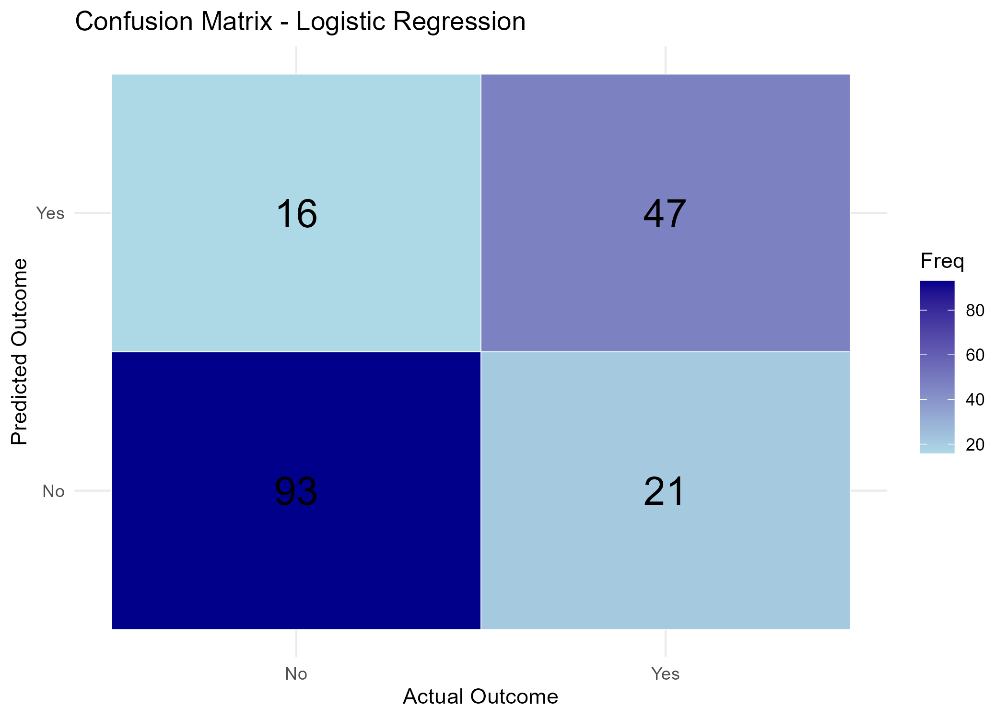
Interpretation: The diagonal cells represent correct predictions, while the off-diagonal cells represent classification errors.

11. ROC Curve Analysis

11.1 Receiver Operating Characteristic Curve
The ROC curve plots the true positive rate against the false positive rate at different classification thresholds.
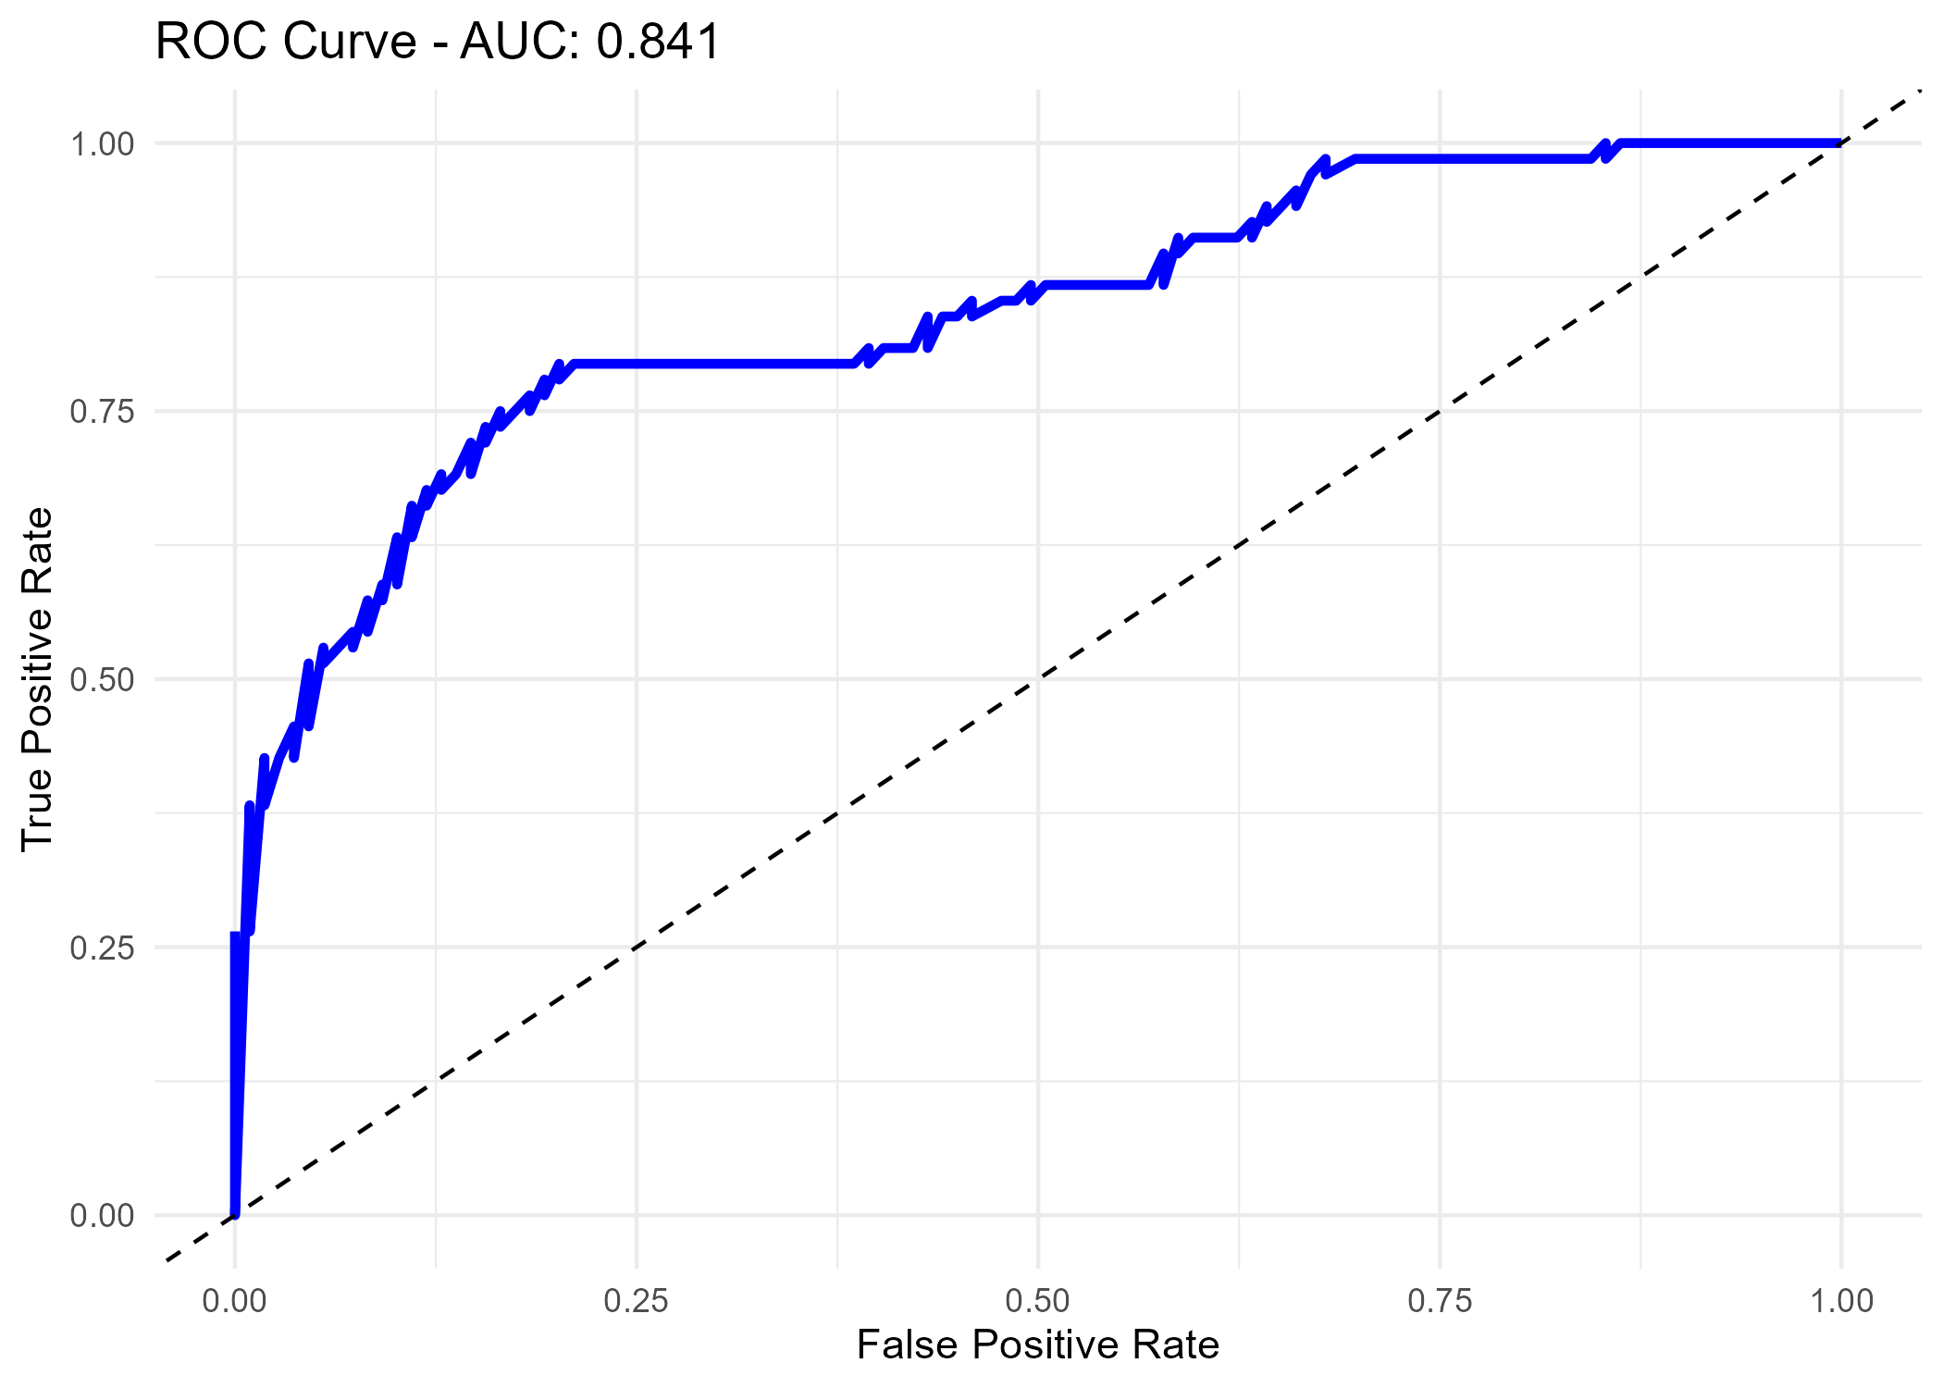
Interpretation: The model achieved an AUC of approximately 0.841, indicating good ability to distinguish between survivors and non-survivors.

12. Model Diagnostics

12.1 Deviance Residuals vs Fitted Values
This plot examines residual patterns against fitted probabilities.
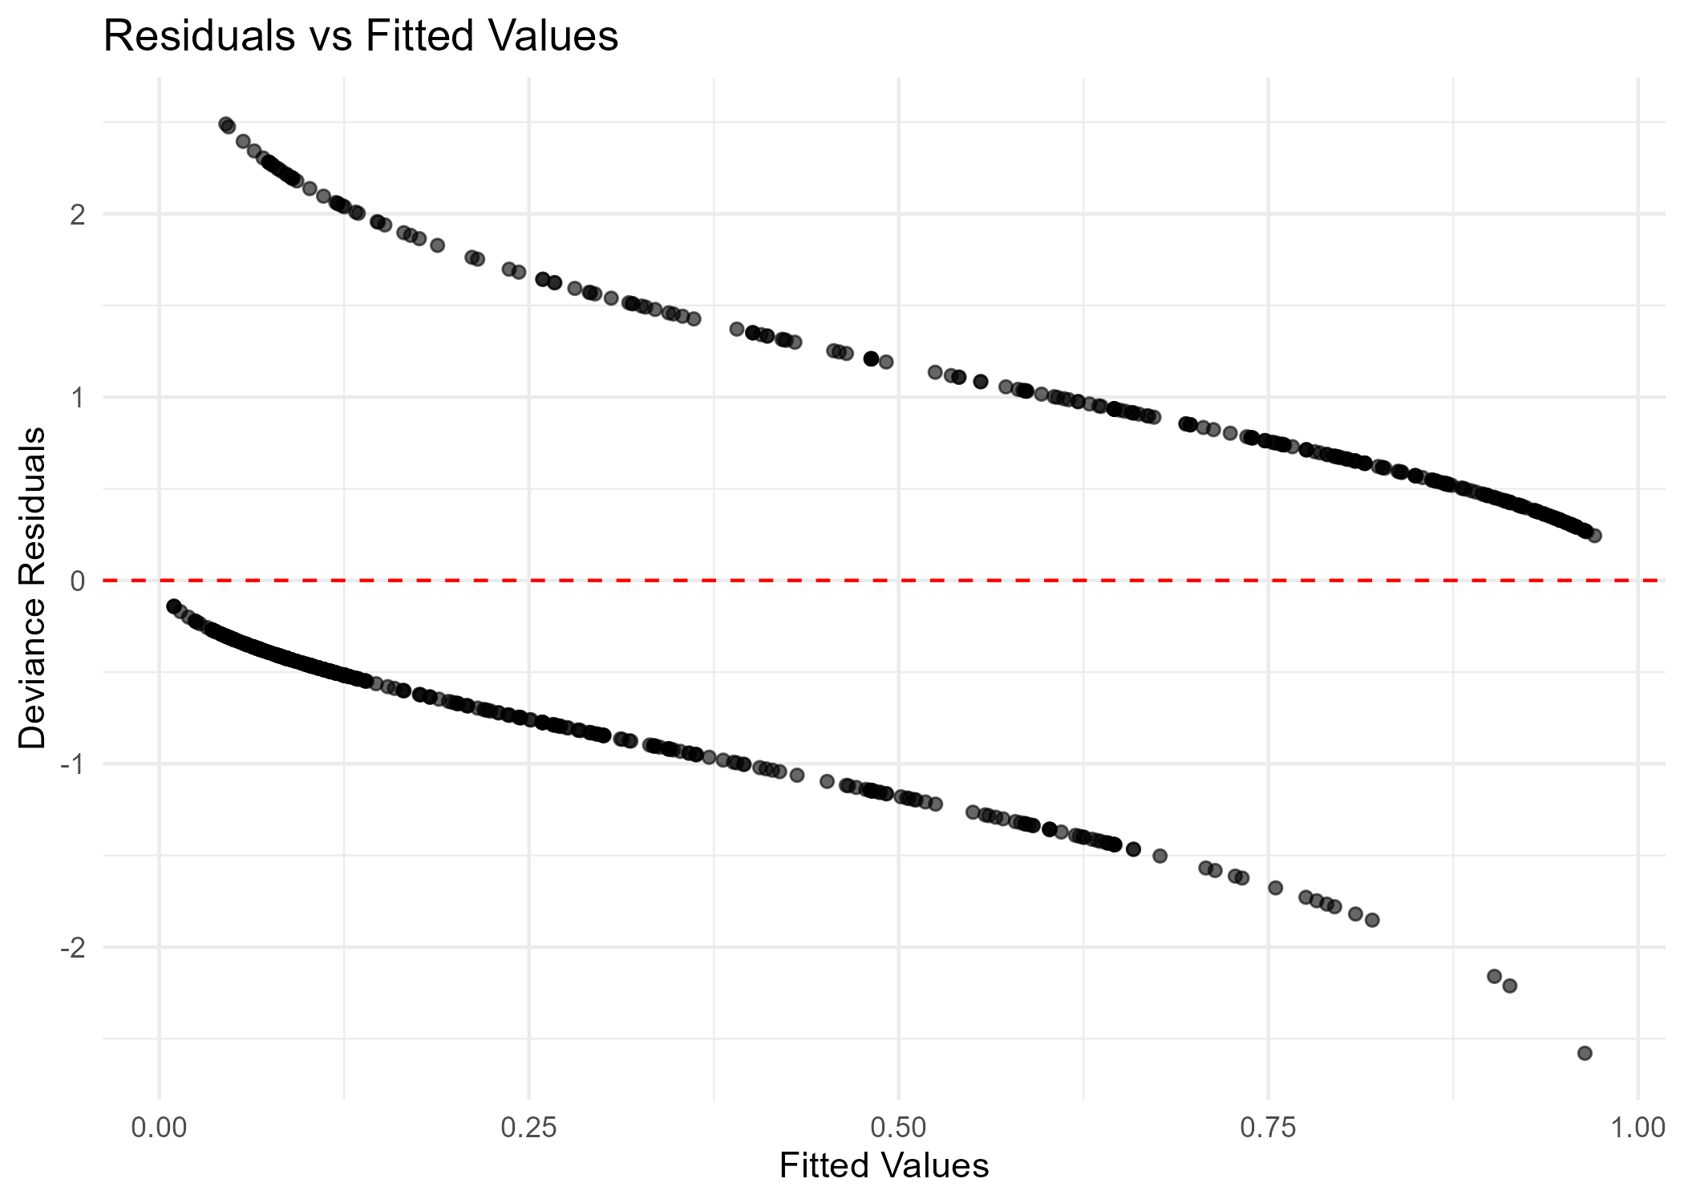
Interpretation: It can help identify unusual residual patterns and observations that may deserve further investigation.

12.2 Q-Q Plot of Deviance Residuals
The Q-Q plot compares ordered deviance residuals with theoretical normal quantiles.
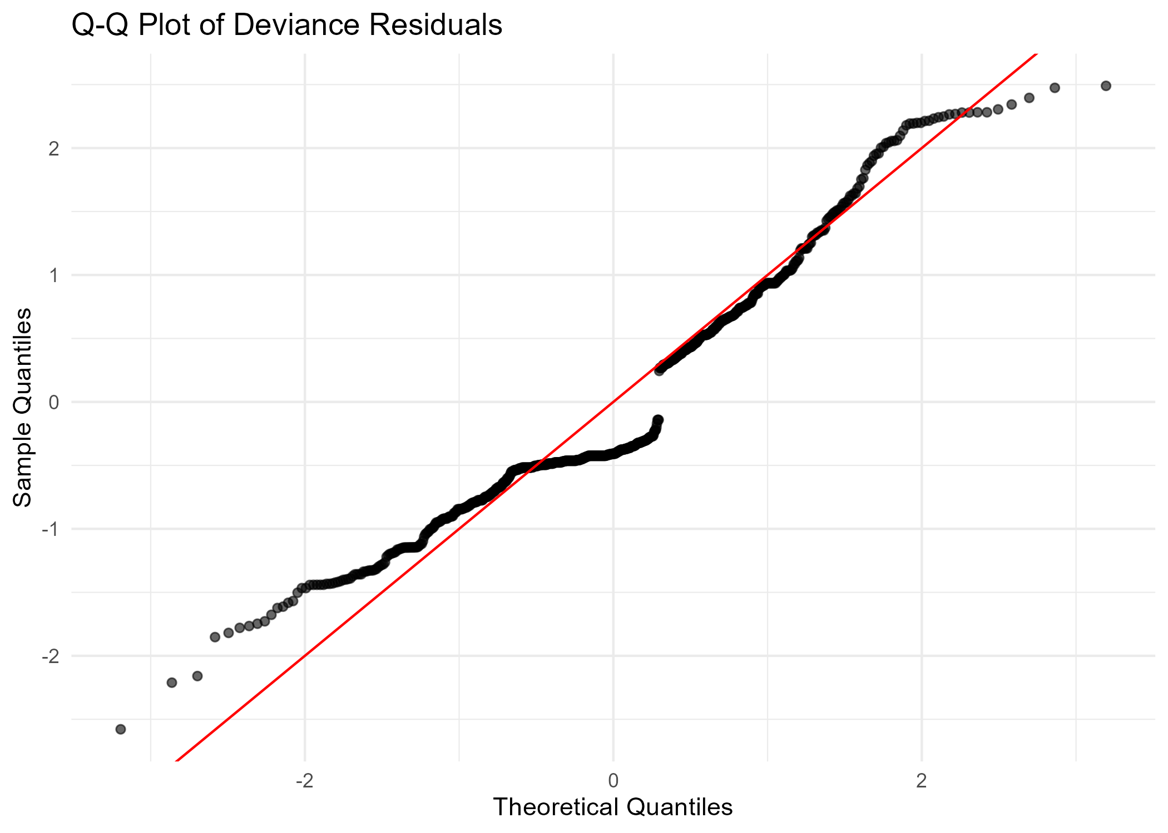
Interpretation: It provides a visual diagnostic, but normality of residuals is not a requirement for logistic regression.
The initial model run produced a rank-deficient fit warning. This indicates that some model coefficients may not be uniquely estimated, potentially because of redundant or empty factor levels. VIF calculation also failed because of aliased coefficients. These issues should be investigated before treating all individual coefficients as reliable.

13. Model Strengths
- Logistic Regression is appropriate for a binary target variable.
- The model achieved 79.10% accuracy on the test dataset.
- The ROC-AUC of 0.841 indicates useful classification ability.
- Five-fold cross-validation was used to assess training performance.
- Multiple evaluation metrics were used rather than accuracy alone.

14. Limitations and Potential Improvements
- Investigate rank-deficient coefficients and factor levels.
- Check blank strings as well as NA values during missing-value handling.
- Use stratified repeated cross-validation for more stable estimates.
- Compare Logistic Regression with Random Forest and other classifiers.
- Consider feature selection and regularization.
- Evaluate probability calibration and alternative classification thresholds.
- Investigate class imbalance and compare balanced performance metrics.
- Use additional data or external validation to test generalization.

15. Conclusion
This project applied statistical analysis and predictive modeling to the Titanic passenger dataset using R. Descriptive statistics, normality testing, correlation analysis, and hypothesis testing were used to explore the data.
A Logistic Regression classifier was developed with an 80:20 training-testing split and five-fold cross-validation. The model achieved 79.10% test accuracy, 71.76% F1-score, and 84.09% ROC-AUC.
The results demonstrate how statistical methods and classification models can be used to investigate patterns and make predictions. The model also has limitations, including a rank-deficiency warning that requires further investigation. Future work can improve the model through data-quality checks, feature selection, regularization, and comparison with other classification methods.

16. Appendix: Complete R Source Code
The following appendix contains the R script used to perform the statistical analysis, hypothesis testing, model development, and evaluation.

# ============================================================
# WEEK 3: STATISTICAL ANALYSIS AND PREDICTIVE MODELING
# Dataset: Titanic Passenger Dataset
# Model: Logistic Regression
# Author: Sahil Jadhao
# ============================================================

# 1. LOAD LIBRARIES
library(tidyverse)
library(caret)
library(pROC)
library(car)

set.seed(123)

# 2. PROJECT PATHS
base_dir <- getwd()

output_graphs <- file.path(base_dir, "Outputs", "Graphs")
output_results <- file.path(base_dir, "Outputs", "Results")
output_models <- file.path(base_dir, "Outputs", "Models")

dir.create(output_graphs, recursive = TRUE, showWarnings = FALSE)
dir.create(output_results, recursive = TRUE, showWarnings = FALSE)
dir.create(output_models, recursive = TRUE, showWarnings = FALSE)

# 3. LOAD DATASET
data <- read.csv(
file.path(base_dir, "Dataset", "titanic_train.csv"),
stringsAsFactors = FALSE
)

cat("\n========== DATASET OVERVIEW ==========\n")
cat("Rows:", nrow(data), "\n")
cat("Columns:", ncol(data), "\n")

write.csv(
data,
file.path(output_results, "original_dataset_summary.csv"),
row.names = FALSE
)

# 4. DATA CLEANING
cat("\n========== DATA CLEANING ==========\n")

# Convert survival into readable categories
data$Survived <- factor(
data$Survived,
levels = c(0, 1),
labels = c("No", "Yes")
)

# Convert categorical variables into factors
data$Sex <- as.factor(data$Sex)
data$Pclass <- as.factor(data$Pclass)
data$Embarked <- as.factor(data$Embarked)

# Missing value summary
missing_summary <- data.frame(
Variable = names(data),
Missing_Values = colSums(is.na(data))
)

write.csv(
missing_summary,
file.path(output_results, "missing_values_summary.csv"),
row.names = FALSE
)

print(missing_summary)

# Replace missing numerical values with median
data$Age[is.na(data$Age)] <- median(data$Age, na.rm = TRUE)
data$Fare[is.na(data$Fare)] <- median(data$Fare, na.rm = TRUE)

# Replace missing Embarked values with mode
mode_value <- names(which.max(table(data$Embarked)))
data$Embarked[is.na(data$Embarked)] <- mode_value

# Remove unnecessary columns
data <- data %>%
select(-PassengerId, -Name, -Ticket, -Cabin)

cat("\nMissing values after cleaning:\n")
print(colSums(is.na(data)))

# 5. DESCRIPTIVE STATISTICS
cat("\n========== DESCRIPTIVE STATISTICS ==========\n")

summary_stats <- data %>%
summarise(
Total_Passengers = n(),
Mean_Age = mean(Age),
Median_Age = median(Age),
SD_Age = sd(Age),
Mean_Fare = mean(Fare),
Median_Fare = median(Fare),
SD_Fare = sd(Fare),
Survival_Rate = mean(Survived == "Yes") * 100
)

print(summary_stats)

write.csv(
summary_stats,
file.path(output_results, "descriptive_statistics.csv"),
row.names = FALSE
)

# 6. DISTRIBUTION ANALYSIS

# Age distribution
p1 <- ggplot(data, aes(x = Age)) +
geom_histogram(bins = 30, fill = "steelblue", color = "white") +
labs(
title = "Distribution of Passenger Age",
x = "Age",
y = "Number of Passengers"
) +
theme_minimal()

ggsave(
file.path(output_graphs, "01_age_distribution.png"),
p1, width = 8, height = 5
)

# Fare distribution
p2 <- ggplot(data, aes(x = Fare)) +
geom_histogram(bins = 30, fill = "darkgreen", color = "white") +
labs(
title = "Distribution of Passenger Fare",
x = "Fare",
y = "Frequency"
) +
theme_minimal()

ggsave(
file.path(output_graphs, "02_fare_distribution.png"),
p2, width = 8, height = 5
)

# 7. NORMALITY TESTING
cat("\n========== NORMALITY TESTING ==========\n")

age_normality <- shapiro.test(data$Age)
fare_normality <- shapiro.test(data$Fare)

normality_results <- data.frame(
Variable = c("Age", "Fare"),
W_Statistic = c(
unname(age_normality$statistic),
unname(fare_normality$statistic)
),
P_Value = c(
age_normality$p.value,
fare_normality$p.value
)
)

print(normality_results)

write.csv(
normality_results,
file.path(output_results, "normality_test_results.csv"),
row.names = FALSE
)

# 8. CORRELATION ANALYSIS
cat("\n========== CORRELATION ANALYSIS ==========\n")

correlation_test <- cor.test(
data$Age,
data$Fare,
method = "spearman"
)

cat("Spearman correlation:", correlation_test$estimate, "\n")
cat("P-value:", correlation_test$p.value, "\n")

correlation_results <- data.frame(
Variables = "Age and Fare",
Correlation = unname(correlation_test$estimate),
P_Value = correlation_test$p.value
)

write.csv(
correlation_results,
file.path(output_results, "correlation_results.csv"),
row.names = FALSE
)

# 9. HYPOTHESIS TESTING

cat("\n========== HYPOTHESIS TESTING ==========\n")

# Test 1: Association between gender and survival
# H0: Gender and survival are independent.
# H1: Gender and survival are associated.

gender_table <- table(data$Sex, data$Survived)

gender_test <- chisq.test(gender_table, correct = FALSE)

cat("\nChi-square test: Gender vs Survival\n")
print(gender_test)

# Test 2: Age difference between survivors and non-survivors
# H0: Age distributions are equal.
# H1: Age distributions are different.

age_test <- wilcox.test(Age ~ Survived, data = data)

cat("\nWilcoxon test: Age vs Survival\n")
print(age_test)

hypothesis_results <- data.frame(
Test = c(
"Chi-square: Gender vs Survival",
"Wilcoxon: Age vs Survival"
),
Statistic = c(
unname(gender_test$statistic),
unname(age_test$statistic)
),
P_Value = c(
gender_test$p.value,
age_test$p.value
)
)

write.csv(
hypothesis_results,
file.path(output_results, "hypothesis_test_results.csv"),
row.names = FALSE
)

# 10. PREPARE MODELING DATA

model_data <- data %>%
select(
Survived,
Pclass,
Sex,
Age,
Fare,
SibSp,
Parch,
Embarked
)

model_data <- droplevels(model_data)

# 11. TRAIN-TEST SPLIT (80:20)

cat("\n========== TRAIN-TEST SPLIT ==========\n")

train_index <- createDataPartition(
model_data$Survived,
p = 0.80,
list = FALSE
)

train_data <- model_data[train_index, ]
test_data <- model_data[-train_index, ]

cat("Training rows:", nrow(train_data), "\n")
cat("Testing rows:", nrow(test_data), "\n")

# 12. FIVE-FOLD CROSS-VALIDATION

cat("\n========== CROSS VALIDATION ==========\n")

control <- trainControl(
method = "cv",
number = 5
)

# 13. LOGISTIC REGRESSION MODEL

cat("\n========== LOGISTIC REGRESSION ==========\n")

model <- train(
Survived ~ .,
data = train_data,
method = "glm",
family = binomial(),
trControl = control,
metric = "Accuracy"
)

print(model)

# Save model
saveRDS(
model,
file.path(output_models, "logistic_regression_model.rds")
)

# 14. PREDICTIONS

predicted_class <- predict(model, newdata = test_data)

predicted_probability <- predict(
model,
newdata = test_data,
type = "prob"
)[, "Yes"]

# 15. CONFUSION MATRIX

cat("\n========== CONFUSION MATRIX ==========\n")

confusion <- confusionMatrix(
predicted_class,
test_data$Survived,
positive = "Yes"
)

print(confusion)

# 16. PERFORMANCE METRICS

accuracy <- as.numeric(confusion$overall["Accuracy"])
precision <- as.numeric(confusion$byClass["Precision"])
recall <- as.numeric(confusion$byClass["Recall"])
f1 <- as.numeric(confusion$byClass["F1"])

roc_object <- roc(
response = test_data$Survived,
predictor = predicted_probability,
levels = c("No", "Yes"),
direction = "<",
quiet = TRUE
)

auc_value <- as.numeric(auc(roc_object))

performance <- data.frame(
Metric = c(
"Accuracy",
"Precision",
"Recall",
"F1 Score",
"ROC-AUC"
),
Value = c(
accuracy,
precision,
recall,
f1,
auc_value
)
)

cat("\n========== MODEL PERFORMANCE ==========\n")
print(performance)

write.csv(
performance,
file.path(output_results, "model_performance.csv"),
row.names = FALSE
)

# 17. CONFUSION MATRIX VISUALIZATION

confusion_data <- as.data.frame(confusion$table)

p3 <- ggplot(
confusion_data,
aes(x = Reference, y = Prediction, fill = Freq)
) +
geom_tile(color = "white") +
geom_text(aes(label = Freq), size = 7) +
scale_fill_gradient(low = "lightblue", high = "darkblue") +
labs(
title = "Confusion Matrix - Logistic Regression",
x = "Actual Outcome",
y = "Predicted Outcome"
) +
theme_minimal()

ggsave(
file.path(output_graphs, "03_confusion_matrix.png"),
p3, width = 7, height = 5
)

# 18. ROC CURVE

roc_data <- data.frame(
Specificity = roc_object$specificities,
Sensitivity = roc_object$sensitivities
)

p4 <- ggplot(
roc_data,
aes(x = 1 - Specificity, y = Sensitivity)
) +
geom_line(color = "blue", linewidth = 1.2) +
geom_abline(
intercept = 0,
slope = 1,
linetype = "dashed"
) +
labs(
title = paste("ROC Curve - AUC:", round(auc_value, 3)),
x = "False Positive Rate",
y = "True Positive Rate"
) +
theme_minimal()

ggsave(
file.path(output_graphs, "04_roc_curve.png"),
p4, width = 7, height = 5
)

# 19. MODEL DIAGNOSTICS

cat("\n========== MODEL DIAGNOSTICS ==========\n")

final_glm <- model$finalModel

# Residuals vs fitted plot
diagnostic_data <- data.frame(
Fitted = fitted(final_glm),
Deviance_Residuals = residuals(
final_glm,
type = "deviance"
)
)

p5 <- ggplot(
diagnostic_data,
aes(x = Fitted, y = Deviance_Residuals)
) +
geom_point(alpha = 0.6) +
geom_hline(
yintercept = 0,
linetype = "dashed",
color = "red"
) +
labs(
title = "Residuals vs Fitted Values",
x = "Fitted Values",
y = "Deviance Residuals"
) +
theme_minimal()

ggsave(
file.path(output_graphs, "05_residual_diagnostic.png"),
p5, width = 7, height = 5
)

# Q-Q plot of deviance residuals
qq_data <- data.frame(
Theoretical = qnorm(ppoints(length(residuals(final_glm)))),
Sample = sort(residuals(final_glm, type = "deviance"))
)

p6 <- ggplot(
qq_data,
aes(x = Theoretical, y = Sample)
) +
geom_point(alpha = 0.6) +
geom_abline(
intercept = 0,
slope = 1,
color = "red"
) +
labs(
title = "Q-Q Plot of Deviance Residuals",
x = "Theoretical Quantiles",
y = "Sample Quantiles"
) +
theme_minimal()

ggsave(
file.path(output_graphs, "06_qq_plot.png"),
p6, width = 7, height = 5
)

# 20. MULTICOLLINEARITY CHECK

cat("\n========== MULTICOLLINEARITY ==========\n")

vif_results <- tryCatch(
car::vif(final_glm),
error = function(e) {
cat("VIF could not be calculated:", e$message, "\n")
NULL
}
)

if (!is.null(vif_results)) {
print(vif_results)

vif_table <- data.frame(
Variable = names(vif_results),
VIF = as.numeric(vif_results)
)

write.csv(
vif_table,
file.path(output_results, "vif_results.csv"),
row.names = FALSE
)
}

# 21. LOGISTIC REGRESSION COEFFICIENTS

coefficient_results <- as.data.frame(
summary(final_glm)$coefficients
)

coefficient_results$Variable <- rownames(coefficient_results)
coefficient_results$Odds_Ratio <- exp(coefficient_results$Estimate)

write.csv(
coefficient_results,
file.path(output_results, "logistic_coefficients.csv"),
row.names = FALSE
)

# 22. FINAL SUMMARY

cat("\n========================================\n")
cat("WEEK 3 ANALYSIS COMPLETED SUCCESSFULLY\n")
cat("========================================\n")

cat("Dataset rows:", nrow(data), "\n")
cat("Training rows:", nrow(train_data), "\n")
cat("Testing rows:", nrow(test_data), "\n")
cat("Cross-validation: 5-fold\n")
cat("Model: Logistic Regression\n")
cat("Accuracy:", round(accuracy * 100, 2), "%\n")
cat("Precision:", round(precision, 3), "\n")
cat("Recall:", round(recall, 3), "\n")
cat("F1 Score:", round(f1, 3), "\n")
cat("ROC-AUC:", round(auc_value, 3), "\n")

cat("\nGraphs saved in:", output_graphs, "\n")
cat("Results saved in:", output_results, "\n")
cat("Model saved in:", output_models, "\n")

cat("\n========================================\n")

