***Abstract – This lab implements the hardware for second-order filters, and then audio mixing console. Filters that satisfy a set of design specifications relating to the center frequencies were designed through a filter design process. Then, the input (buffer/summing amplifier and a microphone) and the output (speaker) from the previous labs were added in series with the filters to make an audio mixing console. The gain and other behaviors of the system were analyzed regarding the equalizer.***

I. INTRODUCTION

Filter design is the process of creating a signal processing filter that satisfies a set of design specifications. For this lab, the given MATLAB program analyzes the filter to get the component values that yield the specified center frequencies. The filters built in this lab are part of a three-channel equalizer system, in which each filter passes or rejects certain range of frequencies. Connecting these filters to the buffer and output summing amplifier creates an audio mixing console.

Analyzing the graph of the output voltage at different frequencies verifies the type of filter. Analyzing the output of the system visually and audially as we manipulate the filter shows which filter controls the output at a certain frequency. Lastly, simulating the filters and the entire system in SPICE confirms the result.

II. LAB PROCEDURE

We built the filter circuits (Appendix A) with V power supplies, resistors, and capacitors from our lab kit. Next, we used a small amplitude 100mV input while sweeping the frequency (1-2-5 sequence from 10Hz to 5000Hz) to measure the center frequency, 3-dB frequencies, and maximum gain for the filter. We repeated the process for all three filters while changing the potentiometer settings to 25%, 50%, and 75% and recorded the values of Vout. We made sure the output was not affected by the slew rate and saturation of the op-amp.

Once all three filters were working as intended, we assembled the audio mixer circuit using three different inputs (one being a microphone with a preamplifier) connected to a summing amplifier which then paired to the equalizer circuit followed by the speaker (Appendix B). Then, we used an input wave of frequency 250Hz and amplitude 100mV and then changed the values of the potentiometers int the three filters to test which filter controls the amplitude of the output. Next, we repeated with input frequencies of 1kHz and 4kHz and repeated the process.

Next, we used a single input and then plotted the gain of the audio mixer over 10Hz and 5kHz by sweeping (1-2-5 sequence from 10Hz to 5000Hz). We also built the circuit in SPICE and used the AC analysis feature to see the transfer function of the system.

III. EXPERIMENTAL ANALYSIS

**Analysis #1**

For the audio equalizer circuit, the resistor values were R1 = R2 = 240kΩ and R3 = R4 = 24kΩ for all center frequencies. The capacitor values were the following:

|  |  |  |
| --- | --- | --- |
| Table 1: Capacitor Values for the Audio Equalizer Filter  For the Given Center Frequencies | | |
|  | C1 | C2 |
| 250 Hz | 0.1μF | 0.01μF |
| 1000 Hz | 0.022μF | 0.0022μF |
| 4000 Hz | 0.0047μF | 500pF |

The resistor and capacitor values were calculated using a MATLAB program given in the prelab. The circuit analysis yields center frequencies of 199Hz, 904Hz, and 4101Hz with the capacitor values above.

**Analysis #2**

The audio equalizer filters with 250Hz, 1000Hz, and 5000Hz center frequencies were built with the components above. Each filter was applied small amplitude sine wave input and swept with potentiometer (γ) at 25%, 50%, and 75%. The following is the plot, center frequency (fc), 3-dB frequencies, and maximum gain of each filter (Appendix C). The data table is in Appendix D.

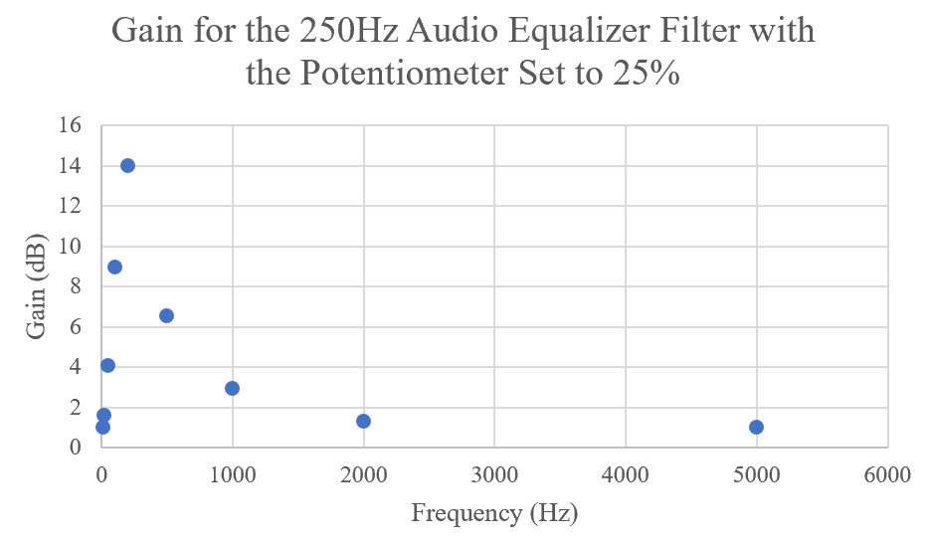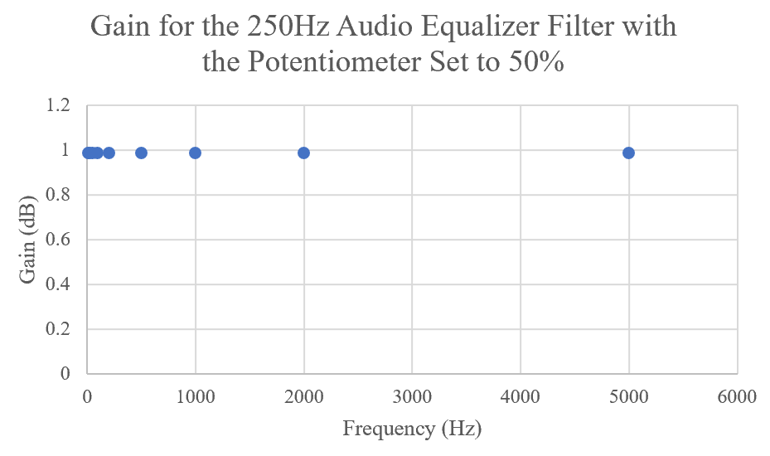

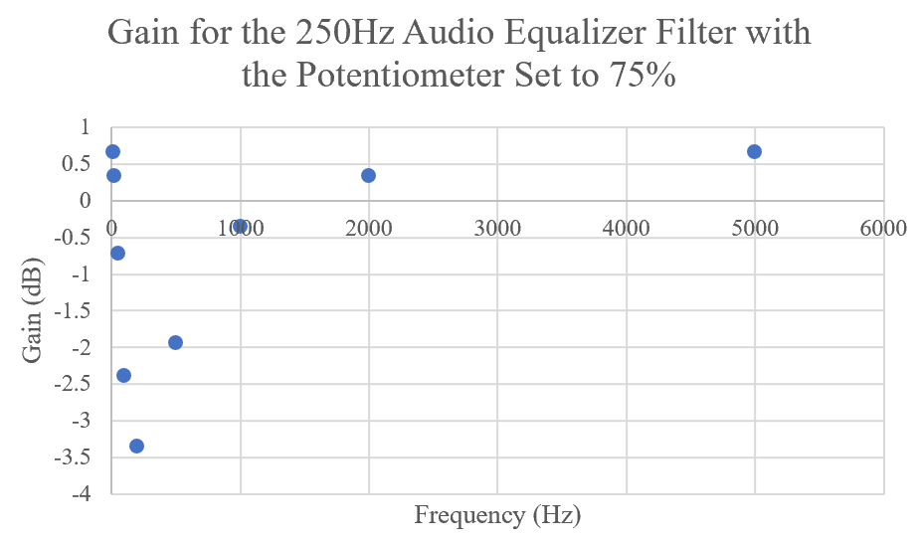

|  |  |  |  |
| --- | --- | --- | --- |
| Table 2: Critical Values for the 250Hz Audio Equalizer Filter | | | |
| γ | fc (Hz) | 3-dB f (Hz) | Max/Min Gain (dB) |
| 25% | 200 | 125, 300 | 14.0 |
| 50% | N/A | N/A | 0.98 |
| 75% | 200 | 53, 670 | -3.88 |

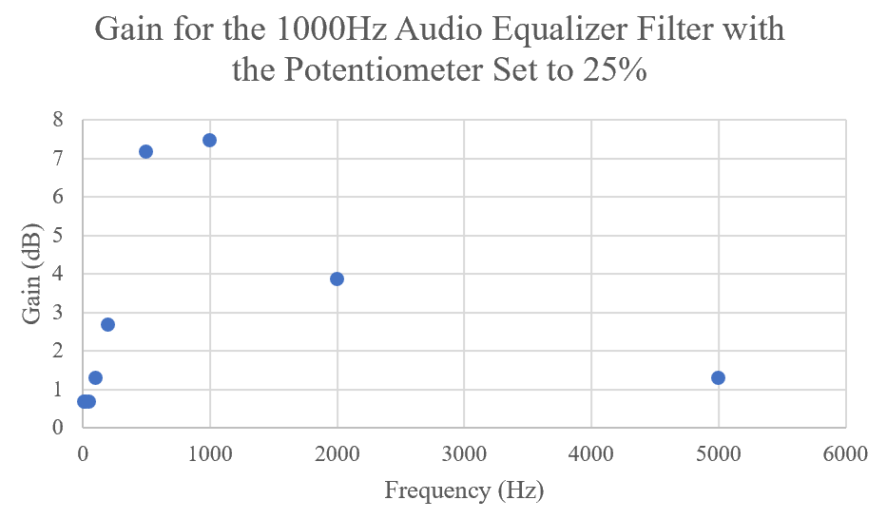 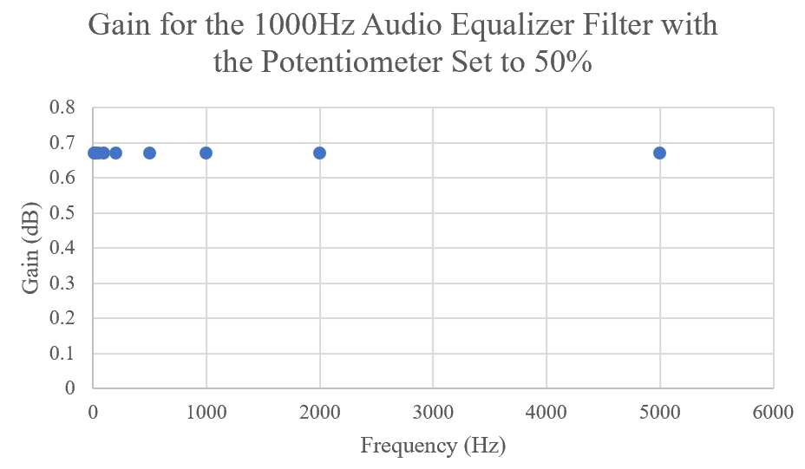

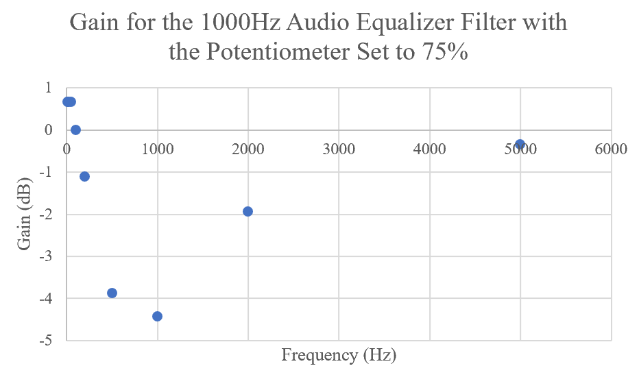

|  |  |  |  |
| --- | --- | --- | --- |
| Table 3: Critical Values for the 1000Hz Audio Equalizer Filter | | | |
| γ | fc (Hz) | 3-dB f (Hz) | Max/Min Gain (dB) |
| 25% | 836 | 340, 1550 | 8.16 |
| 50% | N/A | N/A | 0.67 |
| 75% | 800 | 260, 1800 | -5.03 |

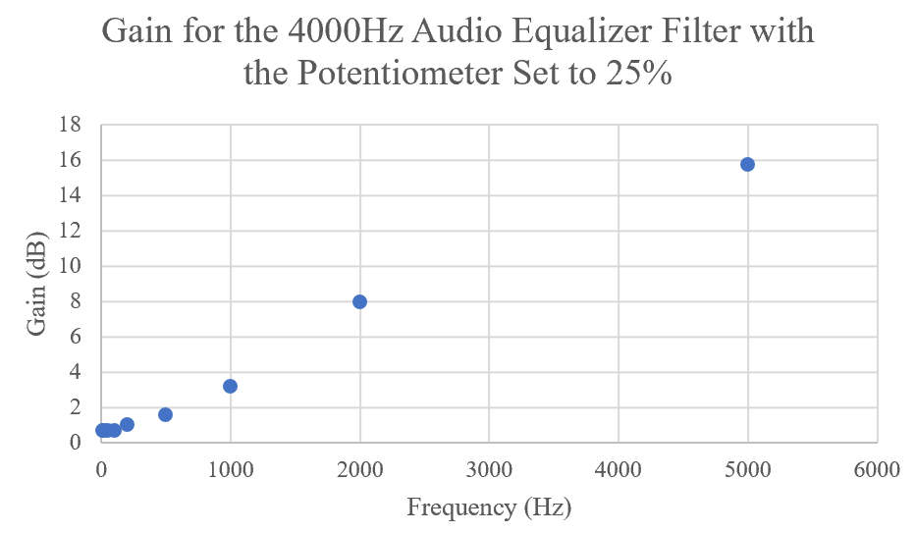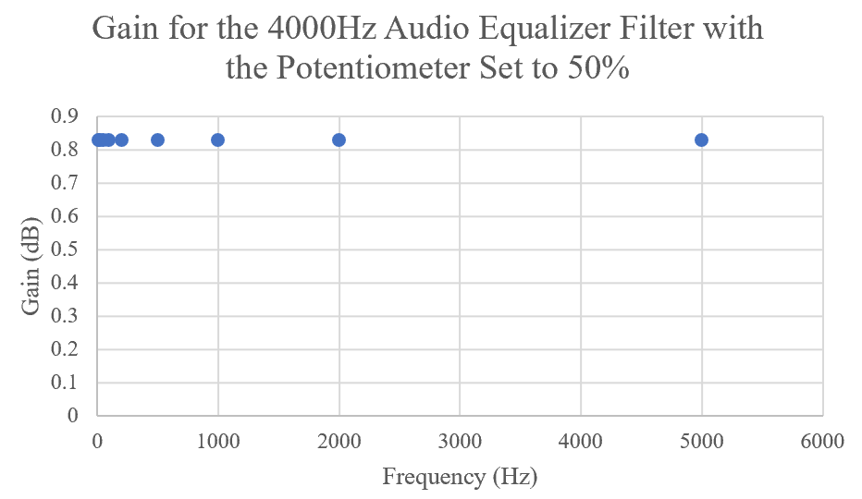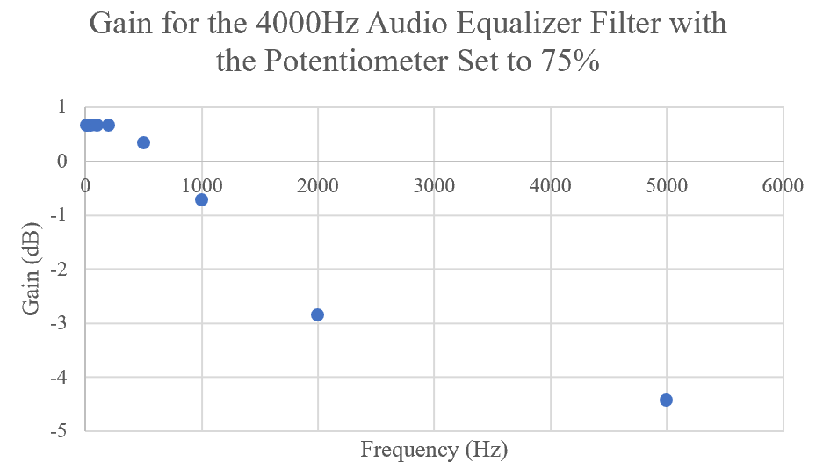

|  |  |  |  |
| --- | --- | --- | --- |
| Table 4: Critical Values for the 4000Hz Audio Equalizer Filter | | | |
| γ | fc (Hz) | 3-dB f (Hz) | Max/Min Gain (dB) |
| 25% | 4480 | 3250, 6420 | 16.1 |
| 50% | N/A | N/A | 0.83 |
| 75% | 4340 | 1440, 12810 | -4.73 |

The data shows that all the filters have center frequencies near their expected values, which confirms that the filter design was correct. At γ=25%, the filters act as a bandpass, and at γ=50%, the filters act as a bandreject. Note that the 4000Hz filter does not show the bandpass and bandreject property on the graphs above because the data was not swept across all of its bandwidth.

**Analysis #3**

The audio mixing console was built as stated in the procedure, and the effect of potentiometers in the equalizers were tested.

With the sine wave with a frequency of 250Hz, the 250Hz filter controls the amplitude of the output filter as supported by the oscilloscope waveforms below. Figure 1 shows the waveform of the input (yellow) and output (blue) of the standard audio mixing console (γ=25% for all three filters). When the γ-value of the potentiometer is changed for the 1000Hz and the 4000Hz, the waveform remained the same as Figure 1. However, when the γ-value is changed in the 250Hz filter, the waveform increased and decreased as shown in Figure 2.

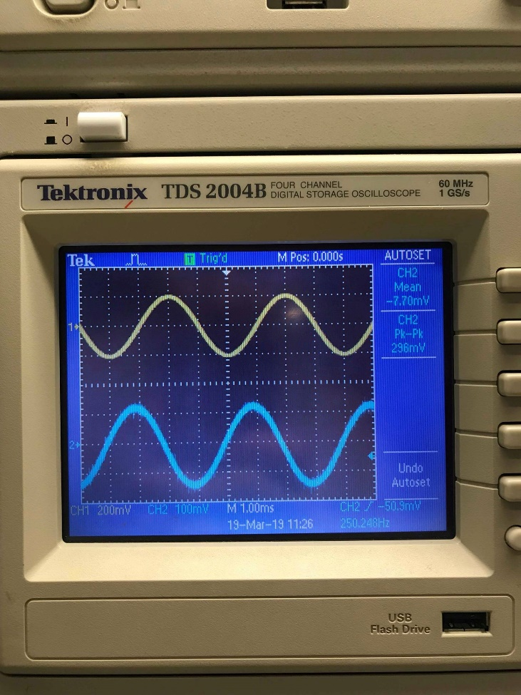

Figure 1: This figure graphs the output (blue) of the audio mixing console with the input frequency of 250Hz. The figure remains the same with the γ-value of 1000Hz and 4000Hz changing.

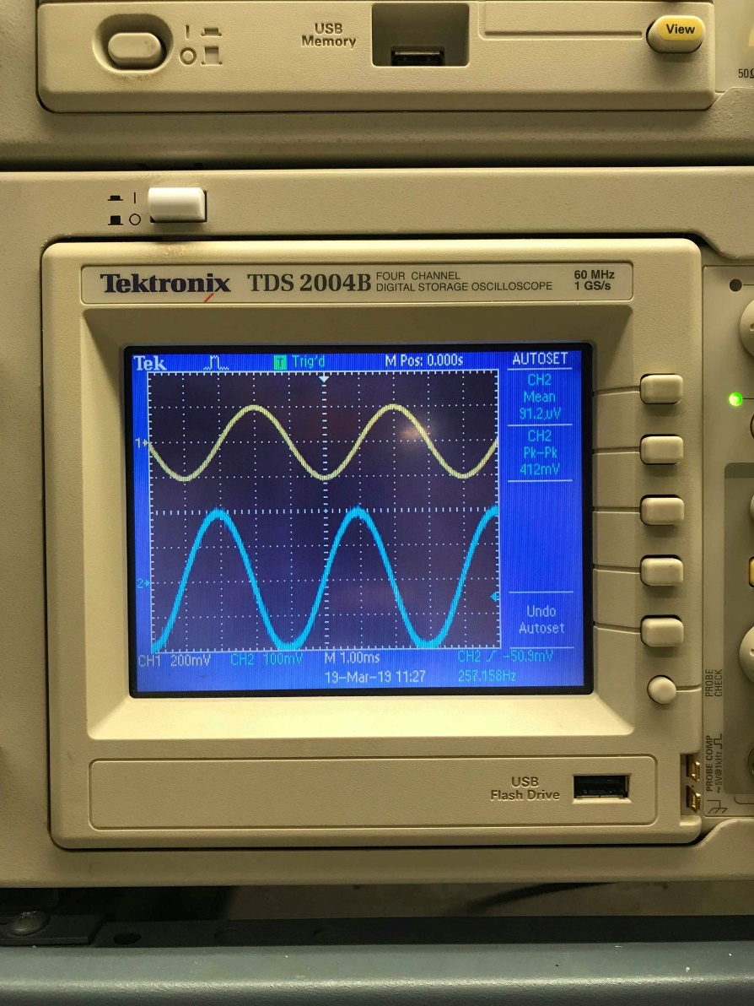

Figure 2: This figure graphs the output (blue) of the audio mixing console with the input frequency of 250Hz and γ-value of 250Hz changed.

**Analysis #4**

Using the same method, we see that the 1000Hz filter controls the amplitude of the output filter at 1000Hz, and the 4000Hz filter controls the amplitude of the output filter at 4000Hz. The figures that support this behavior are the following:

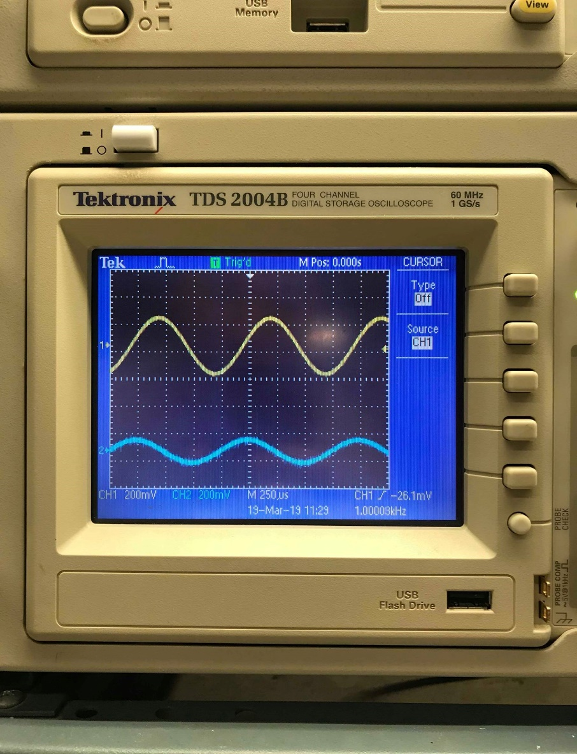

Figure 3: This figure graphs the output (blue) of the audio mixing console with the input frequency of 1000Hz. The figure remains the same with the γ-value of 250Hz and 4000Hz changing.

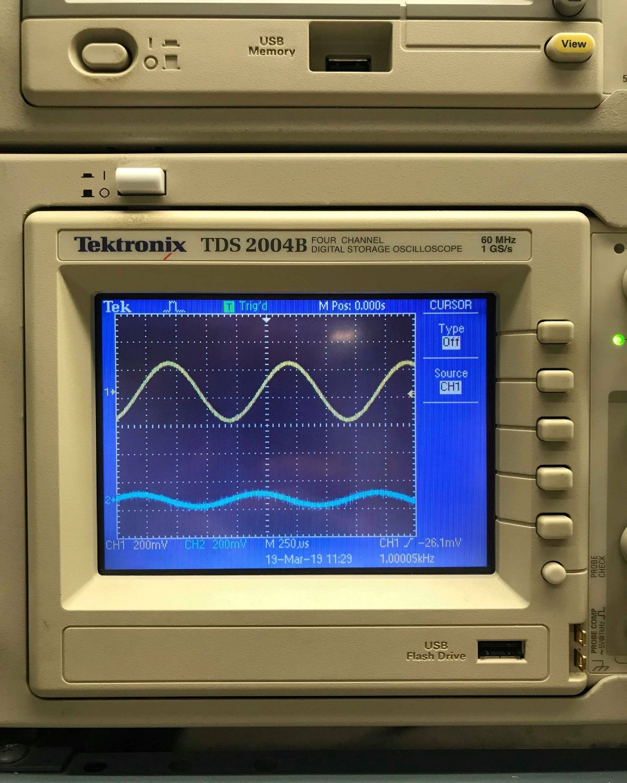

Figure 4: This figure graphs the output (blue) of the audio mixing console with the input frequency of 1000Hz and γ-value of 1000Hz changed.

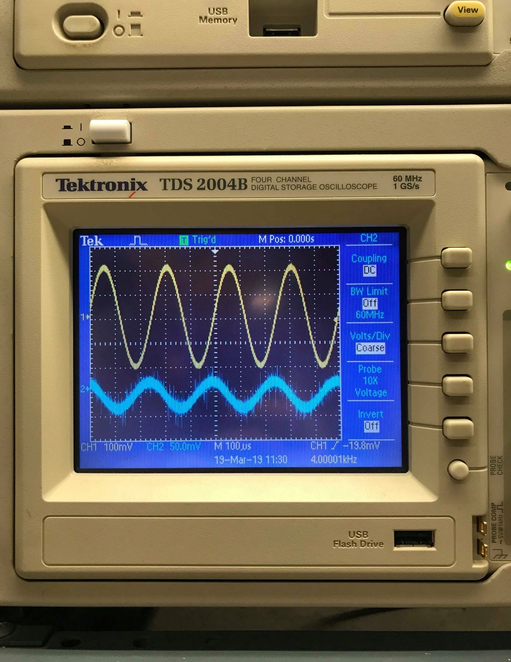

Figure 5: This figure graphs the output (blue) of the audio mixing console with the input frequency of 4000Hz. The figure remains the same with the γ-value of 250Hz and 1000Hz changing.

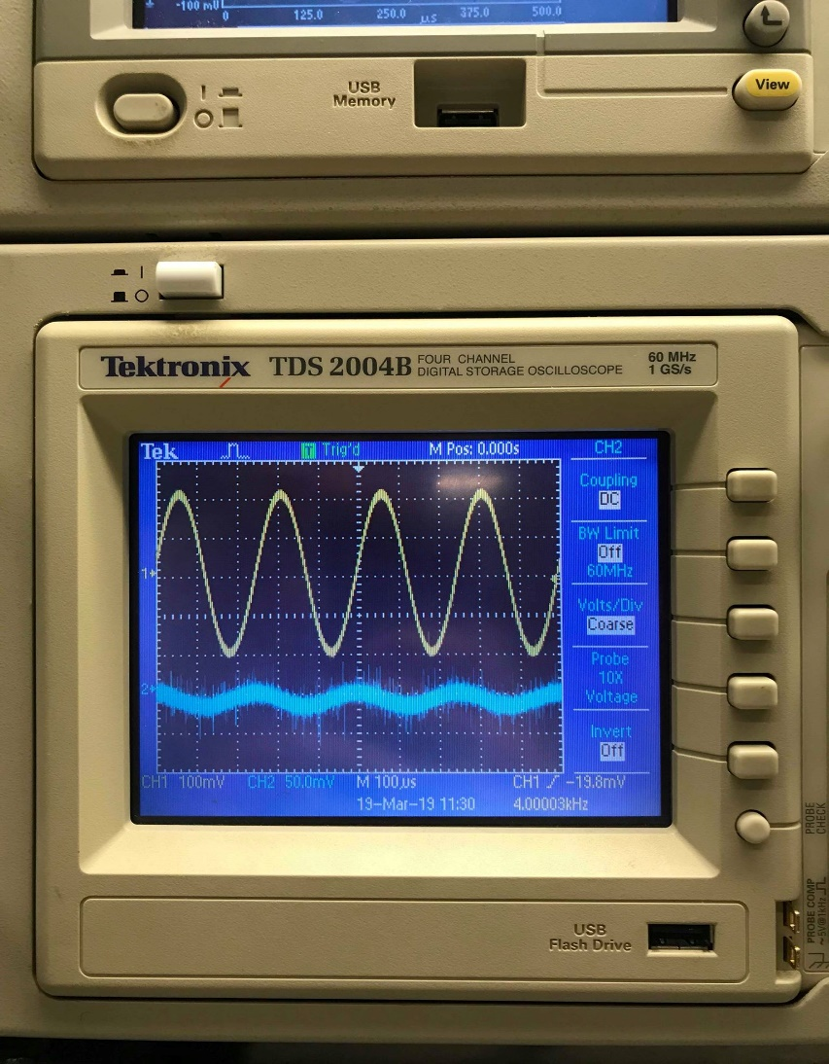

Figure 6: This figure graphs the output (blue) of the audio mixing console with the input frequency of 4000Hz and γ-value of 4000Hz changed.

**Analysis #5**

The gain of the entire audio mixer between 10Hz and 5kHz with a single input by using the 1-2-5 sequence method was plotted. Note that we used three more intermediate data points because 1-2-5 sequence skipped most of the filter’s center frequencies.

|  |  |
| --- | --- |
| Table 5: Gain of the Audio Mixer | |
| Frequency (Hz) | Gain with γ = 25% (dB) |
| 20 | -0.44553 |
| 50 | -0.35458 |
| 100 | 0 |
| 200 | 0.98436 |
| 500 | 0.98436 |
| 1000 | -4.43697 |
| 2000 | -9.52507 |
| 5000 | -14.334 |
| Additional data points | |
| 2500 | -15.2894 |
| 3000 | -13.1515 |
| 4000 | -12.3958 |

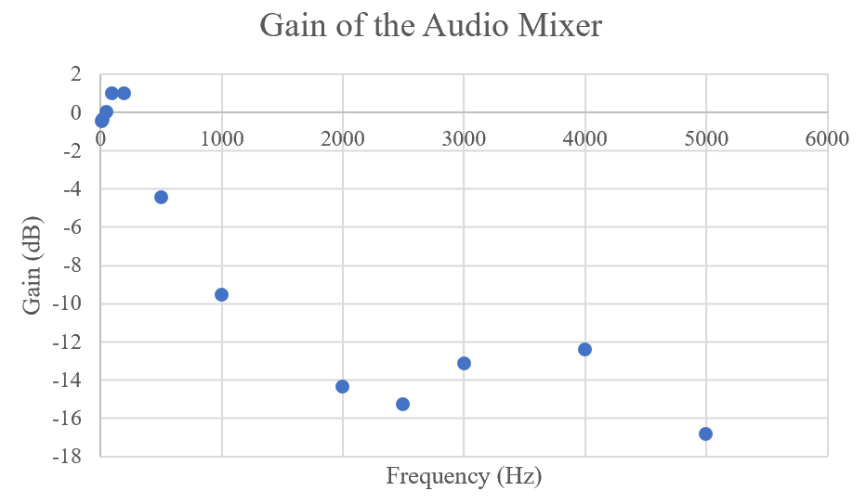

We saw 2 bands in the plot around 250Hz and 4000Hz, and we assume we would have seen the third band at 1000Hz if we took smaller intervals.

**Analysis #6**

The whole audio mixer system was built on SPICE, and its transfer function was plotted using the AC analysis function.

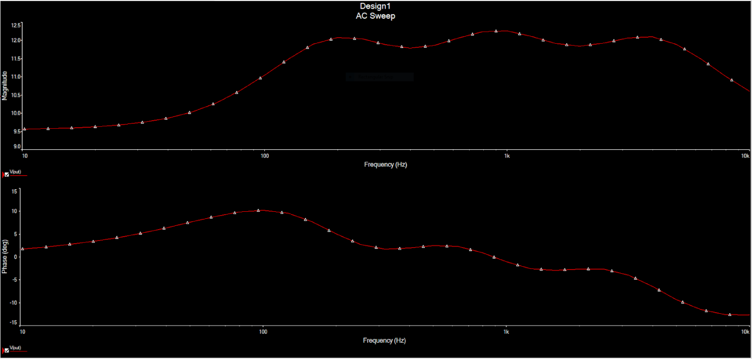

Figure 7: This figure graphs the magnitude (top) and phase (bottom) of the audio mixer system in Multisim.

With one input track, the transfer function has 3 distinct jumps in the gain. The three audio equalizer filters have different center frequencies (250Hz, 1000Hz, and 4000Hz) where they have the most gain because they are bandpass filters. The summing amplifier takes the transfer functions of these filters and adds them to make a single track with 3 bands as shown in the SPICE plot above.

IV. CONCLUSIONS

This report discussed the characteristics of frequency selective circuits. We learned how we can filter out unwanted frequencies in a signal with different combinations of resistors, capacitors, potentiometers, and operational amplifiers in our circuits.

We made multiple types of filters in this lab. We made three band pass filters centered around 250Hz, 1000Hz and 4000Hz. We observed the effect of changing the resistance of the potentiometers and how that changed the output of the filter and even changed the types of filters that we had (bandpass to bandreject).

We incorporated these filters with the circuits that we have built from past labs in order to make a complete audio mixer circuit. This incorporated multiple summing amplifiers, and an equalizer, which consisted of multiple filters and a buffer.

We were able to play audio tracks through the speaker using our computers to generate the output signal and found that we were able to filter out certain frequencies in order to alter the sound. For instance, we could eliminate the bass from a track by adjusting the potentiometers. We were also able to adjust the volume by adjusting other potentiometers. Lastly, the plot of the transfer function was used to explain all these behaviors of the audio mixer system.

Table 6: Team Roles

|  |  |
| --- | --- |
| Activity | Student Name |
| Prelab/circuit analysis | Kyle Hammond |
| Prelab/simulations | Seungjae Moon |
| Prelab/answer questions | Akshat Padney |
| Circuit construction | Kyle Hammond |
| Data collection | Akshat Pandey |
| Data analysis | All |
| Lab report writing | Seungjae Moon |

V. APPENDIX

A. The following is the diagram of the audio equalizer filters.

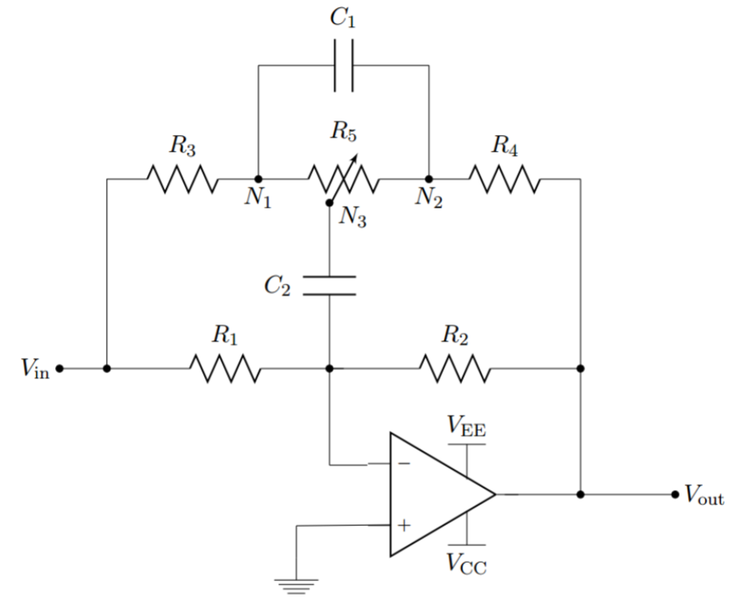

B. The following is the diagram of the audio mixing system.

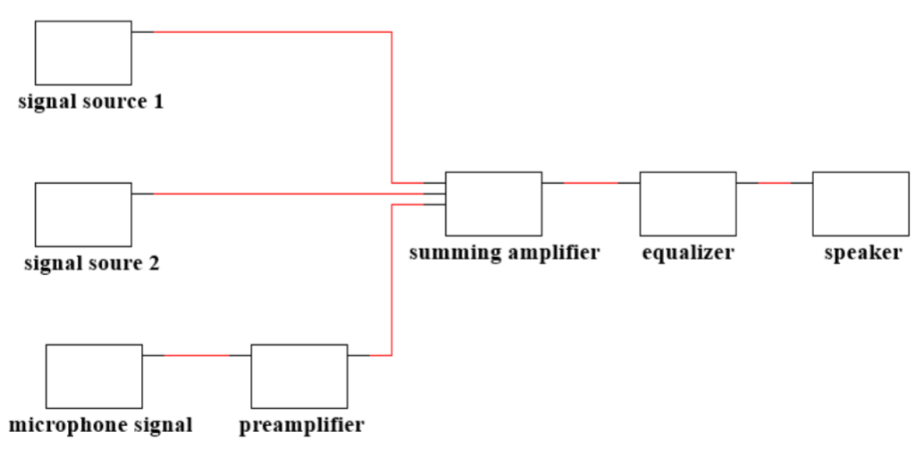

C. The conversion from amplitude voltage to gain is the following:

The 3-dB frequencies are the following:

D. The data tables for Analysis #2 are below:

|  |  |  |  |
| --- | --- | --- | --- |
| Gain of the 250Hz Filter at Different γ-values (dB) | | | |
| Frequency (Hz) | γ = 25% | γ = 50% | γ = 75% |
| 10 | 0.984 | 0.984 | 0.668 |
| 20 | 1.584 | 0.984 | 0.341 |
| 50 | 4.082 | 0.984 | -0.724 |
| 100 | 8.943 | 0.984 | -2.384 |
| 200 | 13.979 | 0.984 | -3.35 |
| 500 | 6.527 | 0.984 | -1.938 |
| 1000 | 2.923 | 0.984 | -0.355 |
| 2000 | 1.289 | 0.984 | 0.341 |

|  |  |  |  |
| --- | --- | --- | --- |
| Gain of the 1000Hz Filter at Different γ-values (dB) | | | |
| Frequency (Hz) | γ = 25% | γ = 50% | γ = 75% |
| 10 | 0.984 | 0.984 | 0.668 |
| 20 | 1.584 | 0.984 | 0.341 |
| 50 | 4.082 | 0.984 | -0.724 |
| 100 | 8.943 | 0.984 | -2.384 |
| 200 | 13.979 | 0.984 | -3.35 |
| 500 | 6.527 | 0.984 | -1.938 |
| 1000 | 2.923 | 0.984 | -0.355 |
| 2000 | 1.289 | 0.984 | 0.341 |

|  |  |  |  |
| --- | --- | --- | --- |
| Gain of the 4000Hz Filter at Different γ-values (dB) | | | |
| Frequency (Hz) | γ = 25% | γ = 50% | γ = 75% |
| 10 | 0.984 | 0.984 | 0.668 |
| 20 | 1.584 | 0.984 | 0.341 |
| 50 | 4.082 | 0.984 | -0.724 |
| 100 | 8.943 | 0.984 | -2.384 |
| 200 | 13.979 | 0.984 | -3.35 |
| 500 | 6.527 | 0.984 | -1.938 |
| 1000 | 2.923 | 0.984 | -0.355 |
| 2000 | 1.289 | 0.984 | 0.341 |