Seungjae Moon, bmoon9

Dylan Lam, dvl3

Hiral Patel, hiralp

Voltage Multiplier Project, Spring 2019

**1. Introduction**

This document is a report on the design and result of the voltage multiplier that builds upon our knowledge of transformers, voltage rectifiers, AC to DC voltage circuits, transistors, and DC to AC converters. In the following sections, the purpose and function, circuit topology, and the components chosen for the circuit are described. This information is followed by simulation and implementation results and the analysis. Finally, the overall results are discussed, and conclusions are made.

**2. Purpose and function of circuit**

The purpose of the voltage multiplier is a device with many applications, including hand-held electronics and beyond. Many electronic devices have a fixed voltage source, usually a battery. However, sub-circuits in a device may need more than one DC voltage source, including voltage values that are larger than the battery voltage. Therefore, the voltage multiplier is used to power these sub-circuits. For us, designing the voltage multiplier provides an opportunity to logically combine various circuits that we studied in EE331 to create a circuit with greater complexity.

**3. Circuit topology and components chosen**

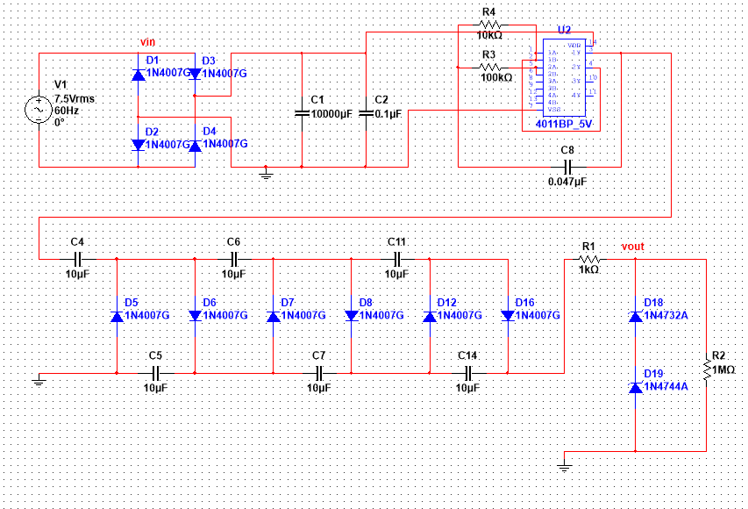

Figure 1: Voltage Multiplier Circuit

First, the design consists of a full-wave bridge rectifier since the purpose of the project is to build a DC-to-DC voltage multiplier. The voltage rectifier takes the AC from the wall-outlet (through a transistor) and converts it to a DC voltage of 10V. We chose the full-wave bridge rectifier because it outputs the least amount of voltage ripple out of the rectifiers we studied. Unlike the bridge rectifier from the previous lab, no resistor is placed in parallel with the capacitor. We want to minimize the ripple even further to 1% that is caused by the discharging of the capacitor. Since there are other loads from the square oscillator, we also use a massive 10000μF capacitor to retain charge and keep current flowing. Note that all the diodes are 1N4007 in the entire voltage multiplier circuit because six of them were already provided in the lab kit, and they have relatively low turn-on voltage.

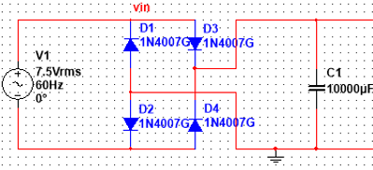

Figure 2: Full-Wave Bridge Rectifier Circuit

The DC output from the full-wave bridge rectifier is then turned back into AC because the voltage multipliers (doubler, tripler, etc.) are AC-to-DC. We use the square wave oscillator circuit identical to the previous lab to fulfill this criterion. Note that the CMOS NAND gate is used to have no static power dissipation.

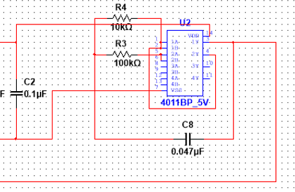

Figure 3: Full-Wave Bridge Rectifier Circuit

The generated AC voltage with amplitude, similar to the original Vin, is then inputted into the voltage multiplier. We implement the voltage doubler from the previous lab with the 1N4007 diode and 10μF capacitors with the addition of another pair of diodes and capacitors to make a voltage tripler. The decision to put a voltage tripler instead of a doubler is analyzed further in the analysis portion (Section 5). The output voltage safely goes over the required output voltage of 18.5-20V.

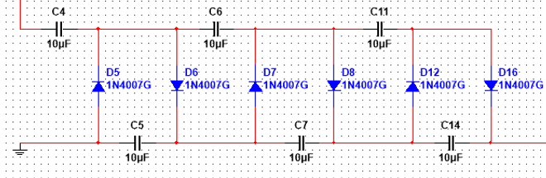

Figure 4: Voltage Multiplier (“Tripler”) Circuit

Lastly, the voltage regulator is used to maintain a constant voltage level at the required output voltage range. The Zener diodes in the figure below have Zener voltage of 15V and 4.7V summing up to 19.7V, and the system of equations were used to figure out the required source resistor value (1kΩ) and load resistor value (1MΩ).

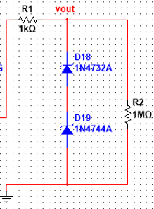

Figure 5: Voltage Regulator Circuit

**4. Simulation and implementation results**

After assembling our entire circuit on Multisim, we took advantage of transient analysis simulation to generate output voltage waveforms and interactive simulation to collect numerical data.

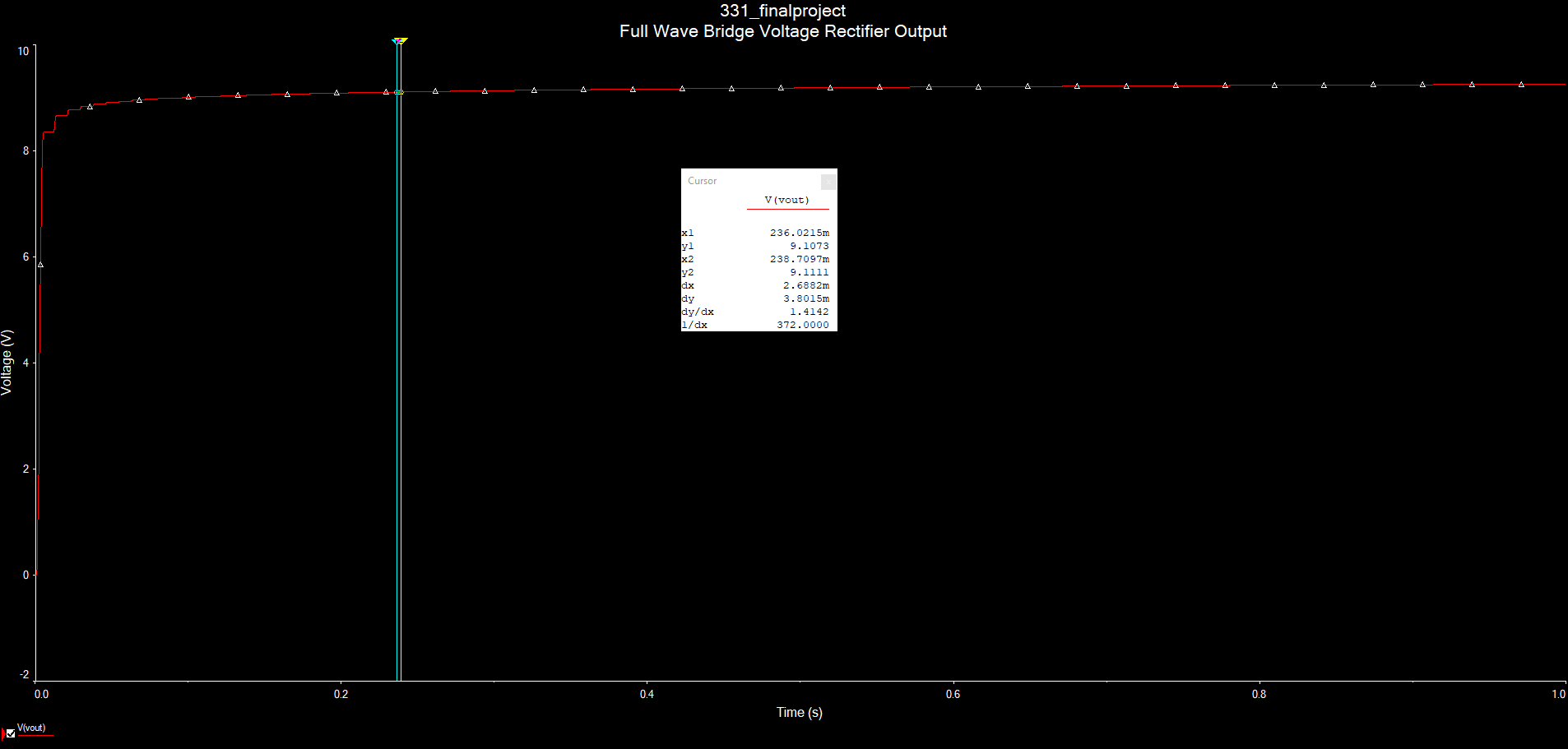

Figure 6: Output voltage from full-wave bridge rectifier

The transient analysis generated the above waveform. The DC output voltage is approximately 9.11V and the resulting ripple voltage is approximately 3.8mV, which is 0.04% of the output voltage. During the design phase, we tried to implement a traditional full-wave bridge rectifier with a resistor and capacitor in parallel to the output. The initial calculations that we performed resulted in the use of a 100kΩ resistor and a 10µF capacitor when Vp = 10.6V, Von = 0.7V, and C = 10µF:

Using these components would result in a DC output voltage of close to 9.2V with a ripple voltage of about 74mV, or 0.8%. Furthermore, a 10µF capacitor was used mainly because of convenience as it was already included in our lab kit. However, our final design completely deviated from our initial design. Instead of using these components, we opted to use only a 10000µF, which yielded a similar output voltage but with a significantly smaller ripple voltage.

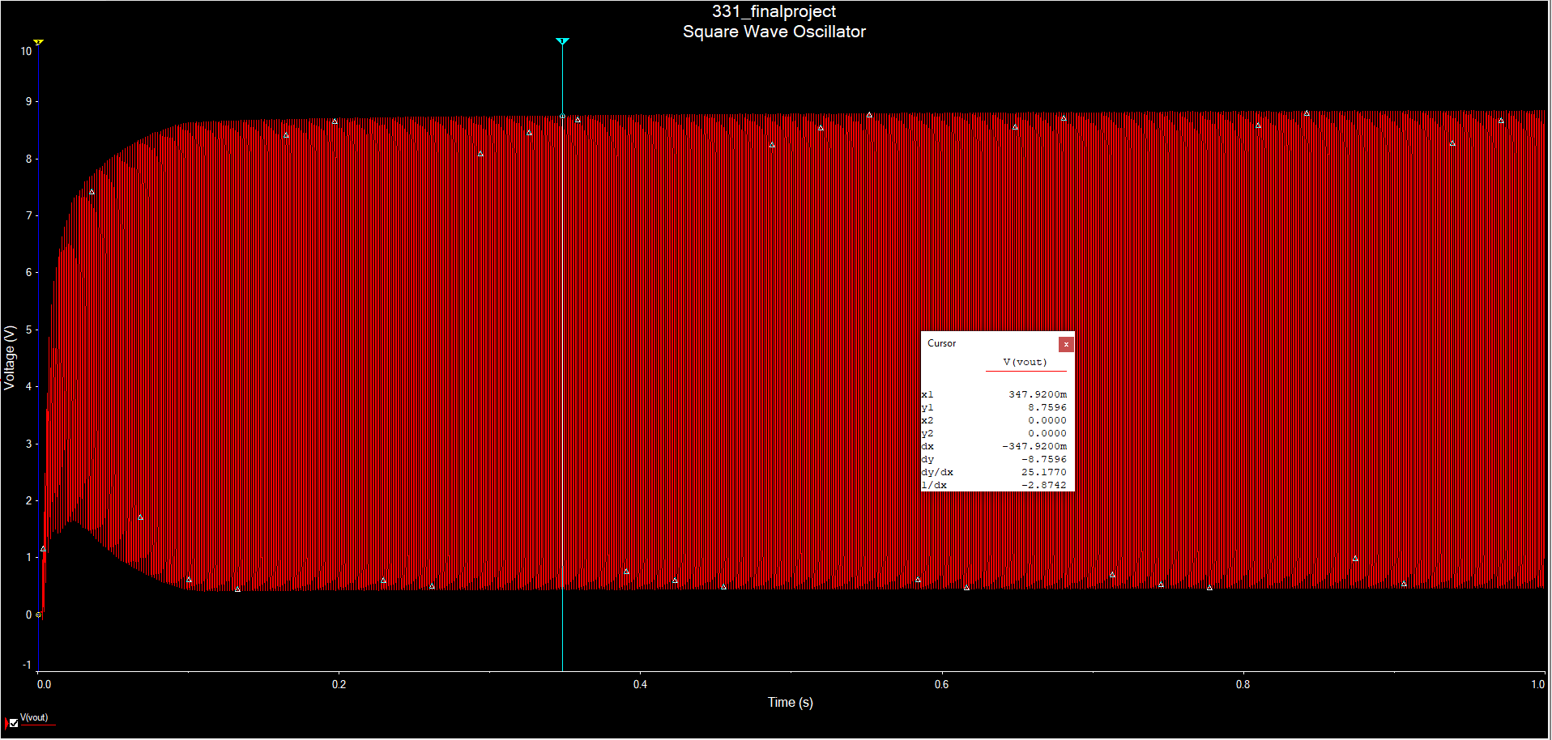

Figure 7: Output voltage from square wave oscillator from transient analysis

From the transient analysis simulation, the resulting square wave has a frequency of about 1kHz and a voltage swing from 0V to 8.76V. Its high frequency makes it difficult to discern a square wave, but upon closer inspection, the square wave is evident.

Figure 8: Output voltage from voltage multiplier

From the transient analysis simulation, the DC output voltage is approximately 20.1V and the ripple voltage is close to 241mV, or 1.2% of the output voltage. Initially this was concerning since this is slightly out-of-spec, but we believed that it was worth implementing the circuit in practice to see how the voltage regulator would affect the final output.

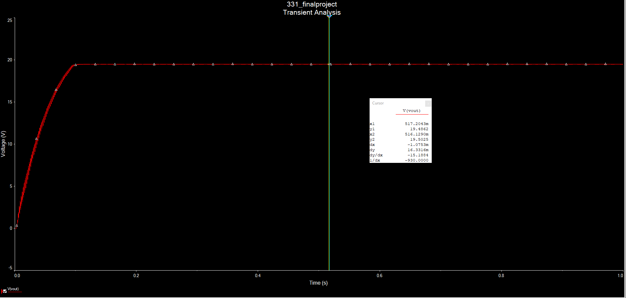

Figure 9: Output voltage from voltage regulator

The resulting output voltage takes on a similar shape as that from the voltage multiplier, but with significantly less ripple, about 16mV or 0.08% of the 19.5V DC output voltage.

We tested the performance of our circuit after building it and produced the following results:

|  |  |
| --- | --- |
| Output voltage (V) | Ripple voltage (mV) |
| 19.05 (no load) | 105 |
| 18.66 (10 kΩ) | 190 |

Additionally, we verified that the output from the square wave oscillator matches that from the Multisim simulation results, as shown below.

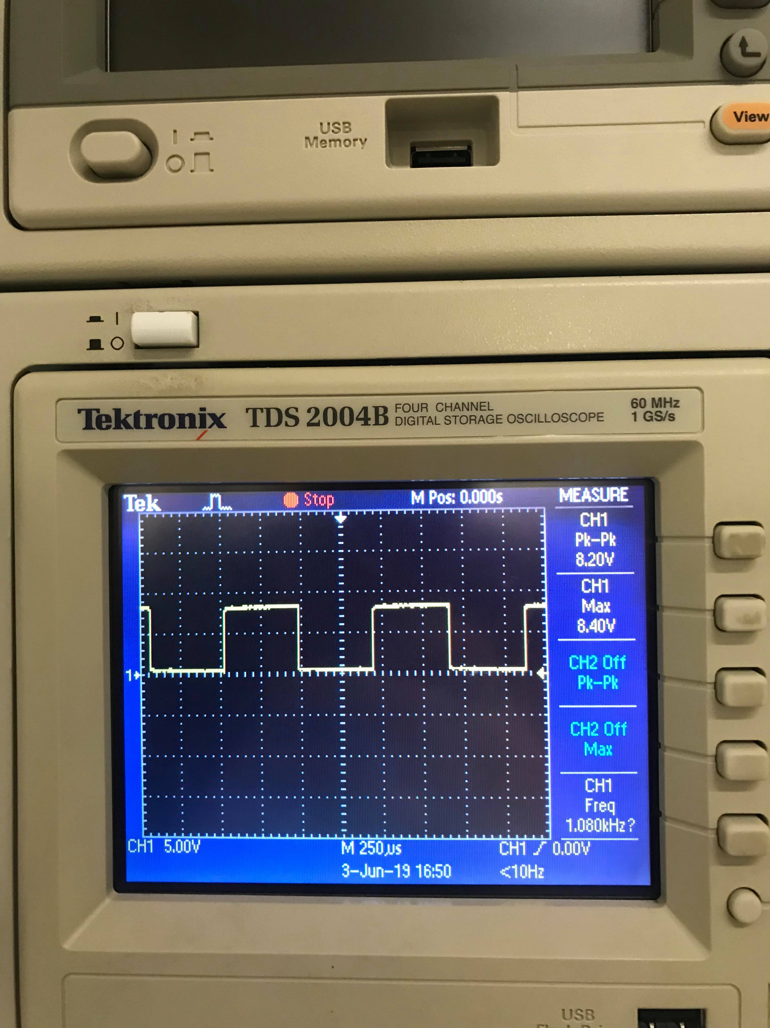

Figure 8: Output waveform from square wave oscillator using the oscilloscope

Furthermore, we determined the maximum current that can be delivered to a load without the output voltage dropping below 18V. Using a 1 MΩ potentiometer, we carefully performed a sweep of its full resistance range while observing the output voltage on the digital multimeter. We found that when the current is maximum, the load resistance is 72.2 kΩ and the output voltage is 18.25V. Thus, the maximum current is about 253 µA:

Overall, the output voltage of our circuit decreased by about 0.8V with a 72.2 kΩ load. As the output current is further increased to 2 mA by gradually decreasing the resistance of the potentiometer, the output voltage drops precipitously to roughly 5V.

The issue at hand here is that as the load draws more current, there is a substantial voltage drop across the internal resistance of our circuit. In order to reduce this effect, diodes with a smaller turn-on voltage can be used. Another possible approach is to reduce the complexity of the voltage multiplier circuit by offsetting the square wave input such that its negative half cycle can be used. This can be achieved using an op-amp. By strategically offsetting the square wave in this way, less capacitors and diodes are needed to multiply the output voltage entering the voltage regulator, therefore reducing any parasitic effects on the final output.

**5. Analysis of results**

**Full Wave Bridge Rectifier**

Vrms = 7.5V

Vm = 7.5 * sqrt(2) = 10.6V

1N4007 Von = 1.1V

Expected Vr = 9.1111V-9.1073V = 3.8mV

Actual Vr = 25mV

The small error in ripple voltage here could be due to the capacitor not being able to hold as much charge as expected.

**Square Wave Oscillator**

Expected 8.7696V at 1k Hz

Actual 8.6V at 1k Hz

The small error in the square wave max output voltage could be due to the capacitors not being able to fully charge to expected capacity or more voltage dropping across resistors than expected

**Voltage Multiplier**

Negative voltage is needed to turn on the three diodes that have their anode end at the top (D5, D7, D12) in the tripler circuit. However, the square wave only goes through the positive cycle. Therefore, these three diodes are not getting turned on and act as an open circuit. After three cycles the three diodes with their anodes at the bottom (D6, D8, D16) are on, acting as a short circuit, and the three capacitors (C4, C6, C11) are charged to the voltage that the square wave oscillator outputs. The output from this circuit is the input, 8.6V * 3 = 25.8V, due to the 3 capacitors being charged fully to the input. However, in practice, each of the six diodes contributes to an overall voltage drop equal to 6 * 0.6 V = 3.6V. Then the actual output voltage from the voltage multiplier is 25.8V – 3.6V = 22.2V, which is approximately what we achieved.

**Voltage Regulator**

The two Zener diodes have breakdown voltages of 4.7V and 15V, respectively. These diodes were used to build the voltage regulator circuit that kept our output steady at 19.7V (4.7+15=19.7). Since the input voltage is changing due to the square wave, the regulator keeps the output from the tripler steady. The remaining voltage, 2.5V, from the multiplier (22.2-19.7 = 2.5V) goes through the resistor in the regulator.

The theoretical output is 19.7V, but we actually got 19.05V when building the circuit. This small error is likely due to small errors in diode, resistor, and/or capacitor manufacturing. For example, one specific cause could be that the turn-on voltages of the Zener diodes in the regulator could be lower than expected.

**6. Conclusion**

In conclusion, we arrived at our given circuit topology by first understanding the goal of each component circuit. We then thoroughly tested each individually through Multisim and combined them for the final simulation. From there, we analyzed the parameters that were out of spec and made the necessary adjustments to achieve the desired output. During this process, we realized that because the square wave from the oscillator had a voltage swing between 0V to 8V, the traditional voltage doubler could not be used and had to be modified accordingly. Overall, we successfully implemented a DC-to-DC voltage multiplier that followed the required specifications. The project allowed us to further investigate the utility of the circuits that we learned about in this class and how they can be combined to achieve useful applications.