# **Title: The Bounce Game**

1. **Genre:** Side Scrolling Game/Endless Running Game
2. **High Concept:**  The player controls just one character which 3 different instances , after level 1 that mode is unlocked for the player to change the instance 5 times per level. It’s a puzzle/mystery clearing game where player has to pass through different hurdles with the given ability in limited amount of time.
3. **Back Story:** A ball and a boy were best friends , they use to play everyday in the evening one day a rude and weird person came while the child was playing with his best fried the ball. By mistake the ball went and got crashed with the Weird person , he became angry and then threw the ball long away into the bushes and eventually it became small and went into a maze of its own. But as the ball had the ability and power to move around , the game begins and it’s a challenge for the ball to get out of the maze and meet with his Master.
4. **Target and Platform:** Mobile , PC and MAC
5. **Game Play:** The player controls a red ball with the requirements to go through all hoops. The ball can also become big, allowing it to float in water areas (which is colored blue). Enemies come in the form of static yellow colored obstacles (called "candles") as well as spiky blue moving objects (commonly referred to as "spiders" by the game fanbase). Touching an enemy will result in the loss of a life. Some additional powers will be received after completion of certain stage in the Game. Different avatars available for the player to chose with different dynamics.
6. **USP (Unique Selling Proposition):** 
   * It has no age limit, anyone who understands the game can play it , so starting right from the age of 8 years kid to 80 years old man , who wants to have a good time enjoying solving the puzzle and mystery can play it.
   * Its available on all the platforms, making it highly available
7. **Competitive Analysis:** List up three similar games (name, web, screen shot image)

* **sample 1 (The Super Mario)**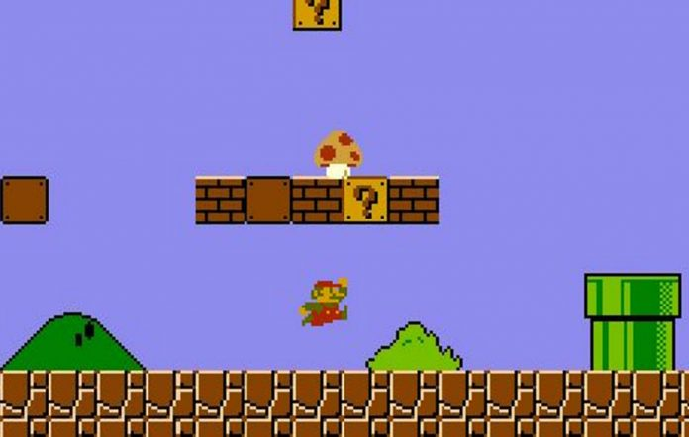
* **sample 2 (Temple Run)**

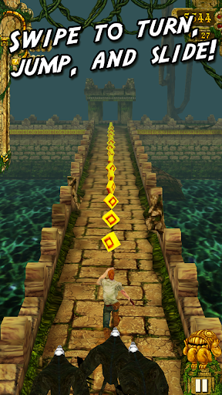

* **sample 3 (Limbo)**

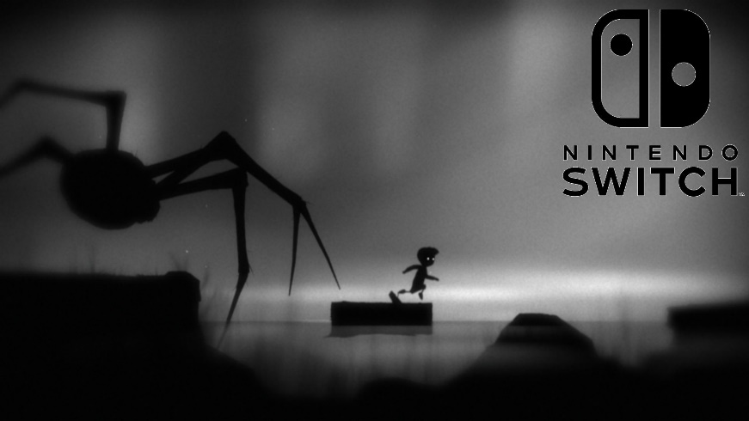

1. **Budget:**

**N/A**

1. **Members:** This is an individual project. Type your name here!

**Name:** SIDDHARTH JAIN

1. **Summary:**  Bounce is a fun game leveling to crazier and difficulty as the user progress in the game forward. The player unlocks more feature and discovers hidden paths making the game even more fun. A level could be solved using different tactics and as the game is time bound so it will also has a universal leaderboard which makes it even more competitive.
2. **Concept Arts:** Copy and Paste some sketches

