# **DESIGN AND ANALYSIS OF LEGO CAR MODEL BY MODIFYING DESIGN PARAMETERS**

**IEE 572: DESIGN OF ENGINEERING EXPERIMENTS**

FINAL REPORT  
  
  
SHREEYA JAIN - 1223548469

## **RECOGNITION OF AND STATEMENT OF PROBLEM**

Testing any vehicle parameter once it is fully manufactured becomes quite difficult. During the optimization process multiple changes can be made to the parts which are then to be manufactured for testing thereby incurring a whole lot of cost. Here’s where using scaled units for preliminary testing comes in handy. The Lego model is used for simulation in this analysis. The Lego model is used as it is cost effective, convenient, allows flexible design and use of more complex designs than traditional manufacturing processes. Also, intricate parts can be made from Lego to provide specific shape, size and easily vary multiple parameters.

The outcome of this approach is to optimize the distance traveled by the car from a 30 degree ramp, by varying the design parameters. The experiment's input factors are the size of the rear tire, the front axle, the weight, and the length of the windshield, while the response variable is the distance traveled by the model.

**CHOICE OF FACTORS, LEVELS AND RANGES**

Multiple factors such as the size of the rear tire, the front axle, the weight, and the length of the windshield, aerodynamic design, model material, surface of the ramp, etc., can have an effect on the response variable However, for our experiment, the following criteria will be taken into account:

* The size of the rear tire: The levels were set between a small set of wheels and a large set of wheels. The rear tire of the model provides maximum traction, therefore acts as a suitable first factor for the design analysis.
* The second factor is the Front axle, level for the front axle is small and large thus providing As a result the car's base has more clearance, allowing it to travel further.
* The third factor considered is the length of the windshield. By varying the windshield length we can balance the aerodynamic forces acting on the car, thereby optimizing the distance traveled by the car.

The parameters chosen, along with their ranges of values of levels are shown in the table below.

|  |  |  |
| --- | --- | --- |
| **PARAMETER** | **LEVEL 1** | **LEVEL 2** |
| Size of the rear wheel  (% wrt the front wheel) | 120 | 150 |
| Front axle (% wrt to rear axle) | 50 | 75 |
| Windshield Length (% wrt to car width) | 120 | 150 |

Table I. Design Parameters and Level Specification

## **SELECTION OF RESPONSE VARIABLE**

Properties such as weight, windshield and axle dimensions, tire size, car design, and aerodynamic stability of model have direct and indirect effect on the car in terms of fuel efficiency which is proportional to fuel consumed and corresponding distance traveled by the car. Here the fuel efficiency is measured by the distance covered by the model in free fall/roll condition. Hence distance is the response parameter in the project. When the model has excellent aerodynamic stability and optimal weight, the distance traveled is maximized.

## **CHOICE OF DESIGN**

We have chosen a 2^3 Factorial design for our experiment, which consists of 3 components and 2 levels. We would then have 8 possible combinations of the chosen process parameters.

Additionally, the chosen parameter combinations will be reproduced three times, giving rise to a sum of 24 iterations of the experiment. Also blocking of replicates is done hence we obtain 3 blocks.

# **CONDUCTING THE EXPERIMENT**

The primary aim of the project was to identify the major contributing factor for the response variable which was the distance traveled by the model car. For this a base car model was assembled using Legos. Legos were used because of the ease of access and durability, and ease in availability, Legos also are a very cheap option for conduction studies. Other methods that can be used are 3d printed downscaled models of each varied model.

After the base model was assembled, design parameters such as rear tire, windshield, and front axle were chosen. The above mentioned parameters have utmost impact on the chosen response variable according to multiple studies hence horizontal distance traveled was chosen as the response variable. As a factorial model with design as 23 with 3 replicates was chosen, the total number of samples would be 24.

A 30 degree inclination ramp was created for the sample runs, once each model was with varying design parameter was assembled it was let off from ramp and the resulting horizontal distance from the base of the ramp was measured.

|  |  |
| --- | --- |
| C:\Users\Ajesh Mathew\Downloads\WhatsApp Image 2022-11-30 at 16.24.25.jpeg | Axle – 50  Rear Tire - 120  Windshield - 150 |
| C:\Users\Ajesh Mathew\Downloads\WhatsApp Image 2022-11-30 at 16.23.45.jpeg | Axle – 50  Rear Tire - 120  Windshield - 120 |
| C:\Users\Ajesh Mathew\Downloads\WhatsApp Image 2022-11-30 at 16.20.30.jpeg | Axle - 50  Rear Tire - 150  Windshield - 150 |
| C:\Users\Ajesh Mathew\Downloads\WhatsApp Image 2022-11-30 at 16.18.32.jpeg | Axle - 50  Rear Tire - 150  Windshield - 120 |
| C:\Users\Ajesh Mathew\Downloads\WhatsApp Image 2022-11-30 at 16.16.47.jpeg | Axle - 75  Rear Tire - 150  Windshield - 150 |
| C:\Users\Ajesh Mathew\Downloads\WhatsApp Image 2022-11-30 at 16.16.03.jpeg | Axle - 75  Rear Tire - 150  Windshield - 120 |
| C:\Users\Ajesh Mathew\Downloads\WhatsApp Image 2022-11-30 at 16.14.33.jpeg | Axle – 75  Rear Tire - 120  Windshield - 150 |
| C:\Users\Ajesh Mathew\Downloads\WhatsApp Image 2022-11-30 at 16.14.32.jpeg | Axle - 75  Rear Tire - 120  Windshield - 120 |

Fig a. Base Lego Car models

# **STATISTICAL ANALYSIS**

The treatment combinations for each of the chosen criteria before replication are shown in Table II. We had used a custom design in JMP with the following continuous factors for our design: Rear Tire size, front axle length and length of windshield, and Horizontal distance traveled as the response variable.

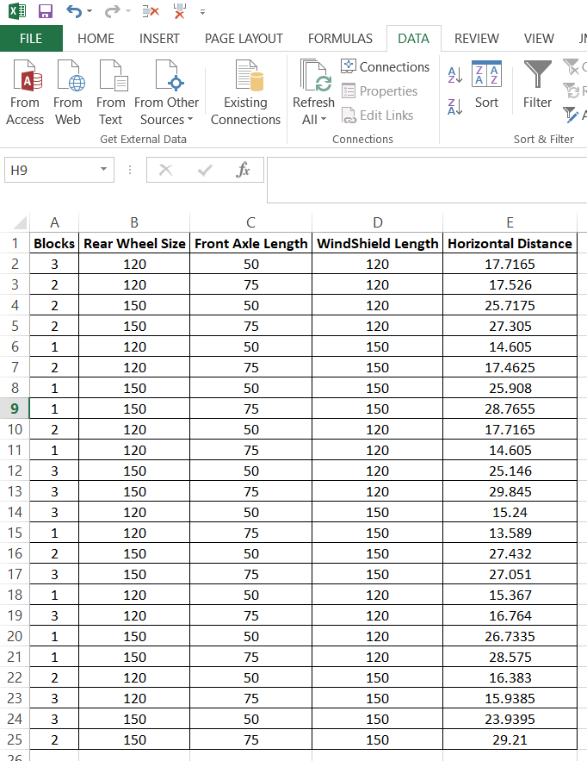

Table II. Randomized parametric combinations

# 

Table III shows a randomized combination of the sample and replicates set in 3 blocks and the corresponding response variable from the experiment is also added into it

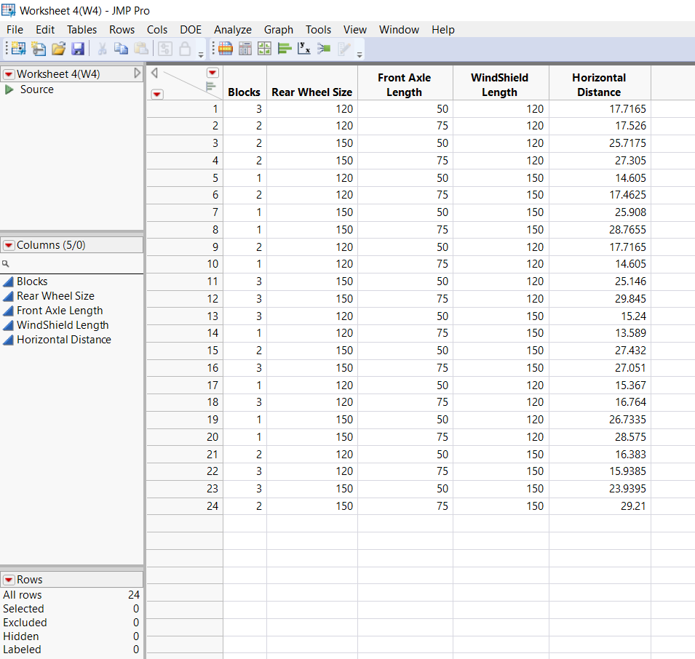

Table III. Randomized Combination of parameters in JMP

JMP Pro software was used to conduct the entire analysis. Table IV shows the ANOVA table obtained from JMP. The model has 8 DOF (3 for each factor, 3 for the 2 factor interactions, 1 for 3 factor interaction and 1 for block). The obtained F value is 47.4992 for a 5% significance value.

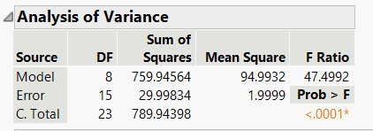

Table IV. Analysis of Variance

Following fig shows the predicted plot of residual horizontal table vs predicted horizontal distance, there is no specific pattern or distribution of the data displayed in the figure. The resulting randomization of the data points fully satisfies the randomization rules, validating the model. . A figure comparing the actual and expected Horizontal distance is shown in Fig c. We can understand that majority of the acquired data sets are contained within the prediction cone by paying closer attention to the plot. This demonstrates that the model has very less notable outliers. The software's anticipated Root Mean Square Error (RMSE) value is 1.4142.

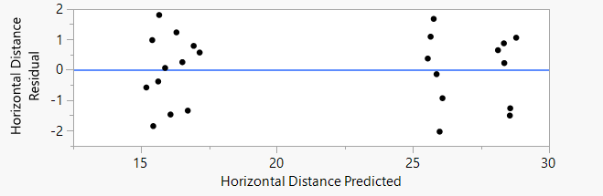

Fig b. Horizontal distance predicted VS residual

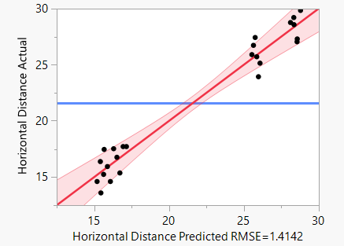

Fig c. Horizontal distance predicted VS actual

Summary of the model fit is provided in table V. The correlation between the dependent and independent variables, or RSquare, in our model is 0.962, while the adjusted RSquare value is 0.941.

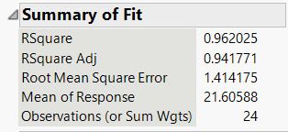

Table V. Summary of fit

The following table shows the effects of all the parameters and their two, three factor interactions. From the table we can identify that the effects of the size of rear wheels, as well as their two-way interaction of front axle and rear wheel have P values that are less than 0.05, making these factors statistically significant since the null hypothesis can be rejected for them.

Also front axle factor p value is at the borderline ~=0.05, hence its effects can also be taken into consideration. A surface profiler is provided in Fig d. to give a better idea of the factor interactions.

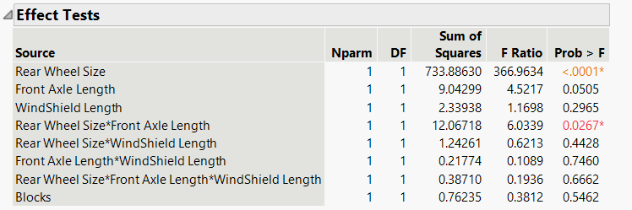

Table VI. Effects test

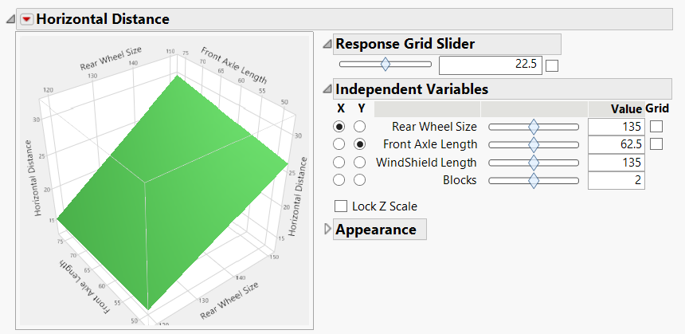

Fig d. surface profiler

The interaction profiler, which displays the significance degree of the various order interactions, is shown in Fig e.

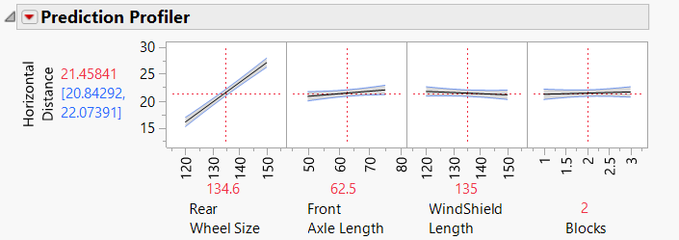

Fig e. Interaction profiler

# **CONCLUSION**

Concluding the study we observed that rear tire size played a major role in determining the travelled horizontal distance along with front axle. From our model, the following insightful observations may be drawn:

1. The rear tire has the major impact on the horizontal distance travelled hence increasing it will increase the distance travelled.
2. Front axle length also has effect on the response variable and its positively correlated with the response variable that is increase in the front axle length would lead to increase in the distance travelled
3. As expected increase in the windshield led to decrease in the distance travelled, where we can safely deduce that air drag has inverse relation with the distance travelled.

# **RECOMMENDATION**

1. 1. Other variables, such as spoiler length, width of chassis, front tire size, etc., can also be used to research and model the design to forecast the travel distance in addition to the three process parameters that were used.
2. Because the third order interaction in our model has such a small impact on the final result, it can be disregarded. In the event of various parametric combinations, this might be untrue.
3. These studies can be used as a reference for real life car simulations and desired results can be obtained at a much faster rate.