Jake Stephens

Assignment #4

August 3, 2021

**Question #1:**

1. Done
2. Done (see M_0.pdf and M_1.pdf)
3. 1. Out of the surviving patients, serum_sodium and platelets have the highest correlation.
   2. Out of the surviving patients, serum_creatine and serum_sodium have the lowest correlation.
   3. Out of deceased patients, serum_sodium and creatinine_phosphokinase have the highest correlation.
   4. Out of deceased patients, serum_creatine and serum_sodium have the lowest correlation.
   5. For both deceased and surviving patients, serum_creatine and serum_sodium have the lowest correlation. But the variables for the highest correlation were different between surviving patients and deceased patients.

**Question #2:**

See console output of q2.py for the values of the weights and the loss functions.

**Question #3:**

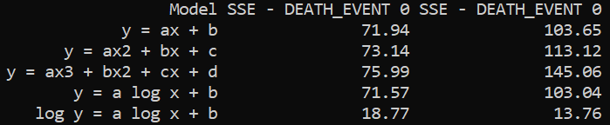

1. I believe the best model is the last one of log(y) = a log(x) + b, since it has significantly lower SSE’s than the other algorithms. This algorithm was the best for both surviving patients and deceased patients.
2. The worst model is the cubic algorithm. It was also the worst algorithm for both surviving patients and deceased patients. I believe this has to do with that fact that depending on the dataset, different algorithms tent to work better than others.