Jake Stephens

Assignment #6

August 17, 2021

**Question #1:**

1. SVM with Linear Kernel

Accuracy: 1.0

Confusion Matrix:

[[35 0]

[ 0 35]]

1. SVM with Gaussian Kernel

Accuracy: 1.0

Confusion Matrix:

[[35 0]

[ 0 35]]

1. SVM with Polynomial Kernel

Accuracy: 1.0

Confusion Matrix:

[[35 0]

[ 0 35]]

**Question #2:**

1. KNN Classifier

Accuracy: 1.0

Confusion Matrix:

[[35 0]

[ 0 35]]



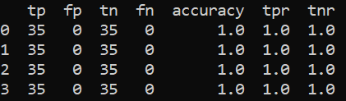

The SVM and KNN classifiers seems to be very accurate for predicting the class, as all methods of classification were 100% accurate.

**Question #3:**



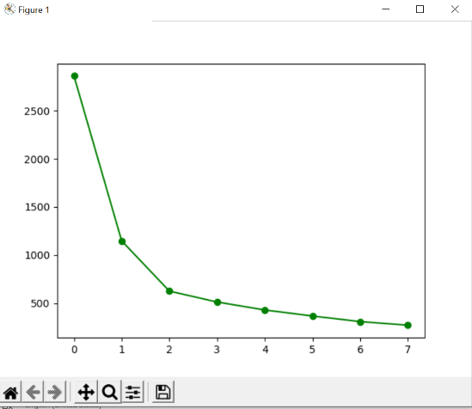

I chose the best k to be 3. Since after that the slope of the line planes off and decreases about the same amount for every added cluster.



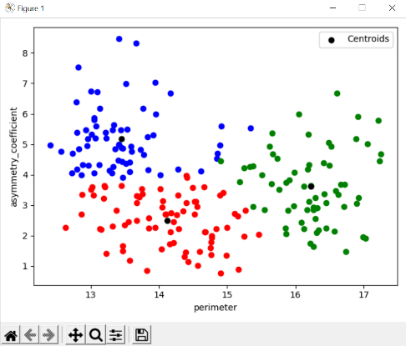

I picked at random, asymmetry_coefficient and perimeter, and I can see the clustering looks as you would expect in the graph. However, I learned later that these 2 columns are not at all the columns you want to look at for determining the class. It is interesting that the blue cluster seems to be pretty dense around the centroid, but the red and green clusters seem to be a bit more spread out.

1. For cluster_1_red the most prominent class is class 1

For cluster_2_blue the most prominent class is class 3

For cluster_3_green the most prominent class is class 2

**Question #4:**

1. **Done**
2. For each 10 values on the x axis, (0-10, 11-20, 21-30, 31-40, 41-50) this is d=1,2,3,4,5. The value of d increases by 1 for each 10 values on the x axis. The values of N increment by 1, all the way to 10 for each value of d.

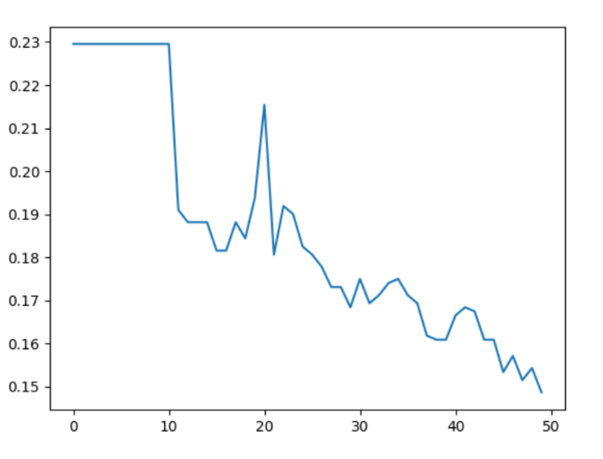

1. Accuracy: 85.14%

With the best combination being **d=5** and **N=10**. The maximum values for each. Which is interesting. I am curious to know if I had increased d and N even further, the accuracy would get better and better. As you can see from the graph, the error rate is trending downward as the values increase.

1. Confusion Matrix:

[[116 128]

[ 30 789]]

**Question #5:**

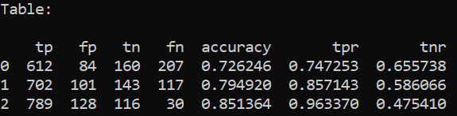

The table above shows the results of the 3 classifiers used. Row 0 is Naïve Bayesian, row 1 is Decision Tree, and row 2 is Random Forest. It is surprising to me how well the accuracy of Random Forest was. However, it was the worst at predicting false positives. Which is bad because in this case, we are talking about the status of a human fetus, and to predict that the fetus is in normal status, when it really is abnormal, is not good at all.

The Naïve Bayesian method had the best true negative rate of 0.655738, which is significantly higher than the other 2 methods. Which is very interesting to me because it had the lowest accuracy overall, but it is the best method for predicting negatives.

The Decision Tree is right in the middle of the other 2 methods it seems. For every value in the table, it is between Naïve Bayesian and Random Forest. But if I were to pick a method for making these predictions, I would choose Naïve Bayesian because of the high true negative rate. In my opinion for this situation it is better to be right about a negative, than wrong about a negative, regardless of the poor accuracy compared to the other 2 methods.