**Problem#1:**

Write Autoencoder code using TensorFlow/Keras for the following data.

• Input: First 20 Fibonacci numbers (the procedure for generating Fibonacci numbers is described on the last page of this assignment)

• Output: Same as input

• Number of neurons in the hidden layer: start from 2 and increase the count to reduce the RMSE

Compute the corresponding Root Mean Square Error (RMSE) for each count of the hidden layer neurons.

RMSE is defined as follows.

𝑅𝑀𝑆𝐸=√1𝑁Σ[𝑓(𝑥𝑖)−𝑥𝑖)]2𝑁𝑖=1

Here 𝑓(𝑥𝑖) is the computed output value and 𝑥𝑖 is the input value.

**Problem#2**

Write Autoencoder code using TensorFlow/Keras for the following data.

• Input: Image file: cat.jpg: crop the input image to 128x128x3 pixels

• Output: Same as input

• Number of neurons in the hidden layer:

start from 5 and increase the count to improve the output image quality

Display both the input and the output image. To get acceptable quality of the output image, vary the number of epochs and number of neurons in the hidden layer. 2

**Problem#3**

Similarity of images is measured by Kullback–Leibler divergence (KL Divergence) metrics.

Suppose the 2 images (size 16 x 16 = 256 pixels) have the following 2 histograms.

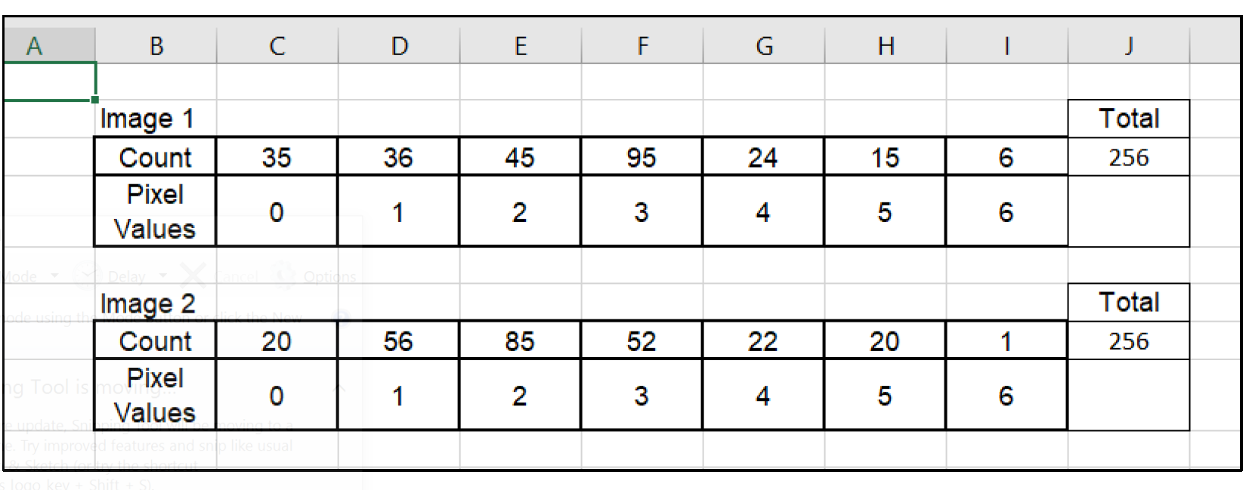

a) Compute the entropy of both images.

b) Compute Cross Entropy of image-1 wrt (with-respect-to) Image-2.

c) Compute Cross Entropy of image-2 wrt Image-1.

1. d) Compute the KL divergence of Image-1 wrt Image-2: 𝐷𝐾𝐿(𝐼1|𝐼2).
2. e) Compute the KL divergence of Image-2 wrt Image-1: 𝐷𝐾𝐿(𝐼2|𝐼1).