**Problem#1**

**Classification**: In this assignment we will build a Neural Network model using TensorFlow software in Colab which can classify if a student will be admitted in college.

The ‘Admission.csv’ data file has the following information about 400 students.

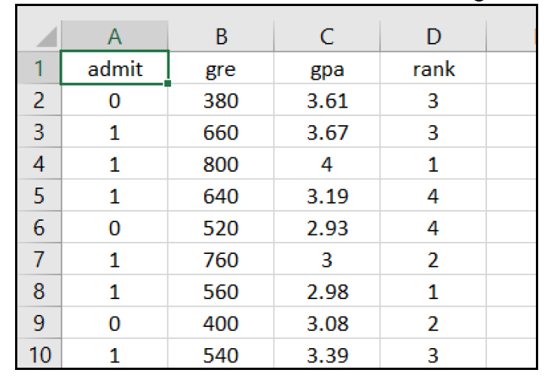

The dataset ‘Admission.csv’ has 4 columns.

* • The ‘gre’ feature represents the GRE examination results of students.
* • The ‘gpa’ feature represents the GPA of students.
* • The ‘rank’ feature represents the rank of the university (4 is the best, 1 is the lowest).
* • The ‘admit’ feature is a categorical variable which indicates if that student was admitted in college (0 means not admitted, 1 means admitted).

Build a Neural Network using TensorFlow software in Colab to predict if a student will be admitted in college given the ‘gre’, ‘gpa’, and ‘rank’ values.

Neural Network Specification

* • Number of input node = 3 (gre, gpa, rank)
* • Number of hidden nodes = 5 (vary this number from 1 to 10 to get highest accuracy of prediction)
* • Number of output node = 2 (categorical: 0,1 means not admitted, 1,0 means admitted)
* • Cost Function: Cross Entropy Cost Function
  1. • Optimization Function: Gradient Descent o Feed “Learning Rate” as a parameter to the optimization function

Before buildingthe Neural Network, scale the predictor variables values between 0 and 1. Otherwise Neural Network may not converge. Since there are 400 observations, split the dataset into training (70%) and testing (30%)

Train the Neural Network model using the training data. In the end, print the values of weights and bias of all the nodes of your Neural Network

**Problem#2**

In problem#1 you used TensorFlow software directly for classification.

In problem#2 you will repeat problem#1. Instead of using TensorFlow directly, use Keras software to interface with TensorFlow. Train the Neural Network model using the training data.

Predict the outcome using the testing dataset. Measure the accuracy of your predictions by building a confusion matrix.

============================================================================

Procedure to build these models is as follows.

1. Read the data set

2. Scale the predictor variable values between 0 and 1

3. Encode the response variable into one-hot variable

4. Split the dataset into ‘train’ (70%) and ‘test’ (30%)

5. Build Neural Network in TensorFlow or Keras

6. Train the Neural Network for epoch = xxxx

7. Print the values of weights and bias of all the nodes of your Neural Network

Only for Keras model

1. Predict the outcome using the test-data

2. Build confusion matrix

3. Compute accuracy of your predictions