CS 5880 Independent Project.

Seungho Jang

Sanjiv Bhatia

Table of Contents

Introduction & Motivation. 2

Motivation 2

Introduction 2

Implementation 2

Backgrounds to prepare a project 3

Operations with images 3

Converting Image to Gray or Color Image 3

Basic Drawing Function – Project 1. 4

Average Intensity 4

Subsampling 5

Bit plane 6

Adjusting Contrast Ratio 6

Histogram Analysis 7

Image Enhancement 8

Morphology 9

Binarization – Global Binarization 11

Adaptive Binarization & Automatic Thresholding 12

Segmentation 13

Background Subtractor – Frame Differencing 13

Research Project: Root Detection. 14

Introduction & Objective 14

Dataset 14

Algorithm & Operation 14

Generalization 14

Reference 14

# Introduction & Motivation.

## Motivation

Most often, we see the development of technology and how it has made our lives easier and richer, such as Face recognition on the iPhone and 3D effect movies. Sometimes these technologies save our lives, such as detecting a disease or cancer, by looking at X-ray images or PET scan. Those technologies have been used from the concepts of digital image processing and computer vision.

Digital image processing allows to manipulate images and to extract important features from images. The range of this application have been varied from medicine to entertainment. Also, the classes of image processing can be divided into image enhancement, image restoration, and image analysis. Within these subclasses, there are many algorithms which are used not only to extract interesting features from image or video frames, but also give a capability to interpret meaning of image or video frames for computer and provide those meaning to human. The concept of these image processing can be further developed into computer vision: be able to write computer programs that can interpret images.

## Introduction

Digital Image processing refers to the manipulation of images to extract more features or information than is original image in the real world. Images are 2-D array or matrix consisting of different pixels and channels: pixels are basic unit represent images, and representation of channels means either color or gray image. Knowing that representation of pixels holds information about the image, image enhancement, compression, and restoration can be achieved. These technique and method will be exploited through project section.

## Implementation

As far as the implementations are concerned on image processing and computer vision, this will be exploited through the OpenCV libraries and C++ language.

The environment that the code was implemented was Ubuntu 18.04 and C Lion for debugging purpose. The version of OpenCV 3.4 and compiled though C++14.

# Backgrounds to prepare a project

## Operations with images

The basic step for computer to understand the image or video, is first capture that image and load into program. Image can be read, as in figure 1.

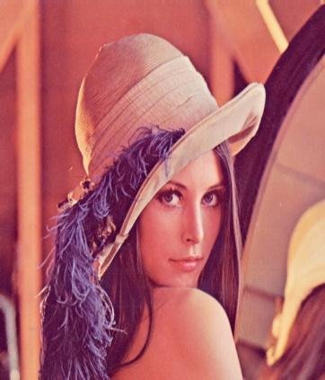

Figure 1. Read Image

## Converting Image to Gray or Color Image

The pixel is a one entity that represent the image as described. The range of those pixel values are 0 – 255: If pixels values are going towards to 0, then it will get darker. If pixel values are going towards to 255, it will get whiter. The major difference between color and gray image is that the number of channels is different such as the color image has channel of three, and the gray image has channel of one. It is sometimes necessary to change color image to gray image for reducing resources and computation time due to heavy computation based on pixel element-wise computation. Furthermore, to predict how much brightness associate with image, gray images can be used to see the effect of brightness.

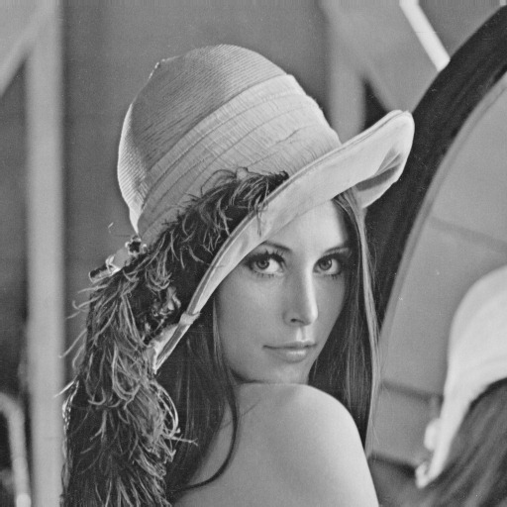

Figure 2. Color Image to Gray Image.

## Basic Drawing Function – Project 1.

It is important for computer to choose the interesting features by pointing that point, drawing the rectangle surroundings, and making the boundary to detect the objects. For these cases, basic drawing function can be easily applied. In the computer point of view, the image is just a 2D matrix, specific points can be pointed in 2D matrix.

Basics Drawing functions can be achieved, as shown in table 1.

|  |  |  |
| --- | --- | --- |
| Type of function. | Description | Implementation. |
| Point | Defining specific points in 2D matrix at (20, 30) |  |
| Scalar | The functionality of scalar is to pass pixels values. One in the above, represent the color image and each a, b, c represents the pixel values in color image. One in the below, represent the gray image and the d is the pixel value of gray image.  Also, you can use hexadecimal, such as 0xff for a, b, and c, which represent 255. | If a, b, and c is 0, it is black. |
| Line | This function is to draw line in given img. The st_pt and end_pt are the starting point and end point (Point class). Thickness can be integer value and line types can be varied by looking at the reference section. |  |
| Rectangle | This function is like line by having starting point and the end point. |  |
| Circle | This function is to draw rectangle in given img. The center_pt is for center point in circle, and radius length represents radius in circle. Rest of them are similar to Line class |  |

Table 1. Basic Drawing Function and Implementation.

This implementation can be explained and referenced on GitHub : <https://github.com/sjang1594/opencv/tree/master/Independent%20Project/Proj1>

## Average Intensity

Intensity is basically whether the pixel values are high or low. Sometimes, it is important to know and analyze the converted gray image using the function provided by OpenCV and manual function that can change color image to gray image.

The manual function should multiply by p where Now then, calculating the average intensity distance is just matrix multiplication with p. Average intensity distance between two identical gray images can be calculated as below.

Figure 3. Average Intensity Distance Equation.

The results are shown below based on same image in table 2.

|  |  |
| --- | --- |
| Average Intensity Distance = 3.8147 | |
|  |  |
|

Table 2. OpenCV (Gray image, left) and Manual Function(right)

## Subsampling

When working with an image, one certain size of image is generally used. However, it is necessary to work with different sizes of various resolutions of the same image. Let’s say that we have an object in the image. If we are exploring one image with this object and another image containing the same object, the size of the object can be different in the two photos. In this case, the resolution of the image to be searched is made in multiple stages, which can yield better results if the object is explored at each stage. In accordance with resolutions, this multiple image set is called image pyramids. There are two different type of subsample images in this pyramid: Gaussian Pyramids and Laplacian Pyramids.

One simple method is to use down-sampling image by alternating the rows and columns. The subsample was obtained from the image in figure 2, as shown below. Resolution of this image is low, because the method used is down-sampling.

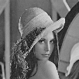

Figure 4. Subsample Image by alternating rows and columns.

## Bit plane

General grayscale image uses 8-bit memory space to save pixel value. Each bit can have either 0 or 1. These bits make up the bit-plane, and it can test whether the value is 0 or 1 for each bit and makes it into a single image. Therefore, a gray scale image can create 8 pages of bit plane, and each bit plane can be expressed as a binary image. That is, if the value of that bit is zero, the grayscale value of the bit plane image is set to zero, and if the value of the bit is 1, the gray scale value is set to 255.

In a grayscale image consisting of eight bits, the bits corresponding to the high-order bits are usually called the most significant bits because the high-order bits retain the information about the image’s outline, as shown in figure 5.

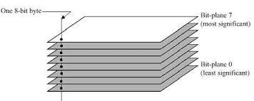

Figure 5. Bit plane

The implementation of figure 5 onto figure 2 is shown below.

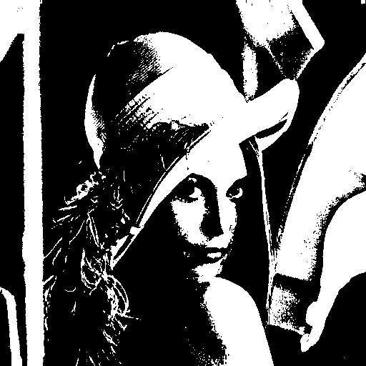

Figure 6. Example: Bit-plane-8 slicing done with image in figure 2.

## Adjusting Contrast Ratio

When it comes to adjusting the brightness of an image, it is just the addition or subtraction on 2D matrix (image). On the other hand, adjusting contrast on an image is multiplication of a proper real number. However, depending on how the multiplication formula to adjust the contrast ratio, the quality of the resulting images may vary.

Contrast in an image is the difference in brightness between the light and dark areas. If the image consists of dark pixels and white pixels overall, it means the contrast ratio is low. Meanwhile, the contrast ratio is high when the image consists of black and white pixels evenly distributed. Most of time, if the contrast ratio is low, the object in an image is hard to detect, and the image might seem blurry. Images with high contrast ratio give a clear sense and understandable distinction between objects.

A simple implementation can be done using the equations, as shown table below.

|  |  |  |
| --- | --- | --- |
| Different Contrast Function/Equation. | Description | Output Image |
|  | Multiplication of floating point of two was multiplied to see if the manipulation of contrast ratio becomes different than input image as shown in figure 2.  For example, if one pixel is 20, that pixel value will be changed to 40. One of the disadvantages was the brightness of image increased easily meaning contrast ratio was increased. |  |
|  | One of the effective ways to set the contrast ratio is to use the median pixel value (128) in gray scale image because it’s important to set the criteria for pixel values to be bright and dark.  Therefore, this will determine the quality of contrast ratio. The pixel value above 128 will be brighter and the pixel value below 128 will be darker |  |

Table 3. Different Contrast Function & Output Image

## Histogram Analysis

One of useful and simple method to analyze image is to use histogram in digital image processing. A histogram is a distribution of the nominal values for pixels in an image. In other words, there will be a distribution of bright and dark dots in one image, which expresses the range and value of the distribution.

The histogram can be drawn by using the same image as figure 2, as shown below. In figure 6, x axis represents the pixel range [0 to 255], and the y axis is the number of pixels in the image that correspond to that pixel value. Assuming if there is bright image or image that has been affected by light, then all this pixel value on this graph will be slanted or shifted to the right.

|  |
| --- |
|  |

Figure 6. Histogram of Lena

## Image Enhancement

With application of histogram, image enhancement can be achieved by either histogram stretching and equalization.

**Histogram Stretching** is a linear transformation method that changes the histogram of an image to be appear over the grayscale interval. The reason to use the histogram stretching is basically stretching the histogram such that histogram graph will be extended over the whole grayscale range, and the result of that will give an image that has high contrast ratio.

As shown in the figure below, histogram stretching was used to compare the figure 6. The results show that the histogram of the original image was starched little bit, and the stretched image is a better-quality image than the original image.

|  |  |  |  |
| --- | --- | --- | --- |
| Original Image | Original Histogram | Stretched Image | Stretched Histogram |
|  |  |  |  |

Figure 7. Original Image, Histogram, Stretched Image, and Stretched Histogram

**Histogram Equalization** is one of the algorithms that changes the distribution of pixel values in image such that it appears evenly across the entire area of the grayscale image along with histogram stretching. The histogram equalization extends or stretches the pixel values that agglomerate in specific area in grayscale image. However, cumulative histogram should be introduced in order to calculate and implement the histogram equalization.

To define the cumulative histogram function, this equation can be used Furthermore, this can be improved as this function, , where, is the maximum brightness value.(255 in grayscale image) and N is the number of pixels in image. As the result, accumulating all the pixels through x axis in histogram, cumulative histogram function can be obtained. As shown in figure 8, histogram equalization can be used to compare the figure 6.

|  |  |  |  |
| --- | --- | --- | --- |
| Original Image | Original Histogram | Equalized Image | Equalized Histogram |
|  |  |  |  |

Figure 8. Original, Image, Histogram with cumulative function, equalized image and histogram.

As shown above, the result of cumulative function is linear function as opposed to cumulative function in original histogram. Also, the equalized image has more contrast ratio than the stretched image.

## Morphology

Morphology operations are used in pre-processing processes (noise removal, feature extraction, etc.) prior to image separation and image processing. This is used to change the shape of the object in binary image. In order to compute the morphology, the get structuring element should be defined. The get structuring element is a small matrix and similar to mask for filtering, in order to compute the morphology computation. There are various get structuring elements with different sizes of mask. But most of the masks are odd number size where the middle point is called anchor point.

Within the concept of morphology, there are two types of operations: erosion and dilation. The erosion on binary images is an operation that evenly cuts out the appearance of the object area by scanning the image, which means that the size of objects will be smaller, and the background will be larger as result. The dilation on a binary image is an operation that expands the appearance of the object area by scanning the image, which means that the objects will be larger, and background will be smaller as a result. Therefore, these two operations allow to get rid of noises around the object. Using those two operations at the same time with different orders might give different result, and this will lead to the concept of opening and closing.

**Opening and Closing** is easily an achievable operation by using erosion and dilation. The operation of opening is to erode objects in image and dilate(expand) eroded objects. In the meanwhile, closing is to dilate objects in an image and erode dilated objects. It might seem that those operation seems similar such that the result of operations are same. However, the results become completely different. Opening does erosion first, which means it will get rid of couple pixel around the objects, then dilated. On the other hand, closing does dilate first, which means that if there are any 0 pixel inside of the objects, it will fill up pixels by scanning the pixel within objects, then it will erode the objects.

If the noise image and binary threshold of that image are obtained as shown in figure 9, opening, closing, dilating, and eroding operation can be done on binary image as shown in Figure 10.

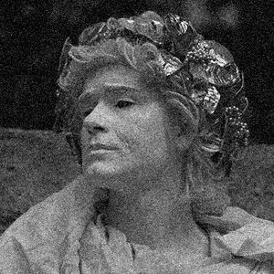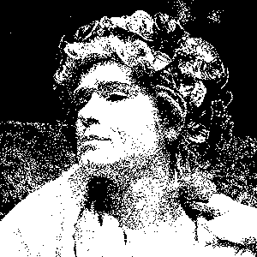

Figure 9. Noise Image(left) and Binary image

|  |  |
| --- | --- |
| Erode | Dilate |
|  |  |
| Opening | Closing |
|  |  |

Figure 10. Erode, Dilate, Opening, and Closing

As discussed before, opening and closing can be done with different get structuring size. The result of opening and closing operation with a 3 by 3 mask are shown below.

|  |  |
| --- | --- |
| Opening with 3 by 3 mask | Closing with 3 by 3 mask |
|  |  |

Figure 11. Opening and Closing with a 3 x 3 mask

## Binarization – Global Binarization

The binarization of image is to divide into two categories from each pixel in image, such as dividing into the background and object region from image or segmenting the region of interest (ROI) and uninterested region. In the concept of binarization, the pixel values in the image will be divided into 0 or 255, which means that it consists of black and white pixels.

As discussed in the morphology section, the input image was binarized to show the effectiveness of dilation and erosion. Within this operation in the grayscale image, if the pixel values are bigger than the specific value, it can set to 255. Also, if the pixel values are small than the specific value, it can set to 0. This is called binary threshold, and the ranges of threshold are 0 to 255. Thresholding is very important because the output of an image could easily be changed depending on what pixel value are for thresholding.

There are 5 types thresholding: thresh binary, thresh binary inverted, thresh truncated, thresh to zero, and thresh to zero inverted as shown below.

|  |  |  |
| --- | --- | --- |
| Truncate | Binary | Binary Inverted |
|  |  |  |
| To Zero | To Zero Inverted |
|  |  |

Figure 12. 5 different thresholding type

## Adaptive Binarization & Automatic Thresholding

With global binarization, there are some limitations where it doesn’t threshold the ROI (Region of Interest) and uninterest region by uneven lighting environment. In this case, adaptive thresholding can be used to resolve the region of interest by using trackbar. Adaptive binarization is a method of setting a square block area of a fixed size in all pixels in the image, and binarizing by determining unique thresholds from the distribution of pixel values inside the block area. The implementation could be varied depends on the threshold value, and 127 and 255 were tested as shown below).

|  |  |  |
| --- | --- | --- |
| Adaptive Method | Threshold (127) | Threshold Max |
| Adaptive Mean |  |  |
| Adaptive Gaussian |  |  |

Figure 13. Adaptive Binarization (Binary) where block size is equal.

As mentioned earlier, it is important to find the proper threshold value. Another method to detect the threshold value automatically is called Otsu method. Otsu method is to find the threshold value by finding the two peaks from the histogram while scanning each pixel values. The result is shown below.

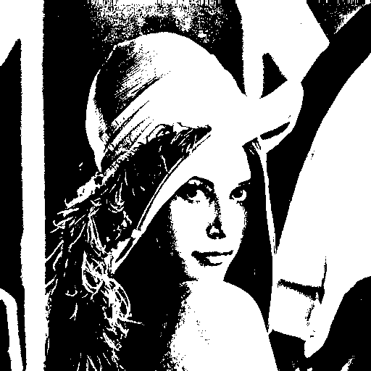

Figure 14. Otsu Method.

## Segmentation

Within the digital image processing, the segmentation can largely be divided into edge-based and region-based. In the case of Edge-based, it is a method of extracting meaningful areas based on boundary lines, which is sensitive to noise and has disadvantage in obtaining a boundary in the form of a closed curve. In the case of region-based, it is good to divide objects in noisy environments by means of similarity in intensity. There is a weak disadvantage in noise or spreading near the boundary.

Watershed algorithm belongs to region-based method. This watershed can be seen as technology that considers the pixel value of the image to be height and divides the image into two-dimensional topography and into pool segment area surrounded by one contour when the water is filled.

Using watershed algorithm, the results can be obtained in figure 15. The results do not seem correct because of thresholding values, which it would affect the distance map.

|  |  |  |  |  |
| --- | --- | --- | --- | --- |
| Input | Distance | Marker | Boarder | Result |
|  |  |  |  |  |

Figure 15. Watershed Algorithm on Coin Input image

## Background Subtractor – Frame Differencing

Background subtraction is the process of separating out foreground objects from the background in a sequence of frames as shown in figure 16.

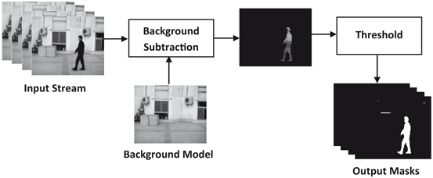

Figure 16. Background Subtraction.

Given similar multiple images either different angles or time-variant images, it will get rid of constant pixels such as background, then it will threshold multiple images and compare it.

# Research Project: Root Detection.

## Introduction & Objective

One way to determine a plant’s phenotype is to take images while the organism is growing and analyze this organism in 2D analysis tool. There is a factor that could determine the plant’s shape in the future is the root system. In order to pass those images into 2D analysis, this plant’s root system must be grown in the transparent gel such that growth of root can be easily obtainable as an image. Furthermore, the root system can be captured in different angles to maximize the performance on analysis of root system, which means that images of root system can be captured while the plants are rotating with different angles. In consequences, develop an algorithm to determine the maximum region of root system from the gel automatically.

## Dataset

Dataset are consisting of one plant’s root system with different angle such as 0, 150, and 300 degrees

## Algorithm & Operation

* Read multiple images set one time, such as one plant’s root system with different angles.
* Compute foreground image by allowing background subtraction.
* With use of foreground images, bitwise or operation can be done in order to capture the overall root system.
* Then this or operation will have one image represents overall root system of one plant.
* Find the region of a root system by finding the vertical and horizontal line in use of morphology.
* Find where black pixels are distributed in row and use this information to calculate the extent of root system.

## Generalization

To further generalize the idea and implementation, segmentation is required, such that any root system should be found within this operation.

Finding the pixels in the histograms were done to insert that pixel values for thresholding but doesn’t seem that it looks correct. Also, there were a limitation of finding the gel region by using the Hough transform. Since separating foreground and background were done, it’s possible to use marker and watershed algorithm to find the region of root system.

The further outputs will be sent via email and communicate how to improve this system better.

# Reference

“Changing the Contrast and Brightness of an Image!” *OpenCV*, docs.opencv.org/3.4/d3/dc1/tutorial_basic_linear_transform.html.

Gonzalez, Rafael C, Woods, and Richard E. Digital Image Processing. Pearson, 2016

Oliver, W. (1998). Histogram Stretching Or Histogram Equalization In Image Processing. Microscopy Today, 6(3), 20-24. doi:10.1017/S1551929500066797

“Histogram Equalization¶.” *Histogram Equalization - OpenCV 2.4.13.7 Documentation*, docs.opencv.org/2.4/doc/tutorials/imgproc/histograms/histogram_equalization/histogram_equalization.html.

N. Otsu, “A threshold selection method from gray-level histograms,” IEEE Trans. Syst., Man, Cybern., vol. SMC-9, pp. 62-66, 1979

Mordvintsev, Alexander, and Abid K. “Image Thresholding¶.” *OpenCV*, 2013, opencv-python-tutroals.readthedocs.io/en/latest/py_tutorials/py_imgproc/py_thresholding/py_thresholding.html.

“More Morphology Transformations.” *OpenCV*, docs.opencv.org/3.4/d3/dbe/tutorial_opening_closing_hats.html.

Beucher, Serge. “IMAGE SEGMENTATION AND MATHEMATICAL MORPHOLOGY.” *The Watershed Transformation Page*, 2010, [www.cmm.mines-paristech.fr/~beucher/wtshed.html](http://www.cmm.mines-paristech.fr/~beucher/wtshed.html).

Shaikh S., Saeed K., Chaki N. (2014) Moving Object Detection Using Background Subtraction. In: Moving Object Detection Using Background Subtraction. SpringerBriefs in Computer Science. Springer, Cham