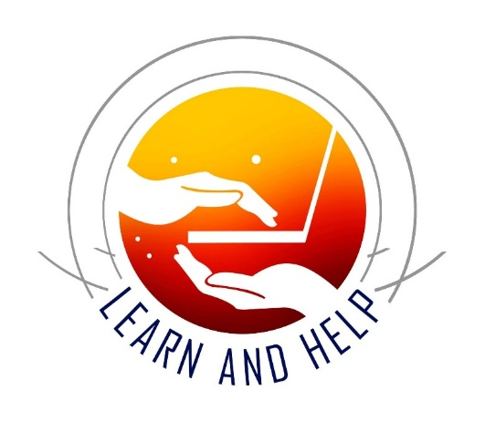
Learn and Help
Empowering Minds, Inspiring Generosity!
www.learnandhelp.com

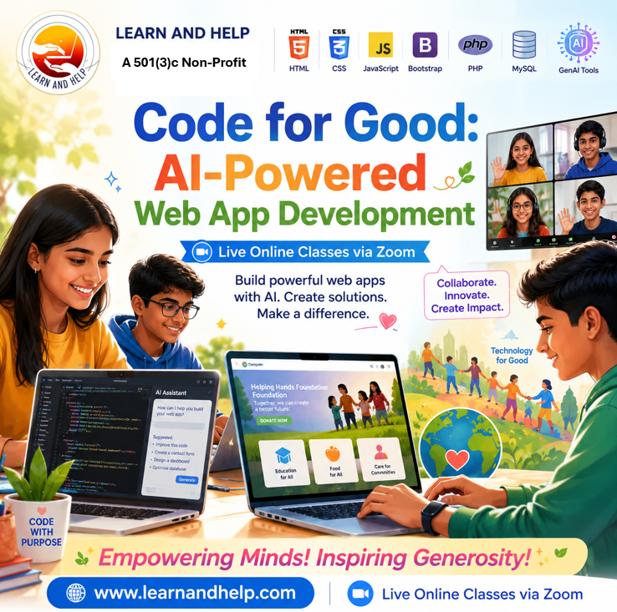
Code for Good (aka Upskill)
AI-Powered Web Application Development
Syllabus and Weekly Planner (30 Weeks)
🎯 Course Overview
This 30-week program teaches full-stack web development with real-world engineering practices. Students build and deploy a real web application for a nonprofit, business, or LLC while learning frontend, backend, databases, security, DevOps, and GenAI tools.
By the end, students will develop a fully deployed, production-style web application for a LLC or non-profit.

🧭 Program Phases
- Phase 1: Foundations and AI Tools (Weeks 1–6)
- Phase 2: Frontend Engineering (Weeks 7–12)
- Phase 3: Backend + Database + Security (Weeks 13–20)
- Phase 4: DevOps + GenAI + Deployment (Weeks 21–26)
- Phase 5: Capstone Delivery (Weeks 27–30)

🤖 GenAI Integration (Across all Phases)
Students will use AI tools such as ChatGPT and Claude for:
- Learning and Exploring
- Planning and Designing
- Creating and Debugging code
- Generating CRUD systems
- Designing database schemas
- Writing documentation
- Improving UI/UX design
- Deployment of the full-stack applications
- Creating the presentations
- Registering non-profits or LLCs

📅 Weekly Planner
🟦 Phase 1 — Foundations
Week | Topic | Key Outcomes
1 | Introduction to Code for Good, Setup (GitHub, Claude and VS Code) | Web ecosystem + social impact mission
2 | HTML Basics, Prompt Engineering Basics | Page structure, semantic tags
3 | HTML Forms, Structured Prompt Templates | Input elements, validation basics
4 | CSS Basics and Layouts | Styling, colors, typography, Responsive design
5 | Project Selection - Phase 1 | Incorporating LLC or Non-Profit; Governance
6 | Git & GitHub Basics | Repositories, commits, push/pull

🟩 Phase 2 — Frontend Engineering
Week | Topic | Key Outcomes
7 | JavaScript Basics | Variables, loops, functions
8 | DOM Manipulation | Interactive UI development
9 | Events & Validation | Form handling, interactivity
10 | jQuery Basics | DOM simplification
11 | Bootstrap / UI Frameworks | Responsive UI components
12 | Mini Project 1 | Responsive landing page

🟨 Phase 3 — Backend + Database + Security
Week | Topic | Key Outcomes
13 | PHP Basics | Server-side programming
14 | PHP Forms & Sessions | State management
15 | MySQL Basics | Tables, queries
16 | Database Design | ER diagrams, normalization
17 | CRUD Applications | Create, Read, Update, Delete
18 | Authentication System | Login, logout, password hashing
19 | Role-Based Access Control (RBAC) | Admin, staff, user roles
20 | Logging & Auditing | Activity tracking system

🟧 Phase 4 — DevOps + GenAI + Deployment
Week | Topic | Key Outcomes
21 | Web Security Basics | OWASP concepts, input validation
22 | Secure PHP Coding | SQL injection & XSS prevention
23 | Advanced Logging & Auditing | System activity tracking
24 | GitHub Workflow | Branching, pull requests, code reviews
25 | Deployment Basics | Hosting with cPanel / shared hosting
26 | Cloud Deployment Intro | AWS / Render / hosting fundamentals

🟥 Phase 5 — Capstone Project (Code for Good)
Week | Topic | Key Outcomes
27 | Project Selection and Organization Setup | Incorporate nonprofit / business / LLC idea
28 | Full Stack Integration | Frontend + backend + database
29 | Testing & Deployment | Security checks, bug fixes, live hosting
30 | Final Demo Day 🎤 | Presentation to industry panel

🏗️ Required Project Features
Each final project must include:
🔐 Authentication & Authorization
- Login / Logout system
- Secure password hashing
- Role-Based Access Control (Admin / User / Staff)
🧱 Database Design
- ER diagrams
- Normalized schema (1NF–3NF basics)
- Relational database with foreign keys
🛡️ Security
- SQL injection prevention
- XSS protection
- Input validation
- Secure session handling
📊 Logging & Auditing
- User activity logs
- CRUD operation tracking
- Audit trail tables
📱 Responsive Design
- Mobile-first UI
- Bootstrap or CSS frameworks
🔄 GitHub Workflow
- Branching strategy
- Pull requests
- Code reviews
- Proper README documentation
🚀 Deployment
- Live hosted web application
- Domain (optional)
- Production-ready configuration

🎯 Final Outcome
By the end of this course, students will:
- Build full-stack web applications
- Design secure systems with RBAC
- Work with databases professionally
- Use GitHub like real developers
- Deploy production applications
- Use AI tools for software development
- Deliver a real-world impact project

🌍 Code for Good Mission
Students will create technology that supports:
- Nonprofits
- Small businesses
- Community organizations
- Social impact initiatives
They will finish the course not just as learners, but as junior full-stack developers ready for real-world projects.

