Metro State Student Services Test Guide
Fictional test data for RAG EVAL 2.0 — Test Case 10. Not official university policy.

Registration Assistance
For this fictional test scenario, students must submit registration assistance requests by November 12, 2026. The registration support reference code is REG-482.
Service | Response Time | Office
Registration Review | 2 business days | Advising
Enrollment Verification | 3 business days | Registrar
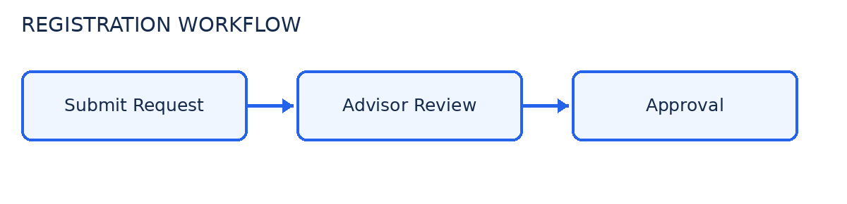

Technology Support
For this fictional test scenario, technology support requests use reference code TECH-739. Priority support is available on Thursdays.
Issue Type | Priority | Support Team
Password Reset | High | Identity Services
Software Installation | Normal | Desktop Support
