**Henry de Percy - Baron of Alnwick (First Scottish War of Independence - England)**

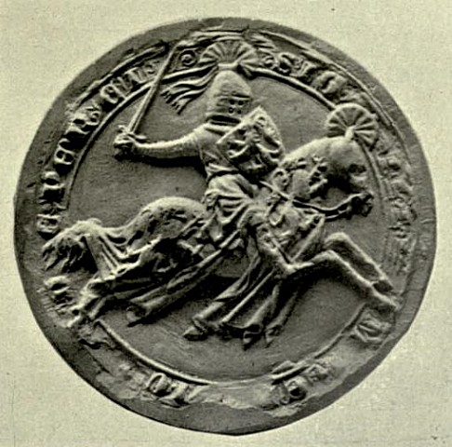

I, Henry de Percy, the Baron of Alnwick, am loyal to King Edward, and have many distinguished estates in my inheritance, including properties in Sussex and Yorkshire. In 1294, I went to war for the first time, summoned by the King to suppress the Welsh rebellion. It was there that I gained my martial skill and learned the art of command and supply of armies in the field. It was there that I had my first triumph in battle. I currently serve in the King’s council, and I am willing to serve him against the rebellious Scots. Even though at present, there may not be talk of war, I believe the next Scottish King will only be chosen after battle, and as there is no proper heir, the King and his council must choose one. A war will ensure that our choice is favourable, and that there will be no one to contest it. I wish to test my mettle in battle once more, and this brewing conflict presents that opportunity, and my victory will allow me to leverage a greater position in England in addition.

In order to defeat the Scots, it is necessary to sow discord among their clans, and render them incapable to resist invasion by our armies. It is of the utmost importance to prevent the Scots from fighting under one banner against us, if this occurs they will be very difficult to defeat. However, it is not enough that the Scots are divided, we English must also be undivided in our aims. If total victory is achieved, the total subjugation of Scotland may be possible.

When the time for war comes, the victor shall be he who has prepared for battle. It is imperative that an great English army is raised, and that the defenses on the border are secured. We must then strike swiftly, before the Scottish armies can be mustered, so our preparation must be kept secret. We should aim to take their cities, especially Glasgow and Edinburgh, and if possible extend our influence until Aberdeen. The South and Centre of Scotland must be captured. We must also have superior supply if our campaign is to continue for any length of time, since the highlands will only make the march northwards onerous. It will be advantageous if our King was in England, and not campaigning elsewhere, such as in France during this war, as it will be necessary to win over the Barons, and if possible even some Scottish lords. Most importantly, we must field our most clever marshals to outwit the enemy. In our domestic affairs, it is important to separate obligations in a way that facilitates ruling the nation, raising taxes, and making war. It is necessary to deter baron from rebelling, especially in a war with Scotland, as a rearguard action this could prove disastrous for English forces.

I believe that the question of Scottish inheritance is best solved by war against Scotland, which will allow the English court to impose its absolute will over the next King of the highlands. I would like to personally command an army in this endeavour, and would defeat the Scots in the field of battle due to our superior preparation.

Bibliography

Arms (ancient) of the House of Percy. Digital image. Wikipedia. Accessed November 4, 2016. https://en.wikipedia.org/wiki/File:House_of_Percy.png.

Arms (modern) of the House of Percy. Digital image. Wikipedia. Accessed November 4, 2016. https://en.wikipedia.org/wiki/File:Redvers.svg.

"Edward I of England." Wikipedia. Accessed November 04, 2016. https://en.wikipedia.org/wiki/Edward_I_of_England.

"First War of Scottish Independence." Wikipedia. Accessed November 04, 2016. https://en.wikipedia.org/wiki/First_War_of_Scottish_Independence.

Kingsford, Charles L. "Percy, Henry (1272?-1315)." In *Dictionary of National Biography*, 392-93. Vol. 44. 1885-1900.

Mitrovic, Tijana, Peter Dropping Furberg, Yakau Feldman, Austin Northey, and Shiraz Zia. "Scottish War of Independence: England Background Guide." Accessed November 4, 2016. http://www.ssuns.org/static/BG/JC%20Scottish%20War%20of%20Indep-England.pdf.

Walden, Howard De. "Seal of Henry De Percy, 1st Baron Percy." Digital image. Wikipedia. 1904. https://en.wikipedia.org/wiki/File:Percy3.jpg.