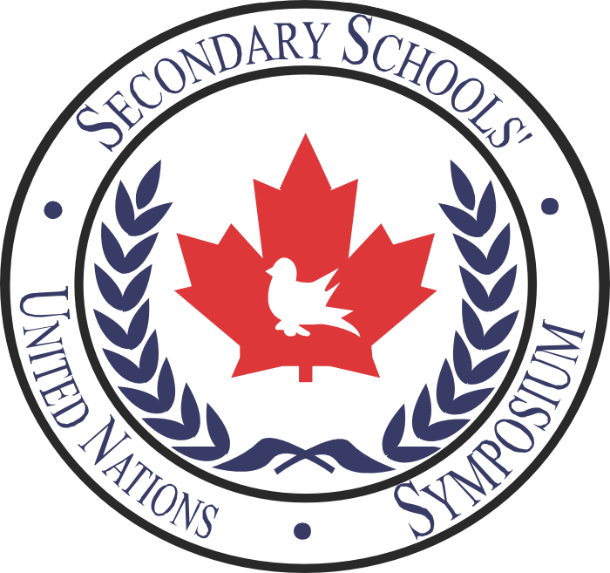**Committee:** African Union

**Topic:** Access to Education for Women and Girls

**Country:** Algeria

Education is something that allows humans to make our world evolve. It gets people to expand their knowledge, to learn how to become good citizens and to develop new sciences or invent things. It is a gift that not all of us have the luxury to access. In many countries specifically in the African continent, women and girls do not receive the same accessibility to schooling, as do men and boys. The reasoning behind this injustice includes socio-economic status, social norms, cultural expectations, education policies and violence. For example, when it comes to sending a child to school, the household’s income must be taken in consideration. If we look at the social and cultural norms, it is to be expected that the women abandon school and become housewives. Violence may seem like an obscure barrier to girls’ education but many parents remove their children from that environment as they could be victims of abuse. A few policies were adopted. Their main focus was to protect women’s rights and improve gender equality as a way to help women attend school. However they failed to do so primarily because the policies were not updated and simply because female education is not part of government officials’ priorities.

Algeria, a northern African country, established a good education system in the 1950’s. It offers free education (primary level) to all children between the ages of 6 and 15. That said, for the past 20 years, the ratio of girls and boys enrolled in school has increased. According to World Bank Indicators, the ratio went from 84.2% in 1990, to 91.9 % in the year 2000, to 94.1 % in 2010. In the past 5 years, women’s empowerment has progressed immensely. Nonetheless, Algeria still suffers with a stereotypical type of society where women are seen as powerless and without rights to education or employment. Since 2010, women have made it steps closer to gender equality with the help of many government controlled organizations such as the Syndicat National Autonome des Personnels de l’Administration Publique. The SNAPAP has provided women with a voice. They’ve learned to understand their rights and fight for them. Today, many have chosen to pursue their studies or find a workplace in different fields including education and nursing.

Seeing Algeria’s progress, a solution that should be discussed that might also seem contradicting would be education. Informing women on their rights is a way to get them to realize the injustice they’ve been living and it is a way to get them to act upon it. If organizations can get together to teach girls at a young age how important they are, they will grow with that mentality and become more present in the workplace. In the past, organizations have tried to do so yet failed. They had trouble convincing governments to prioritize the situation. Once again, the only way to convince the party is by educating them about the benefits women’s education has for the world.

**Committee:** African Union

**Topic:** Foreign Direct Investment in Africa

**Country:** Algeria

Foreign direct investment (FDI) is a method used to favour a country’s development in business and technology. Countries seek investment with other regions to help finance projects or to help balance debts. Africa is dealing with big problems related to this subject. It is one of the regions with the least FDI inflows. Depending on the countries’ best interests, all kinds of things can persuade them to invest. In this case, natural resources such as oils and mines are where there seems to be the most activity in Africa. However, invertors wish to put their money in a politically stable country. This is one of the main consequences to such poor investing in the African continent. Also, it has a domino effect that leads to decreasing the economic development. Therefore, Africa would become dependent of FDIs because it would be the only factor driving their economy. State and local governments have offered financial assistance to promote the developing of countries. Likewise, Africa faces financial aid dependency. In the past, organizations have worked on improving the continent’s stability in politics and in economy.

Algeria stands in the top ten recipients of Africa’s FDI. However, according to the 2016 Doing Business report, they country was ranked 163rd out of 189. Which means there is room for progress. What has attracted FDIs in Algeria was the fact that it is rich in oils and gas, that it is economically stable and it is undergoing infrastructure projects. To avoid corruption, Algeria has a rule limiting the amount of local FDIs to 49%. Regardless, the government is looking for foreign investor in telecommunication and infrastructure and energy. The country is expecting more inflow in the near future considering there is development in the hydrocarbon fields and construction of ironworks complex. Algeria’s main focus is on its economic liberalization meaning a lessening of government regulations.

A solution to this issue would be to attract investors by lowering prices in several fields convincing them it is worth it. the government has accommodated investors by including “the reduction of corporate taxes for investment in specific locations, a reduction in social security contributions for new recruitments of young employees, the concession of land by mutual agreement for up to 33 years and tax exemptions throughout the life of the project for exporting projects.”

**Committee:** African Union

**Topic:** Promoting Integrity and Transparency in Democratically Elected Governments

**Country:** Algeria

Citizens wish to live in an area where their government is well run. We define good governance with its level of integrity and transparency. A government is doing right by considering the citizens interests in the decisions that it makes and provides all information on their services. Otherwise, a government that does not respect integrity and transparency gets identified as corrupted. It is important to discuss Africa’s situation because the majority of the corrupt countries are in Africa. Corruption is caused by many things including : “ weak state institutions, low/ unreliable salarie, inefective use of oversight and institutional culture of corruption’’. For example, Angola, a corrupted country, accepts bribery, divids revenues unfarily to workers and leaves injustice unpunished. NGOs have tried addressing the situation by influencing governments to monitor all incomes and outcomes. Technology is a good method to do so. It allows information and communication to be secure and accurate. The APRM, an intra-African organization, works on promoting democracy and improving governance. The issue still has its place despite the effective actions proposed in the past.

Algeria seems to be in the same boat as the rest of the continent. The country experiences corruption in many sectors such as the judicial system, public services, natural resources etc. Algeria knows that it has impacted on the economy’s development and it is a fundamental need to change things in order to reach good governance. Bouteflika, the president of Algeria, pushed to fight against corruption by proposing a law in 2006 and a commission was created but it did not go any further. Recently, [El-Fadjr newspaper announced that the 2006’s commission will finally be implemented in the field](http://www.al-fadjr.com/ar/rtila/137526.html) this year.

The greatest solution to the problem would be to create new laws prohibiting all forms of bribery or salary inequality. Technology is a good way to monitor revenues but in these types of countries Internet is more difficult to obtain.

**BIBLIOGRAPHY**

“Education System in Agleria”. Classbase <http://www.classbase.com/countries/Algeria/Education-System> n.d.

“In Algeria, Women’s Employment and Education go Hand in Hand in Unexpected Ways”. Naila Missous<http://muftah.org/algeria-womens-employment-education-go-hand-hand-unexpected-ways/#.WB-0iRSXV-U> 8 Oct. 2014

“Algeria Gender Equality Profile”. UNICEF. <http://www.unicef.org/gender/files/Algeria-Gender-Eqaulity-Profile-2011.pdf> Oct 2011

“Ratio of girls to boys in primary and secondary education in Algeria”. Trading Economics.<http://www.tradingeconomics.com/algeria/ratio-of-girls-to-boys-in-primary-and-secondary-education-percent-wb-data.html> n.d.

[“Women do not Enjoy Employment Stability as Algerian Men do”. Naila Missous. http://www.yourmiddleeast.com/opinion/how-to-tackle-the-algerian-womans-struggle-against-social-expectations_26524](http://www.yourmiddleeast.com/opinion/how-to-tackle-the-algerian-womans-struggle-against-social-expectations_26524) 10 September 2014

“Algeria” World Bank.[http://www.worldbank.org/en/country/algeria/overview#1](http://www.worldbank.org/en/country/algeria/overview" \l "1) 31 March 2016

“Foreign investment in Algeria” Ben Abderrehaman. <https://www.hg.org/article.asp?id=4848> n.d.

“2015 Investment Climate Statement- Algeria” U.S Department of State. <http://www.state.gov/e/eb/rls/othr/ics/2015/241455.htm> Mai 2015

“Algeria Foreign Investment” Santander. <https://en.portal.santandertrade.com/establish-overseas/algeria/foreign-investment> November 2016

“Algeria Corruption Report” Business Anti-Corruption Portal.<http://www.business-anti-corruption.com/country-profiles/algeria> n.d.

“Fighting Against Corruption in Algeria” Patriots on Fire. <https://vivalalgerie.wordpress.com/2010/01/03/fighting-against-corruption-in-algeria/> 3 Jan 2010