Topics: Access to education

Foreign Direct Investment (FDI)

Integrity and transparency in government

Country: Burkina Faso

Committee: African Union

Phil Speiss – Blyth Academy Lawrence Park

1. Due to the increased importance of globalization in the modern world its effect on the developing world has also increased, specifically the effect of foreign direct investment. Foreign direct investment also known as FDI is a term used to describe foreign investments taken by individuals or companies in other countries to acquire businesses, land rights, and the rights to harvest natural resources. Although African nations have large amounts of natural resources they do not yet receive the same amount of FDI as other nation such as ones in Asia and Latin America. African nations view this as a problem due to the fact that it keeps Africa from becoming a larger economy and thus a larger global power. Many countries have implemented their own ways of promoting FDI in Africa but it is not enough, we need the help of the international community.

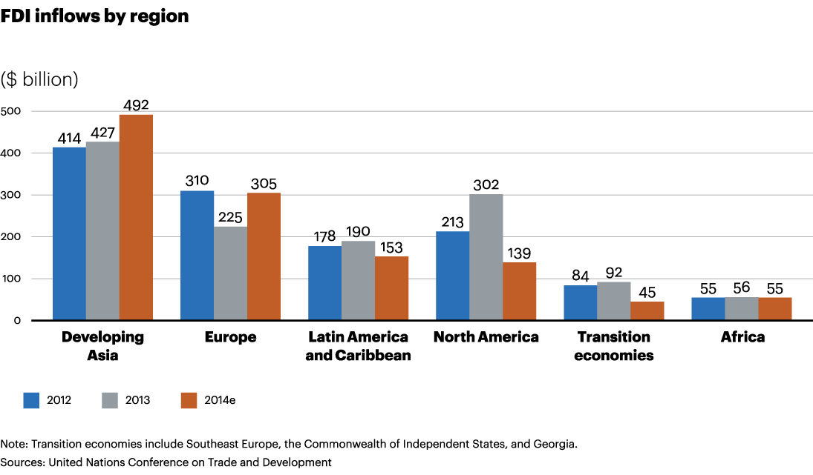

1. As a small African nation, this issue is very important to Burkina Faso as we value our continued growth and stability for our people. A significant amount of our GDP comes from FDI (as much a 4% in 2013). The amount of FDI into our country has led to an average growth rate of 5.5% annually in the past 4 years. As such, we have deemed it very important to maintain this level as well as try to increase it.

Like many other African nations, Burkina Faso lacks the resources and staff to develop a well-functioning education system. This has led to them having one of the lowest adult literacy rates in the world at 25.3

Throughout the previous years, the government of Burkina Faso has been becoming more and more transparent. Last year ranking just below the world average in government transparency.

1. The government of Burkina Faso over the past 35 years has followed the trend in Africa of trying to incentivize foreign investments by reducing taxation and customs exemptions on companies and governments trying to invest in the mining and agricultural industries. This has been done through the modification of our tax code in 2010, 2012, and 2013. In 2012, the national assembly passed a bill granting further tax cuts to companies who sign investment agreements with the states. Because this mostly effected the larger companies investing in Burkina Faso, the government created the Burkina Faso Investment Promotion Agency as well as registration centers which could walk small companies through the process of foreign investing known as CEFOREs. The government has also created similar agencies to aid in the acquisition of building permits.



Burkina Faso relies heavily on the World Trade Organization (WTO) to effectively sell the goods it produces or exports such as gold, manganese, other minerals, and cotton to other countries around the world. Members of the WTO have expressed their appreciation to the government of Burkina Faso for liberalizing their trade policy. The WTO also believes that there is still a lot of work to be done by the government to reduce complexities and redundancies in their trade tariffs. Through incentives made by the WTO, FDI to Burkina Faso could increase significantly, helping out economy to grow and become more stable

The UN launched a global study in September of 2014 into the topic of illegal gold mining. This received much praise from the government of Burkina Faso as they believe that a significant amount of income is lost due to illegal mining as gold mining makes up almost 20% of their GDP.

The government of Burkina Faso has put in legislation to try and reduce the overcrowding of schools and their class rooms by limiting their class sizes to 65 students. Although this has worked decently well in cities, due to the large rural population and lack of teachers, this is commonly not followed with class sizes upwards of 100 students.

Although no legislation has been passed to increase government transparency, the removal of a long reigning dictator and his replacement with a democratically elected government has led to more open policy making.

1. It is the belief of Burkina Faso that if the WTO puts in place incentives for trading with African nations that we can achieve our goal of increased FDI and stable growth for our country.

Development projects to build schools as well as teachers sent by the UN’s member countries would help to alleviate the struggle of education in Burkina Faso.

Continued oversite from the UN while our democracy grows will be instrumental in maintaining the government integrity and transparency that we currently have.

"Executive Summary Mining Agriculture Transport - State.gov." N.p., n.d. Web. 5 Nov. 2016.

<https://www.state.gov/documents/organization/227134.pdf>

"Burkina Faso - EY." N.p., n.d. Web. 5 Nov. 2016.

<http://www.ey.com/Publication/vwLUAssets/ey-tax-guide-burkina-faso-february-2014/$FILE/ey-tax-guide-burkina-faso-february-2014.pdf>

Page, Sheila, and Dirk Willem Te Velde. "Foreign Direct Investment by African Countries." N.p., 17 Dec. 2004. Web. 5 Nov. 2016.

<https://www.odi.org/sites/odi.org.uk/files/odi-assets/publications-opinion-files/5739.pdf>

"WORLD TRADE ORGANIZATION." *WTO*. N.p., n.d. Web. 05 Nov. 2016.

<https://www.wto.org/english/tratop_e/tpr_e/tp92_e.htm>

"Burkina Faso Overview." *Burkina Faso Overview*. N.p., 11 Oct. 2016. Web. 05 Nov. 2016.

<http://www.worldbank.org/en/country/burkinafaso/overview>

"Burkina Faso - Worldapedia." *Burkina Faso - Worldapedia*. United Nations Statistics Division, n.d. Web. 05 Nov. 2016.

<http://data.un.org/CountryProfile.aspx?crName=burkina%20faso>

Maylie, Devon. "United Nations to Probe Illegal Gold Mining." *WSJ*. Wsj.com, 2014. Web. 05 Nov. 2016.

<http://www.wsj.com/articles/united-nations-to-probe-illegal-gold-mining-1408933802>