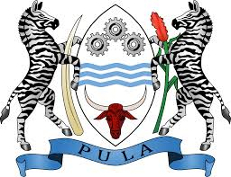Bryce Phillips

Hatboro-Horsham High School

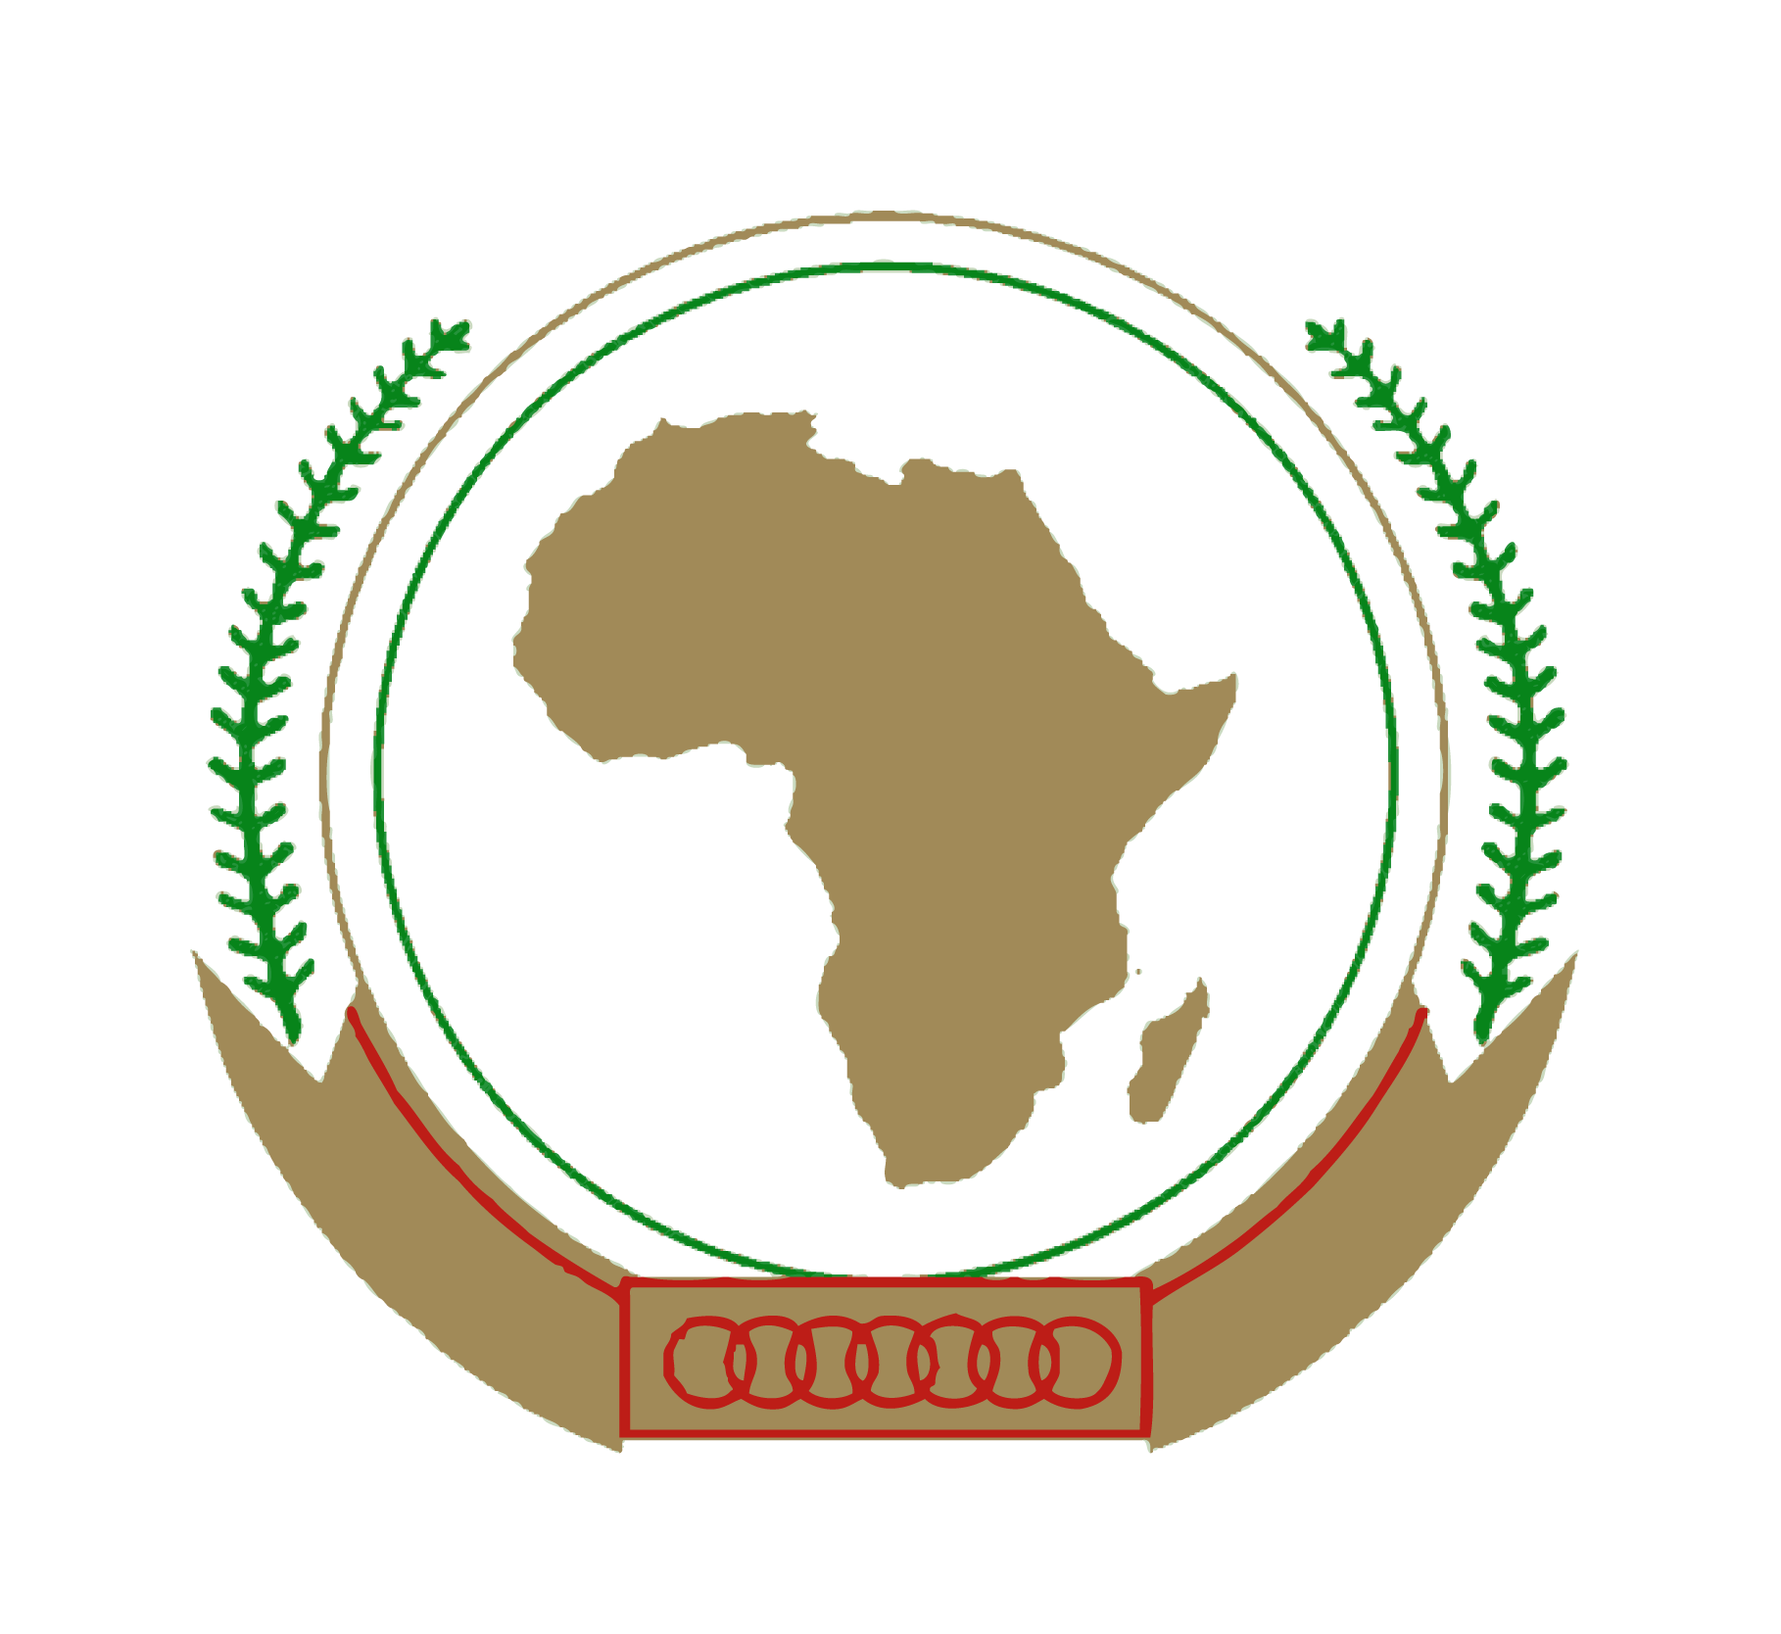Botswana

African Union

**Topic 1: Access to Education for Women and Girls**

Botswana understands that access to proper education is a universal right for all people regardless of gender or socioeconomic status. Education is a fundamental element of economic and societal development. In recent years, Botswana has taken measures in order to improve its education programs as well as ensure that all children are able to go to school. For instance, Botswana spends ten percent of its annual budget on its education system, this is the fifth largest proportion in the world[1]. Grassroots organizations such as the Girl’s Education Movement have also been instrumental in providing equal education for all genders. Currently, the literacy rate for boys and girls is equal at 88%.

International efforts have also been made with regard to girl’s education. The African Union- International Centre for Girls and Women’s Education in Africa (AU/CIEFFA) is an African Union agency which performs fact finding missions on the education programs of member nations[2]. The United Nations Girl’s Education Initiative has also been established by the international community in order to make education more accessible for girls around the world[3].

Botswana believes that efforts made by the international community to improve girls’ education have been effective at raising more awareness for the issue of girl’s education worldwide. However, it is also Botswana’s belief that a plan which focuses more on individual member states rather than a holistic approach could best serve African nations. This is because top down approaches, such as the AU/CIEFFA, are limited in their ability to adapt to the customs and economy of individual member states. Botswana endorses a solution which emphasizes the responsibilities of member states to take measures themselves. Another possible solution would be the creation of a framework that ensures that each member state takes the appropriate measures in order to ensure that each country understands their responsibility in providing education. Such an agreement could use the AU/CIEFFA as a monitoring agency.



Bryce Phillips

****Hatboro-Horsham High School

Botswana

African Union

**Topic 2: Foreign Direct Investment**

Although Botswana is not one of the largest destinations of foreign direct investment, its economic growth, low corruption and diamond reserves have made it attractive for foreign companies such as De Beers. While diamonds may be the largest element of Botswana’s economy, Botswana has also been utilizing revenues from the industry in order to improve its infrastructure and increase foreign direct investment. Botswana has also seen an average growth rate of 5% over the past decade, which is the largest in the world. Botswana believes that foreign direct investment is an important factor in the economic development of African nations.

While bodies such as the International Monetary Fund and the World Bank have worked to improve the economies of African states through loans and aid programs, Botswana does not see these measures as a totally necessary element in economic development. Efforts by member states in order to improve their economies as well as ensure that that government revenues are properly managed are crucial to their success. Botswana therefore encourages the African Union to seek a solution which gives member states the ability to manage their economies properly with little oversight. This can ensure that governments are able to take steps which may improve their economies while also allowing for such improvements to be made with little oversight.

Bryce Phillips

Hatboro-Horsham High School

Botswana

African Union

**Topic 3: Promoting Integrity and Transparency in Democratically Elected Governments**

Corruption is a very serious concern for African nations because it can hinder nationwide economic and social progress. Organizations such as Transparency International as well as international agreements such as the United Nations Convention against Corruption are working on an international scale in order to defeat corruption globally. The African Union advisory board on Corruption is also very important for its fight on the regional level and its ability to monitor corruption levels in Africa. This Board established protocols and measures which it then recommends to member states to implement in their own anti-corruption policies[4].

Botswana is considered one of the least corrupt nations in Africa. This is due to its work in strengthening the judiciary of the nation as well as the establishment of the Directorate on Corruption and Economic Crime in 1994 (DCEC). The DCEC was established as a direct result to the discovery of the misappropriation of funds and an abuse of political privileges during the 1990’s[5]. Since then, Botswana has worked to become a nation which aggressively fights against corruption at all levels. Botswana also is free of violent political conflict within the country and has kept its elections free of corruption.

Botswana believes that in order for African nations to succeed in defeating corruption, they must strengthen independent agencies who have the ability to properly prosecute against any official who may be acting in a corrupt manner. This has worked very well in Botswana with the DCEC and a granting of greater independence to the judiciary branch in order to best ensure that corruption can be addressed. The appointing of an ombudsman also an important step for the African nations who do not already have one.

1. "The World Factbook: BOTSWANA." Central Intelligence Agency. Central Intelligence Agency, n.d. Web. 10 Nov. 2016.
2. "Historique - UA/CIEFFA | Centre International Pour L'Education Des Filles Et Des Femmes En Afrique De L'Union Africaine." Historique - UA/CIEFFA | Centre International Pour L'Education Des Filles Et Des Femmes En Afrique De L'Union Africaine. N.p., n.d. Web. 10 Nov. 2016.
3. "UNITED NATIONS GIRLS EDUCATION INITIATIVE." UNGEI. N.p., n.d. Web. 10 Nov. 2016.
4. "African Union Advisory Board on Corruption In Brief." African Union Advisory Board on Corruption. N.p., n.d. Web. 10 Nov. 2016.
5. "Www.transparency.org." N.p., n.d. Web. 10 Nov. 2016.