DELEGATE NAME: Alexander Larson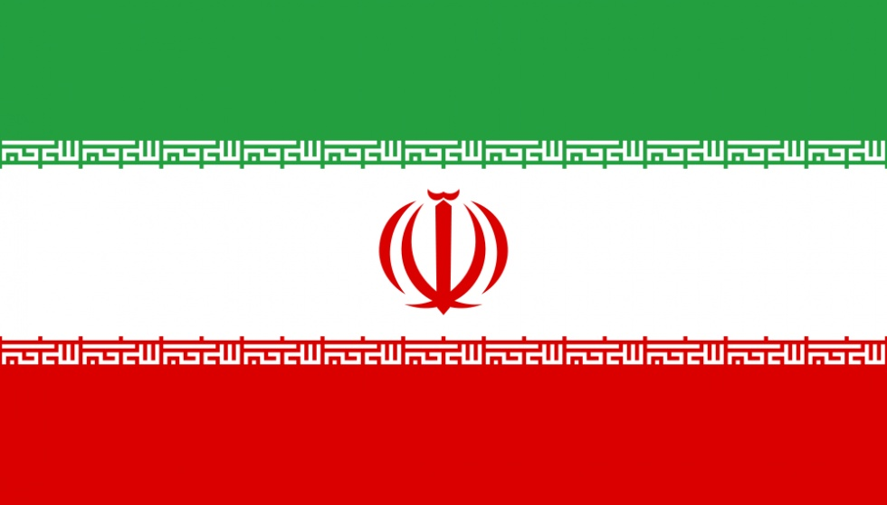

COUNTRY/DELEGATION: Islamic Republic of Iran

COUNCIL/COMMITTEE: International Atomic Energy Agency

TOPIC: Addressing the Threat of Nuclear Terrorism

SCHOOL: Columbia Grammar and Preparatory School

The Delegation of the Islamic Republic of Iran believes that addressing the threat of nuclear terrorism also means addressing the threat of terrorism itself. This philosophy began between the years of 1984 to 1987, when the Republic of Iraq bombed the country’s Bushehr nuclear plant six times. Ever since, the Islamic Republic of Iran has been devoted to stopping all forms of terrorism.

In order for there to not be any threats of nuclear terrorism, and following the belief that nuclear terrorism springs from terrorist groups, the Islamic Republic of Iran believes that terrorist associations such as the Islamic State of Iraq and the Levant must be defeated. Even with the effects of the Joint Comprehensive Plan of Action, the Islamic Republic will continue to support its regional allies in the fight against terror.

The solution of nuclear terrorism is relatively straightforward: remove the terrorist groups, and there will no longer be nuclear terrorism. In order for this to occur, however, the Islamic Republic of Iran believes that the United Nations should pass a resolution stating that all countries, or at least countries that are major powers, should form a coalition and focus all efforts on eradicating all forms terrorism.

DELEGATE NAME: Alexander Larson

COUNTRY/DELEGATION: Islamic Republic of Iran

COUNCIL/COMMITTEE: International Atomic Energy Agency

TOPIC: Nuclear Energy as an Alternate Source of Energy

SCHOOL: Columbia Grammar and Preparatory School

The foundation of the Islamic Republic of Iran’s nuclear energy program was the concept of peaceful uses of said energy. Ever since 1974, the goal of the nuclear program was to use atomic energy to gain more electrical power, instead of using petroleum. These same principals are still upholded to this day. In 2010 the nuclear program produced enriched uranium in the production of medical radioisotopes, which are used to help treat and cure diseases and sicknesses. While the majority of the enriched uranium has been taken out of the country due to the Joint Comprehensive Plan of Action, natural uranium is still being used to do the same things.

The majority of the Islamic Republic of Iran approves of the county’s nuclear program. The population of Iran finds this issue important, more so to the point that they do not even want a nuclear weapons program if it means that they would lose the entire nuclear energy program. What has worked in the past is the same thing that is happening currently; the Islamic Republic is using their nuclear energy program as an alternative source of power, especially for electrical use.

Because of the Joint Comprehensive Plan of Action, the sole use of the nuclear program in the Islamic Republic of Iran is for peaceful purposes. The only thing the energy is being used for at the moment is for other sources of energy. Less fossil fuels are being burned, and the Islamic Republic is leaving a smaller carbon footprint. Because this is already being implemented, there is no serious issue with this in the country, so there is no reason for change.

DELEGATE NAME: Alexander Larson

COUNTRY/DELEGATION: Islamic Republic of Iran

COUNCIL/COMMITTEE: International Atomic Energy Agency

TOPIC: Measures to Implement and Enforce the Nuclear Program in Iran

SCHOOL: Columbia Grammar and Preparatory School

In 2002, the Islamic Republic of Iran suspended the conversion and enrichment nuclear activities, in accordance to the International Atomic Energy Agency (IAEA), and in 2004 agreed to work with the European Union Three to find a diplomatic solution, after facing sanctions threats. In 2006, the Islamic Republic started enrichment once more, and the United Nations Security Council forced our country to work with the IAEA once more. After over 30 years of numerous threats, in 2015, the Islamic Republic of Iran and the Security Council (as well as Germany) reached the agreement called the Joint Comprehensive Plan of Action, which called for the nuclear program within the Islamic Republic to be used for peaceful purposes only.

The Delegation of the Islamic Republic of Iran believes that any suspension of enrichment in our country is intended to take away the right to have independent nuclear technology. The Joint Comprehensive Plan of Action agreement allows the our country to retain the rights to nuclear energy, even though it is prohibited to weaponize, which, after countless disagreements, is the most reasonable course of action.

In light of the Joint Comprehensive Plan of Action, the Delegation of the Islamic Republic of Iran believes that no more actions by the United Nations are needed, because as it stands our country has signed the Joint Comprehensive Plan of Action. Our country only has good intentions, and has taken this response to continue to use nuclear energy, but solely for peaceful purposes. Thus far, the Islamic Republic of Iran has held true to that belief, and as a result, our country believes that this agreement is sufficient enough and no more has to change. Enough limitations have been made, and there is no need for more.